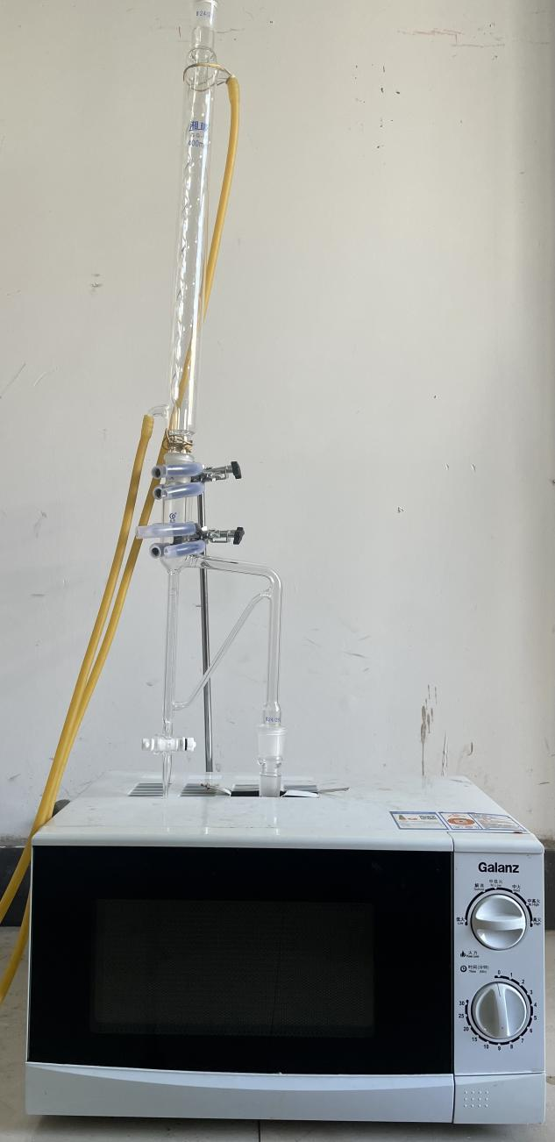
Fig. S1. Microwave extraction device

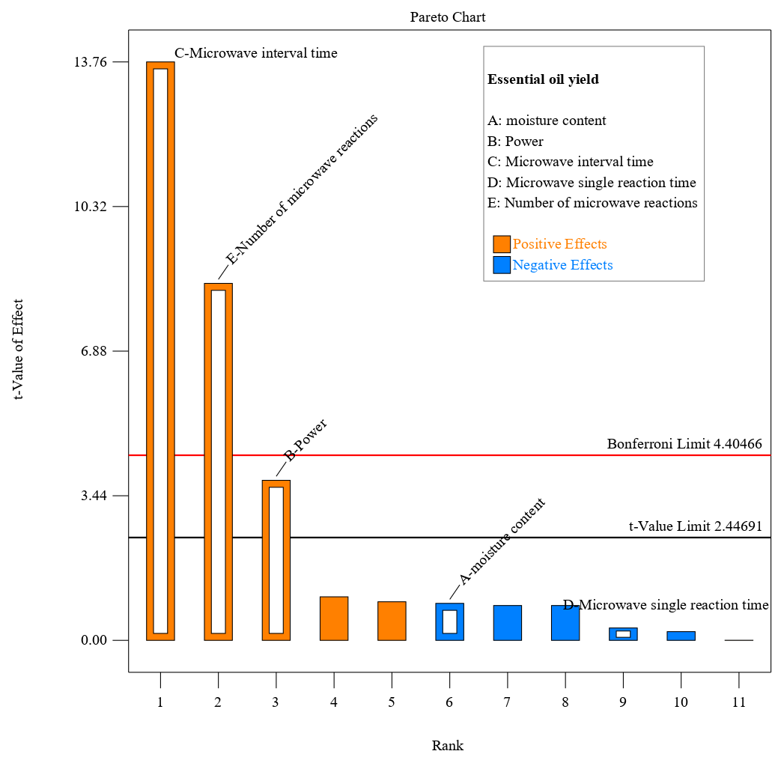
Fig. S2. Pareto Chart of the Standardized Effects (α = 0.05)

