Supplementary Material
Unveiling differences in source apportionment and optical properties of wintertime carbonaceous aerosols in northern and southern Chinese Cities

Rui Li^{1,2,3}, Qiyuan Wang^{1,3 *}, Jie Tian¹, Yong Zhang¹, TingTing Wu^{1,2,3}, Lu Qi⁴, Yang Chen⁵, Shaofei Kong⁶, Suixin Liu¹, Jin Wang¹, Julian Shi^{1,2}, Yuemei Han¹, André S. H. Prévôt⁴, Junji Cao^{7 *}
1 State Key Laboratory of Loess Science, Institute of Earth Environment, Chinese Academy of Sciences, Xi'an 710061, China
2 Xi'an Institute for Innovative Earth Environment Research, Xi'an 710061, China
3 National Observation and Research Station of Regional Ecological Environment Change and Comprehensive Management in the Guanzhong Plain, Shaanxi, Xi'an 710061, China
4 PSI Center for Energy and Environmental Sciences, Laboratory of Atmospheric Chemistry, Paul Scherrer Institute (PSI), Villigen 5232, Switzerland
5 Chongqing Institute of Green and Intelligent Technology, Chinese Academy of Sciences, Chongqing 400714, China
6 Department of Atmospheric Science, School of Environmental Sciences, China University of Geosciences, Wuhan, 430074, China
7 Institute of Atmospheric Physics, Chinese Academy of Sciences, Beijing 100029, China

*Corresponding author:
Qiyuan Wang wangqy@ieecas.cn, Junji Cao jjcao@mail.iap.ac.cn
Special Issue: New Advances in Air Pollution Source Apportionment

Text S1. The species of input for HERM model and the calculation method of uncertainty.
The carbon components selected to input the HERM model including OC1, OC2, OC3, OC4, EC1, EC2, EC3, OP, and ionic element input K⁺. Due to the differences in monitoring reliability of inorganic elements, selected Ca, Ti, Mn, Fe, Zn, As, Se, Pb in XA; Ca, Ti, Mn, Fe, Cr, Ni, Zn, As, Se, Pb in SJZ; Ca, Ti, Mn, Fe, Ni, Zn, As, Se, Pb in WH; Ca, Ti, Mn, Fe, Cr, Cu, Zn, As, Se, Ba, Pb in CQ, respectively.
The calculation method of uncertainty data of chemical species is referred to the PMF model (P. et al. 2014). The calculation method is as follows:
If the concentration of the chemical element is lower than the MDL, the uncertainty is calculated as follow:
$\text{Unc}=\frac{5}{6}⋅\text{MDL}$ (1)
If the concentration of the chemical element is higher than the MDL, the uncertainty is calculated as follow:
$\text{Unc}=\sqrt{{\left(EF×C_{j}\right)}^{2}+{\left(0.5×MDL\right)}^{2}}$ (2)
where C_{j} is the mass of the chemical element, EF is the error fraction of species. The error fraction was set to 7% in XA and SJZ, 6% in WH and CQ.
Text S2. HERM solution diagnostics
In this study, try 2-8 factors to search the optimal number of factors without selecting the source spectral information in four cities, and each factor was run 30 times. The optimal solution was determined by calculating the ratio of Q and expected Q (Q_{exp}). The ratio of Q_{exp} in HERM was calculated as follows:
$Q_{\text{exp}}=n×m-p×\left(n+m\right)$ (3)
where n represents the sample numbers, m represents the species numbers, p represents the factors numbers.
The variation of Q/Q_{exp} in four cities was shown in Figure S1. The value of Q/Q_{exp} decreased as the number of factors increases, which means that increase the number of factors may cause HERM to interpret the variance better (Visser et al. 2015; Salameh et al. 2018). When the chang trend of Q/Q_{exp} tends to be stable, which means that to the factor solution is preferable (Liu et al. 2021). As shown in Fig.S1, the optimal HERM solutions was six-factors solution for XA, and were five-factors solution for other three cities.
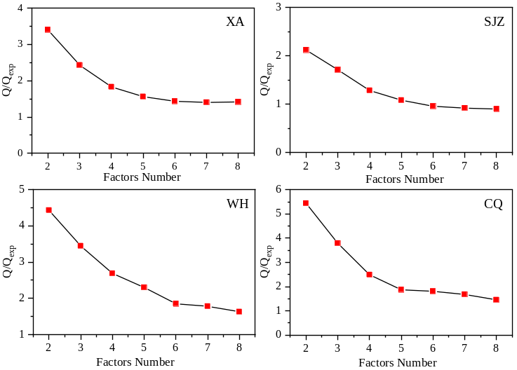
Fig. S1 Values of Q/Q_{exp} for the selected optimal HERM solutions with 2-8 factors
Text S3. Estimation of secondary organic carbon
The concentration of SOC can be estimated using the EC tracer method (i.e. the (OC/EC)_{min} ratio method). SOC, POC and PTC can be expressed by Eq. (4-6):
SOC=OC -EC×(OC/EC)_{min} (4)
POC=OC-SOC (5)
PTC=TC-SOC (6)
where (OC/EC)_{min} is the minimum ratio of OC and EC during the sampling period of each city. The primary total carbon (PTC) could be calculated by SOC subtracted from TC.

Table S1 The concentration of carbonaceous and the ratio of OC/EC during wintertime in four cities in the last decades.
City | Year | OC | EC | OC/EC | References
City | Year | μg m-3 | μg m-3 |  | References
Xi'an | 2003 | 95.8 | 21.5 | 4.5 | (Cao et al. 2012)
Xi'an | 2006 | 35.9 | 11.4 | 3.1 | (Xu et al. 2016)
Xi'an | 2008 | 30.2 | 9.9 | 3.0 | (Xu et al. 2016)
Xi'an | 2010 | 37.5 | 14.7 | 2.6 | (Xu et al. 2016)
Xi'an | 2012 | 35.2 | 8.2 | 4.3 | (Zhang et al. 2015)
Xi'an | 2013 | 28.6 | 7.1 | 4.0 | (Niu et al. 2016)
Xi'an | 2014 | 35.9 | 2.5 | 14.4 | (Dai et al. 2018)
Xi'an | 2018 | 26.3 | 4.9 | 5.4 | (Wang et al. 2022)
Xi'an | 2020* | 15.4 | 3.8 | 4.1 | This study
Shijiazhuang | 2010 | 75.6 | 12.2 | 6.2 | (Zhao et al. 2013)
Shijiazhuang | 2015 | 82 | 16.3 | 5.0 | (Huang et al. 2017)
Shijiazhuang | 2016 | 63.2 | 13.5 | 4.7 | (Liu et al. 2019)
Shijiazhuang | 2017 | 31.2 | 6.5 | 4.8 | (Liu et al. 2019)
Shijiazhuang | 2018 | 35.8 | 10.1 | 3.5 | (Zhang et al. 2020)
Shijiazhuang | 2022* | 8.8 | 4.1 | 2.1 | This study
WuHan | 2003 | 33.8 | 8.0 | 4.2 | (Cao et al. 2012)
WuHan | 2012 | 26.53 | 8.60 | 3.1 | (Xiong et al. 2017)
WuHan | 2014 | 24.88 | 13.93 | 1.8 | (Zhang et al. 2022)
WuHan | 2017 | 8.9 | 3 | 3.0 | (Huang et al. 2019)
WuHan | 2020 | 7.27 | 0.96 | 7.6 | (Zhang et al. 2022)
WuHan | 2021* | 7.8 | 3.5 | 2.2 | This study
Chongqing | 2003 | 75.2 | 17.2 | 4.4 | (Cao et al. 2012)
Chongqing | 2013 | 14.5 | 4.0 | 3.6 | (Chen et al. 2017)
Chongqing | 2014.0 | 16.3 | 1.8 | 9.1 | (Peng et al. 2018)
Chongqing | 2015.0 | 27.6 | 5.3 | 5.2 | (Feng et al. 2021)
Chongqing | 2020* | 14.1 | 3.8 | 3.7 | This study

Table S2 The average concentrations of secondary organic carbon components and the ratios in four cities.
Ingredient | XA | SJZ | WH | CQ
(OC/EC)_{min} | 2.10 | 1.49 | 1.66 | 2.69
SOC (μg m-3) | 7.42±4.56 | 2.62±1.83 | 2.06±1.36 | 3.94±2.95
POC (μg m-3) | 7.96±4.28 | 6.19±2.19 | 5.72±2.39 | 10.2±4.49
PTC (μg m-3) | 11.76±6.33 | 10.34±3.66 | 9.18±3.84 | 13.99±6.16
SOC/OC | 47.5% | 27.3% | 24.9% | 25.6%

Table S3 Correlation coefficient between emission source and the light absorption coefficient b_{abs}
Emission source | Light absorption coefficient b_{abs}
Emission source | XA | SJZ | WH | CQ
Biomass burning | 0.219 | -0.114 | 0.721** | /
Coal combustion | 0.523** | 0.743** | 0.839** | /
Fugitive dust | 0.232* | 0.174 | 0.302** | -0.483**
Industrial emission | 0.578** | -0.447** | 0.618** | 0.650**
Vehicle emission | 0.560** | 0.825** | 0.353** | 0.342**
Stationary combustion source | / | / |  | 0.689**
Firework | 0.502** | / |  | 0.389**
**: significant correlation at 0.01 level (bilateral); *: significant correlation at 0.05 level (bilateral).

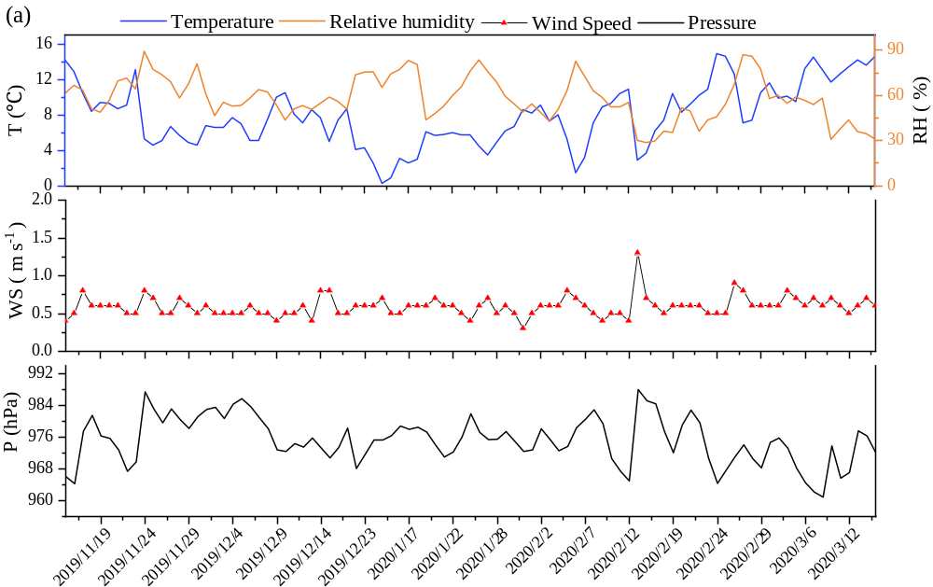
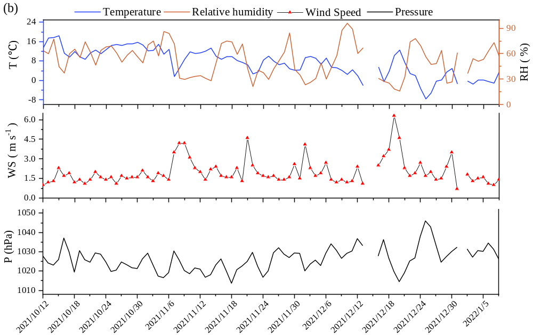
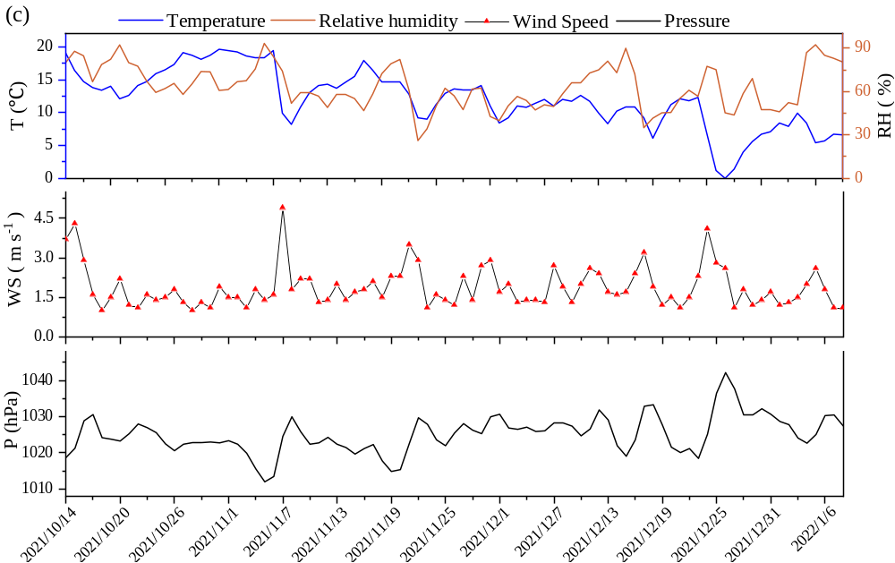
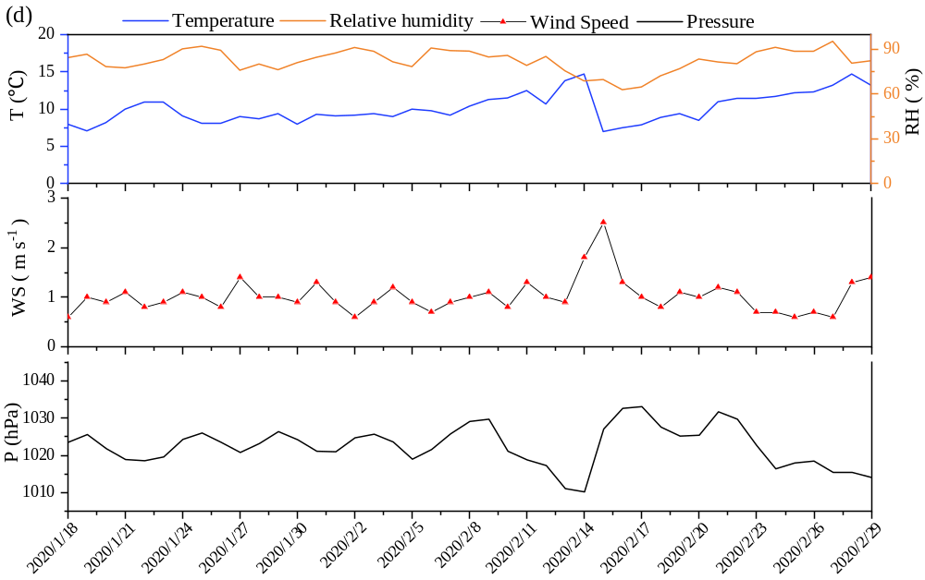
Fig. S2 Time series of temperature (T), relative humidity (RH), wind speed (WS) and pressure (P) during the sampling periods in XA (a), SJZ (b), WH (c) and CQ (d).

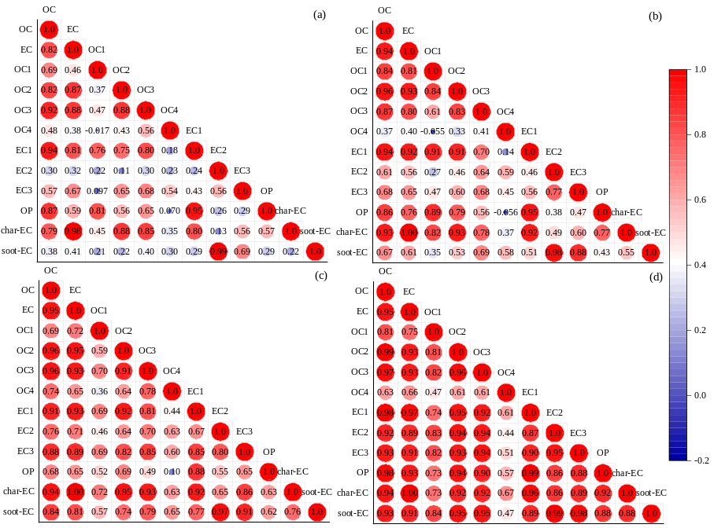
Fig. S3 The correlation between carbonaceous components in XA (a),SJZ (b), WH (c) and CQ (d).

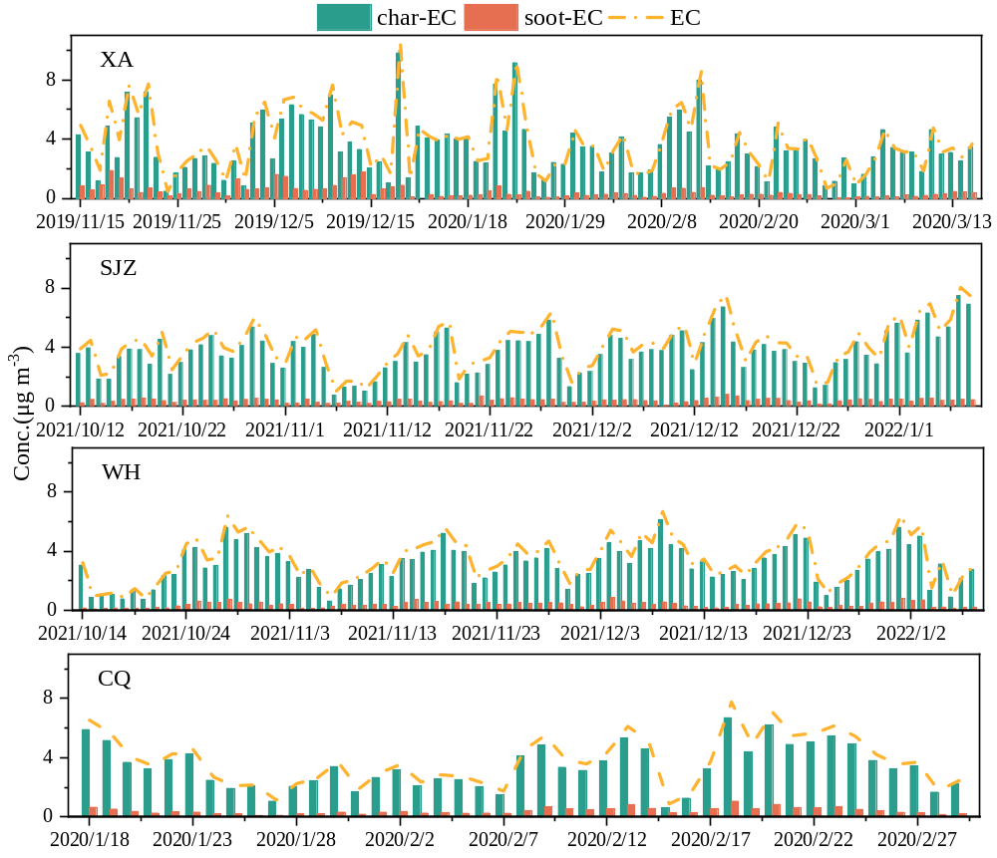
Fig. S4 The daily average concentration of char-EC, soot-EC and EC in four cities.

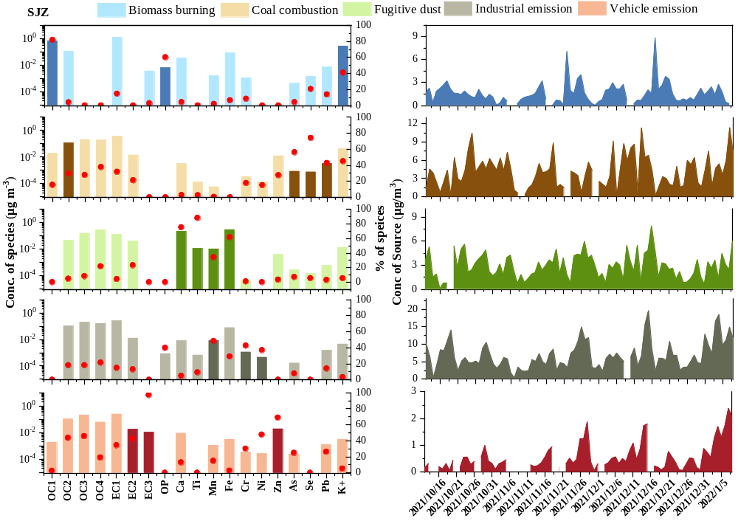
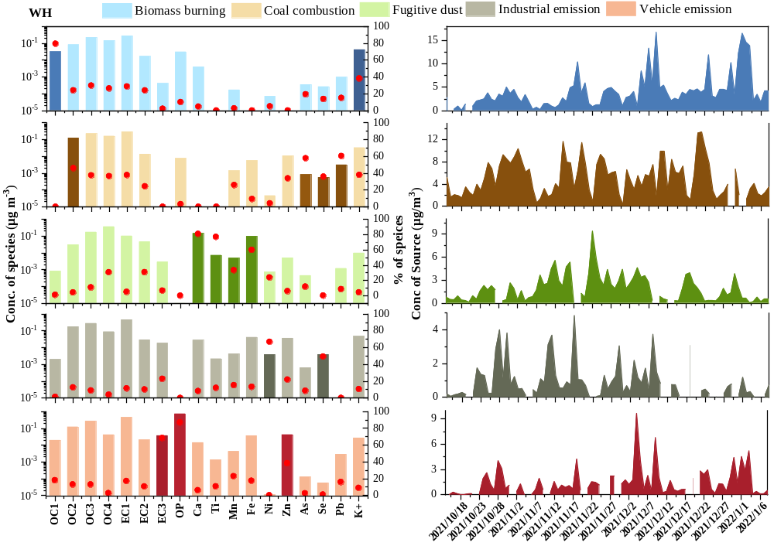
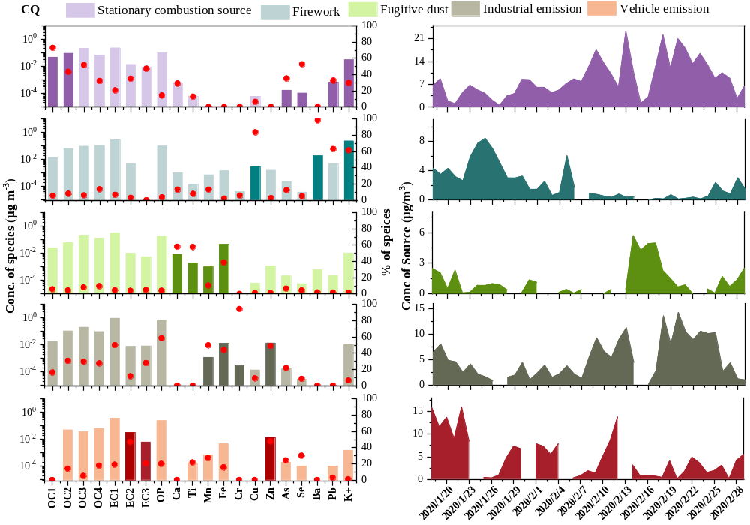
Fig. S5 The source profiles of the carbonaceous aerosols resolved from the HERM model in the SJZ, WH and CQ.

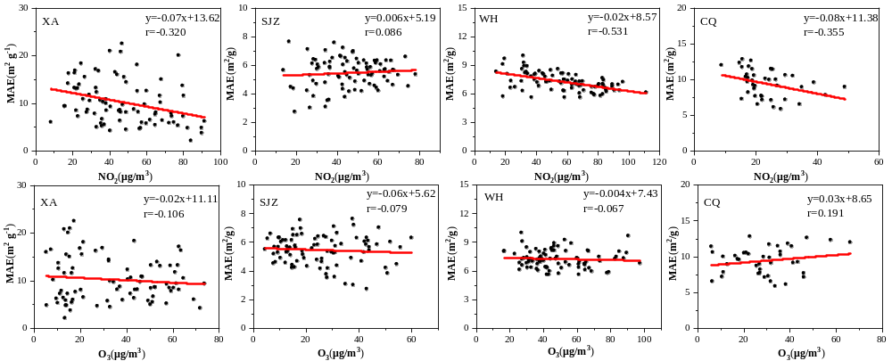
Fig. S6 Correlation between the MAE and NO₂, O₃ in the four cities.

Reference:
Cao J-J, Shen Z-X, Chow J C, Watson J G, Lee S-C, Tie X-X, Ho K-F, Wang G-H, Han Y-M (2012) Winter and summer PM_{2.5} chemical compositions in fourteen Chinese cities. Journal of the Air & Waste Management Association 62: 1214-1226. https://doi.org/10.1080/10962247.2012.701193
Chen Y, Xie S, Luo B, Zhai C (2017) Particulate pollution in urban Chongqing of southwest China: Historical trends of variation, chemical characteristics and source apportionment. Science of the Total Environment 584-585: 523-534. https://doi.org/10.1016/j.scitotenv.2017.01.060
Dai Q, Bi X, Liu B, Li L, Ding J, Song W, Bi S, Schulze B C, Song C, Wu J (2018) Chemical nature of PM_{2.5} and PM₁₀ in Xi'an, China: Insights into primary emissions and secondary particle formation. Environmental Pollution 240: 155-166. https://doi.org/10.1016/j.envpol.2018.04.111
Feng T, Cai Y M, Li ZL, Yang F M, Wang FW (2021) Seasonal variation and source apportionment of PM_{2.5} carbonaceous aerosol in a typical urban area of Chongqing. Acta Scientiae Circumstantiae 41(5):1703-1717. 10.13671/j.hjkxxb.2020.0446
Huang F, Zhou J, Chen N, Li Y, Li K, Wu S (2019) Chemical characteristics and source apportionment of PM_{2.5} in Wuhan, China. Journal of Atmospheric Chemistry 76: 245-262. https://doi.org/10.1007/s10874-019-09395-0
Huang X, Liu Z, Liu J, Hu B, Wen T, Tang G, Zhang J, Wu F, Ji D, Wang L (2017) Chemical characterization and source identification of PM_{2.5} at multiple sites in the Beijing–Tianjin–Hebei region, China. Atmospheric Chemistry and Physics 17: 12941-12962. https://doi.org/10.5194/acp-17-12941-2017
Liu G, Xin J, Wang X, Si R, Ma Y, Wen T, Zhao L, Zhao D, Wang Y, Gao W (2019) Impact of the coal banning zone on visibility in the Beijing-Tianjin-Hebei region. Science of the Total Environment 692: 402-410. https://doi.org/10.1016/j.scitotenv.2019.07.006
Liu H, Wang Q, Ye J, Su X, Zhang T, Zhang Y, Tian J, Dong Y, Chen Y, Zhu C (2021) Changes in Source‐Specific Black Carbon Aerosol and the Induced Radiative Effects Due to the COVID‐19 Lockdown. Geophysical Research Letters 48: e2021GL092987. https://doi.org/10.1029/2021GL092987
Niu X, Cao J, Shen Z, Ho S S H, Tie X, Zhao S, Xu H, Zhang T, Huang R (2016) PM_{2.5} from the Guanzhong Plain: Chemical composition and implications for emission reductions. Atmospheric Environment 147: 458-469. https://doi.org/10.1016/j.atmosenv.2016.10.029
P, Paatero, S, Eberly, S, G, Brown, G, A, Norris (2014) Methods for estimating uncertainty in factor analytic solutions. Atmospheric Measurement Techniques Discussions 7(3): 781-797. https://doi.org/10.5194/amt-7-781-2014
Peng X-L, Hao Q-J, Wen T-X, Ji D-S, Liu Z-R, Wang Y-S, Chen J-B, Jiang C-S (2018) Pollution characteristics of organic carbon and elemental carbon in atmospheric aerosols in Beibei District, Chongqing. Environmental Science 39(08):3502-3510. 10.13227/j.hjkx.201711205
Salameh D, Pey J, Bozzetti C, El Haddad I, Detournay A, Sylvestre A, Canonaco F, Armengaud A, Piga D, Robin D, et al (2018) Sources of PM_{2.5} at an urban-industrial Mediterranean city, Marseille (France): Application of the ME-2 solver to inorganic and organic markers. Atmospheric Research 214: 263-274. https://doi.org/10.1016/j.atmosres.2018.08.005
Visser S, Slowik J G, Furger M, Zotter P, Bukowiecki N, Canonaco F, Flechsig U, Appel K, Green D.C, Tremper A.H. et al (2015) Advanced source apportionment of size-resolved trace elements at multiple sites in London during winter. Atmospheric chemistry and physics 15(19):11291-11309. https://doi.org/10.5194/acp-15-11291-2015
Wang Z, Wang R, Wang J, Wang Y, Donahue N M, Tang R, Dong Z, Li X, Wang L, Han Y, Cao J (2022) The seasonal variation, characteristics and secondary generation of PM_{2.5} in Xi'an, China, especially during pollution events. Environmental Research 212: 113388. https://doi.org/10.1016/j.envres.2022.113388
Xiong Y, Zhou J, Schauer, James, J, Yu WY, Hu Y (2017) Seasonal and spatial differences in source contributions to PM_{2.5} in Wuhan, China. Science of the Total Environment 577: 155-165. https://doi.org/10.1016/j.scitotenv.2016.10.150
Xu H, Cao J, Chow J C, Huang R-J, Shen Z, Chen L A, Ho K F, Watson J G (2016) Inter-annual variability of wintertime PM_{2.5} chemical composition in Xi'an, China: evidences of changing source emissions. Science of the Total Environment 545: 546-555. https://doi.org/10.1016/j.scitotenv.2015.12.070
Zhang Q, Shen Z, Cao J, Zhang R, Zhang L, Huang R-J, Zheng C, Wang L, Liu S, Xu H (2015) Variations in PM_{2.5}, TSP, BC, and trace gases (NO₂, SO₂, and O₃) between haze and non-haze episodes in winter over Xi'an, China. Atmospheric Environment 112: 64-71. https://doi.org/10.1016/j.atmosenv.2015.04.033
Zhang W, Liu B, Zhang Y, Li Y, Sun X, Gu Y, Dai C, Li N, Song C, Dai Q, Han Y, Feng Y (2020) A refined source apportionment study of atmospheric PM_{2.5} during winter heating period in Shijiazhuang, China, using a receptor model coupled with a source-oriented model. Atmospheric Environment 222: 117157. https://doi.org/10.1016/j.atmosenv.2019.117157
Zhang X, Ji G, Peng X, Kong L, Zhao X, Ying R, Yin W, Xu T, Cheng J, Wang L (2022) Characteristics of the chemical composition and source apportionment of PM_{2.5} for a one-year period in Wuhan, China. Journal of Atmospheric Chemistry 79: 101-115. https://doi.org/10.1007/s10874-022-09431-6
Zhang Z H, Chen N, Zhu B, Tao H T, Cheng H R (2022) Source analysis of ambient PM_{2.5} in Wuhan city based on random forest model. Environmental Science 43(03): 1151-1158. 10.13227/j.hjkx.202108051
Zhao P, Dong F, He D, Zhao X, Zhang X, Zhang W, Yao Q, Liu H (2013) Characteristics of concentrations and chemical compositions for PM_{2.5} in the region of Beijing, Tianjin, and Hebei, China. Atmospheric Chemistry and Physics 13: 4631-4644. https://doi.org/10.5194/acp-13-4631-2013

