Supporting information
Figure S1 (A) Protein structure of AcsHSP and AcDNAJB13. Location of alpha-crystallin domain and CⅠ NTD motif are indicated for AcsHSP. J-domain with HPD motif, G/F domain, peptide-binding Ⅰ and peptide-binding Ⅱ domains are indicated for AcDNAJB13. (B) Alignment of AcsHSP with cytosolic Ⅰ class members of Arabidopsis. (C) Alignment of AcDNAJB13 with other type Ⅱ J-domain proteins.

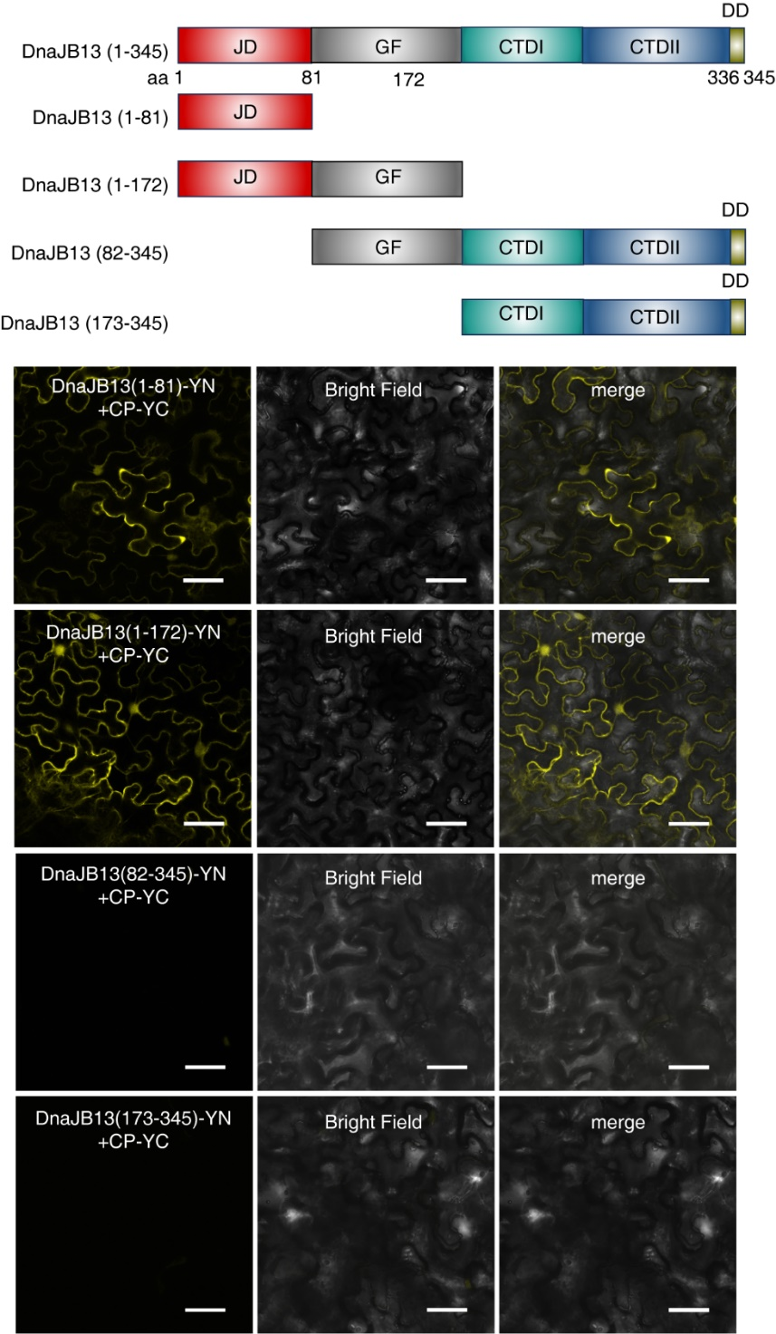
Figure S2. Interaction between CP and truncated AcDNAJB13. The truncated fragments and domains of AcDNAJB13 were represented in upper panel. Bimolecular fluorescence complementation (BiFC) assay demonstrates the interaction between the N-terminal fragments of YFP fused to the truncated fragments (1-81aa, 1-172aa, 82-345aa and 173-345aa) of AcDNAJB13 and CP fused with C-terminal of YFP respectively. Leaves of N. benthamiana was collected 72 h post-infiltration (hpi).
Figure S3. Interaction between AcDNAJB13 and CP is independent on the interaction of AcDNAJB13 with AcHSP70. (A) Bimolecular fluorescence complementation (BiFC) assay demonstrates the interaction of AcHSP70-YC with YN-AcsHSP and YN-AcDNAJB13, respectively. (B) BiFC demonstrates no interaction of AcHSP70-YC with AcDnaJB13(∆HPD)-YN. (C) BiFC demonstrates the interaction of CP-YC with both nYFP-AcDnaJB13 and nYFP-AcDnaJB13(∆HPD). Leaves of N. benthamiana was collected 72 h post-infiltration (hpi). Bars, 50 μm.

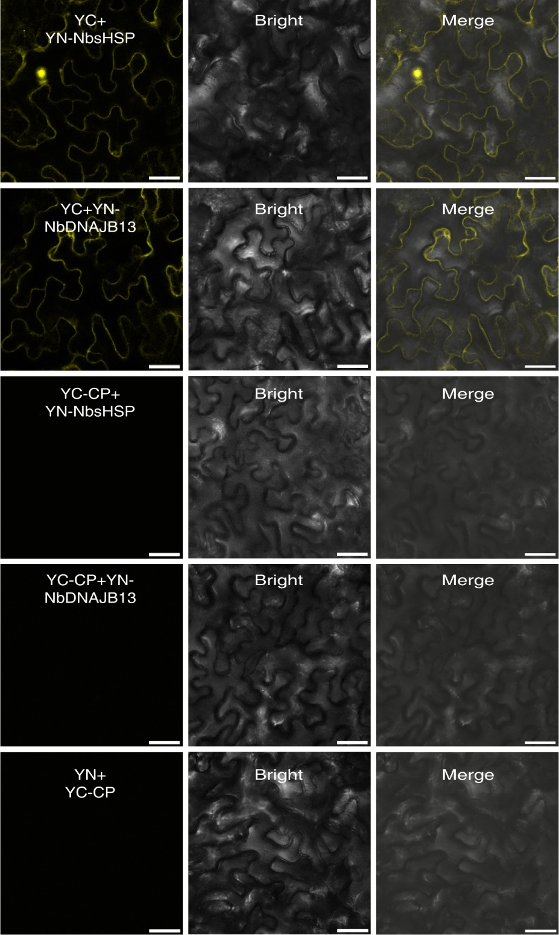
Figure S4. Bimolecular fluorescence complementation (BiFC) assay demonstrating interaction between CP and NbsHSP or NbDNAJB13. The N- or C-terminal fragments of yellow fluorescent protein (YFP) were fused to the C-terminus of NbsHSP or NbDNAJB13 and CP. The leaves of Nicotiana benthamiana were collected for imaging by confocal microscopy at 72 h post-infiltration (hpi). The results were reproduced in three independent experiments using three leaves in each experiment. Representative results are presented. Bars, 50 μm.

Figure S5. APV1 infection induces host UPR. (A-B) RT-qPCR analysis of the UPR-related genes in APV1-infected N. benthamiana or areca palm. Actin was used as an internal reference. The values represent the means of relative expression levels ± SD relative to the mock plants (n = 3 biological replicates). Asterisks denote significant differences (**P < 0.01, n.s. = not significant) between RSV-infected and mock plants. (C) Western blotting analysis of GFP or CP-GFP in N. benthamiana leaves treated with DTT following of transient expression of GFP or CP-GFP. Each half of a leaf was treated with DTT or ddH2O for the DTT test. The total protein was extracted at 18 hpt following by western blotting analysis. NbATG8 were detected by anti-GFP antibody. The loading controls was shown by staining Rubisco.

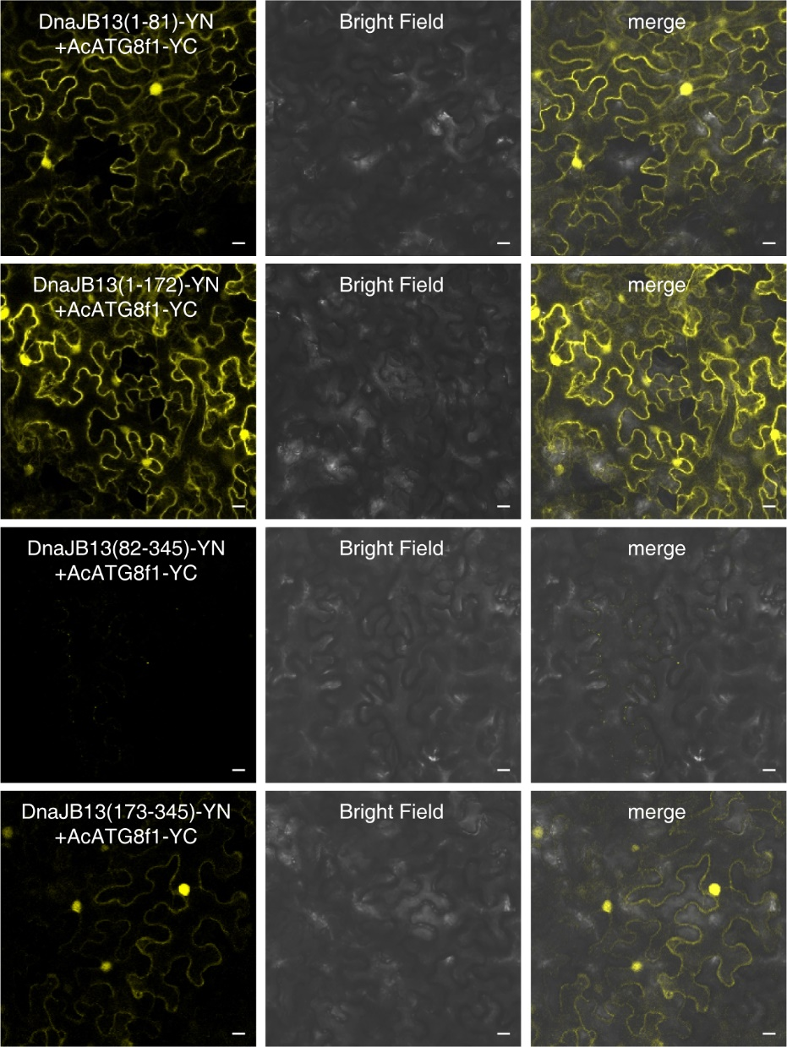
Figure S6. Interaction between AcATG8f1 and truncated AcDNAJB13. The truncated fragments and domains were represented in upper panel. Bimolecular fluorescence complementation (BiFC) assay demonstrating the interaction between the N-terminal fragments of YFP fused to the truncated fragments (1-81aa, 1-172aa, 82-345aa and 173-234aa) of AcDNAJB13 and AcATG8f1 fused with C-terminal of YFP respectively. Leaves of N. benthamiana was collected 72 h post-infiltration (hpi). Bars, 50 μm.

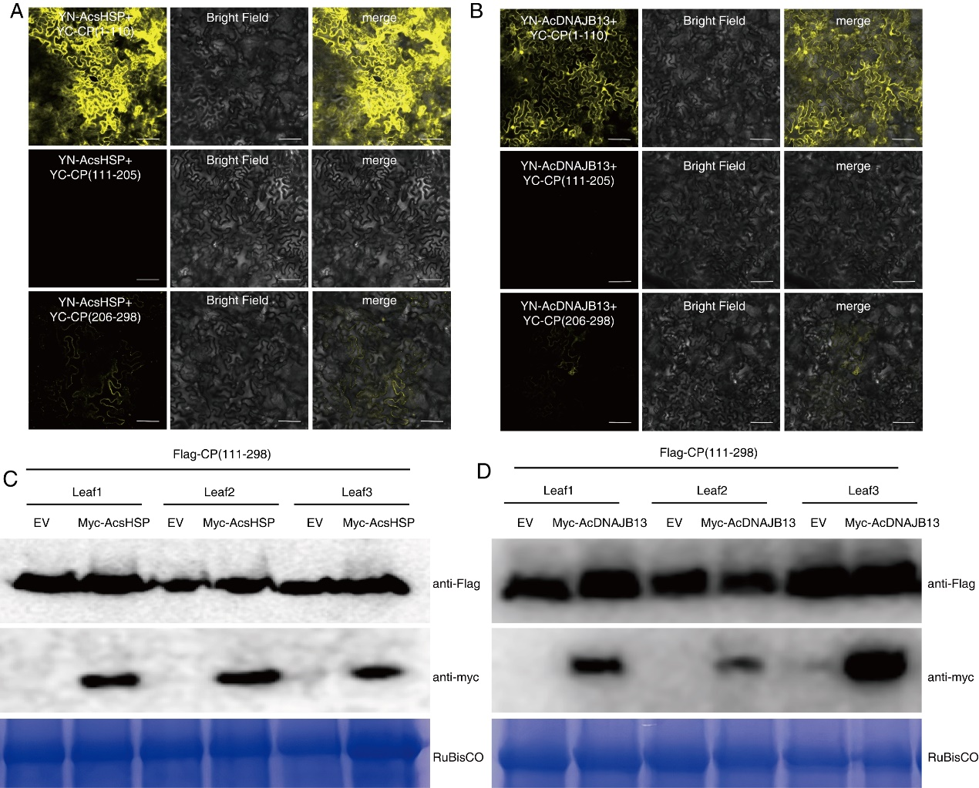
Figure S7. Interactions of CP with AcsHSP and AcDNAJB13 are required for CP degradation. (A-B) Determination of the fragments of CP interacted with AcsHSP and AcDNAJB13. Truncated fragments of CP, e.g. 1-110aa, 111-205aa and 206-298aa, were fused with c-YFP and co-expressed with nYFP-AcsHSP and nYFP-AcDNAJB13 in N. benthamiana, respectively. Confocal microscopy was used to image 72 h post-infiltration (hpi), bars, 50μm. (C-D) Expression of AcsHSP and AcDNAJB13 did not did not affect the stability of truncated CP. Flag-CP (111-2998aa) was co-expressed with myc-AcsHSP or myc-AcDNAJB13. The leaves were treated with 100 μM CHX and then collected for Western-blot 72h after treatment using anti-Flag (upper panel) and anti-myc (lower panel) antibodies, respectively.
Table S1. Annotation of prey from areca palm determined by yeast two hybrid using APV1 CP as bait.
 | Annotation of prey | Accession Nr.
1 | Phoenix dactylifera 16.9 kDa class I heat shock protein 2-like | XM_039128788
2 | Elaeis guineensis DnaJ homolog subfamily B member 13 | XM_010921102
3 | Elaeis guineensis chromatin remodeling protein EBS | XM_010934464.3
4 | Elaeis guineensis ferredoxin--NADP reductase, leaf isozyme | XM_019849839
5 | Elaeis guineensis chlorophyll a-b binding protein 6 | XM_010908185.3
6 | Elaeis guineensis dormancy-associated protein 1 | XM_010945645.2
7 | Phoenix dactylifera probable histone H2A.2 | XM_008786436.3
8 | Elaeis guineensis DCC family protein At1g52590 | XM_029263078.1
9 | Elaeis guineensis eukaryotic translation initiation factor | XM_010935945.3
10 | Elaeis guineensis ATP-dependent Clp protease adapter protein CLPS1 | XM_010907787.2
TABLE S2. Primers list used in this work.
Gene cloning | Primer Sequence (5’-3’) | Purpose
BD-CP-F | tcagaggaggacctgcatatgatggatagacttaacttacttagaaac | cloning
BD-CP-R | ccgctgcaggtcgacggatccttaccgtctagtattaccaacaat | cloning
AD-HSP471-F | gtaccagattacgctcatatgATGTCGATCATCAGGCGGAGC | cloning
AD-HSP471-R | acgattcatctgcagctcgagTCAACCCGAGATCTCGATGGA | cloning
AD-HSP1035-F | gtaccagattacgctcatatgATGGGAGTGGACTACTATAAAGT | cloning
AD-HSP1035-R | cagctcgagctcgatggatccCTAAGGACCGAGCAGTCTTTTAA | cloning
YC-CP-F | CTCTCGAGCTTTCGCGAGCTCaTGGATAGACTTAACTTACTTAGAAAC | cloning
YC-CP-R | CGCCGGACGGGTACCGGATCCCCGTCTAGTATTACCAACAATTTG | cloning
YN-AcHSP471-F | CTCTCGAGCTTTCGCGAGCTCATGTCGATCATCAGGCGGA | cloning
YN-AcHSP471-R | GATGGATCTTCTAGAGGATCCACCCGAGATCTCGATGGATTTCA | cloning
nYFP-AcDnaJB13-F | CTCTCGAGCTTTCGCGAGCTCATGGGAGTGGACTACTATAAAGT | cloning
nYFP-AcDnaJB13-R | GATGGATCTTCTAGAGGATCCAGGACCGAGCAGTCTTTTAAT | cloning
nY-NbsHSP-F | CTCTCGAGCTTTCGCGAGCTCATGTCACTGATTCCAAGAGT | cloning
nY-NbsHSP-R | GATGGATCTTCTAGAGGATCCACCAGCAATCTCAATGGAT | cloning
nY-NbDnaJB13-F | CTCTCGAGCTTTCGCGAGCTCATGGGTGTGGACTACTACA | cloning
nY-NbDnaJB13-R | GATGGATCTTCTAGAGGATCCTGTTAAATATCGCTTAATG | cloning
nYFP-DnaJ(1-81)-F | CTCTCGAGCTTTCGCGAGCTCATGGGAGTGGACTACTATAA | cloning
nYFP-DnaJ(1-81)-R | ATGGATCTTCTAGAGGATCCGGGGGGCGGGACCTGCCCCTT | cloning
nYFP-DnaJ(1-172)-F | CTCTCGAGCTTTCGCGAGCTCATGGGAGTGGACTACTATAA | cloning
nYFP-DnaJ-(1-172)-R | ATGGATCTTCTAGAGGATCCCAAATTCTCGATCGGCACCGC | cloning
nYFP-DnaJ-(81-343)-F | CTCTCGAGCTTTCGCGAGCTCatgGGGGCTGGCGGGGCCTCCT | cloning
nYFP-DnaJ(81-343)-R | GATGGATCTTCTAGAGGATCCAGGACCGAGCAGTCTTTTAA | cloning
nYFP-DnaJ-(172-343)-F | CTCTCGAGCTTTCGCGAGCTCatgTTGCCTTGTAGCCTCGAGGA | cloning
nYFP-DnaJ(172-343)-R | GATGGATCTTCTAGAGGATCCAGGACCGAGCAGTCTTTTAA | cloning
cY-CP(1-110)-R | CGCCGGACGGGTACCGGATCCTTGACAAACGAAATCAAC | cloning
cY-CP(111-205)-F | CTCTCGAGCTTTCGCGAGCTCATGGCGCCGGATGAACTA | cloning
cY-CP(111-205)-R | CGCCGGACGGGTACCGGATCCTGCCTTAAGTGCATTGACC | cloning
cY-CP(206-298)-F | CTCTCGAGCTTTCGCGAGCTCatgATTCCCAACGTGTTGC | cloning
cLuc-AcsHSP-F | TCCCGGGGCGGTACCcgggatccaATGTCGATCATCAGGC | cloning
cLuc-AcsHSP-R | ACGAAAGCTCTGCAGGTCGACTCAACCCGAGATCTCGAT | cloning
cLuc-AcDNAJB13-F | CCGGGGCGGTACCcgggatccaATGGGAGTGGACTACTA | cloning
cLuc-AcDNAJB13-R | acgaACGAAAGCTCTGCAGGTCGACCTAAGGACCGAGCAG | cloning
nLuc-AcATG8f1-F | GCTCGGTACCcgggatccATGGCGAAGAGTTCCTTCAA | cloning
nLuc-AcATG8f1-R | cgtacgagatctggtcgacGGAGGACCCAAATGTGTTCT | cloning
pET30a-AcsHSP-F | GTGGTGGTGGTGGTGCTCGAGACCCGAGATCTCGATGGA | cloning
pET30a-AcsHSP-R | GCTGATATCGGATCCGAATTCATGTCGATCATCAGGCGG | cloning
pET-30a-AcDNAJB13-F | GTGGTGGTGGTGGTGCTCGAGAGGACCGAGCAGTCTTTTA | cloning
pET-30a-AcDNAJB13-R | GCTGATATCGGATCCGAATTCATGGGAGTGGACTACTATAAAG | cloning
GST-CP-F | TGGGATCCCCGGAATTCCCGatggatagacttaacttacttagaaac | cloning
GST-CP-R | ATGCGGCCGCTCGAGTCGACCttaccgtctagtattaccaacaat | cloning
Y-FLAG-ORF6-(111-298)-F | AGAACACGGGGGACGAGCTCATGGCGCCGGATGAACTAT | cloning
Y-FLAG-ORF6-(111-298)-R | TCGTCGACTCTAGAGGATCCCCGTCTAGTATTACCAACAA | cloning
1302-MYC-F | ACGGGGGACTCTTGACCATGGAGCAGAAACTCATCTCTGAAGAGGATCTGTGA | cloning
1302-MYC-R | GGGAAATTCGAGCTGGTCACCTCACAGATCCTCTTCAGAGATGAGTTTCTGCTC | cloning
1302-CP-GFP-F | CACGGGGGACTCTTGACCATGGATAGACTTAACTTACTTA | cloning
1302-CP-GFP-R | AGTCAGATCTACcatggtCCGTCTAGTATTACCAACAATT | cloning
1302-Myc-AcDNAJB13-F | GGACTCTTGACCATGGAGCAGAAACTCATCTCTGAAGAGGATCTGGGAGTGGACTACTATAAAGTCC | cloning
1302-Myc-AcDNAJB13-R | GGGAAATTCGAGCTGGTCACCCTAAGGACCGAGCAGTCTTTTA | cloning
1302-Myc-AcsHSP-F | GGACTCTTGACCATGGAGCAGAAACTCATCTCTGAAGAGGATCTGTCGATCATCAGGCG | cloning
1302-Myc-AcsHSP-R | GGGGAAATTCGAGCTGGTCACCTCAACCCGAGATCTCGATG | cloning
AcATG8f1-RFP-1F | GAGAACACGGGGGACGAGCTCATGGCGAAGAGTTCCTTCA | cloning
AcATG8f1-RFP-1R | CATGTCGACTCTAGAGGATCCGGAGGACCCAAATGTGTTCT | cloning
NbATG8f1-RFP-F | GAGAACACGGGGGACGAGCTCATGGCTAAGAGCTCATTCAA | cloning
NbATG8f1-RFP-R | CATGTCGACTCTAGAGGATCCCAGCTTGTTCAGGTCCCC | cloning
TRV-NbATG3A1(BanHI)-F | agaaggcctccatggggatccAAGCAGAACTTCACCTCCAG | cloning
TRV-NbATG3A1(XhoI)-R | gggacatgcccgggcctcgagATGGTACTGTCGCAGAAGA | cloning
TRV-NbATG5(BanHI)-F | agaaggcctccatggggatccACGTTCAGGTTCTGCACAAA | cloning
TRV-NbATG5(XhoI)-R | gggacatgcccgggcctcgagATGGGAAGTAAAGGGGCAG | cloning
TRV-NbATG7A(BanHI)-F | agaaggcctccatggggatccCAACGTGTTTGTATTGAG | cloning
TRV-NbATG7A(XhoI)-R | gggacatgcccgggcctcgagATGGCGGATAGTGGAAGAG | cloning
TRV-NbATG8f1(BanHI)-F | agaaggcctccatggggatccCTTCTTTTCGTCATAGAT | cloning
TRV-NbATG8f1(XhoI)-R | gggacatgcccgggcctcgagATGGCTAAGAGCTCATTCA | cloning
TRV-NbBeclin1(BanHI)-F | agaaggcctccatggggatccTCCTCGTCCTCGAGACTGAA | cloning
TRV-NbBeclin1(XhoI)-R | gggacatgcccgggcctcgagATGATGAAAAATAGCAGCA | cloning
TRV-GFP(BanHI)-F | agaaggcctccatggggatccCTTGAAGAAGATGGTCCTC | cloning
TRV-GFP(XhoI)-R | gggacatgcccgggcctcgagAGTAAAGGAGAAGAACTT | cloning
TRV-GUS(BanHI)-F | agaaggcctccatggggatccCACTTTGCCGTAATGAGTG | cloning
TRV-GUS(XhoI)-R | gggacatgcccgggcctcgagAACCGACGACTCGTCCGTC | cloning
TRV-NbDnaJB13-BamHI-F | agaaggcctccatggggatccCCGGAACGACCCATGACC | cloning
TRV-NbDnaJB13-XhoI-R | ggacatgcccgggcctcgagATGGGTGTGGACTACTACAA | cloning
TRV-NbsHSP-BamHI-F | agaaggcctccatggggatccACACGGTGCCAAGTATCAT | cloning
TRV-NbsHSP-XhoI-R | gggacatgcccgggcctcgagACCTCTGCATTCGCTAACA | cloning
NbActin-qRT-F | AAGACCAGCTCATCCGTGGA | RT-qPCR
NbActin-qRT-R | CTCATCCTATCAGCAATGCCC | RT-qPCR
NbDnaJB13-qPCR-F | GATGAGAAGCCGCATAGTG | RT-qPCR
NbDnaJB13-qPCR-R | AGCGTTGTTATTTGAGCAGTA | RT-qPCR
NbsHSP-qPCR-F | ACACGGTGCCAAGTATCAT | RT-qPCR
NbsHSP-qPCR-R | CGCTAATCTGAAGAACCCTA | RT-qPCR
AcDnaJB13-qPCR-F | TGTTCGGGGATGACTTGT | RT-qPCR
AcDnaJB13-qPCR-R | CTTCTTCGTGGTGCCTTT | RT-qPCR
AcsHSP-qPCR-F | AGAGGAGCAGCGGCAAAT | RT-qPCR
AcsHSP-qPCR-R | CGCTCACCGACAGAACCC | RT-qPCR
Acactin-F | CCCCAGAAGAACACCCA | RT-qPCR
Acactin-R | AATAGCCACATACATAGCAG | RT-qPCR
AcbZIP17qRT-PCR-F | GGACAATCCAAAGGTAGAA | RT-qPCR
AcbZIP17qRT-PCR-R | AAAGCAATGCAGGAAGAGT | RT-qPCR
AcbZIP28qRT-PCR-F | AGAGCAGGGTCAAGAAAGT | RT-qPCR
AcbZIP28qRT-PCR-R | ACCTAATCCACCAAATACA | RT-qPCR
AcbZIP60qRT-PCR-F | TCTTGGCAGGGTTCTTTTC | RT-qPCR
AcbZIP60qRT-PCR-R | TTCTCCTTCGGCTCACTTT | RT-qPCR
NbbZIP60_qRT-F | ATTGACTCTAAGGACGGCTCT | RT-qPCR
NbbZIP60_qRT-R | ATACAACTTCTTCCGCTCTCG | RT-qPCR
NbbZIP17-1_qRT-F | TGGCTTGTTGTTCTTCATGCTC | RT-qPCR
NbbZIP17-1_qRT-R | AAAATTCTTCCGCGATGCCTT | RT-qPCR
NbBLP-4_qRT-F | TCGTTTTCGCAATCGTCCT | RT-qPCR
NbBLP-4_qRT-R | ATGTCCGTTCTTGTAGACACC | RT-qPCR
NbPDI_qRT-F | TTATTGCCAATCTTGACGCTGA | RT-qPCR
NbPDI_qRT-R | TTGCCCTTTCGAATCACGGCTA | RT-qPCR
NbCRT1_qRT-F | GGCTCCTTTGATTGACAACCC | RT-qPCR
NbCRT1_qRT-R | TGGCATACTCTGGATCATCGC | RT-qPCR
NbSKP1-1/-2_qRT-F | CTAGAGTCGCAGACAATCAAGCA | RT-qPCR
NbSKP1-1/-2_qRT-R | CGCTTGCAGTACTCAATCACC | RT-qPCR
NbSKP1-4_qRT-F | GTCCGCTTTGTTTCTCTCGTT | RT-qPCR
NbSKP1-4_qRT-R | CGTCGGAACTCTTCAACACA | RT-qPCR
NbbZIP17-2/-3_qRT-F | GCCTGCACCAAAGAGTAGCAA | RT-qPCR
NbbZIP17-2/-3_qRT-R | CCACTCATAAACGGTTCCCTC | RT-qPCR
NbATG3_qRT2-F | ATAATCTCGTCTCCAAATGCCCTA | RT-qPCR
NbATG3_qRT2-R | TGTCAGCAGGTAAATATGACTTCC | RT-qPCR
NbATG5_qRT2-F | GGCAGCATACATAATCAATGGGAA | RT-qPCR
NbATG5_qRT2-R | AATCATCCACTAATAGGCCAAG | RT-qPCR
NbATG7_qRT2-F | TCTTGTGATGGCTATTCCGAT | RT-qPCR
NbATG7_qRT2-R | CGACTTTCCCGTGTATCAGT | RT-qPCR
NbATG8c_qRT-F | CACCCACTTGAAAGGCGACAGGC | RT-qPCR
NbATG8c_qRT-R | GCCTTCTCAGCACTAAGCTTTATTCTC | RT-qPCR
NbTOR_qRT-F | ACAGCAGCTCTTCAACCAG | RT-qPCR
NbTOR_qRT-R | AGTCTGAGATATACACGAGCAAC | RT-qPCR
NbATG8d_qRT-F | AGTTAATACTTGTTCCTGCTGATCTGG | RT-qPCR
NbATG8d_qRT-R | ATTGCAGACGAATTCGCCAGAGTC | RT-qPCR
NbATG8h_qRT-F | TTCAGACGATGAGAGACTCGCAGAATC | RT-qPCR
NbATG8h_qRT-R | TTCCCAGGAGCCAGATGGAGTC | RT-qPCR
NbBECN1_Qpcr-F | AACCGTTGTGTCTTGAATGC | RT-qPCR
NbBECN1_Qpcr-R | TGCTTCAAGTTTCCGCTCT | RT-qPCR
qPCR-ATG8f1-F | GAATCAAATTGAGTGCAGAA | RT-qPCR
qPCR-ATG8f1-R | AAGTAACATAAAGGAAACCATC | RT-qPCR
AcATG8c-qRT-1F | ACTTAGTCCCAGCAGATTT | RT-qPCR
AcATG8c-qRT-1R | TTTGTTTTCCTCATAGATTG | RT-qPCR
AcATG8c-qRT-2F | ATGGCGAGGAGTTCTTTTA | RT-qPCR
AcATG8c-qRT-2R | CAGCTTTCTCAACAATCACAG | RT-qPCR
AcATG8f-qRT-1F | GCCTATGTTATTCGCAAGA | RT-qPCR
AcATG8f-qRT-1R | ATTCTGAACCCCAAAAGTG | RT-qPCR
AcATG3A1-qRT-1F | CTTGTCTAAGGAGGGCTGTT | RT-qPCR
AcATG3A1-qRT-1R | TGAAGGGATGGACCGAATG | RT-qPCR
AcATG3B1-qRT-1F | AGCGTTTCTGAGTTCGTCC | RT-qPCR
AcATG3B1-qRT-1R | ATGAGATACTGCTTGTCGG | RT-qPCR
AcATG5A-qRT-1F | AGGGTTGCGGATTGGGTAT | RT-qPCR
AcATG5A-qRT-1R | CCACGGCCTTTCTGGTTCT | RT-qPCR
AcATG7A-qRT-1F | AAGGGCAGCGGTTAGGGTG | RT-qPCR
AcATG7A-qRT-1R | CGCAAGTCCAGGTCGTGTC | RT-qPCR

