Supplementary information to

Flavonoid-modifying capabilities of the gut microbiome – an in silico study

Tobias Goris¹, Rafael Cuadrat², Annett Braune¹
¹Department of Molecular Toxicology, Research Group Intestinal Microbiology, German Institute of Human Nutrition Potsdam-Rehbruecke, Arthur-Scheunert-Allee 114-116, 14558 Nuthetal, Germany
²Department of Epidemiology, German Institute of Human Nutrition Potsdam-Rehbruecke, Arthur-Scheunert-Allee 114-116, 14558 Nuthetal, Germany

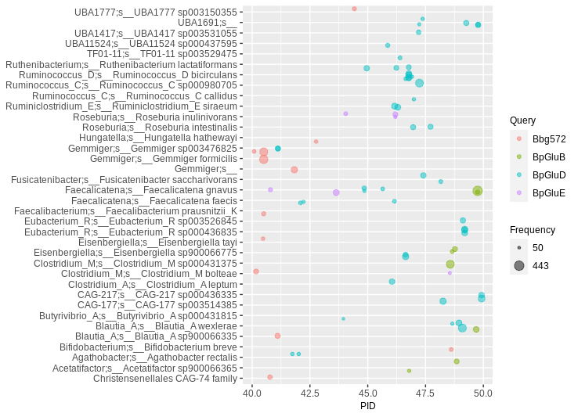
Supplementary Figure 1: Hits of human gut MAGs to flavonoid O-deglycosidases. A PID threshold of 40 to 50 was chosen to the queries shown in the color code (for abbreviations and details see Table 1). Hits were filtered for at least 50 occurrences, so that each bubble represents a number of redundant sequences ranging from 50 to 443.

Supplementary Table 1: Distribution of BLAST hits (PID > 40) to flavonoid-modifying enzymes across all MAGs of species discussed in the text. For the number of MAGs with hits to flavonoid-modifying enzyme sequences, we counted the MAGs (genomes assigned to isolates in the UHGG metadata were excluded) carrying at least one BLAST hit to the corresponding enzyme sequence. Each genome was counted only once to avoid double counts when different hits to different queries were present.
Species | Number of MAGs with hits | Overall number of species MAGs
O-Deglycosylation
Bifidobacterium adolescentis | 2229 | 2404
Bifidobacterium pseudocatenulatum | 1016 | 1063
Bifidobacterium infantis | 1708 | 2717
Bacteroides thetaiotaomicron | 489 | 553
Bacteroides ovatus | 474 | 1027
Bacteroides cellulosilyticus | 420 | 452
Bacteroides eggerthii | 198 | 409
Faecalicatena gnavus | 1155 | 1197
Gemmiger sp003476825 | 3184 | 3216
CAG-180 sp000434995 | 2226 | 2419
CAG-217 sp000436335 | 1124 | 1404
Blautia wexlerae | 1871 | 2179
Eubacterium sp000434995 | 584 | 683
Faecalibacterium prausnitzii K | 1243 | 1380
De-rhamnosylation
Bacteroides dorei | 5246 | 5588
Bacteroides thetaiotaomicron | 492 | 553
Bifidobacterium pseudocatenulatum | 604 | 1063
Gemmiger sp003476825 | 2852 | 3216
Alistipes onderdonkii (unclassified Alistipes) | 1800 | 1997
Parabacteroides distasonis | 3782 | 4543
Paracacteroides merdae | 1636 | 1723
C-Deglycosylation
Faecalicatena gnavus (Ruminococcus gnavus) | 82 | 1197
Agathobacter faecis (unclassified Roseburia) | 804 | 2819
Dai-to-equol transformation
CAG1427 sp000435475 | 35 | 81
Adlercreutzia equolifaciens | 33 | 271
Phy
Dialister succinatiphilus | 318 | 345
Flavonifractor plautii | 563 | 610
FLR
Fusobacterium mortiferum | 165 | 270
Flavonifractor plautii | 610 | 610
Clostridoides difficile | 114 | 338
Fcr
Flavonifractor plautii | 509 | 610
Chalcone isomerization/Taxifolin isomerization
Flavonifractor plautii | 579 | 610
Clostridoides difficile | 117 | 338
O-Demethylation
Intestinibacter bartlettii | 69 | 85
In brackets: Different taxonomy database entries (e.g. old/non-GTDB entries).
Supplementary Figure 2: Phylogenetic tree of O-deglycosidase sequences. Most abundant species genomes are indicated besides the triangles. Colored in red are nodes containing the six reference sequences of Bifidobacteria and Bacteroides species (in brackets, for abbreviations see Table 1). Only nodes with an overall number of at least 500 genomes (including isolate genomes) were included as triangles, the lengths of the triangles represent the number of genomes as indicated by the scale. ¹: Heterogenous group, also Ruminoclostridium siraeum and Ruminococcus species highly abundant.
²: Heterogenous group, also high abundance of CAG-177 and Eubacterium genomes. ³: Heterogenous group, also high abundance of Faecalicatena gnavus genomes.

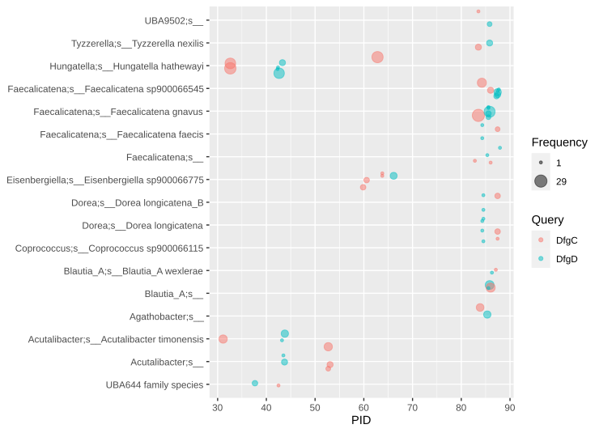
Supplementary Figure 3: Hits to sequences of the flavonoid O-deglycosidase DfgCD from E. ramulus. Hits were filtered for MAGs in which both genes were co-occurring.

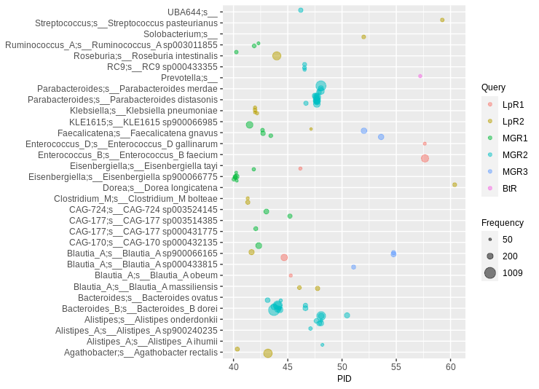
Supplementary Figure 4: Hits with 40 to 65 PID to flavonoid rhamnosidase sequences. Filtered for at least 50 occurrences per redundant sequence so that each bubble represents 50 to 1009 sequences.

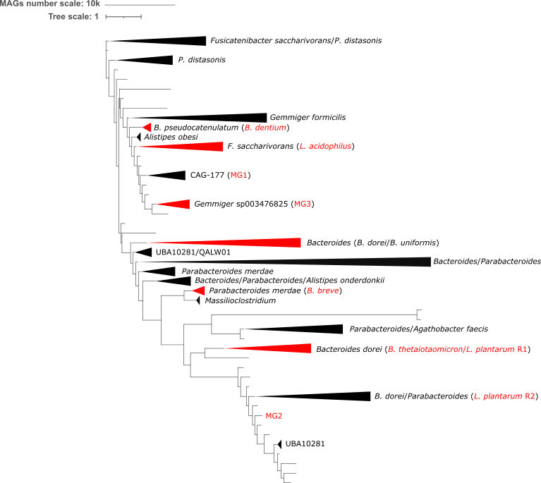
Supplementary Figure 5: Phylogenetic tree of rhamnosidase sequences. Most abundant species genomes are indicated besides the triangles. Colored in red are nodes containing the nine reference sequences (in brackets, for details see Table 1). Only nodes with an overall number of at least 500 genomes (including isolate genomes) were included as triangles, the lengths of the triangles represent the number of genomes as indicated by the scale.
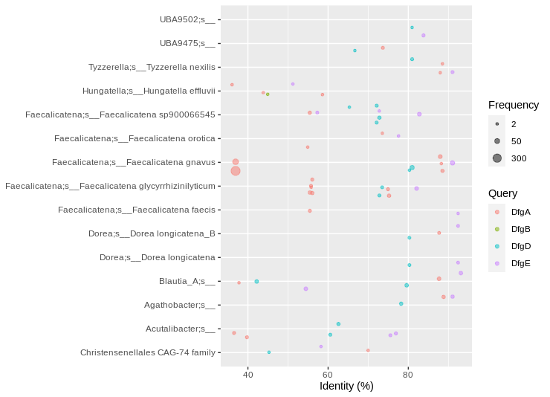
Supplementary Figure 6: Hits to the enzyme query sequences of the C-deglycosylation pathway of E. cellulosolvens. Filtered for the co-occurrence of at least three of the five enzymes and at least two identical/redundant sequences per bubble. There were no hits toDfgC.

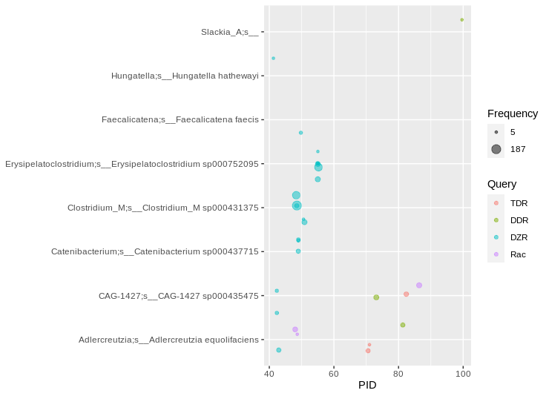
Supplementary Figure 7: Hits to daidzein-to-equol enzyme query sequences. Filtered was only for a PID of at least 40 and at least five occurrences of sequences per bubble, not for co-occurrences of the genes in one genome. Note the presence of a number of DZR hits at about 50 PID.

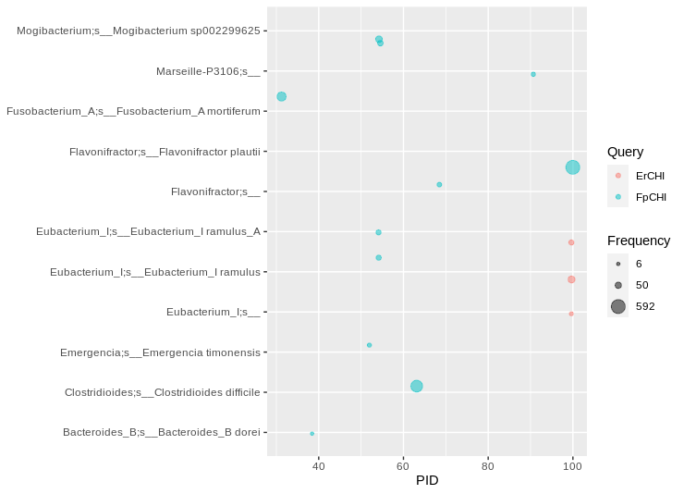
Supplementary Figure 8: CHI-like enzymes in human gut bacteria. Hits were filtered for at least five occurrences, so that each bubble represents a number of redundant sequences ranging from 6 to 592.

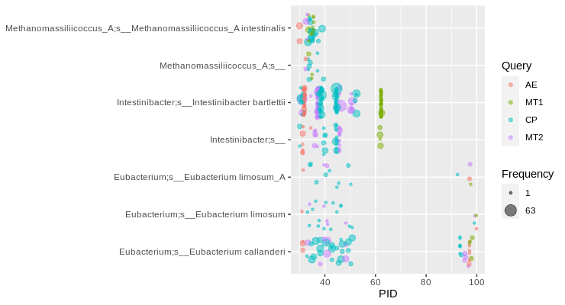
Supplementary Figure 9: Putative O-demethylase systems in human gut bacteria. Hits were filtered for the co-occurrence of all four genes encoding the enzymes required for O-demethylation (MT1, MT2, AE, CP) in one MAG.

FXW45_RS03760
FXW45_RS03785
CobW
MT1
CP1
AE
CP2
MT2
FXW45_RS03775
Supplementary Figure 10: O-Demethylase gene cluster of Intestinibacter bartletti. The representative MAG genome MGYG-HGUT-00062 (NCBI accession number NZ_CABIXZ010000001.1, GUT_GENOME000245) was used. Selected locus tags are given below the genes encoding the corresponding enzymes of O-demethylation (for abbreviations see Table 1). Accessory proteins colored violet. CP2 with a lower PID than CP1 to the E. limosum CP in light blue. NCBI protein accession numbers of main proteins: MT1: WP_147616460.1; CP1: WP_007286937.1; AE: WP_147616461.1; MT2 WP_007286933.1.

