Supplementary Figures and legends
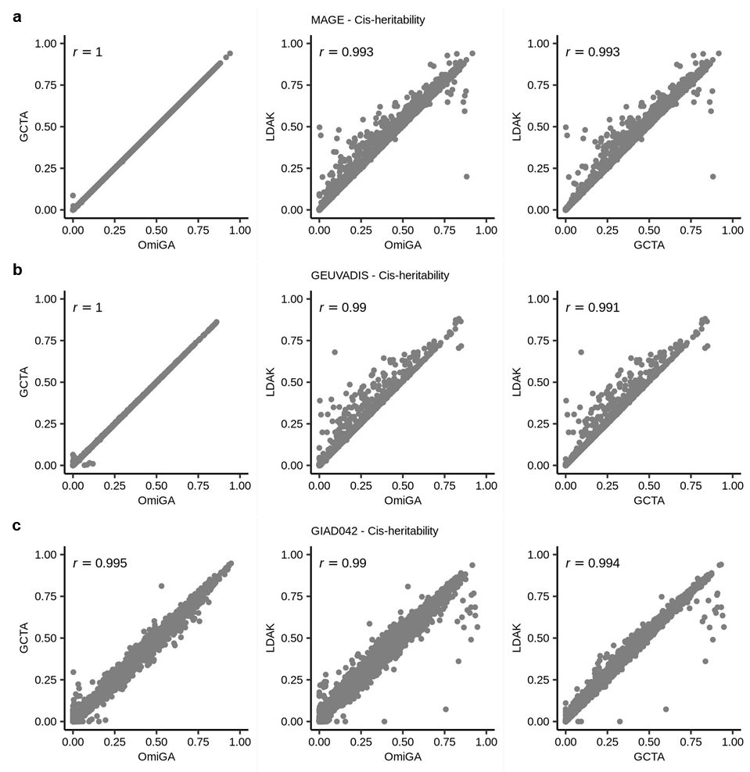
Supplementary Figure 1 | Correlations between cis-heritability estimates computed from OmiGA, GCTA v1.94.1, and LDAK v6 in different datasets. We retained only the cis-heritability results with converged estimates in both tools for each panel. The labels (r) in the panels represent the Pearson’s correlation.

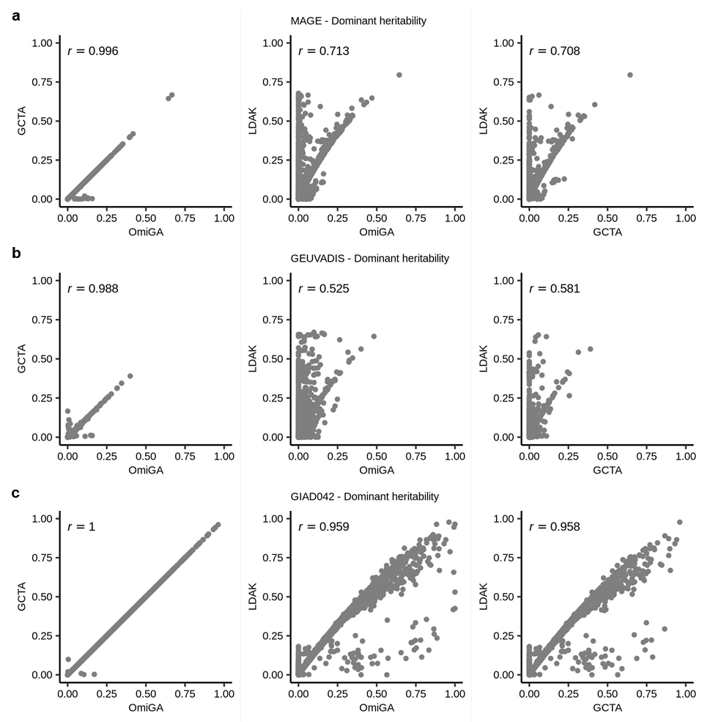
Supplementary Figure 2 | Correlations between dominant heritability estimates computed from OmiGA, GCTA v1.94.1, and LDAK v6 in different datasets. We retained only the dominant heritability results with converged estimates in both tools for each panel. The labels (r) in the panels represent the Pearson’s correlation.

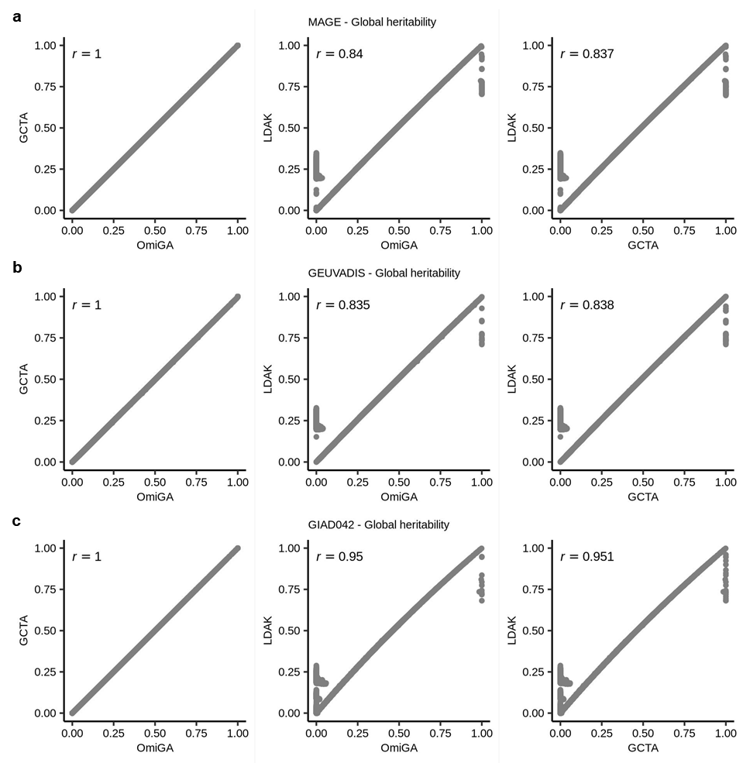
Supplementary Figure 3 | Correlations between global additive heritability estimates computed from OmiGA, GCTA v1.94.1, and LDAK v6 in different datasets. We retained only the heritability results with converged estimates in both tools for each panel. The labels (r) in the panels represent the Pearson’s correlation.

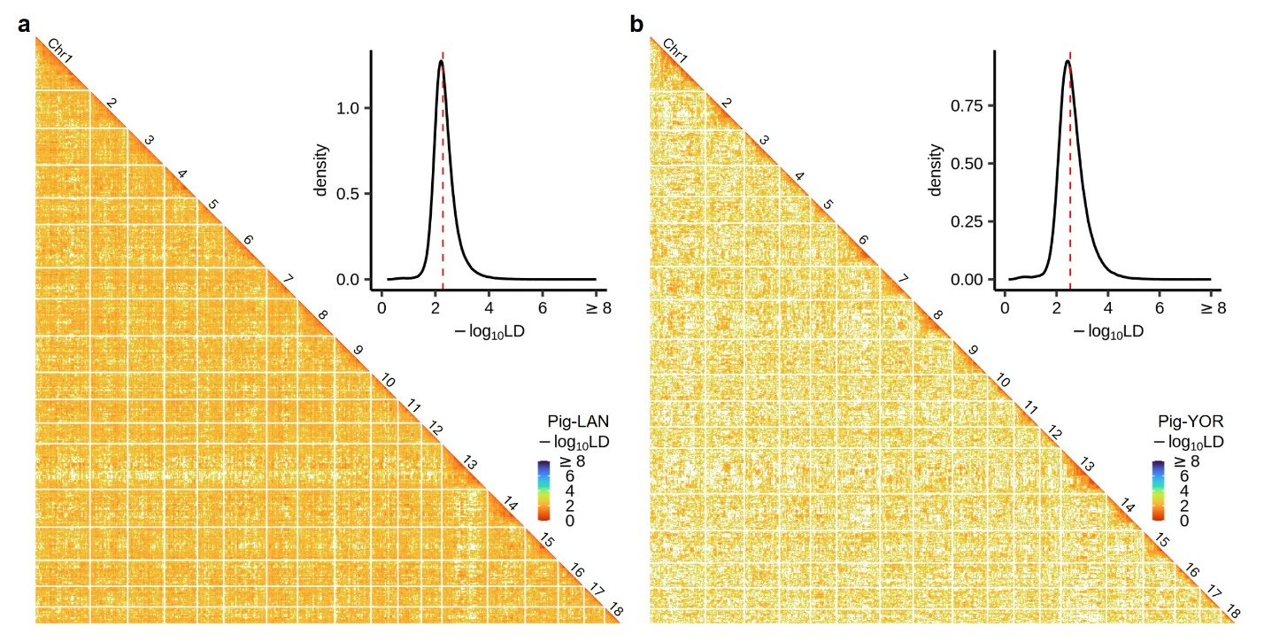
Supplementary Figure 4 | Linkage disequilibrium (LD) of sub-populations from GIAD042. Log10-scaled linkage disequilibrium (LD) and their distribution across the whole-genome variants for Landrace (LAN) sub-population (a) and Yorkshire (YOR) sub-population (b) of GIAD042 dataset. We estimated the global LD using GEAR (https://github.com/gc5k/gear2)¹. The white lines in the heatmap splitted the different chromosomes. The red dotted lines in the density plot represent median values.

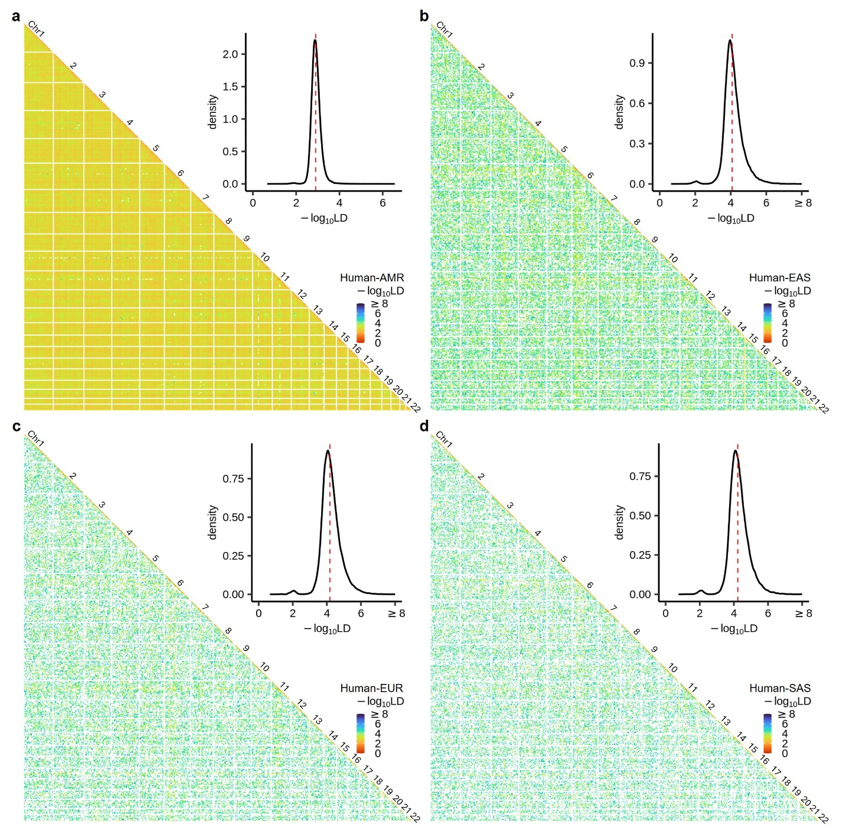
Supplementary Figure 5 | Linkage disequilibrium (LD) of sub-populations from MAGE. Log10-scaled linkage disequilibrium (LD) and their distribution across the whole-genome variants for AMR sub-population (a), EAS sub-population (b), EUR sub-population (c), and SAS sub-population (d) of MAGE dataset. We estimated the global LD using GEAR (https://github.com/gc5k/gear2). The white lines in the heatmap splitted the different chromosomes. The red dotted lines in the density plot represent median values.

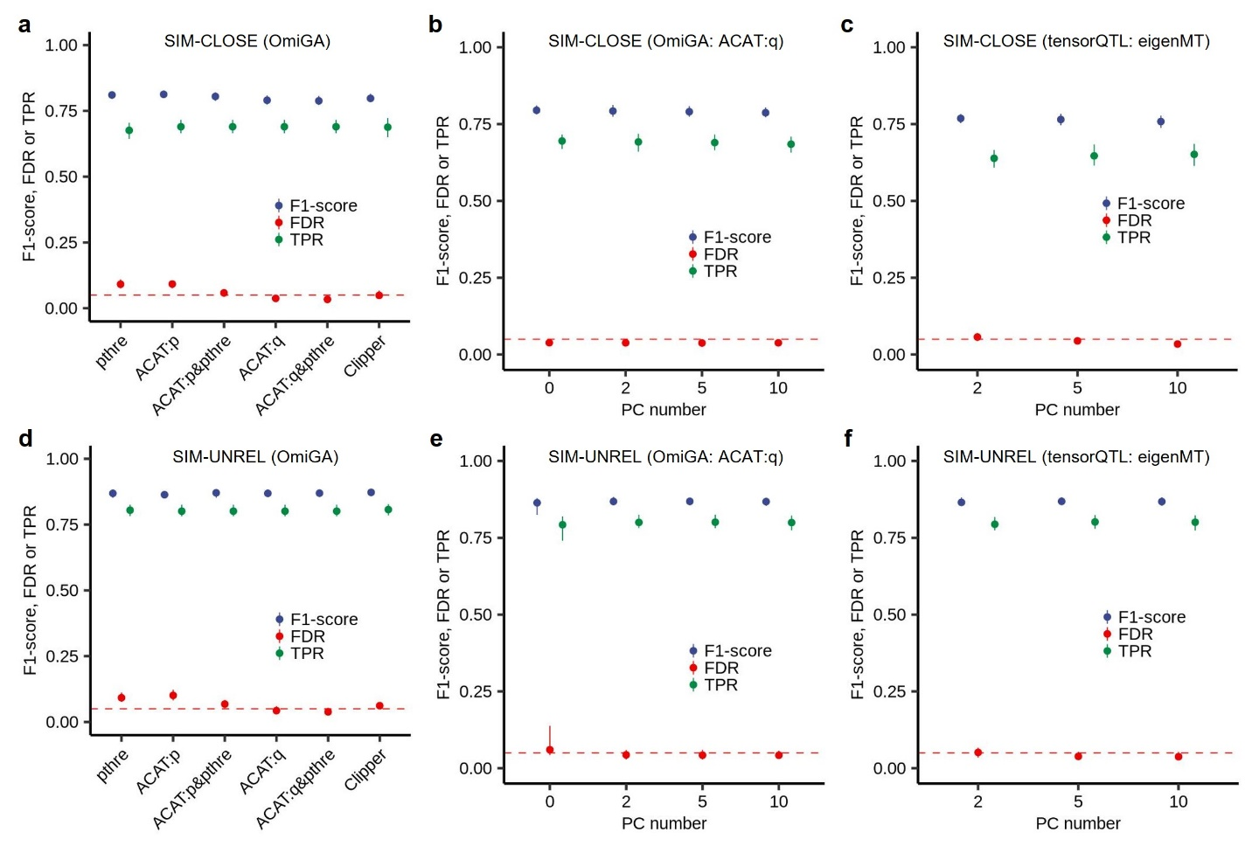
Supplementary Figure 6 | Comparison of multiple-testing approaches and the number of genotype principal component (PC) for interaction cis-eQTL (cis-ieQTL) mapping. a, Cis-ieQTL mapping using OmiGA in the SIM-CLOSE. pthre: the nominal P-values of lead variants below the variant-level threshold obtained from permutations. ACAT:p: the gene-level P-values obtained from ACAT < 0.05. ACAT:p&pthre: the combinations of ACAT:p and pthre. ACAT:q: the Benjamini & Hochberg (BH) adjusted gene-level P-values obtained from ACAT < 0.05. ACAT:q&pthre: the combinations of ACAT:q and pthre. Clipper: the gene-level P-values obtained from ClipperQTL < 0.05. b, Cis-eQTL mapping using OmiGA with ACAT:q in the SIM-CLOSE. c, Cis-ieQTL mapping using tensorQTL with eigenMT in the SIM-CLOSE. d, Cis-ieQTL mapping using OmiGA in the SIM-UNREL. e, Cis-ieQTL mapping using OmiGA with ACAT:q in the SIM-UNREL. f, Cis-ieQTL mapping using tensorQTL with eigenMT in the SIM-UNREL. The points and the error bars represent the mean and the range, respectively, in all panels.

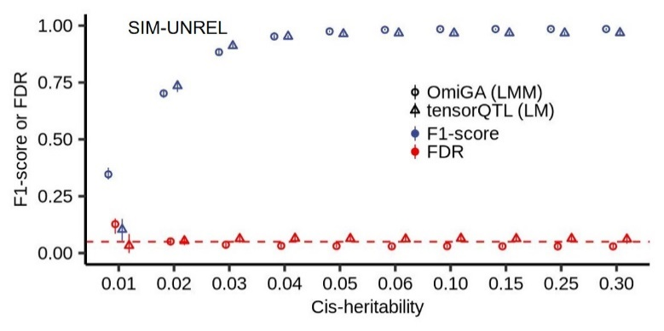
Supplementary Figure 7 | F1-score and FDR of eGene discovery for gene with different cis-heritability using LMM-based OmiGA and LM-based tensorQTL in the SIM-UNREL. The points and the error bars represent the mean and the range, respectively.

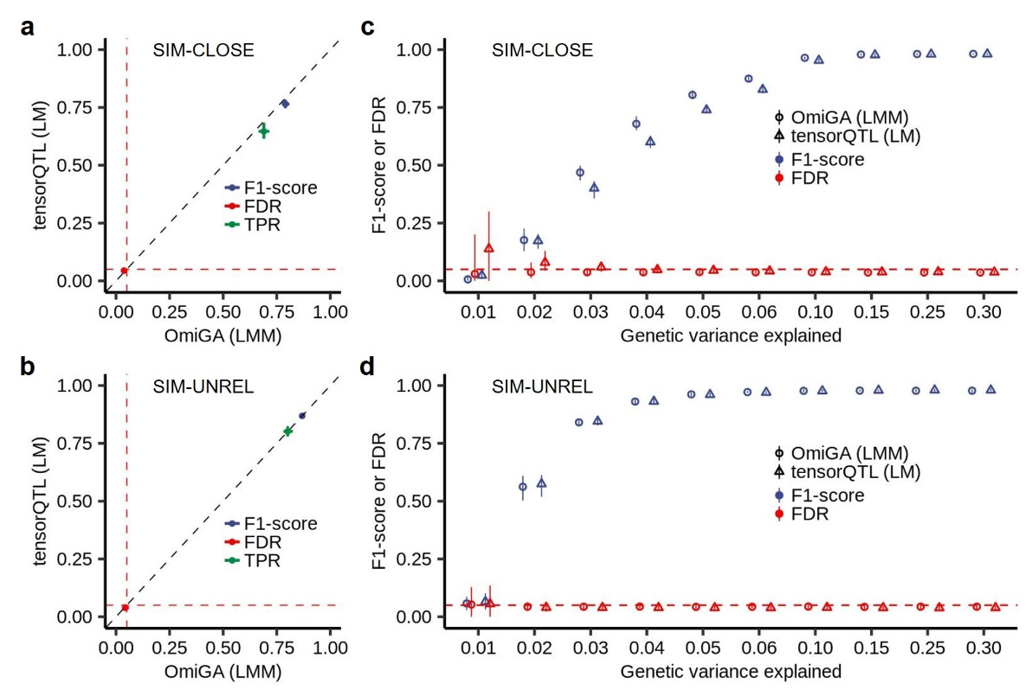
Supplementary Figure 8 | Comparison of simulated ieGenes discovered by OmiGA and tensorQTL. a,b, F1-score and FDR of ieGene discovery for gene with different genetic variance explained by cis-variants using linear mixed model (LMM) of OmiGA and linear model (LM) in the SIM-CLOSE (a) and the SIM-UNREL (b). c,d, F1-score, FDR, and TPR of cis-ieQTL mapping to identify ieGene using LMM of OmiGA and LM of tensorQTL in the SIM-CLOSE (c) and SIM-UNREL (d).

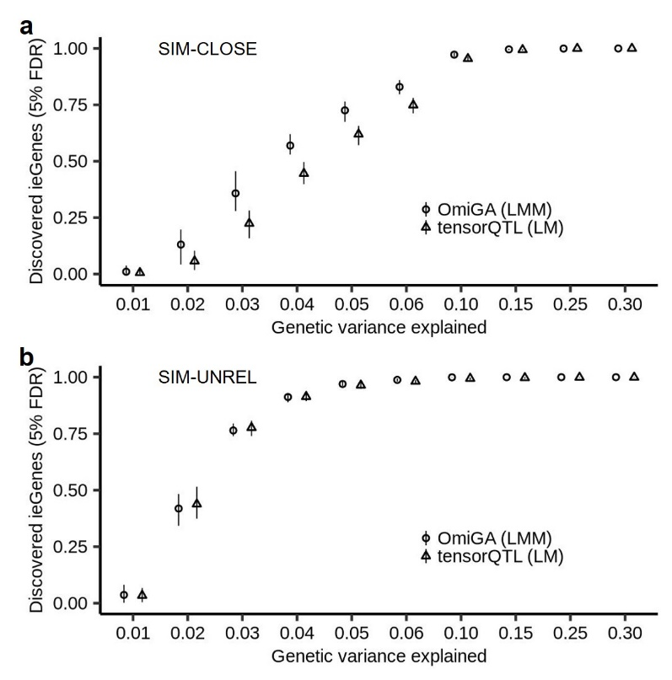
Supplementary Figure 9 | Proportion of simulated ieGenes discovered by OmiGA and tensorQTL. a,b, For the cis-ieQTL mapping results from the SIM-CLOSE (a) and the SIM-UNREL (b), we sorted the genes by the P-values at gene-level and summarized the proportion of ieGenes discovered at 5% false discovery rate. The point and error bar represent the median and quantile, respectively.

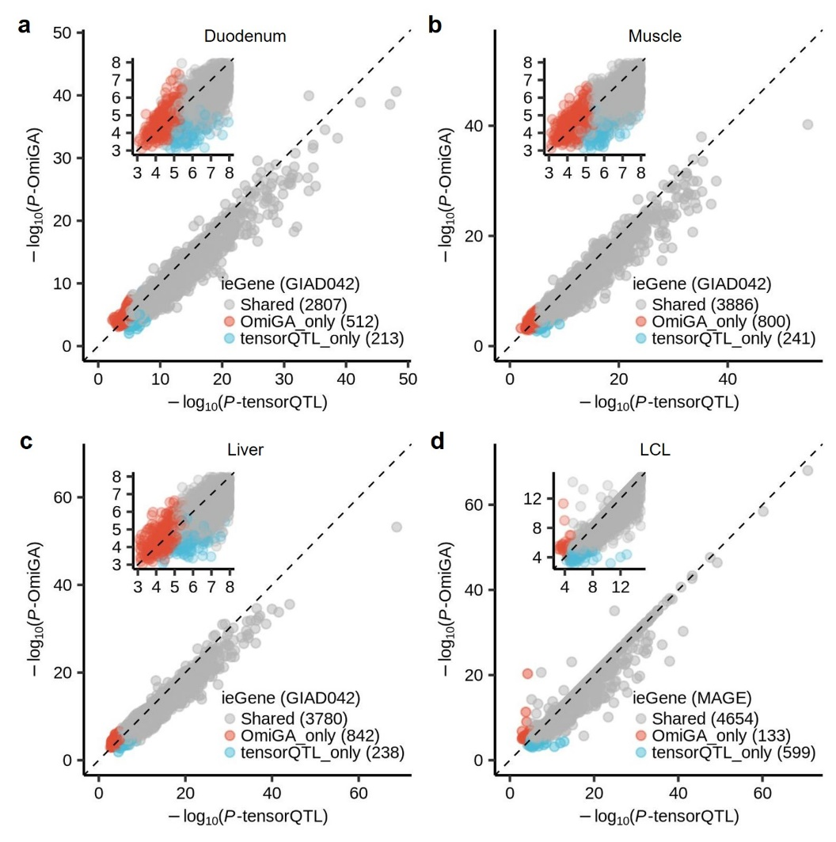
Supplementary Figure 10 | Comparison of ieGenes discovered by OmiGA and tensorQTL. a-c, -log10-scaled P-values of lead cis-ieQTLs detected in muscle (a), liver (b), and duodenum (c) from GIAD042 dataset and LCL from MAGE (d) dataset.

Supplementary Tables
Table S1 | The number of casual variants within cis-region and sampled probability for simulating gene expression levels
Type | # of casual variants | Probability
non-eGene | 0 | 0.35483532
eGene | 1 | 0.34962617
eGene | 2 | 0.18326554
eGene | 3 | 0.07072812
eGene | 4 | 0.02498728
eGene | 5 | 0.01655758

Table S2 | The number of casual variants within cis-region and sampled probability for simulating gene expression levels with ancestry interaction eQTL effects
Type | # of casual variants | Probability
non-ieGene | 0 | 0.55483532
ieGene | 1 | 0.24962617
ieGene | 2 | 0.13326554
ieGene | 3 | 0.04072812
ieGene | 4 | 0.01498728
ieGene | 5 | 0.00655758

References
1. Zhu, T.-N. et al. An Atlas of Linkage Disequilibrium Across Species. Preprint at https://doi.org/10.1101/2024.09.24.614726 (2024).

