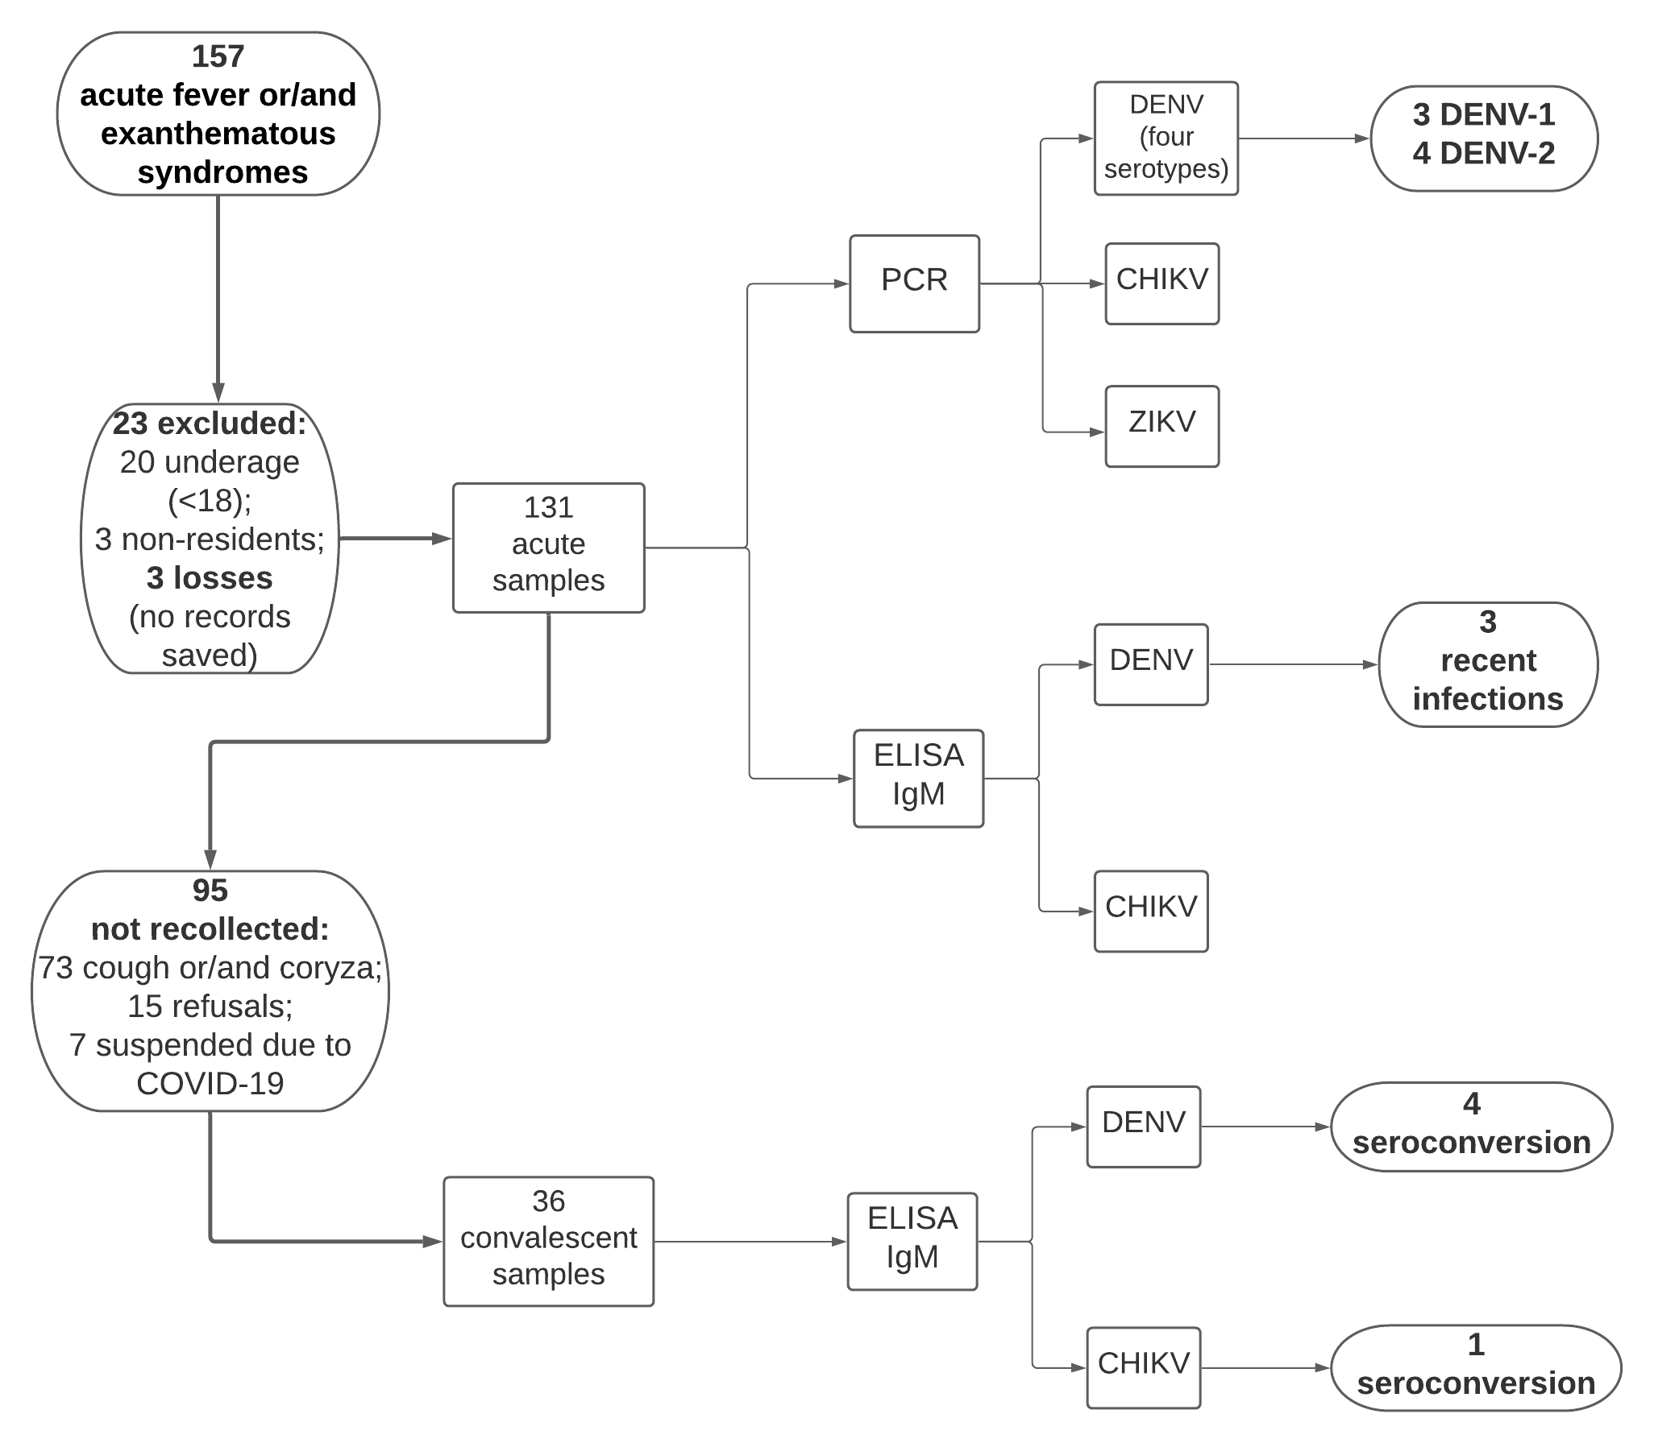
Supplementary Material 1. Patient flow flowchart of laboratory syndromic surveillance, Cidade Estrutural health unit.

