Figure S1
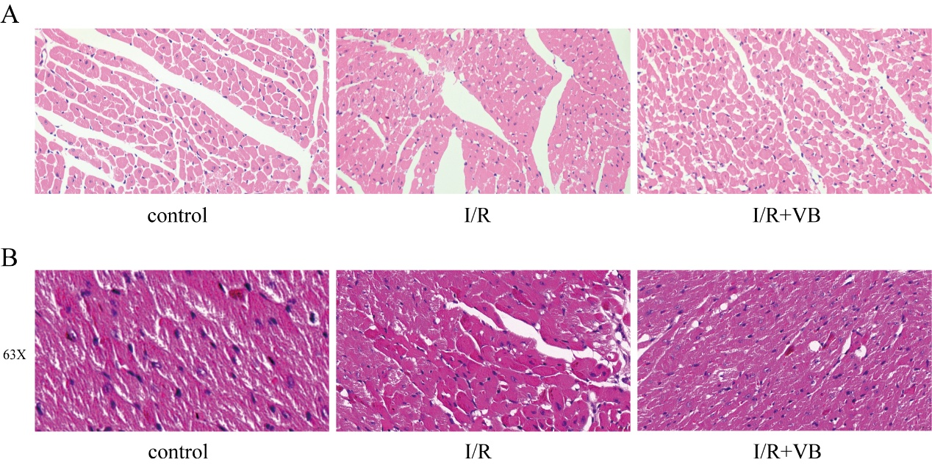
Figure S1. HE staining. (A) Additional HE-stained sections showing more pronounced myocardial vacuolization. (B) Maximum magnification of 63X.
Figure S2
Figure S2. TUNEL staining.
Figure S3
Figure S3. The protein expression of the ferritin heavy chain 1(FTH1).

