Fig.2C
Cleaved-caspase3:
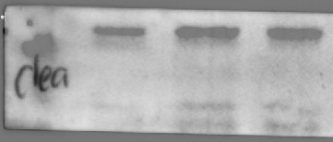
15KD

Bcl-2:
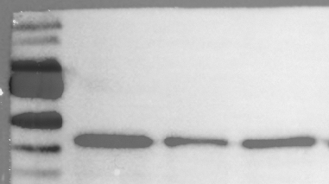
25KD

30KD

BAX:
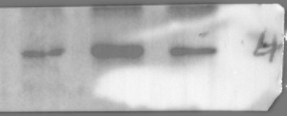
15KD

25KD

β-actin:
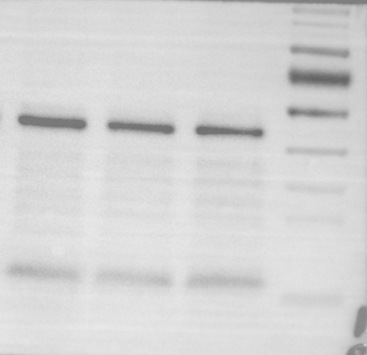
40KD

50KD

Fig.2G
ACSL4:
75KD

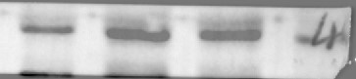
SLC7A11:
75KD

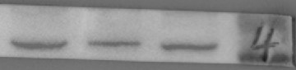
50KD

GPX4:
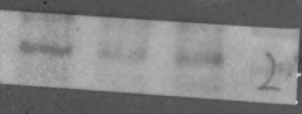
20KD

β-actin:
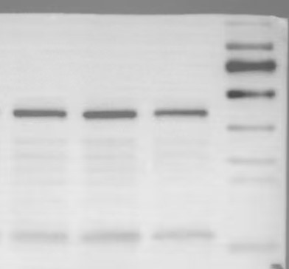
40KD

50KD

Fig.4D
ACSL4:
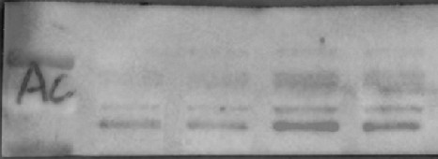
100KD

70KD

SLC7A11:
70KD

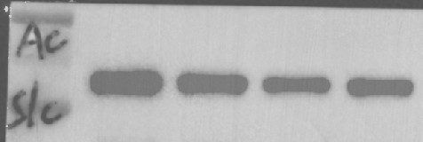
50KD

GPX4:
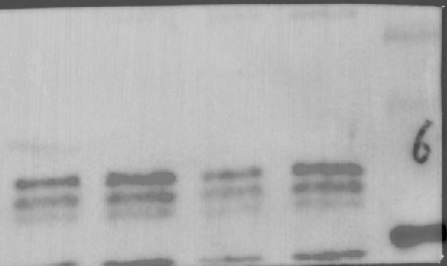
25KD

15KD

β-actin:
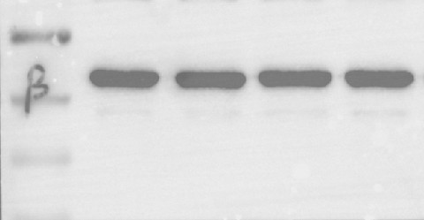
40KD

Fig.5E
GDF15:
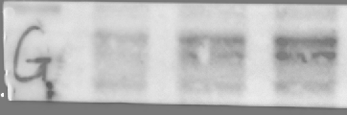
35KD

β-actin:
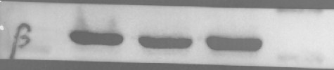
40KD

Fig.5I
GDF15:
35KD

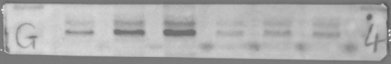
β-actin:
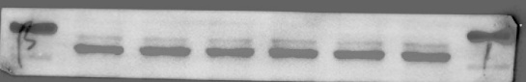
40KD

Fig.5R
ACSL4:
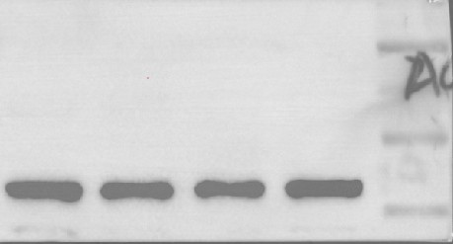
100KD

70KD

SLC7A11:
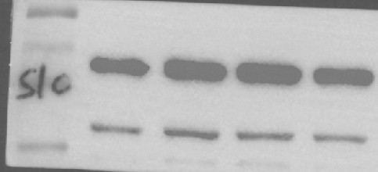
70KD

50KD

GPX4:
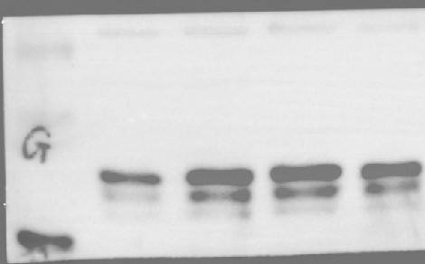
15KD

20KD

β-actin:
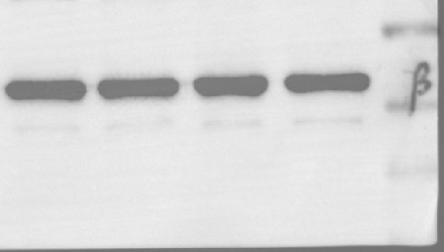
40KD

Fig.6A
GPX4:
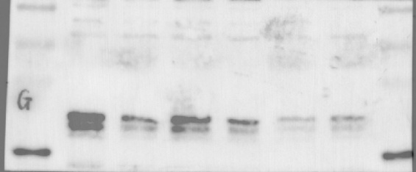
15KD

20KD

β-actin:
40KD

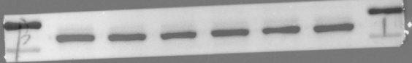
Fig.6J
ACSL4:
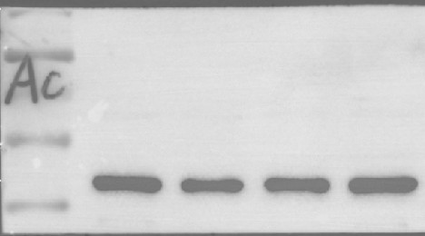
100KD

70KD

SLC7A11:
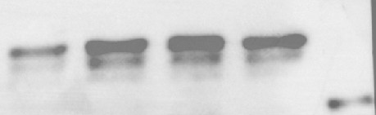
40KD

β-actin:
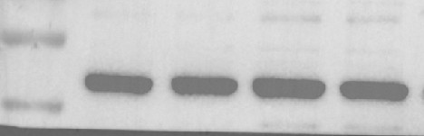
40KD

