Supplementary material

Materials and Methods
Mosquito collections using modified Trinidad No. 17 traps and sentinel vertebrates.
Modified animal-baited Trinidad No. 17 traps were used to sample host-seeking adult female mosquitoes. The traps were manually constructed and consisted of three primary components: a lid, a net, and a bait cage (Supplementary Fig. 1). The lid, a circular disc 30 cm in diameter, was constructed from plywood and had a durable plastic top layer, colored white on both sides. A white, translucent polyester fabric net was attached to the top and bottom by a 10-gauge wire ring, also 30 cm in diameter. The design included a 10 cm elastic steam at the bottom of the net for access to the bait cage and mosquitoes that entered the traps.
The bait cage was a cylindrical unit crafted of about 4 cm diameter polyvinyl chloride (PVC) tubing 10 cm in height. The sides were constructed from 1 cm x 1 cm wire mesh securely fastened to the PVC tubing with two 2 cm wide PVC rings, one at the top and another 4 cm from the bottom. Both the cage floor and lid were constructed using wire mesh. To accommodate different bait animals, the cage floor was positioned strategically: 3 cm above the PVC base for cages housing mice and hamsters and flush with the base for chickens, providing more space.
Mosquitoes were collected across three periods using animal-baited Trinidad traps: June 2017 (mice, 3 traps x 3 days = 9 trap-days), June 2018 (hamsters, 5 traps x 5 days = 25 trap-days; chickens, 5 traps x 5 days = 25 trap-days, toads, 2 traps x 5 days = 10 trap-days), and October 2019 (hamsters, 10 traps x 6 days = 60 trap-days).

Arbovirus screening

The reactions were carried out using the viral amplification kit One Step RT-PCR (Quiagen, Germany). Each primer set was tested under optimized thermal cycling conditions specific to its viral target. For Alphavirus primers, reactions began with an initial step at 48°C for 45 minutes, followed by 94°C for 2 minutes. Amplification proceeded through 40 cycles of 94°C for 30 seconds (denaturation), 52°C for 1 minute (annealing) and 68°C for 30 seconds (elongation), concluding with a final extension at 68°C for 5 minutes. For Orthoflavivirus primers, the cycling protocol included an initial incubation at 50°C for 30 minutes, followed by 94°C for 15 minutes, then 40 cycles of 94°C for 1 minute, 58°C for 1 minute, and 72°C for 1 minute, with a final extension step at 72°C for 10 minutes. Lastly, for Phlebovirus primers, reactions began with 38°C for 45 minutes and 94°C for 2 minutes, followed by 40 cycles of 94°C for 30 seconds, 45°C for 1 minute, and 68°C for 30 seconds. A final extension was performed at 68°C for 5 minutes.

Inclusion criteria for Proactive febrile surveillance
Patients were invited to participate in the study at the health centers, and informed consent was obtained from each individual who voluntarily agreed to participate. Cases without malaria, human immunodeficiency virus (HIV), hepatitis B virus (HBV), or hepatitis C virus (HCV), aged between 5 and 75 years, presenting with a rash lasting no more than seven days, and at least one of the following symptoms—fever, myalgia, arthralgia, periarticular edema, or conjunctivitis—were recruited, evaluated, and interviewed to gather clinical and demographic data and to obtain ethical consent at each health center.

Real-time RT-PCR and viral screening for Aguas calientes, Madrid/Matusagaratí, Aruza viruses

All real-time RT-PCRs were performed on a Rotor-Gene Q instrument (Qiagen, USA) using 20µL reactions of the Luna Probe One-Step RT-qPCR Kit (New England Biolabs, USA) and 5µL of genomic RNA from type strains. Cycling conditions for the singleplex and monoplex reactions were: 52°C for 15 minutes, 94°C for 2 minutes, and 45 cycles of 94°C for 15 seconds, 55°C for 40 seconds, and 68°C for 20 seconds.
Next, the linear range of the multiplex assay was evaluated with synthesized, quantified ssDNA (Integrate DNA Technologies, USA) and reference RNA by plasmids. RNA extracts were quantified with ssDNA, and then a dilution series was tested to establish linearity with RNA and the 95% lower limit of detection (LLOD). Four concentrations (8.0, 6.0, 4.0, and 2.0 log₁₀ copies/µL) were run in quadruplicate on a single run of the assay (Supplementary Table 4). Linear regression of Ct-values versus concentration was performed in Excel, and the assay’s linear range was defined as the range of concentration over which R² ≥ 0.99. Additionally, we validated the method with clinical samples collected from a dengue outbreak in Paraguay between 2019 and 2020. All samples had previously tested negative for Zika, chikungunya, and dengue viruses. In addition, we evaluated this assay using genomic RNA from a set of flaviviruses, bunyaviruses, and alphaviruses (Supplementary Table 4).

Real-time RT-PCR and viral screening for orthobunyaviruses
Based on new orthobunyavirus genomes, we designed primers and probes, and optimized RT-PCR protocols. The linear range of each assay included in the multiplex real-time RT-PCR extended from 2.0 to 8.0 log₁₀ copies/µL of eluate (Fig 3. A-F). Lower limits of 95% detection, expressed as copies/µL of eluate, were: Aguas Calientes, 16.1; Aruza, 2.5; and Matusagaratí/Madrid, 10.0. During evaluation of assay exclusivity, no signal was observed from any tested orthoflavivirus, alphavirus, or bunyavirus (Supplementary Table 1). All clinical samples tested for evaluation of specificity (n=39) were negative.

Supplementary tables

Supplementary table 1. Primer sequences for Arboviruses RT-PCR
Name | Virus | Secuence (5’- 3’) | Autor
Alpha1 + | Alphaviruses | GAYGCITAYYTIGAYATGGTIGAIGG | Sánchez-Seco et al. 2001
Alpha1 - | Alphaviruses | KYTCYTCIGTRTGYTTIGTICCIGG | Sánchez-Seco et al. 2001
FLAVI-1 | Flavivirus | AATGTACGCTGATGACACAGCTGGCTGGGACAC | Ortiz et al. 2012
FLAVI-2 | Flavivirus | TCCAGACCTTCAGCATGTCTTCTGTTGTCATCCA | Ortiz et al. 2012
NPhlebo1+ | Phleboviruses | ATGGARGGITTTGTIWSICIICC | Sánchez-Seco et al. 2003
NPhlebo1- | Phleboviruses | AARTTRCTIGWIGCYTTIARIGTIGC | Sánchez-Seco et al. 2003

Supplementary table 2. Absolute and relatively small mammals abundance by year and collection site.
Species | Years‡ |  | Collection sites†
Species | 2011 | 2012 | El Real | Los Pavitos | Santa Librada | El Cacao | Cirí Grande
Species | n/N (%) | n/N (%) | n/N (%) | n/N (%) | n/N (%) | n/N (%) | n/N (%)
Didelphis marsupialis | 1/430 (0.2) | 0/169 (0.0) | 0/202 (0.0) | 0/165 (0.0) | 0/158 (0.0) | 0/56 (0.0) | 1/18 (5.6)
Liomys adspersus | 4/430 (0.9) | 0/169 (0.0) | 0/202 (0.0) | 0/165 (0.0) | 0/158 (0.0) | 4/56 (7.1) | 0/18 (0.0)
Marmosa robinsoni | 1/430 (0.23) | 0/169 (0.0) | 1/202 (0.5) | 0/165 (0.0) | 0/158 (0.0) | 0/56 (0.0) | 0/18 (0.0)
Marmosa sp. | 1/430 (0.2) | 0/169 (0.0) | 0/202 (0.0) | 0/165 (0.0) | 0/158 (0.0) | 0/56 (0.0) | 1/18 (5.6)
Melanomys caliginosus | 18/430 (4.2) | 3/169 (1.8) | 21/202 (10.4) | 0/165 (0.0) | 0/158 (0.0) | 0/56 (0.0) | 0/18 (0.0)
Mus musculus | 0/430 (0.0) | 13/169 (7.7) | 9/202 (4.5) | 4/165 (2.4) | 0/158 (0.0) | 0/56 (0.0) | 0/18 (0.0)
Handleyomys alfaroi | 6/430 (1.4) | 5/169 (3.0) | 6/202 (3.0) | 1/165 (0.6) | 4/158 (2.5) | 0/56 (0.0) | 0/18 (0.0)
Transandinomys bolivaris | 6/430 (1.4) | 3/169 (1.8) | 5/202 (2.5) | 1/165 (0.6) | 3/158 (1.9) | 0/56 (0.0) | 0/18 (0.0)
Oryzomys sp. | 16/430 (3.7) | 0/169 (0.0) | 6/202 (3.0) | 10/165 (6.1) | 0/158 (0.0) | 0/56 (0.0) | 0/18 (0.0)
Ototylomys phyllotis | 0/430 (0.0) | 2/169 (1.2) | 2/202 (1.0) | 0/165 (0.0) | 0/158 (0.0) | 0/56 (0.0) | 0/18 (0.0)
Proechimys semispinosus | 53/430 (12.3) | 20/169 (11.8) | 19/202 (9.4) | 3/165 (1.8) | 1/158 (0.6) | 37/56 (66.1) | 13/18 (72.2)
Rattus rattus | 9/430 (2.1) | 5/169 (3.0) | 8/202 (4.0) | 2/165 (1.2) | 0/158 (0.0) | 3/56 (5.4) | 1/18 (5.6)
Rattus sp. | 2/430 (0.5) | 0/169 (0.0) | 1/202 (0.5) | 0/165 (0.0) | 1/158 (0.6) | 0/56 (0.0) | 0/18 (0.0)
Sigmodon hirsutus | 5/430 (1.2) | 3/169 (1.8) | 0/202 (0.0) | 0/165 (0.0) | 0/158 (0.0) | 8/56 (14.3) | 0/18 (0.0)
Sigmodon sp. | 1/430 (0.2) | 0/169 (0.0) | 0/202 (0.0) | 0/165 (0.0) | 0/158 (0.0) | 1/56 (1.8) | 0/18 (0.0)
Zygodontomys brevicauda | 307/430 (71.4) | 115/169 (68.1) | 124/202 (61.4) | 144/165 (87.3) | 149/158 (94.3) | 3/56 (5.4) | 2/18 (11.1)
Total | 430/599 (71.8) | 169/599 (28.2) | 202/599 (33.7) | 165/599 (27.5) | 158/599 (26.3) | 56/599 (9.3) | 18/599 (3.0)
‡Rodent abundance total by year: 2011 n=430 and 2012 n=169; abundance total n=599
†Rodent abundance total by collation site: El Real n=202, Los Pavitos n=165, Santa Librada n=158, El Cacao n=56 and Cirí Grande n=18

Supplementary table 3. Abundance of mosquitoes collected using animal-baited Trinidad traps
Species name* | Mouse | Hamster | Chicken | Frog
Ae. (Och.) fulvus | 1 | 0 | 0 | 0
Ae. (Och.) serratus | 3 | 0 | 0 | 0
An. (Ano.) apicimacula | 0 | 1 | 0 | 0
Cq. (Rhy.) venezuelensis | 149 | 1847 | 378 | 4
Cx. (Cux.) coronator | 0 | 28 | 7 | 0
Cx. (Cux.) interrogator | 161 | 24 | 22 | 0
Cx. (Cux.) nigripalpus | 115 | 58 | 18 | 2
Cx. (Cux.) pseudostigmatosoma | 33 | 0 | 0 | 0
Cx. (Cux.) spp. | 23 | 45 | 4 | 0
Cx. (Mel.) adamesi | 1 | 117 | 13 | 0
Cx. (Mel.) dunni | 11 | 6 | 1 | 0
Cx. (Mel.) epanatasis | 1 | 0 | 0 | 0
Cx. (Mel.) ocossa | 0 | 12 | 3 | 0
Cx. (Mel.) pedroi | 200 | 710 | 55 | 1
Cx. (Mel.) spissipes | 331 | 3416 | 146 | 3
Cx. (Mel.) vomerifer | 21 | 83 | 20 | 0
Cx. (Mel.) spp. | 0 | 191 | 30 | 0
Cx. (Phc.) spp. | 1 | 0 | 0 | 0
Cx. spp. | 16 | 127 | 12 | 1
Is. espini | 1 | 0 | 0 | 0
Jb. leucopus | 1 | 0 | 0 | 0
Jb. longipes | 4 | 0 | 0 | 0
Ma. (Man.) amazonensis | 239 | 2408 | 105 | 5
Ma. (Man.) titillans | 1 | 4 | 1 | 0
Ps. (Gra.) cingulata | 0 | 1 | 0 | 0
Tr. lampropus | 1 | 0 | 0 | 0
Wy. (Den.) luteoventralis | 2 | 0 | 0 | 0
Wy. (Mia.) codiocampa | 1 | 0 | 0 | 0
Wy. (Wyo.) arthrostigma | 29 | 0 | 0 | 0
Wy. (Wyo.) nigritubus | 1 | 0 | 0 | 0
Total | 1347 | 9078 | 815 | 16
Genus and subgenus abbreviations follow nomenclature in Wilkerson, R. C., Linton, Y.-M. & Strickman, D. Mosquitoes of the World. Vol. 1 and 2 (Johns Hopkins University Press, 2021).
Supplementary table 4. Abundance of mosquitoes collected using CDC traps in 2018 and 2019
Species name* | 2018 | 2019
Ae. (Ady.) squamipennis | 40
An. (Ano.) pseudopunctipennis |  | 5
An. (Ano.) punctimacula | 7
An. (Ano.) punctipennis |  | 1
An. (Nys.) albimanus |  | 1
An. spp. | 51 | 6
Cq. (Rhy.) venezuelensis | 1239 | 76
Cx. (Ads.) amazonensis | 65 | 2
Cx. (Cux.) coronator | 27 | 131
Cx. (Cux.) declarator | 3 | 4
Cx. (Cux.) interrogator | 57 | 153
Cx. (Cux.) nigripalpus | 58 | 248
Cx. (Cux.) spp. | 6 | 239
Cx. (Mel.) adamesi | 10
Cx. (Mel.) crybda | 7
Cx. (Mel.) dunni | 11 | 9
Cx. (Mel.) erraticus | 1
Cx. (Mel.) ocossa | 86
Cx. (Mel.) pedroi | 43 | 12
Cx. (Mel.) spissipes | 41 | 16
Cx. (Mel.) spp. | 27 | 6
Cx. (Mel.) vomerifer | 1 | 1
Cx. sp.
Ma. (Man.) titillans | 12 | 1
Ma. spp. | 7
Ps. (Gra.) cingulata |  | 27
Ps. (Pso.) ciliata | 7
Ps. spp. | 11
Ur. (Ura.) geometrica | 1
Ur. (Ura.) hystera | 1
Ur. (Ura.) leucoptera | 19
Ur. (Ura.) lowii | 144 | 13
Ur. (Ura.) nataliae |  | 1
Ur. (Ura.) pallidoventer | 4 | 2
Ur. (Ura.) typhlosomata | 1
Ur. spp. | 89
Total | 2076 | 954
Genus and subgenus abbreviations follow nomenclature in Wilkerson, R. C., Linton, Y.-M. & Strickman, D. Mosquitoes of the World. Vol. 1 and 2 (Johns Hopkins University Press, 2021).

Supplementary table 5. Information of Orthobunyavirus strain isolates.
Strain designation | Year | Host | Tissue | Passage history | Virus | Segment | Length | Reads mapped | depth-coverage
705358 | 2017 | Mouse | liver | Passage 4 | Madrid | S  M  L | X | X | X
705361 | 2017 | Mouse | spleen | Passage 4 | Aguas Calientes | S  M  L | 1091  4806  7016 | 403867  1124204  1314305 | 1.69  4.72  5.51
705363 | 2018 | Hamster | kidney | Passage 2 | Aruza | S  M  L | 1149  4579  7040 | 506601  870429  1247985 | 2.19  3.76  5.39
705364 | 2018 | Hamster | kidney | Passage2 | Madrid | S  M  L | X | X | X
705369 | 2018 | Hamster | liver | Passage 2 | Matusagaratí | S  M  L | X | X | X
705373 | 2011 | Z. brevicauda | spleen | Passage 2 | Madrid | S  M  L | X | X | X
Not available= X

Supplementary table 6. Optimized primer-probe sequences for orthobunyavirus multiplex real-time RT-PCR.

Primer-Probe Name |  | Sequence (5' →3')ª | Concentration (nM)^{b}
Primers
Aruza | Forward | CCTCGAACTGGCACCAAATG | 400
Aruza | Reverse | GCGATTGGGTTCACGATGTT | 400
Matusagaratí /Madrid^{c} | Forward | TCGAATTTTCTTCCTCCGCG | 400
Matusagaratí /Madrid^{c} | Reverse | GTTTGATGCATTTCCGGGGT | 400
Aguas Calientes | Forward | CGTCAGGTGGCAGAAGGTAA | 400
Aguas Calientes | Reverse | GTGACTTCTCTAGCAGGGGT | 400
Probes | Aruza | 5’-FAM-AGACTGGCTGCAGCAGAAAT-BHQ-1-3’ | 200
 | Matus Madrid | 5’-CFO560-TTGGCAGTTGGAAGGTCGAG-BHQ-1-3’ | 200
 | Aguas  Calientes | 5’-CFR610-CCGGACTTGGCCTACAATGT-BHQ-1-3’ | 200
ª Probe sequences are listed in the following order: 5’-fluorophore-sequence-quencher-3’. ^{b} Concentration in the final reaction mixture.^{c} Combined assay for Matusagaratí and Madrid viruses.
BHQ, black hole quencher; FAM, fluorescein; CFO560, Cal Fluor orange 560; CFR610, Cal Fluor red 610.

Supplementary table 7. Comparison of cycle threshold (Ct) values for singleplex and multiplex rRT-PCR assays.
Sample  (Code) | Singleplex Ct-value | Multiplex Ct-value
Aruza (702150) | 21.50 | 21.72
Aruza (702150), 1:100 dilution | 36.19 | 36.75
Aruza (702151) | 25.90 | 26.04
Aruza (702151), 1:100 dilution | 32.51 | 32.52
*Aguas (701674) | 28.73 | 31.69
*Aguas (701674), 1:100 dilution | 33.64 | 37.52
*Aguas (701675) | 27.59 | 30.21
*Aguas (701675), 1:100 dilution | 33.74 | 37.45
Matus/Madrid (702154) | 22.99 | 24.98
Matus/Madrid (702154), 1:100 dilution | 29.49 | 31.72
Matus/Madrid (702156) | 30.88 | 31.43
Matus/Madrid (702156), 1:100 dilution | 28.21 | 30.44
*Sample also contained Madrid virus

Supplementary table 8. Mosquito pools positive for orthobunyaviruses.

Species name* | Aruza virus | Madrid/Matusargatí virus | Aguas calientes virus | N Pools
Ad. (Ady.) squamipennis | 0 | 0 | 0 | 1
Ae. (Och.) fulvus | 0 | 0 | 0 | 1
Ae. (Och.) scapularis | 0 | 0 | 0 | 1
Ae. (Och.) serratus | 0 | 0 | 0 | 3
Ae. (Och.) serratus/nubilus | 0 | 0 | 0 | 1
Ae. (Och.) taeniorhynchus | 0 | 0 | 0 | 1
An. (Ano.) apicimacula | 0 | 0 | 0 | 1
An. (Ano.) punctipennis | 0 | 0 | 0 | 1
An. spp. | 0 | 0 | 0 | 3
Cq. (Rhy.) venezuelensis | 5 | 1 | 1 | 163
Cx. (Ads.) amazonensis | 1 | 1 | 18 | 163
Cx. (Cux.) coronator | 0 | 0 | 0 | 17
Cx. (Cux.) declarator | 0 | 0 | 0 | 4
Cx. (Cux.) interrogator | 0 | 0 | 0 | 41
Cx. (Cux.) nigripalpus | 0 | 0 | 0 | 36
Cx. (Cux.) pseudostigmatosoma | 0 | 0 | 0 | 6
Cx. (Cux.) quinquefasciatus | 0 | 0 | 0 | 1
Cx. (Cux.) spp. | 0 | 0 | 0 | 18
Cx. (Mel.) adamesi | 1 | 0 | 0 | 20
Cx. (Mel.) atratatus group | 0 | 0 | 0 | 1
Cx. (Mel.) bastagarius | 0 | 0 | 0 | 1
Cx. (Mel.) crybda | 0 | 0 | 0 | 1
Cx. (Mel.) dunni | 0 | 0 | 0 | 12
Cx. (Mel.) epanatasis | 0 | 0 | 0 | 1
Cx. (Mel.) erraticus | 0 | 0 | 0 | 1
Cx. (Mel.) intrincatus group | 0 | 0 | 0 | 2
Cx. (Mel.) ocossa | 0 | 0 | 0 | 12
Cx. (Mel.) pedroi | 4 | 1 | 0 | 74
Cx. (Mel.) pilosus | 0 | 0 | 0 | 2
Cx. (Mel.) spissipes | 11 | 0 | 2 | 233
Cx. (Mel.) theobaldi | 0 | 0 | 0 | 1
Cx. (Mel.) vomerifer | 2 | 1 | 0 | 24
Cx. (Mel.) spp. | 0 | 0 | 0 | 8
Cx. (Phc.) spp. | 0 | 0 | 0 | 2
Cx. spp. | 0 | 0 | 1 | 51
Hg. (Hag.) equinus | 0 | 0 | 0 | 1
Is. espini | 0 | 0 | 0 | 3
Jb. leucopus | 0 | 0 | 0 | 1
Jb. longipes | 0 | 0 | 0 | 1
Ma. (Man.) dyari | 0 | 0 | 0 | 1
Ma. (Man.) titillans | 0 | 0 | 0 | 6
Ps. (Gra.) cingulata | 0 | 0 | 0 | 2
Ps. spp. | 0 | 0 | 0 | 3
Sa. spp. | 0 | 0 | 0 | 1
Tr. spp. | 0 | 0 | 0 | 1
Tr. digitatum | 0 | 0 | 0 | 3
Tr. lampropus | 0 | 0 | 0 | 1
Tr. spp. | 0 | 0 | 0 | 1
Ur. (Ura.) lowii | 0 | 0 | 0 | 3
Ur. spp. | 0 | 0 | 0 | 1
Wy. (Den.) jocosa | 0 | 0 | 0 | 1
Wy. (Den.) luteoventralis | 0 | 0 | 0 | 1
Wy. (Mia.) codiocampa | 0 | 0 | 0 | 1
Wy. (Wyo.) arthrostigma | 0 | 0 | 0 | 3
Wy. (Wyo.) celaenocephala | 0 | 0 | 0 | 1
Wy. (Wyo.) nigritubus | 0 | 0 | 0 | 2
Wy. spp. | 0 | 0 | 0 | 10
Total | 24 | 4 | 22 | 947
*Genus and subgenus abbreviations follow nomenclature in Wilkerson, R. C., Linton, Y.-M. & Strickman, D. Mosquitoes of the World. Vol. 1 and 2 (Johns Hopkins University Press, 2021).

Supplementary table 9. Mosquito blood meal analysis and identity.
code | Location | Species | species2 | common name | % ID
19 | Limon | Cx. saltanensis | Equus caballus | Horse | 100
21 | Limon | Cx. nigripalpus | Gallus gallus | chicken | 100
39 | Laguna | Cx. spissipes | Bos taurus | Cow | 99.48
74 | Laguna | Cx. spissipes | Bos taurus | Cow | 99.48
75 | P8 | Cx. spissipes | Aramides cajaneus | grey-necked wood rail | 99.44
17 | Limon | Cx. (mel) mel | Anolis vittigerus | Garland anole | 99.4
59 | Laguna | Cx. nigripalpus | Gallus gallus | chicken | 99.32
27 | Limon | Cx. nigripalpus | Equus caballus | Horse | 99.21
5 | Limon | Cx. pedroi | Equus caballus | Horse | 99.2
56 | Laguna | Cx. amazonensis | Bos taurus | Cow | 99.16
20 | Limon | Cx. saltanensis | Equus caballus | Horse | 98.98
2 | Limon | Cx. pedroi | Bos taurus | Cow | 98.97
26 | Limon | Cx. nigripalpus | Gallus gallus | chicken | 98.97
30 | Limon | Cx. nigripalpus | Bos taurus | Cow | 98.97
43 | Laguna | Cx. amazonensis | Bos taurus | Cow | 98.97
53 | Laguna | Cx. spissipes | Bos taurus | Cow | 98.97
8 | Limon | Cx. pedroi | Equus caballus | Horse | 98.92
48 | Laguna | Cx. spissipes | Aramides cajanea | grey-necked wood rail | 98.89
60 | Laguna | Cx. nigripalpus | Aramides cajanea | grey-necked wood rail | 98.72
62 | Laguna | Cx. nigripalpus | Tigrisoma lineatum | Rufescent tiger heron | 98.72
22 | Limon | Cx. nigripalpus | Bos taurus | Cow | 98.71
64 | Laguna | Cx. (mel) mel | Basiliscus galeritus | red-headed basilisk | 98.71
78 | Laguna | Cx. spissipes | Gallus gallus | chicken | 98.68
37 | Limon | Cx. pedroi | Equus caballus | Horse | 98.64
4 | Limon | Cx. pedroi | Equus caballus | Horse | 98.51
61 | Laguna | Cx. nigripalpus | Aramides cajanea | grey-necked wood rail | 98.47
63 | Laguna | Cx. spissipes | Aramides cajanea | grey-necked wood rail | 98.47
57 | Laguna | Cx. saltanensis | Bos taurus | Cow | 98.46
7 | Limon | Cx. pedroi | Equus caballus | Horse | 98.4
36 | Laguna | Cx. (mel) mel | Basiliscus galeritus | red-headed basilisk | 98.39
51 | Laguna | Cx. spissipes | Aramides cajanea | grey-necked wood rail | 98.22
70 | Laguna | Cx. spissipes | Bos taurus | Cow | 98.21
35 | Laguna | Cx. (mel) mel | Basiliscus galeritus | red-headed basilisk | 98.11
58 | Laguna | Cx. saltanensis | Bos taurus | Cow | 97.94
69 | Laguna | Cx. spissipes | Cebus capucinus | white-footed capuchin | 97.85
38 | P8 | Cx. spissipes | Gallbula ruficauda | The rufous-tailed jacamar | 97.8
13 | Limon | Ps. cingulata | Bos taurus | Cow | 97.69
41 | Laguna | Cx. spissipes | Aramides cajanea | grey-necked wood rail | 97.68
6 | Limon | Cx. pedroi | Equus caballus | Horse | 97.48
46 | Laguna | Cx. spissipes | Bos taurus | Cow | 97.32
47 |  | unknown | Aramides cajanea | grey-necked wood rail | 97.09
28 | Limon | Cx. nigripalpus | Bos taurus | Cow | 97.01
29 | Limon | Cx. nigripalpus | Gallus gallus | chicken | 96.92
68 | Laguna | Cx. spissipes | Bos taurus | Cow | 96.92
52 | Laguna | Cx. spissipes | Basiliscus galeritus | red-headed basilisk | 96.83
42 | Laguna | An. aribalzaga | Equus caballus | Horse | 96.7
11 | Limon | Cx. (mel) mel | Iguana ignuana | Iguana | 95.82
76 | P8 | Cx. spissipes | Sylvilagus gabbi | tapeti/Brazillian cottontail | 95.72
72 | Laguna | Cx. spissipes | Trogon melanurus | Ecuadorian Trogon | 95.54
32 | Limon | Cx. saltanensis | Sylvilagus gabbi | tapeti/Brazillian cottontail | 95.5
73 | Laguna | Cx. spissipes | Bos taurus | Cow | 95.49
67 | Laguna | Cx. spissipes | Bos taurus | Cow | 95.34
25 | Limon | Cx. nigripalpus | Gallus gallus | chicken | 95.14
10 | Limon | Cx. (mel) mel | Iguana ignuana | Iguana | 95.12
33 | Laguna | Cx. spissipes | Sylvilagus gabbi | tapeti/Brazillian cottontail | 95.12
45 | Laguna | Cx. pedroi | Bos taurus | Cow | 95.09
16 | P8 | Cx. pedroi | Sylvilagus gabbi | tapeti/Brazillian cottontail | 95.05
40 | Laguna | Cx. ocossa | Cx. mel. sp.
15 | P8 | Ur. sapphirina | Ur. Sp. |  | 94.49
44 | Laguna | Ur. apicalis | Cx. sp. |  | 90.62
12 | Limon | Cx. (mel) mel | Iguana ignuana | Iguana | 89.56
9 | Limon | Cx. (mel) mel | Brachymymex sp. |  | 88.33
3 | Limon | Cx. pedroi | NA
14 | Limon | Ps. cingulata
18 | P8 | Ur. sapphirina/socialis
23 | Limon | Cx. nigripalpus
24 | Limon | Cx. nigripalpus
31 | Limon | Cx. nigripalpus | NA
34 | Laguna | Cx. spissipes | NA
65 | P8 | Ur. geometrica | Ur. Sp.
71 | Laguna | Cx. spissipes | Ae. aegypti
77 | Laguna | Ur. sapphirina
%ID = percentage of identity

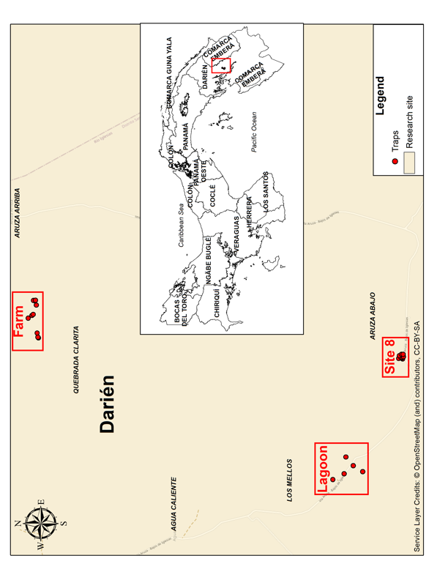
Supplementary figure 1. Map of Panama and Collection Sites. The figure highlights the locations of the Lagoon, Site 8, and the designated farm collection sites.

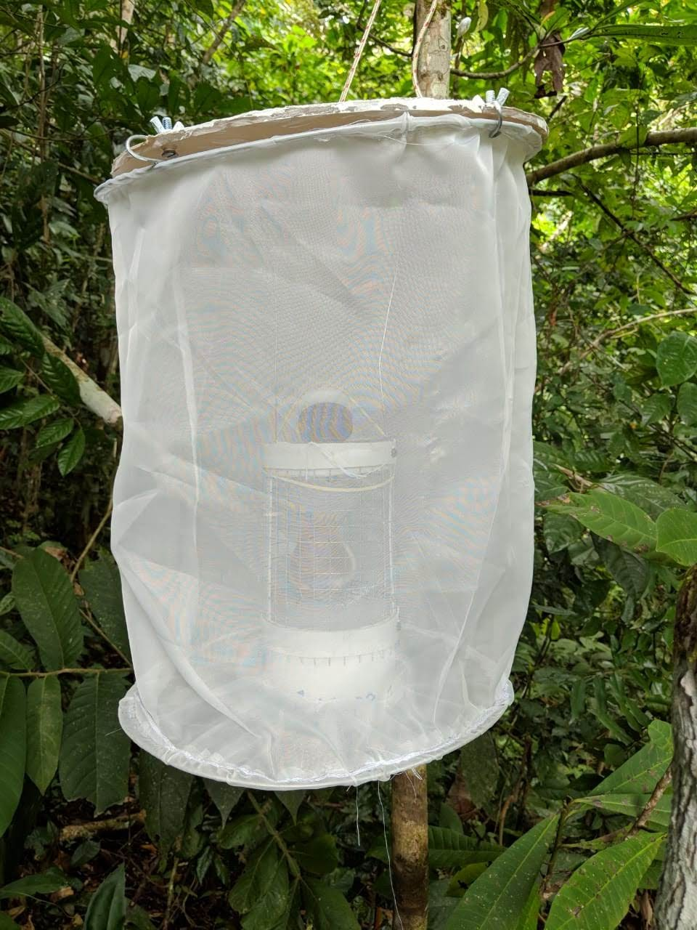

Supplementary figure 2. A modified Trinidad No. 17 trap baited with a hamster in secondary forest in Aruza, called as site 8.

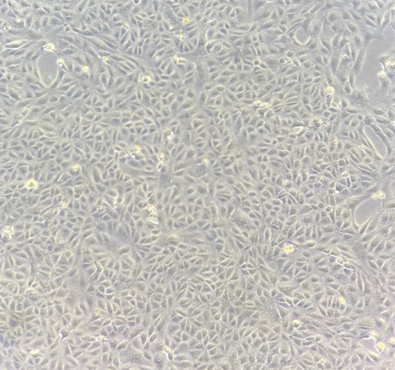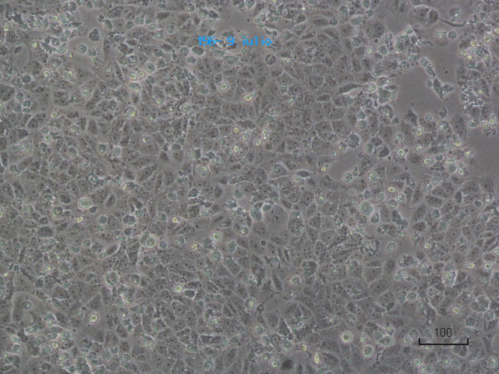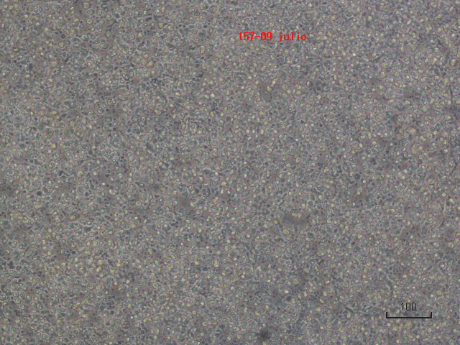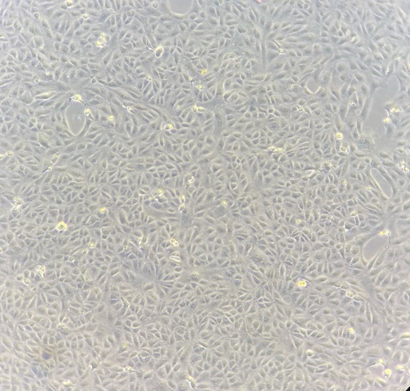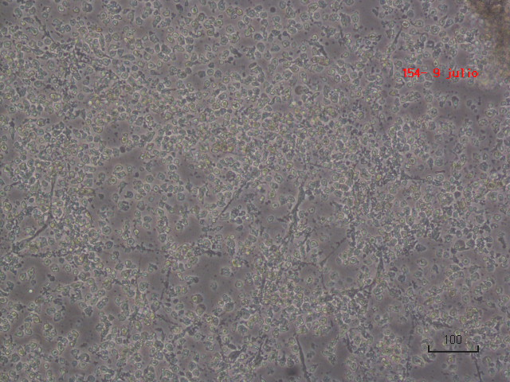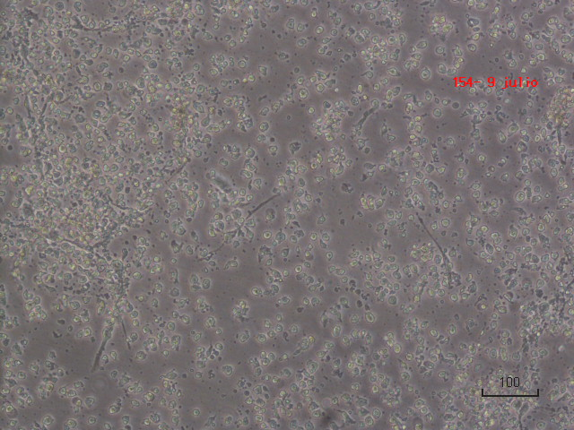
F
D
B
A
C
E

Supplementary figure 3. Cytopathic effects were observed in Vero cells inoculated with supernatants derived from various tissues of individual mice exhibiting signs of disease in 2017. A and B. Mock cells. C. Cytopathic effect from heart tissue. D. Cytopathic effect from liver tissue. E. Cytopathic effect from spleen tissue and F. Cytopathic effect from spleen tissue. CPE after 4- and 8-days post inoculation.

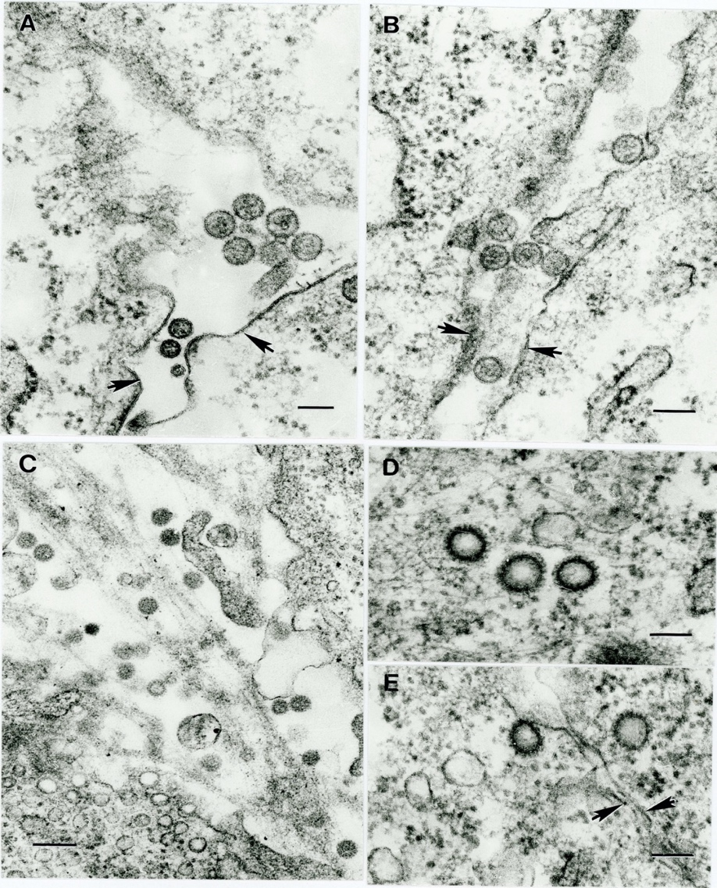
Supplementary figure 4. Ultrastructure of Aguas Calientes (strains 701674, 701675), Aruza (702150) and Matusagaratí (702152) viruses in Vero cell monolayers. (A) Viral particles of Matusagaratí virus (702152) 80-100 nm in diameter in extracellular space between two cells. Arrows indicate cell membranes. Bar = 100 nm; (B) Viral particles of Aguas Calientes virus (701674) 80-100 nm in diameter in extracellular space between two cells. Arrows indicate cell membranes. Bar = 100 nm.; (C) Viral particles with 70-75 nm in diameter of Aruza virus (702150) in extracellular spaces between the cells. Bar = 200 nm; (D, E) Virus-like particles 125-150 nm in diameter deeper in the cytosol (D) or close to the cell surface (E). Arrows indicate plasma membranes of two adjacent cells. Bars = 100 nm.

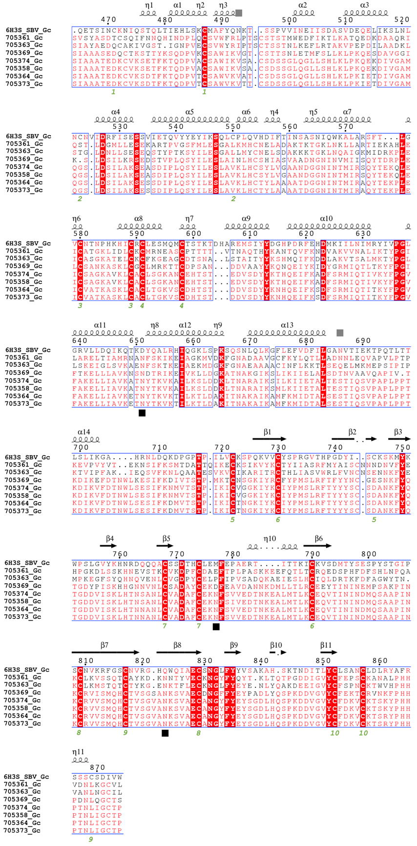

Supplementary figure 5. Multiple amino acid sequence alignment of orthobunyaviral Gc glycoproteins.

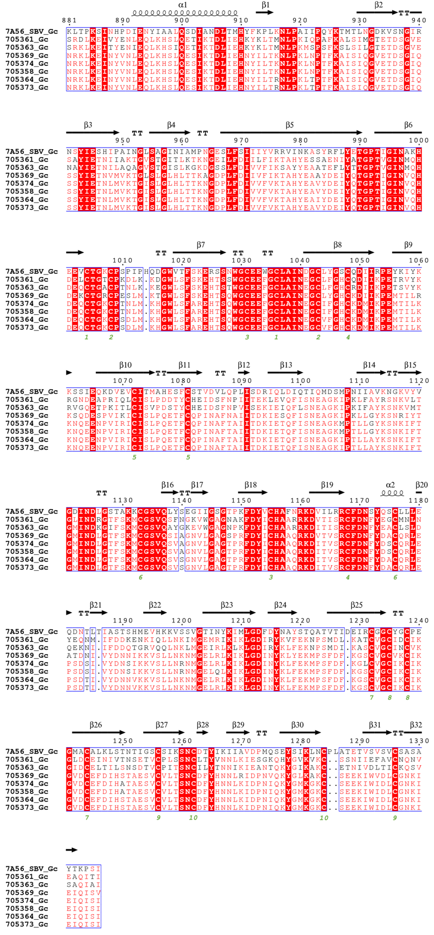
Supplementary figure 6. Multiple amino acid sequence alignment of orthobunyaviral Gc glycoproteins.

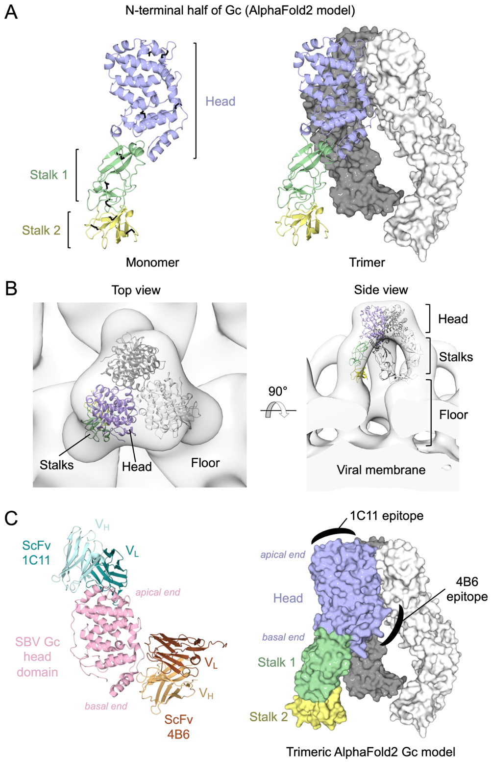
Supplementary figure 7. Structure modeling of the N-terminal half of orthobunyaviral Gc glycoproteins. The N-terminal half of the isolate Gc (strain 705358) was structurally modeled using AlphaFold2⁵⁰ (c (A) (Left) Monomeric model of the N-terminal half of Gc in cartoon representation. The head domain is colored purple, and the stalk subdomains are colored green and yellow, respectively. Conserved disulfide bonds are shown as black sticks. (Right) Trimeric model of the N-terminal half of Gc. For visual clarity, one protomeric copy is shown as cartoon while the other two are shown in surface representation (white and grey). (B) Rigid fitting of the trimeric Gc model (cartoon) into an electron cryo-tomography map (grey; EMD-2352)⁷². The head and stalk domains form a tripodal pyramid architecture. The C-terminal ‘floor’ domain which connects the N-terminal half to the viral membrane was not modeled. (C) Antibody epitope mapping. (Left) Structure ⁴⁸of SBV Gc head domain (pink) in complex with single-chain variable fragment (ScFv) 1C11 (cyan; PDB ID: 6H3T) and 4B6 (brown; PDB ID: 6H3U). V_{H} and V_{L} denote variable heavy and variable light chains. (Right) Mapping of 1C11 and 4B6 epitopes onto the AlphaFold2-derived model of the isolate Gc N-terminal half (surface representation) in trimeric form. The antibody targeted sites are indicated with filled, black crescents.

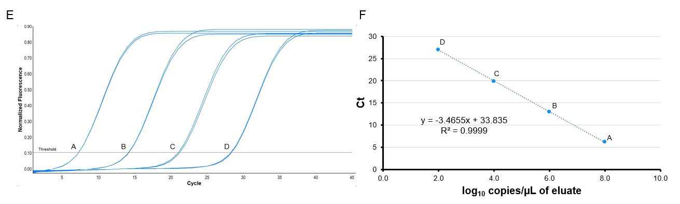
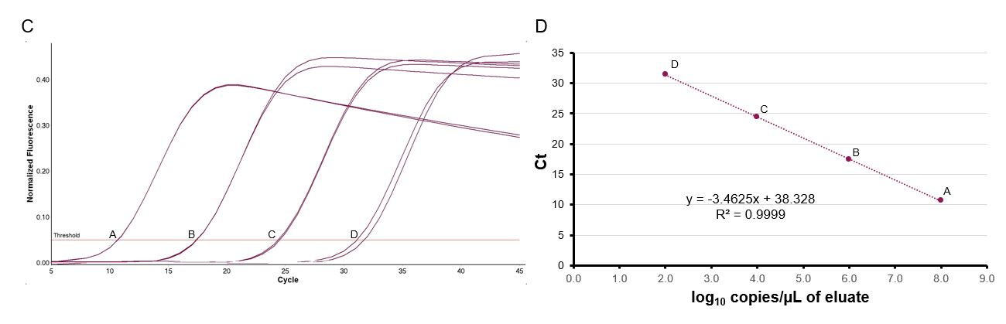
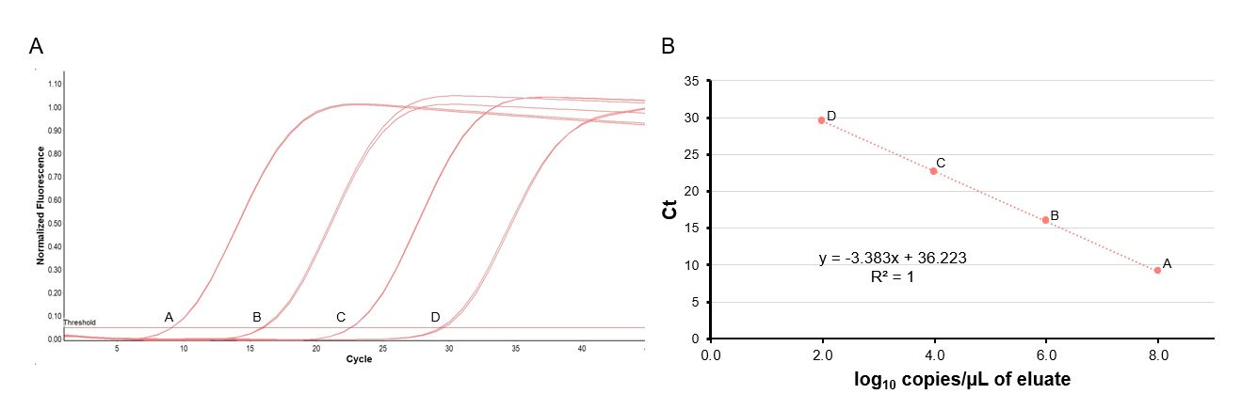

Supplementary figure 8. Linear range for the multiplex rRT-PCR assay for four novel orthobunyaviruses: Aguas Calientes (A-B), Aruza (C-D), and Matusagaratí/Madrid (E-F). Four concentrations (8.0, 6.0, 4.0, and 2.0 log₁₀ copies/µL of eluate) were run in quadruplicate on a single run of the assay. All curves and data points are displayed.

