Table S1. List of genome-wide association study data used.
Traits/  phenotype | Characteristics | N_total | N_case | N_control | Ancestry | Data source | PMID

Renal
BUN | quantitative | 567,460 | - | - | European | CKDGen round 4 | 31152163
eGFR | quantitative | 567,460 | - | - | European | CKDGen round 4 | 31152163
CKD | binary | 480,698 | 41,395 | 439,303 | European | CKDGen round 4 | 31152163
IgAN | binary | 26,734 | 5,556 | 21,178 | European | Kiryluk Lab website | 37337107
KSD | binary | 720,199 | 17,969 | 702,230 | European | UKB and FinnGen | 37980427

Gut
PUD | binary | 816,412 | 26,687 | 789,725 | European | UKB and FinnGen | 38036781
GORD | binary | 456,327 | 54,854 | 401,473 | European | UKB | 33608531
IBD | binary | 462,014 | 34,125 | 427,889 | European | IIBDGC and FinnGen | 37156999
IBS | binary | 486,601 | 53,400 | 433,201 | European | UKB and the Bellygenes initiative | 36753304
N_total, N_case, N_control represent the number of total samples, cases and controls, respectively.
Abbreviations: BUN, Blood urea nitrogen; eGFR, Estimated glomerular filtration rate; CKD, Chronic kidney disease; IgAN, IgA nephropathy; KSD, Kidney stone disease; PUD, Peptic ulcer disease; GORD, Gastro-oesophageal Reflux Disease; IBD, Inflammatory bowel disease; IBS, irritable bowel syndrome; UKB, UK Biobank; CKDGen, CKD Genetics Consortium.

Table S2. Global and Local Genetic Correlation Between 20 Pairwise Traits.
Trait-pair | LDSC |  |  |  |  | 𝝆-HESS
Trait-pair | r_{g} (SE) | P for LDSC | Intercept (SE) | P for Intercept |  | r_{g} (SE) | P for 𝝆-HESS
BUN-PUD | -0.035 (0.053) | 5.07×10⁻¹ | 0.002 (0.006) | 7.01×10⁻¹ |  | -0.011 (0.028) | 6.96×10⁻¹
BUN-GORD ^{b} | -0.057 (0.038) | 1.32×10⁻¹ | 0.001 (0.006) | 8.54×10⁻¹ |  | -0.053 (0.019) | 5.00×10⁻³
BUN-IBD ª | 0.158 (0.065) | 1.54×10⁻² | -0.010 (0.005) | 5.70×10⁻² |  | 0.020 (0.021) | 3.29×10⁻¹
BUN-IBS ^{a, b} | -0.086 (0.044) | 4.77×10⁻² | -0.004 (0.006) | 4.72×10⁻¹ |  | -0.101 (0.022) | 3.60×10⁻⁶
eGFR-PUD | -8.34×10⁻⁵ (0.041) | 9.98×10⁻¹ | -0.003 (0.006) | 6.63×10⁻¹ |  | -0.008 (0.023) | 7.11×10⁻¹
eGFR-GORD | -0.023 (0.028) | 4.17×10⁻¹ | -0.007 (0.006) | 3.10×10⁻¹ |  | -0.013 (0.017) | 4.24×10⁻¹
eGFR-IBD | -0.054 (0.046) | 2.43×10⁻¹ | 0.009 (0.005) | 1.03×10⁻¹ |  | -0.010 (0.017) | 5.82×10⁻¹
eGFR-IBS | -0.027 (0.031) | 3.84×10⁻¹ | 0.008 (0.006) | 2.22×10⁻¹ |  | 0.017 (0.019) | 3.79×10⁻¹
CKD-PUD | 0.083 (0.070) | 2.39×10⁻¹ | -0.001 (0.006) | 8.44×10⁻¹ |  | 0.021 (0.040) | 6.08×10⁻¹
CKD-GORD | 0.069 (0.053) | 1.96×10⁻¹ | 0.003 (0.005) | 5.97×10⁻¹ |  | 0.051 (0.030) | 8.90×10⁻²
CKD-IBD ^{a, c} | 0.204 (0.092) | 2.64×10⁻² | -0.009 (0.005) | 4.60×10⁻² |  | 0.020 (0.032) | 5.38×10⁻¹
CKD-IBS | 0.028 (0.059) | 6.37×10⁻¹ | -0.005 (0.005) | 3.27×10⁻¹ |  | -0.023 (0.035) | 5.20×10⁻¹
IgAN-PUD | 0.166 (0.091) | 6.77×10⁻² | -0.001 (0.005) | 8.62×10⁻¹ |  | 0.284 (0.177) | 1.09×10⁻¹
IgAN-GORD | 0.035 (0.083) | 6.72×10⁻¹ | 0.001 (0.005) | 8.39×10⁻¹ |  | 0.204 (0.120) | 8.90×10⁻²
IgAN-IBD ^{a, b, c} | -0.291 (0.144) | 4.33×10⁻² | -0.016 (0.005) | 5.67×10⁻⁴ |  | -0.838 (0.276) | 2.00×10⁻³
IgAN-IBS | -0.055 (0.078) | 4.81×10⁻¹ | -0.001 (0.005) | 8.57×10⁻¹ |  | 0.021 (0.148) | 8.90×10⁻¹
KSD-PUD ^{a, b, c} | 0.201 (0.052) | 1.00×10⁻⁴ | 0.016 (0.005) | 2.00×10⁻³ |  | 0.394 (0.049) | 5.95×10⁻¹⁶
KSD-GORD ^{a, b} | 0.224 (0.042) | 6.74×10⁻⁸ | 0.004 (0.005) | 5.01×10⁻¹ |  | 0.277 (0.034) | 8.12×10⁻¹⁶
KSD-IBD | -0.076 (0.071) | 2.82×10⁻¹ | 0.008 (0.005) | 1.06×10⁻¹ |  | -0.003 (0.035) | 9.25×10⁻¹
KSD-IBS ^{a, b} | 0.256 (0.038) | 1.82×10⁻¹¹ | -0.003 (0.005) | 5.38×10⁻¹ |  | 0.286 (0.038) | 1.10×10⁻¹³
r_{g} represents genome-wide genetic correlation and SE represents standard error.
ª Pairwise trait with significant genetic correlation by LDSC.
^{b} Pairwise trait with significant genetic overlap by 𝝆-HESS.
^{c} Genome-wide association study summary data with potentially significant sample overlap.
Abbreviations: BUN, Blood urea nitrogen; eGFR, Estimated glomerular filtration rate; CKD, Chronic kidney disease; IgAN, IgA nephropathy; KSD, Kidney stone disease; PUD, Peptic ulcer disease; GORD, Gastro-oesophageal Reflux Disease; IBD, Inflammatory bowel disease; IBS, irritable bowel syndrome; LDSC, linkage disequilibrium score regression; HESS, Heritability Estimation from Summary Statistics.

Table S3. Characterization of pleiotropic variants and loci.
Trait pair | Variant | Locus | PP4>0.7 | Drug
BUN-PUD | 554 | 13 | 0 | 3
BUN-GORD | 553 | 16 | 1 | 1
BUN-IBD | 539 | 14 | 0 | 2
BUN-IBS | 423 | 8 | 0 | 0
eGFR-PUD | 623 | 21 | 3 | 7
eGFR-GORD | 2,130 | 26 | 2 | 4
eGFR-IBD | 1,234 | 27 | 3 | 4
eGFR-IBS | 1,299 | 29 | 1 | 3
CKD-PUD | 175 | 6 | 0 | 0
CKD-GORD | 1,480 | 6 | 1 | 1
CKD-IBD | 77 | 7 | 2 | 0
CKD-IBS | 51 | 2 | 0 | 1
IgAN-PUD | 122 | 2 | 0 | 2
IgAN-GORD | 1,923 | 1 | 1 | 0
IgAN-IBD | 1,582 | 7 | 2 | 2
IgAN-IBS | 677 | 3 | 0 | 0
KSD-PUD | 216 | 11 | 2 | 3
KSD-GORD | 3571 | 7 | 0 | 3
KSD-IBD | 759 | 8 | 2 | 1
KSD-IBS | 454 | 8 | 1 | 4
Total | 18,442 | 222 | 21 | 41
The 2nd to 3rd columns represent the total number of significant variants or loci, respectively; the 4th and 5th columns indicate the number of loci with PP4>0.7 or available drugs, respectively. Abbreviations: BUN, Blood urea nitrogen; eGFR, Estimated glomerular filtration rate; CKD, Chronic kidney disease; IgAN, IgA nephropathy; KSD, Kidney stone disease; PUD, Peptic ulcer disease; GORD, Gastro-oesophageal Reflux Disease; IBD, Inflammatory bowel disease; IBS, irritable bowel syndrome; PP4, posterior probability of H4.
Table S4. 21 Colocalized Loci Identified by Colocalization Analysis Performed on 222 Pleiotropic Loci.
Trai-pair | Lead SNP | Consequence | Nearest gene | Cytoband | PP3 | PP4 | Best causal | maxSNP.PP4
BUN-GORD | rs3129861 | intergenic | HLA-DRA | 6p21.32 | 0.162 | 0.814 | rs3129861* | 0.204
eGFR-PUD | rs3129897 | intergenic | HLA-DRA | 6p21.32 | 0.055 | 0.721 | rs3129897* | 0.290
eGFR-PUD | rs11751605 | intronic | LPA | 6q25.3 | 0.139 | 0.724 | rs11751605* | 1.000
eGFR-PUD | rs10120819 | intronic | UBAP2 | 9p13.3 | 0.035 | 0.847 | rs6476426 | 0.065
eGFR-GORD | rs7752448 | intronic | ZSCAN31 | 6p22.1 | 0.035 | 0.965 | rs7752448* | 0.964
eGFR-GORD | rs79346194 | intronic | DEPTOR | 8q24.12 | 0.236 | 0.707 | rs79346194* | 0.130
eGFR-IBD | rs27879 | intergenic | CSF2 | 5q31.1 | 0.021 | 0.974 | rs27879* | 0.290
eGFR-IBD | rs12572072 | intronic | KIF5B | 10p11.22 | 0.036 | 0.929 | rs12572072* | 0.109
eGFR-IBD | rs240707 | intergenic | IL27 | 16p11.2 | 0.145 | 0.733 | rs240707* | 0.231
eGFR-IBS | rs1356292 | intronic | ETV5 | 3q27.2 | 0.073 | 0.769 | rs112545201 | 0.171
CKD-GORD | rs34788973 | exonic | OR2B2 | 6p22.1 | 0.014 | 0.970 | rs34788973* | 0.611
CKD-IBD | rs61844306 | intergenic | KIF5B | 10p11.22 | 0.047 | 0.898 | rs61844306* | 0.093
CKD-IBD | rs138610699 | intronic | PVALEF | 17q25.3 | 0.005 | 0.800 | rs138610699* | 0.646
IgAN-GORD | rs3099844 | ncRNA exonic | MICB-DT | 6p21.33 | 0.027 | 0.973 | rs3099844* | 0.963
IgAN-IBD | rs6873866 | intronic | ERAP2 | 5q15 | 0.109 | 0.800 | rs6873866* | 0.183
IgAN-IBD | rs4077515 | exonic | CARD9 | 9q34.3 | 0.024 | 0.976 | rs4077515* | 0.139
KSD-PUD | rs7536483 | intronic | NUCKS1 | 1q32.1 | 0.024 | 0.875 | rs7536483* | 0.215
KSD-PUD | rs1155347 | intergenic | KCNK5 | 6p21.2 | 0.016 | 0.925 | rs1155347* | 0.737
KSD-IBD | rs115622727 | intergenic | ARIH2OS | 3p21.31 | 0.002 | 0.947 | rs115622727* | 0.823
KSD-IBD | rs200150039 | intronic | RRP9 | 3p21.2 | 0.007 | 0.876 | rs200150039* | 0.950
KSD-IBS | rs9266244 | upstream | HLA-B | 6p21.33 | 0.228 | 0.768 | rs9266244* | 0.437
Abbreviations: BUN, Blood urea nitrogen; eGFR, Estimated glomerular filtration rate; CKD, Chronic kidney disease; IgAN, IgA nephropathy; KSD, Kidney stone disease; PUD, Peptic ulcer disease; GORD, Gastro-oesophageal Reflux Disease; IBD, Inflammatory bowel disease; IBS, irritable bowel syndrome; PP3, posterior probability of H3; PP4, posterior probability of H4; maxSNP.PP4. posterior probability of the best causal variant.
*The Lead SNP in this locus was also identified as a candidate causal SNP.
Table S5. 29 Pleiotropic genes with approved or investigational drugs.
Trai-pair | Lead SNP | P_{PLACO} | Nearest Gene | Drug | Indication | Action*
BUN-PUD | rs13171906 | 2.12×10⁻⁸ | PIK3R1 | SF1126 | Cancer | Unknown
BUN-PUD | rs3129861 | 6.22×10⁻⁹ | HLA-DRA | 1D09C3 | Cancer (in trials) | Unknown
BUN-PUD | rs7857390 | 6.24×10⁻¹¹ | ABO | Uridine-Diphosphate-N-Acetylgalactosamine | Unknown | Unknown
BUN-GORD | rs3129861 | 6.40×10⁻¹¹ | HLA-DRA | 1D09C3 | Cancer (in trials) | Unknown
BUN-IBD | rs150766190 | 4.38×10⁻⁸ | CPN1 | Zinc | Gastro-esophageal, Reflux Disease, Renal Insufficiency (in trials) | Unknown
BUN-IBD | rs1861758 | 4.89×10⁻⁸ | NOD2 | Mifamurtide | Osteosarcoma | Ligand
eGFR-PUD | rs10911211 | 1.97×10⁻⁸ | LAMC1 | Lanoteplase | myocardial infarction | Antagonist
eGFR-PUD | rs12988055 | 1.23×10⁻⁸ | LRP2 | Urokinase | Pulmonary embolism, Stroke (in trials) | Activator
eGFR-PUD | rs1437370 | 1.08×10⁻⁹ | CPS1 | Carglumic Acid | Hrammonaemia | Allosteric modulator
eGFR-PUD | rs28544962 | 1.61×10⁻⁹ | PRKAA1 | Adenosine Phosphate | Asthma, Migraine (in trials) | Activator
eGFR-PUD | rs3129897 | 8.75×10⁻¹⁰ | HLA-DRA | 1D09C3 | Cancer (in trials) | Unknown
eGFR-PUD | rs11751605 | 7.86×10⁻¹² | LPA | Aminocaproic Acid | Hemorrhage, Chronic Kidney Disease (in trials) | Inhibitor
eGFR-PUD | rs81204 | 1.35×10⁻⁸ | KCNQ1 | Enflurane | Analgesia | Substrate
eGFR-GORD | rs12467887 | 4.42×10⁻⁹ | CPS1 | Carglumic Acid | Hrammonaemia | Allosteric modulator
eGFR-GORD | rs60072495 | 4.48×10⁻⁹ | SLC9A3 | Tenapanor | Chronic kidney disease, Irritable bowel syndrome | Inhibitor
eGFR-GORD | rs7130955 | 3.94×10⁻⁹ | MAP3K11 | Fostamatinib | Immunoglobulin A Nephropathy, Impaired Renal Function, Colorectal Neoplasms (in trials) | Inhibitor
eGFR-GORD | rs6503222 | 9.61×10⁻⁹ | SMG6 | Grn163l | Leukemia | Unknown
eGFR-IBD | rs79664696 | 1.03×10⁻⁸ | PIK3R1 | SF1126 | Cancer | Unknown
eGFR-IBD | rs27879 | 6.00×10⁻¹¹ | CSF2 | KB002 | Rheumatoid Arthritis | Unknown
eGFR-IBD | rs11857726 | 3.29×10⁻⁸ | CHP1 | Calcium Citrate | Calcium deficiency, Impaired Renal Function | Substrate
eGFR-IBD | rs74443719 | 3.57×10⁻⁸ | CYP24A1 | CTA018 | Chronic kidney disease, Psoriasis | Unknown
eGFR-IBS | rs12618979 | 6.49×10⁻¹⁰ | CPS1 | Carglumic Acid | Hrammonaemia | Allosteric modulator
eGFR-IBS | rs62473722 | 2.12×10⁻¹⁰ | PTPN12 | Tiludronic Acid | Paget's disease of bone | Binder
eGFR-IBS | rs12602010 | 4.69×10⁻⁸ | NFE2L1 | Dodecyldimethylamine N-oxide | Unknown | Unknown
CKD-GORD | rs1153852 | 8.99×10⁻¹³ | GATM | Ornithine | Hepatic Encephalopathy, Colorectal Cancer (in trials) | Unknown
CKD-IBS | rs9266257 | 1.11×10⁻⁹ | HLA-B | Abacavir | Hiv-1 infection, Renal Insufficiency (in trials) | Inhibitor
IgAN-PUD | rs10922109 | 6.19×10⁻⁹ | CFH | Zinc | Gastro-esophageal, Reflux Disease, Renal Insufficiency (in trials) | Unknown
IgAN-PUD | rs6937696 | 4.97×10⁻¹¹ | HLA-DRA | 1D09C3 | Cancer (in trials) | Unknown
IgAN-IBD | rs4957300 | 1.06×10⁻⁸ | PTGER4 | Trichostatin A | Hematologic Malignancies (in trials) | Unknown
IgAN-IBD | rs17496549 | 2.81×10-26 | HLA-DRA | 1D09C3 | Cancer (in trials) | Unknown
KSD-PUD | rs1256332 | 2.54×10⁻¹⁰ | ALPL | Mersalyl | Elevated Blood pressure, Edema | Antagonist
KSD-PUD | rs11888760 | 2.03×10⁻⁹ | SF3B1 | H3B-8800 | Acute Myeloid Leukemia (in trials) | Inhibitor
KSD-PUD | rs75179845 | 2.51×10⁻⁹ | ABO | Uridine-Diphosphate-N-Acetylgalactosamine | Unknown | Unknown
KSD-GORD | rs838717 | 8.85×10⁻¹⁰ | DGKD | alpha-Tocopherol succinate | Androgenic Alopecia | Unknown
KSD-GORD | rs242559 | 4.24×10⁻¹¹ | MAPT | Lansoprazole | Renal Dialysis, Peptic Ulcer, Gastro-esophageal Reflux Disease | Inhibitor
KSD-GORD | rs199456 | 7.07×10⁻⁹ | NSF | 1-Ethyl-Pyrrolidine-2,5-Dione | Unknown | Unknown
KSD-IBD | rs838717 | 5.46×10⁻¹⁴ | DGKD | alpha-Tocopherol succinate | Androgenic Alopecia | Unknown
KSD-IBS | rs838717 | 1.56×10⁻¹¹ | DGKD | alpha-Tocopherol succinate | Androgenic Alopecia | Unknown
KSD-IBS | rs9266244 | 1.94×10⁻¹² | HLA-B | Abacavir | Hiv-1 infection, Renal Insufficiency (in trials) | Inhibitor
KSD-IBS | rs4142109 | 1.58×10⁻⁸ | DGKH | alpha-Tocopherol succinate | Androgenic Alopecia | Unknown
KSD-IBS | rs2585442 | 7.99×10⁻⁹ | CYP24A1 | CTA018 | Chronic kidney disease, Psoriasis | Unknown
Drugs indicated for gastrointestinal tract and renal traits/ diseases were marked in bold. *: Unknown indicates the drug is in some phase of the drug approval process (investigational group in the DrugBank database).
Abbreviations: BUN, Blood urea nitrogen; eGFR, Estimated glomerular filtration rate; CKD, Chronic kidney disease; IgAN, IgA nephropathy; KSD, Kidney stone disease; PUD, Peptic ulcer disease; GORD, Gastro-oesophageal Reflux Disease; IBD, Inflammatory bowel disease; IBS, irritable bowel syndrome.
Table S6. Results of Bidirectional Mendelian Randomization Analysis From Main Analysis and Alternative Methods Between 4 Gastrointestinal Diseases and 5 Renal Traits/ Disease.
Exposure | Outcome | Method | No. of IVs | β | SE | P
BUN | PUD | Inverse variance weighted | 58 | -0.0051 | 0.1841 | 9.78×10⁻¹
BUN | GORD | Inverse variance weighted | 63 | -0.1616 | 0.1373 | 2.39×10⁻¹
BUN | IBD | Inverse variance weighted | 63 | -0.0808 | 0.1858 | 6.64×10⁻¹
BUN | IBS | Inverse variance weighted | 69 | 0.1249 | 0.1434 | 3.84×10⁻¹
BUN | PUD | MR Egger | 58 | -0.3713 | 0.4563 | 4.19×10⁻¹
BUN | GORD | MR Egger | 63 | -0.3600 | 0.3514 | 3.10×10⁻¹
BUN | IBD | MR Egger | 63 | 0.1449 | 0.4710 | 7.59×10⁻¹
BUN | IBS | MR Egger | 69 | 0.2778 | 0.3673 | 4.52×10⁻¹
BUN | PUD | Weighted median | 58 | -0.1207 | 0.2544 | 6.35×10⁻¹
BUN | GORD | Weighted median | 63 | -0.1427 | 0.1777 | 4.22×10⁻¹
BUN | IBD | Weighted median | 63 | -0.1211 | 0.2518 | 6.30×10⁻¹
BUN | IBS | Weighted median | 69 | 0.1559 | 0.1804 | 3.87×10⁻¹
BUN | PUD | Weighted mode | 58 | -0.5711 | 0.5715 | 3.22×10⁻¹
BUN | GORD | Weighted mode | 63 | -0.0565 | 0.2677 | 8.34×10⁻¹
BUN | IBD | Weighted mode | 63 | -0.0749 | 0.3445 | 8.29×10⁻¹
BUN | IBS | Weighted mode | 69 | 0.0993 | 0.2786 | 7.23×10⁻¹
BUN | PUD | BWMR | 58 | -0.0268 | 0.1880 | 8.87×10⁻¹
BUN | GORD | BWMR | 63 | -0.1642 | 0.1381 | 2.34×10⁻¹
BUN | IBD | BWMR | 63 | -0.0799 | 0.1886 | 6.72×10⁻¹
BUN | IBS | BWMR | 69 | 0.1393 | 0.1434 | 3.31×10⁻¹
BUN | PUD | RAPS | 58 | -0.0052 | 0.1622 | 9.74×10⁻¹
BUN | GORD | RAPS | 63 | -0.1653 | 0.1110 | 1.36×10⁻¹
BUN | IBD | RAPS | 63 | -0.0823 | 0.1654 | 6.19×10⁻¹
BUN | IBS | RAPS | 69 | 0.1278 | 0.1152 | 2.67×10⁻¹
BUN | PUD | Simple mode | 58 | -0.4732 | 0.6405 | 4.63×10⁻¹
BUN | GORD | Simple mode | 63 | 0.0637 | 0.3679 | 8.63×10⁻¹
BUN | IBD | Simple mode | 63 | -0.2302 | 0.4912 | 6.41×10⁻¹
BUN | IBS | Simple mode | 69 | -0.0155 | 0.3591 | 9.66×10⁻¹
eGFR | PUD | Inverse variance weighted | 222 | -0.0127 | 0.2195 | 9.54×10⁻¹
eGFR | GORD | Inverse variance weighted | 228 | -0.1069 | 0.1772 | 5.46×10⁻¹
eGFR | IBD | Inverse variance weighted | 207 | 0.0045 | 0.2362 | 9.85×10⁻¹
eGFR | IBS | Inverse variance weighted | 239 | 0.0225 | 0.1803 | 9.01×10⁻¹
eGFR | PUD | MR Egger | 222 | -0.0933 | 0.5615 | 8.68×10⁻¹
eGFR | GORD | MR Egger | 228 | 0.2268 | 0.4536 | 6.18×10⁻¹
eGFR | IBD | MR Egger | 207 | -0.4631 | 0.5972 | 4.39×10⁻¹
eGFR | IBS | MR Egger | 239 | -0.3229 | 0.4633 | 4.86×10⁻¹
eGFR | PUD | Weighted median | 222 | -0.0281 | 0.3648 | 9.39×10⁻¹
eGFR | GORD | Weighted median | 228 | -0.0468 | 0.2442 | 8.48×10⁻¹
eGFR | IBD | Weighted median | 207 | -0.0617 | 0.3730 | 8.69×10⁻¹
eGFR | IBS | Weighted median | 239 | -0.2128 | 0.2659 | 4.24×10⁻¹
eGFR | PUD | Weighted mode | 222 | 0.2316 | 0.7744 | 7.65×10⁻¹
eGFR | GORD | Weighted mode | 228 | -1.4696 | 1.3883 | 2.91×10⁻¹
eGFR | IBD | Weighted mode | 207 | -0.6755 | 0.6898 | 3.29×10⁻¹
eGFR | IBS | Weighted mode | 239 | -0.8430 | 0.5103 | 9.99×10⁻²
eGFR | PUD | BWMR | 222 | -0.0105 | 0.2246 | 9.63×10⁻¹
eGFR | GORD | BWMR | 228 | -0.0828 | 0.1818 | 6.49×10⁻¹
eGFR | IBD | BWMR | 207 | -0.0040 | 0.2402 | 9.87×10⁻¹
eGFR | IBS | BWMR | 239 | 0.0426 | 0.1876 | 8.20×10⁻¹
eGFR | PUD | RAPS | 222 | -0.0129 | 0.2195 | 9.53×10⁻¹
eGFR | GORD | RAPS | 228 | -0.1092 | 0.1560 | 4.84×10⁻¹
eGFR | IBD | RAPS | 207 | 0.0046 | 0.2401 | 9.85×10⁻¹
eGFR | IBS | RAPS | 239 | 0.0230 | 0.1632 | 8.88×10⁻¹
eGFR | PUD | Simple mode | 222 | 0.0023 | 1.0410 | 9.98×10⁻¹
eGFR | GORD | Simple mode | 228 | -1.2842 | 0.9982 | 2.00×10⁻¹
eGFR | IBD | Simple mode | 207 | 0.2680 | 1.1280 | 8.12×10⁻¹
eGFR | IBS | Simple mode | 239 | -1.1039 | 0.7376 | 1.36×10⁻¹
CKD | PUD | Inverse variance weighted | 13 | 0.0112 | 0.0536 | 8.34×10⁻¹
CKD | GORD | Inverse variance weighted | 13 | -0.0280 | 0.0324 | 3.88×10⁻¹
CKD | IBD | Inverse variance weighted | 16 | -0.0279 | 0.0379 | 4.62×10⁻¹
CKD | IBS | Inverse variance weighted | 17 | 0.0347 | 0.0271 | 2.00×10⁻¹
CKD | PUD | MR Egger | 13 | 0.0674 | 0.2499 | 7.92×10⁻¹
CKD | GORD | MR Egger | 13 | -0.0394 | 0.1470 | 7.94×10⁻¹
CKD | IBD | MR Egger | 16 | -0.2412 | 0.1791 | 1.99×10⁻¹
CKD | IBS | MR Egger | 17 | -0.1016 | 0.1265 | 4.34×10⁻¹
CKD | PUD | Weighted median | 13 | 0.0099 | 0.0594 | 8.68×10⁻¹
CKD | GORD | Weighted median | 13 | -0.0304 | 0.0395 | 4.42×10⁻¹
CKD | IBD | Weighted median | 16 | -0.0539 | 0.0535 | 3.14×10⁻¹
CKD | IBS | Weighted median | 17 | 0.0273 | 0.0373 | 4.65×10⁻¹
CKD | PUD | Weighted mode | 13 | 0.0607 | 0.1172 | 6.14×10⁻¹
CKD | GORD | Weighted mode | 13 | -0.0935 | 0.0635 | 1.67×10⁻¹
CKD | IBD | Weighted mode | 16 | -0.0558 | 0.0867 | 5.30×10⁻¹
CKD | IBS | Weighted mode | 17 | 0.0208 | 0.0665 | 7.58×10⁻¹
CKD | PUD | BWMR | 13 | 0.0224 | 0.0547 | 6.83×10⁻¹
CKD | GORD | BWMR | 13 | -0.0271 | 0.0329 | 4.10×10⁻¹
CKD | IBD | BWMR | 16 | -0.0283 | 0.0387 | 4.66×10⁻¹
CKD | IBS | BWMR | 17 | 0.0361 | 0.0267 | 1.76×10⁻¹
CKD | PUD | RAPS | 13 | 0.0117 | 0.0381 | 7.59×10⁻¹
CKD | GORD | RAPS | 13 | -0.0287 | 0.0277 | 3.00×10⁻¹
CKD | IBD | RAPS | 16 | -0.0284 | 0.0385 | 4.60×10⁻¹
CKD | IBS | RAPS | 17 | 0.0355 | 0.0266 | 1.82×10⁻¹
CKD | PUD | Simple mode | 13 | 0.0632 | 0.1205 | 6.09×10⁻¹
CKD | GORD | Simple mode | 13 | -0.0969 | 0.0649 | 1.61×10⁻¹
CKD | IBD | Simple mode | 16 | -0.0410 | 0.1011 | 6.91×10⁻¹
CKD | IBS | Simple mode | 17 | 0.0222 | 0.0689 | 7.52×10⁻¹
IgAN | PUD | Inverse variance weighted | 7 | 0.0212 | 0.0168 | 2.07×10⁻¹
IgAN | GORD | Inverse variance weighted | 8 | 0.0190 | 0.0140 | 1.74×10⁻¹
IgAN | IBD | Inverse variance weighted | 5 | -0.0926 | 0.0240 | 1.11×10⁻⁴
IgAN | IBS | Inverse variance weighted | 9 | 0.0215 | 0.0082 | 8.91×10⁻³
IgAN | PUD | MR Egger | 7 | -0.0449 | 0.0703 | 5.51×10⁻¹
IgAN | GORD | MR Egger | 8 | 0.0066 | 0.0461 | 8.90×10⁻¹
IgAN | IBD | MR Egger | 5 | -0.0759 | 0.1595 | 6.66×10⁻¹
IgAN | IBS | MR Egger | 9 | 0.0147 | 0.0152 | 3.66×10⁻¹
IgAN | PUD | Weighted median | 7 | 0.0245 | 0.0202 | 2.26×10⁻¹
IgAN | GORD | Weighted median | 8 | 0.0102 | 0.0137 | 4.56×10⁻¹
IgAN | IBD | Weighted median | 5 | -0.0868 | 0.0275 | 1.60×10⁻³
IgAN | IBS | Weighted median | 9 | 0.0174 | 0.0090 | 5.42×10⁻²
IgAN | PUD | Weighted mode | 7 | 0.0025 | 0.0257 | 9.27×10⁻¹
IgAN | GORD | Weighted mode | 8 | -0.0047 | 0.0164 | 7.83×10⁻¹
IgAN | IBD | Weighted mode | 5 | -0.0795 | 0.0323 | 6.94×10⁻²
IgAN | IBS | Weighted mode | 9 | 0.0201 | 0.0082 | 4.04×10⁻²
IgAN | PUD | BWMR | 7 | 0.0213 | 0.0170 | 2.10×10⁻¹
IgAN | GORD | BWMR | 8 | 0.0199 | 0.0148 | 1.79×10⁻¹
IgAN | IBD | BWMR | 5 | -0.0936 | 0.0244 | 1.21×10⁻⁴
IgAN | IBS | BWMR | 9 | 0.0245 | 0.0095 | 9.87×10⁻³
IgAN | PUD | RAPS | 7 | 0.0213 | 0.0172 | 2.15×10⁻¹
IgAN | GORD | RAPS | 8 | 0.0197 | 0.0098 | 4.50×10⁻²
IgAN | IBD | RAPS | 5 | -0.0939 | 0.0218 | 1.71×10⁻⁵
IgAN | IBS | RAPS | 9 | 0.0223 | 0.0078 | 4.17×10⁻³
IgAN | PUD | Simple mode | 7 | 0.0266 | 0.0283 | 3.83×10⁻¹
IgAN | GORD | Simple mode | 8 | -0.0113 | 0.0264 | 6.80×10⁻¹
IgAN | IBD | Simple mode | 5 | -0.0475 | 0.0426 | 3.27×10⁻¹
IgAN | IBS | Simple mode | 9 | 0.0265 | 0.0143 | 1.01×10⁻¹
KSD | PUD | Inverse variance weighted | 37 | 0.0308 | 0.0237 | 1.94×10⁻¹
KSD | GORD | Inverse variance weighted | 37 | 0.0102 | 0.0174 | 5.59×10⁻¹
KSD | IBD | Inverse variance weighted | 35 | 0.0039 | 0.0210 | 8.52×10⁻¹
KSD | IBS | Inverse variance weighted | 39 | 0.0222 | 0.0179 | 2.16×10⁻¹
KSD | PUD | MR Egger | 37 | -0.0131 | 0.0706 | 8.54×10⁻¹
KSD | GORD | MR Egger | 37 | -0.0224 | 0.0516 | 6.67×10⁻¹
KSD | IBD | MR Egger | 35 | 0.0057 | 0.0632 | 9.28×10⁻¹
KSD | IBS | MR Egger | 39 | -0.0227 | 0.0541 | 6.77×10⁻¹
KSD | PUD | Weighted median | 37 | 0.0437 | 0.0281 | 1.20×10⁻¹
KSD | GORD | Weighted median | 37 | -0.0155 | 0.0207 | 4.55×10⁻¹
KSD | IBD | Weighted median | 35 | -0.0100 | 0.0304 | 7.42×10⁻¹
KSD | IBS | Weighted median | 39 | 0.0133 | 0.0220 | 5.44×10⁻¹
KSD | PUD | Weighted mode | 37 | 0.0538 | 0.0437 | 2.26×10⁻¹
KSD | GORD | Weighted mode | 37 | -0.0445 | 0.0353 | 2.15×10⁻¹
KSD | IBD | Weighted mode | 35 | -0.0094 | 0.0551 | 8.65×10⁻¹
KSD | IBS | Weighted mode | 39 | 0.0140 | 0.0346 | 6.88×10⁻¹
KSD | PUD | BWMR | 37 | 0.0300 | 0.0238 | 2.08×10⁻¹
KSD | GORD | BWMR | 37 | 0.0106 | 0.0179 | 5.55×10⁻¹
KSD | IBD | BWMR | 35 | 0.0030 | 0.0215 | 8.90×10⁻¹
KSD | IBS | BWMR | 39 | 0.0192 | 0.0188 | 3.06×10⁻¹
KSD | PUD | RAPS | 37 | 0.0318 | 0.0187 | 8.79×10⁻²
KSD | GORD | RAPS | 37 | 0.0105 | 0.0136 | 4.40×10⁻¹
KSD | IBD | RAPS | 35 | 0.0040 | 0.0215 | 8.53×10⁻¹
KSD | IBS | RAPS | 39 | 0.0229 | 0.0147 | 1.19×10⁻¹
KSD | PUD | Simple mode | 37 | 0.0461 | 0.0528 | 3.89×10⁻¹
KSD | GORD | Simple mode | 37 | -0.0374 | 0.0439 | 4.00×10⁻¹
KSD | IBD | Simple mode | 35 | -0.0192 | 0.0571 | 7.39×10⁻¹
KSD | IBS | Simple mode | 39 | 0.0389 | 0.0473 | 4.16×10⁻¹
PUD | BUN | Inverse variance weighted | 4 | -0.0037 | 0.0072 | 6.09×10⁻¹
PUD | eGFR | Inverse variance weighted | 8 | 0.0056 | 0.0021 | 8.73×10⁻³
PUD | CKD | Inverse variance weighted | 8 | -0.0210 | 0.0731 | 7.74×10⁻¹
PUD | IgAN | Inverse variance weighted | 5 | 0.2399 | 0.2223 | 2.80×10⁻¹
PUD | KSD | Inverse variance weighted | 9 | 0.0890 | 0.0759 | 2.41×10⁻¹
PUD | BUN | MR Egger | 4 | 0.0096 | 0.0258 | 7.47×10⁻¹
PUD | eGFR | MR Egger | 8 | 0.0167 | 0.0073 | 6.19×10⁻²
PUD | CKD | MR Egger | 8 | -0.1688 | 0.3350 | 6.32×10⁻¹
PUD | IgAN | MR Egger | 5 | 0.9769 | 1.0609 | 4.25×10⁻¹
PUD | KSD | MR Egger | 9 | 0.2107 | 0.2997 | 5.05×10⁻¹
PUD | BUN | Weighted median | 4 | -0.0043 | 0.0082 | 5.98×10⁻¹
PUD | eGFR | Weighted median | 8 | 0.0055 | 0.0027 | 4.42×10⁻²
PUD | CKD | Weighted median | 8 | -0.0351 | 0.0766 | 6.47×10⁻¹
PUD | IgAN | Weighted median | 5 | 0.3130 | 0.2627 | 2.33×10⁻¹
PUD | KSD | Weighted median | 9 | 0.1240 | 0.0831 | 1.36×10⁻¹
PUD | BUN | Weighted mode | 4 | -0.0042 | 0.0095 | 6.90×10⁻¹
PUD | eGFR | Weighted mode | 8 | 0.0051 | 0.0037 | 2.14×10⁻¹
PUD | CKD | Weighted mode | 8 | -0.0444 | 0.0846 | 6.16×10⁻¹
PUD | IgAN | Weighted mode | 5 | 0.3715 | 0.3177 | 3.07×10⁻¹
PUD | KSD | Weighted mode | 9 | 0.1432 | 0.1002 | 1.91×10⁻¹
PUD | BUN | BWMR | 4 | -0.0037 | 0.0073 | 6.10×10⁻¹
PUD | eGFR | BWMR | 8 | 0.0058 | 0.0021 | 6.47×10⁻³
PUD | CKD | BWMR | 8 | -0.0303 | 0.0741 | 6.83×10⁻¹
PUD | IgAN | BWMR | 5 | 0.2410 | 0.2254 | 2.85×10⁻¹
PUD | KSD | BWMR | 9 | 0.0881 | 0.0794 | 2.67×10⁻¹
PUD | BUN | RAPS | 4 | -0.0037 | 0.0074 | 6.18×10⁻¹
PUD | eGFR | RAPS | 8 | 0.0057 | 0.0020 | 4.80×10⁻³
PUD | CKD | RAPS | 8 | -0.0217 | 0.0543 | 6.90×10⁻¹
PUD | IgAN | RAPS | 5 | 0.2405 | 0.2278 | 2.91×10⁻¹
PUD | KSD | RAPS | 9 | 0.0916 | 0.0614 | 1.36×10⁻¹
PUD | BUN | Simple mode | 4 | -0.0079 | 0.0112 | 5.33×10⁻¹
PUD | eGFR | Simple mode | 8 | 0.0115 | 0.0047 | 4.39×10⁻²
PUD | CKD | Simple mode | 8 | -0.1548 | 0.1270 | 2.62×10⁻¹
PUD | IgAN | Simple mode | 5 | 0.2934 | 0.3673 | 4.69×10⁻¹
PUD | KSD | Simple mode | 9 | 0.1490 | 0.1183 | 2.43×10⁻¹
GORD | BUN | Inverse variance weighted | 7 | -0.0039 | 0.0088 | 6.59×10⁻¹
GORD | eGFR | Inverse variance weighted | 7 | 0.0072 | 0.0034 | 3.71×10⁻²
GORD | CKD | Inverse variance weighted | 7 | -0.1711 | 0.0915 | 6.13×10⁻²
GORD | IgAN | Inverse variance weighted | 5 | 0.0476 | 0.3695 | 8.97×10⁻¹
GORD | KSD | Inverse variance weighted | 5 | 0.1238 | 0.1449 | 3.93×10⁻¹
GORD | BUN | MR Egger | 7 | 0.0450 | 0.0725 | 5.62×10⁻¹
GORD | eGFR | MR Egger | 7 | 0.0278 | 0.0268 | 3.47×10⁻¹
GORD | CKD | MR Egger | 7 | -0.2403 | 0.7020 | 7.46×10⁻¹
GORD | IgAN | MR Egger | 5 | -3.1460 | 3.3225 | 4.14×10⁻¹
GORD | KSD | MR Egger | 5 | 0.4045 | 2.1130 | 8.60×10⁻¹
GORD | BUN | Weighted median | 7 | -0.0039 | 0.0113 | 7.26×10⁻¹
GORD | eGFR | Weighted median | 7 | 0.0053 | 0.0045 | 2.31×10⁻¹
GORD | CKD | Weighted median | 7 | -0.1577 | 0.1109 | 1.55×10⁻¹
GORD | IgAN | Weighted median | 5 | 0.1864 | 0.4740 | 6.94×10⁻¹
GORD | KSD | Weighted median | 5 | 0.1472 | 0.1710 | 3.89×10⁻¹
GORD | BUN | Weighted mode | 7 | 0.0024 | 0.0161 | 8.85×10⁻¹
GORD | eGFR | Weighted mode | 7 | 0.0049 | 0.0067 | 4.96×10⁻¹
GORD | CKD | Weighted mode | 7 | -0.1595 | 0.1766 | 4.01×10⁻¹
GORD | IgAN | Weighted mode | 5 | 0.1971 | 0.6168 | 7.65×10⁻¹
GORD | KSD | Weighted mode | 5 | 0.1941 | 0.2537 | 4.87×10⁻¹
GORD | BUN | BWMR | 7 | -0.0038 | 0.0094 | 6.81×10⁻¹
GORD | eGFR | BWMR | 7 | 0.0073 | 0.0036 | 3.99×10⁻²
GORD | CKD | BWMR | 7 | -0.1740 | 0.0942 | 6.48×10⁻²
GORD | IgAN | BWMR | 5 | 0.0517 | 0.3798 | 8.92×10⁻¹
GORD | KSD | BWMR | 5 | 0.1266 | 0.1501 | 3.99×10⁻¹
GORD | BUN | RAPS | 7 | -0.0040 | 0.0089 | 6.55×10⁻¹
GORD | eGFR | RAPS | 7 | 0.0073 | 0.0036 | 4.17×10⁻²
GORD | CKD | RAPS | 7 | -0.1726 | 0.0958 | 7.16×10⁻²
GORD | IgAN | RAPS | 5 | 0.0482 | 0.3845 | 9.00×10⁻¹
GORD | KSD | RAPS | 5 | 0.1274 | 0.1297 | 3.26×10⁻¹
GORD | BUN | Simple mode | 7 | 0.0028 | 0.0169 | 8.76×10⁻¹
GORD | eGFR | Simple mode | 7 | 0.0049 | 0.0070 | 5.17×10⁻¹
GORD | CKD | Simple mode | 7 | -0.1595 | 0.1663 | 3.74×10⁻¹
GORD | IgAN | Simple mode | 5 | 0.1895 | 0.6229 | 7.76×10⁻¹
GORD | KSD | Simple mode | 5 | 0.0827 | 0.2684 | 7.73×10⁻¹
IBD | BUN | Inverse variance weighted | 21 | 0.0012 | 0.0032 | 7.06×10⁻¹
IBD | eGFR | Inverse variance weighted | 23 | 0.0015 | 0.0013 | 2.49×10⁻¹
IBD | CKD | Inverse variance weighted | 26 | -0.0192 | 0.0256 | 4.54×10⁻¹
IBD | IgAN | Inverse variance weighted | 3 | 0.1568 | 0.1441 | 2.77×10⁻¹
IBD | KSD | Inverse variance weighted | 26 | -0.0108 | 0.0283 | 7.03×10⁻¹
IBD | BUN | MR Egger | 21 | -0.0048 | 0.0061 | 4.39×10⁻¹
IBD | eGFR | MR Egger | 23 | -0.0020 | 0.0024 | 4.15×10⁻¹
IBD | CKD | MR Egger | 26 | -0.0128 | 0.0413 | 7.59×10⁻¹
IBD | IgAN | MR Egger | 3 | 0.1149 | 0.3576 | 8.02×10⁻¹
IBD | KSD | MR Egger | 26 | -0.1147 | 0.0439 | 1.54×10⁻²
IBD | BUN | Weighted median | 21 | 0.0030 | 0.0039 | 4.40×10⁻¹
IBD | eGFR | Weighted median | 23 | 0.0005 | 0.0016 | 7.76×10⁻¹
IBD | CKD | Weighted median | 26 | -0.0577 | 0.0358 | 1.07×10⁻¹
IBD | IgAN | Weighted median | 3 | 0.1024 | 0.1552 | 5.09×10⁻¹
IBD | KSD | Weighted median | 26 | -0.0820 | 0.0391 | 3.59×10⁻²
IBD | BUN | Weighted mode | 21 | 0.0015 | 0.0044 | 7.35×10⁻¹
IBD | eGFR | Weighted mode | 23 | 0.0001 | 0.0019 | 9.67×10⁻¹
IBD | CKD | Weighted mode | 26 | -0.0509 | 0.0426 | 2.44×10⁻¹
IBD | IgAN | Weighted mode | 3 | 0.0955 | 0.1602 | 6.12×10⁻¹
IBD | KSD | Weighted mode | 26 | -0.0840 | 0.0394 | 4.29×10⁻²
IBD | BUN | BWMR | 21 | 0.0005 | 0.0032 | 8.64×10⁻¹
IBD | eGFR | BWMR | 23 | 0.0012 | 0.0012 | 2.91×10⁻¹
IBD | CKD | BWMR | 26 | -0.0208 | 0.0258 | 4.21×10⁻¹
IBD | IgAN | BWMR | 3 | 0.1580 | 0.1459 | 2.79×10⁻¹
IBD | KSD | BWMR | 26 | -0.0129 | 0.0280 | 6.47×10⁻¹
IBD | BUN | RAPS | 21 | 0.0012 | 0.0028 | 6.62×10⁻¹
IBD | eGFR | RAPS | 23 | 0.0015 | 0.0010 | 1.50×10⁻¹
IBD | CKD | RAPS | 26 | -0.0195 | 0.0232 | 4.02×10⁻¹
IBD | IgAN | RAPS | 3 | 0.1571 | 0.1458 | 2.81×10⁻¹
IBD | KSD | RAPS | 26 | -0.0110 | 0.0274 | 6.88×10⁻¹
IBD | BUN | Simple mode | 21 | 0.0053 | 0.0064 | 4.21×10⁻¹
IBD | eGFR | Simple mode | 23 | 0.0012 | 0.0032 | 7.19×10⁻¹
IBD | CKD | Simple mode | 26 | -0.0423 | 0.0700 | 5.51×10⁻¹
IBD | IgAN | Simple mode | 3 | 0.1038 | 0.2005 | 6.56×10⁻¹
IBD | KSD | Simple mode | 26 | -0.0602 | 0.0651 | 3.64×10⁻¹
IBS | BUN | Inverse variance weighted | 5 | -0.0153 | 0.0104 | 1.43×10⁻¹
IBS | eGFR | Inverse variance weighted | 4 | 0.0065 | 0.0044 | 1.38×10⁻¹
IBS | CKD | Inverse variance weighted | 5 | -0.1513 | 0.1171 | 1.97×10⁻¹
IBS | IgAN | Inverse variance weighted | 3 | -0.3903 | 0.4891 | 4.25×10⁻¹
IBS | BUN | MR Egger | 5 | -0.1265 | 0.1379 | 4.27×10⁻¹
IBS | eGFR | MR Egger | 4 | -0.0682 | 0.0746 | 4.57×10⁻¹
IBS | CKD | MR Egger | 5 | 2.1482 | 1.3699 | 2.15×10⁻¹
IBS | IgAN | MR Egger | 3 | 2.2018 | 7.4389 | 8.17×10⁻¹
IBS | BUN | Weighted median | 5 | -0.0157 | 0.0130 | 2.27×10⁻¹
IBS | eGFR | Weighted median | 4 | 0.0058 | 0.0052 | 2.65×10⁻¹
IBS | CKD | Weighted median | 5 | -0.2503 | 0.1417 | 7.73×10⁻²
IBS | IgAN | Weighted median | 3 | -0.2933 | 0.6092 | 6.30×10⁻¹
IBS | BUN | Weighted mode | 5 | -0.0197 | 0.0179 | 3.33×10⁻¹
IBS | eGFR | Weighted mode | 4 | 0.0027 | 0.0071 | 7.26×10⁻¹
IBS | CKD | Weighted mode | 5 | -0.2615 | 0.1747 | 2.09×10⁻¹
IBS | IgAN | Weighted mode | 3 | -0.2280 | 0.6592 | 7.62×10⁻¹
IBS | BUN | BWMR | 5 | -0.0155 | 0.0108 | 1.51×10⁻¹
IBS | eGFR | BWMR | 4 | 0.0066 | 0.0046 | 1.45×10⁻¹
IBS | CKD | BWMR | 5 | -0.1578 | 0.1118 | 1.58×10⁻¹
IBS | IgAN | BWMR | 3 | -0.3959 | 0.5046 | 4.33×10⁻¹
IBS | KSD | BWMR | 1 | NA | NA | NA
IBS | BUN | RAPS | 5 | -0.0154 | 0.0110 | 1.59×10⁻¹
IBS | eGFR | RAPS | 4 | 0.0066 | 0.0046 | 1.54×10⁻¹
IBS | CKD | RAPS | 5 | -0.1557 | 0.1110 | 1.61×10⁻¹
IBS | IgAN | RAPS | 3 | -0.3915 | 0.5136 | 4.46×10⁻¹
IBS | KSD | RAPS | 1 | 0.2242 | 0.3144 | 4.76×10⁻¹
IBS | BUN | Simple mode | 5 | -0.0215 | 0.0173 | 2.82×10⁻¹
IBS | eGFR | Simple mode | 4 | 0.0107 | 0.0074 | 2.42×10⁻¹
IBS | CKD | Simple mode | 5 | -0.2652 | 0.1796 | 2.14×10⁻¹
IBS | IgAN | Simple mode | 3 | -0.2280 | 0.6300 | 7.52×10⁻¹
IBS | KSD | Wald ratio | 1 | 0.2242 | 0.2964 | 4.49×10⁻¹
Abbreviations: BUN, Blood urea nitrogen; eGFR, Estimated glomerular filtration rate; CKD, Chronic kidney disease; IgAN, IgA nephropathy; KSD, Kidney stone disease; PUD, Peptic ulcer disease; GORD, Gastro-oesophageal Reflux Disease; IBD, Inflammatory bowel disease; IBS, irritable bowel syndrome NA, not applicable; No. of IVs, the number of instrumental SNPs selected for Mendelian randomization analysis; SE, standard error; OR, odds ratio. Significant results with P < 0.05 are highlighted in bold.

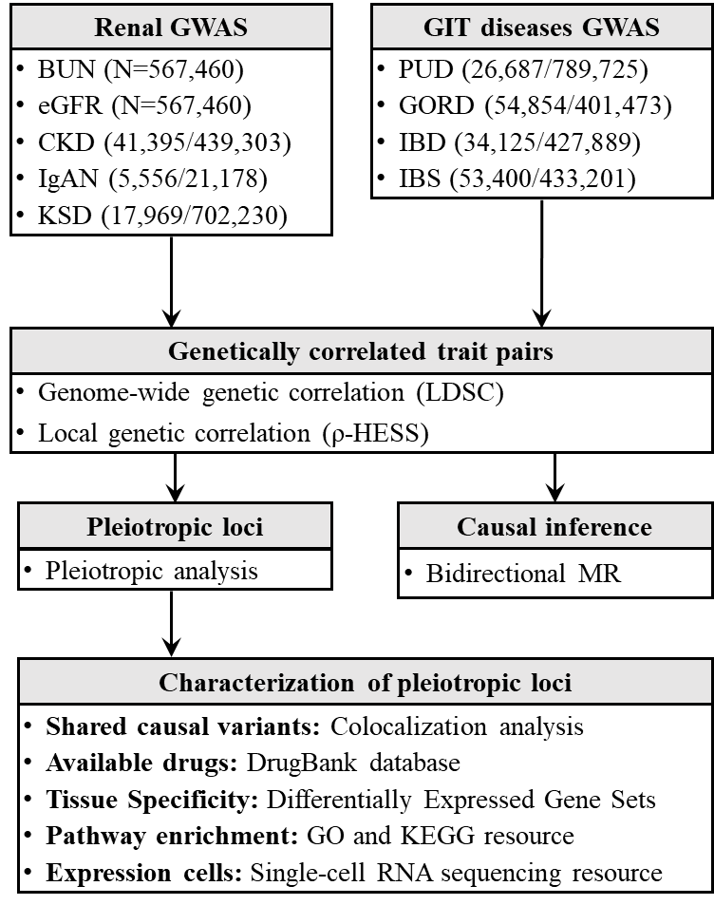
Figure S1. Study design.
Abbreviations: BUN, Blood urea nitrogen; eGFR, Estimated glomerular filtration rate; CKD, Chronic kidney disease; IgAN, IgA nephropathy; GIT, gastrointestinal tract; PUD, peptic ulcer disease; GORD, gastro-esophageal reflux disease; IBD, inflammatory bowel disease; IBS, irritable bowel syndrome; GO, Gene Ontology; KEGG, Kyoto Encyclopedia of Genes and Genomes; MR, Mendelian randomization. For renal function GWASs, the total sample size was indicated as N; for renal disease and GIT disease GWASs, the numbers of cases and controls were present in the bracket.
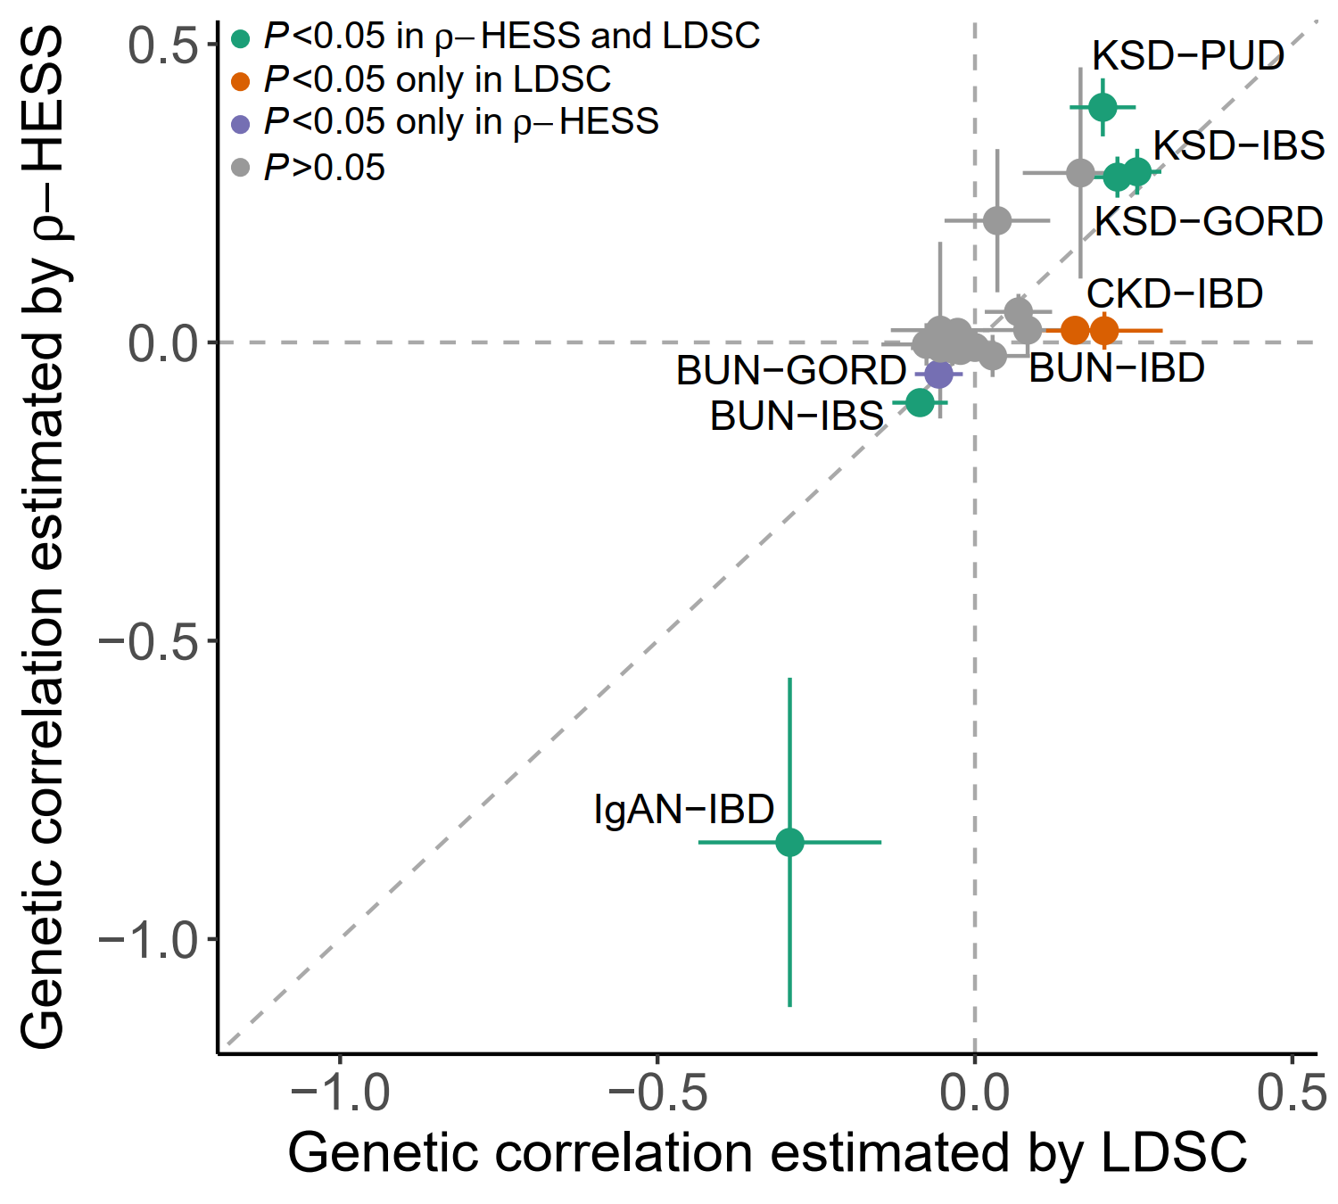
Figure S2. Genetic correlations from LD score regression analyses and 𝝆-HESS. Genetic correlations between renal and GIT diseases. Four correlated trait pairs were identified by LDSC and ρ-HESS (green); one correlated trait pairs was identified only by ρ-HESS (orange); one trait pairs was identified only by LDSC (purple); one trait pairs was with P>0.05 (grey). The horizontal and vertical dashed lines indicate the genetic correlation is 0; the slope of the diagonal dashed line is 1.
Abbreviations: BUN, Blood urea nitrogen; CKD, Chronic kidney disease; IgAN, IgA nephropathy; PUD, peptic ulcer disease; GORD, Gastro-oesophageal Reflux Disease; IBD, Inflammatory bowel disease; IBS, irritable bowel syndrome.

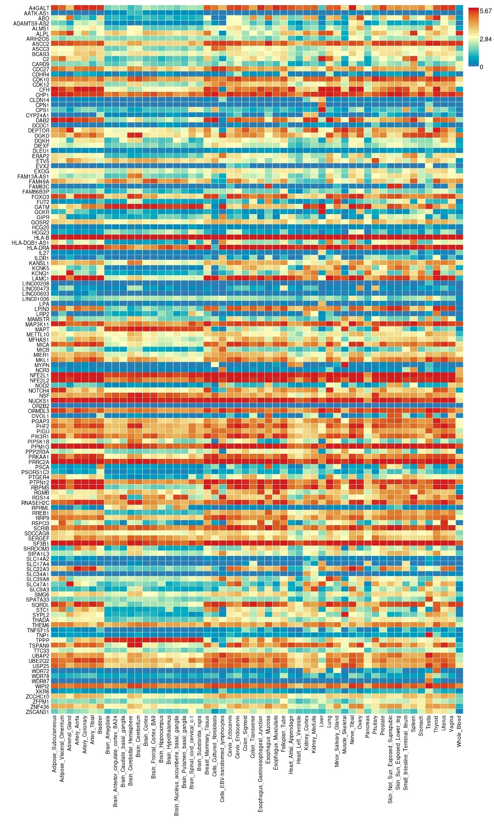
Figure S3. Gene Expression Heatmap for 169 Candidate Pleiotropic Genes. The x-axis corresponds the GTEx v8 54 tissue types, and the y-axis is the pleiotropic genes recognized in GTEx dataset. Cells filled in red represent compared to cells filled in blue across genes and labels.
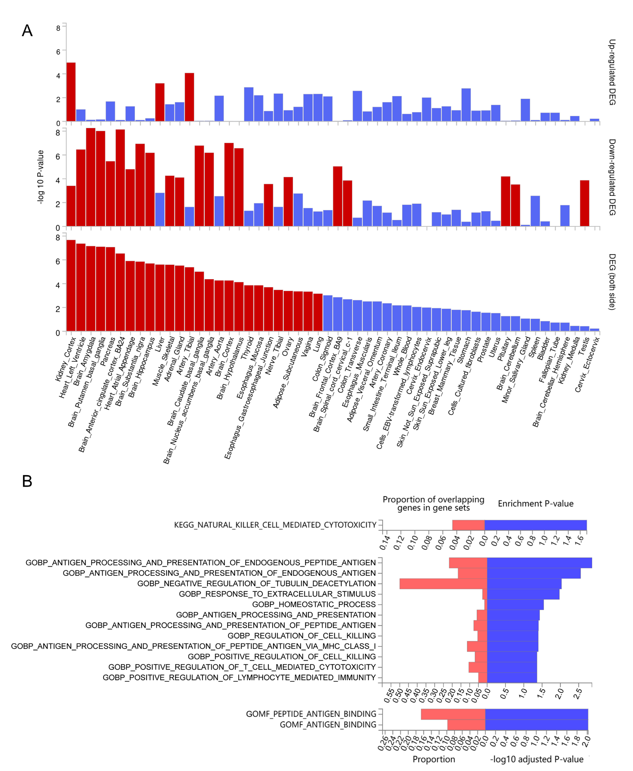 Figure S4. Tissue and Pathway Specificity for Candidate Pleiotropic Genes. (A) The x-axis corresponds the GTEx v8 54 tissues, and the y-axis is the -log10 one-sided P values of the DEG Tissue specificity test. Tissues are ordered by two-side DEG P-value. Significant enrichment at Bonferroni corrected P-value ≤ 0.05 are colored in red. (B) Hypergeometric tests are performed to test if pleiotropic genes of interest are overrepresented in any of the gene sets in KEGG and GO Resource.
Abbreviations: KEGG, Kyoto Encyclopedia of Genes and Genomes; GO, Gene Ontology; GOBP, GO biological processes; GOMF, GO molecular functions;
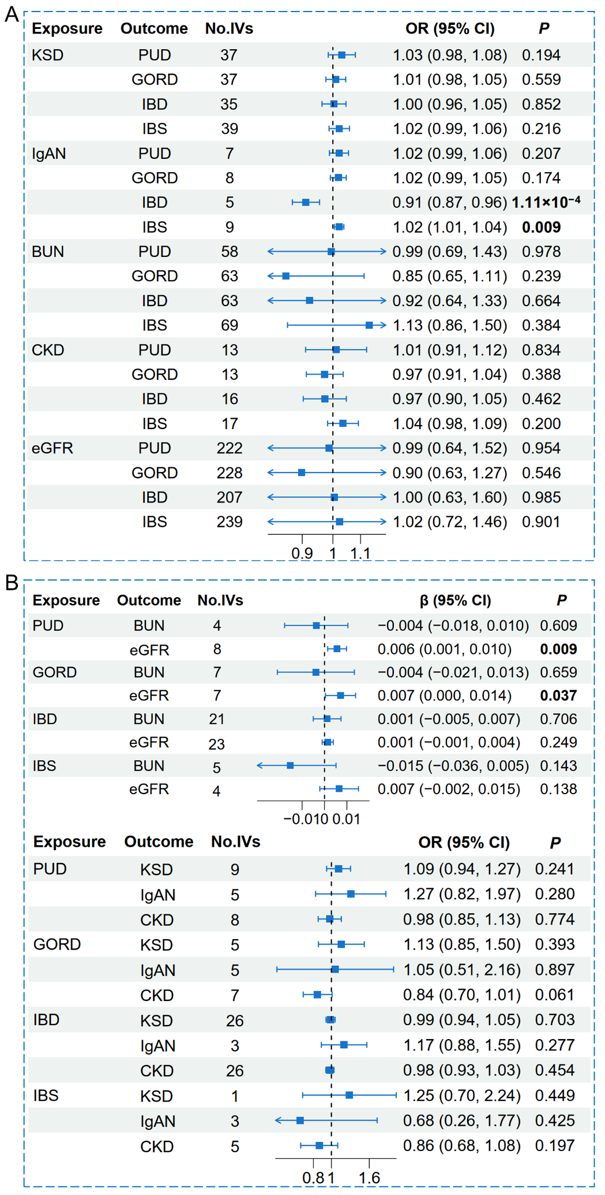
Figure S5. Bidirectional Mendelian randomization by inverse-variance weighted method. (A) Causal effects of gastrointestinal tract diseases on renal traits. (B) Causal effects of renal traits on gastrointestinal tract diseases. No.IVs is the number of instrumental variables; β (95% CI) and OR (95% CI) represent the effect size and odds ratio with the corresponding 95% confidence interval. P values of nominal significant causal effect were in bold.

