Appendix.
Data sources: City-level data are compiled from a variety of sources, as described in the text. Here we further provide details and a bibliography of the data and describe how we encoded the variables.
We measure scientific innovation from two sources, scientific figures and patented inventions, respectively from Poggendorff (1863-2004) and Darmstaedter, du Bois-Reymond, and Schaefer (1908).
Poggendorff (1863-2004) covers biographies of European scientists in German language. The first two volumes were published in 1863; after his death a third volume appeared in 1898, covering the period 1858-1883, and a fourth in 1904. From 1912, the Royal Saxon Society of Sciences in Leipzig, now the Saxon Academy of Sciences in Leipzig, was responsible for the continuation of the work. The date of birth and death, place of birth and death and job information of each scientific figure are recorded, as shown in a sample in Figure A.
We also construct an alternative scientific outcomes using recorded inventions and discoveries based on Darmstaedter, du Bois-Reymond, and Schaefer’s Handbuch zur Geschichte der Naturwissenschaften und Technik published in 1908. Darmstaedter, du Bois-Reymond, and Schaefer (1908) covers the major scientific and technological innovations since the antiquity to the beginning of 20th century and was published in 1908. We use the discoveries and inventions between 1800 and 1899 with biographic information on location, the field of activity, and employment, as shown in a sample in Figure B.

Figure A. Biographies of European scientists from Poggendorff (1863)
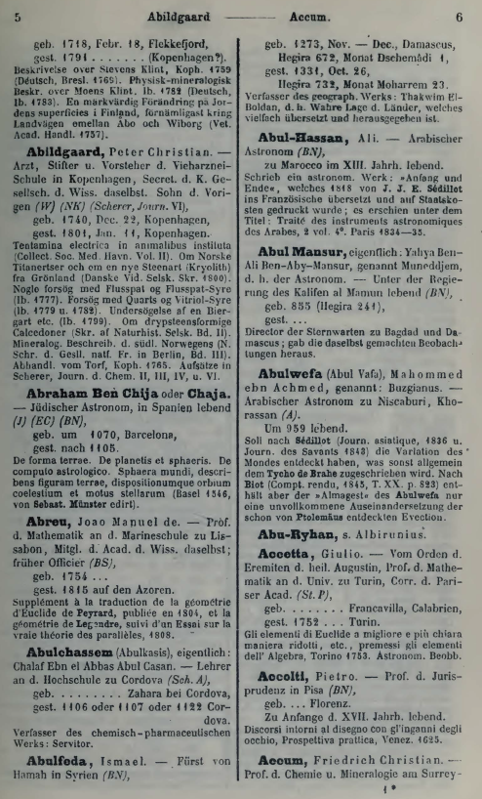

Figure B. Scientific and technological innovations compiled by Darmstaedter, du Bois-Reymond, and Schaefer (1908)
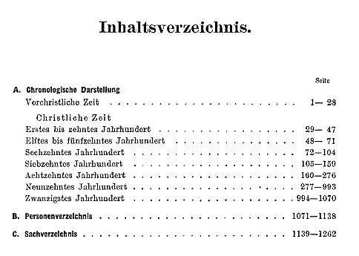
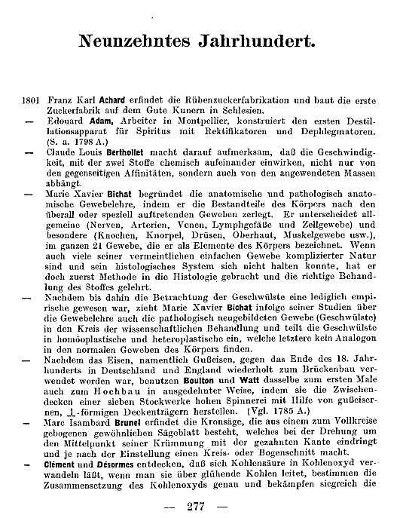
Our data source of the main independent variable is based on the atlas of Châtel and Dollfus (1931). This atlas plots the location of 124 major modern time coalfields within Europe, as shown in Figure C. The spatial distribution of coalfields contained in Châtel and Dollfus (1931), which was digitized by Fernihough and O’Rourke (2020), inverting the distance from each city to the nearest coalfield into a proximity.
We define the carbon variable by inverting the distance from each city to the nearest Carboniferous strata into a proximity. The carboniferous surface data were constructed as in Fernihough and O’Rourke (2020), we exploit data collated by the German Federal Institute for Earth Sciences and Natural Resources (BGR) for the project to map the Geological landscape of Europe, i.e., 1:5 million International Geological Map of Europe and adjacent Areas (Asch, 2005).
In the robustness checks, the historical coal mines from the European Route of Industrial Heritage (https://www.erih.net/) is used. We coded the location of 18th century coalmine, textile and manufacturing factories that emerged as European industrial heritage in our sample (see, e.g., Esposito and Abramson, 2021).

Figure C The location of 124 major modern time coalfields by Châtel and Dollfus (1931)
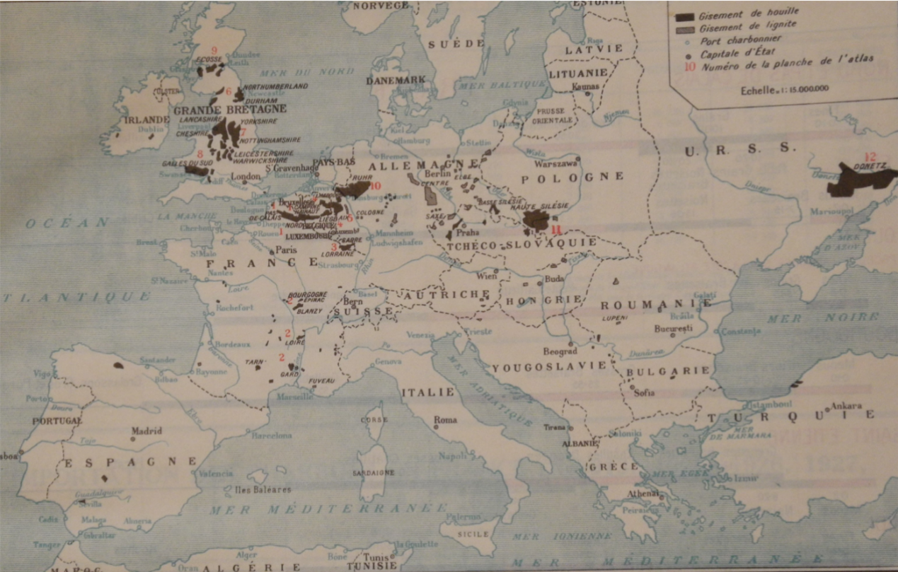

City-level population in 1800 was sourced from the urban population dataset of Bairoch et al (1988), which was derived from https://github.com/JakeRuss/bairoch-1988.
Data on European universities are drawn from Rüegg (1996), which lists all universities in existence between 1500 and 1800. We coded 191 universities that existed in 1800 and use the nearest distance to a university as a measure of the city’s access to higher education.
We use the adoption dummy of Protestant religion at the city level as the control variable. The predominant religion at the city level is sourced from Rubin (2014) and complemented by Herbermann et al. (1913) for our study sample.
The usual geographic controls are added to measure the influence of geographic differences on regression identification, including the distance to the Atlantic, the Mediterranean, all other coasts, primary and secondary rivers. We follow Nunn and Puga (2010) and Nunn and Qian (2011) to control crop suitability of potatoes, wheat and oats, and altitude, and temperature (median and range) were used as additional control variables.

