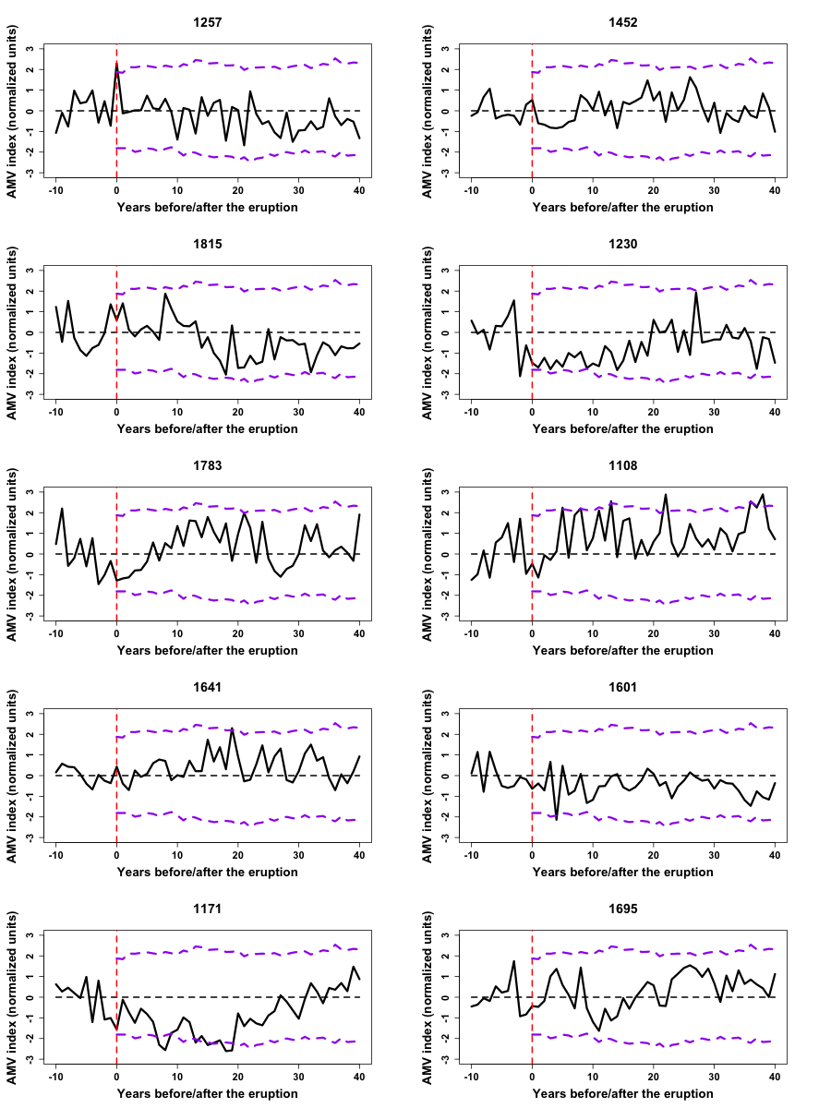
Extended Data Fig. 4 | Individual AMV responses to the largest volcanic eruptions. The year of the corresponding eruption is indicated above each panel. For each panel, the sub-timeseries of the AMV are centered to their average of the 10 years preceding the eruption. Two-tailed 95% confidence levels, calculated using a Monte-Carlo sampling⁴⁷ of length 1000, are given by the dashed purple lines (see Methods).

