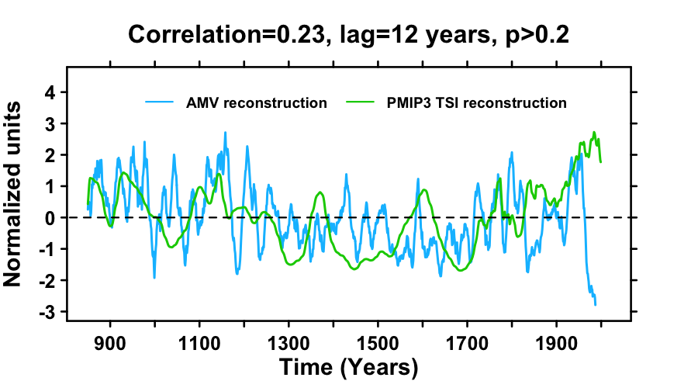
Extended Data Fig. 5 | Comparison of the AMV reconstruction with the PMIP3 TSI reconstruction⁴⁸. Units have been normalized.

