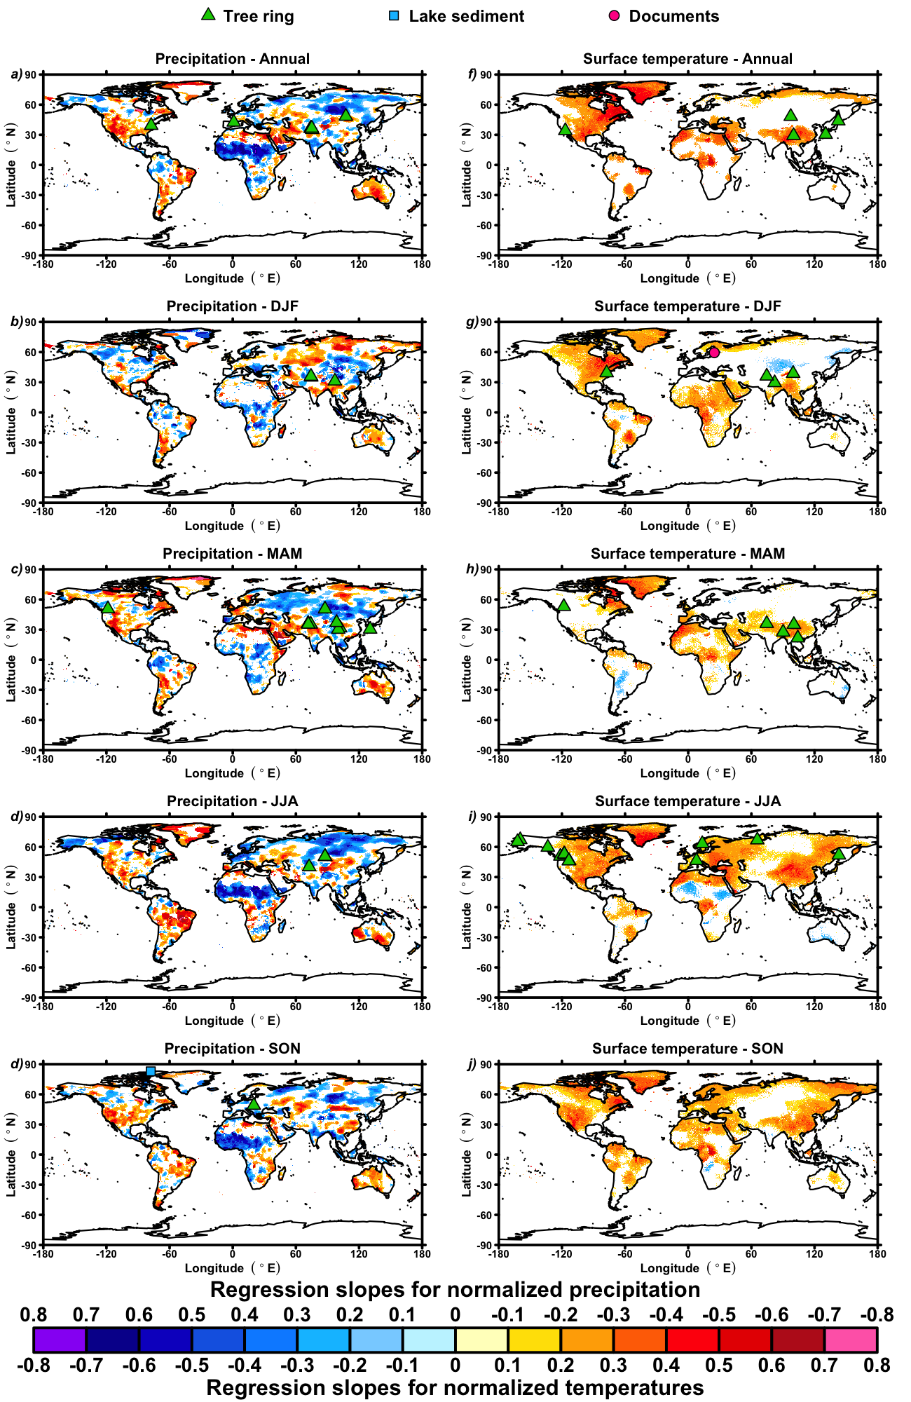
Extended Data Fig. 3 | Location of proxy records and AMV climate fingerprint. Same regression maps as Fig. 1 but with the location of the 54 (out of 55) terrestrial proxy records used for the reconstruction presented in this study.

