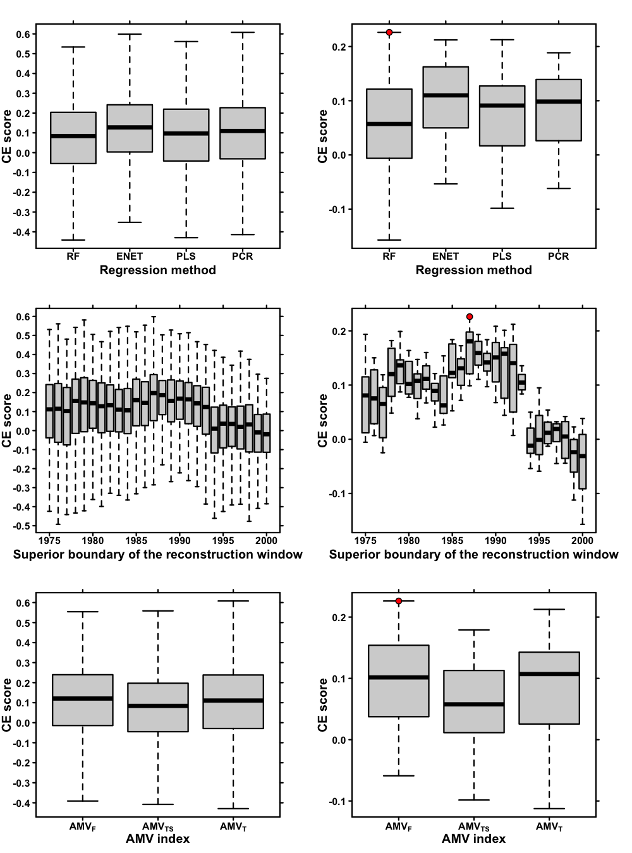
Extended Data Figure 2 | Score by level of inputs for the 496 reconstructions. Coefficient of Efficiency³⁸ (CE) scores for the 312 reconstructions compared in this study for the different sources of methodological choices (regression method, reconstruction frame and AMV index). a) and b) give the CE scores by regression methods (312/4=78 reconstructions by method). c) and d) give the CE scores by superior boundary of the reconstruction window (312/26=12 final reconstructions by window). e) and f) give the CE scores by AMV index (312/3=104 final reconstructions by index). a), c) and e) give the CE scores for all the training splits (312*30=9,360 scores) b), d) and f) give CE scores for each final reconstruction as the averages of the 30 corresponding individual CE scores (312 average scores). Red dots indicate the highest average score obtained for the particular level of input. For all boxplots, medians are shown as heavy dark lines. Boxplots edges give first and third quartiles. Boxplot “whiskers” give the 10%-90% range. Outliers are not shown. A point from a boxplot is here considered as an outlier when it is outside 1.5 times the interquartile range above the upper quartile and below the lower quartile.

