
Fig. 1 Kappaphycus alvarezii
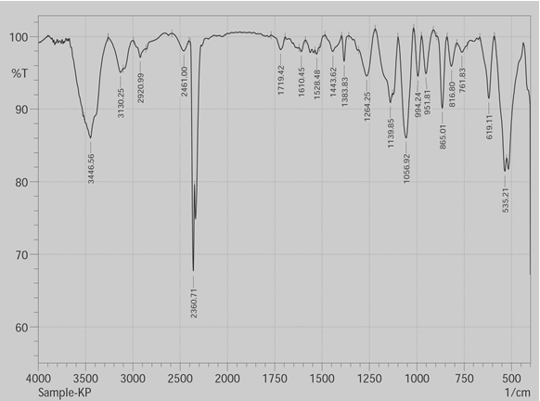
Fig. 2 FT-IR analysis of phycoerythrin

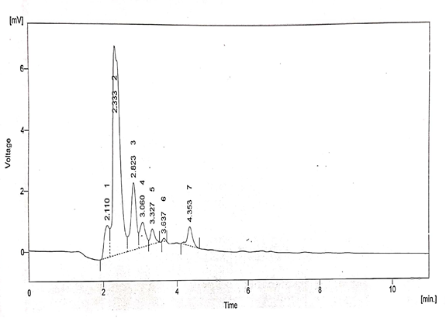
Fig. 3 HPLC analysis of phycoerythrin

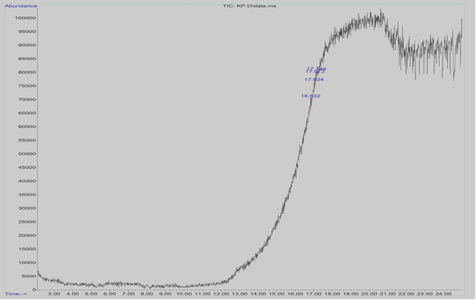
Fig. 4 GC-MS analysis of phycoerythrin
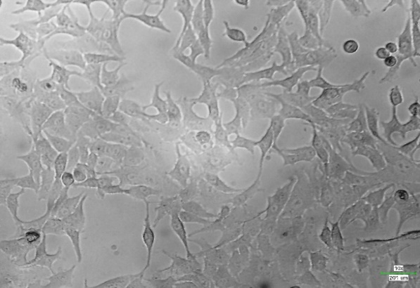
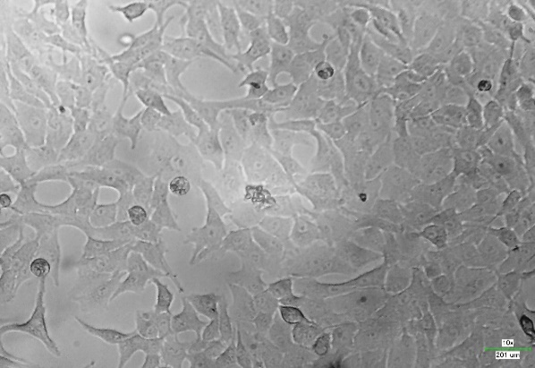

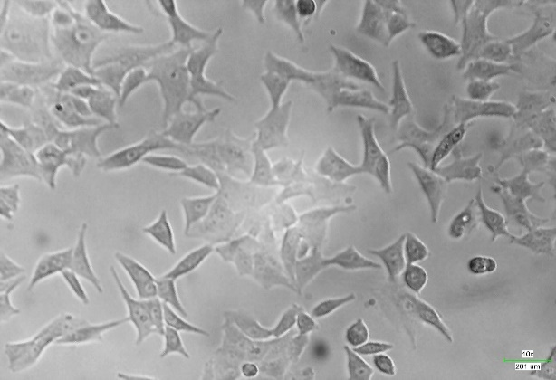
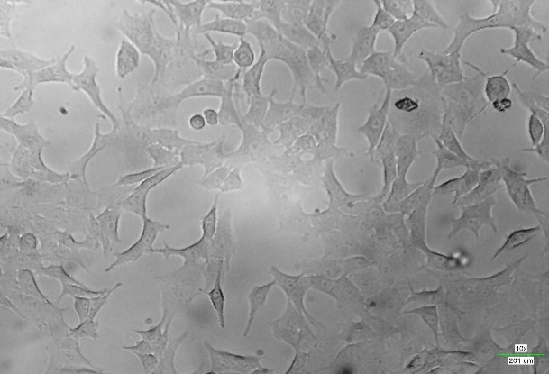
Control cells 50 μg/ml

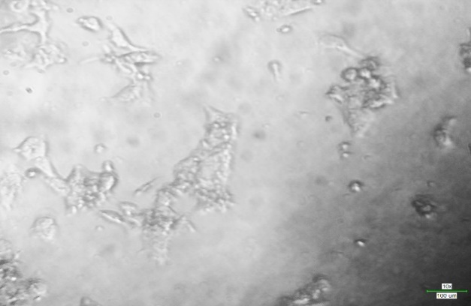
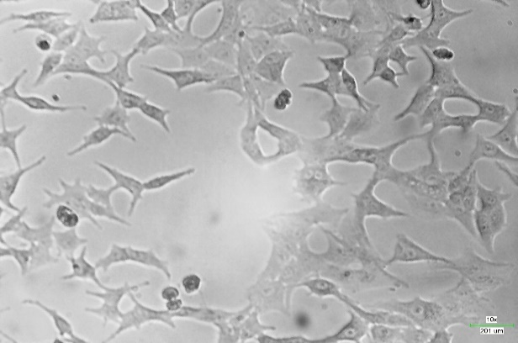
100 μg/ml 200 μg/ml

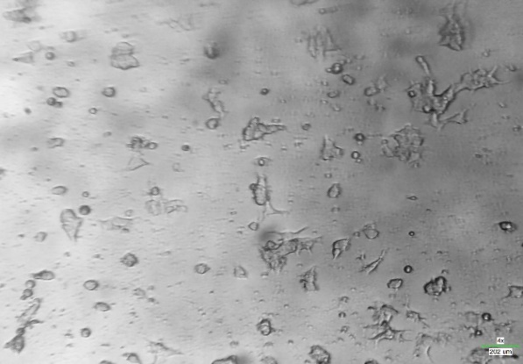
300 μg/ml 400 μg/ml

500 μg/ml
Fig. 5 The morphological view of human lung cancer cells assesses the proliferation of cell inhibitory concentrations (50, 100, 200, 300, 400, and 500 µg mL⁻¹) of phycoerythrin pigment.
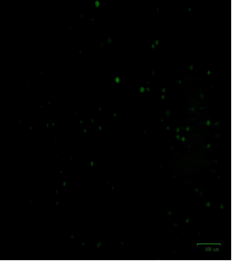
Fig. 6a Phycoerythrin produces programmed cell death in human lung cancer cells. (a) Control cells exhibited a green color, signifying that the cells were alive

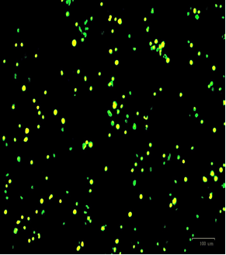
Fig. 6b Phycoerythrin produces programmed cell death in human lung cancer cells. (b) Cells treated with phycoerythrin at a concentration of 203.4 μg mL⁻¹ displayed live cells (green color), dead cells (red color), and apoptotic cells (yellow color).

Fig. 7 The target protein Spore coat polysaccharide biosynthesis protein SpsA docked with the compound of three- and two-dimensional structure such as 1,2-Benzisothiazol-3-amine (a, b), 2-Ethylacridine (c, d), 2,4-Dimethylbenzo[h]quinolone (e, f), 2-bromobutyloxychalcone (g, h) respectively.

Fig. 8 The target protein S. aureus tyrosyl-tRNA synthetase docked with the compound of three- and two-dimensional structure such as 1,2-Benzisothiazol-3-amine (a, b), 2-Ethylacridine (c, d), 2,4-Dimethylbenzo[h]quinoline (e, f), 2-bromobutyloxychalcone (g, h) respectively.

Fig. 9 The target protein Isoleucyl-tRNA synthetase docked with the compound of three- and two-dimensional structure such as 1,2-Benzisothiazol-3-amine (a, b), 2-Ethylacridine (c, d), 2,4-Dimethylbenzo[h]quinoline (e, f), 2-bromobutyloxychalcone (g, h) respectively.

Fig. 10 The target protein Transcriptional regulator qacR docked with the compound of three- and two-dimensional structure such as 1,2-Benzisothiazol-3-amine (a, b), 2-Ethylacridine (c, d), 2,4-Dimethylbenzo[h]quinoline (e, f), 2-bromobutyloxychalcone (g, h) respectively.

Fig. 11 The target protein HTH-Type Transcriptional Regulator MgrA docked with the compound of three- and two-dimensional structure such as 1,2-Benzisothiazol-3-amine (a, b), 2-Ethylacridine (c, d), 2,4-Dimethylbenzo[h]quinoline (e, f), 2-bromobutyloxychalcone (g, h) respectively.

Fig. 12 YcgJ protein from Bacillus subtilis [PDB ID 2GLU] with the compound of three- and two-dimensional structure such as 1,2-Benzisothiazol-3-amine (a, b), 2-Ethylacridine (c, d), 2,4-Dimethylbenzo[h]quinoline (e, f), 2-bromobutyloxychalcone (g, h) respectively.

Fig. 13 The target protein Dihydropteroate synthase docked with the compound of three- and two-dimensional structure such as 1,2-Benzisothiazol-3-amine (a, b), 2-Ethylacridine (c, d), 2,4-Dimethylbenzo[h]quinoline (e, f), 2-bromobutyloxychalcone (g, h) respectively.

Fig. 14 The target protein Processed Glycerol Phosphate Lipoteichoic Acid Synthase 2 docked with the compound of three- and two-dimensional structure such as 1,2-Benzisothiazol-3-amine (a, b), 2-Ethylacridine (c, d), 2,4-Dimethylbenzo[h]quinoline (e, f), 2-bromobutyloxychalcone (g, h) respectively.

Fig. 15 The target protein DNA Gyrase Subunit B, DNA Gyrase Subunit A docked with the compound of three- and two-dimensional structure such as 1,2-Benzisothiazol-3-amine (a, b), 2-Ethylacridine (c, d), 2,4-Dimethylbenzo[h]quinoline (e, f), 2-bromobutyloxychalcone (g, h) respectively.
Fig. 16 The target protein DNA topoisomerase 4 subunit A docked with the compound of three- and two-dimensional structure such as 1,2-Benzisothiazol-3-amine (a, b), 2-Ethylacridine (c, d), 2,4-Dimethylbenzo[h]quinoline (e, f), 2-bromobutyloxychalcone (g, h) respectively.
Fig. 17 The target protein Dihydrofolate reductase docked with the compound of three- and two-dimensional structure such as 1,2-Benzisothiazol-3-amine (a, b), 2-Ethylacridine (c, d), 2,4-Dimethylbenzo[h]quinoline (e, f), 2-bromobutyloxychalcone (g, h) respectively.
Fig. 18 The target protein Penicillin-binding protein 3 docked with the compound of three- and two-dimensional structure such as 1,2-Benzisothiazol-3-amine (a, b), 2-Ethylacridine (c, d), 2,4-Dimethylbenzo[h]quinoline (e, f), 2-bromobutyloxychalcone (g, h) respectively.

Fig. 19 The target protein Transcriptional regulator MvfR docked with the compound of three- and two-dimensional structure such as 1,2-Benzisothiazol-3-amine (a, b), 2-Ethylacridine (c, d), 2,4-Dimethylbenzo[h]quinoline (e, f), 2-bromobutyloxychalcone (g, h) respectively.

