Supporting Information for:
Intrinsic Zero-Linear and Zero-Area Compressibility over an Ultra-Wide Pressure Range within a “Gear-Spring” Structure
Dequan Jiang¹, Ting Wen¹*, Huimin Song², Zimin Jiang¹, Chen Li¹, Ke Liu¹, Wenge Yang¹, Ho-kwang Mao¹ and Yonggang Wang¹*
¹Center for High Pressure Science and Technology Advanced Research (HPSTAR), Beijing 100094, China
²Center of Materials Science and Optoelectronics Engineering, University of Chinese Academy of Sciences, Beijing 100049, China
Emails: ting.wen@hpstar.ac.cn, yonggang.wang@hpstar.ac.cn

Content
Table S1 The cell parameters obtained from the high-pressure XRD patterns.
Fig. S1 Rietveld refinement of Li₂Ti(IO₃)₆ under ambient pressure with the space group of P6₃, cell parameters a = b = 9.372 Å, c = 5.113 Å.
Fig. S2 The parallel manner of the lone pairs on I cations. The purple, red and green balls represent I, O and Ti atoms, respectively.
Fig. S3 The XRD patterns of the recovered sample and the sample at 0.7 GPa.
Fig. S4 The shifts of (2$\overline{1}$0), (2$\overline{1}$1), and (300) Bragg peaks under compression.
Fig. S5 The linear compressibilities calculated by the empirical function l = l₀ + λ (p - p_{c})^{υ} in the regions of (a) 0-8 GPa, (b) 8-18.9 GPa, (c) 18.9-40.2 GPa, and (d) 0-18.9 GPa.
Fig. S6 The linear and area compressibilities as a function of applied pressure calculated by the formula K_{l} = -Δl/lΔp, K_{s} = -Δs/sΔp.
Fig. S7 (a) High-pressure Raman spectra of Li₂Ti(IO₃)₆ at selected pressures. (b) Pressure-dependence of the Raman peak positions in the wavenumber range of 400-850 cm⁻¹.
Fig. S8 (a) The SHG intensity as a function of applied pressure. (b) The relative value of cell parameter c as a function of applied pressure.

Table S1. The cell parameters obtained from the high-pressure XRD patterns.

P (GPa) | a (Å) | b (Å) | c (Å)
0.7 | 9.353 | 9.353 | 5.019
1.7 | 9.33 | 9.33 | 4.977
2.4 | 9.313 | 9.313 | 4.933
3.2 | 9.302 | 9.302 | 4.891
4.1 | 9.288 | 9.288 | 4.842
5 | 9.279 | 9.279 | 4.8
6 | 9.265 | 9.265 | 4.755
7.1 | 9.259 | 9.259 | 4.696
8 | 9.259 | 9.259 | 4.632
9.2 | 9.261 | 9.261 | 4.548
10.6 | 9.267 | 9.267 | 4.48
12.1 | 9.281 | 9.281 | 4.386
13.6 | 9.295 | 9.295 | 4.285
15.4 | 9.326 | 9.326 | 4.161
16.7 | 9.346 | 9.346 | 4.081
17.8 | 9.378 | 9.378 | 3.983
18.9 | 9.395 | 9.395 | 3.921
20.1 | 9.394 | 9.394 | 3.856
22 | 9.384 | 9.384 | 3.813
24.6 | 9.367 | 9.367 | 3.762
26.1 | 9.352 | 9.352 | 3.721
28.4 | 9.336 | 9.336 | 3.693
31.9 | 9.324 | 9.324 | 3.679
34.6 | 9.311 | 9.311 | 3.666
36.6 | 9.293 | 9.293 | 3.653
38.5 | 9.29 | 9.29 | 3.652
40.2 | 9.281 | 9.281 | 3.646

Fig. S1 Rietveld refinement of Li₂Ti(IO₃)₆ under ambient pressure with the space group of P6₃, cell parameters a = b = 9.372 Å, c = 5.113 Å.

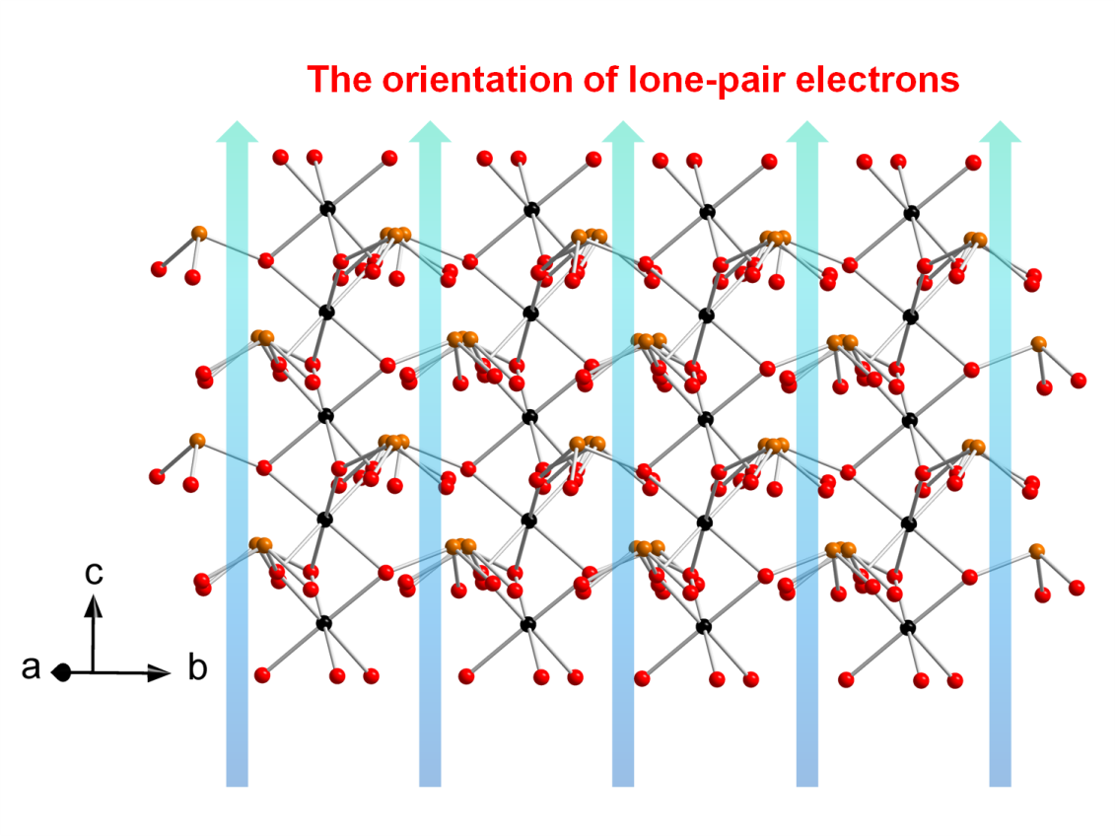
Fig. S2 The parallel manner of the lone pairs on I cations. The brown, red and black balls represent I, O and Ti atoms, respectively.

Fig. S3 The XRD patterns of the recovered sample and the sample at 0.7 GPa.

Fig. S4 The shifts of (2$\overline{1}$0), (2$\overline{1}$1), and (300) Bragg peaks under compression.
Fig. S5 The linear compressibilities calculated by the empirical function l = l₀ + λ (p - p_{c})^{υ} in the regions of (a) 0-8 GPa, (b) 8-18.9 GPa, (c) 18.9-40.2 GPa, and (d) 0-18.9 GPa.

Fig. S6 The linear and area compressibilities as a function of applied pressure calculated by the formula K_{l} = -Δl/lΔp, K_{s} = -Δs/sΔp.
Fig. S7 (a) High-pressure Raman spectra of Li₂Ti(IO₃)₆ at selected pressures. (b) Pressure-dependence of the Raman peak positions in the wavenumber range of 400-850 cm⁻¹.

Fig. S8 (a) The SHG intensity as a function of applied pressure. (b) The relative value of cell parameter c as a function of applied pressure.

