Supplementary materials to:
Depression and anxiety symptom change during psychological therapy for autistic clients: Evidence from national healthcare records in England

Contents
Appendix A: The NHS Talking Therapies for Anxiety and Depression services (TTad), previously named Improving Access to Psychological Therapies (IAPT) 18
Appendix B: Measurement and the MODIFY dataset 19
Appendix C: Study flow diagram 22
Appendix D: Primary outcome measures: Distribution and missing data 23
Appendix E: Fit indices 27
Appendix F: Latent Growth Curve Models (LGCM) 28
Appendix G: Latent Class Growth Analyses (LCGA) 30
Appendix H: Growth Mixture Models (GMM) 32
Appendix I: Characteristics of GMM Latent Trajectory Classes 38
Appendix J: Sensitivity Analysis – Multinomial logistic regression (including WSAS employment subscale) 40
Appendix K: Guidelines for Reporting on Latent Trajectory Studies (GRoLTS) Checklist(17) 43
Appendix L: The REporting of studies Conducted using Observational Routinely-collected Data (RECORD) Checklist(21) 45
References 50

Appendix A: The NHS Talking Therapies for Anxiety and Depression services (TTad), previously named Improving Access to Psychological Therapies (IAPT)

Detailed information about the TTad treatment procedure is available in the IAPT manual (National Collaborating Centre for Mental Health [NCCMH], 2018). TTad follows a stepped-care model.
Service users included in the dataset were initially seen for an assessment to ascertain the primary presenting problem. Following this, individuals with mild to moderate levels of difficulty were commonly offered low-intensity (short-term, guided self-help) intervention in individual or group format. Where clients did not respond to this treatment, or where initial presenting difficulties showed greater severity or complexity, they were offered a high-intensity treatment (16-20 session individual evidence-based therapy), as outlined in Table 1 below.
Table 1: The TTad stepped-care model
Intervention step within stepped-care model | Condition | Intervention
Step 1: Assessment |  | Recognition of problem  Assessment / watchful waiting
Step 2: Low-intensity interventions | Mild-moderate:  - Depression  - Panic disorder  - Generalised Anxiety Disorder (GAD)  - Obsessive Compulsive Disorder (OCD) | - Computerised Cognitive Behavioural Therapy (cCBT), guided self-help, Behavioural Activation (BA) and exercise  - cCBT, guided self-help, pure self-help  - cCBT, guided self-help, psycho-education groups, pure self-help  - Guided self-help
Step 3: High-intensity interventions | Moderate-severe (and mild-moderate if no improvement at Step 2):  - Depression  - Panic Disorder  - GAD  - Social phobia (mild-severe)  - Post-traumatic stress disorder (PTSD) (mild-severe)  - OCD | - CBT, Interpersonal Therapy (IPT), BA, Dynamic Interpersonal Therapy (DIT), couples’ therapy and counselling for depression  - CBT  - CBT  - CBT  - CBT, Eye Movement Desensitisation and Reprocessing (EMDR)  - CBT

Appendix B: Measurement and the MODIFY dataset

The TTad dataset includes routinely collected data for all service users seen in IAPT services across England between 2012 and 2019. For each person, it includes demographic information, and information on the intervention received (e.g., dates seen, treatment delivered and measures collected). At each treatment appointment, service users were asked by clinical staff to complete a set of standardised measures that includes the Generalized Anxiety Disorder Assessment-7 (GAD-7; Spitzer, Kroenke, & Williams, 2006), the Patient Health Questionnaire-9 (PHQ-9; Kroenke, Spitzer, & Williams, 2001) and the Work and Social Adjustment Scale (WSAS; Mundt et al., 2002).
The Hospital Episode Statistics (HES) dataset includes individual-level data from care records for inpatient, outpatient and Accident and Emergency (A&E) treatment from all National Health Service (NHS) hospitals across England. It includes demographic, geographical, administrative and clinical information (NHS Digital, 2019).
The Mental Health Services Dataset (MHSDS) includes individual-level data from secondary care services (i.e., outpatient and community specialist services), and includes diagnostic codes relating to mental health conditions and neurodevelopmental conditions (including autism and Intellectual Disability) (NHS Digital, 2024)
The Hospital Episode Statistics-Office of National Statistics (HES-ONS) dataset linked information from the HES and Office of National Statistics (ONS) mortality data. It includes individual-level information about the cause, date and place of death (NHS Digital, 2023).
Data from HES, MHSDS and HES-ONS were only retrieved for individuals with TTad data available. All data were fully anonymised, and linkage was achieved using anonymised subject identifiers provided by NHS Digital.
Measurement information for variables from MODIFY used in the present study are shown in Table 2.
Table 2: Information on variables and measures
Measure | Source | Information
Primary outcome measures
Patient Health Questionnaire-9 (PHQ-9) (Kroenke, Spitzer, & Williams, 2001) | TTad | The PHQ-9 is a 9-item depression screening tool and questionnaire, rated using a Likert scale (0-3). The PHQ-9 was routinely collected at each appointment. The PHQ-9 has been used extensively in general population research and in clinical settings, with good validity and reliability (Kroenke et al., 2001).
Generalized Anxiety Disorder Assessment-7 (GAD-7) (Spitzer, Kroenke, & Williams, 2006) | TTad | The GAD-7 is a 7-item screening tool and questionnaire for Generalised Anxiety Disorder (GAD), rated using a Likert scale (0-3), and was routinely collected at each appointment. The GAD-7 has shown good reliability and validity, excellent internal consistency, and good sensitivity and specificity in detecting clinical anxiety (Spitzer et al., 2006).
Secondary outcome measures
Work and Social Adjustment Scale (WSAS) (Mundt et al., 2002) | TTad | The WSAS is a 5-item questionnaire assessing impact on i) work, ii) home management, iii) social leisure activities, iv) private leisure activities and v) close relationships. It is rated on a Likert scale (0-8), and was routinely collected at each appointment. It has shown good test-retest reliability and internal consistency, and is sensitive to disorder severity and treatment-related change (Mundt et al., 2002). In TTad, clients are instructed to answer “N/A” (not applicable) to question i) (work) if they are retired or unemployed. Hence in the present study, this subscale was excluded and total WSAS scores were computed from questions 2-5 (more below).
Demographic and clinical variables
Age | TTad, HES, MHSDS | Calendar age in years, at the point at which the referral was received.
Gender | TTad, HES, MHSDS | A binary variable, identified by the service user (male/female).
Ethnicity | TTad, HES, MHSDS | A binary variable (White, ethnically minoritised), created from a range of categories identified by the service user due to low cell counts in many categories.
Intellectual disability | MHSDS | A binary variable, identified from relevant MHSDS ICD-10 codes (yes/no).
Employment | TTad, HES, MHSDS | A binary variable (in employment, not in employment), created from a range of categories identified by the service user
Psychotropic medication | TTad, HES, MHSDS | A binary variable (taking psychotropic medication, not taking psychotropic medication), identified by the service user
Long-term health condition | TTad, HES, MHSDS | A binary variable (has a long-term health condition, does not have a long-term health condition), identified by the service user and healthcare records
Recovery metrics
Reliable improvement | TTad | A binary variable, calculated to indicate whether reduction in PHQ-9 or GAD-7 scores between first and last measurement points exceeds the error threshold for the measurement scale (PHQ-9 change > 5; GAD-7 change > 3).
Reliable recovery | TTad | A binary variable, calculated to indicate the presence of i) reliable improvement and ii) the final measurement score is below the “caseness” threshold for the measure.
Reliable deterioration | TTad | A binary variable, calculated to indicate the inverse of reliable improvement, i.e., increase in scores between first and last measurement points that exceeds the error threshold for the measure.

Ethnicity
Ethnicity needed to be treated as a binary variable for R3Step analyses, due to small cell counts in a number of categories as shown below (Table 3).
Table 3: Ethnicity data
Office for National Statistics Ethnicity Category | Frequency (N) | Percent (%)
White | 6,107 | 93.97
Mixed | 145 | 2.23
Asian | 135 | 2.08
Black | 85 | 1.31
Chinese | 5 | .08
Other | 22 | .34

PHQ-9 and GAD-7: Days between baseline and timepoints 2-8
PHQ-9 and GAD-7 measurements are attempted at each session in an TTad setting. The TTad dataset contains data for up to 30 measurements. In this study, 8 timepoints were modelled.
The date of the first and last appointments were available, and therefore were used to generate the number of days in treatment for each participant. Dividing this by the number of sessions received created an estimate of the average time between sessions for each participant (Table 4).
Table 4: Days between baseline and timepoints 2-8 (PHQ-9, GAD-7)
 | Mean (SD) | Median (IQR) | Range
Days between sessions | 20·48 (13·94) | 17 (11·86 – 24·61) | 2 – 133·5
Days between baseline and timepoint 8 | 163·84 (111·52) | 136 (94·86 – 196·89) | 16 - 1,796

WSAS
The WSAS total score constitutes a measure of functional impairment (difficulties with daily living tasks), comprising employment, home management, social leisure activities, private leisure activities and close relationships (Mundt et al., 2002). In TTad settings, clients who are retired or not in employment are instructed to mark the employment subscale as “N/A” (not applicable), coded “9” in the TTad dataset (NCCMH, 2018). Table 4 shows that in the present sample, N>1,000 participants coded the employment question as “not applicable.” For this reason and in keeping with prior research using TTad data (Barnett et al., 2023; Saunders et al., 2019; Skelton et al., 2023), the WSAS data used in this study excluded the employment subscale. Total scores were computed by summing home management, social leisure, private leisure and close relationship subscales. Sensitivity analyses that included the employment subscale were conducted and reported in Appendix J.
Table 5: Missing and N/A subscale data: WSAS (N = 7,175)
WSAS subscale | Missing | Coded N/A | N (baseline)
Employment | 2,985 | 1,219 | 2,971
Home management | 2,945 | 6 | 4,224
Social leisure activities | 2,955 | 6 | 4,214
Private leisure activities | 2,949 | 6 | 4,226
Close relationships | 2,947 | 7 | 4,221

Appendix C: Fit indices

Table 6, presented below, reports the range of fit indices designed to test various models, and the thresholds and selection process applied.
Table 6: Fit indices used across various modelling approaches
Index | Step | Information
Root Mean Square Error of Approximation (RMSEA) | LGCM | An absolute fit index, which assesses how far a hypothesised model is from a perfect model· RMSEA values <·05 indicate a good fit, <·08 a reasonable fit and <·10 a mediocre fit (Browne & Cudeck, 1992).
Comparative Fit Index (CFI), Tucker-Lewis Index (TLI) | LGCM | The CFI and TLI are incremental fit indices, which compare the fit of a hypothesised model with that of a baseline model. CFI and TLI values >·95 indicates a good fit and >·90 an acceptable fit (Hu & Bentler, 1999).
Standardised Root Mean Square Residual (SRMR) | LGCM | A measure of the mean absolute correlation residual. SRMR values <·05 indicates a good fit, and <·08 a reasonable fit (Hu & Bentler, 1999).
Bayesian Inference Criteria (BIC), Sample Size-Adjusted BIC (SA-BIC) | LGCM, LCGA, GMM | The BIC and SABIC use the log likelihood value, and penalise based on the number of parameters. The SABIC also penalises based on the sample size. BIC and SABIC are commonly used to compare growth mixture models with increasing class numbers, and the model with the lowest value would typically be deemed optimal (Nylund, Asparouhov, & Muthén, 2007).
Vuong-Lo-Mendell-Rubin Likelihood Ratio Test (VLMR-LRT), Lo-Mendell-Rubin Adjusted Likelihood Ratio Test (LMR-A LRT), Bootstrap Likelihood Ratio Test (BLRT) | LCGA, GMM | The VLMR-LRT, LMR-A-LRT and BLRT compare the ratio of log-likelihoods for a k-class model with the k-1 class model, and report a significance test to clarify whether the addition of the kth class made an improvement (Grimm, Mazza, & Davoudzadeh, 2017).
Key: LGCM = Latent Growth Curve Model; LCGA = Latent Class Growth Analysis; GMM = Growth Mixture Model

Appendix D: Study flow diagram

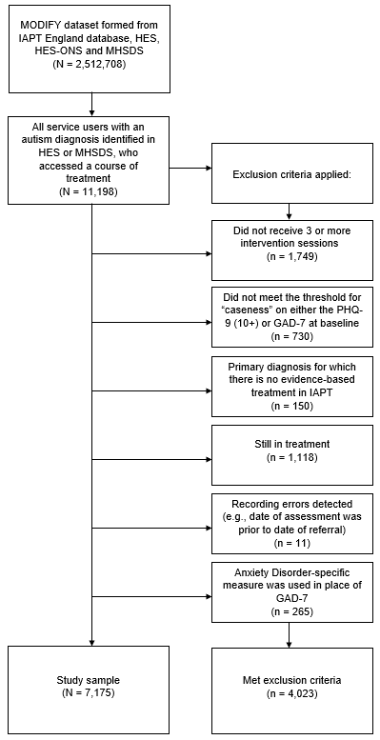
Figure 1: Study flow diagram

Appendix E: Primary outcome measures: Distribution and missing data

The distribution of the PHQ-9 and GAD-7 is described in Table 6 and Q-Q plots are presented below (Figure 1, Figure 2). Data were negatively skewed and leptokurtic but skewness and kurtosis were judged to fall within reasonable bounds.
Table 7: Distributions (PHQ-9 and GAD-7)
Variable | N | Mean (SD) | Median (IQR) | Skewness | Kurtosis | Doornik-Hansen  χ² (p)
PHQ-9:
t1 | 6,969 | 16·75 (5·41) | 17 (13-21) | -·28 | 2·58 | 237·11 (<·01)
t2 | 6,946 | 15·66 (5·91) | 16 (12-20) | -·26 | 2·53 | 227·65 (<·01)
t3 | 6,919 | 14·55 (6·28) | 15 (10-19) | -·13 | 2·31 | 230·14 (<·01)
t4 | 5,998 | 13·69 (6·48) | 14 (9-18) | ·00 | 2·25 | 190·19 (<·01)
t5 | 5,157 | 13·20 (6·58) | 13 (8-18) | ·05 | 2·26 | 161·24 (<·01)
t6 | 4,308 | 12·90 (6·65) | 13 (8-18) | ·11 | 2·22 | 173·30 (<·01)
t7 | 3,485 | 12·72 (6·75) | 12 (7-18) | ·14 | 2·17 | 168·27 (<·01)
t8 | 2,756 | 12·81 (6·73) | 12 (8-18) | ·15 | 2·22 | 121·74 (<·01)
GAD-7:
t1 | 6,966 | 14·77 (4·32) | 15 (12-18) | -·53 | 2·74 | 682·27 (<·01)
t2 | 6,944 | 13·81 (4·94) | 14 (10-18) | -·48 | 2·53 | 723·48 (<·01)
t3 | 6,919 | 12·84 (5·35) | 13 (9-17) | -·31 | 2·23 | 542·44 (<·01)
t4 | 6,002 | 12·10 (5·54) | 12 (8-17) | -·16 | 2·06 | 407·05 (<·01)
t5 | 5,162 | 11·59 (5·65) | 12 (7-16) | -·09 | 2·05 | 313·32 (<·01)
t6 | 4,311 | 11·30 (5·70) | 11 (7-16) | -·02 | 2·03 | 252·65 (<·01)
t7 | 3,490 | 11·09 (5·78) | 11 (7-16) | -·01 | 2·01 | 218·54 (<·01)
t8 | 2,758 | 11·10 (5·79) | 11 (7-16) | ·00 | 2·02 | 168·05 (<·01)

Figure 2: Q-Q Plots: PHQ-9 (t1- t8)
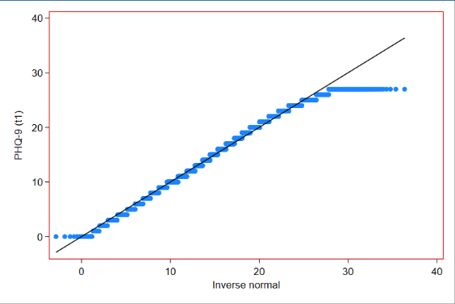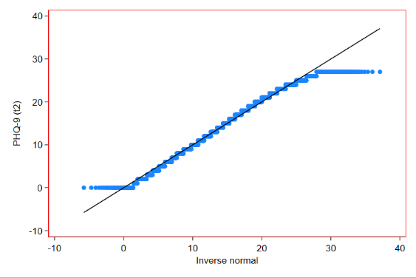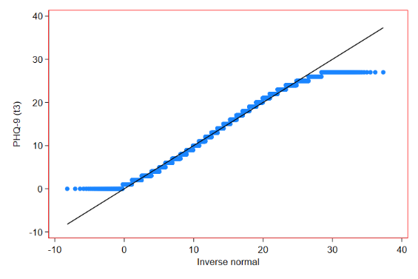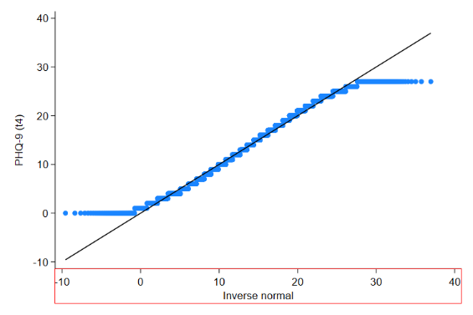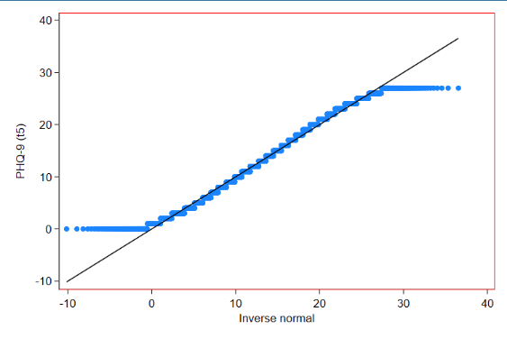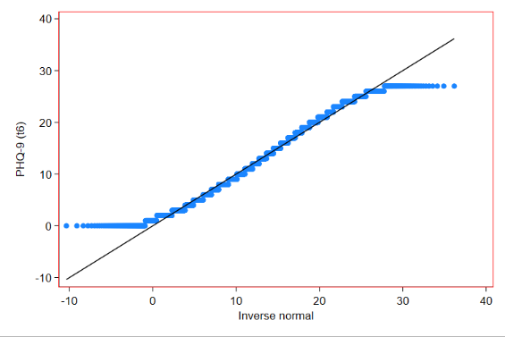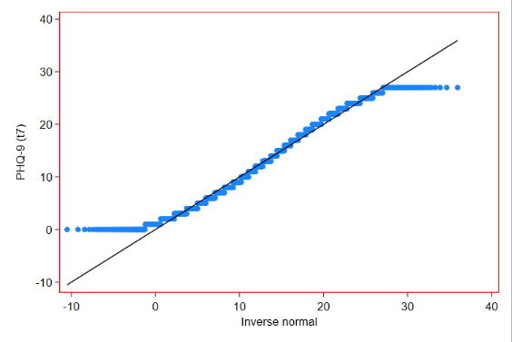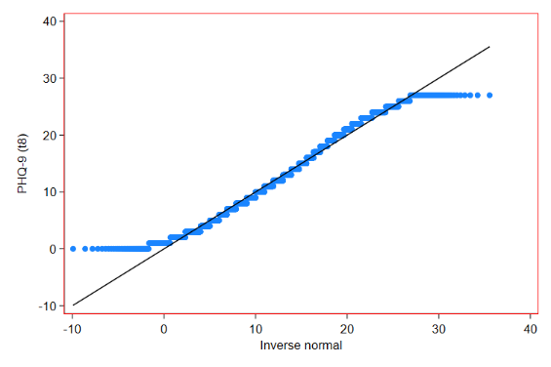

Figure 3: Q-Q Plots: GAD-7 (t1-t8)
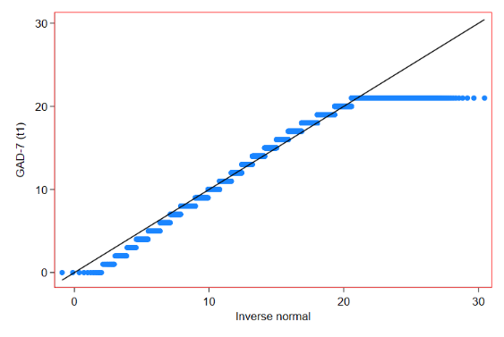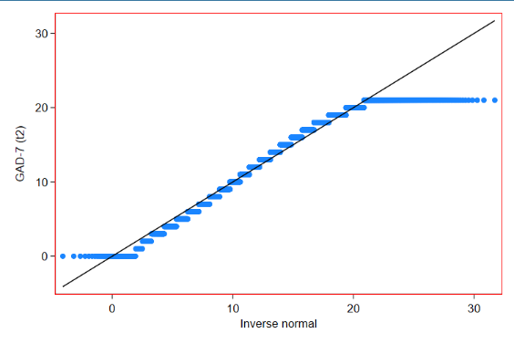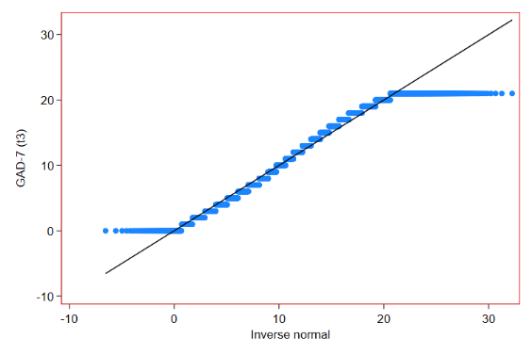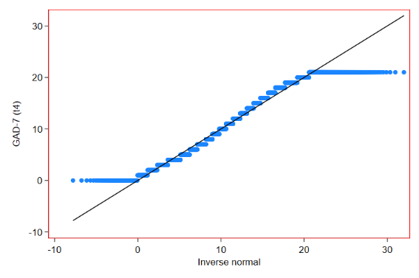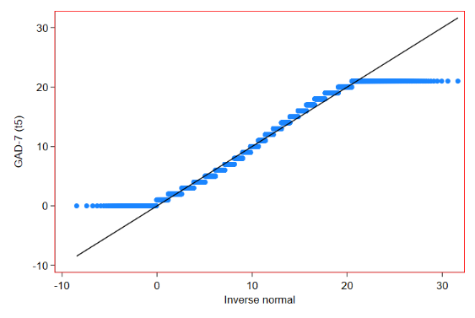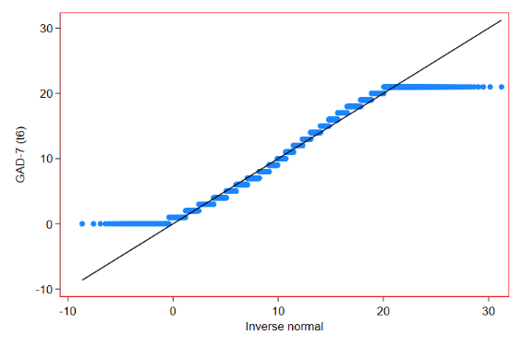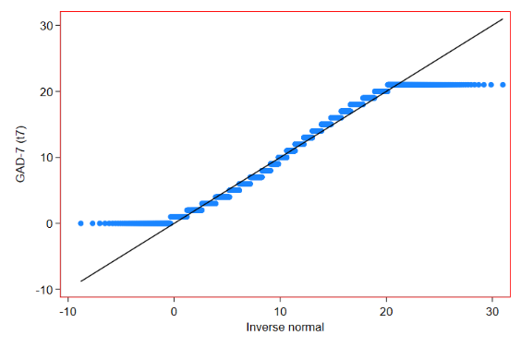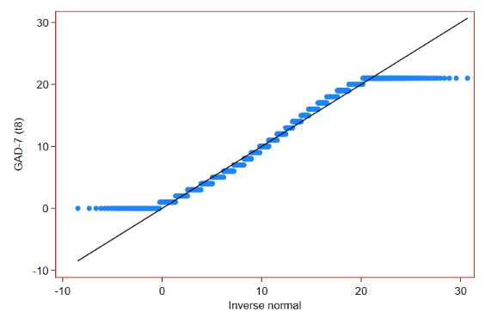
Missing data mechanism
Using STATA, variables were created to represent data missingness for PHQ-9 and GAD-7 at baseline and at the final timepoint (t8). Logistic regression models were fitted for these new variables, with gender, ethnicity, employment status, primary diagnosis, long-term health conditions and Intellectual Disability as covariates. Odds Ratios revealed that no covariates were significantly related to data missingness at baseline, but ethnically-minoritised ethnicity was significantly related to greater odds of missing data by the final timepoint (Table 8).
Data were considered to be Missing at Random (MAR), and the increased likelihood of dropout for service users from ethnically-minoritised background was accounted for in subsequent interpretation.
Table 8: Logistic regression of missing data with covariates
Variable | Baseline OR (95% CI) | t8 OR (95% CI)
PHQ-9:
Gender | ·78 (·59 – 1·03) | 1·08 (·98 – 1·19)
Ethnicity | 1·84 (·81 – 4·19) | 1·29 (1·05 – 1·58)
Employment status | ·75 (·53 – 1·04) | ·82 (·74 - ·90)
Primary diagnosis | 1·00 (·98 – 1·03) | ·99 (·98 – 1·00)
Long-term condition | ·71 (·50 – 1·02) | 1·07 (·96 – 1·20)
Intellectual Disability | 1·27 (·59 – 2·72) | ·82 (·65 – 1·05)
GAD-7:
Gender | ·83 (·63 – 1·10) | 1·08 (·98 – 1·19)
Ethnicity | 1·88 (·83 – 4·26) | 1·30 (1·06 – 1·60)
Employment status | ·75 (·53 – 1·04) | ·82 (·74 - ·90)
Primary diagnosis | 1·00 (·97 – 1·02) | ·99 (·98 – 1·00)
Long-term condition | ·76 (·53 – 1·09) | 1·07 (·96 – 1·20)
Intellectual Disability | 1·29 (·61 – 2·76) | ·82 (·65 – 1·05)

Appendix F: Latent Growth Curve Models (LGCM)

Model specifications
Two model specifications were designed, and the syntax is shown below in Figure 4 and Figure 5. In the first of these, time was modelled using fixed intervals between sessions (Figure 4). In the second of these, the assumption of fixed intervals was relaxed after session 2, so that the best-fitting time model could be obtained (Figure 5). Fit indices for LGCM are reported below (Table 9), and graphs are presented for depression (Figure 6) and anxiety (Figure 7).

VARIABLE: | Names = d1 d2 d3 d4 d5 d6 d7 d8 a1 a2 a3 a4 a5 a6 a7 a8 id;  Usevariables = d1 d2 d3 d4 d5 d6 d7 d8;  Idvariable = id;  Missing = all(-9999);
MODEL: | Int Slo | d1@0 d2@1 d3@2 d4@3 d5@4 d6@5 d7@6 d8@7;
Figure 4: Model specification - LGCM (time fixed)

VARIABLE: | Names = d1 d2 d3 d4 d5 d6 d7 d8 a1 a2 a3 a4 a5 a6 a7 a8 id;  Usevariables = d1 d2 d3 d4 d5 d6 d7 d8;  Idvariable = id;  Missing = all(-9999);
MODEL: | Int Slo | d1@0 d2@1 d3* d4* d5* d6* d7* d8*;
Figure 5: Model specification - LGCM (time freed)

Table 9: Model fit indices - LGCM
Measure | Model | AIC | BIC | SA-BIC | RMSEA (95% CI) | CFI / TLI | SRMR
PHQ 9 | Time fixed | 246504 | 246552 | 246552 | ·088 (·085 - ·092) | ·945 / ·951 | ·109
 | Time freed | 246050 | 246180 | 246180 | ·084 (·080 - ·088) | ·960 / ·955 | ·063
GAD 7 | Time fixed | 234797 | 234886 | 234845 | ·092 (·088 - ·095) | ·936 / ·942 | ·124
 | Time freed | 234321 | 234452 | 234391 | ·088 (·084 - ·092) | ·952 / ·947 | ·070

Figure 6: LGCM (Depression)

Figure 7: LGCM (Anxiety)

Appendix G: Latent Class Growth Analyses (LCGA)

LCGA is recommended as an intermediate model-fitting step between LGCM and GMM, due to the more restricted nature of this approach and the improved likelihood of model convergence (Ram & Grimm, 2009). The model syntax is presented below in Figure 8. Models were specified with 100 random initial starts and 50 final starts, with 10 starting iterations using maximum likelihood estimation with robust standard errors. The model was specified to freely estimate time intervals after session 2 using the best-fitting model, building on the superior fit of the LGCM. Fit indices for the LCGA models are presented below in Table 10.
VARIABLE: | Names = d1 d2 d3 d4 d5 d6 d7 d8 a1 a2 a3 a4 a5 a6 a7 a8 id;  Usevariables = d1 d2 d3 d4 d5 d6 d7 d8;  Idvariable = id;  Missing = all(-9999);  Classes = c(8);
ANALYSIS: | Type = Mixture;  Estimator = mlr;  Starts = 100 50;  Stiterations = 10;
MODEL: | %OVERALL%  Int Slo | d1@0 d2@1 d3* d4* d5* d6* d7* d8*;  Int-Slo@0;
Figure 8: Model specification – LCGA (depression)

Table 10: Model fit indices - LCGA
Measure | Model | AIC | BIC | SA-BIC | VLMR-LRT (p) | LMR-A-LRT (p) | BLRT (p)
PHQ-9 | 1-class | 276379 | 276489 | 276438 | - | - | -
 | 2-class | 258029 | 258160 | 258099 | <·0001 | <·0001 | <·0001
 | 3-class | 251579 | 251730 | 251660 | <·0001 | <·0001 | <·0001
 | 4-class | 249327 | 249499 | 249419 | <·0001 | <·0001 | <·0001
 | 5-class | 248375 | 248568 | 248479 | ·0153 | ·0171 | <·0001
 | 6-class | 247644 | 247857 | 247759 | ·0028 | ·0033 | <·0001
 | 7-class | 247114 | 247348 | 247240 | ·0022 | ·0027 | <·0001
 | 8-class | 246712 | 246967 | 246849 | ·0165 | ·0185 | <·0001
GAD-7 | 1-class | 261937 | 262047 | 261996 | - | - | -
 | 2-class | 243857 | 243988 | 243928 | <·0001 | <·0001 | <·0001
 | 3-class | 238488 | 238640 | 238570 | <·0001 | <·0001 | <·0001
 | 4-class | 236455 | 236627 | 236548 | <·0001 | <·0001 | <·0001
 | 5-class | 235609 | 235802 | 235713 | ·0003 | ·0004 | <·0001
 | 6-class | 234848 | 235061 | 234963 | <·0001 | <·0001 | <·0001
 | 7-class | 234315 | 234549 | 234441 | ·0019 | ·0023 | <·0001
 | 8-class | 233981 | 234235 | 234118 | ·1010 | ·1064 | <·0001

Appendix H: Growth Mixture Models (GMM)
Following LGCM and LCGA, GMM models were specified with the same numbers of random starts and starting iterations used in the LCGA (Appendix G). In GMM, the assumption that all group members have the same intercept and slope values is relaxed, to obtain variances around these growth parameters.
The model specification is shown below in Figure 9. Fit indices are shown below in Table 11. These showed improved fit over LCGA (AIC, BIC, SA-BIC) and classes were more clearly identified for the anxiety model. On this basis, GMM models were selected as an improved specification over LCGA.
The 5-class depression model was selected on the basis that VLMR-LRT and LMR-A-LRT tests showed significant results (indicating no significant improvement in fit) for the 6-class model. While AIC, BIC and SA-BIC continued to improve, inspection of scree plots confirmed that improvements were small and the 5-class model reflected an “elbow” in the plot line.
The 7-class anxiety model was selected on the basis that VLMR-LRT and LMR-A-LRT tests showed significant results for the 8-class model, and in addition the BIC value increased (indicating poorer fit). Reductions in AIC and SA-BIC values were small, and inspection of scree plots again confirmed that improvements were small and the 7-class model reflected an “elbow” in the plot line.
BLRT tests failed to reach significance for any of the models, indicating that according to this index models continued to improve with the addition of further classes. Fit indices are commonly not in agreement, and hence researchers have been urged to be transparent about the basis for model selection (Grimm, Mazza & Davoudzaleh, 2017; van de Schoot et al., 2017).
Sample means by most likely class assignment are reported in the body of the main paper. In Figures 10 and 11 below, sample means for the GMM are presented when weighted by class probabilities (Tech7 output in MPlus) – Table 11 reports means and standard deviations at each time point. In Figures 12 and 13 below, the plot for the model-estimated means are presented. Each of these alternative specifications serves as a complement to the plot of the model sample means by most likely class in the Results section of the paper.
Alternative specifications were subsequently attempted, but which returned MPlus errors and which are reported at the end of Appendix H in Figure 14, Table 13 and Table 14. The decision was therefore taken to keep the previous model.

VARIABLE: | Names = d1 d2 d3 d4 d5 d6 d7 d8 a1 a2 a3 a4 a5 a6 a7 a8 id;  Usevariables = d1 d2 d3 d4 d5 d6 d7 d8;  Idvariable = id;  Missing = all(-9999);  Classes = c(5);
ANALYSIS: | Type = Mixture;  Estimator = mlr;  Starts = 100 50;  Stiterations = 10;
MODEL: | %OVERALL%  Int Slo | d1@0 d2@1 d3* d4* d5* d6* d7* d8*;
Figure 9: Model specification - GMM (depression)

Table 11: Model fit indices - GMM
Measure | Model | AIC | BIC | SA-BIC | VLMR-LRT (p) | LMR-A-LRT (p) | BLRT (p) | Entropy
PHQ-9 | 1-class | 246050 | 246180 | 246120 | - | - | - | 1·00
 | 2-class | 245897 | 246049 | 245979 | <·0001 | <·0001 | <·0001 | ·48
 | 3-class | 245726 | 245898 | 245819 | <·0001 | <·0001 | <·0001 | ·51
 | 4-class | 245674 | 245867 | 245778 | ·0001 | ·0002 | <·0001 | ·59
 | 5-class | 245635 | 245849 | 245750 | ·0107 | ·0125 | <·0001 | ·56
 | 6-class | 245613 | 245847 | 245739 | ·1837 | ·1930 | <·0001 | ·54
GAD-7 | 1-class | 234321 | 234452 | 234391 | - | - | - | 1·00
 | 2-class | 233986 | 234137 | 234068 | <·0001 | <·0001 | <·0001 | ·59
 | 3-class | 233681 | 233853 | 233774 | <·0001 | <·0001 | <·0001 | ·56
 | 4-class | 233614 | 233806 | 233717 | ·0002 | ·0003 | <·0001 | ·62
 | 5-class | 233510 | 233724 | 233625 | ·0120 | ·0136 | <·0001 | ·60
 | 6-class | 233467 | 233701 | 233593 | ·0120 | ·1039 | <·0001 | ·62
 | 7-class | 233409 | 233664 | 233546 | ·0163 | ·0190 | <·0001 | ·61
 | 8-class | 233395 | 233670 | 233542 | ·4288 | ·4391 | <·0001 | ·66

Figure 10: Sample means, weighted by estimated probabilities: Depression model

Figure 11: Sample means, weighted by estimated probabilities: Anxiety model

Model-estimated trajectory models

Figure 12: Model-estimated trajectories (depression)

Figure 13: Model-estimated trajectories (anxiety)

Table 12: Sample means and standard deviations for probability-weighted models (PHQ-9 and GAD-7), reported by latent trajectory class
Measure | Class | t1 (SD) | t2 (SD) | t3 (SD) | t4 (SD) | t5 (SD) | t6 (SD) | t7 (SD) | t8 (SD)
PHQ-9 | D1 | 19·46 (4·23) | 19·37 (4·36) | 19·13 (4·52) | 18·82 (4·69) | 18·49 (4·81) | 18·36 (4·82) | 18·11 (4·93) | 17·74 (5·20)
 | D2 | 19·40 (3·96) | 15·73 (5·61) | 10·92 (6·04) | 7·90 (5·34) | 5·91 (4·62) | 4·84 (3·81) | 4·36 (3·54) | 3·77 (3·59)
 | D3 | 18·93 (4·11) | 17·32 (4·69) | 15·16 (5·15) | 13·41 (5·23) | 12·03 (5·10) | 10·91 (4·90) | 10·05 (4·86) | 9·86 (4·88)
 | D4 | 12·44 (4·41) | 10·95 (4·67) | 9·97 (4·84) | 9·28 (4·80) | 8·94 (4·80) | 8·64 (4·72) | 8·34 (4·78) | 8·50 (4·77)
 | D5 | 11·50 (4·43) | 12·00 (5·19) | 14·46 (5·52) | 15·37 (5·15) | 16·58 (5·10) | 17·65 (4·96) | 17·72 (5·06) | 17·20 (5·33)
GAD-7 | A1 | 17·69 (2·68) | 17·64 (2·79) | 17·47 (3·08) | 17·30 (3·12) | 16·96 (3·30) | 16·76 (3·36) | 16·41 (3·55) | 16·10 (3·83)
 | A2 | 17·48 (2·50) | 14·86 (4·09) | 10·50 (5·08) | 7·28 (4·45) | 5·36 (3·56) | 4·33 (3·19) | 3·45 (2·64) | 2·96 (2·78)
 | A3 | 17·08 (2·62) | 15·78 (3·37) | 14·08 (3·98) | 12·52 (4·08) | 11·03 (4·02) | 9·98 (3·82) | 9·08 (2·48) | 8·61 (3·89)
 | A4 | 12·06 (3·02) | 11·42 (3·56) | 11·09 (3·66) | 10·70 (3·63) | 10·42 (3·65) | 10·19 (3·70) | 10·05 (3·68) | 9·71 (3·84)
 | A5 | 12·84 (3·00) | 10·01 (3·89) | 7·78 (3·94) | 6·45 (3·60) | 5·43 (3·33) | 5·01 (3·18) | 4·51 (3·08) | 4·42 (3·25)
 | A6 | 10·80 (3·15) | 11·91 (4·08) | 13·68 (3·85) | 14·48 (3·74) | 15·25 (3·49) | 15·51 (3·49) | 15·59 (3·42) | 15·26 (3·95)
 | A7 | 7·32 (3·10) | 6·14 (3·19) | 5·82 (3·36) | 5·53 (3·32) | 5·56 (3·39) | 5·35 (3·25) | 5·24 (3·47) | 5·48 (3·40)

Key
D1 | Moderately severe, not improving
D2 | Moderately severe, rapidly improving
D3 | Moderately severe, gradually improving
D4 | Moderate, limited improvement
D5 | Moderate, deteriorating
A1 | Severe, not improving
A2 | Severe, rapidly improving
A3 | Severe, gradually improving
A4 | Moderate, limited improvement
A5 | Moderate, improving
A6 | Moderate, deteriorating
A7 | Mild

Alternative model specifications for variances-covariances and residual variances across latent classes
Two additional model designs were investigated after the selected model reported above and in this study, in case these produced superior results. One “fully variant” (FV) model was designed in which both variances-covariances and residual variances were allowed to vary between latent classes, and one “mixed” model in which variances-covariances were allowed to vary between latent classes, but residual variances were held constant across classes. These model specifications are shown below in figure 14.

MODEL:  VARIABLE: | Fully variant  Names = d1 d2 d3 d4 d5 d6 d7 d8 a1 a2 a3 a4 a5 a6 a7 a8 id;  Usevariables = d1 d2 d3 d4 d5 d6 d7 d8;  Idvariable = id;  Missing = all(-9999);  Classes = c(2); | Mixed model  Names = d1 d2 d3 d4 d5 d6 d7 d8 a1 a2 a3 a4 a5 a6 a7 a8 id;  Usevariables = d1 d2 d3 d4 d5 d6 d7 d8;  Idvariable = id;  Missing = all(-9999);  Classes = c(2);
ANALYSIS: | Type = Mixture;  Estimator = mlr;  Starts = 100 50;  Stiterations = 10; | Type = Mixture;  Estimator = mlr;  Starts = 100 50;  Stiterations = 10;
MODEL: | %OVERALL%  Int Slo | d1@0 d2@1 d3* d4* d5* d6* d7* d8*;  %c#1%  [Int Slo]  Int (c1_intvar);  Slo(c1_slovar);  Int with Slo (c1_covintslo);  d1 d2 d3 d4 d5 d6 d7 d8 (c1_resfix);  %c#2%  [Int Slo]  Int (c2_intvar);  Slo(c2_slovar);  Int with Slo (c2_covintslo);  d1 d2 d3 d4 d5 d6 d7 d8 (c2_resfix); | %OVERALL%  Int Slo | d1@0 d2@1 d3* d4* d5* d6* d7* d8*;  %c#1%  [Int Slo]  Int (c1_intvar);  Slo(c1_slovar);  Int with Slo (c1_covintslo);  d1 d2 d3 d4 d5 d6 d7 d8 (resfix);  %c#2%  [Int Slo]  Int (c2_intvar);  Slo(c2_slovar);  Int with Slo (c2_covintslo);  d1 d2 d3 d4 d5 d6 d7 d8 (resfix);
Figure 14: Model specification - GMM (depression)
The FV anxiety model returned a problem with the covariance matrix at the point the 4th class was added (Table 13). The mixed model returned psi matrix errors when the 3rd anxiety class and 4th depression class respectively were added (Table 14). By contrast there were no psi matrix or covariance matrix problems encountered with the more restricted model that held both variances-covariances and residual variances equal across classes (Figure 9, Table 11 above). Therefore although these alternative specifications showed improved entropy values and fit indices (AIC, BIC, SA-BIC), the original model was retained.

Table 13: Fully variant model output
Measure | Model | AIC | BIC | SA-BIC | VLMR-LRT (p) | LMR-A-LRT (p) | BLRT (p) | Entropy
PHQ-9 | 1-class | 246078 | 246160 | 246122 | - | - | - | 1·00
 | 2-class | 242397 | 242520 | 242463 | <·0001 | <·0001 | <·0001 | ·49
 | 3-class | 241693 | 241858 | 241782 | <·0001 | <·0001 | <·0001 | ·56
 | 4-class | 241243 | 241449 | 241354 | <·0001 | <·0001 | <·0001 | ·63
 | 5-class | 241044 | 241291 | 241177 | ·0250 | ·0264 | <·0001 | ·67
 | 6-class | 240907 | 241196 | 241063 | ·0073 | ·0079 | <·0001 | .63
 | 7-class | 240810 | 241140 | 240988 | .1140 | .1171 | <·0001 | .63
GAD-7 | 1-class | 234396 | 234478 | 234440 | - | - | - | 1·00
 | 2-class | 230225 | 230349 | 230291 | <·0001 | <·0001 | <·0001 | ·60
 | 3-class | 229178 | 229343 | 229267 | .0236 | .0249 | <·0001 | .60
 | 4-class | 233614 | 233806 | 233717 | ·0002 | ·0003 | <·0001 | ·62
 | 5-class | 233510 | 233724 | 233625 | ·0120 | ·0136 | <·0001 | ·60
 | 6-class | 233467 | 233701 | 233593 | ·0120 | ·1039 | <·0001 | ·62
 | 7-class | 233409 | 233664 | 233546 | ·0163 | ·0190 | <·0001 | ·61
 | 8-class | 233395 | 233670 | 233542 | ·4288 | ·4391 | <·0001 | ·66

Table 14: Mixed model output
Measure | Model | AIC | BIC | SA-BIC | VLMR-LRT (p) | LMR-A-LRT (p) | BLRT (p) | Entropy
PHQ-9 | 1-class | 246050 | 246180 | 246120 | - | - | - | 1·00
 | 2-class | 245897 | 246049 | 245979 | <·0001 | <·0001 | <·0001 | ·48
 | 3-class | 245726 | 245898 | 245819 | <·0001 | <·0001 | <·0001 | ·51
 | 4-class | 245674 | 245867 | 245778 | ·0001 | ·0002 | <·0001 | ·59
 | 5-class | 245635 | 245849 | 245750 | ·0107 | ·0125 | <·0001 | ·56
 | 6-class | 245613 | 245847 | 245739 | ·1837 | ·1930 | <·0001 | ·54
GAD-7 | 1-class | 234321 | 234452 | 234391 | - | - | - | 1·00
 | 2-class | 233986 | 234137 | 234068 | <·0001 | <·0001 | <·0001 | ·59
 | 3-class | 233681 | 233853 | 233774 | <·0001 | <·0001 | <·0001 | ·56
 | 4-class | 233614 | 233806 | 233717 | ·0002 | ·0003 | <·0001 | ·62
 | 5-class | 233510 | 233724 | 233625 | ·0120 | ·0136 | <·0001 | ·60
 | 6-class | 233467 | 233701 | 233593 | ·0120 | ·1039 | <·0001 | ·62
 | 7-class | 233409 | 233664 | 233546 | ·0163 | ·0190 | <·0001 | ·61
 | 8-class | 233395 | 233670 | 233542 | ·4288 | ·4391 | <·0001 | ·66

Appendix I: Characteristics of GMM Latent Trajectory Classes

The characteristics of the individual GMM trajectory classes as they relate to outcomes, treatment factors and joint class membership and primary diagnosis are presented in this section. Table 15 below reports the proportion of each trajectory class that experienced reliable improvement, recovery or deterioration respectively during treatment.
Key
D1 | Moderately severe, not improving
D2 | Moderately severe, rapidly improving
D3 | Moderately severe, gradually improving
D4 | Moderate, limited improvement
D5 | Moderate, deteriorating
A1 | Severe, not improving
A2 | Severe, rapidly improving
A3 | Severe, gradually improving
A4 | Moderate, limited improvement
A5 | Moderate, improving
A6 | Moderate, deteriorating
A7 | Mild

Table 15: Treatment outcomes (reliable improvement, recovery and deterioration), reported by latent trajectory class
Measure | Class | Reliable improvement (%) | Reliable recovery (%) | Reliable deterioration (%)
PHQ-9 | D1 | 24·94 | 9·70 | 7·17
 | D2 | 99·67 | 97·39 | ·00
 | D3 | 88·81 | 57·46 | ·38
 | D4 | 44·98 | 39·06 | 2·36
 | D5 | 6·54 | 6·54 | 62·62
GAD-7 | A1 | 30·80 | 9·40 | 9·22
 | A2 | 99·42 | 94·83 | ·29
 | A3 | 91·72 | 48·56 | ·38
 | A4 | 38·51 | 37·66 | 7·29
 | A5 | 96·49 | 89·38 | ·40
 | A6 | 5·41 | 5·41 | 74·59
 | A7 | 37·92 | 26·25 | 7·29

Appendix J: Sensitivity Analysis – Multinomial logistic regression (including WSAS employment subscale)
This section reports a sensitivity analysis, whereby the multiple regression analyses reported in the main paper were re-analysed using WSAS-5 scores in place of WSAS-4 scores (i.e., the employment question was excluded in our main analysis and was included in this sensitivity analysis; see Appendix B for further information). The multinomial logistic regression output for the depression model is reported in Table 16 and output for the anxiety model is in Table 17.
Table 16: Multinomial logistic regression output (depression model)
Key
D1 | Moderately severe, not improving
D2 | Moderately severe, rapidly improving
D3 | Moderately severe, gradually improving
D4 | Moderate, limited improvement
D5 | Moderate, deteriorating

Comparison group: D1 | D2 |  |  | D3 |  |  | D4 |  |  | D5
 | OR | 95% CI |  | OR | 95% CI |  | OR | 95% CI |  | OR | 95% CI
Model 1:
Gender (female vs male) | ·50 | ·23 – 1·11 |  | ·96 | ·62 – 1·47 |  | ·66 | ·46 - ·94 |  | 1·18 | ·46 – 3·03
Age | 1·03 | 1·00 – 1·05 |  | ·97 | ·95 - ·99 |  | 1·02 | 1·00 – 1·03 |  | 1·04 | 1·01 – 1·07
Ethnicity (ethnically minoritised group vs White) | ·37 | ·03 – 3·96 |  | ·51 | ·15 – 1·68 |  | 1·13 | ·55 – 2·33 |  | 3·01 | ·83 – 10·87
Employment | ·74 | ·36 – 1·51 |  | ·79 | ·51 – 1·22 |  | ·75 | ·52 – 1·06 |  | ·84 | ·33 – 2·14
Psychotropic medication | ·88 | ·41 – 1·86 |  | ·83 | ·52 – 1·33 |  | ·45 | ·31 - ·64 |  | 1·20 | ·42 – 3·41
Long-term health condition | ·87 | ·41 – 1·83 |  | 1·56 | 1·01 – 2·42 |  | 1·07 | ·75 – 1·55 |  | ·83 | ·31 – 2·27
Intellectual Disability (has diagnosis vs does not have diagnosis) | 1·51 | ·52 – 4·40 |  | ·87 | ·39 – 1·93 |  | 1·42 | ·72 – 2·78 |  | 2·47 | ·66 – 9·23
WSAS Total Score | ·90 | ·83 - ·97 |  | ·98 | ·94 – 1·02 |  | ·80 | ·77 - ·83 |  | ·82 | ·76 - ·88
Model 2:
WSAS: Employment | ·85 | ·71 – 1·03 |  | ·92 | ·81 – 1·05 |  | ·78 | ·71 - ·86 |  | ·73 | ·57 - ·94
WSAS: Home | ·96 | ·78 – 1·19 |  | ·95 | ·84 – 1·07 |  | ·82 | ·76 - ·89 |  | ·88 | ·73 – 1·05
WSAS: Social leisure | ·90 | ·71 – 1·14 |  | ·90 | ·78 – 1·03 |  | ·81 | ·75 - ·89 |  | ·88 | ·74 – 1·05
WSAS: Private leisure | ·85 | ·70 – 1·03 |  | 1·04 | ·93 – 1·17 |  | ·75 | ·68 - ·81 |  | ·83 | ·68 – 1·02
WSAS: Close relationships | ·90 | ·70 – 1·18 |  | 1·07 | ·92 – 1·24 |  | ·83 | ·76 - ·90 |  | ·76 | ·62 - ·93
Comparison group: D4 | D1 |  |  | D2 |  |  | D3 |  |  | D4
 | OR | 95% CI |  | OR | 95% CI |  | OR | 95% CI |  | OR | 95% CI
Model 1:
Gender (female vs male) | - | - |  | ·77 | ·34 – 1·75 |  | 1·46 | ·89 – 2·41 |  | 1·80 | ·73 – 4·47
Age | - | - |  | 1·01 | ·99 – 1·04 |  | ·96 | ·93 - ·98 |  | 1·02 | 1·00 – 1·05
Ethnicity (ethnically minoritised group vs White) | - | - |  | ·33 | ·03 – 3·40 |  | ·45 | ·11 – 1·84 |  | 2·66 | ·85 – 8·29
Employment (in employment vs not in employment) | - | - |  | ·99 | ·48 – 2·07 |  | 1·06 | ·63 – 1·77 |  | 1·13 | ·46 – 2·79
Psychotropic medication (taking vs not taking) | - | - |  | 1·97 | ·92 – 4·21 |  | 1·86 | 1·10 – 3·16 |  | 2·70 | 1·02 – 7·16
Long-term health condition (has diagnosed condition vs does not have diagnosed condition) | - | - |  | ·81 | ·38 – 1·73 |  | 1·46 | ·87 – 2·42 |  | ·78 | ·30 – 2·03
Intellectual Disability (has diagnosis vs does not have diagnosis) | - | - |  | 1·07 | ·33 – 3·45 |  | ·61 | ·25 – 1·50 |  | 1·74 | ·55 – 5·55
WSAS Total Score | - | - |  | 1·12 | 1·04 – 1·21 |  | 1·22 | 1·17 – 1·28 |  | 1·02 | ·96 – 1·10
Model 2:
WSAS: Employment |  |  |  | 1·09 | ·90 – 1·33 |  | 1·18 | 1·03 – 1·35 |  | ·94 | ·74 – 1·18
WSAS: Home | - | - |  | 1·17 | ·94 – 1·46 |  | 1·15 | 1·00 – 1·32 |  | 1·07 | ·90 – 1·27
WSAS: Social leisure | - | - |  | 1·10 | ·86 – 1·41 |  | 1·11 | ·96 – 1·27 |  | 1·08 | ·92 – 1·27
WSAS: Private leisure | - | - |  | 1·14 | ·93 – 1·39 |  | 1·40 | 1·22 – 1·60 |  | 1·11 | ·91 – 1·36
WSAS: Close relationships | - | - |  | 1·09 | ·83 – 1·43 |  | 1·29 | 1·11 – 1·49 |  | ·91 | ·75 – 1·10

Table 17: Multinomial logistic regression output (anxiety model)
Key
A1 | Severe, not improving
A2 | Severe, rapidly improving
A3 | Severe, gradually improving
A4 | Moderate, limited improvement
A5 | Moderate, improving
A6 | Moderate, deteriorating
A7 | Mild

Comparison group: A1 | A2 |  |  | A3 |  |  | A4 |  |  | A5 |  |  | A6 |  |  | A7
 | OR | 95% CI |  | OR | 95% CI |  | OR | 95% CI |  | OR | 95% CI |  | OR | 95% CI |  | OR | 95% CI
Model 1:
Gender (female vs male) | ·87 | ·50 – 1·51 |  | ·84 | ·57 – 1·23 |  | ·75 | ·52 – 1·08 |  | ·52 | ·32 - ·82 |  | ·68 | ·31 – 1·49 |  | ·32 | ·19 - ·56
Age | ·99 | ·96 – 1·02 |  | ·99 | ·97 – 1·01 |  | ·99 | ·97 – 1·01 |  | 1·01 | ·99 – 1·03 |  | 1·01 | ·99 – 1·04 |  | 1·01 | ·99 – 1·03
Ethnicity (ethnically minoritised group vs White) | * | * |  | ·74 | ·34 – 1·61 |  | ·91 | ·43 – 1·93 |  | ·96 | ·42 – 2·21 |  | 2·13 | ·81 – 5·62 |  | 1·32 | ·59 – 2·94
Employment (in employment vs not in employment) | ·91 | ·54 – 1·54 |  | ·85 | ·58 – 1·25 |  | 1·03 | ·71 – 1·49 |  | ·91 | ·57 – 1·44 |  | 1·72 | ·86 – 3·43 |  | 1·09 | ·69 – 1·73
Psychotropic medication (taking vs not taking) | ·96 | ·55 – 1·68 |  | ·78 | ·53 – 1·14 |  | ·89 | ·61 – 1·29 |  | ·58 | ·36 - ·93 |  | ·97 | ·48 – 1·99 |  | ·69 | ·43 – 1·11
Long-term health condition (has diagnosed condition vs does not have diagnosed condition) | ·62 | ·34 – 1·13 |  | ·92 | ·63 – 1·26 |  | ·77 | ·52 – 1·12 |  | ·93 | ·59 – 1·45 |  | ·67 | ·29 – 1·53 |  | ·90 | ·56 – 1·43
Intellectual Disability (has diagnosis vs does not have diagnosis) | 1·14 | ·49 – 2·67 |  | ·89 | ·45 – 1·76 |  | ·74 | ·37 – 1·48 |  | 1·44 | ·77 – 2·68 |  | ·67 | ·16 – 2·74 |  | ·60 | ·24 – 1·51
WSAS Total Score | ·92 | ·88 - ·96 |  | ·95 | ·92 - ·99 |  | ·90 | ·87 - ·92 |  | ·85 | ·82 - ·88 |  | ·87 | ·83 - ·92 |  | ·86 | ·84 - ·89
Model 2:
WSAS: Employment | ·98 | ·86 – 1·12 |  | ·99 | ·89 – 1·10 |  | ·92 | ·83 – 1·01 |  | ·85 | ·74 - ·98 |  | ·90 | ·73 – 1·12 |  | ·86 | ·76 - ·97
WSAS: Home | ·98 | ·87 – 1·11 |  | ·93 | ·85 – 1·03 |  | ·95 | ·87 – 1·04 |  | ·88 | ·78 - ·99 |  | ·93 | ·79 – 1·09 |  | ·92 | ·81 – 1·04
WSAS: Social leisure | ·86 | ·76 - ·98 |  | ·80 | ·71 - ·90 |  | ·82 | ·74 - ·90 |  | ·72 | ·63 - ·82 |  | ·78 | ·66 - ·92 |  | ·80 | ·71 - ·91
WSAS: Private leisure | ·86 | ·75 - ·97 |  | 1·04 | ·95 – 1·14 |  | ·87 | ·79 - ·95 |  | ·82 | ·72 - ·95 |  | ·88 | ·74 – 1·05 |  | ·83 | ·72 - ·94
WSAS: Close relationships | ·93 | ·81 – 1·06 |  | 1·00 | ·90 – 1·11 |  | ·91 | ·84 - ·99 |  | 1·00 | ·90 – 1·12 |  | ·85 | ·72 - ·99 |  | ·90 | ·81 - ·99
Comparison group: A4 | A1 |  |  | A2 |  |  | A3 |  |  | A5 |  |  | A6 |  |  | A7
 | OR | 95% CI |  | OR | 95% CI |  | OR | 95% CI |  | OR | 95% CI |  | OR | 95% CI |  | OR | 95% CI
Model 1:
Gender (female vs male) | - | - |  | 1·15 | ·64 – 2·10 |  | 1·11 | ·70 – 1·78 |  | ·69 | ·38 – 1·22 |  | ·91 | ·37 – 2·21 |  | ·43 | ·22 - ·82
Age | - | - |  | 1·00 | ·97 – 1·03 |  | 1·00 | ·98 – 1·02 |  | 1·02 | 1·00 – 1·05 |  | 1·02 | ·99 – 1·05 |  | 1·02 | 1·00 – 1·05
Ethnicity (ethnically minoritised group vs White) | - | - |  | * | * |  | ·81 | ·31 – 2·14 |  | 1·05 | ·35 – 3·14 |  | 2·34 | ·70 – 7·87 |  | 1·44 | ·51 – 4·08
Employment (in employment vs not in employment) | - | - |  | ·89 | ·50 – 1·56 |  | ·83 | ·52 – 1·34 |  | ·88 | ·49 – 1·58 |  | 1·68 | ·75 – 3·72 |  | 1·07 | ·60 – 1·88
Psychotropic medication (taking vs not taking) | - | - |  | 1·09 | ·60 – 1·97 |  | ·88 | ·55 – 1·40 |  | ·66 | ·36 – 1·18 |  | 1·10 | ·48 – 2·90 |  | ·78 | ·44 – 1·40
Long-term health condition (has diagnosed condition vs does not have diagnosed condition) | - | - |  | ·80 | ·42 – 1·52 |  | 1·20 | ·74 – 1·96 |  | 1·21 | ·67 – 2·16 |  | ·87 | ·34 – 2·26 |  | 1·17 | ·65 – 2·10
Intellectual Disability (has diagnosis vs does not have diagnosis) | - | - |  | 1·53 | ·59 – 3·96 |  | 1·20 | ·49 – 2·94 |  | 1·94 | ·82 – 4·55 |  | ·90 | ·18 – 4·64 |  | ·81 | ·27 – 2·45
WSAS Total Score | - | - |  | 1·03 | ·99 – 1·08 |  | 1·01 | 1·03 – 1·10 |  | ·95 | ·92 - ·98 |  | ·97 | ·93 – 1·02 |  | ·96 | ·94 - ·99
Model 2:
WSAS: Employment |  |  |  | 1·07 | ·91 – 1·26 |  | 1·08 | ·94 – 1·23 |  | ·93 | ·77 – 1·11 |  | ·98 | ·76 – 1·27 |  | ·94 | ·81 – 1·09
WSAS: Home | - | - |  | 1·03 | ·89 – 1·20 |  | ·98 | ·87 – 1·10 |  | ·92 | ·79 – 1·07 |  | ·97 | ·81 – 1·18 |  | ·97 | ·83 – 1·12
WSAS: Social leisure | - | - |  | 1·06 | ·91 – 1·23 |  | ·98 | ·88 – 1·10 |  | ·88 | ·76 – 1·02 |  | ·96 | ·81 – 1·13 |  | ·98 | ·86 – 1·12
WSAS: Private leisure | - | - |  | ·99 | ·84 – 1·16 |  | 1·20 | 1·07 – 1·35 |  | ·95 | ·80 – 1·14 |  | 1·02 | ·83 – 1·26 |  | ·95 | ·81 – 1·12
WSAS: Close relationships | - | - |  | 1·02 | ·87 – 1·20 |  | 1·09 | ·97 – 1·22 |  | 1·10 | ·96 – 1·25 |  | ·93 | ·78 – 1·10 |  | ·98 | ·87 – 1·11

Appendix K: Guidelines for Reporting on Latent Trajectory Studies (GRoLTS) Checklist(17)

Item number | Checklist item | Yes/No | Location in manuscript | Comments
1 | Is the metric of time used in the statistical model reported? | Yes | Methods: Procedure
2 | Is information presented about the mean and variance of time within a wave? | Yes | Appendix B
3a | Is the missing data mechanism reported? | Yes | Appendix C
3b | Is a description provided of what variables are related to attrition / missing data? | Yes | Appendix C
3c | Is a description provided of how missing data in the analyses were dealt with? | Yes | Methods: Procedure
4 | Is information about the distribution of the observed variables included? | Yes | Appendix C
5 | Is the software mentioned? | Yes | Methods: Procedure
6a | Are alternative specifications of within-class heterogeneity considered (e.g., LCGA vs LGMM) and clearly documented? If not, was sufficient justification provided as to eliminate certain specifications from consideration? | Yes | (LCGA)  Methods: Procedure; Appendix G
6b | Are alternative specifications of the between-class differences in variance-covariance matrix structure considered and clearly documented? If not, was sufficient justification provided as to eliminate certain specifications from consideration? | Yes |  | We attempted models in which variances and residual variances were estimated separately between classes, but these encountered errors with psi-matrix. These are reported in Appendix H.
7 | Are alternative shape/functional forms of the trajectories described? | Yes | Method; Appendix F | We compared linear (intercept and slope) with a model that makes no assumptions about the shape of growth (free time scores)
8 | If covariates have been used, can analyses still be replicated? | N.A |  | Covariates were not included in the model; instead, the R3Step procedure was followed (see Methods: Procedure)
9 | Is information reported about the number of random start values and final iterations included? | Yes | Appendix G; Appendix H
10 | Are the model comparison (and selection) tools described from a statistical perspective? | Yes | Appendix E
11 | Are the total number of fitted models reported, including a one-class solution? | Yes | Appendix F; Appendix G; Appendix H
12 | Are the number of cases per class reported for each model (absolute sample size, or proportion)? | Yes | Results; Appendix H
13 | If classification of cases in a trajectory is the goal, is entropy reported? | Yes | Appendix H
14a | Is a plot included with the mean trajectories of the final solution? | Yes | Results
14b | Are plots included with the estimated mean trajectories for each model? | Yes | Appendix H | Sample mean trajectories are also reported in Results
14c | Is a plot included of the combination of estimated means of the final model and the observed individual trajectories split out for each latent class? | Yes | Appendix H
15 | Are characteristics of the final class solution numerically described (i.e., means, SD/SE, n, C1 etc.)? | Yes | Appendix H
16 | Are the syntax files available (either in the appendix, supplementary materials, or from the authors)? | Yes | Appendix F; Appendix G; Appendix H

Appendix L: The REporting of studies Conducted using Observational Routinely-collected Data (RECORD) Checklist(21)

The RECORD statement – checklist of items, extended from the STROBE statement, that should be reported in observational studies using routinely collected health data.

 | Item No. | STROBE items | Location in manuscript where items are reported | RECORD items | Location in manuscript where items are reported
Title and abstract
 | 1 | (a) Indicate the study’s design with a commonly used term in the title or the abstract (b) Provide in the abstract an informative and balanced summary of what was done and what was found | a) Abstract  b) Abstract | RECORD 1.1: The type of data used should be specified in the title or abstract. When possible, the name of the databases used should be included.  RECORD 1.2: If applicable, the geographic region and timeframe within which the study took place should be reported in the title or abstract.  RECORD 1.3: If linkage between databases was conducted for the study, this should be clearly stated in the title or abstract. | - Abstract  - Abstract  - Abstract
Introduction
Background rationale | 2 | Explain the scientific  background and rationale for the investigation being reported | Introduction
Objectives | 3 | State specific objectives, including any prespecified hypotheses | Introduction
Methods
Study Design | 4 | Present key elements of study design early in the paper | Methods: Study design
Setting | 5 | Describe the setting, locations, and relevant dates, including periods of recruitment, exposure, follow-up, and data collection | Methods: Study design; Participants

Participants | 6 | - Cohort study - Give the eligibility criteria, and the sources and methods of selection of participants. Describe methods of follow-up  Case-control study - Give the eligibility criteria, and the sources and methods of case ascertainment and control selection. Give the rationale for the choice of cases and controls Cross-sectional study - Give the eligibility criteria, and the sources and methods of selection of participants  - Cohort study - For matched studies, give matching criteria and number of exposed and unexposed  Case-control study - For matched studies, give matching criteria and the number of controls per case | - Methods: Participants; Results  - N.A | RECORD 6.1: The methods of study population selection (such as codes or algorithms used to identify subjects) should be listed in detail. If this is not possible, an explanation should be provided.  RECORD 6.2: Any validation studies of the codes or algorithms used to select the population should be referenced. If validation was conducted for this study and not published elsewhere, detailed methods and results should be provided.  RECORD 6.3: If the study involved linkage of databases, consider use of a flow diagram or other graphical display to demonstrate the data linkage process, including the number of individuals with linked data at each stage. | - Methods: Participants  - Methods: Participants  - Results (Figure 1)
Variables | 7 | Clearly define all outcomes, exposures, predictors, potential confounders, and effect modifiers. Give diagnostic criteria, if applicable. | Participants: Measures; Appendix B | RECORD 7.1: A complete list of codes and algorithms used to classify exposures, outcomes, confounders, and effect modifiers should be provided. If these cannot be reported, an explanation should be provided. | Method: Participants; Method: Procedure
Data sources/ measurement | 8 | For each variable of interest, give sources of data and details of methods of assessment (measurement).  Describe comparability of assessment methods if there is  more than one group | Participants: Measures; Appendix B

Bias | 9 | Describe any efforts to address potential sources of bias | Methods: Procedure; Appendix C
Study size | 10 | Explain how the study size was arrived at | Methods: Participants; Results (Figure 1)
Quantitative variables | 11 | Explain how quantitative variables were handled in the analyses. If applicable, describe which groupings were chosen,  and why | Methods: Procedure; Appendices E-H
Statistical methods | 12 | (a) Describe all statistical methods, including those used to control for confounding (b) Describe any methods used to examine subgroups and interactions  - Explain how missing data were addressed  - Cohort study - If applicable, explain how loss to follow-up was addressed  Case-control study - If applicable, explain how matching of cases and controls was addressed  Cross-sectional study - If applicable, describe analytical methods taking account of sampling strategy  - Describe any sensitivity analyses | - Methods: Procedure  - Methods: Procedure  - Methods: Procedure; Appendix C  - Methods: Procedure; Appendix C  - N.A
Data access and cleaning methods |  | .. |  | RECORD 12.1: Authors should describe the extent to which the investigators had access to the database population used to create the study population. | Methods: Study Design

 |  |  |  | RECORD 12.2: Authors should provide information on the data cleaning methods used in the study. | Methods: Participants; Methods: Procedure; Appendix C
Linkage |  | .. |  | RECORD 12.3: State whether the study included person-level,  institutional-level, or other data linkage across two or more databases. The methods of linkage and methods of linkage quality evaluation should be provided. | Methods: Study design
Results
Participants | 13 | - Report the numbers of individuals at each stage of the study (e.g., numbers potentially eligible, examined for eligibility, confirmed eligible, included in the study, completing follow-up, and analysed)  - Give reasons for nonparticipation at each stage. (c) Consider use of a flow diagram | - Results (Figure 1)  - Results (Figure 1)  - Results (Figure 1) | RECORD 13.1: Describe in detail the selection of the persons included in the study (i.e., study population selection) including filtering based on data quality, data availability and linkage. The selection of included persons can be described in the text and/or by means of the study flow diagram. | Methods: Participants; Results (Figure 1)
Descriptive data | 14 | - Give characteristics of study participants (e.g., demographic, clinical, social) and information on exposures and potential  confounders  - Indicate the number of participants with missing data for each variable of interest (c) Cohort study - summarise follow-up time (e.g., average and total amount) | - Appendix D  - Appendix B; Appendix C  - Appendix B
Outcome data | 15 | Cohort study - Report numbers of outcome events or summary measures over time  Case-control study - Report numbers in each exposure | Methods: Procedure; Results; Appendix C; Appendix H

category, or summary measures of exposure
Cross-sectional study - Report numbers of outcome events or summary measures
Main results | 16 | (a) Give unadjusted estimates and, if applicable, confounderadjusted estimates and their precision (e.g., 95% confidence interval). Make clear which confounders were adjusted for and why they were included (b) Report category boundaries when continuous variables were categorized  (c) If relevant, consider translating estimates of relative risk into absolute risk for a meaningful time period | a) Appendix J  b) N.A  c) N.A
Other analyses | 17 | Report other analyses done—  e.g., analyses of subgroups and interactions, and sensitivity analyses | Appendix I; Appendix J
Discussion
Key results | 18 | Summarise key results with reference to study objectives | Discussion
Limitations | 19 | Discuss limitations of the study, taking into account sources of potential bias or imprecision. Discuss both direction and magnitude of any potential bias | Discussion: Limitations | RECORD 19.1: Discuss the  implications of using data that were not created or collected to answer the specific research question(s). Include discussion of misclassification bias, unmeasured confounding, missing data, and changing eligibility over time, as they pertain to the study being reported. | Discussion: Limitations
Interpretation | 20 | Give a cautious overall interpretation of results considering objectives,  limitations, multiplicity of analyses, results from similar studies, and other relevant evidence | Discussion
Generalisability | 21 | Discuss the generalisability (external validity) of the study results | Discussion
Other Information
Funding | 22 | Give the source of funding and the role of the funders for the present study and, if applicable, for the original study on which the present article is based | Summary: Funding; Methods: Role of the funding source; Declaration of interests
Accessibility of protocol, raw data, and programming code |  | .. |  | RECORD 22.1: Authors should provide information on how to access any supplemental information such as the study protocol, raw data, or programming code.

*Reference: Benchimol EI, Smeeth L, Guttmann A, Harron K, Moher D, Petersen I, Sørensen HT, von Elm E, Langan SM, the RECORD Working Committee. The REporting of studies Conducted using Observational Routinely-collected health Data (RECORD) Statement. PLoS Medicine 2015; in press.

*Checklist is protected under Creative Commons Attribution (CC BY) license.

REFERENCES (Supplement)
Barnett, P., Saunders, R., Buckman, J. E., Naqvi, S. A., Singh, S., Stott, J., ... & Pilling, S. (2023). The association between trajectories of change in social functioning and psychological treatment outcome in university students: a growth mixture model analysis. Psychological Medicine, 53(14), 6848-6858.
Bauer, D. J., & Curran, P. J. (2003). Distributional assumptions of growth mixture models: implications for overextraction of latent trajectory classes. Psychological methods, 8(3), 338.
Benchimol, E. I., Smeeth, L., Guttmann, A., Harron, K., Moher, D., Petersen, I., ... & RECORD Working Committee. (2015). The REporting of studies Conducted using Observational Routinely-collected health Data (RECORD) statement. PLoS medicine, 12(10), e1001885.
Browne, M. W., & Cudeck, R. (1992). Alternative ways of assessing model fit. Sociological methods & research, 21(2), 230-258.
Diallo, T. M., Morin, A. J., & Lu, H. (2016). Impact of misspecifications of the latent variance–covariance and residual matrices on the class enumeration accuracy of growth mixture models. Structural Equation Modeling: A Multidisciplinary Journal, 23(4), 507-531.
El Baou, C., Bell, G., Saunders, R., Buckman, J. E., Mandy, W., Dagnan, D., ... & Stott, J. (2023). Effectiveness of primary care psychological therapy services for treating depression and anxiety in autistic adults in England: a retrospective, matched, observational cohort study of national health-care records. The Lancet Psychiatry, 10(12), 944-954.
Grimm, K. J., Mazza, G. L., & Davoudzadeh, P. (2017). Model selection in finite mixture models: A k-fold cross-validation approach. Structural Equation Modeling: A Multidisciplinary Journal, 24(2), 246-256.
Hu, L. T., & Bentler, P. M. (1999). Cutoff criteria for fit indexes in covariance structure analysis: Conventional criteria versus new alternatives. Structural equation modeling: a multidisciplinary journal, 6(1), 1-55.
Kroenke, K., Spitzer, R. L., & Williams, J. B. (2001). The PHQ‐9: validity of a brief depression severity measure. Journal of general internal medicine, 16(9), 606-613.
Mundt, J. C., Marks, I. M., Shear, M. K., & Greist, J. M. (2002). The Work and Social Adjustment Scale: a simple measure of impairment in functioning. The British Journal of Psychiatry, 180(5), 461-464.
Muthén, B. (2003). Statistical and substantive checking in growth mixture modeling: comment on Bauer and Curran (2003).
Nylund, K. L., Asparouhov, T., & Muthén, B. O. (2007). Deciding on the number of classes in latent class analysis and growth mixture modeling: A Monte Carlo simulation study. Structural equation modeling: A multidisciplinary Journal, 14(4), 535-569.
National Collaborating Centre for Mental Health. (2018). The improving access to psychological therapies manual. https://www.england.nhs.uk/wp-content/uploads/2018/06/the-nhs-talking-therapies-manual-v6.pdf.
NHS Digital. (2019). Hospital Episode Statistics (HES) analysis guide. https://digital.nhs.uk/binaries/content/assets/website-assets/data-and-information/data-tools-and-services/data-services/hospital-episode-statistics/hes_analysis_guide_december_2019-v1.0.pdf.
NHS Digital. (2023). Hospital Episode Statistics (HES) and Office for National Statistics (ONS) linked mortality data guide. https://digital.nhs.uk/data-and-information/data-tools-and-services/data-services/linked-hes-ons-mortality-data/hes-and-ons-linked-mortality-data-guide.
NHS Digital (2024). User guidance: Mental Health Services Data Set (MHSDS). https://digital.nhs.uk/binaries/content/assets/website-assets/data-and-information/datasets/mhsds/mhsdsv6.0_userguidance_v6.0.3_may2024.pdf.
Ram, N., & Grimm, K. J. (2009). Methods and measures: Growth mixture modeling: A method for identifying differences in longitudinal change among unobserved groups. International journal of behavioral development, 33(6), 565-576.
Saunders, R., Buckman, J. E., Cape, J., Fearon, P., Leibowitz, J., & Pilling, S. (2019). Trajectories of depression and anxiety symptom change during psychological therapy. Journal of affective disorders, 249, 327-335.
Skelton, M., Carr, E., Buckman, J. E., Davies, M. R., Goldsmith, K. A., Hirsch, C. R., ... & Eley, T. C. (2023). Trajectories of depression and anxiety symptom severity during psychological therapy for common mental health problems. Psychological medicine, 53(13), 6183-6193.
Spitzer, R. L., Kroenke, K., Williams, J. B., & Löwe, B. (2006). A brief measure for assessing generalized anxiety disorder: the GAD-7. Archives of internal medicine, 166(10), 1092-1097.
Van De Schoot, R., Sijbrandij, M., Winter, S. D., Depaoli, S., & Vermunt, J. K. (2017). The GRoLTS-checklist: guidelines for reporting on latent trajectory studies. Structural Equation Modeling: A Multidisciplinary Journal, 24(3), 451-467.

