Supporting Information
Glucose Deprivation-Mediated Disulfide Stress Induces Cell Death in FH^{deficient} Renal Cell Carcinoma
Peng Dou^{1,2#}, Xin Lu^{1,2,7#}, Pengyu Geng^{1,2#}, Yasemin Cole^{4#}, Miao Bao^{1,2}, Xin Ge⁵, Siming Pu^{1,2,3}, Lina Zhou^{1,2,3}, Xinyu Liu^{1,2,3}, Hang Li^{1,2,3}, Jinhui Zhao^{1,2} Fating Chen^{1,2}, Zhikun Lin^{1,2}, Ting Wang^{1,2}, Qi Li^{1,2}, Jianwen Hu⁸, Jie Dai⁸, Xu Qian^{5,6*}, Zhengping Zhuang^{4*}, Guowang Xu^{1,2,3,9*}
1. State Key Laboratory of Medical Proteomics, CAS Key Laboratory of Separation Science for Analytical Chemistry, Dalian Institute of Chemical Physics, Chinese Academy of Sciences, Dalian, 116023, China
2. Liaoning Province Key Laboratory of Metabolomics, Dalian, China
3. University of Chinese Academy of Sciences, Beijing 100049, China
4. Neuro-Oncology Branch Center for Cancer Research National Cancer Institute National Institutes of Health Bethesda MD 20892, USA
5. Department of Nutrition and Food Hygiene, Center for Global Health, School of Public Health, Nanjing Medical University, Nanjing, Jiangsu 211166, China
6. Jiangsu Key Lab of Cancer Biomarkers, Prevention and Treatment, Collaborative Innovation Center for Cancer Personalized Medicine, Nanjing Medical University, Nanjing, Jiangsu 211166, China
7. Institute of Medical and Drug Research, Qiqihar Medical University, Qiqihar 161000, China
8. Shanghai Bioprofile Technology Company Ltd. Shanghai 200000, China
# These authors contributed equally to this work
*Correspondence: xqianmedres@njmu.edu.cn(Q.X), zhengping.zhuang@nih.gov (Z.Z.), xugw@dicp.ac.cn (G.X.)
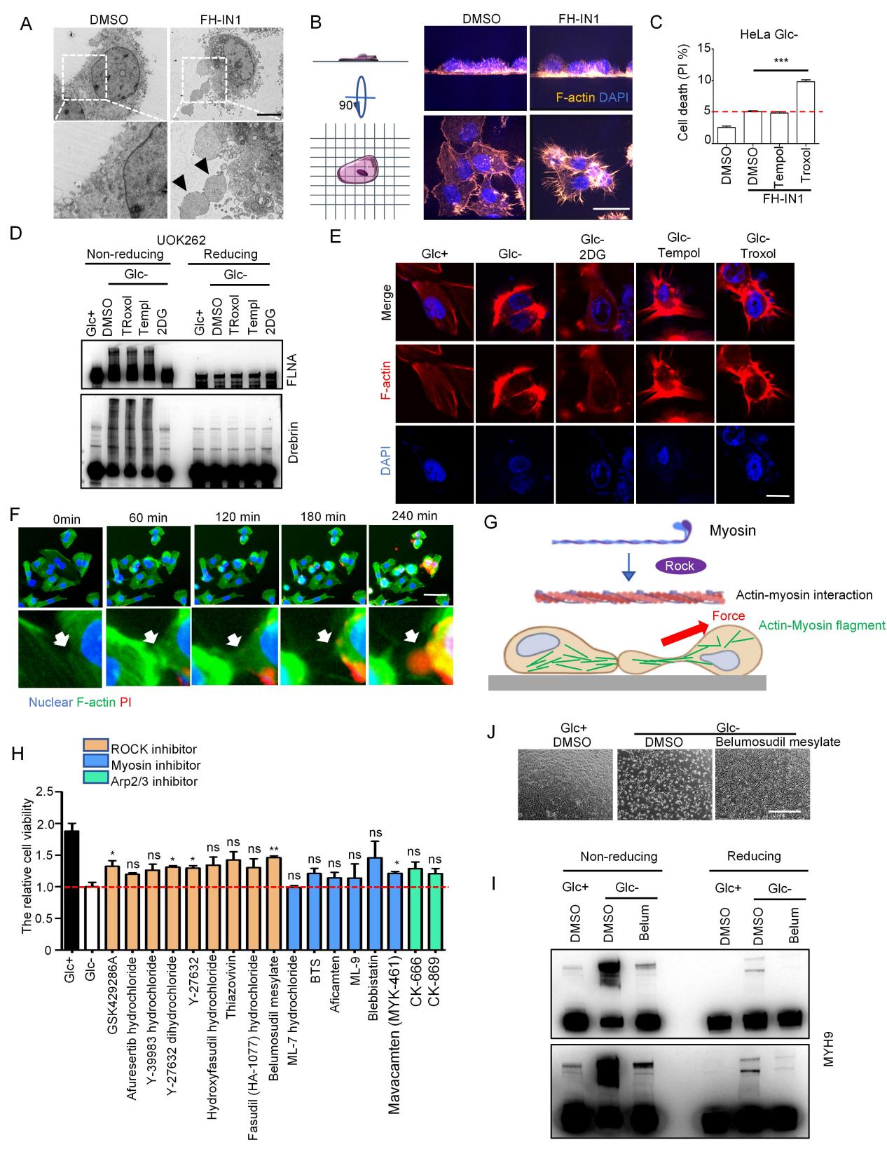

Figure S1
- Representative transmission electron microscopic images of HeLa cells cultured in glucose-free medium with or without 10um FH-IN1 for 20 hours. Scale bar: 5 μm.
- Representative 3D-confocal images of F-actin in HeLa cells cultured in glucose-free medium with or without 10 μM FH-IN1 for 16 hours. Scale bar: 10 μm.
- Cell death in HeLa cells cultured in glucose-free medium with 10 μM FH-IN1, 25 μM Tempol or 100 μM Troxol for 22 hours. The red dashed line represents the proportion of cell death induced by glucose-free medium with 10 μM FH-IN1.
- E) FH^{deficient} UOK262 cells cultured in glucose-containing medium or glucose-free medium medium with the indicated treatment for 12 hours (25 μM Troxol, 100 μM Temple and 2 mM 2DG). (D) actin cytoskeleton associated proteins and (E) images of F-actin were analyzed. Scale bar: 10 μm.
- Living cell image of FH^{deficient} UOK262 cells cultured in glucose-free medium for the indicated times (beinging at 10 h glucose starvation) scale bar: 50 μm.
- ROCK function
- FH^{deficient} UOK262 cells were cultured in glucose-free medium with 10 μM of ROCK, Myosin, Arp2/3 inhibiors treatment for 12 hours and cell death were analyzed by CCK-8 assay.
(I-J) FH^{deficient} UOK262 cells were cultured in glucose-free medium with 10 μM Belumosudil mesylate treatment for 8 hours. (I) Cell morphology and (J) actin cytoskeleton associated proteins were analyzed.
P-values were obtained by the two-tailed Students’ t-test. Data are presented as mean ± SD; n=3
independent repeats, ns: not significant, *p<0.05, **p<0.01, ***p<0.001.
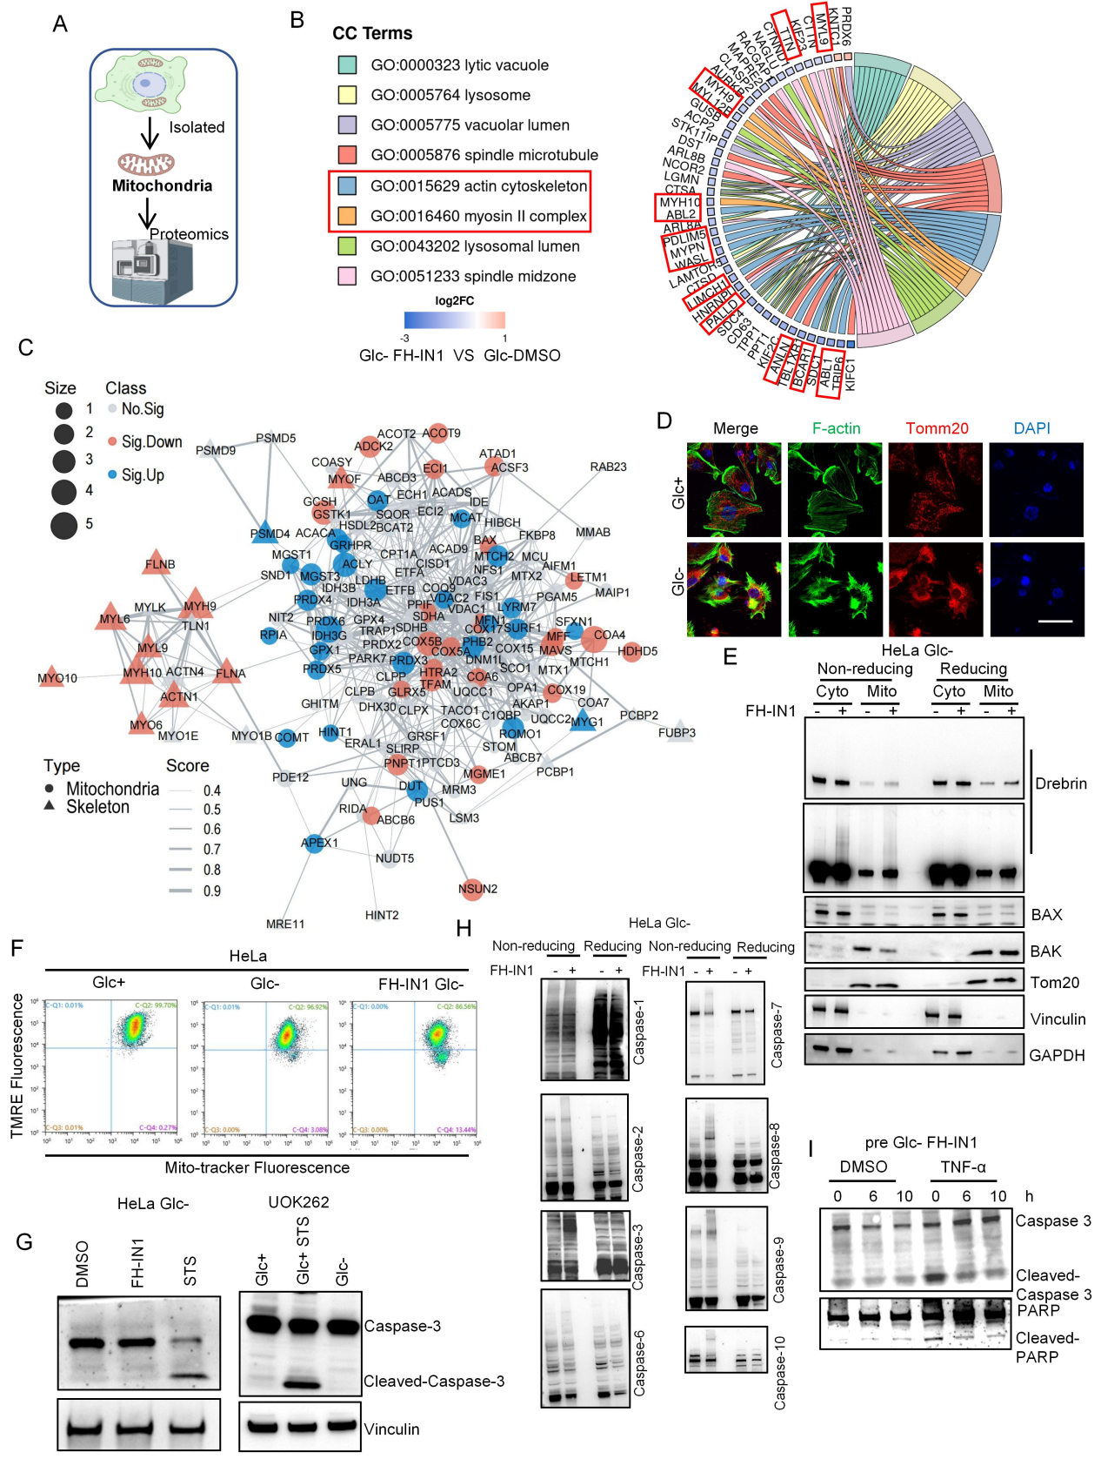

Figure S2
(A) Experimental workflow for isolating mitochondria for quantitative proteomic analysis.
(B) Gene Ontology (Cellular component) analysis of mitochondria-related proteins. Highlighted in red region are the myosin II complex and actin cytoskeleton.
(C) Interaction network of actin cytoskeleton proteins interacting with mitochondria (fold change = FH^{Inact} Glc- protein level / Glc- protein level). Blue circles represent increased mitochondria expression and red triangles represent decreased expression of actin cytoskeleton related proteins under disulfidptosis).
(D) Images of F-actin and Tomm20 in UOK262 cells cultured in Glc+ and Glc- medium for 12 hours. Scale bar (20 μm)
(E) MCF-7 cells cultured in glucose-free medium with or without 10 μM FH-IN1 for 18 hours, non-reduction/reduction immunoblots analysis of mitochondrial and cytoplasmic proteins .
(F) The mitochondria membrane potential were analyzed in HeLa cells with the indicated treatment.
(G) immunoblots showed cleaved Caspase-3 level in the indicated conditions (DMSO, 10 μM FH-IN1, and 1 μM STS treated HeLa cells for 9 h under glucose-free condition; For UOK262 cells, 1 μM STS treated for 8 hours or glucose starvation for 12 hours).
(H) Aggregation status of caspases in FH^{Inact} HeLa cells by non-reducing/reducing immunoblots analysis. HeLa cells were cultured in glucose-free medium with or without 10 μM FH-IN1 for 16 hours.
(I) HeLa cells were cultured in glucose-free medium with or without 10 μM FH-IN1 for indicated times, and then treated with or without 100 μg/mL CHX (cycloheximide) and 10 μg/mL TNF-α for 6 h. Immunoblots showing Caspase-3 and PARP1.

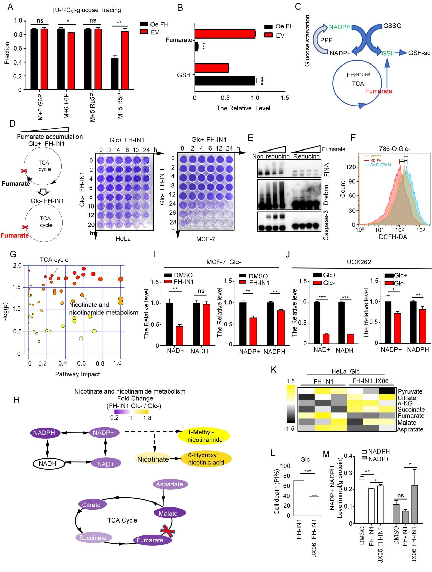
Figure S3
- PPP metabolic flux changes in empty vector and FH-overexpressing UOK262 cells with [U-¹³C₆]-glucose labeling for 8 hours; n = 3 independent experiments; ns, not significant, *P < 0.05, **P < 0.01. Data were analyzed by two-tail t-test.
- Fumarate and GSH level in empty vector and FH-overexpressing UOK262 cells; n=3 independent experiments; ***P < 0.01. Data were analyzed by two-tail t-test.
- Schematic diagram of fumarate succination GSH.
- HeLa cells were cultured in glucose-containing medium with 10 μM FH-IN1 for gradient fumarate accumulation and then cultured in glucose-free medium with 10 μM FH-IN1 for indicated times. Colony forming assay showing cell death in HeLa and MCF-7 cells.
- HeLa cells were cultured in glucose-containing medium with 10 μM FH-IN1 for gradient fumarate accumulation and reducing/non-reducing immunoblots showing FlNA, Drebrin, Caspase-3 in HeLa cell with different fumarate levels under gluocse starvation.
- Flow cytometry peak diagram depicting ROS level (analyzed by 2',7'-Dichlorodihydrofluorescein diacetate, DCFH-DA) in vector control, SLC7A11 (oe SLC7A11), KD-FH 786-O cells cultured in glucose-free medium for 12 hours.
- H) Disruption of metabolic pathways in HeLa cells cultured in Glc- medium with 10 μM FH-IN1 for 12 hours. (G) Significant pathways with a p-value of TCA cycle and Nicotinate and nicotinamide metabolism are labeled. (H) Diagram illustrating metabolite fold level changes in nicotinate and nicotinamide metabolism and the impact on the TCA cycle.
(I) MCF-7 cells cultured in Glc- medium with or without 10 μM FH-IN1 treatment for 8h. The relative of NAD+/NADH (left) and NADP+/NADPH (right) were analyzed.
(J) UOK262 cells cultured in Glc- or Glc+ medium for 8 h. The relative of NAD+/NADH (left) and NADP+/NADPH (right) were analyzed.
(K) Heatmap illustrating alterations in concentration of the indicated metabolites in HeLa cells with PDK inhibition for 8 h.
(L) Cell death of HeLa cells after 24 h of PDK inhibitor treatment.
(M) NADP+ and NADPH levels in MCF-7 cells cultured in glucose-free medium with and without FH inhibition and/or PDK inhibition for 6 h (FH-IN1 at 10 μM, JX06 at 10 μM).
P-values were obtained by the two-tailed Students’ t-test. Data are presented as mean ± SD; n=3 independent repeats, ns: not significant, *p<0.05, **p<0.01, ***p<0.001.

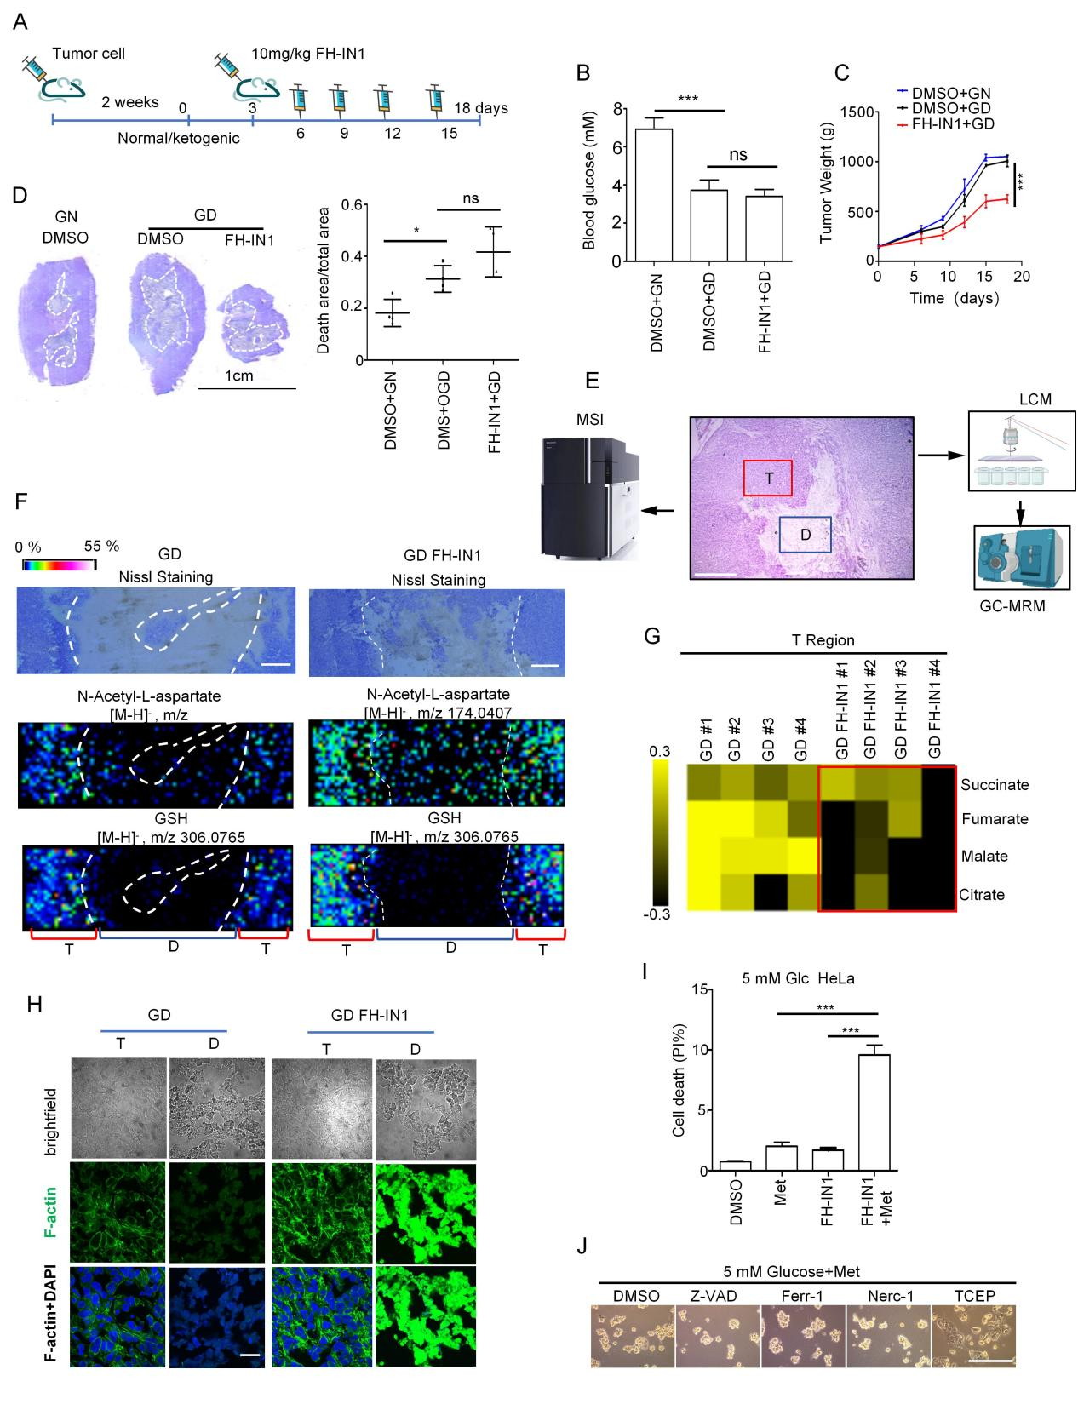

Figure S4
(A) Diagram depicting treatment course in NYG mice. FH inhibitors were injected at 3-day intervals and mice were sacrificed on day 18.
(B-C) Analysis of murine blood glucose and tumor volumes over the treatment time course. (B) Blood glucose. (C) Tumor volumes of HeLa xenografts with/without 10 mg/kg FH-IN1 injection when fed with normal diet (glucose normal, GN) or ketogenic diet (glucose deprivation, GD) (n=4 for each group).
(D) Analysis of relative cellular necrosis (death area/total area) (right panel) in tumors at day 18, and representative images of maximum tumor section. White dotted area outlines the necrotic zone (scale bar: 1 cm).
(E) Graphical representation of spatial metabolomic analysis in D (necrotic) and T (tumor) regions of murine tumors. Metabolic differences between regions were analyzed by MSI and LCM-GC-MS based spatial metabolomics analysis for GD/FH-IN1 group.
(F) MSI results showing the distribution of N-Acetyl-L-aspartate and GSH for D and T regions of the GD/FH-IN1 group. Scale bar: 1mm.
(G) Heatmap and bar graphs showing TCA metabolite differences in T regions between the GD and GD/FH-IN1 groups.
(H) Representative confocal images of F-actin distribution in D and T regions of GD and GD/FH-IN1 groups (Scale bar: 20 μm).
(I) Cell death in HeLa cells cultured in Glc- medium with the indicated treatment for 18 hours (10 μM FH-IN1, 5 mM metformin).
(J) Observation of the effects of various cell death inhibitors on cell morphology using differential interference contrast microscopy (Scale bar: 100 μm).
For (B to D ) n=4, data was presented in mean ± SEM. for (I) n=3, data are presented as mean ± SD; ns, not significant, *p<0.05, **p<0.01, ***p<0.01, p values were calculated by an unpaired two-tailed Student’s t-test.

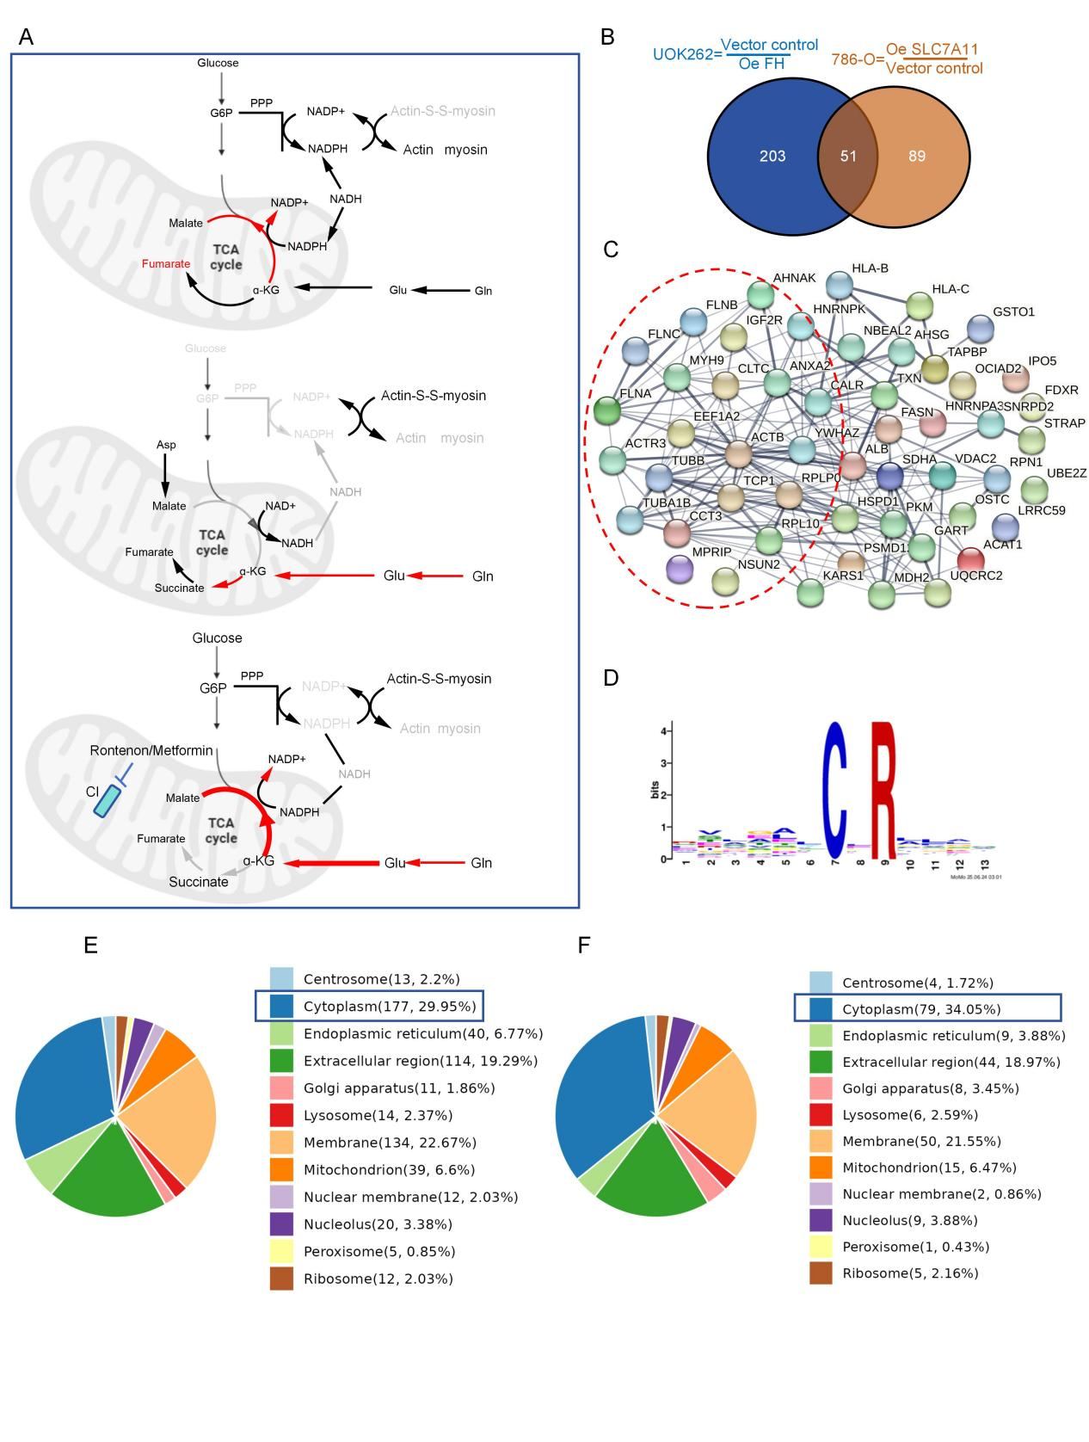
Figure S5
- Schematic diagram of disulfide stress in FH^{deficient} cells.
- Venn diagram showing the overlap of proteins associated with up-regulated cysteine-containing peptides between (Oe SLC7A11 vs Vector control) 786-O and (Vector control vs Oe FH) UOK262 cells.
(C) Protein-protein interaction (PPI) network analysis of up-regulated cysteine-containing proteins in the context of Oe SLC7A11 786-O and vector control UOK262 cells. Actin cytoskeleton, cell junction, and cytoskeletal protein networks are represented in red dash cycle .
(D) Cysteine-containing sequences involved in disulfide bond formation in FH^{deficient} cells
(E-F) Subcellular distribution of proteins involved in abnormal disulfide bond formation in (E) FH^{deficient} UOK262 cells and (F) SCL7A11-overexpression 786-O cells . (Boxed area shows the proportion of proteins with abnormal disulfide bonds in the cytoplasm)

