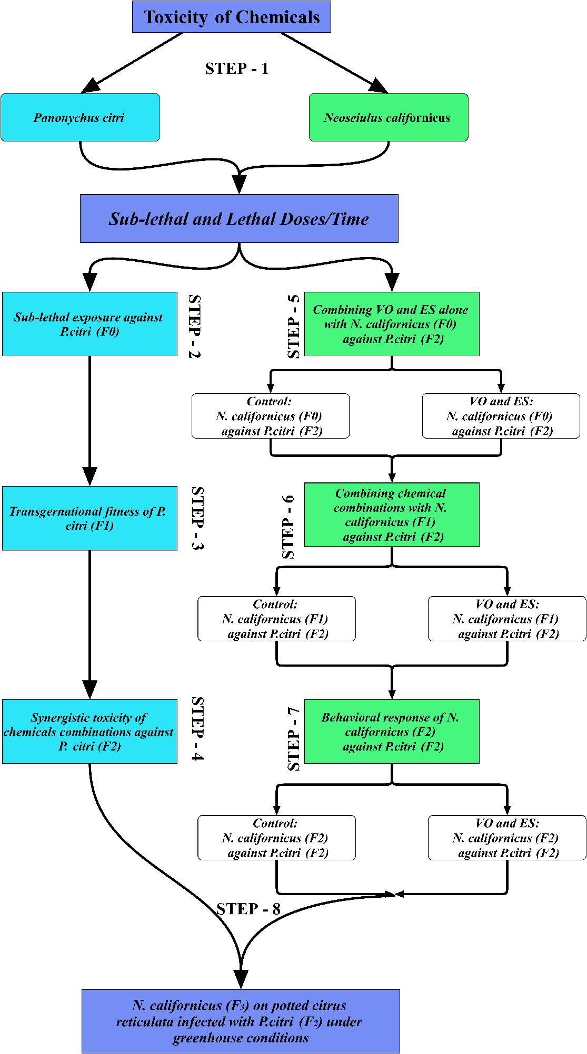
Fig 1S. Experimental Layout of the current study.
Soybean oil extraction, Trans-methylation, and Gas chromatographic analysis
The gums/non-fatty materials formation (via hydrolysis) was obtained by using a degumming water system with the addition of (1-3%) water (75% of phosphate content of oil) to crude oil at 150 ± 10 ºF with constant mixing for 30 min (O'brien, 2008). First, the precipitate formation due to hydration was separated from oil with a centrifuge (Carr, 1978). Then, Trans-methylation was performed with the addition of Soybean oil (0.05%) in hexane for gas chromatographic (GC) analysis. Finally, the GC-MS (Gas chromatography-mass spectrometry) analysis (qualitative and quantitative) was performed on an Agilent-gas chromatograph (7890N), with a mass selective detector (GC-MS, Agilent 5975C) equipped with MS-HP-5, capillary column (30 m ×0.25 mm ID, film thickness 0.25 μm, Agilent Technologies, USA). The column's temperature was programmed as follows: 248 ºF for 1 min (Injector temperature), 39.2 ºF /min to 482 ºF, and 41 ºF/min to 536 ºF (Detector temperature). The full scan mode (50-400 m/z) was used (0.2 scans/s with 70 eV (electron ionization)) to acquire GC-MS data with 536 ºF and 446 ºF temperatures for injector and ion source, respectively (Oliveira et al., 2017). The identification of compounds (qualitative and quantitative) was made based on retention time (Rt) and NIST.11 library mass spectra (Murphy et al., 2012).

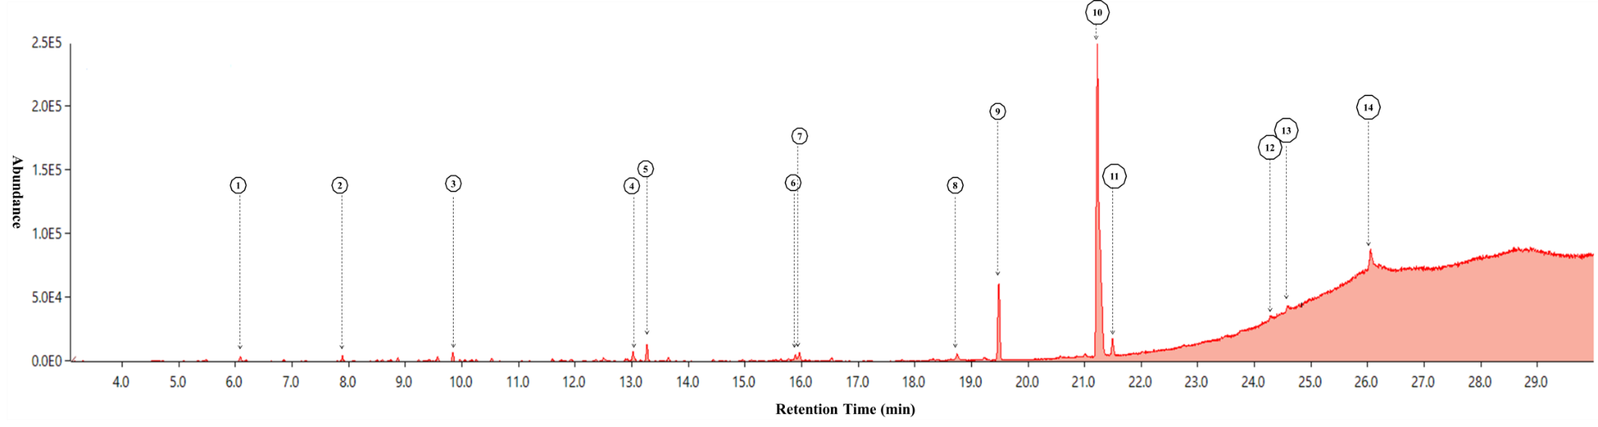
S2 Fig. The component peaks (GC-MS analysis) (A) of Soybean oil with their retention time (Rt). Here, 14 major peaks are presented.

S1 Table. GC-MS analysis of components of Soybean oil.
Peak # | Rtª | Compound Name^{b} | Chemical Formula | Relative (A)^{c} % | Relative (B)^{d} % | KIe (Exp) | Al^{f} (Exp)
1 | 6.087 | Undecane, 5,7-dimethyl- | C₁₃H₂₈ | 0.42263567 | 0.537038 | 614 | 614
2 | 7.891 | Acetohydroxamic acid | C₂H₅NO₂ | 0.453836686 | 0.576685 | 794 | 794
3 | 9.841 | Undecane, 5-ethyl- | C₁₃H₂₈ | 0.744956445 | 0.946607 | 988 | 988
4 | 13.023 | Eicosane | C ₂₀H ₄₂ | 1.161348401 | 1.475711 | 1310 | 1310
5 | 13.272 | Phenol, 2,5-bis(1,1-dimethylethyl)- | C₁₄H₂₂O | 1.640212609 | 2.084198 | 1333 | 1333
6 | 15.896 | Acetic acid, 5-hydroxy-4-nitrotetrahydropyran-3-yl ester | C₉H₁₃NO₇ | 0.530569418 | 0.674188 | 1593 | 1593
7 | 15.964 | Tetratetracontane | C₄₄H₉₀ | 0.868800839 | 1.103975 | 1602 | 1602
8 | 18.751 | Octacosane | C₂₈H₅₈ | 0.917404672 | 1.165735 | 1883 | 1883
9 | 19.486 | Hexadecanoic acid, ethyl ester | C₁₈H₃₆O₂ | 8.812514018 | 11.19796 | 1956 | 1956
10 | 21.228 | Linoleic acid ethyl ester | C₂₀H₃₆O₂ | 54.72729042 | 69.54131 | 2144 | 2144
11 | 21.493 | Octadecanoic acid, ethyl ester (Stearic acid) | C₂₀H₄₀O₂ | 1.807610859 | 2.296909 | 2154 | 2154
12 | 24.296 | 1,2,4-Benzenetricarboxylic acid, 4-dodecyl dimethyl ester | C₁₂H₁₂O₆ | 0.798212343 | 1.014279 | 2431 | 2431
13 | 24.587 | Octasiloxane, 1,1,3,3,5,5,7,7,9,9,11,11,13,13,15,15-hexadecamethyl- | C₁₆H₅₀O₇Si₈ | 0.728273381 | 0.925408 | 2460 | 2460
14 | 26.053 | Cyclotrisiloxane, hexamethyl- | C₆H₁₈O₃Si₃ | 5.083857997 | 6.459997 | 2615 | 2615

Identification methods: based on comparison with authentic compounds, NIST 08 MS databases; RI, based on a comparison of calculated RI with those reported in Adams or NIST 08.
ª Retention time.
^{b} Components are listed in order of their retention time.
^{c} Relative % among all identified peaks.
^{d} Relative % among the listed peaks.
^{e} Linear retention index on HP-5 (30 m x 0.25 mm, 0.25 µl film thickness).
^{f} Arithmetic retention index on HP-5 (30 m x 0.25 mm, 0.25 µl film thickness).
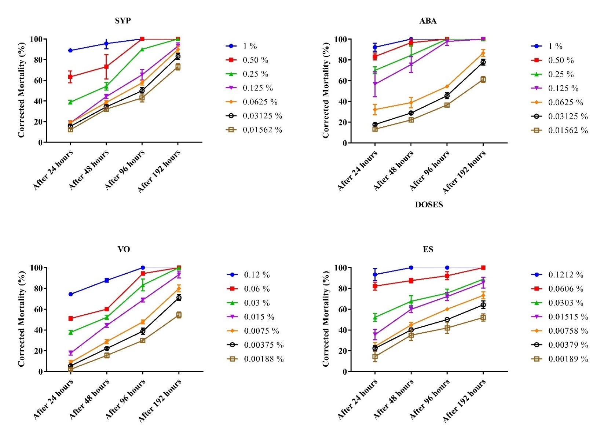
S3 Fig. Dose-dependent response of Panonychus citri adult (♀) at different exposure times (1(24h), 2(48h), 3(96h), and 4(196h). Abamectin (5%), SYP-9625 (30%) and Mineral Oil (99%) were purchased from North China Pharmaceutical Group Ainuo Co. Ltd., Shandong, China, Shenyang Kechuang Chemicals Co. Ltd., Liaoning, China, Korea oil energy Ltd., Seoul, Korea, respectively.
Table 2S. Toxicity of synthetic chemicals and oils against adult females.
Treatments | Slope (±SE) | LC₁₀^{b} | LC₃₀ | LC₅₀ | LC₉₀ | χ2 | t-ratio | P
Treatments | Slope (±SE) | (95% C.I.) | (95% C.I.) | (95% C.I.) | (95% C.I.) | χ2 | t-ratio | P
Panonychus citri (n = 30)
SYP-9625 (30%) | 1.104 (0.166) | 0.013 (0.005-0.025) | 0.065 (0.038-0.098) | 0.196 (0.133-0.306) | 2.836 (1.321-10.774) | 1.692 | 6.652 | 0.89
Abamectin (5%) | 1.479 (0.184) | 0.015 (0.007-0.024) | 0.049 (0.031-0.068) | 0.11 (0.081-0.150) | 0.812 (0.509-1.657) | 0.749 | 8.036 | 0.98
Soybean oil (99%) | 1.546 (0.216) | 0.008 (0.004-0.011) | 0.024 (0.017-0.032) | 0.051 (0.037-0.079) | 0.347 (0.181-0.965) | 0.731 | 7.161 | 0.981
EnSpray (99%) | 1.074 (0.167) | 0.002 (0.000-0.003) | 0.08 (0.004-0.012) | 0.024 (0.016-0.037) | 0.368 (0.166-1.541) | 1.585 | 6.422 | 0.903
Neoseiulus californicus (n=15)
SYP-9625 (30%) | 0.829 (0.227) | 0.011 (0.000- 0.033) | 0.09 (0.029- 0.186) | 0.387 (0.187- 1.716) | 13.588 (2.539- 2747.780) | 1.2396 | 3.658 | 0.941018
Abamectin (5%) | 0.684 (0.226) | 0.01 (0.000- 0.037) | 0.132 (0.037-0.375) | 0.771 (0.293-20.900) | 57.682 (5.090-3603917.921) | 0.162 | 3.02 | 0.999468
Soybean oil (99%) | 0.96 (0.353) | 0.026 (0.005-0.071) | 0.157 (0.060-11.663) | 0.554 (0.143-916.976) | 11.972 (0.935-49398514.685) | 0.708 | 2.721 | 0.983
EnSpray (99%) | 0.626 (0.259) | 0.006 (0.000-0.017) | 0.093 (0.031-72.212) | 0.643 (0.115-1452146.919) | 71.526 (1.752-7.882E+16) | 0.319 | 2.419 | 0.997

All dose unit in % in 100ml. The LC values were calculated using mean corrected mortality %.

S3 Table. Toxicity of synthetic chemicals and oils against adult females.
Treatments | Highest concentration |  |  |  | Lowest concentration
Treatments | Slope (± SE) | LT₅₀ª (h)  (95% C.I.) | χ² | P | Slope (± SE) | LT₅₀ (h)  (95% C.I.) | χ² | P
Panonychus citri (n = 30)
SYP-9625 (30%) | 3.435 (1.598) | 12.948 | 0.873 | 0.646 | 1.442 (0.370) | 106.437 | 0.531 | 0.767
 |  | (0.003-20.143) |  |  |  | (72.924-201.069)
Abamectin (5%) | 2.852 (2.130) | 7.335 | 0.346 | 0.841 | 1.557 (0.386) | 139.926 | 0.328 | 0.849
 |  |  |  |  |  | (96.068-293.608)
Soybean oil (99%) | 2.713 (0.881) | 14.689 | 1.214 | 0.545 | 1.948 (0.440) | 170.380 | 0.086 | 0.958
 |  | (2.992-22.305) |  |  |  | (121.181-330.107)
EnSpray (99%) | 2.795 (2.263) | 6.708 | 0.293 | 0.864 | 1.128 (0.368) | 149.503 | 0.967 | 0.617
 |  |  |  |  |  | (90.780-648.775)
Neosiulus californicus (n = 15)
SYP-9625 (30%) | 2.639  (0.723) | 12.242 | 1.008 | 0.799 | 0.972 (0.537) | 269.851 | 0.071 | 0.995
 |  | (5.011-17.839)
Abamectin (5%) | 1.885 (0.517) | 17.607  (7.103- 26.548) | 1.642 | 0.650 | 0.897 (0.576) | 494.825 | 0.104 | 0.991
Soybean oil (99%) | 0.766 (0.458) | 80.770 | 0.209 | 0.976 | 1.466 (1.185) | 769.645 | 0.201 | 0.977
EnSpray (99%) | 0.765 ( 0.450) | 48.611 | 0.632 | 0.889 | 0.570 (0.634) | 7426.750 | 0.334 | 0.954
Lethal time. Highest concentrations (>75% mortality): 1% for SYP-9625 and Abamectin; 0.12% for Soybean oil and EnSpray, Lowest concentrations (>10% mortality): 0.01652 % For SYP-9625 and Abamectin; 0.002% for Soybean oil and EnSpray. All dose unit in % in 100ml. The LT values were calculated using mean corrected mortality % and mean mortality.

Table S4. Sublethal effects of chemical toxicity on the mortality (%), adult longevity, fecundity and % hatchability for the F₀ generation of P. citri.

F0 generation |  | Control | SYP-9625 | Abamectin | Vegetable oil | EnSpray 99
Mortality  (%) | After 24 hours | 0.00 ± 0.00d | 36.67 ± 3.33a | 38.67 ± 1.33a | 11.67 ± 1.67c | 21.53 ± 0.97b
Mortality  (%) | After 48 hours | 0.00 ± 0.00d | 47.32 ± 1.201b | 52.85 ± 1.528a | 36.08 ± 1.447c | 41.99 ± 1.016b
Mortality  (%) | After 96 hours | 1.05 ± 0.621d | 69.41 ± 1.766b | 81.26 ± 2.915b | 55.23 ± 0.989c | 61.52 ± 0.972c
Mortality  (%) | After 192 hours | 1.42 ± 0.712c | 97.85 ± 1.119a | 96 ± 2.221a | 86.66 ± 1.925b | 93.33 ± 1.925ab
Parameters | Longevity (d) | 8.9 ± 0.4a | 7.3 ± 0.321a | 7.3 ± 0.493a | 8.68 ± 0.126a | 8.03 ± 0.094a
Parameters | Number of egg/female adult | 24.47 ± 0.97a | 11.30 ± 0.73b | 11.8 ± 0.86b | 11.86 ± 0.97b | 10.87 ± 0.76b
Parameters | Eggs/female/day | 2.19 ± 0.201a | 1.83 ± 0.217b | 1.91 ± 0.346ab | 1.92 ± 0.176ab | 1.76 ± 0.891b
Parameters | % Hatchability | 100 ± 0a | 94.67 ± 1.333b | 88.33 ± 2.028c | 100 ± 0a | 99.33 ± 1.33ab

Standard errors (SE) of life parameters were estimated using the bootstrap method with 100,000 re-samplings; Means (± SE) followed by the same letters within a row are significantly different according to the Tukey post-hoc test (p < 0.005).

Table 5S. Developmental and reproductive parameters (mean ± SE) of life table of Panonychus citri (F₁ generation), when parental mothers (F₀) exposed to the LC₃₀ of synthetic chemicals and oils.
 | Parameters | Control | SYP-9625 | Abamectin | Vegetable oil | EnSpray 99
Female | Egg (d) | 5.41 ± 0.084a | 5.1 ± 0.1ab | 5 ± 0.091b | 4.33 ± 0.097c | 4.25 ± 0.094c
Female | Larva (d) | 1.74 ± 0.0511ab | 1.7 ± 0.065ab | 1.86 ± 0.062a | 1.33 ± 0.061c | 1.58 ± 0.064b
Female | Protonymph (d) | 1.62 ± 0.057a | 1.5 ± 0.071a | 1.64 ± 0.057a | 1.58 ± 0.064a | 1.42 ± 0.064a
Female | Deutonymph (d) | 1.58 ± 0.057a | 1.3 ± 0.065b | 1.36 ± 0.057b | 1.33 ± 0.061b | 1.5 ± 0.065ab
Female | Longevity (d) | 8.91 ± 0.084a | 8.5 ± 0.115a | 7.43 ± 0.180b | 7.5 ± 0.135b | 7.08 ± 0.098b
Female | Pre-adult (d) | 10.35 ± 0.109a | 9.6 ± 0.131b | 9.86 ± 0.127b | 8.58 ± 0.112c | 8.75 ± 0.120c
Female | Pre-adult survival rate (Sa) | 0.93 ± 8.07E-05a | 0.7 ± 1.45E-04e | 0.86 ± 1.10E-04b | 0.75 ± 1.37E-04d | 0.85 ± 1.13E-04c
Female | Total life span (d) | 19.26 ± 0.115a | 18.1 ± 0.196b | 17.29 ± 0.2249c | 16.08 ± 0.179d | 15.83 ± 0.128d
Female | APOP (Adult pre-oviposition period of female adult) (d) | 0.905 ± 0.077cd | 1.4 ± 0.07a | 1.214 ± 0.049ab | 0.833 ± 0.048d | 1.083 ± 0.036bc
Female | TPOP (Total pre-oviposition period of female counted from birth) (d) | 11.257 ± 0.118a | 11 ± 0.169a | 11.071 ± 0.132a | 9.417 ± 0.1242b | 9.833 ± 0.116b
Female | Fecundity (eggs/female) | 21.162 ± 0.309a | 9.8 ± 0.228d | 16.643 ± 0.616b | 14.167 ± 0.386c | 16.083 ± 0.413b
Female | Ovi-days (d) | 7.068 ± 0.139a | 4.9 ± 0.118d | 5.071 ± 0.167cd | 5.667 ± 0.122b | 5.583 ± 0.135bc
Female | Eggs/Ovi.days | 3.052 ± 0.057b | 2.039 ± 0.0543d | 3.261 ± 0.0479a | 2.496 ± 0.0325c | 2.913 ± 0.0618b
Female | Female proportion (N_{f}/N) | 0.74 ± 1.39E-04a | 0.50 ± 1.59E-04d | 0.70 ± 1.45E-04b | 0.60 ± 1.56E-04c | 0.60 ± 1.55E-04c
Female | Male Proportion (N_{m}/N) | 0.19 ± 1.25E-04c | 0.20 ± 1.27E-04b | 0.16 ± 1.16E-04d | 0.15 ± 1.13E-04e | 0.25 ± 1.37E-04a
Female | N_{fr}, N_{n} | 74, 7 | 50, 30 | 70, 14 | 60, 25 | 60, 15
Male | Egg (d) | 5 ± 0.000a | 5 ± 0.1622a | 4.63 ± 0.125ab | 4.33 ± 0.126b | 4.8 ± 0.153ab
Male | Larva (d) | 1.42 ± 0.116b | 2 ± 0.000a | 2 ± 0.000a | 1.33 ± 0.126b | 1.4 ± 0.1b
Male | Protonymph (d) | 1.47 ± 0.117b | 2.25 ± 0.099a | 2.38 ± 0.125a | 2.33 ± 0.126a | 1.6 ± 0.1b
Male | Deutonymph (d) | 1.37 ± 0.113b | 1.75 ± 0.099ab | 1.69 ± 0.119ab | 1.67 ± 0.126ab | 1.8 ± 0.081a
Male | Longevity (d) | 9.11 ± 0.130ab | 9.55 ± 0.184a | 8.25 ± 0.25c | 8.53 ± 0.133bc | 8.2 ± 0.152c
Male | Pre-adult (d) | 9.26 ± 0.103b | 11 ± 0.162a | 10.69 ± 0.119a | 9.67 ± 0.252b | 9.6 ± 0.208b
Male | Total life span (d) | 18.37 ± 0.156bc | 20.55 ± 0.184a | 18.94 ± 0.213b | 18.2 ± 0.222bc | 17.8 ± 0.326c
The data were generated by using TWOSEX life table software(Chi 1988); Standard errors (SE) was estimated using the bootstrap method with 100,000 re-samplings; Means (± SE) followed by the same letters within a row are significantly different according to the Tukey post-hoc test (p < 0.005).

Fig 4S. Age-specific survival rate (s_{xj}) of Panonychus citri offsprings (F₁ generation) from the LC₃₀ treated (synthetic chemicals and oils) parental mothers (F₀ generation).
Fig 5S. Impact of sublethal (LC₃₀) concentrations of synthetic chemicals and oils on the life expectancy (e_{xj}) of egg, larva, protonymph, deutonymph, adult female and adult male of Panonychus citri offsprings (F₁ generation) from the treated (LC₃₀) parental mothers (F₀ generation) (color figure refer to the online version).

Fig 6S. Impact of sublethal (LC₃₀) concentrations of synthetic chemicals and oils on the reproductive value (v_{xj}) of the Panonychus citri offsprings (F₁ generation) from the treated (LC₃₀) parental mothers (F₀ generation). The adult male has no v_{xj} values to the next generation (color figure refer to the online version).
Fig 7S. Impact of sublethal (LC₃₀) concentrations of synthetic chemicals and oils on the Stage structure curves (Population projection) of the Panonychus citri offsprings (F₁ generation) from the treated (LC₃₀) parental mothers (F₀ generation) with an initial population of newborns. The dashed line indicates the total number of adults on 59 days of predicted stage structure curves (color figure refer to the online version).
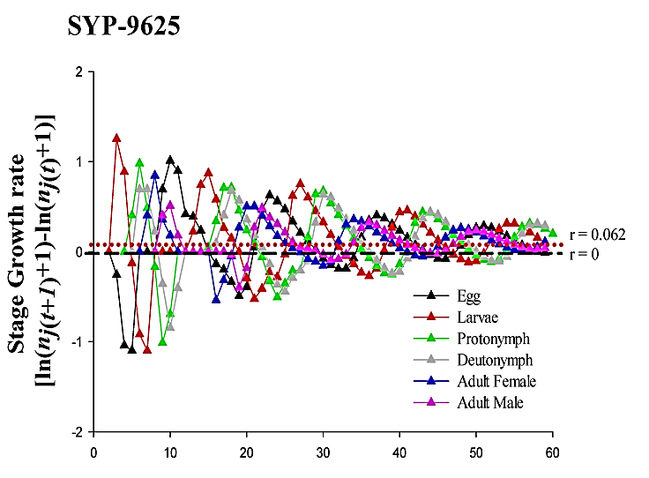
Fig 8S. Impact of sublethal (LC₃₀) concentrations of synthetic chemicals and oils on the Stage Growth rate (Population projection) of the P. citri with an initial population of newborns. The red dash lines indicate the total growth rate (r) predicted on 59 days and the black dah line the actual growth rate (r = 0) (color figure refer to the online version).

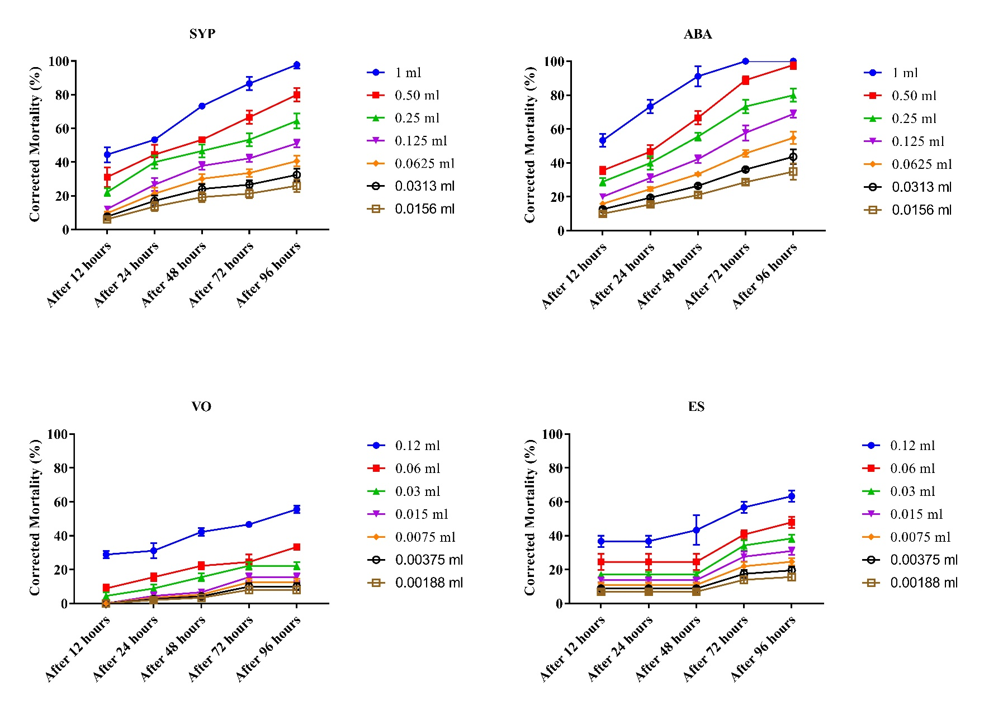
S9 Fig. Dose-dependent response of N. californicus adult (♀) at different exposure times.

S6 Table. Effect of different doses and post-treatment times on the population reduction of N. califormicus (n = 30/replicate for each treatment).
One-Way ANOVA |  |  | SYP |  |  | ABA |  |  | VO |  |  | ES
Time |  | Mean Square |  | F | Sig. | Mean Square | F | Sig. | Mean Square | F | Sig. | Mean Square | F | Sig.
After 12 hours | Between Groups, df (6,20) | 615.045 |  | 22.815 | 0.000 | 706.761 | 60.904 | 0.000 | 339.194 | 53.423 | 0.000 | 328.916 | 18.222 | 0.000
After 24 hours | Between Groups, df (6,20) | 684.644 |  | 17.024 | 0.000 | 1186.413 | 52.342 | 0.000 | 334.445 | 19.329 | 0.000 | 328.916 | 18.222 | 0.000
After 48 hours | Between Groups, df (6,20) | 1059.933 |  | 54.605 | 0.000 | 1851.181 | 69.039 | 0.000 | 602.603 | 93.362 | 0.000 | 479.208 | 10.279 | 0.000
After 76 hours | Between Groups, df (6,20) | 1640.094 |  | 57.420 | 0.000 | 2182.175 | 109.147 | 0.000 | 528.008 | 28.892 | 0.000 | 662.190 | 29.042 | 0.000
After 96 hours | Between Groups, df (6,20) | 2055.145 |  | 59.200 | 0.000 | 1960.052 | 57.146 | 0.000 | 862.756 | 72.302 | 0.000 | 857.339 | 45.696 | 0.000

S7 Table. Statistical comparison of tested chemicals and their mixtures against Panonychus citri (n = 30/replicate for each treatment).
Compounds | LT50 (h) |  | 95 % C.I. (lower-upper) | Slope | ± SE | χ2 | p-value
ES |  | 323.806 |  | 0.656 | 0.428 | 0.05 | 0.975
VO |  | 280.701 |  | 0.562 | 0.413 | 0.081 | 0.96
ABA |  | 161.238 |  | 0.536 | 0.401 | 0.194 | 0.907
SYP |  | 220.514 |  | 0.546 | 0.408 | 0.222 | 0.895
SYP:ABA (1:1) |  | 33.543 | (13.290-107.331) | 0.924 | 0.395 | 0.196 | 0.906
VO:ABA (1:1) |  | 51.439 | (25.686-1099022488) | 0.797 | 0.395 | 0.209 | 0.901
VO:SYP (1:1) |  | 219.536 |  | 0.671 | 0.416 | 0.339 | 0.844
VO:ABA (3:1) |  | 38.668 | (20.058-142.296) | 0.975 | 0.396 | 0.03 | 0.985
VO:SYP (3:1) |  | 95.626 | (46.653-4.059E+11) | 0.838 | 0.408 | 0.045 | 0.978
VO:ES (1:1) |  | 298.03 |  | 0.662 | 0.426 | 0.052 | 0.975
VO:ES (3:1) |  | 231.3 |  | 0.684 | 0.421 | 0.057 | 0.972
ES:SYP (1:1) |  | 102.217 |  | 0.783 | 0.408 | 0.387 | 0.824
ES:SYP (3:1) |  | 277.809 |  | 0.668 | 0.424 | 0.053 | 0.974
ES:ABA (1:1) |  | 75.577 |  | 0.723 | 0.399 | 0.096 | 0.953
ES:ABA (3:1) |  | 232.641 |  | 0.684 | 0.421 | 0.057 | 0.972

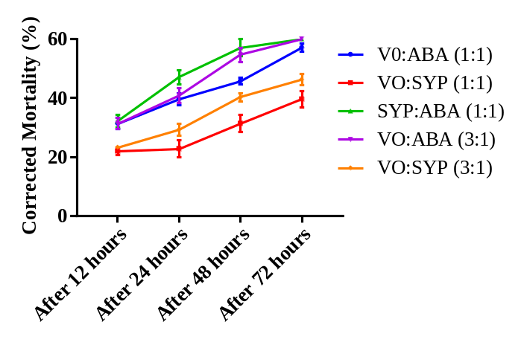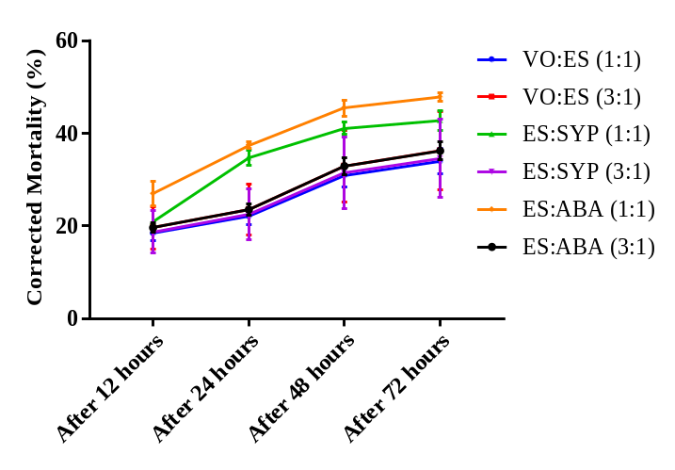
Fig 10S. Corrected mortality (%) of the combinations of compounds against Panonychus citri (F₂ generation) over time. The data presented in corrected mortality (%) (Mean ± SE) by replicated three times. One-way ANOVA between the treatments was analyzed the data. A significant difference was observed between each treatment's concentrations within post-treatment time (in both graphs).

S8 Table: Synergistic and antagonistic of chemicals by calculating co-toxicity coefficient.
Combination |  | Alone | Co-toxicity coefficient | Combination |  | Alone | Co-toxicity coefficient
VO:ABA (1:1) | VS | VO | 545.6968 | VO:ABA (1:1) | VS | ABA | 313.4548
VO:SYP (1:1) | VS | VO | 127.861 | VO:SYP (1:1) | VS | SYP | 100.4455
VO:ABA (3:1) | VS | VO | 725.9258 | VO:ABA (3:1) | VS | ABA | 416.9804
VO:SYP (3:1) | VS | VO | 293.5405 | VO:SYP (3:1) | VS | SYP | 230.6005
VO:ES (1:1) | VS | VO | 94.18548 | VO:ES (1:1) | VS | ES | 108.6488
VO:ES (3:1) | VS | VO | 121.358 | VO:ES (3:1) | VS | ES | 139.9939
ES:SYP (1:1) | VS | ES | 316.7829 | ES:SYP (1:1) | VS | SYP | 215.7312
ES:SYP (3:1) | VS | ES | 116.5571 | ES:SYP (3:1) | VS | SYP | 79.37612
ES:ABA (1:1) | VS | ES | 428.4452 | ES:ABA (1:1) | VS | ABA | 213.3427
ES:ABA (3:1) | VS | ES | 139.187 | ES:ABA (3:1) | VS | ABA | 69.30765
SYP:ABA (1:1) | VS | SYP | 657.4069 | SYP:ABA (1:1) | VS | SYP | 480.6905

S9 Table. Joint action of the mixture of vegetable oil from kitchen waste with SYP-9625 and Abamectin against Panonychuscitri at different time intervals (n = 30/replicate for each treatment).
 | After 24 hours |  |  | After 48 hours |  |  | After 72 hours
Compounds | Actual Mortality (%) | Theoritical Mortality (%) | Poison ratio | Actual Mortality (%) | Theoritical Mortality (%) | Poison ratio | Actual Mortality (%) | Theoritical Mortality (%) | Poison ratio
VO:ABA (1:1) | 39.616 | 32.049 | 1.236107 | 45.798 | 33.998 | 1.347079 | 57.132 | 40.665 | 1.404943
VO:ABA (1:1) | 40.95 | 32.049 | 1.277731 | 54.664 | 33.998 | 1.607859 | 60 | 40.665 | 1.47547
VO:SYP (1:1) | 22.854 | 25.917 | 0.881815 | 31.426 | 33.665 | 0.933492 | 39.666 | 37.998 | 1.043897
VO:SYP (3:1) | 29.284 | 25.917 | 1.129915 | 40.282 | 33.665 | 1.196554 | 46.332 | 37.998 | 1.219327
VO:ES (1:1) | 22.06128 | 25.3838 | 0.869109 | 30.88579 | 31.11732 | 0.99256 | 33.97437 | 35.29615 | 0.962552
VO:ES (3:1) | 23.556816 | 25.3838 | 0.928026 | 32.97954 | 31.11732 | 1.059845 | 36.2775 | 35.29615 | 1.027803
ES:ABA (1:1) | 37.47333333 | 28.2628 | 1.325889 | 45.50667 | 33.11732 | 1.374105 | 47.87667 | 38.62915 | 1.239392
ES:ABA (3:1) | 23.52132338 | 28.2628 | 0.832236 | 32.92985 | 33.11732 | 0.994339 | 36.22284 | 38.62915 | 0.937707
ES:SYP (1:1) | 34.80333333 | 22.1308 | 1.57262 | 41.12667 | 32.78432 | 1.254461 | 42.78807 | 35.96215 | 1.189808
ES:SYP (3:1) | 22.46367408 | 22.1308 | 1.015041 | 31.44914 | 32.78432 | 0.959274 | 34.59406 | 35.9622 | 0.96196
ABA:SYP (1:1) | 47.14 | 28.796 | 1.637033 | 57.142 | 35.665 | 1.602187 | 60 | 41.331 | 1.45169
Note: Poison ratio was determined as; synergistic effect value >1, antagonistic effect value <1.

S10 Table. Statistical comparison of vegetable oil (LC₅₀) in combinations with predator (Neoseiuluscalifornicus) against Panonychuscitri (1:30, predator.prey).
 | Compounds | LT50 (h) | 95 % C.I. (lower-upper) | Slope (± SE) | SE | χ2 (df) | Co-toxicity coefficient | p-value
Control | Predator | 123 | (56.029-1136.343) | 1.22 | 0.32 | 0.606 |  | 0.962
VO+ES | VO + predator | 23.645 | (17.574-35.679) | 1.717 | 0.273 | 1.768 |  | 0.778
VO+ES | ES + predator | 21.425 | (15.870-32.180) | 1.651 | 0.26 | 2.392 |  | 0.664
Control F₁ | ES:SYP (3:1) + predator | 18.019 | (13.647-25.550) | 1.746 | 0.261 | 2.538 | 682.6128 | 0.638
Control F₁ | VO:ES (1:1) + predator | 17.309 | (13.082-24.522) | 1.719 | 0.258 | 2.666 | 710.613 | 0.615
Control F₁ | ES:ABA (3:1) + predator | 18.775 | (14.22-26.726) | 1.762 | 0.264 | 2.488 | 655.1265 | 0.647
VO+ES F₁ | ES:SYP (3:1) + predator | 17.888 | (13.376-25.901) | 1.65 | 0.253 | 3.547 | 687.6118 | 0.471
VO+ES F₁ | VO:ES (1:1) + predator | 15.66 | (11.657-22.491) | 1.589 | 0.246 | 3.951 | 785.4406 | 0.413
VO+ES F₁ | ES:ABA (3:1) + predator | 14.242 | (10.571-20.294) | 1.56 | 0.243 | 4.257 | 863.6427 | 0.372

Fig. S11. Experimental layout for behavioral responses of N. californicus in laboratory and greenhouse experiments.

Fig. S12. Behavioral response and prey consumption (Mean (%) ± SE) of N. californicus (F₂) to leaf discs subjected to treated and untreated (blank solution) at different times (P < .05, t-test).

Equations of life parameters and growth rate
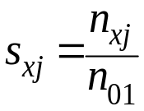
n_{xj} is the number of survived individuals at age x and stage j; n₀₁ is new-borns/eggs at the start of the life table (Chang et al., 2016).
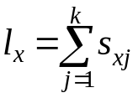
Where, k is the number of stages.
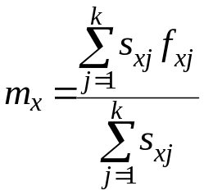
Where, f_{xj} is fecundity at age x and stage j.
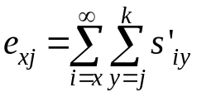and 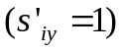
s’_{iy} is the probability of individuals of x and j to survive to age i and y (Chi & Su, 2006; Tuan et al., 2014).
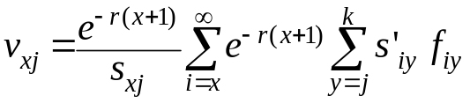
Where, f_{iy} is fecundity to age i and y (Yang et al., 2015).
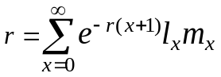
Where, r is the intrinsic rate of increase (Goodman, 1982).
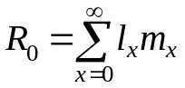
Where, R₀ is the net reproductive rate.
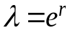
Where, λ is the finite rate of increase (Wei et al., 2020).
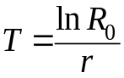
Where, T is mean generation time.
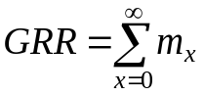
Where GRR is the gross reproduction rate.
The stage growth rate at time t (i.e., r_{j,t}) was calculated as:
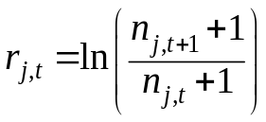
n_{j,t} is the number of individuals; r_{j,t} is the growth rate of stage j at time t (Akca et al., 2015; Chi et al., 2020; Huang et al., 2018).
All stages' growth rate curves will approach the finite rate of increase (λ). The “ln” used to find the intrinsic rate of increase (r) as described by (Akca et al., 2015; Huang et al., 2018).
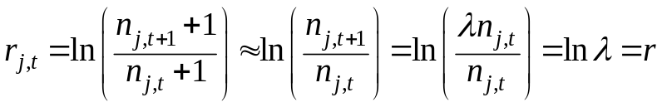
The Ovi. Days and eggs per Ovi. Days (Chen et al., 2018)were calculted as;
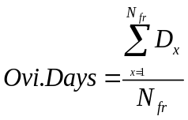
D_{x} is the number of oviposition days of one female and N_{fr} is the number of reproductive females.
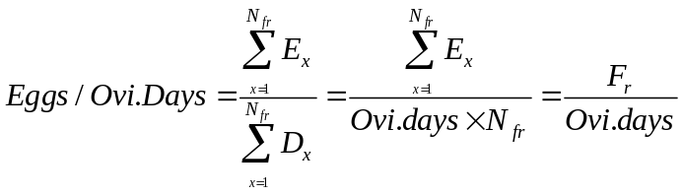
Where F_{r} (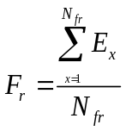) is mean fecundity of reproductive females

References
Akca, I., Ayvaz, T., Yazici, E., Smith, C. L., & Chi, H. (2015). Demography and population projection of Aphis fabae (Hemiptera: Aphididae): with additional comments on life table research criteria. Journal of Economic Entomology, 108, 1466-1478. doi:https://doi.org/10.1093/jee/tov187
Carr, R. A. (1978). Refining and degumming systems for edible fats and oils. Journal of the American Oil Chemists Society, 55, 765-771.
Chang, C., Huang, C. Y., Dai, S. M., Atlihan, R., & Chi, H. (2016). Genetically engineered ricin suppresses Bactrocera dorsalis (Diptera: Tephritidae) based on demographic analysis of group-reared life table. Journal of Economic Entomology, 109, 987-992. doi:https://doi.org/10.1093/jee/tow091
Chen, G.-M., Chi, H., Wang, R.-C., Wang, Y.-P., Xu, Y.-Y., Li, X.-D., . . . Zheng, F.-Q. (2018). Demography and uncertainty of population growth of Conogethes punctiferalis (Lepidoptera: Crambidae) reared on five host plants with discussion on some life history statistics. Journal of Economic Entomology, 111(5), 2143-2152. doi:https://doi.org/10.1093/jee/toy202
Chi, H., & Su, H.-Y. (2006). Age-stage, two-sex life tables of Aphidius gifuensis (Ashmead)(Hymenoptera: Braconidae) and its host Myzus persicae (Sulzer)(Homoptera: Aphididae) with mathematical proof of the relationship between female fecundity and the net reproductive rate. Environmental Entomology, 35, 10-21. doi:https://doi.org/10.1603/0046-225X-35.1.10
Chi, H., You, M., Atlıhan, R., Smith, C. L., Kavousi, A., Özgökçe, M. S., . . . Xu, Y.-Y. (2020). Age-Stage, two-sex life table: an introduction to theory, data analysis, and application. Entomologia Generalis, 102-123. doi:10.1127/entomologia/2020/0936
Goodman, D. (1982). Optimal life histories, optimal notation, and the value of the reproductive value. American Naturalist, 119, 803-823.
Huang, H. W., Chi, H., & Smith, C. L. (2018). Linking demography and consumption of Henosepilachna vigintioctopunctata (Coleoptera: Coccinellidae) fed on Solanum photeinocarpum (Solanales: Solanaceae): With a new method to project the uncertainty of population growth and consumption. Journal of Economic Entomology, 111, 1-9. doi:https://doi.org/10.1093/jee/tox330
Murphy, K. R., Wenig, P., Parcsi, G., Skov, T., & Stuetz, R. M. (2012). Characterizing odorous emissions using new software for identifying peaks in chemometric models of gas chromatography–mass spectrometry datasets. Chemometrics and Intelligent Laboratory Systems, 118, 41-50.
Soybean Oil Purification 377-408 (AOCS Press, Urbana, Illinois 2008).
Oliveira, N. N. F. C., Galvão, A. S., Amaral, E. A., Santos, A. W. O., Sena-Filho, J. G., Oliveira, E. E., & Teodoro, A. V. (2017). Toxicity of vegetable oils to the coconut mite Aceria guerreronis and selectivity against the predator Neoseiulus baraki. Experimental and Applied Acarology, 72, 23-34. doi:https://doi.org/10.1007/s10493-017-0134-x
Tuan, S. J., Lee, C. C., & Chi, H. (2014). Population and damage projection of Spodoptera litura (F.) on peanuts (Arachis hypogaea L.) under different conditions using the age-stage, two-sex life table. Pest Management Science, 70, 805-813. doi:https://doi.org/10.1002/ps.3618
Wei, M., Chi, H., Guo, Y., Li, X., Zhao, L., & Ma, R. (2020). Demography of Cacopsylla chinensis (Hemiptera: Psyllidae) reared on four cultivars of Pyrus bretschneideri (Rosales: Rosaceae) and P. communis pears with estimations of confidence intervals of specific life table statistics. Journal of Economic Entomology, 113, 2343-2353. doi:https://doi.org/10.1093/jee/toaa149
Yang, Y., Li, W., Xie, W., Wu, Q., Xu, B., Wang, S., . . . Zhang, Y. (2015). Development of Bradysia odoriphaga (Diptera: Sciaridae) as affected by humidity: an age–stage, two-sex, life-table study. Applied Entomology and Zoology, 50, 3-10. doi:https://doi.org/10.1007/s13355-014-0295-6

