SUPPLEMENTAL MATERIAL
Figure s1 Flow diagram
Study drop out (n=34)
- surgeries were delayed / cancelled (n=17)
- primary outcome evaluation was missed due to organizational problems/admission intensive care unit (n=10)
- parents withdraw their consent (n=4)
- included in an interventional study, not obvious at inclusion (n=1)
- organizational problems (n=1)
- neurological disease, not obvious at inclusion (n=1)
EEG drop out (n=58)
- had no intraoperative EEG recording (n=54)
- EEG analysis not possible due to artifacts intraoperative (n=4)
Included in analysis (n=97)
Non Emergence delirium (n=57)
Emergence delirium (n=40)
Excluded (n=223)
- Not meeting inclusion criteria (n=104)
- Declined to participate (n=112)
- Other reasons (n=7)
Included in study (n=189)
Assessed for eligibility (n=412)

EEG suppression related to clinical parameters
Burst suppression periods occurred more frequently in children receiving a mixed induction of anaesthesia with Sevoflurane and Propofol, compared with children receiving Propofol or Sevoflurane alone (Burst suppression occurrence: Sevoflurane induction 24%; Propofol induction 46%, mixed induction 68%; R² 0.323, P = 0.001) (supplemental material, Figure s2). Duration of Burst Suppression, as well as duration of isoelectric line were related to the anaesthetic agents given for induction (Burst suppression duration: Sevoflurane induction 0 sec (IQR 0 to 113) (supplement material, Figure s2); Propofol induction 0 sec (IQR 0 to 230); mixed induction 180 sec (IQR 0 to 824); P = 0.003; Isoelectric line duration: Sevoflurane induction 0 sec (IQR 0 to 113); Propofol induction 0 sec (IQR 0 to 43); mixed induction 84 sec (IQR 0 to 385); P = 0.002) and for anaesthesia maintenance (Burst suppression duration: Sevoflurane 0 sec (IQR 0 to 229); Propofol 300 sec (IQR 0 to 600); P = 0.051; isoelectric line duration: Sevoflurane 0 sec (IQR 0 to 68); Propofol 83 sec (IQR 0 to 373); P = 0.055).
We did not find a correlation between EEG suppression and age (months), concentration of Midazolam (mg kg⁻¹ body weight) premedication or concentration of Remifentanil (µg kg⁻¹ body weight min⁻¹) intraoperatively.

Figure s2 Burst Suppression activity related to the anaesthetic agent at induction

Figure s3 Occurrence and Duration of Burst Suppression activity in the EEG related to the anaesthetic agent used for induction, as Sevoflurane, Propofol or a mixture of both. Burst Suppression occurrence (%) is significantly correlated to the anaesthetic agent used (R² 0.323, p = 0.001; Spearman Rho Correlation).
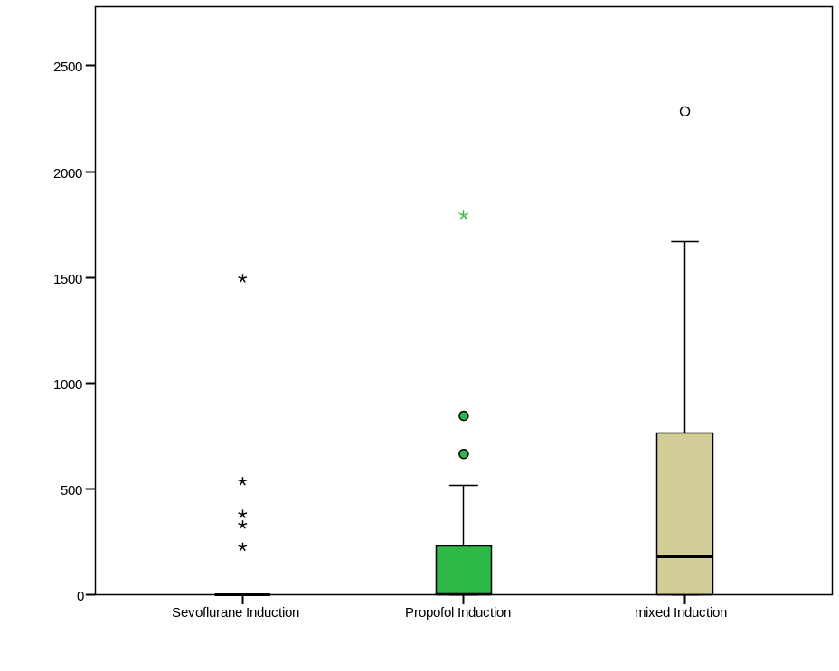

Figure s4 Burst Suppression duration related to anesthetic agent used for anesthesia maintenance.
