Supplementary Information
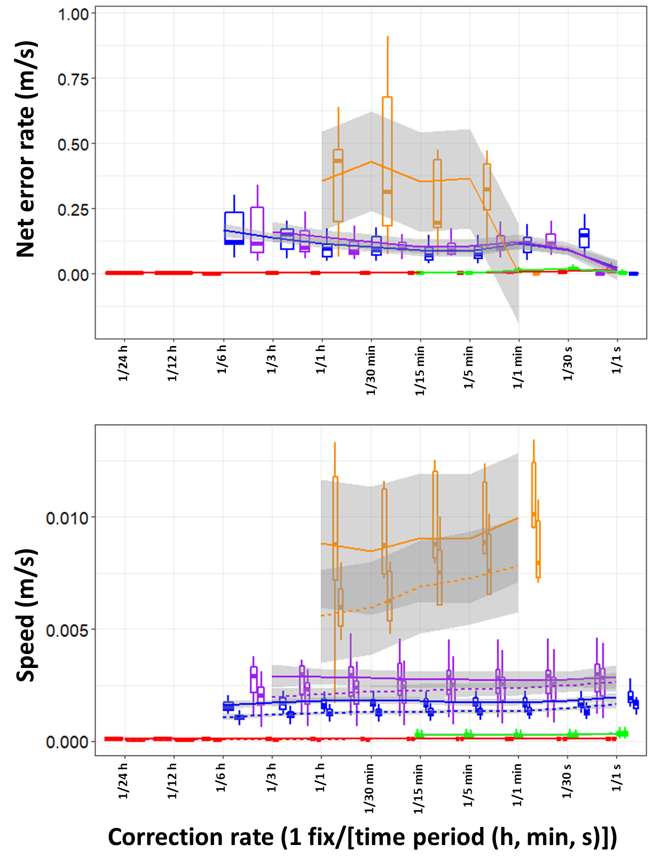
Figure SI1. Boxplots demonstrating the magnitude of net error (top panel) and distance moved (bottom panel), per VP correction rate and animal, standardised according to trip duration to provide an approximate rate. Mean values were aggregated per individual and VP correction rate. Boxes encompass the 25-75 % interquartile range and horizontal bars denote the median value with ‘loess’ smooth line (grey shading show the standard error and Whiskers extend to 1.5 * Interquartile range).

