Metaproteomics and metabonomics reveal the metabolic dysfunction of gut microbiota in Tibetan Minipigs in Atherosclerosis

Liye Shen ^{a,1}, Jinlong Wang^{b,1}, Yongming Pan^{d}, Yueqin Caiª, Junjie Huang^{d}, and Huiying Hu^{c}, Minli Chen^{a, d*}, Xianfu Ke^{c*}, Wenwei Zhou^{c*}

ªSchool of Pharmaceutical Sciences, Zhejiang Chinese Medical University, Hangzhou 310024, China
^{b}Key Laboratory of Systems Health Science of Zhejiang Province, Hangzhou Institute for Advanced Study, University of Chinese Academy of Sciences, Chinese Academy of Sciences, Hangzhou 310024, China
^{c}Key Laboratory of experimental animal and safety research of Zhejiang Province, Hangzhou Medical College, Hangzhou 310024, China
^{d}Translational medicine Research Center, Hangzhou Lifutai Biotechnology Co., Ltd, Hangzhou 310024, China

Funding：This work was supported by the National Natural Science Foundation of China (31970514), Zhejiang Provincial Public Welfare Technology Research Program (LTGD23C040012)

¹ These authors contributed equally to this work.
Liye Shen, Jinlong Wang,
*Corresponding author
Correspondence should be addressed to hh5498@126.com ( Wenwei Zhou) , kxf@hmc.edu.cn ( XianFu Ke), cmli991@zcmu.edu.cn ( MinLi Chen).

Abstract
Atherosclerosis is fundamental in the development of cardiovascular disease. The unhealthy dietary habits, high fat and cholesterol intake could change the composition of gut microbes and metabolites which play a critical role in the development of atherosclerosis. However, few studies have systematically investigated the metabolism of gut microbes in atherosclerosis. In this study, we build an atherosclerosis model using the Tibetan minipigs, then we identified metabolites in the feces and serum, and explored the functions of the gut microbiota by metaproteomics. We found that, in the feces, multiple signal pathways showed obvious metabolic dysfunction that could influence the abundance of blood metabolic products. Several metabolites such as 3-dehydro-2-deoxyecdysone from cholesterol metabolism, leukotriene B4 from arachidonic acid metabolism, indole-3-acetate and 3-hydroxyanthranilate from tryptophan metabolism, 9,10-epoxyoctadecenoic acid from linoleic acid metabolism and 13(S)-HPOT from linolenic acid metabolism were significantly increased in the blood. These partially increasing metabolites were associated with inflammation that contributes the development of atherosclerosis. Our finding could provide novel clues for studying on the mechanism of arteriosclerosis.

Keywords: Arteriosclerosis, Metaproteomics, Metabonomics, Gut microbiota metabolites, Tibetan Minipigs

Introduction
Cardiovascular disease (CVD) is a leading cause of death worldwide, with more than 17 million CVD-related deaths expected in 2020 ^{[1]}. Causes of CVD include atherosclerosis, congenital heart disease, arrhythmias, and heart failure. Atherosclerosis is the most common cause and is the result of complex interactions between environmental and genetic factors ^{[2]}. Among the environmental factors, diet is essential. Different foods interact with the gut microbiome, and the gut microbiome produces a large number of metabolites. Recent studies have shown that gut metabolites play a key role in the development of atherosclerosis ^{[3]}.
The gut microbiome, consisting of trillions of bacteria in the stomach and intestine, is a complex community whose metabolic activities and interactions with the immune system extend beyond the gut itself. The gut microbiome can be thought of as an endocrine organ, with each microbe having the ability to produce hundreds of known and unknown metabolites that act outside the gut. Host-microbiome interactions involving inflammation and metabolic pathways have been proposed to play a role in the pathogenesis of several immune-mediated diseases and metabolic disorders such as atherosclerosis, diabetes, and obesity. Host-microbiome interactions play a critical role in maintaining body balance and disease susceptibility, and microbial metabolites are potent regulators of host physiology ^{[4, 5]}.
Short-chain fatty acids (SCFAs) are the end products of fiber fermentation and are the main source of energy for colon cells that maintain the intestinal mucosal barrier. Butyrate appears to be more closely associated with atherosclerosis, and several studies have reported a reduction in the abundance of butyrate-producing bacteria in patients with coronary artery stenosis ^{[6]}. In addition to direct relevance, there have been studies showing that SCFAs are involved in inflammation and glucose and lipid metabolism in the body. SCFAs bind to G protein-coupled receptors 41 (GPR41) and 43 (GPR43) and bind to GPR41 and GPR43, transforming them into free fatty acid receptors 3 (FFAR3) and 2 (FFAR2). FFAR3 and FFAR2 inhibit multiple inflammation pathways such as interleukin 4 (IL-4), interleukin 6 (IL-6), and tumor necrosis factor (TNF-α) in the body ^{[7, 8]}. SCFAs can increase the expression of glucose transporter 4 (GLUT4) and transport it to the cell membrane, promoting myoblasts to absorb more glucose. SCFAs can regulate glucose metabolism in the body through this pathway. In addition to glucose metabolism, SCFAs can also regulate many physiological and pathological processes of lipid metabolism. Kindt et al. found in mice that the gut microbiome promotes hepatic lipid metabolism by providing high levels of acetate as a precursor for palmitate and stearate synthesis ^{[9]}. SCFAs not only serve as substrates for lipid metabolism but also act as regulators of lipid metabolism. The experiment by Li et al. showed that butyric acid increased fatty acid oxidation in brown adipose tissue of mice, ameliorating diet-induced obesity and insulin resistance ^{[10]}.
Another intestinal metabolite, trimethylamine (TMA), also plays a crucial role in the progression of atherosclerosis. Foods rich in fat (saturated, polyunsaturated, and monounsaturated) typically contain dietary nutrients with TMA components such as phosphatidylcholine, choline, and L-carnitine. TMA is produced by the gut microbiome through a series of microbial enzymes that metabolize choline, phosphatidylcholine, L-carnitine, and betaine. TMA then enters the portal vein and is oxidized by liver flavin monooxygenase 3 (FMO3) to trimethylamine oxide (TMAO). TMAO has received widespread attention as an important factor in CVD, with studies showing a direct correlation between plasma TMAO levels and the size and severity of atherosclerotic plaques ^{[11, 12]}.
In addition to SCFAs and TMA, secondary bile acids also play a key role in the occurrence and development of atherosclerosis. Cholesterol is converted into primary bile acids in the liver, and is converted into secondary bile acids with the help of intestinal microorganisms, promoting the absorption of lipids in the body. It regulates lipid metabolism through famesoid X receptor (FXR) signal transduction pathway, resulting in related metabolic diseases^{[13, 14]}. Studies have found that carnitine acetyltransferase (CRAT) mediated by influencing the bile acid synthesis ways to cardiac energy metabolism, cholesterol steady-state and myocardial cell innate immune reaction to promote within myocardial inflammation and chronic heart failure^{[15]}. In mice, supplementation with probiotics that regulate bile acid metabolism has been found to improve aortic plaque accumulation and serum and liver lipid levels in atherosclerotic mice^{[16]}.
The cardiovascular system, lipid metabolism structure, and AS lesion sites of miniature pigs are very similar to those of humans. Tibetan minipig is a characteristic breed in China, which has been widely used in the research of cardiovascular disease and diabetes. Our previous studies showed that Tibetan minipigs are susceptible to the formation of arteriosclerosis lesions by feeding high-fat diets, and obvious lipid disorders and inflammatory reactions can be observed ^{[17, 18]}. Tibetan minipigs as an arteriosclerosis model animal for studying the pathogenesis of human arteriosclerosis have a clear advantage. In this study, a model of atherosclerosis was induced in Tibetan minipigs by a high-fat diet, and non-targeted metabolites were determined in colonic feces and serum. The metabolites and pathways associated with atherosclerosis were selected to provide a reference for the study of the metabolic mechanisms of the atherosclerosis model.

Methods
2.1 Laboratory animal
Twelve male Tibetan minipigs, around 4 to 5 months old, were obtained from Dongguan Songshan Lake Pearl Laboratory Animal Technology Co., LTD. (SCXK (yue) 2017-0030) with certificate number 44410500000286. These minipigs were raised in the standard environment of the minipig laboratory at the Animal Experimental Research Center of Zhejiang Chinese Medical University (SYXK (zhe) 2018-0012), with conditions maintained at a temperature of 22±1 ℃, relative humidity between 40% and 60%, and light-dark cycles lasting 12 hours. After spending a month adjusting to the laboratory setting, six animals were randomly sorted into groups based on their weight and blood test results, ensuring that there were no significant variations among the groups. All animal care and experimental procedures were approved by the Laboratory Animal Management and Use Committee of the Animal Experimental Research Centre of Zhejiang Chinese Medical University, following strict adherence to guidelines for the welfare of laboratory animals (IACUC approval number: 20191021-10).
2.2 Animal serum, faeces and Aortic vessel
The AS model group (model group) received a high-fat, high-cholesterol (HFC) diet (HFC diet composition: 15% shortening, 10% egg yolk powder, 1.5% cholesterol, 0.5% choline, 73.0% basal diet), while the normal control group (NC group) was given a 100% basal diet. After 28 weeks, 5 mL of blood was drawn from the anterior vena cava of Tibetan minipigs in the NC group, and the supernatant was obtained following centrifugation at 3000 rpm for 10 minutes. Colon contents(faeces), iliac arteries, and coronary arteries were taken after euthanasia of miniature pigs. All supernatants were preserved in a freezer at -80°C.
2.3 HE staining to Observe the Patholo gical Morphology of Iliac arteries and Coronary arteries
Following the sacrifice of the animals, the iliac arteries and coronary artery were carefully isolated and immediately fixed in 10% formaldehyde. The tissues were then dehydrated, made transparent, embedded in wax, cut into 5 μm slices, patched, stained with HE dye (Thermo, Waltham, MA, USA), and finally mounted for analysis.The pathological sections of the vascular tissue were scanned using a 2.0 RS Nana Zoomer digital slide scanner (Hamamatsu, Hamamatsu, Japan). The NDP view 2 software was employed to accurately measure the intima-media thickness (IMT) of the vascular tissue.
2.4 Non-targeted metabolomics analysis
All the samples underwent thawing at a temperature of 4°C. A volume of 100 µL from each sample was placed into a 2 mL centrifuge tube. Following this step, 400 µL of methanol (-20 ℃) was introduced to each tube, and then shaken for a period of 60 seconds, ensuring thorough mixing. Subsequently, the mixture underwent centrifugation at a speed of 12000 rpm and a temperature of 4 ℃ for a duration of 10 minutes. The complete supernatant resulting from this process was gathered and moved to a fresh 1.5 mL centrifuge tube for vacuum concentration and subsequent drying.
The chromatographic separation procedure was conducted by utilizing a sophisticated Thermo Vanquish system equipped with an ACQUITY UPLC® HSS T3 column (150 × 2.1 mm, 1.8 µm, Waters) maintained at a constant temperature of 40 ℃. The autosampler temperature was set at 8 ℃. The separation of analytes involved the use of a gradient elution system comprising 0.1% formic acid in water (A1) and 0.1% formic acid in acetonitrile (B1) or 5 mM ammonium formate in water (A2) and acetonitrile (B2) at a steady flow rate of 0.25 mL/min. After the equilibration process, 2 μL of each sample was injected and subjected to analysis. A progressive linear gradient of solvent B (v/v) was applied in the following manner: 0~1 min, 2% B2/B1; 1~9 min, 2%~50% B2/B1; 9~12 min, 50%~98% B2/B1; 12~13.5 min, 98% B2/B1; 13.5~14 min, 98%~2% B2/B1; 14~20 min, 2% B1 positive model (14~17 min, 2% B2 negative model). The ESI-MSn experiments were executed on the Thermo Q Exactive Plus mass spectrometer with a spray voltage of 3.5 kV and -2.5 kV in positive and negative modes, correspondingly. The sheath gas and auxiliary gas were regulated at 30 and 10 arbitrary units, respectively. The capillary temperature was sustained at 325°C. The analyzer conducted a comprehensive scan over a mass range of m/z 81-1,000 for a full scan at a remarkable mass resolution of 70,000. Data-dependent acquisition (DDA) MS/MS experiments were implemented utilizing the HCD scan. The normalized collision energy was precisely set at 30%.
Proteowizard software was used to convert the original data into mzXML format, and R's XCMS package was used for peak identification, peak filtration, and peak alignment. The data matrix including mass-to-charge ratio (m/z), retention time, and intensity was obtained to establish metabolomics. The metabolites were confirmed based on the accurate molecular weight (molecular weight error <= 30ppm) and then the MS/MS fragment was analyzed using the Human Metabolome Database (HMDB) (http://www.hmdb.ca), METLIN (http://metlin.scripps.edu), Massbank (http://www.massbank.jp/), LipidMaps (http://www.lipidmaps.org), mzClound (https://www.mzcloud.org) and the self-established standard databases for metabolite annotation.
2.5 metaproteomics analysis
The feces samples underwent an initial centrifugation step at 700 g, 4 °C for 5 minutes, followed by transferring the supernatant to a new tube for subsequent centrifugation at 14,000 g, 4 °C for 20 minutes. The resulting pellet fraction was then collected for metaproteomic analysis. Proteins were extracted utilizing a protein lysis buffer that consisted of 8M urea in a 50 mM Tris-HCl buffer (pH 8.0). To ensure thorough elimination of any residual cell debris, a high-speed centrifugation at 14,000g, 4°C for 10 minutes was performed. For the in-solution trypsin digestion process, each sample containing 30 μg of protein was subjected to reduction and alkylation using 10mM dithiothreitol and 20mM iodoacetamide, respectively. Subsequently, 0.5 μg of trypsin was introduced for overnight digestion at 37°C with agitation. The resulting tryptic peptides were then purified on a C18 column and subjected to analysis using a Q Exactive mass spectrometer (ThermoFisher Scientific Inc.). The peptides were loaded and separated on an analytical column (75 μm × 30 cm) packed with reverse phase beads (1.7 μm) employing a 1.5-hour gradient from 5 to 35% acetonitrile (v/v) at a flow rate of 400 nl/min. The instrumental methodology encompassed a full MS scan covering the range from 300 to 1800 m/z, succeeded by a data-dependent MS/MS scan targeting the 20 most intense ions.
The MS RAW data underwent processing through MetaLab 2.3, serving as an integrated analysis platform for metaproteomics. The integrated Gut Microbiome Protein Database, which encompassed a vast 798,410 entries, was utilized as a pivotal reference protein database. Label-free quantification was executed utilizing the MaxLFQ algorithm for data analysis and quantification.
2.6 Targeted quantification of bile acids
A mount of 200 μL of serum or feces samples was prepared and 600 μL of methanol was added to a 2 mL EP tube, the tubes were vortexed for 2 minutes and centrifuged at 4°C at 12,000 rpm for 20 minutes. The supernatants were collected and the sample was dehydrated at ambient temperature using a vacuum concentrator. Approximately 200 μL of methanol at -20°C was used to dissolve the sample for analysis. An ACQUITY UPLC® BEH C18 column (Waters USA, 2.1×100 mm, 1.7 μm) with an injection volume of 10 μL was used. The column temperature was set at 40°C. Mobile phases A (0.01% formic acid water) and B (acetonitrile) were used. The elution gradient was designed to follow these parameters: 0-8 minutes, 25% B; 8-18 minutes, 25-30% B; 18-28 minutes, 30-36% B; 28-36 minutes, 36-38% B; 36-48 minutes, 38-50% B; 48-64 minutes, 50-75% B; 64-70 minutes, 75-100% B; 70-76 minutes, 100-25% B. The flow rate was set at 0.25 mL/min. Multiple reaction monitoring (MRM) was performed.
2.7 Statistical and Data Analysis.
All charts were created using R language statistics, with x±SEM used to show the differences between the two groups compared via Student’s t-test, P < 0.05 was statistically significant. P values were corrected by the Benjamini and Hochberg method.

Data and materials availability
All data needed to evaluate the conclusions in the paper are presented in the paper and/or the Supplementary Materials. Raw data are available upon request.
The mass spectrometry metaproteomics data have been deposited to the iProX database (https://www.iprox.cn/) with the dataset identifier IPX0009047001.

Results
The identification of metabolites in serum and gut of Tibetan Minipigs in Atherosclerosis
To investigate the metabolites present in the serum and intestines in the atherosclerosis, we established an atherosclerosis model by feeding Tibetan mini-pigs with a high-fat diet. Following a period of 28 weeks, we observed the presence of atherosclerotic plaque (Fig. 1A and 1B) and the intima media thickness is significantly increased in coronary artery and iliac artery vessels (Fig. 1C). Subsequently, we characterized the metabolites in the serum and feces specimens obtained from 6 control and 6 atherosclerotic Tibetan minipigs utilizing advanced untargeted metabolomics technology. Principal component analysis (PCA) based on the abundance of metabolites revealed an obvious separation between control and model groups (Fig. 1D and 1E). A total of 492 and 704 metabolites were identified in serum and feces, respectively. Remarkably, approximately 296 metabolites were identified in both serum and feces (Fig. 1F). Then, we analyzed the differentially changed metabolites in both serum and feces. Unfortunately, only 9 metabolites showed a similar trend, five metabolites such as deoxycholic acid, deoxyinosine, ascorbate, oleic acid, and pyrimidodiazepine were up-regulated in the AS group, and four metabolites such as kynurenic acid, acetylcholine, spermidine, and isoetharine were down-regulated in the AS group (Fig. 1G). The oleic acid is an unsaturated fatty acid that could induces damage in epithelial and endothelial cells and has been linked to metabolic and inflammatory diseases ^{[19, 20]}. Deoxycholic acid belongs to the bile acid, that as signaling molecule for coordinately regulating metabolism and inflammation via the nuclear farnesoid X receptor (FXR) and the Takeda G protein-coupled receptor 5 (TGR5)^{[21]}.
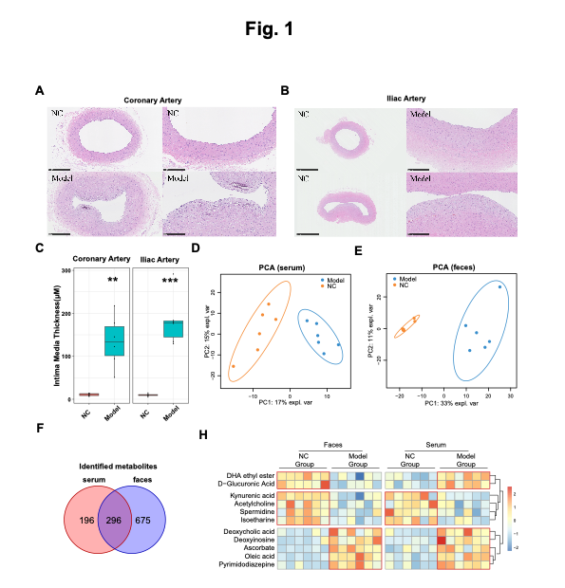
The bile acids were enriched in the gut of Tibetan Minipigs in Atherosclerosis
To comprehensively examine the characteristics of bile acids in atherosclerosis, we analyzed 36 bile acids in serum and feces samples through targeted metabolomics. Notably, 19 out of 36 bile acids in the feces samples and 6 out of 36 bile acids in the serum were significantly elevated in the AS group, with none showing a decrease (Fig. 2A). In human, bile acids can be divided into two major categories based on their structure: one is free bile acids, including cholic acid, deoxycholic acid, alpha-deoxycholic acid, and a small amount of lithocholic acid; the other is conjugated bile acids, which are products of the combination of free bile acids with glycine or taurine. Overall, total bile acids, free bile acids, and glycine-type bile acids were notably increased in the feces samples, while taurine-type bile acids exhibited no significant changes. In the serum, only free bile acids displayed a significant increase (Fig. 2B). Principal component analysis (PCA) based on the abundance of bile acids revealed a substantial separation between samples of the control and AS groups in the feces samples, indicating significant differences in bile acid composition (Fig. 2C). Furthermore, there was a significant increase in the diversity of bile acids in the AS group in both serum and feces samples (Fig. 2D). The distribution homogeneity of bile acids was assessed using the Gini coefficient and visualized with Lorenz curves. A Gini coefficient closer to zero indicates a more even distribution of bile acids. In Lorenz curves, a greater curvature signifies a more unequal distribution of bile acids, and vice versa. Consequently, the lower curvature in the Lorenz curves observed and the reduced Gini coefficient in the AS group indicate a more even distribution of bile acids in the AS group, both in serum and feces samples (Fig. 2E and 2F).
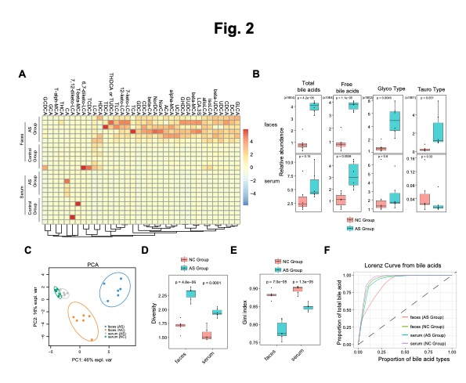
The metabolic pathways of cholesterol and arachidonic acid were significantly enriched in the feces of the AS group.
Furthermore, the metabolic pathways enrichment analysis was performed. We found that cholesterol and arachidonic acid were significantly increased in the feces of the AS group (Fig. 3A). To explore serum metabolites derived from increasing the pathway in the feces, we mapped the all the changed metabolites from serum and feces samples to these pathways. Multiple cholesterol related pathways including steroid hormone biosynthesis, insect hormone biosynthesis, cortisol synthesis and bile acid biosynthesis were increased (Fig. 3B). In addition to the observation that bile acids were elevated in the serum, 3-Dehydro-2-deoxyecdysone was increased in the serum. The 3-Dehydro-2-deoxyecdysone is a natural product found in the bacteria ^{[22]}. It implied that the products of cholesterol metabolism from gut microbiota were absorbed into blood. For arachidonic acid metabolism, decreasing arachidonic acid and increasing products of arachidonic acid were observed in the feces, especially, a number of prostaglandin were increased in the feces (Fig. 3C). The 11,12-EET, a product of arachidonic acid, is an anti-inflammatory eicosapentaenoic acid metabolite belonging to the EETs (epoxyedientriols) family and reduced in the feces. It has a variety of biological functions, including, antioxidant, vasodilator and blood pressure regulation ^{[23]}. Prostaglandins have been thought to act mainly to mediate acute inflammation ^{[24]}. Leukotriene B4, which was increased in the serum, can cause physiological effects such as vasodilation, leukocyte chemotaxis and activation of inflammatory cells^{[25]}.
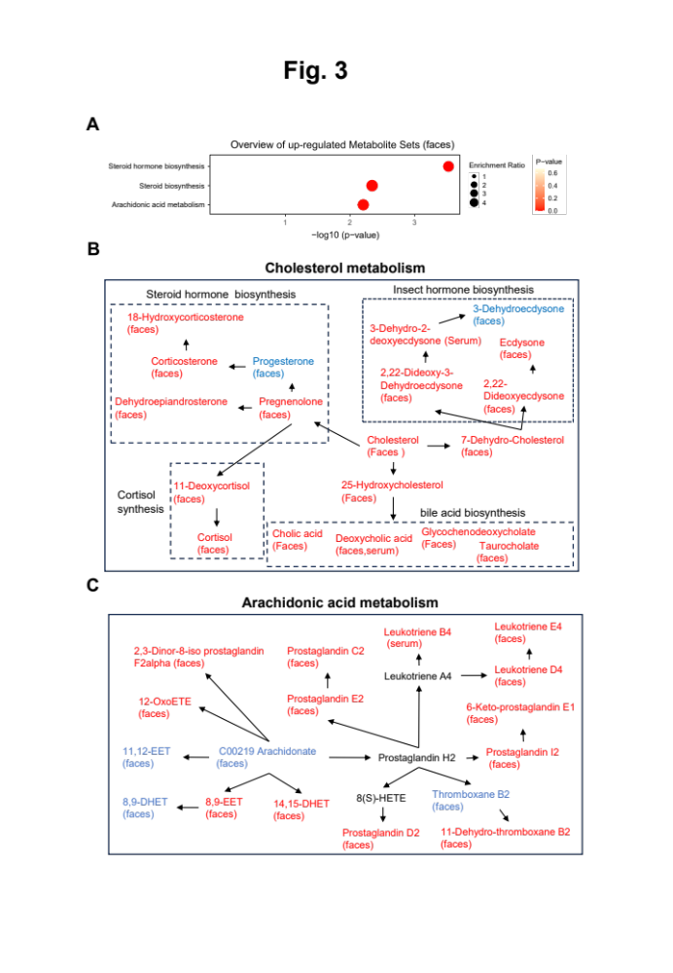
The multiple metabolic pathways were significantly reduced in the feces of the AS group.
Using the same method, we analyzed the down-regulated proteins in the feces. Three pathway including tryptophan biosynthesis, Biosynthesis of unsaturated fatty acids and Linoleic acid metabolism were significantly decreased in the feces of the AS group (Fig. 4A). After mapping the all the changed metabolites from serum and feces samples to these pathways, In the tryptophan biosynthesis, tryptophan, Indole and Indol-3-acetamide were reduced in the feces and Indole-3-acetate was induced in the feces. Importantly, these four metabolites were turned into Indole-3-acetate and Indole-3-acetate was significantly increased in the serum. It implied that the product of tryptophan metabolism in the serum could be influenced by gut microbiota (Fig. 4B). For unsaturated fatty acids, Multiple polyunsaturated fatty acids including icosatrienoic acid(Δ11,14,17) in serum, linoleic acid (Δ9,12) in feces, dihomo-gammalinolenic acid (Δ8,11,14) in feces and arachidonic acid(Δ5,8,11,14) in feces were reduced and multiple monounsaturated fatty acids including (9Z)-octadecenoic acid(Δ9) in feces and icosenoic acid (Δ11) in feces were induced (Fig. 4C). Polyunsaturated fatty acids could lower cholesterol levels, reduce inflammation, and improve vascular function for preventing and treating arterial stiffness ^{[26]}. For linoleic acid metabolism, the ω-oxidation products arachidonate and dihomo-gamma-linolenate were decreased, a few epoxidation products and downstream products including 9-OxoODE, 9(10)-EpOME, 9,10-DHOME, 13(S)-HPODE and 13(S)-HODE were increased (Fig. 4D). Such metabolic abnormalities were also observed in Linolenic acid metabolism (Fig. 4E).
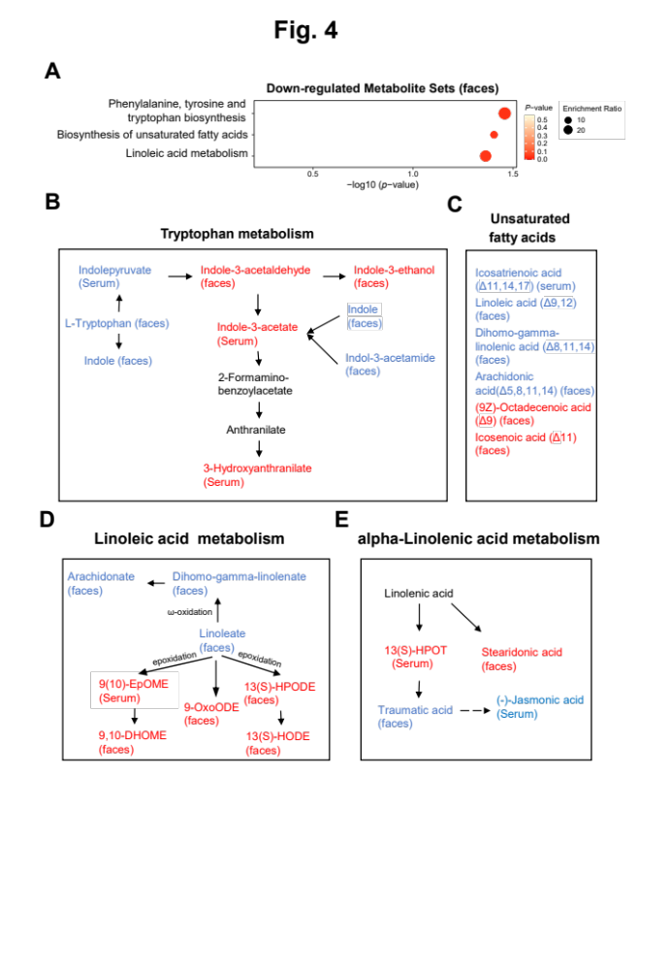
The functional compositions of microbiome in AS group.
To characterize the functionality of intestinal microbiome in the AS, we performed an analysis of microbiota proteins by a metaproteomics technique in 6 control samples and 6 feces samples. Using data dependent acquisition (DDA), a total of 8467 peptides with taxonomy annotation were identified and which were correspond to 3851 protein groups, 57 species, 47 genera, 35 families, 25 orders, 19 classes and 10 phyla. In different levels, the diversity and distribution evenness were evaluated, increasing diversity and decreasing unevenness were observed in the species level between control and AS group, while no obvious difference was observed in the genera, families, orders, classes and phyla levels (Fig. 5A). Principal component analysis (PCA) based on the abundance of species showed an obvious difference between control and AS group (Fig. 5B). With strict filtering, four species including Oscillibacter sp. KLE 1745, Ruminococcus Callidus, Ruminococcus flavefaciens and Dorea longicatena were up-regulated with fold change >2 and adjusted p-value <0.01 and none of species were down-regulated (Fig. 5C). Dorea longicatena was associated with obesity that could be contributed the cardiovascular disease ^{[27]}. Ruminococcus Callidus is associated with Inflammation-related diseases ^{[28]}.
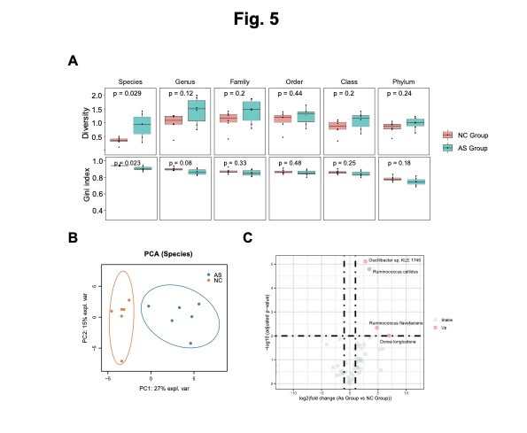
To expore the microbial functions, we annotated all the quantified microbial proteins using the COG database. Consequently, functions related to Translation, ribosomal structure and biogenesis (10 COGs in category J), Posttranslational modification, protein turnover, chaperones (6 COGs in category O), Carbohydrate transport and metabolism (5 COGs in category G) and General function prediction only (2 COGs in category R), Inorganic ion transport and metabolism (2 COGs in category P), Energy production and conversion (4 COGs in category C) and 7 other COGs were among the most significantly increased functions identified in AS group. Only 3 COGs including Zinc metallochaperone YeiR/ZagA and related GTPases, G3E family (COG0523), Outer membrane receptor for Fe3+−dicitrate (COG4772) and ABC−type Fe3+−hydroxamate transport system, periplasmic component (COG0614) were decreased in the AS group (Fig. 6A).
Apart from that, we analyzed the abundance of fatty acids and cholesterol-related proteins. Three proteins ACADS, ACAT, and fabB were enriched in the AS group in some bacteria. ACADS and ACAT were involved in fatty acids degradation, and these two proteins were increased in the Oscillospiraceae of AS group (Fig 6B).
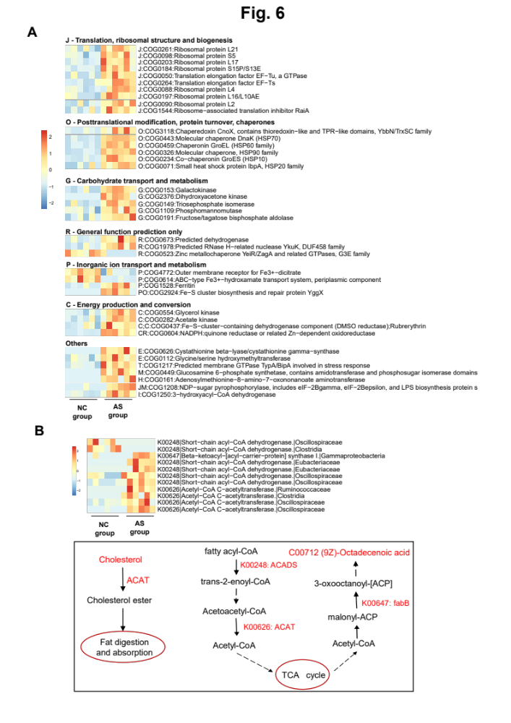
Disscussion
Abnormal changes of metabolites in the blood may be affected by intestinal metabolism of substances such as TMAO which is produced by intestinal bacteria and has been implicated in the development of cardiovascular and metabolic diseases and could promote the development of atherosclerosis and cardiovascular diseases ^{[29]}. This study systematically explored the metabolism of intestinal microbiota and potential blood metabolites that could be affected by intestinal microbiota in arteriosclerosis. Several metabolites such as 3-dehydro-2-deoxyecdysone from cholesterol metabolism, leukotriene B4 from arachidonic acid metabolism, indole-3-acetate and 3-hydroxy anthranilate from tryptophan metabolism, 9(10)-EpOME (9,10-epoxyoctadecenoic acid) from linoleic acid metabolism, and 13(S)-HPOT from linolenic acid metabolism were significantly increased in the blood and abundance of these metabolites could be affected by the intestinal microbiota. Importantly, leukotriene B4 and 9(10)-EpOME had been reported to be associated with inflammation that contributes the development of atherosclerosis.
In recent years, increasing evidences have shown that bile acids are associated with inflammation ^{[30, 31]}. In this study, a number of bile acids were increased in the serum and feces in the AS group and a clear species bias for these increasing bile acids was observed. In the feces, the free bile acids, and glycine-type bile acids were notably increased, while taurine-type bile acids exhibited no significant changes. In the serum, only free bile acids displayed a significant increase. The bile acid is synthesized by the liver, its main function is to help digestion and absorption of fat. After being synthesized in the liver, bile acids are stored in the gallbladder and released when food enters the small intestine, if the body consumes too much fat and cholesterol, the amount of bile acids synthesized by the liver may increase, leading to excessive accumulation of bile acids. Excessive accumulation of bile acids may further affect lipid metabolism in the blood and increase blood cholesterol and triglyceride levels. These abnormal lipid metabolic states will accelerate the oxidative and inflammatory responses of arterial endothelial cells, and promote the formation and development of atherosclerotic plaques.
Unsaturated fatty acids along with their derivatives have the potential to disturb the typical integrity of endothelial cells, ultimately diminishing the endothelium's capacity to function as a selectively permeable barrier for blood components. The reasons behind fatty acid-induced dysfunction in endothelial cells could possibly be associated with alterations in fatty acid makeup and a rise in oxidative stress within the cells. In this study, linoleic acid metabolism is disturbed in feces, epoxidation of linoleic acid is elevated, and several increasing epoxidation products were observed, among which, 9,10-EpOME, also known as leukotoxin, are detected in the blood. Linoleic acid is converted to linoleic epoxides 9,10-epoxyoctadecenoic acid (9,10-EpOME), by cytochrome P450 (CYP) enzymes ^{[32]}. 9,10-EpOME induced inflammation and oxidative stress by activated NF-κB and AP-1 transcription factors ^{[33]}.
Declarations
Ethics approval and consent to participate
All animal care and experimental procedures were approved by the Laboratory Animal Management and Use Committee of the Animal Experimental Research Centre of Zhejiang Chinese Medical University, following strict adherence to guidelines for the welfare of laboratory animals (IACUC approval number: 20191021-10).
Consent for publication
All authors agree to publication.
Conflicts of Interest
All authors declare that there is no conflict of interest.
Availability of data and materials
All data needed to evaluate the conclusions in the paper are presented in the paper and/or the Supplementary Materials. Raw data are available upon request.
The mass spectrometry metaproteomics data have been deposited to the iProX database (https://www.iprox.cn/) with the dataset identifier IPX0009047001.
Competing interests
There are no competing interests in this article.
Funding
The work was supported by the national natural science foundation of China (31970514) and Zhejiang Provincial Public Welfare Technology Research Program (LTGD23C040012)
Authors’ Contributions
Minli Chen, Xianfu Ke and Wenwei Zhou is responsible for project administration and funding acquisition. Liye Shen is responsible for conducting experiments, analyzing data, and writing the manuscript. Jinlong Wang is responsible for analyzing data, and writing the manuscript. All the authors are responsible for revising the manuscript.
Acknowledgments
The work was supported by the national natural science foundation of China (31970514); Zhejiang Provincial Public Welfare Technology Research Program (LTGD23C040012) and the laboratory of the Animal Experimental Research Center of Zhejiang Chinese Medical University.

Reference
1. Acosta S, Johansson A, Drake I. Diet and Lifestyle Factors and Risk of Atherosclerotic Cardiovascular Disease—A Prospective Cohort Study. Nutrients 2021, 13(11).
2. Yu Z, Yin J, Tang Z, Hu T, Wang Z, Chen Y, et al. Non-coding RNAs are key players and promising therapeutic targets in atherosclerosis. Frontiers in Cell and Developmental Biology 2023, 11.
3. Tang WHW, Bäckhed F, Landmesser U, Hazen SL. Intestinal Microbiota in Cardiovascular Health and Disease. Journal of the American College of Cardiology 2019, 73(16): 2089-2105.
4. Wang G, Fan Y, Zhang G, Cai S, Ma Y, Yang L, et al. Microbiota-derived indoles alleviate intestinal inflammation and modulate microbiome by microbial cross-feeding. Microbiome 2024, 12(1).
5. Litvak Y, Byndloss MX, Bäumler AJ. Colonocyte metabolism shapes the gut microbiota. Science (New York, NY) 2018, 362(6418).
6. Trøseid M, Andersen GØ, Broch K, Hov JR. The gut microbiome in coronary artery disease and heart failure: Current knowledge and future directions. EBioMedicine 2020, 52.
7. He J, Zhang P, Shen L, Niu L, Tan Y, Chen L, et al. Short-Chain Fatty Acids and Their Association with Signalling Pathways in Inflammation, Glucose and Lipid Metabolism. International Journal of Molecular Sciences 2020, 21(17).
8. Pingitore A, Gonzalez-Abuin N, Ruz-Maldonado I, Huang GC, Frost G, Persaud SJ. Short chain fatty acids stimulate insulin secretion and reduce apoptosis in mouse and human islets in vitro: Role of free fatty acid receptor 2. Diabetes, obesity & metabolism 2019, 21(2): 330-339.
9. Kindt A, Liebisch G, Clavel T, Haller D, Hörmannsperger G, Yoon H, et al. The gut microbiota promotes hepatic fatty acid desaturation and elongation in mice. Nature Communications 2018, 9(1).
10. Li Z, Yi C-X, Katiraei S, Kooijman S, Zhou E, Chung CK, et al. Butyrate reduces appetite and activates brown adipose tissue via the gut-brain neural circuit. Gut 2018, 67(7): 1269-1279.
11. Tang WHW, Li DY, Hazen SL. Dietary metabolism, the gut microbiome, and heart failure. Nature Reviews Cardiology 2018, 16(3): 137-154.
12. Yoo W, Zieba JK, Foegeding NJ, Torres TP, Shelton CD, Shealy NG, et al. High-fat diet-induced colonocyte dysfunction escalates microbiota-derived trimethylamine N-oxide. Science (New York, NY) 2021, 373(6556): 813-818.
13. Fogelson KA, Dorrestein PC, Zarrinpar A, Knight R. The Gut Microbial Bile Acid Modulation and Its Relevance to Digestive Health and Diseases. Gastroenterology 2023, 164(7): 1069-1085.
14. Xu H, Fang F, Wu K, Song J, Li Y, Lu X, et al. Gut microbiota-bile acid crosstalk regulates murine lipid metabolism via the intestinal FXR-FGF19 axis in diet-induced humanized dyslipidemia. Microbiome 2023, 11(1): 262.
15. Mao H, Angelini A, Li S, Wang G, Li L, Patterson C, et al. CRAT links cholesterol metabolism to innate immune responses in the heart. Nature metabolism 2023, 5(8): 1382-1394.
16. Liang X, Zheng X, Wang P, Zhang H, Ma Y, Liang H, et al. Bifidobacterium animalis subsp. lactis F1-7 Alleviates Lipid Accumulation in Atherosclerotic Mice via Modulating Bile Acid Metabolites to Downregulate Intestinal FXR. Journal of agricultural and food chemistry 2024, 72(5): 2585-2597.
17. Shen L, Wang J, Pan Y, Huang J, Zhu K, Tu H, et al. Characteristics of Metabolites in the Development of Atherosclerosis in Tibetan Minipigs Determined Using Untargeted Metabolomics. Nutrients 2023, 15(20).
18. Yang Q, Xu Y, Shen L, Pan Y, Huang J, Ma Q, et al. Guanxinning Tablet Attenuates Coronary Atherosclerosis via Regulating the Gut Microbiota and Their Metabolites in Tibetan Minipigs Induced by a High-Fat Diet. Journal of immunology research 2022, 2022: 7128230.
19. Gonçalves-de-Albuquerque CF, Silva AR, Burth P, Castro-Faria MV, Castro-Faria-Neto HC. Acute Respiratory Distress Syndrome: Role of Oleic Acid-Triggered Lung Injury and Inflammation. Mediators of Inflammation 2015, 2015: 1-9.
20. Menezes SLS, Bozza PT, Faria Neto HCC, Laranjeira AP, Negri EM, Capelozzi VL, et al. Pulmonary and extrapulmonary acute lung injury: inflammatory and ultrastructural analyses. Journal of Applied Physiology 2005, 98(5): 1777-1783.
21. Chávez-Talavera O, Tailleux A, Lefebvre P, Staels B. Bile Acid Control of Metabolism and Inflammation in Obesity, Type 2 Diabetes, Dyslipidemia, and Nonalcoholic Fatty Liver Disease. Gastroenterology 2017, 152(7): 1679-1694.e1673.
22. Roussel JP. [New studies on 3-dehydroecdysteroids in the biosynthetic pathway of ecdysone in Locusta migratoria]. Archives internationales de physiologie, de biochimie et de biophysique 1994, 102(1): 33-41.
23. Deng Y, Theken KN, Lee CR. Cytochrome P450 epoxygenases, soluble epoxide hydrolase, and the regulation of cardiovascular inflammation. Journal of molecular and cellular cardiology 2010, 48(2): 331-341.
24. Yao C, Narumiya S. Prostaglandin-cytokine crosstalk in chronic inflammation. British journal of pharmacology 2019, 176(3): 337-354.
25. Crooks SW, Stockley RA. Leukotriene B4. The international journal of biochemistry & cell biology 1998, 30(2): 173-178.
26. Liput KP, Lepczyński A, Ogłuszka M, Nawrocka A, Poławska E, Grzesiak A, et al. Effects of Dietary n-3 and n-6 Polyunsaturated Fatty Acids in Inflammation and Cancerogenesis. Int J Mol Sci 2021, 22(13).
27. Companys J, Gosalbes MJ, Pla-Pagà L, Calderón-Pérez L, Llauradó E, Pedret A, et al. Gut Microbiota Profile and Its Association with Clinical Variables and Dietary Intake in Overweight/Obese and Lean Subjects: A Cross-Sectional Study. Nutrients 2021, 13(6).
28. Zhou Z, Lv H, Lv J, Shi Y, Huang H, Chen L, et al. Alterations of gut microbiota in cirrhotic patients with spontaneous bacterial peritonitis: A distinctive diagnostic feature. Frontiers in Cellular and Infection Microbiology 2022, 12.
29. Cho CE, Caudill MA. Trimethylamine-N-Oxide: Friend, Foe, or Simply Caught in the Cross-Fire? Trends in endocrinology and metabolism: TEM 2017, 28(2): 121-130.
30. Cai J, Sun L, Gonzalez FJ. Gut microbiota-derived bile acids in intestinal immunity, inflammation, and tumorigenesis. Cell host & microbe 2022, 30(3): 289-300.
31. Guo C, Xie S, Chi Z, Zhang J, Liu Y, Zhang L, et al. Bile Acids Control Inflammation and Metabolic Disorder through Inhibition of NLRP3 Inflammasome. Immunity 2016, 45(4): 802-816.
32. Hildreth K, Kodani SD, Hammock BD, Zhao L. Cytochrome P450-derived linoleic acid metabolites EpOMEs and DiHOMEs: a review of recent studies. The Journal of Nutritional Biochemistry 2020, 86.
33. Viswanathan S, Hammock BD, Newman JW, Meerarani P, Toborek M, Hennig B. Involvement of CYP 2C9 in mediating the proinflammatory effects of linoleic acid in vascular endothelial cells. Journal of the American College of Nutrition 2003, 22(6): 502-510.

Figure Legend
Figure 1. Identification of differential abundance of metabolites in the serum and feces based on the untargeted metabolome in Tibetan miniature pig.
(A) and (B) Comparison of HE staining of coronary artery vessels (A) and iliac artery vessels (B) between model and NC groups.
(C) Box graph showing the difference in Intima Media Thickness (μM) of coronary artery vessels and iliac artery vessels between the NC and model groups. The * indicates p < 0.05, the ** indicates p < 0.01, the *** indicates p < 0.001.
(D) and (E) PCA visualization for serum (D) and feces (E) metabolites between NC and model groups.
(F) The Venn graph showing the overlapping of identified metabolites between serum and feces.
(G) The heat map showing the abundance of Differential metabolites between NC and model groups both in the serum and feces.

Figure 2. The profiling of bile acids in the serum and feces based on the targeted metabolome.
(A) Heat map showing hierarchical clustering of 36 bile acids for NC and AS groups.
(B) Box graph showing the difference of relative abundance of total bile acids, free bile acids, glyco-type bile acids and tauro-type bile acids between the NC and model groups in feces and serum. The * indicates p < 0.05, the ** indicates p < 0.01, the *** indicates p < 0.001.
(C) PCA visualization for bile acids of serum and feces between NC and model groups.
(D) and (E) Box graph showing the difference of diversity (D) and gini coefficient (E) between the NC and model groups in feces and serum. The * indicates p < 0.05, the ** indicates p < 0.01, the *** indicates p < 0.001.
(F) Comparation of Lorenz curve for bile acids between the NC and model groups in feces and serum.

Fig. 3 The metabolic pathways increased in the AS model group
(A) Enriched metabolite sets from up-regulated metabolites in the KEGG database in AS model group
(B) and (C) The flow chart showing the cholesterol metabolism (B) and arachidonic acid metabolism (C). The red and blue color indicates the up-regulated and down-regulated metabolites from serum or feces in the AS, respectively.

Fig. 4 The metabolic pathways decreased in the AS model group
(A) Enriched metabolite sets from down-regulated metabolites in the KEGG database in AS model group
(B-E) The flow chart showing tryptophan metabolism (B), unsaturated fatty acids (C), linoleic acid metabolism (D) and linolenic acid metabolism (E). The red and blue color indicates the up-regulated and down-regulated metabolites from serum or feces in the AS, respectively.

Fig. 5 The changed gut microbiota in the AS model group
(A) The box graph showing the difference of diversity and gini coefficient between the NC and model groups in different taxonomy levels. The * indicates p < 0.05, the ** indicates p < 0.01, the *** indicates p < 0.001.
(B) PCA visualization in the species levels between NC and model groups.
(C) The volcano graph showing the species changing between the NC and model group with fold change >= 2, adjusted p value < 0.01.

Fig. 6 Functional compositions of microbiome in AS group.
(A) Heatmap of differentially abundant COGs between the NC and model group. Representative COG categories are shown and the colors indicate the LFQ intensity for each samples. Each row corresponds to a COG with the COG id and
name indicated.
(B) The flow chart showing fatty acid and metabolism. The red and blue color indicates the up-regulated and down-regulated proteins or metabolites from feces in the AS, respectively.

