Supplementary Information
Tuning Cyanide Coordination Electronic Structure Enables Stable Prussian Blue Analogues for Sodium-ion Batteries
Yuanheng Wang ¹, Jiaxin Yan ¹, Bingxing Xie ^{2,}*, Yan Meng ¹, Chuankai Fu ¹, Fanpeng Kong ¹, Xingyu Wang ¹, Qingjie Zhou ¹, Xin Chen ¹, Jianting Li ¹, Chunyu Du ¹, Liguang Wang ^{3,}*, Pengjian Zuo ^{1,}*
¹ State Key Laboratory of Space Power-Sources, MIIT Key Laboratory of Critical Materials Technology for New Energy Conversion and Storage, School of Chemistry and Chemical Engineering, Harbin Institute of Technology, No.92 West-Da Zhi Street, Harbin 150001, China
² School of New Energy, Nanjing University of Science and Technology, Jiangyin 214443, PR China
³ College of Chemical and Biological Engineering, Zhejiang University, Hangzhou, 310058, China
Corresponding Author
*zuopj@hit.edu.cn; bingxingxie@njust.edu.cn; wanglg@zju.edu.cn

Supporting equation
i = av^{b} Equation S1
log(i) = blog(v) + log(a) Equation S2
where i and v represent the peak current and scan rate, respectively, a and b are constant. The value of b reveals the sodium storage mechanism, i.e., a diffusion-limited process with b = 0.5, a surface-limited process with b = 1.0.

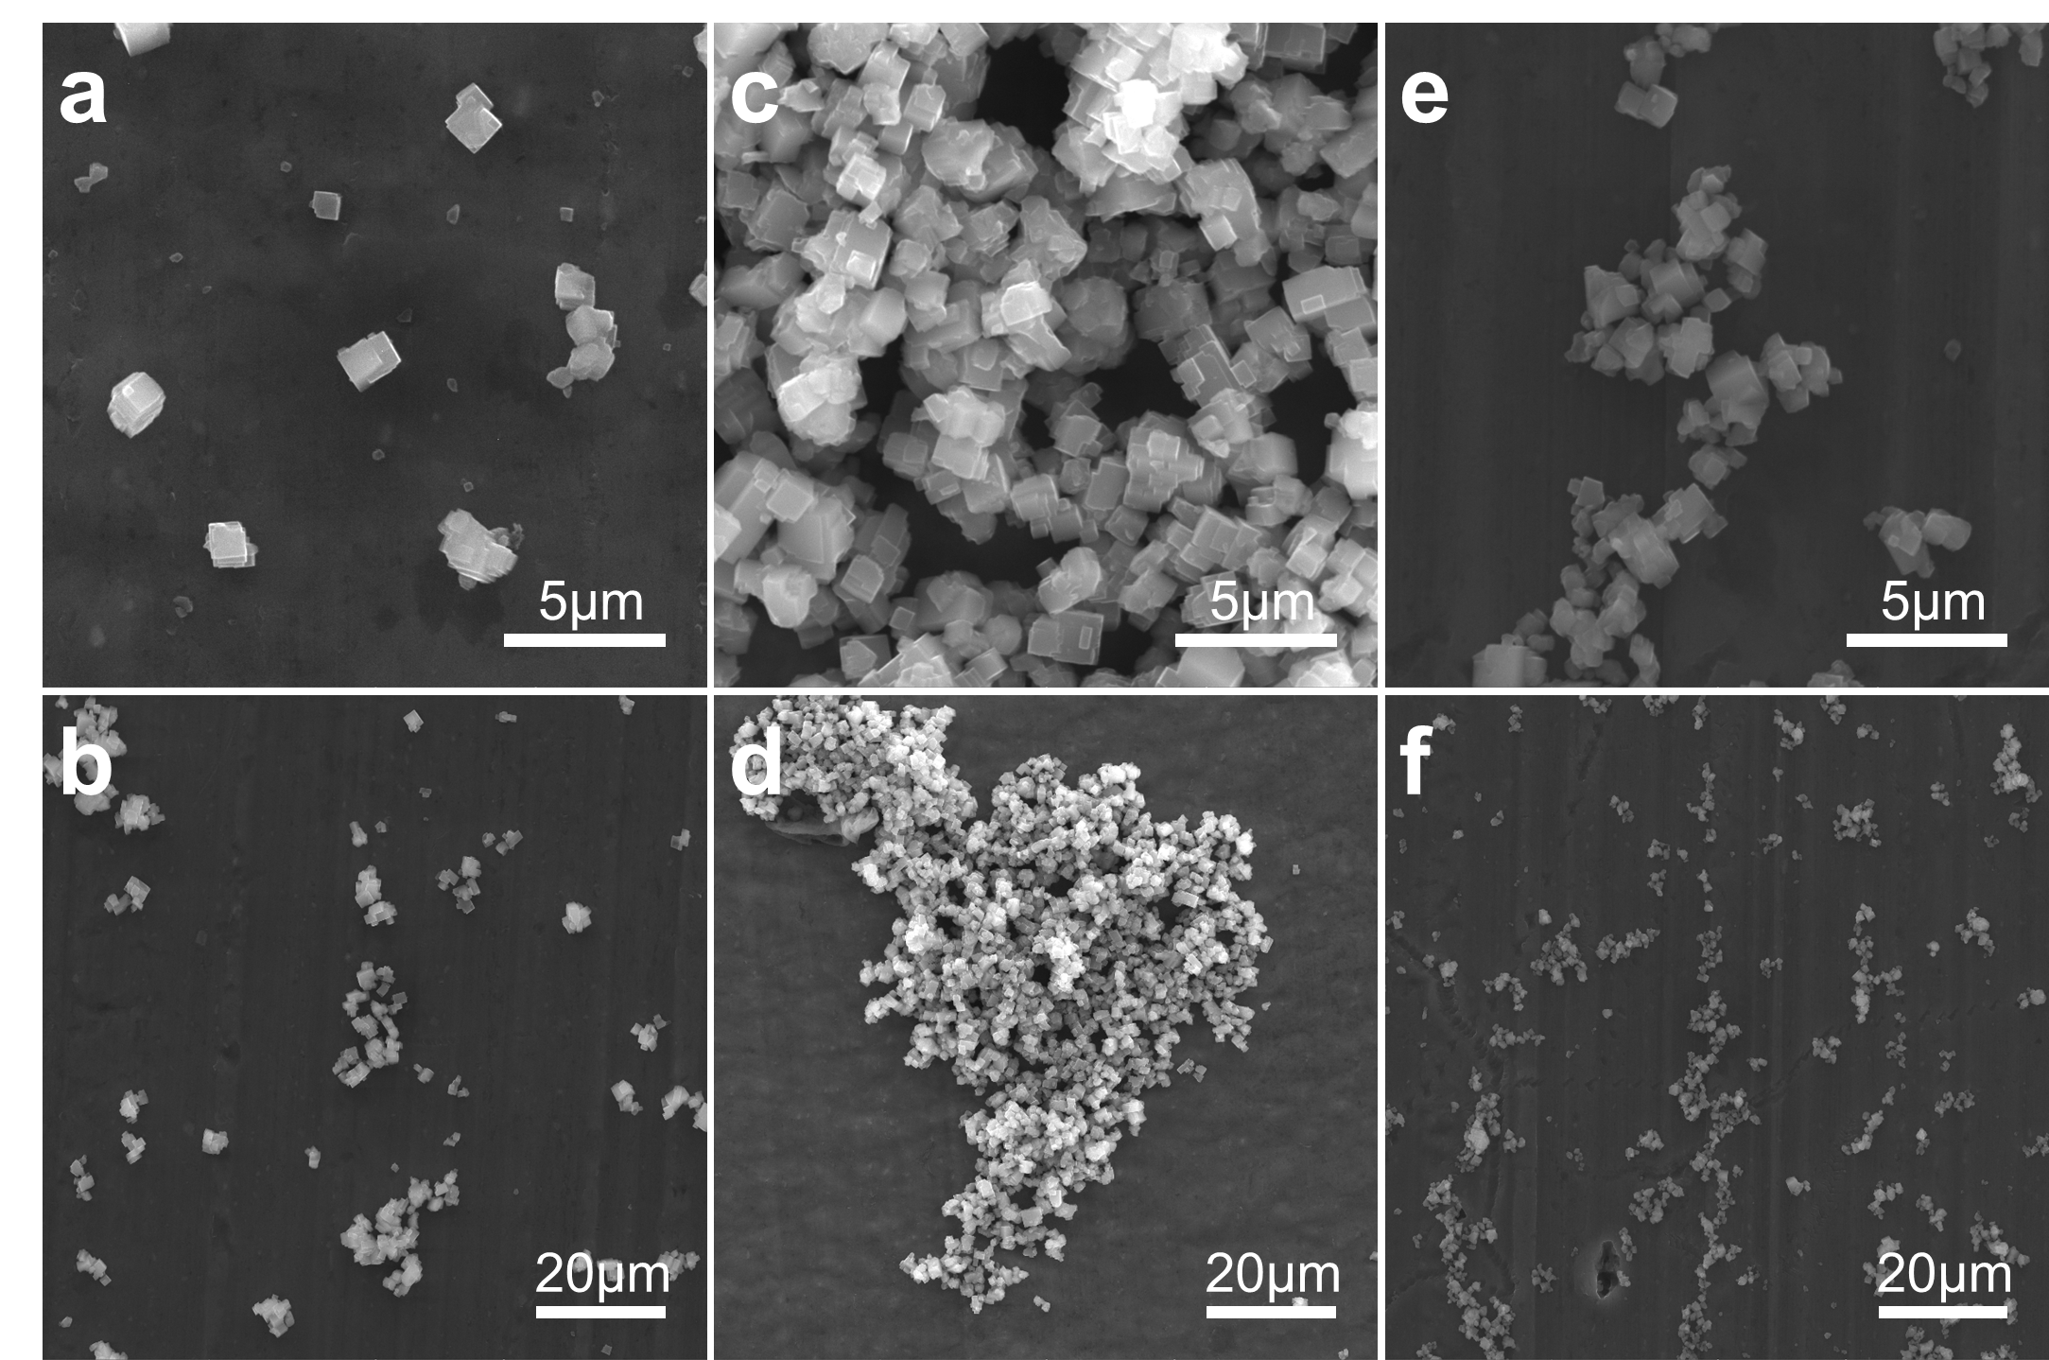
Fig.S1 SEM images of the samples: a, b M2-PBA, c, d M4-PBA, and e, f M5-PBA

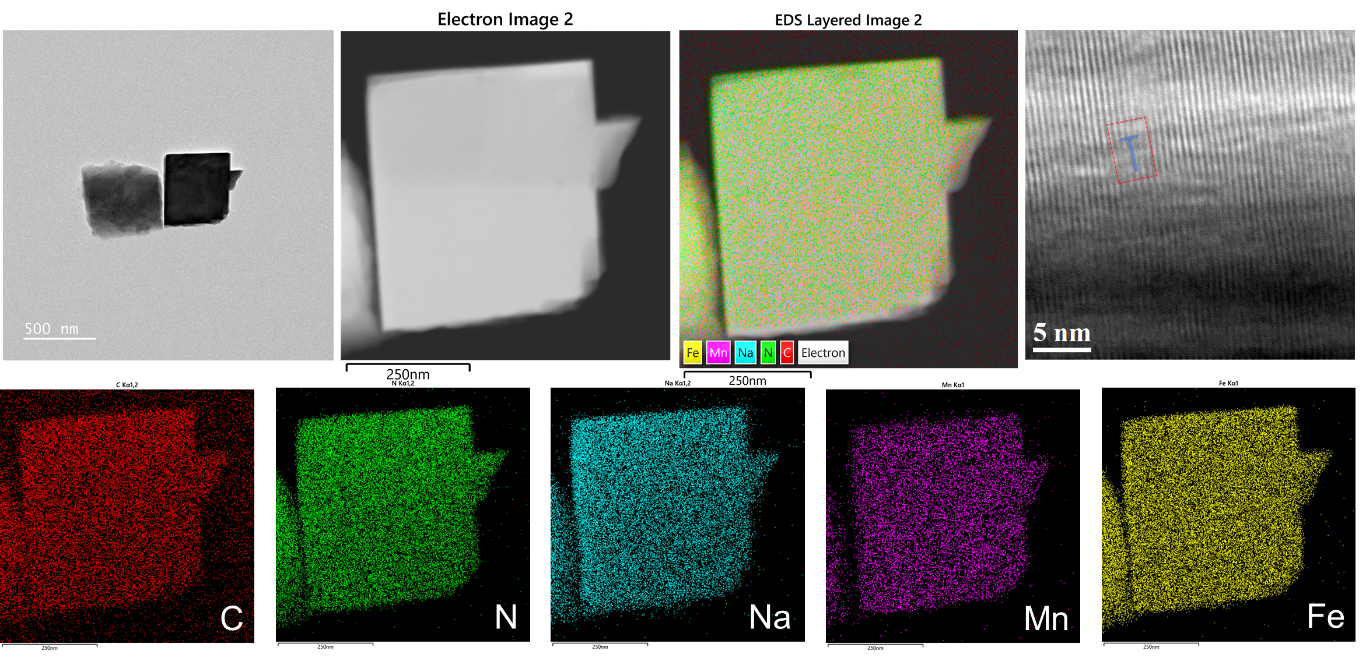
Fig.S2 TEM images of M2-PBA

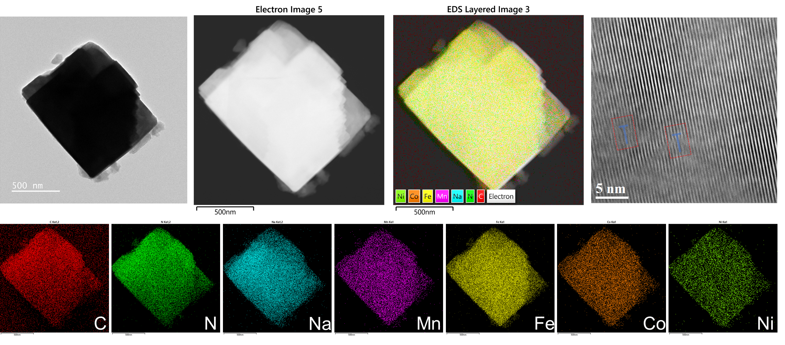
Fig.S3 TEM images of M4-PBA

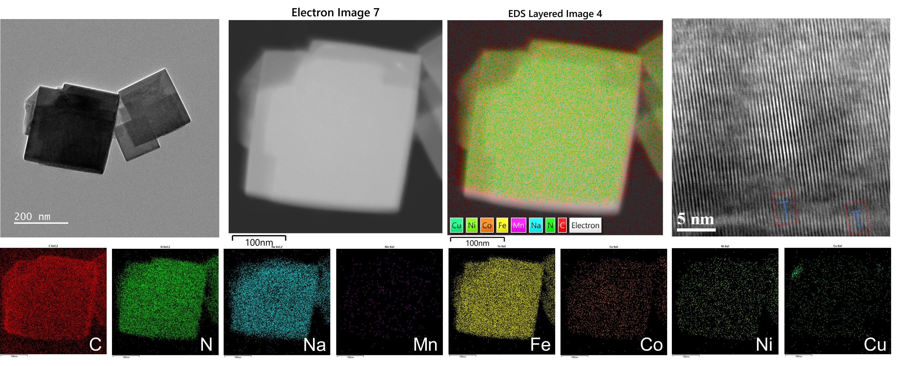
Fig.S4 TEM images of M5-PBA

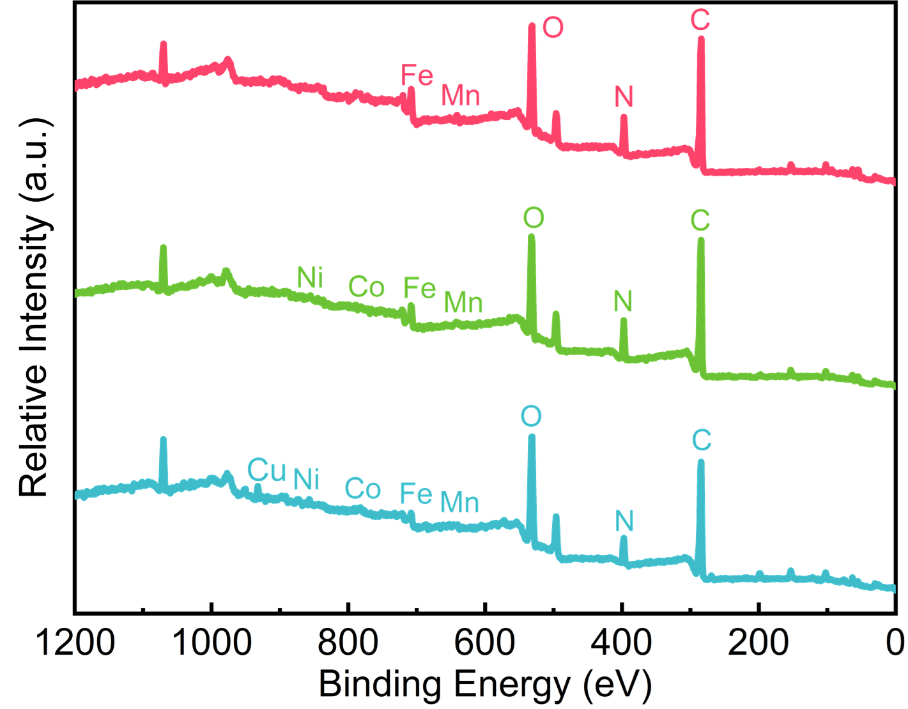
Fig.S5 XPS full spectrum of the three samples with M2-PBA in red, M4-PBA in green, M5-PBA in blue.

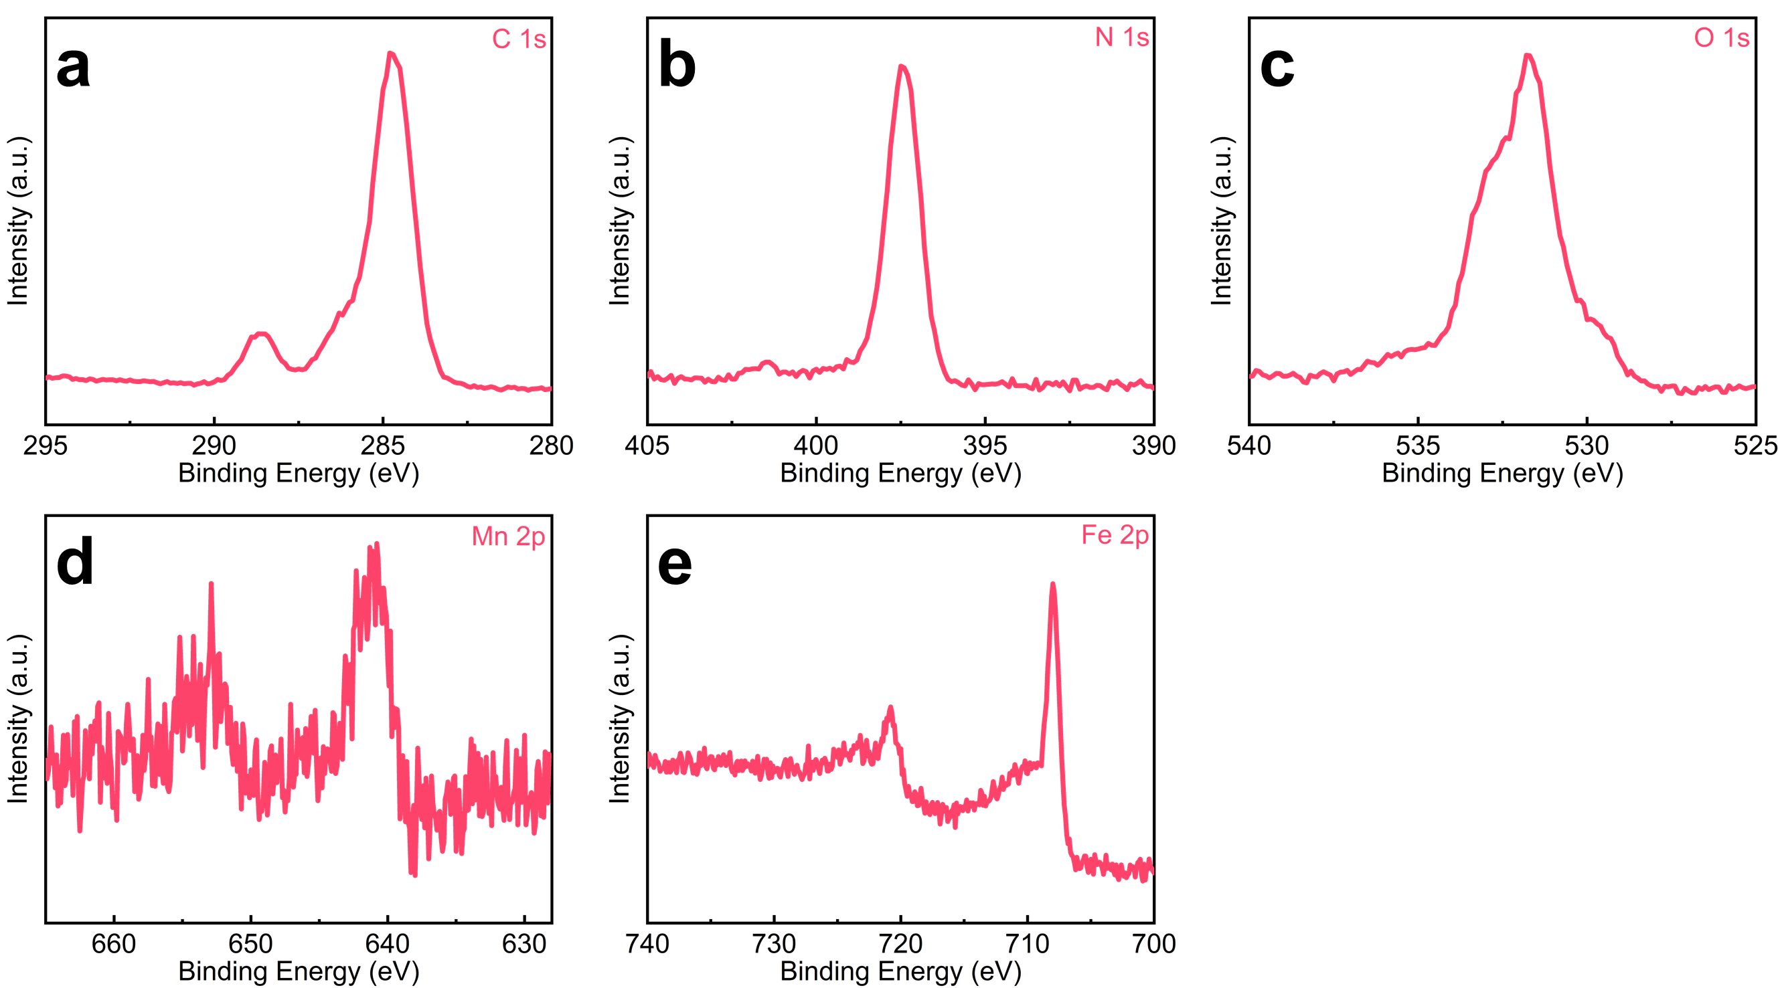
Fig.S6 XPS fine spectrum of M2-PBA. a C 1s, b N 1s, c O 1s, d Mn 2p, and e Fe 2p.

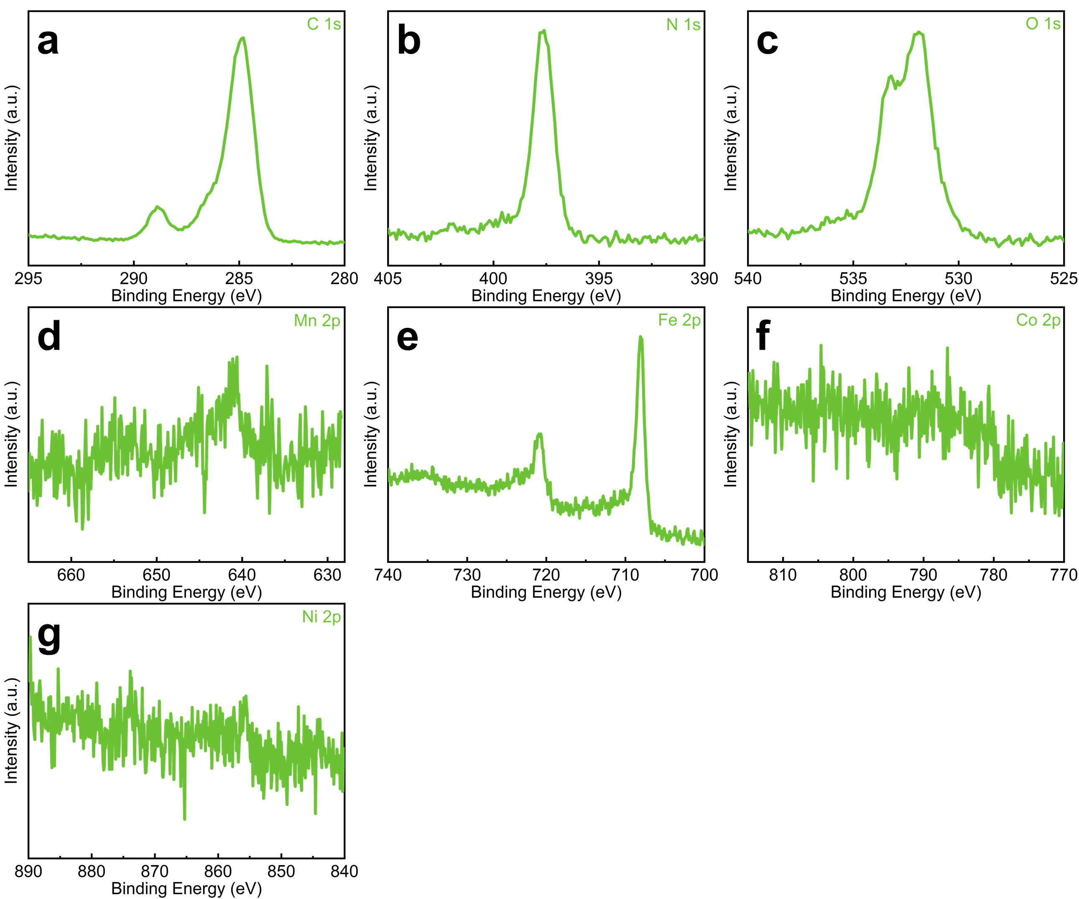
Fig.S7 XPS fine spectrum of M4-PBA. a C 1s, b N 1s, c O 1s, d Mn 2p, e Fe 2p, f Co 2p, and g Ni 2p.

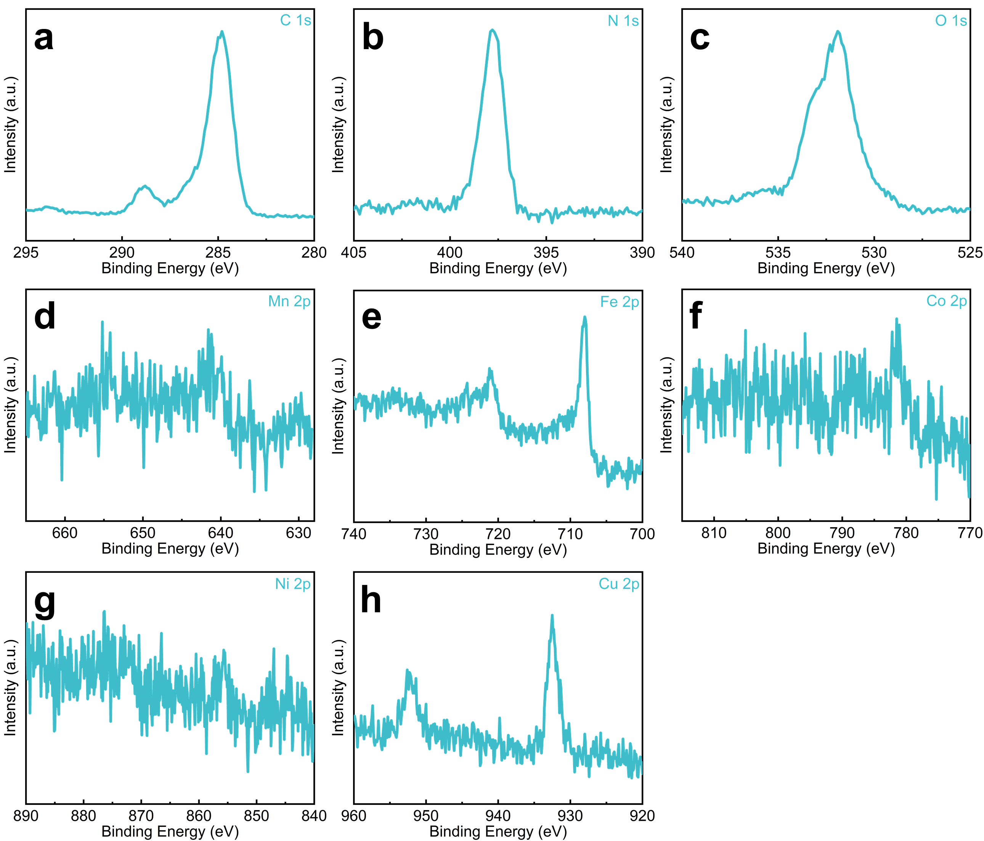
Fig.S8 XPS fine spectrum of M5-PBA. a C 1s, b N 1s, c O 1s, d Mn 2p, e Fe 2p, f Co 2p, g Ni 2p, and h Cu 2p.

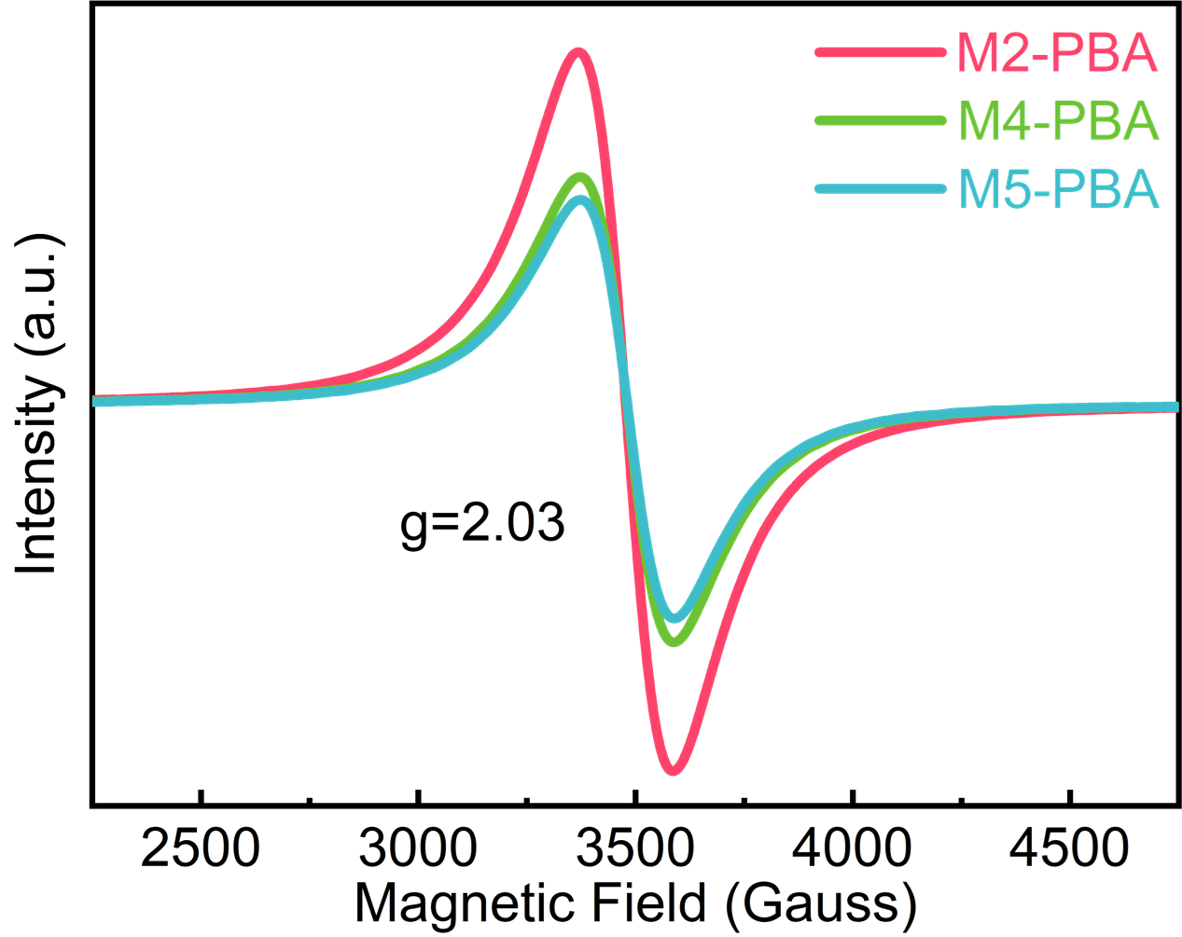
Fig.S9 EPR results of M2-PBA, M4-PBA and M5-PBA.

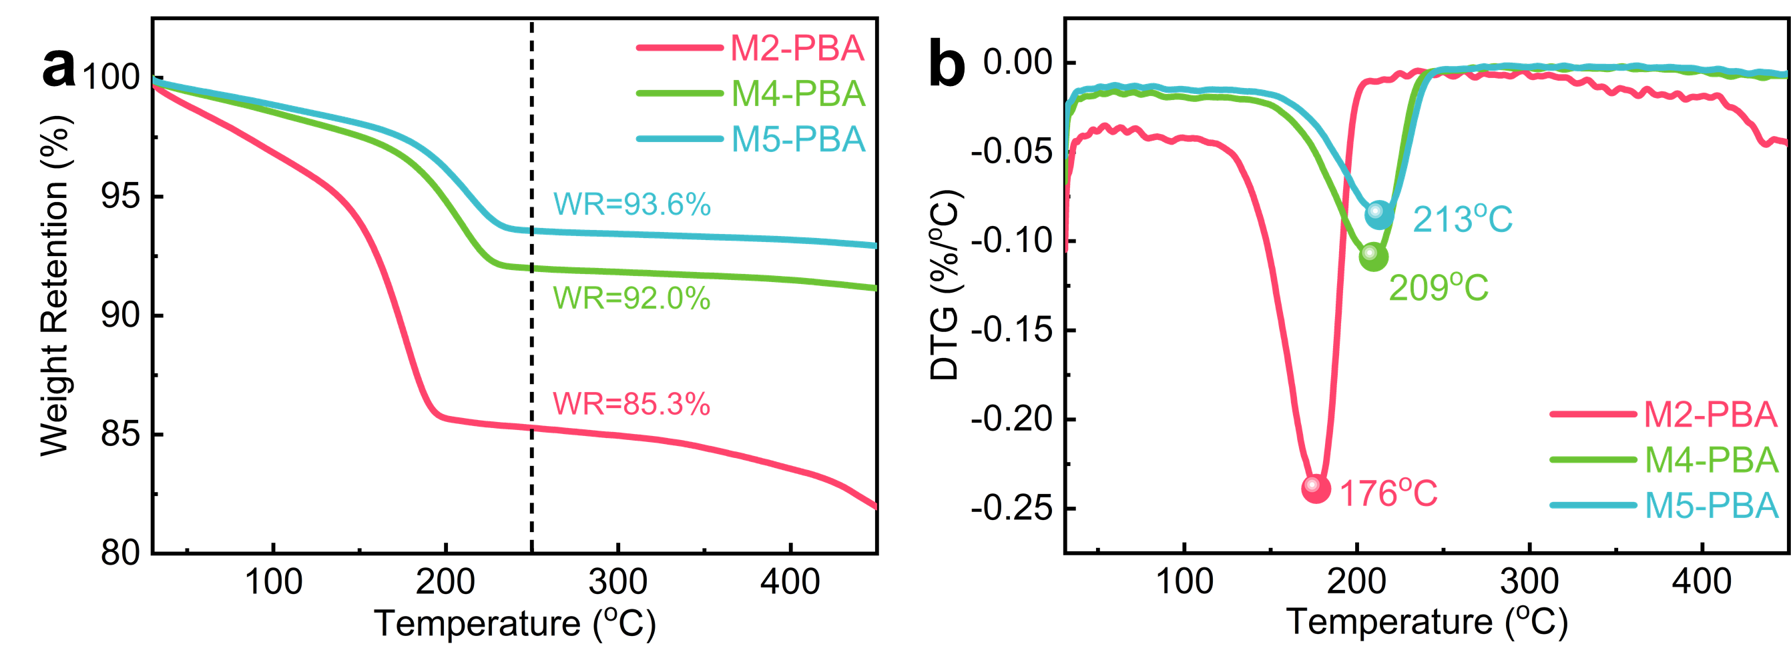
Fig.S10 a TG, b DSC curves of M2-PBA, M4-PBA and M5-PBA.

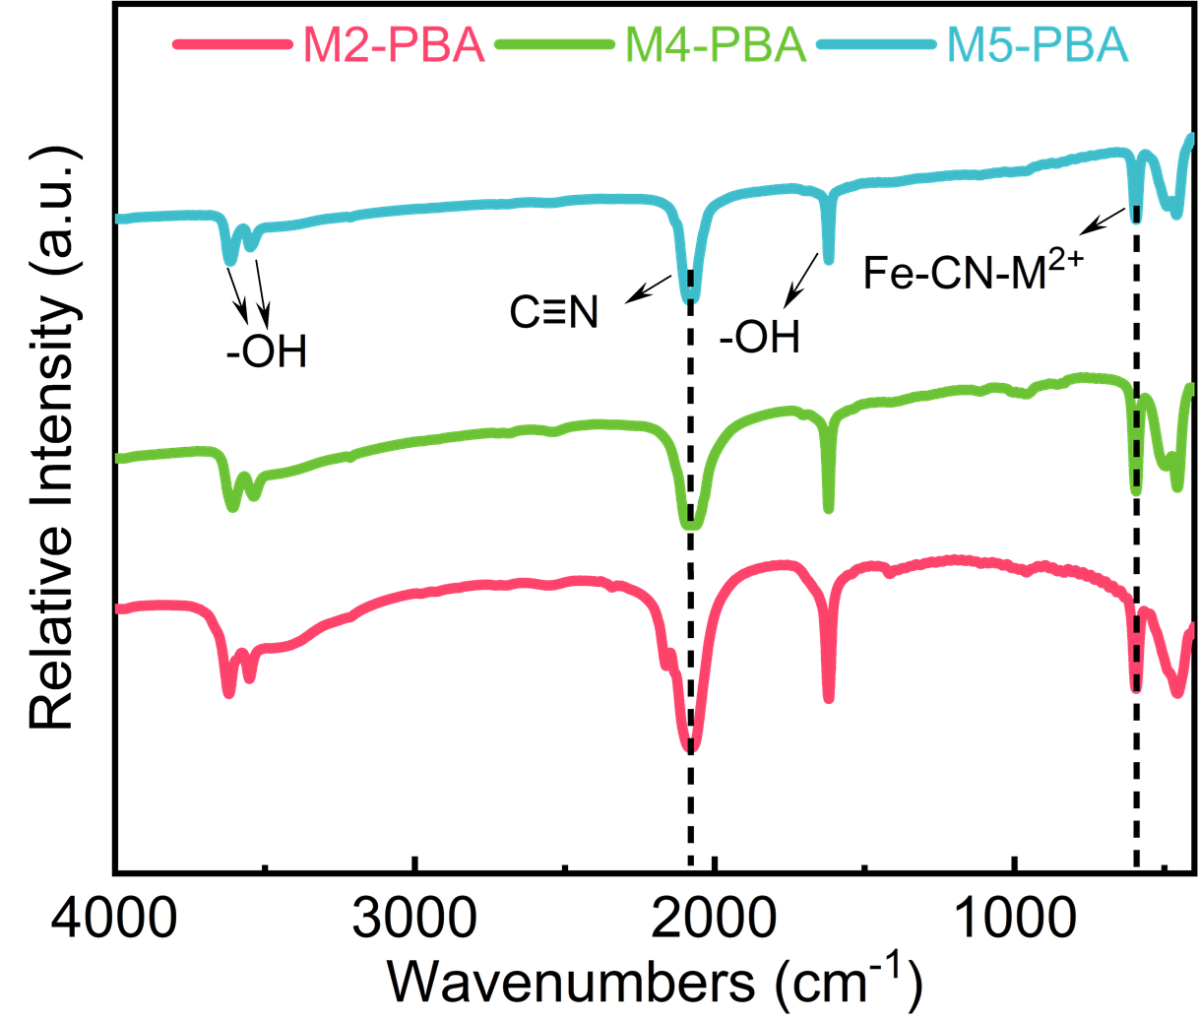
Fig.S11 FT-IR results of M2-PBA, M4-PBA and M5-PBA.

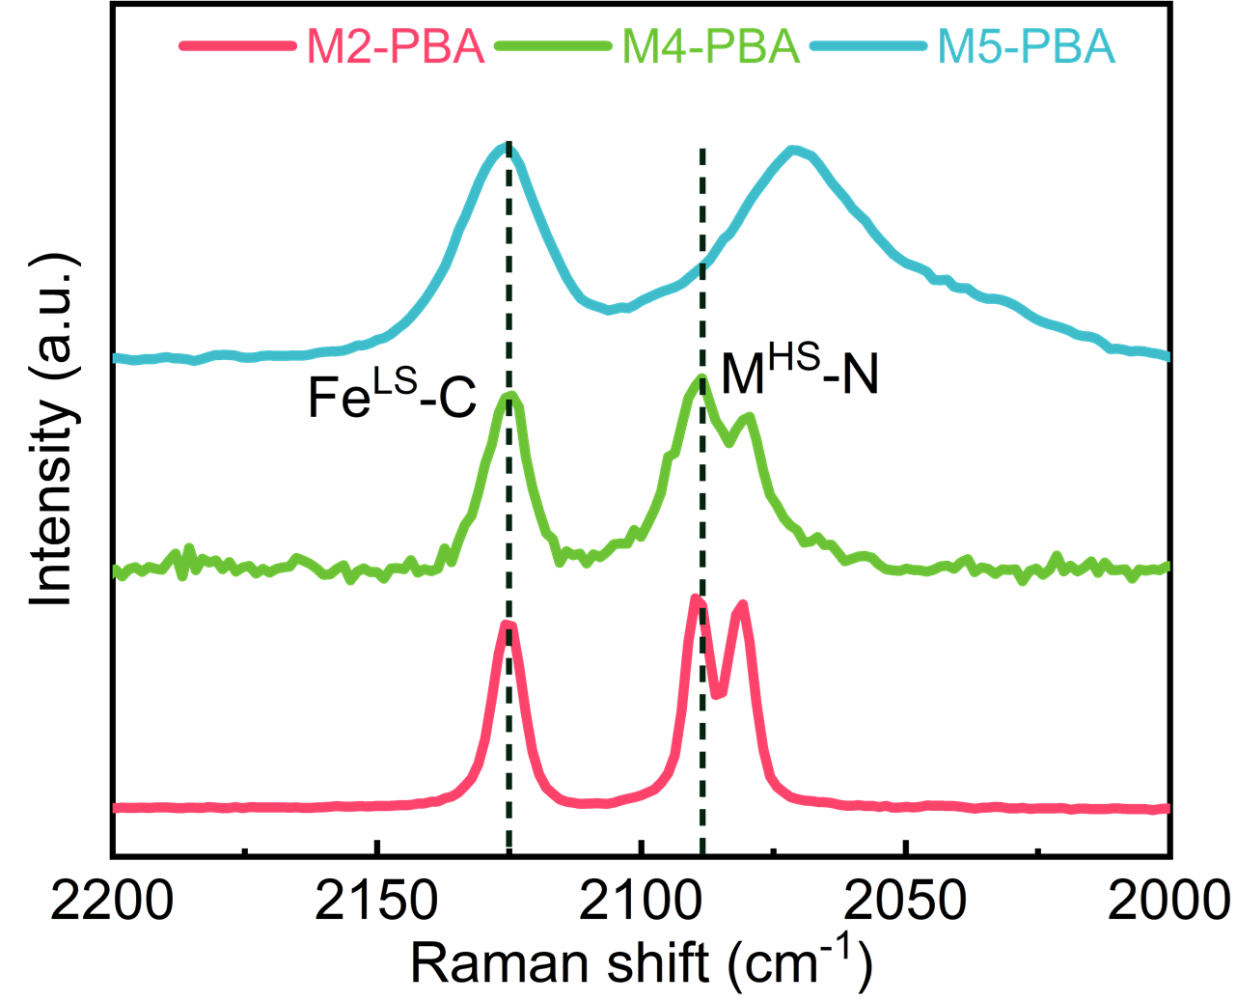
Fig.S12 Raman spectra of M2-PBA, M4-PBA and M5-PBA.

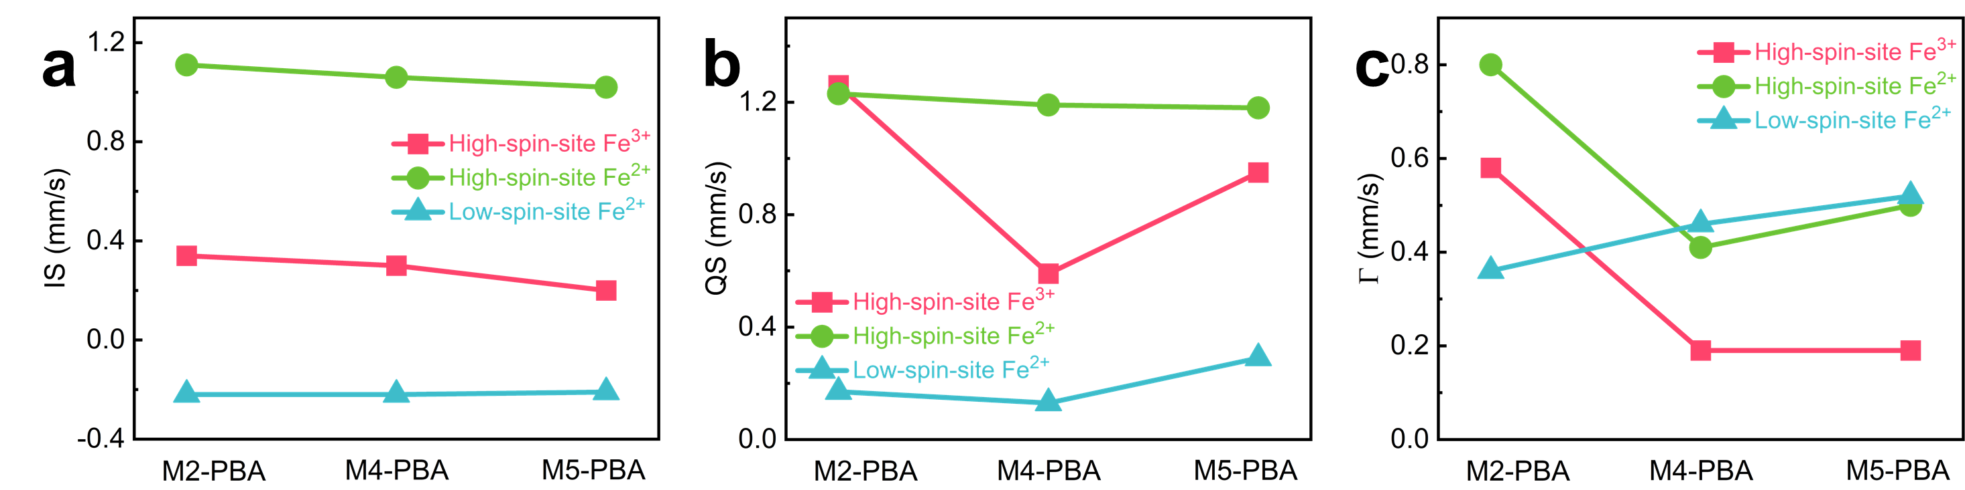
Fig.S13 a IS values, b QS values and c Γ comparation of Mössbauer spectra in M2-PBA, M4-PBA and M5-PBA.

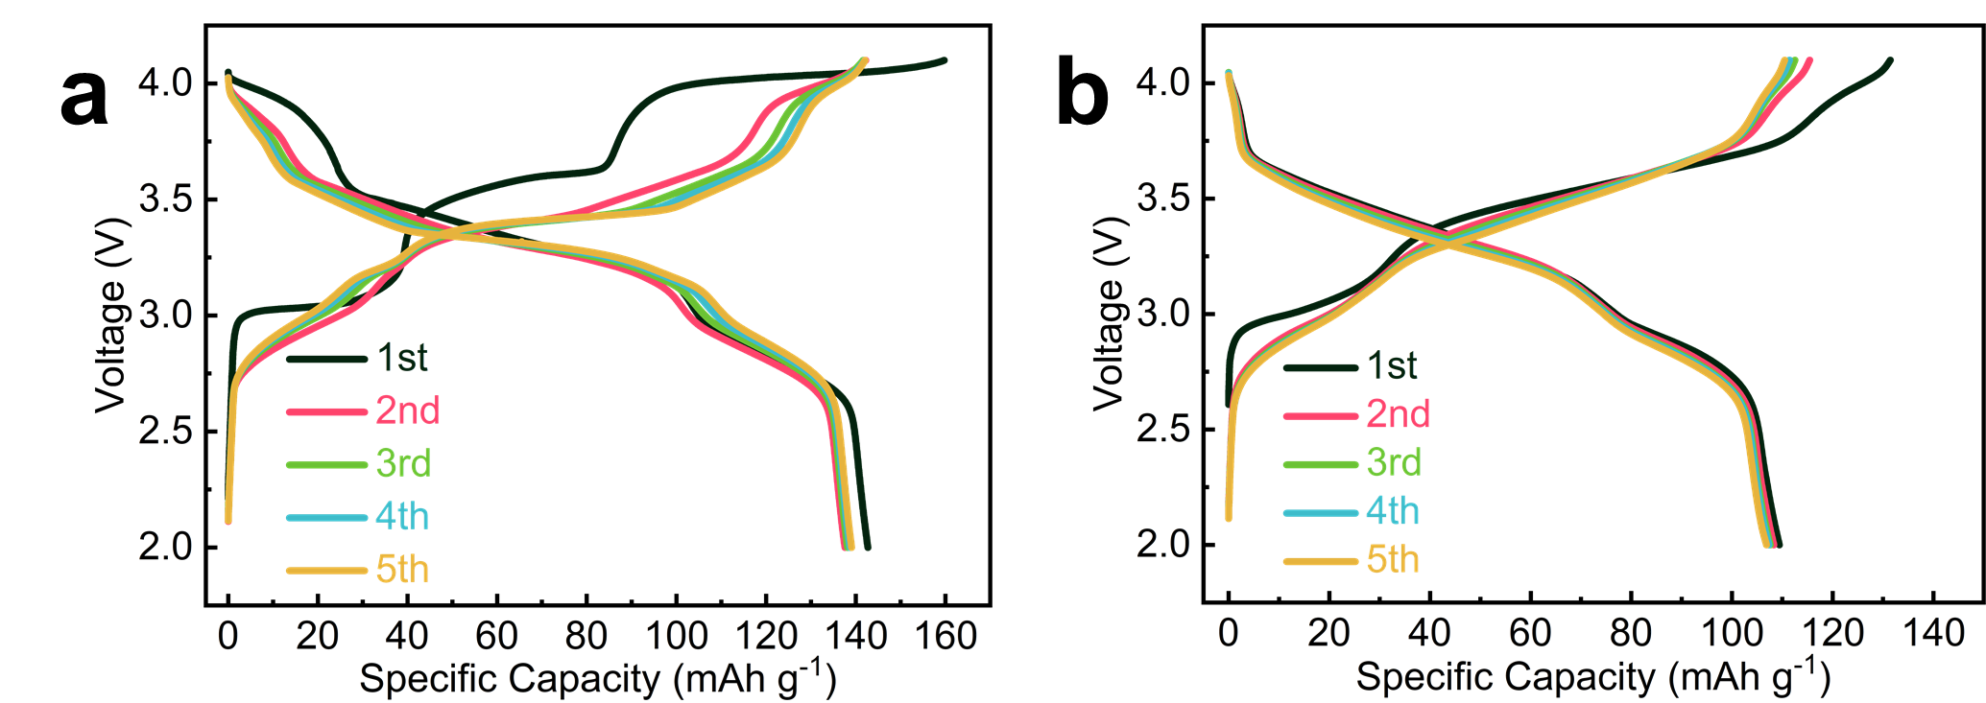
Fig. S14 The first five times galvanostatic charge and discharge curves of a M2-PBA and b M5-PBA.

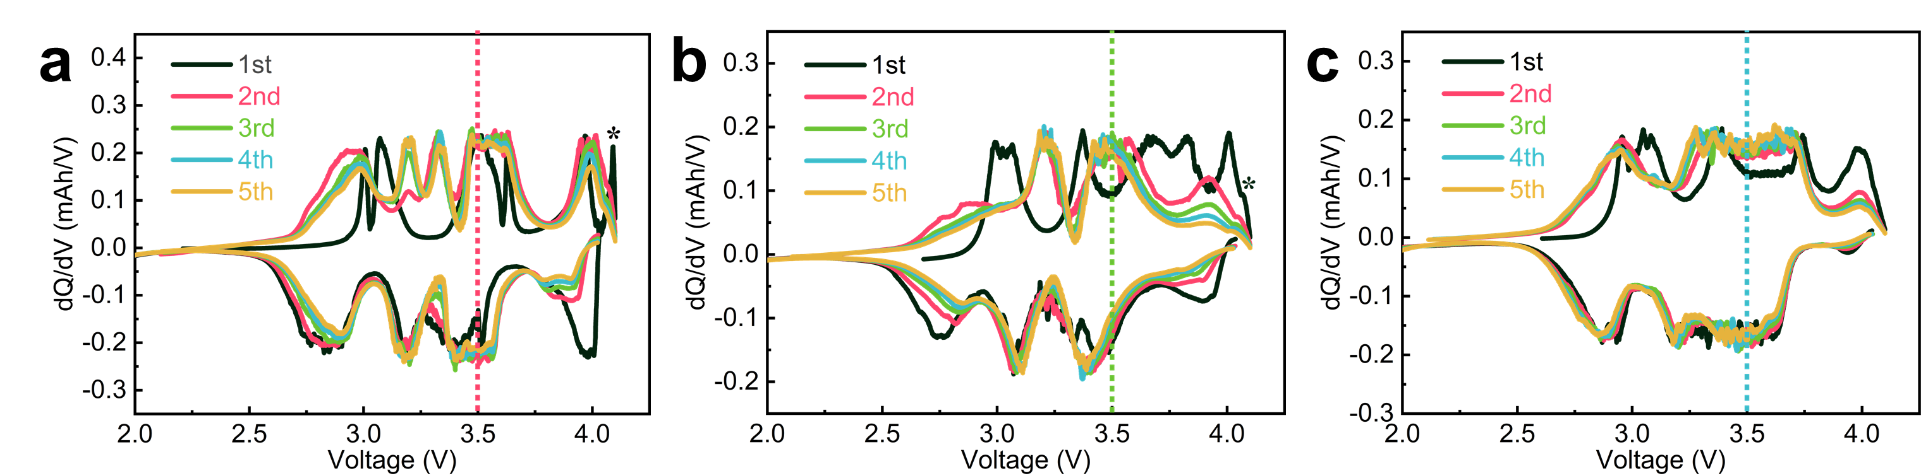
Fig.S15 Comparation of dQ/dV curves. a M2-PBA, b M4-PBA, and c M5-PBA.

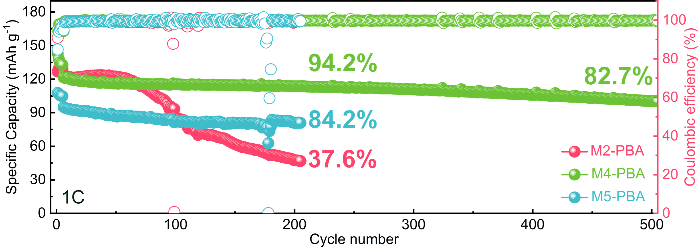
Fig.S16 Comparation of cycling performance at 1 C for M2-PBA, M4-PBA and M5-PBA.

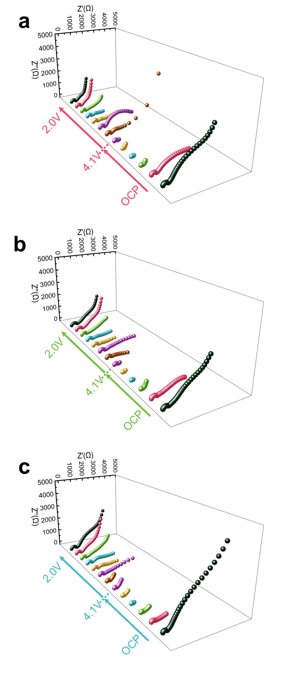
Fig.S17 Comparation of EIS testing results. a M2-PBA, b M4-PBA, and c M5-PBA.

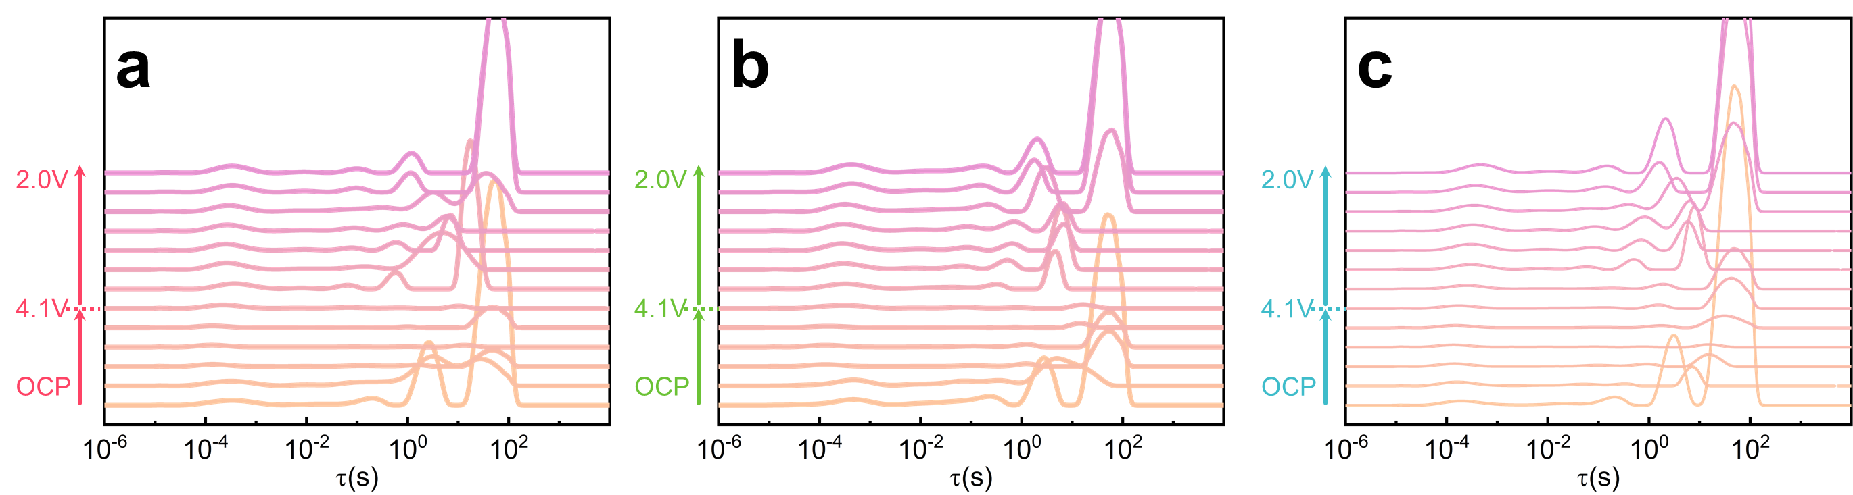
Fig.S18 Comparation of DRT results. a M2-PBA, b M4-PBA, and c M5-PBA.

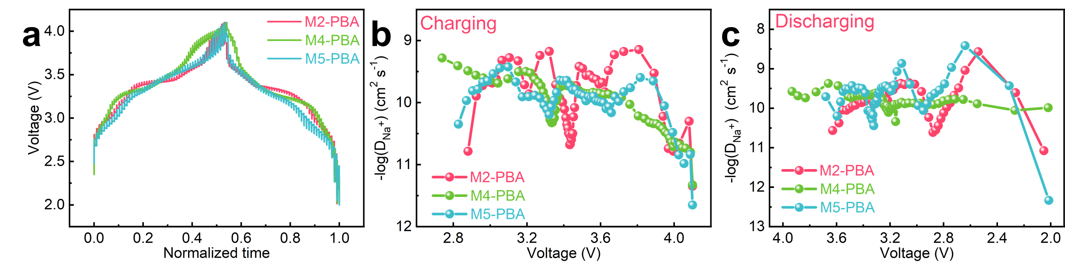
Fig.S19 a GITT testing curves, Na⁺ diffusion coefficients altered with electrode voltage for b charging and c discharging procedure in M2-PBA, M4-PBA and M5-PBA.

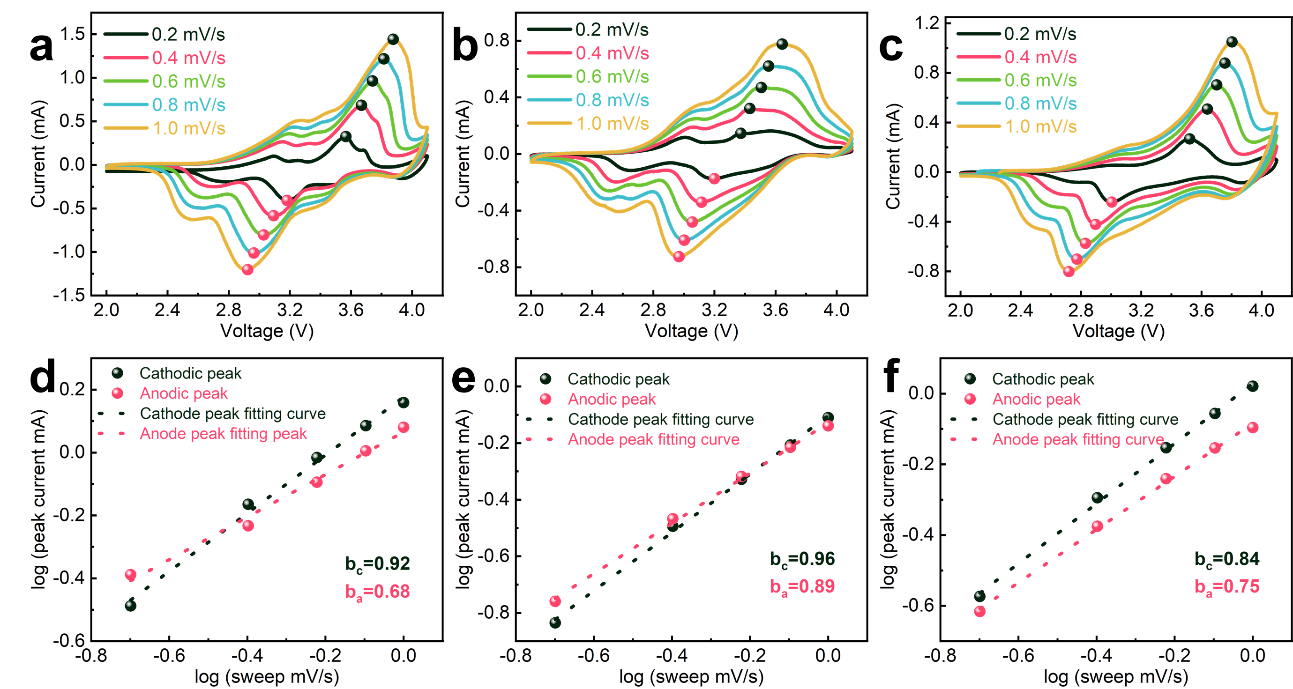
Fig.S20 CV curves at various scan rates: a M2-PBA, b M4-PBA, and c M5-PBA. Corresponding line-fitting slopes: d M2-PBA, e M4-PBA, and f M5-PBA.

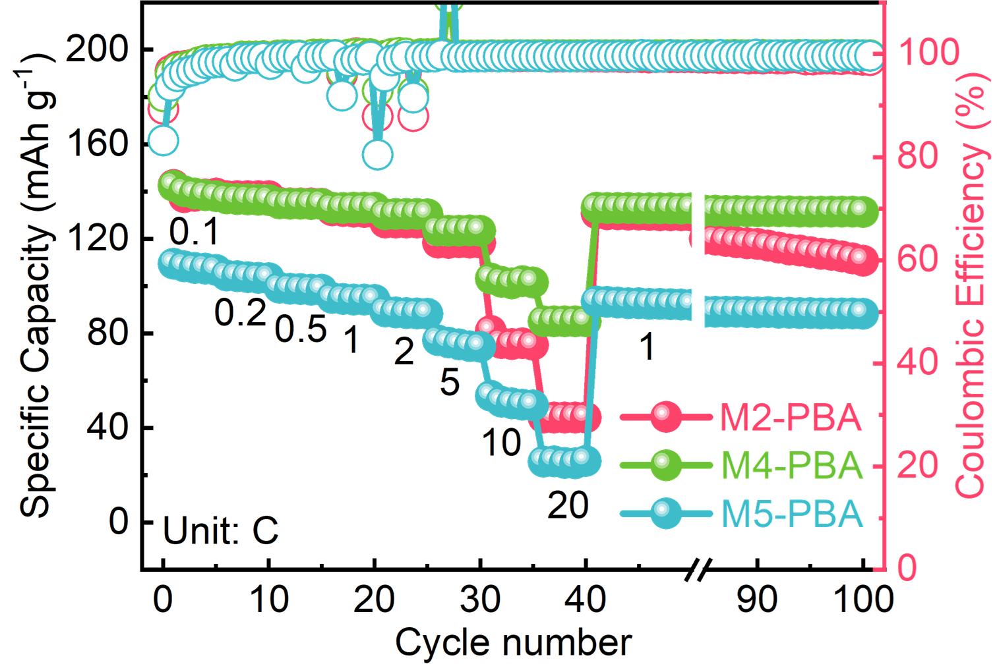
Fig.S21 Comparation of rate performance.

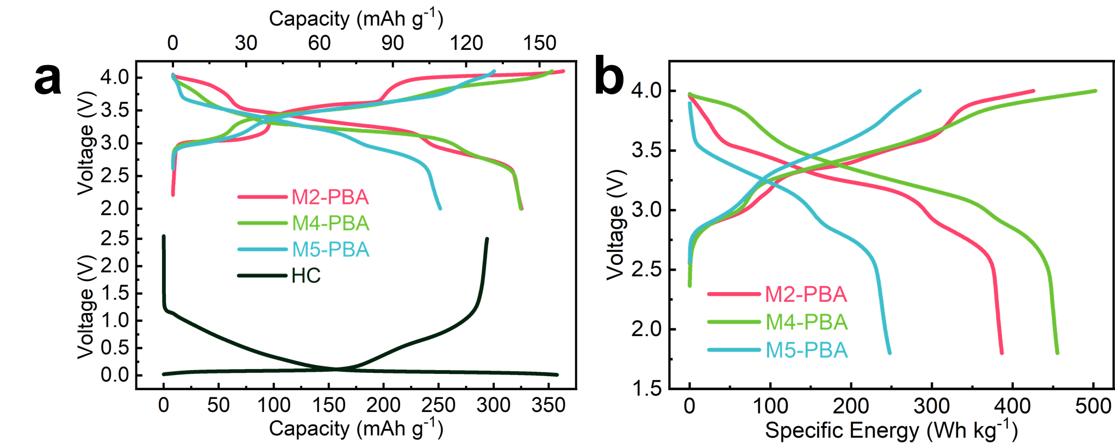
Fig.S22 Comparation of full cell electrochemical performance. a specific capacity of PBA cathodes and hard carbon anode, b specific energy.

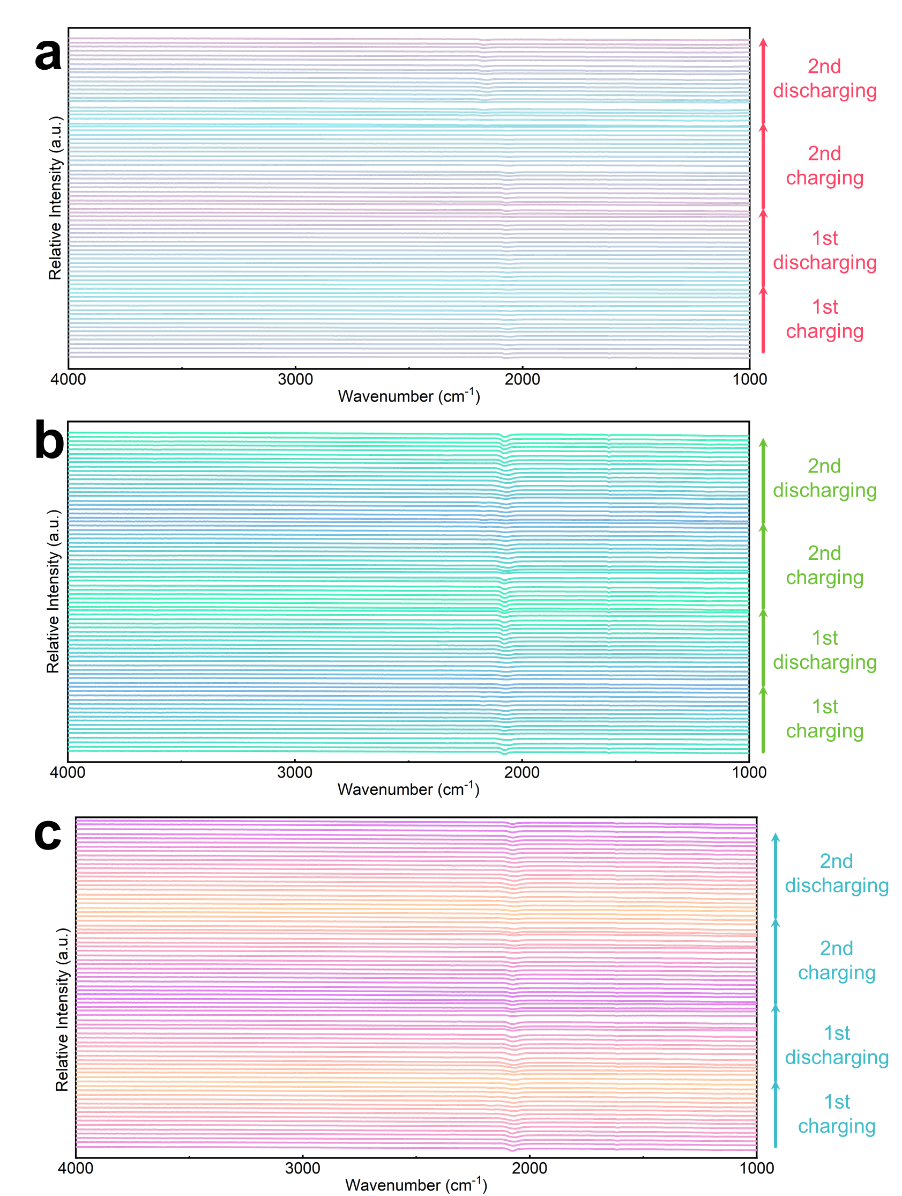
Fig.S23 Comparation of in-situ FT-IR full spectra during the first two cycles. a M2-PBA, b M4-PBA, and c M5-PBA.

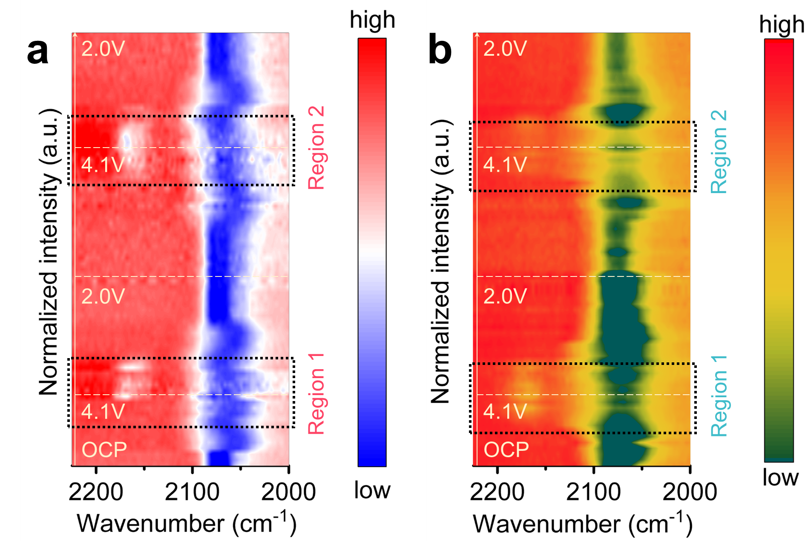
Fig.S24 In-situ FT-IR results of a M2-PBA, and b M5-PBA.

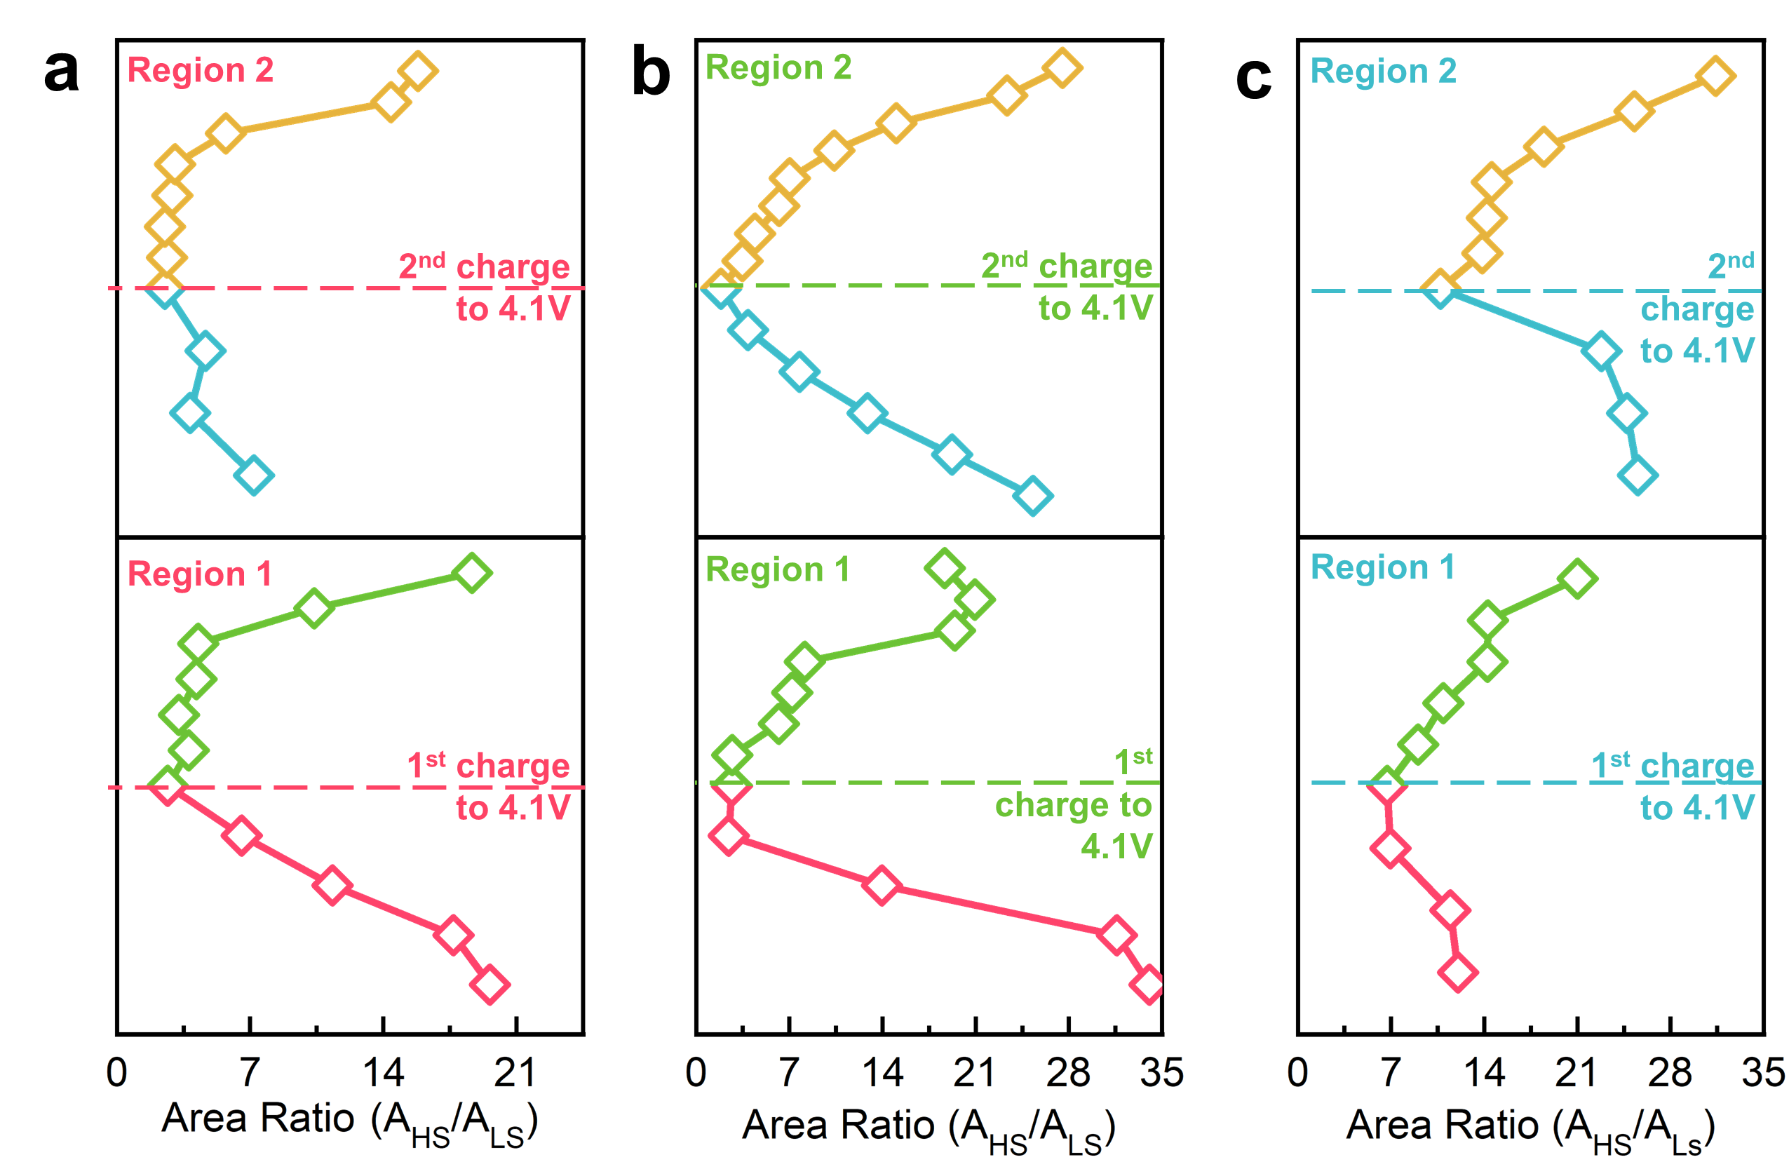
Fig.S25 The area ratios of peaks 1 and 2 in in-situ FT-IR for a M2-PBA, b M4-PBA and c M5-PBA.

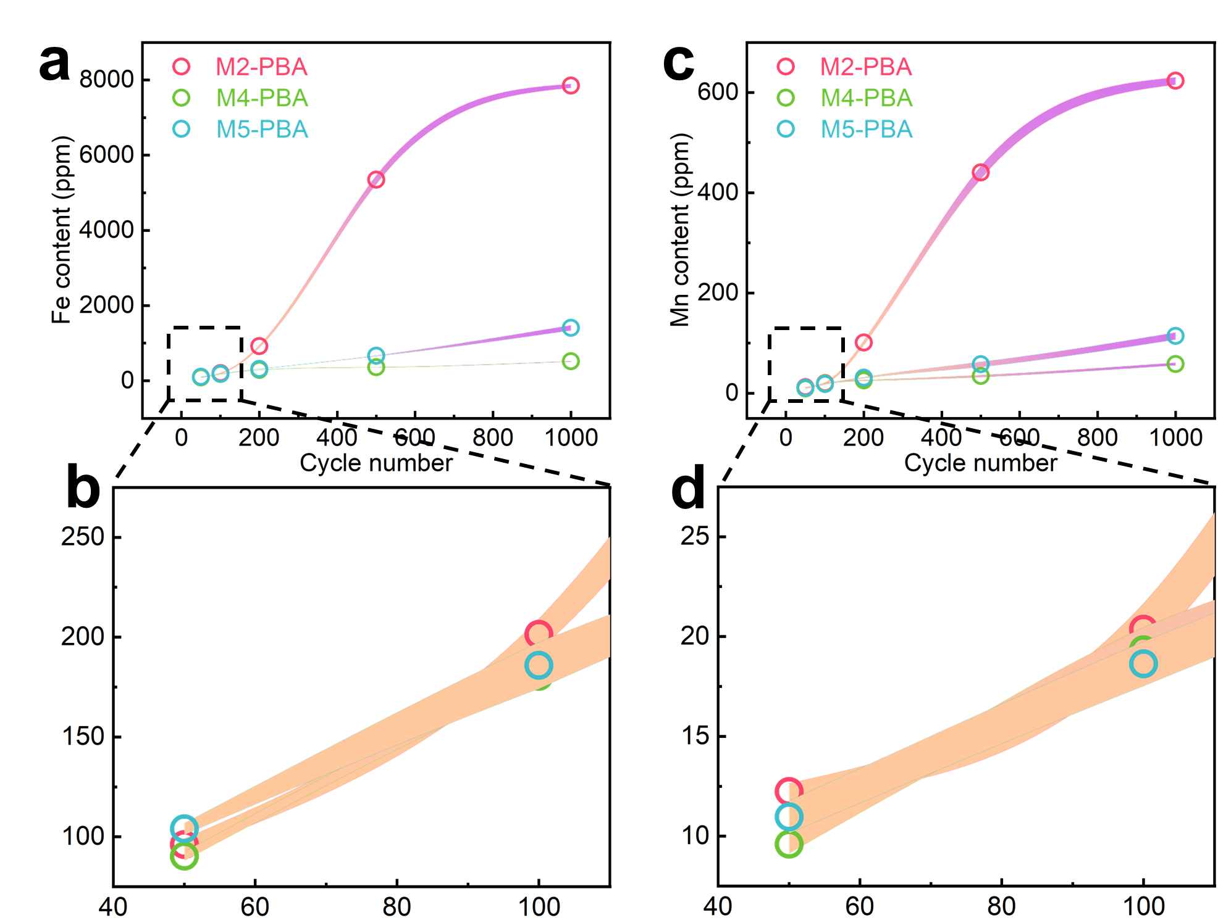
Fig.S26 Ex-situ ICP-OES testing results of the dissolvement metal elements in the electrolyte for M2-PBA, M4-PBA and M5-PBA with current density of 5C. Three sets of parallel samples form error bands, and the hollow circle mark represents the average of the three samples. a, b Fe content, and c, d Mn content.

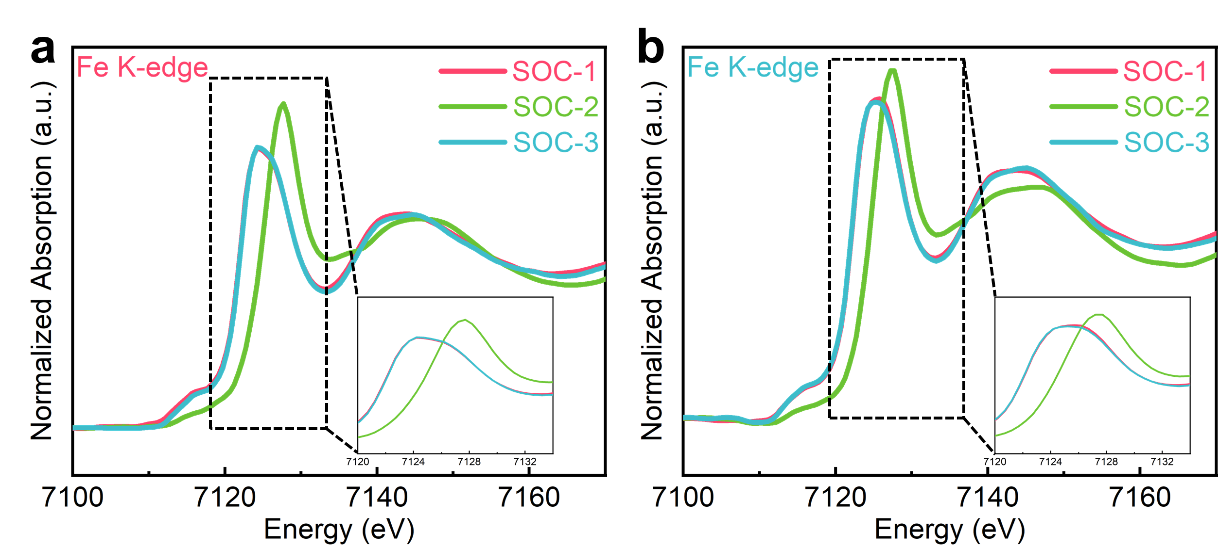
Fig.S27 Ex-situ XANES profiles of a M2-PBA and b M5-PBA at different SOC with pre-edge in the insets. (The final state of charge for the first discharge cycle was defined as SOC-1, while the charging and discharging final states of charge for the second cycle were defined as SOC-2 and SOC-3, respectively.)

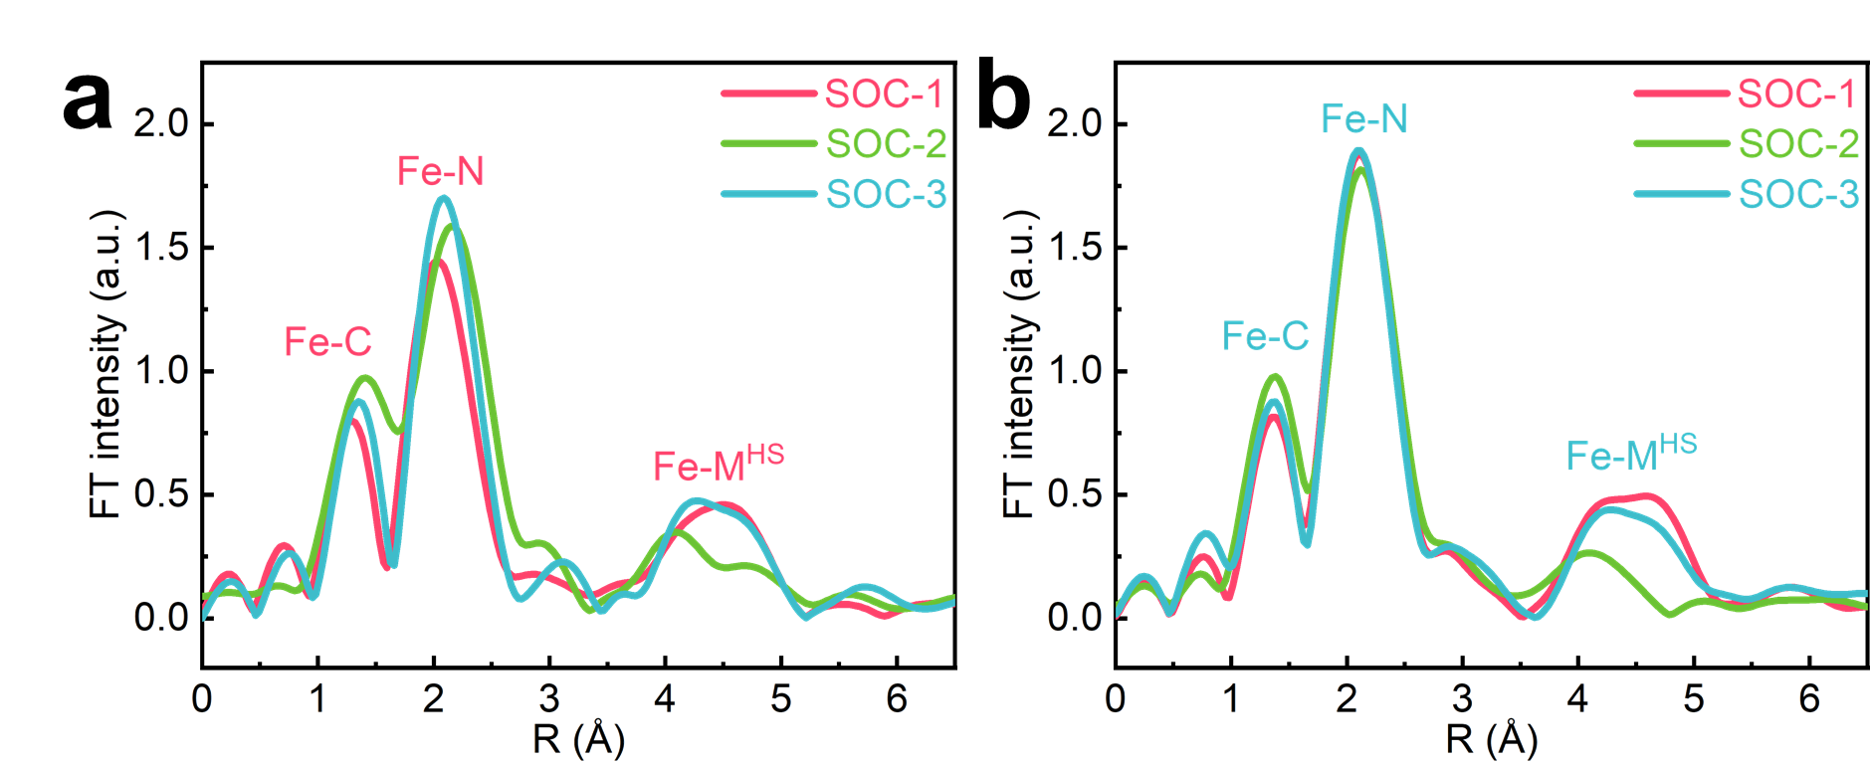
Fig.S28 Ex-situ EXAFS profiles of a M2-PBA and b M5-PBA at different SOC. (The final state of charge for the first discharge cycle was defined as SOC-1, while the charging and discharging final states of charge for the second cycle were defined as SOC-2 and SOC-3, respectively.)

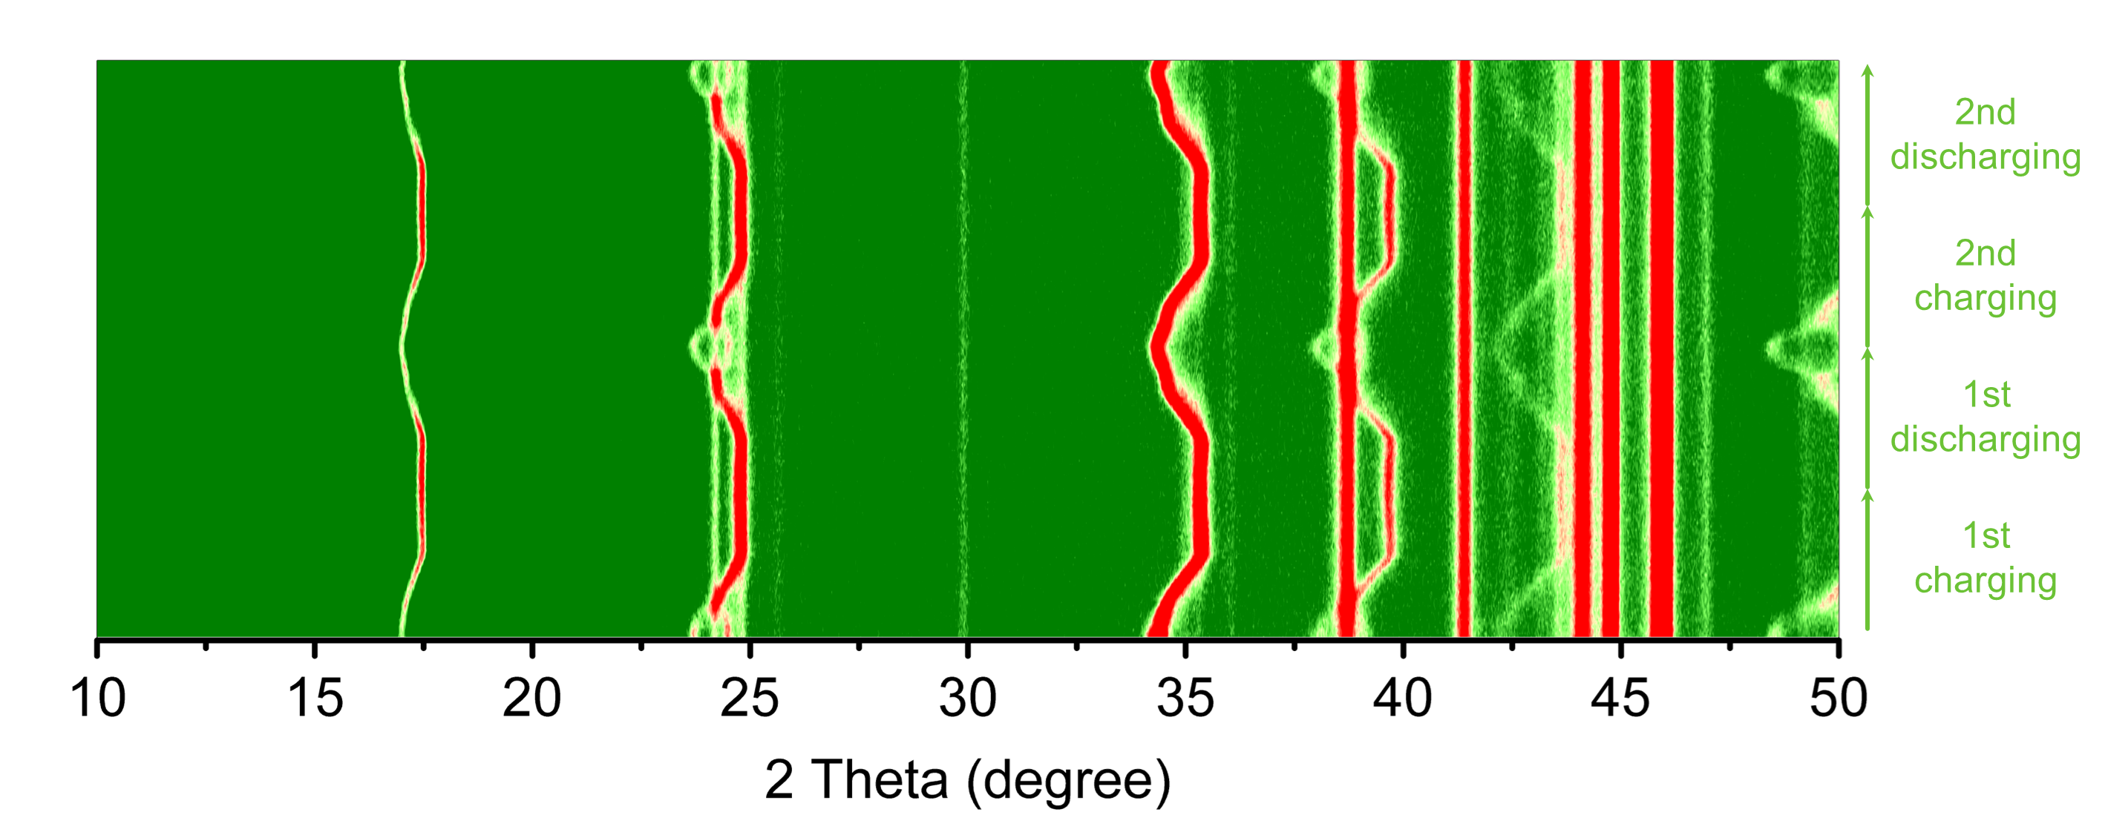
Fig.S29 In-situ XRD full patterns of M4-PBA.

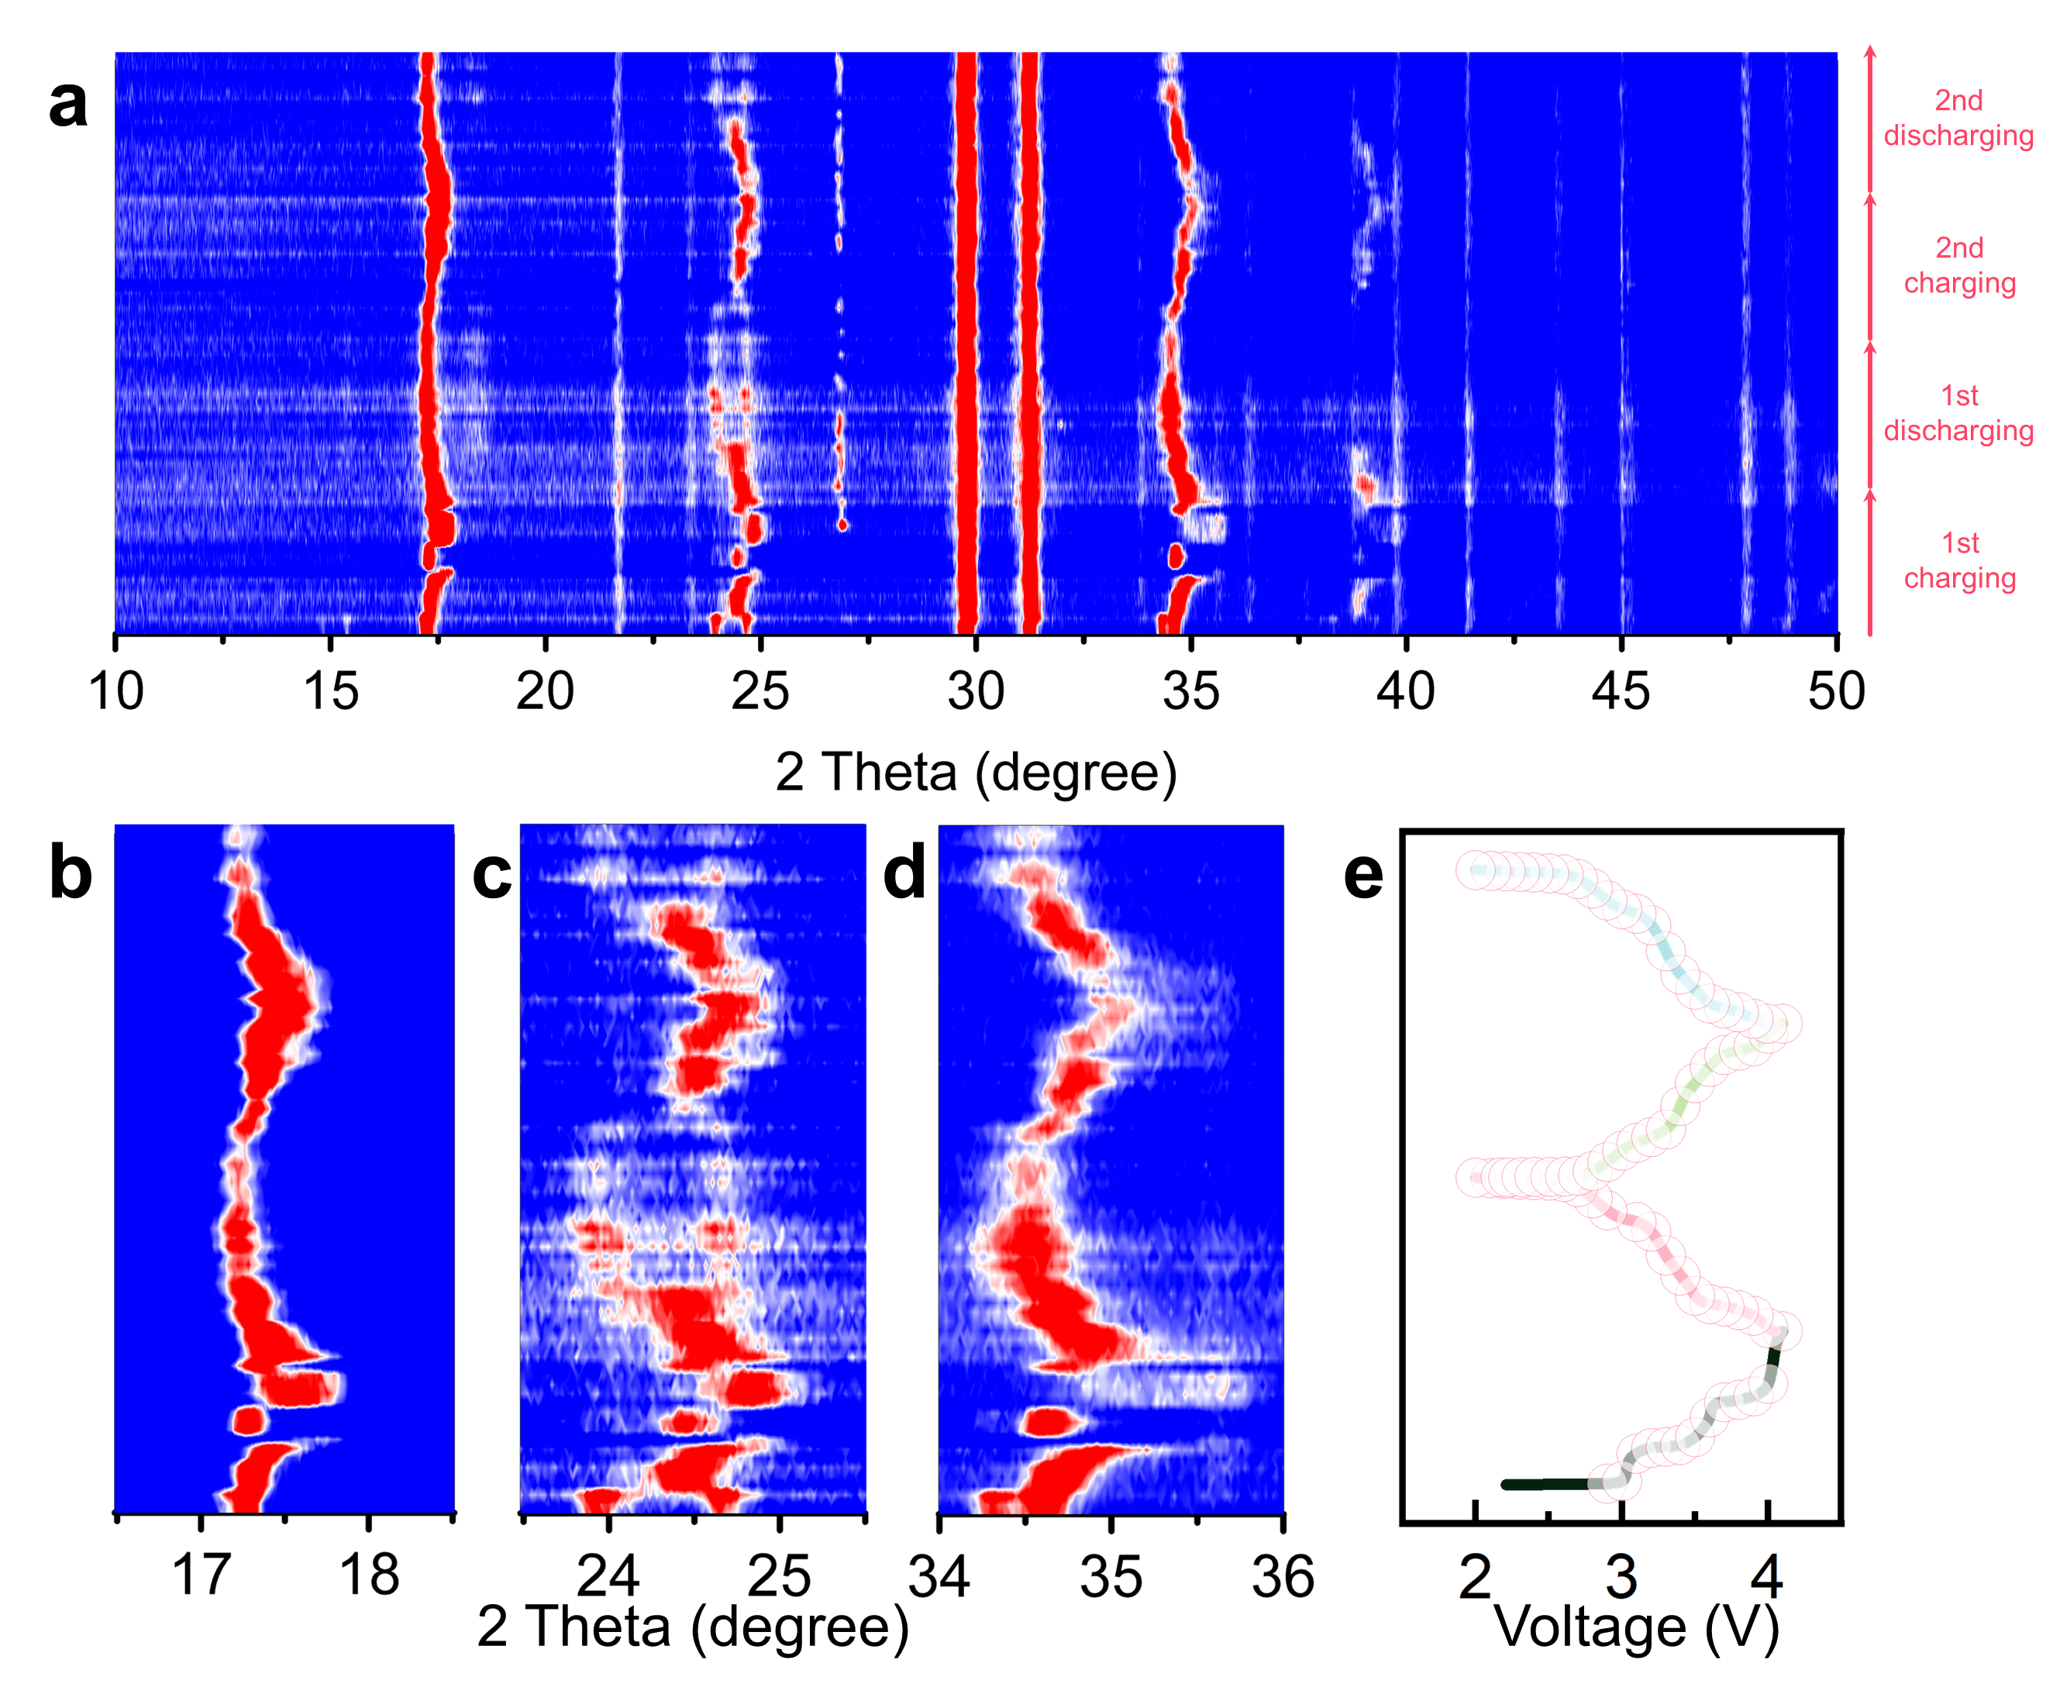
Fig.S30 Ex-situ XRD results of M2-PBA. a full pattern, b-d detailed patterns and corresponding e galvanostatic charge and discharge curves.

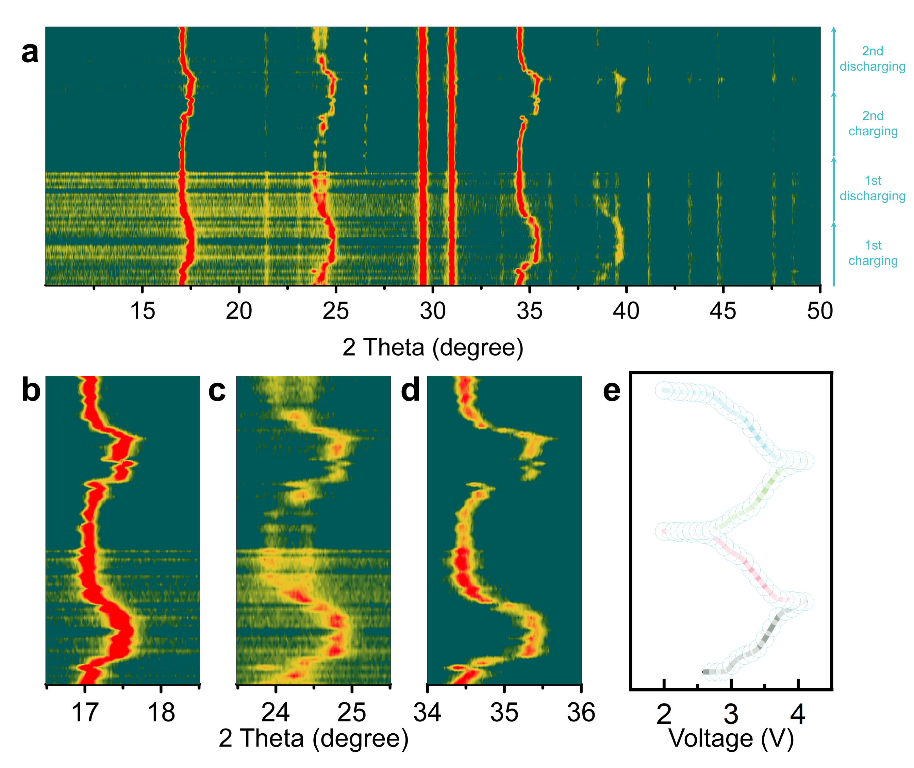
Fig.S31 Ex-situ XRD results of M5-PBA. a full pattern, b-d detailed patterns and corresponding e galvanostatic charge and discharge curves.
Table S1 Testing results of ICP-OES
M5-PBA | Elements | Na | Mn | Fe | Co | Ni | Cu
M5-PBA | Mass (mg/ml) | 4.681 | 0.2178 | 1.1462 | 0.1915 | 0.1913 | 0.1695
M5-PBA | Formula | Na_{1.898}Mn_{0.211}Fe_{0.202} Co_{0.199} Ni_{0.198}Cu_{0.190}[Fe(CN)₆]_{0.927}·0.675H₂O
M4-PBA | Elements | Na | Mn | Fe | Co | Ni
M4-PBA | Mass (mg/ml) | 4.7525 | 0.2745 | 1.2386 | 0.2386 | 0.2309
M4-PBA | Formula | Na_{1.927}Mn_{0.266}Fe_{0.247} Co_{0.248} Ni_{0.239} [Fe(CN)₆]_{0.943}·0.862H₂O
M2-PBA | Elements | Na | Mn | Fe
M2-PBA | Mass (mg/ml) | 4.538 | 0.5191 | 1.4101
M2-PBA | Formula | Na_{1.84}Mn_{0.503}Fe_{0.497} [Fe(CN)₆]_{0.892}·1.633H₂O

Table S2 Rietveld refined result of M2-PBA
M2-PBA Monoclinic, space group P21/n,
a=10.54333 Å, b=7.4986 Å, c=7.27486 Å, V=574.610 Å³
Atom | x | y | z | Occ. | Site
C1 | 0.005 | 0.301 | 0.313 | 1 | 4e
C2 | 0.183 | 0.5 | 0.5 | 1 | 4e
C3 | 0.0034 | 0.6838 | 0.3 | 1 | 4e
N1 | 0.0049 | 0.1994 | 0.197 | 1 | 4e
N2 | 0.3024 | 0.502 | 0.5022 | 1 | 4e
N3 | 0 | 0.8063 | 0.26 | 1 | 4e
Na | 0.249 | 0.516 | 0.023 | 1 | 4e
Mn | 0 | 0 | 0 | 0.5 | 2a
Fe1 | 0 | 0.5 | 0.5 | 1 | 2d
Fe2 | 0 | 0 | 0 | 0.5 | 2a

Table S3 Rietveld refined result of M4-PBA
M4-PBA Monoclinic, space group P21/n,
a=10.20561 Å, b=7.36109 Å, c=7.13838 Å, V=535.735 Å³
Atom | x | y | z | Occ. | Site
C1 | 0.005 | 0.303 | 0.323 | 1 | 4e
C2 | 0.183 | 0.517 | 0.523 | 1 | 4e
C3 | 0.0034 | 0.6838 | 0.2989 | 1 | 4e
N1 | 0.0048 | 0.1984 | 0.197 | 1 | 4e
N2 | 0.3022 | 0.504 | 0.5022 | 1 | 4e
N3 | 0.003 | 0.8063 | 0.209 | 1 | 4e
Na | 0.229 | 0.497 | 0.023 | 1 | 4e
Mn | 0 | 0 | 0 | 0.25 | 2a
Fe1 | 0 | 0.5 | 0.5 | 1 | 2d
Fe2 | 0 | 0 | 0 | 0.25 | 2a
Co | 0 | 0 | 0 | 0.25 | 2a
Ni | 0 | 0 | 0 | 0.25 | 2a

Table S4 Rietveld refined result of M4-PBA
M5-PBA Monoclinic, space group P21/n,
a=10.3029 Å, b=7.39674 Å, c=7.17513 Å, V=546.706 Å³
Atom | x | y | z | Occ. | Site
C1 | 0.006 | 0.303 | 0.324 | 1 | 4e
C2 | 0.186 | 0.527 | 0.529 | 1 | 4e
C3 | 0.0034 | 0.6831 | 0.3002 | 1 | 4e
N1 | 0.0052 | 0.1992 | 0.196 | 1 | 4e
N2 | 0.3011 | 0.5044 | 0.5016 | 1 | 4e
N3 | 0.0025 | 0.806 | 0.207 | 1 | 4e
Na | 0.262 | 0.539 | 0.005 | 1 | 4e
Mn | 0 | 0 | 0 | 0.2 | 2a
Fe1 | 0 | 0.5 | 0.5 | 1 | 2d
Fe2 | 0 | 0 | 0 | 0.2 | 2a
Co | 0 | 0 | 0 | 0.2 | 2a
Ni | 0 | 0 | 0 | 0.2 | 2a
Cu | 0 | 0 | 0 | 0.2 | 2a

Table S5 Detailed fitting parameters of Mössbauer spectra
M2-PBA | IS(mm/s) | QS(mm/s) | Γ(mm/s) | Area(%)
High-spin Fe³⁺ | 0.34 | 1.26 | 0.58 | 4.1
High-spin Fe²⁺ | 1.11 | 1.23 | 0.8 | 28.9
Low-spin Fe²⁺ | -0.22 | 0.17 | 0.46 | 67

M4-PBA | IS(mm/s) | QS(mm/s) | Γ(mm/s) | Area(%)
High-spin Fe³⁺ | 0.3 | 0.59 | 0.19 | 2.9
High-spin Fe²⁺ | 1.06 | 1.19 | 0.41 | 30
Low-spin Fe²⁺ | -0.22 | 0.13 | 0.36 | 67.1

M5-PBA | IS(mm/s) | QS(mm/s) | Γ(mm/s) | Area(%)
High-spin Fe³⁺ | 0.2 | 0.95 | 0.19 | 2.5
High-spin Fe²⁺ | 1.02 | 1.18 | 0.5 | 28.2
Low-spin Fe²⁺ | -0.21 | 0.29 | 0.52 | 69.2

Table S6 Comparison of the electrochemical performance of the as-prepared PBAs with other researcher for SIBs reported within the past three years
Samples | Capacity  (mAh·g⁻¹@mA·g⁻¹) | Cycle life  (cycles, retention%@mA·g⁻¹) | Rate performance  (mAh·g⁻¹@ mA·g⁻¹) | Reference
M4-PBA | 142.4@14.875 | 1000, 91.7@743.75 | 85.1@2975 | This work
MnNiPB-4xcit | 93@100 | 500, 96@100 | 70@4000 | Angew. Chem. Int. Ed.¹
HE-PBA | 120@10 | 100, 94@100 | 62@1000 | Adv. Mater.²
R-PB | 145@15 | 3500, 59.1@750 | 93.8@1500 | Adv. Energy Mater.³
HEM-HCF | 117@100 | 200, 90@100 | 79@1000 | Adv. Funct. Mater.⁴
FeZn-PB | 145@20 | 500, 74.9@1000 | 98.5@1000 | Chemical Engineering Journal⁵
SC-HEPBA | 115.4@100 | 1000, 76.1@500 | 74.4@3000 | Energy Storage Materials⁶
HE-HCF | 105.1@15 | 10000, 95@1500 | 55.7@3000 | Angew. Chem. Int. Ed.⁷
MnHCF-5%Co_{x}B | 149@34 | 450, 81@750 | 130@1700 | Angew. Chem. Int. Ed.⁸
NKPB-3 | 147.9@15 | 300, 83.5@150 | about 105@300 | Angew. Chem. Int. Ed.⁹
K-FeMnPBA3 | 139.1@100 | 700, 77.1@100 | 118.3@3000 | Adv. Funct. Mater.¹⁰
PB-130 | 113.6@30 | 1200, 85.5@1200 | 86@2000 | ACS Nano¹¹
HE-PW | 129@10 | 1000, about 67@500 | 73@500 | Angewandte Chemie International Edition¹²
PBA(Cu)□Fe | 135.7@20 | 200, 78.5@500 | 77.5@1000 | Adv. Funct. Mater.¹³
MnCuNi-PBA | 116@10 | 500, 81.8@100 | 66.2@2000 | Adv. Mater.¹⁴
MNHCF-3 | about 100@15 | 10000, 90.1@750 | 90.9@3000 | ACS Nano¹⁵
SP-PBA | 120.6@25 | 1500, 85.7@500 | 80@2500 | Adv. Mater.¹⁶
NaFeHCF@rGO | 124.6@25 | 1000, 81@1000 | 102.4@4000 | Adv. Energy Mater.¹⁷
EDTA-1MVC | 122.5@100 | 10000, 86.32@6000 | 82@6000 | Small¹⁸
PB-325 | 131@24 | NA | 99@1200 | Chemical Engineering Journal¹⁹
AgHCF@CNTs | 168.4@50 | 500, 74@500 | 90.7@2000 | ACS Energy Lett²⁰
HC-PB | 140@34 | 1000, 94.6@1700 | 105@5100 | Energy Storage Materials²¹

References
1 Gebert, F. et al. Epitaxial nickel ferrocyanide stabilizes Jahn-Teller distortions of manganese ferrocyanide for sodium-ion batteries. Angew. Chem. Int. Ed. Engl. 60, 18519-18526 (2021).
2 Ma, Y. et al. High-entropy metal-organic frameworks for highly reversible sodium storage. Adv. Mater. 33, e2101342 (2021).
3 Peng, J. et al. Processing rusty metals into versatile prussian blue for sustainable energy storage. Adv. Energy Mater. 11, 2102356 (2021).
4 Ma, Y. et al. Resolving the role of configurational entropy in improving cycling performance of multicomponent hexacyanoferrate cathodes for sodium‐ion batteries. Adv. Funct. Mater. 32, 2202372 (2022).
5 Zhang, L. L. et al. Effect of Zn-substitution induced structural regulation on sodium storage performance of Fe-based Prussian blue. Chem. Eng. J. 433, 133739 (2022).
6 Huang, Y. et al. Boosting the sodium storage performance of Prussian blue analogs by single-crystal and high-entropy approach. Energy Stor. Mater. 58, 1-8 (2023).
7 Peng, J. et al. A disordered rubik's cube-inspired framework for sodium-ion batteries with ultralong cycle lifespan. Angew. Chem. Int. Ed. Engl. 62, e202215865 (2023).
8 Xu, C. et al. Surface engineering stabilizes rhombohedral sodium manganese hexacyanoferrates for high-energy Na-ion batteries. Angew. Chem. Int. Ed. Engl. 62, e202217761 (2023).
9 Zhang, H. et al. Prussian blue analogues with optimized crystal plane orientation and low crystal defects toward 450 Wh kg⁻¹ alkali-ion batteries. Angew. Chem. Int. Ed. Engl. 62, e202303953, (2023).
10 Gao, Y. et al. Structurally stable, low H₂O Prussian blue analogs toward high performance sodium storage. Adv. Funct. Mater. 34, 2314860 (2024).
11 Ge, L. et al. Elaborating the crystal water of Prussian blue for outstanding performance of sodium ion batteries. ACS Nano 18, 3542-3552 (2024).
12 He, Y. et al. Entropy-mediated stable structural evolution of Prussian white cathodes for long-life Na-ion batteries. Angew. Chem. Int. Ed. Engl. 63, e202315371 (2024).
13 Liu, J. C. et al. Boosting sodium storage in Prussian blue analogs through iron vacancies and copper doping. Adv. Funct. Mater. 34, 2314167 (2024).
14 Luo, Y. et al. Inhibiting the Jahn-Teller effect of manganese hexacyanoferrate via Ni and Cu codoping for advanced sodium-ion batteries. Adv. Mater. 36, e2405458 (2024).
15 Peng, J. et al. Structural engineering of Prussian blue analogues enabling all-climate and ultralong cycling sodium-ion batteries. ACS Nano, 18, 19854-19864 (2024).
16 Tang, C. et al. Toward ultrahigh rate and cycling performance of cathode materials of sodium ion battery by introducing a bicontinuous porous structure. Adv. Mater. 36, e2402005 (2024).
17 Tang, Y. et al. Epitaxial nucleation of Na_{x}FeFe(CN)₆@rGO with improved lattice regularity as ultrahigh‐rate cathode for sodium‐ion batteries. Adv. Energy Mater. 14, 202303015 (2024).
18 Wang, Y. et al. Highly crystalline multivariate Prussian blue analogs via equilibrium chelation strategy for stable and fast charging sodium-ion batteries. Small, e2403211 (2024).
19 Wang, Z. et al. Charge transfer induced highly active low-spin iron of Prussian blue cathode through calcination strategy for high performance sodium-ion batteries. Chem. Eng. J. 488, 151090 (2024).
20 Zhao, X. Y. et al. Four-electron redox reaction in Prussian blue analogue cathode material for high-rerformance sodium-ion batteries. ACS Energy Lett. 9, 2748-2757 (2024).
21 Ma, H. et al. Medium-mediated high-crystalline Prussian blue toward exceptionally boosted sodium energy storage. Energy Stor. Mater. 70, 103411 (2024).

