SUPPLEMENTARY MATERIAL

Evaluation of optimal fermentation conditions for volatile fatty acids production from artisanal fish waste

L. S. Cadavid-Rodríguez ¹*, V. E. Castro-López¹ and J. Plácido^{2,3*}

1. Departamento de Ingeniería. Facultad de Ingeniería y Administración. Universidad Nacional de Colombia sede Palmira. Carrera 32 No. 12-00 Vía a Candelaria. Palmira, Colombia.
2. Institute of Life Science, Swansea University Medical School, Swansea University, Swansea, SA2 8PP, Wales, UK
3. VEDAS Corporación de Investigación e Innovación (VEDAS CII), Calle 8 B 65-261, Medellín, Colombia.

ANNEX 1
Statistical analysis for the VFA production experiment

ANNEX 2
Additional variables measured for the VFA production from FW experiment

Figure 1. COD removal %

Figure 2. Grade of acidification

Figure 3. Hydrolysis efficiency

ANNEX 1
Statistical analysis for the VFA production experiment

The ANOVA Procedure for a Randomized Complete Block with Area under the curve of VFA as Dependent Variable:

Source | DF | Sum of Squares | Mean Square | F Value | Pr > F
Model | 15 | 1.0179838E12 | 67865585694 | 15.39 | <.0001
Error | 14 | 61724325241 | 4408880374.4
Corrected Total | 29 | 1.0797081E12

R-Square | Coeff Var | Root MSE | VFA_AUC Mean
0.942832 | 14.44937 | 66399.40 | 459531.6

Source | DF | Anova SS | Mean Square | F Value | Pr > F
Block | 1 | 21233435889 | 21233435889 | 4.82 | 0.0456
pH | 2 | 930875043002 | 465437521501 | 105.57 | <.0001
IS | 4 | 57191091930 | 14297772982 | 3.24 | 0.0443
IS*pH | 8 | 8684214595.3 | 1085526824.4 | 0.25 | 0.9737

Duncan's Multiple Range Test for AUC_VFA
Note: This test controls the Type I comparison wise error rate, not the experiment wise error rate.

Alpha | 0.05
Error Degrees of Freedom | 14
Error Mean Square | 4.4089E9

Number of Means | 2 | 3
Critical Range | 63689 | 66736

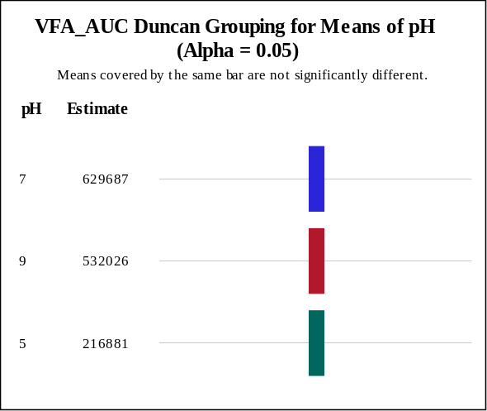
Duncan's Multiple Range Test for AUC_VFA
Note: This test controls the Type I comparison wise error rate, not the experiment wise error rate.

Alpha | 0.05
Error Degrees of Freedom | 14
Error Mean Square | 4.4089E9

Number of Means | 2 | 3 | 4 | 5
Critical Range | 82222 | 86156 | 88582 | 90224

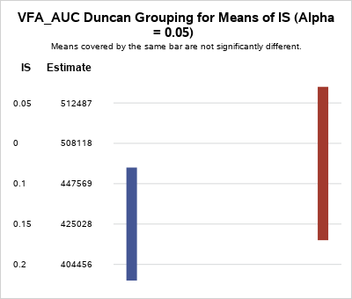

The statistical analysis of the VFA production utilising the area under the curve (AUC) revealed a similar description as depicted in Figure 1. The two-way ANOVA demonstrated that existed significant differences between the treatments (p value <0.0001, α=0.05). In this case, pH and I/S ratio, the main effects, were significant to the model (pH p value <0.0001 and I/S ratio p value <0.04, α=0.05), however, the interaction between pH and I/S ratio was not significant (p value <0.9737, α=0.05). These results agreed with the data presented in Figure 1, where the figures had a similar profile for the three pH even though they have different values. As the interaction term in ANOVA’s model was not significant, the main effects can be described and optimised individually. The Duncan’s multiple range test was used to evaluate the differences in the pH and I/S ratio for the AUC of the VFA production (AUC-VFA).

The ANOVA Procedure for a Randomized Complete Block with Area under the curve of TAN as Dependent Variable:

Source | DF | Sum of Squares | Mean Square | F Value | Pr > F
Model | 15 | 93023991311 | 6201599420.8 | 12.41 | <.0001
Error | 14 | 6998790639.3 | 499913617.09
Corrected Total | 29 | 100022781951

R-Square | Coeff Var | Root MSE | AUC-TAN Mean
0.930028 | 16.12076 | 22358.75 | 138695.4

Source | DF | Anova SS | Mean Square | F Value | Pr > F
Block | 1 | 62769185050 | 62769185050 | 125.56 | <.0001
pH | 2 | 27691233497 | 13845616748 | 27.70 | <.0001
IS | 4 | 1988246725 | 497061681 | 0.99 | 0.4427
IS*pH | 8 | 575326040 | 71915755 | 0.14 | 0.9952

Duncan's Multiple Range Test for AUC-TAN
Note: This test controls the Type I comparison wise error rate, not the experiment wise error rate.

Alpha | 0.05
Error Degrees of Freedom | 14
Error Mean Square | 4.9991E8

Number of Means | 2 | 3
Critical Range | 21446 | 22472

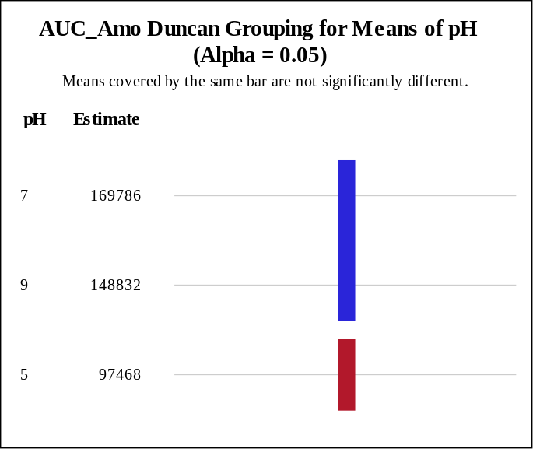
TAN statistical analysis (Annex 1-Supplementary material) also utilised AUC to have a more complete view of the TAN production process Figure 3. The two-way ANOVA demonstrated that existed significant differences between the treatments (p value <0.0001, α=0.05). In this case, only the pH was significant to the model (pH p value <0.0001) while I/S ratio (p value <0.4427, α=0.05) and the interaction between pH and I/S ratio (p value <0.99952, α=0.05) were not significant. Although, the TAN figures described high peaks at different I/S ratio, the lack of significance in this variable revealed the importance of using a variable that unite all the points instead of individual maximums. As I/S ratio and the interaction were not significant, pH was the only main effect that can be utilised for optimisation. The Duncan’s multiple range test was used to evaluate the differences in the pH for the AUC of the TAN production (AUC-TAN).

The ANOVA Procedure for a Randomized Complete Block with Area under the curve of Ln of Biogas-AUC

Source | DF | Sum of Squares | Mean Square | F Value | Pr > F
Model | 15 | 69.82241100 | 4.65482740 | 3.01 | 0.0229
Error | 14 | 21.61599345 | 1.54399953
Corrected Total | 29 | 91.43840445

R-Square | Coeff Var | Root MSE | AUC-Biogas Mean
0.763600 | 16.10672 | 1.242578 | 7.714655

Source | DF | Anova SS | Mean Square | F Value | Pr > F
Block | 1 | 17.21021291 | 17.21021291 | 11.15 | 0.0049
pH | 2 | 28.33714674 | 14.16857337 | 9.18 | 0.0028
IS | 4 | 10.44277666 | 2.61069417 | 1.69 | 0.2078
IS*pH | 8 | 13.83227469 | 1.72903434 | 1.12 | 0.4071

Duncan's Multiple Range Test for AUC_Biogas
Note: This test controls the Type I comparison wise error rate, not the experiment wise error rate.

Alpha | 0.05
Error Degrees of Freedom | 14
Error Mean Square | 1.544

Number of Means | 2 | 3
Critical Range | 1.192 | 1.249

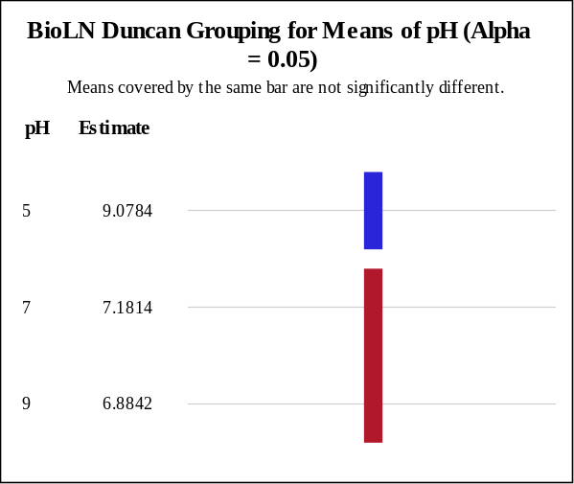
The AUC from the biogas plots (Figure 4) was used as variable for the statistical analysis (Annex 1-Supplementary material). The two-way ANOVA demonstrated that existed significant differences between the treatments (p value <0.0229, α=0.05). Similar to TAN, only the pH was significant to the model (pH p value <0.0028) while I/S ratio (p value <0.2078, α=0.05) and the interaction between pH and I/S ratio (p value <0.4071, α=0.05) were not significant. The statistical result confirmed the strong effect the pH had on biogas production as showed in Figure 4. As I/S ratio and the interaction between pH and I/S ratio were not significant, pH was the main effect employed for optimisation. The Duncan’s multiple range test determined the differences produced by the pH on the AUC of the Biogas figures (AUC-TAN).

The ANOVA Procedure for a Randomized Complete Block with Area under the curve of COD soluble

Source | DF | Sum of Squares | Mean Square | F Value | Pr > F
Model | 15 | 207352448402 | 13823496560 | 2.40 | 0.0546
Error | 14 | 80500404763 | 5750028911.6
Corrected Total | 29 | 287852853164

R-Square | Coeff Var | Root MSE | COD-AUC Mean
0.720342 | 4.184483 | 75828.95 | 1812146

Source | DF | Anova SS | Mean Square | F Value | Pr > F
Block | 1 | 17499233786 | 17499233786 | 3.04 | 0.1030
pH | 2 | 97590228749 | 48795114374 | 8.49 | 0.0039
IS | 4 | 55843729606 | 13960932402 | 2.43 | 0.0967
IS*pH | 8 | 36419256261 | 4552407033 | 0.79 | 0.6187
Duncan's Multiple Range Test for COD soluble
Note: This test controls the Type I comparison wise error rate, not the experiment wise error rate.

Alpha | 0.05
Error Degrees of Freedom | 14
Error Mean Square | 5.75E9

Number of Means | 2 | 3
Critical Range | 72733 | 76213

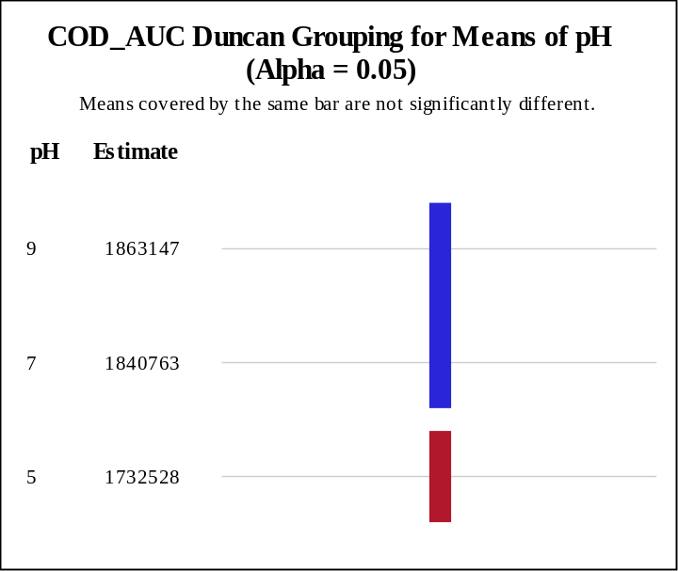
Duncan's Multiple Range Test for COD soluble
Note: This test controls the Type I comparison wise error rate, not the experiment wise error rate.

Alpha | 0.05
Error Degrees of Freedom | 14
Error Mean Square | 5.75E9

Number of Means | 2 | 3 | 4 | 5
Critical Range | 93898 | 98391 | 101162 | 103037

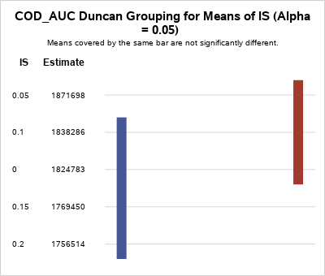

The statistical analysis of the AUC for sCOD (Annex 1-Supplementary material) corroborated the effect of pH and I/S ratio on sCOD concentration Figure 5. The two-way ANOVA demonstrated that existed significant differences between the treatments (p value <0.0546, α=0.1). In this variable, pH and I/S ratio were significant to the model (pH p value <0.0039 and I/S ratio p value <0.096, α=0.1), while, the interaction between pH and I/S ratio was not significant (p value <0.6187, α=0.1). As both main effects were significant, their best conditions can be selected using the Duncan’s test.
The Duncan’s test described pH 7 and 9 (Figure 5F) as the best conditions for sCOD as they had the highest values and were statistically similar. On the other hand, the Duncan’s test showed the I/S ratios of 0.05, 0.1 and 0 as the better conditions for sCOD as they had the highest values and were not statistically different.

The ANOVA Procedure for a Randomized Complete Block with Area under the curve of the square of COD reduction %

Source | DF | Sum of Squares | Mean Square | F Value | Pr > F
Model | 15 | 0.05492069 | 0.00366138 | 1.39 | 0.2736
Error | 14 | 0.03698152 | 0.00264154
Corrected Total | 29 | 0.09190222

R-Square | Coeff Var | Root MSE | COD-AUC Mean
0.597599 | 8.092765 | 0.051396 | 0.635084

Source | DF | Anova SS | Mean Square | F Value | Pr > F
Block | 1 | 0.03038716 | 0.03038716 | 11.50 | 0.0044
pH | 2 | 0.00221480 | 0.00110740 | 0.42 | 0.6655
IS | 4 | 0.00436082 | 0.00109020 | 0.41 | 0.7967
IS*pH | 8 | 0.01795791 | 0.00224474 | 0.85 | 0.5769
Duncan's Multiple Range Test for COD soluble
Note: This test controls the Type I comparison wise error rate, not the experiment wise error rate.

Alpha | 0.05
Error Degrees of Freedom | 14
Error Mean Square | 0.002642

Number of Means | 2 | 3
Critical Range | .04930 | .05166

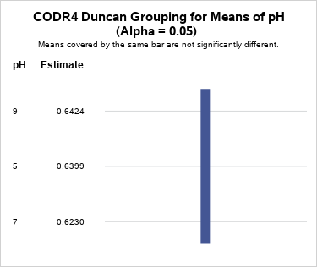
ANNEX 2
Additional variables measured during the VFA production from FW experiment

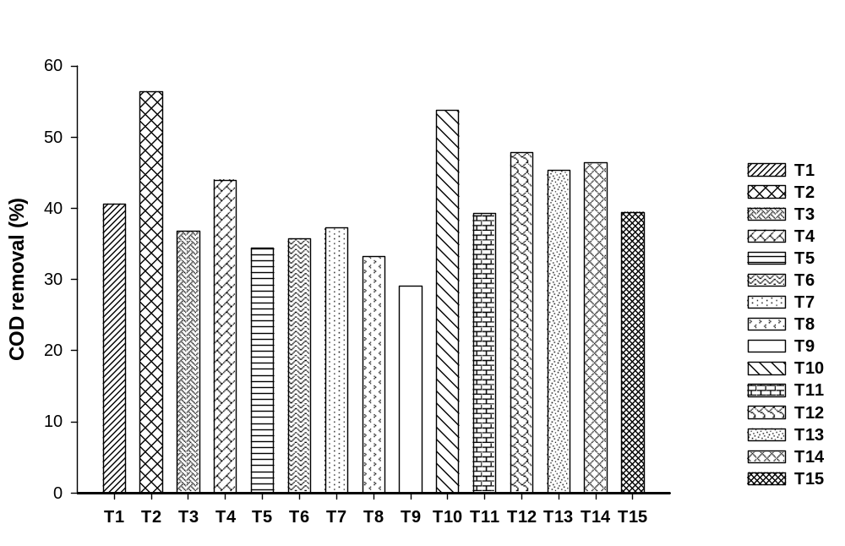
Figure 1. COD removal %
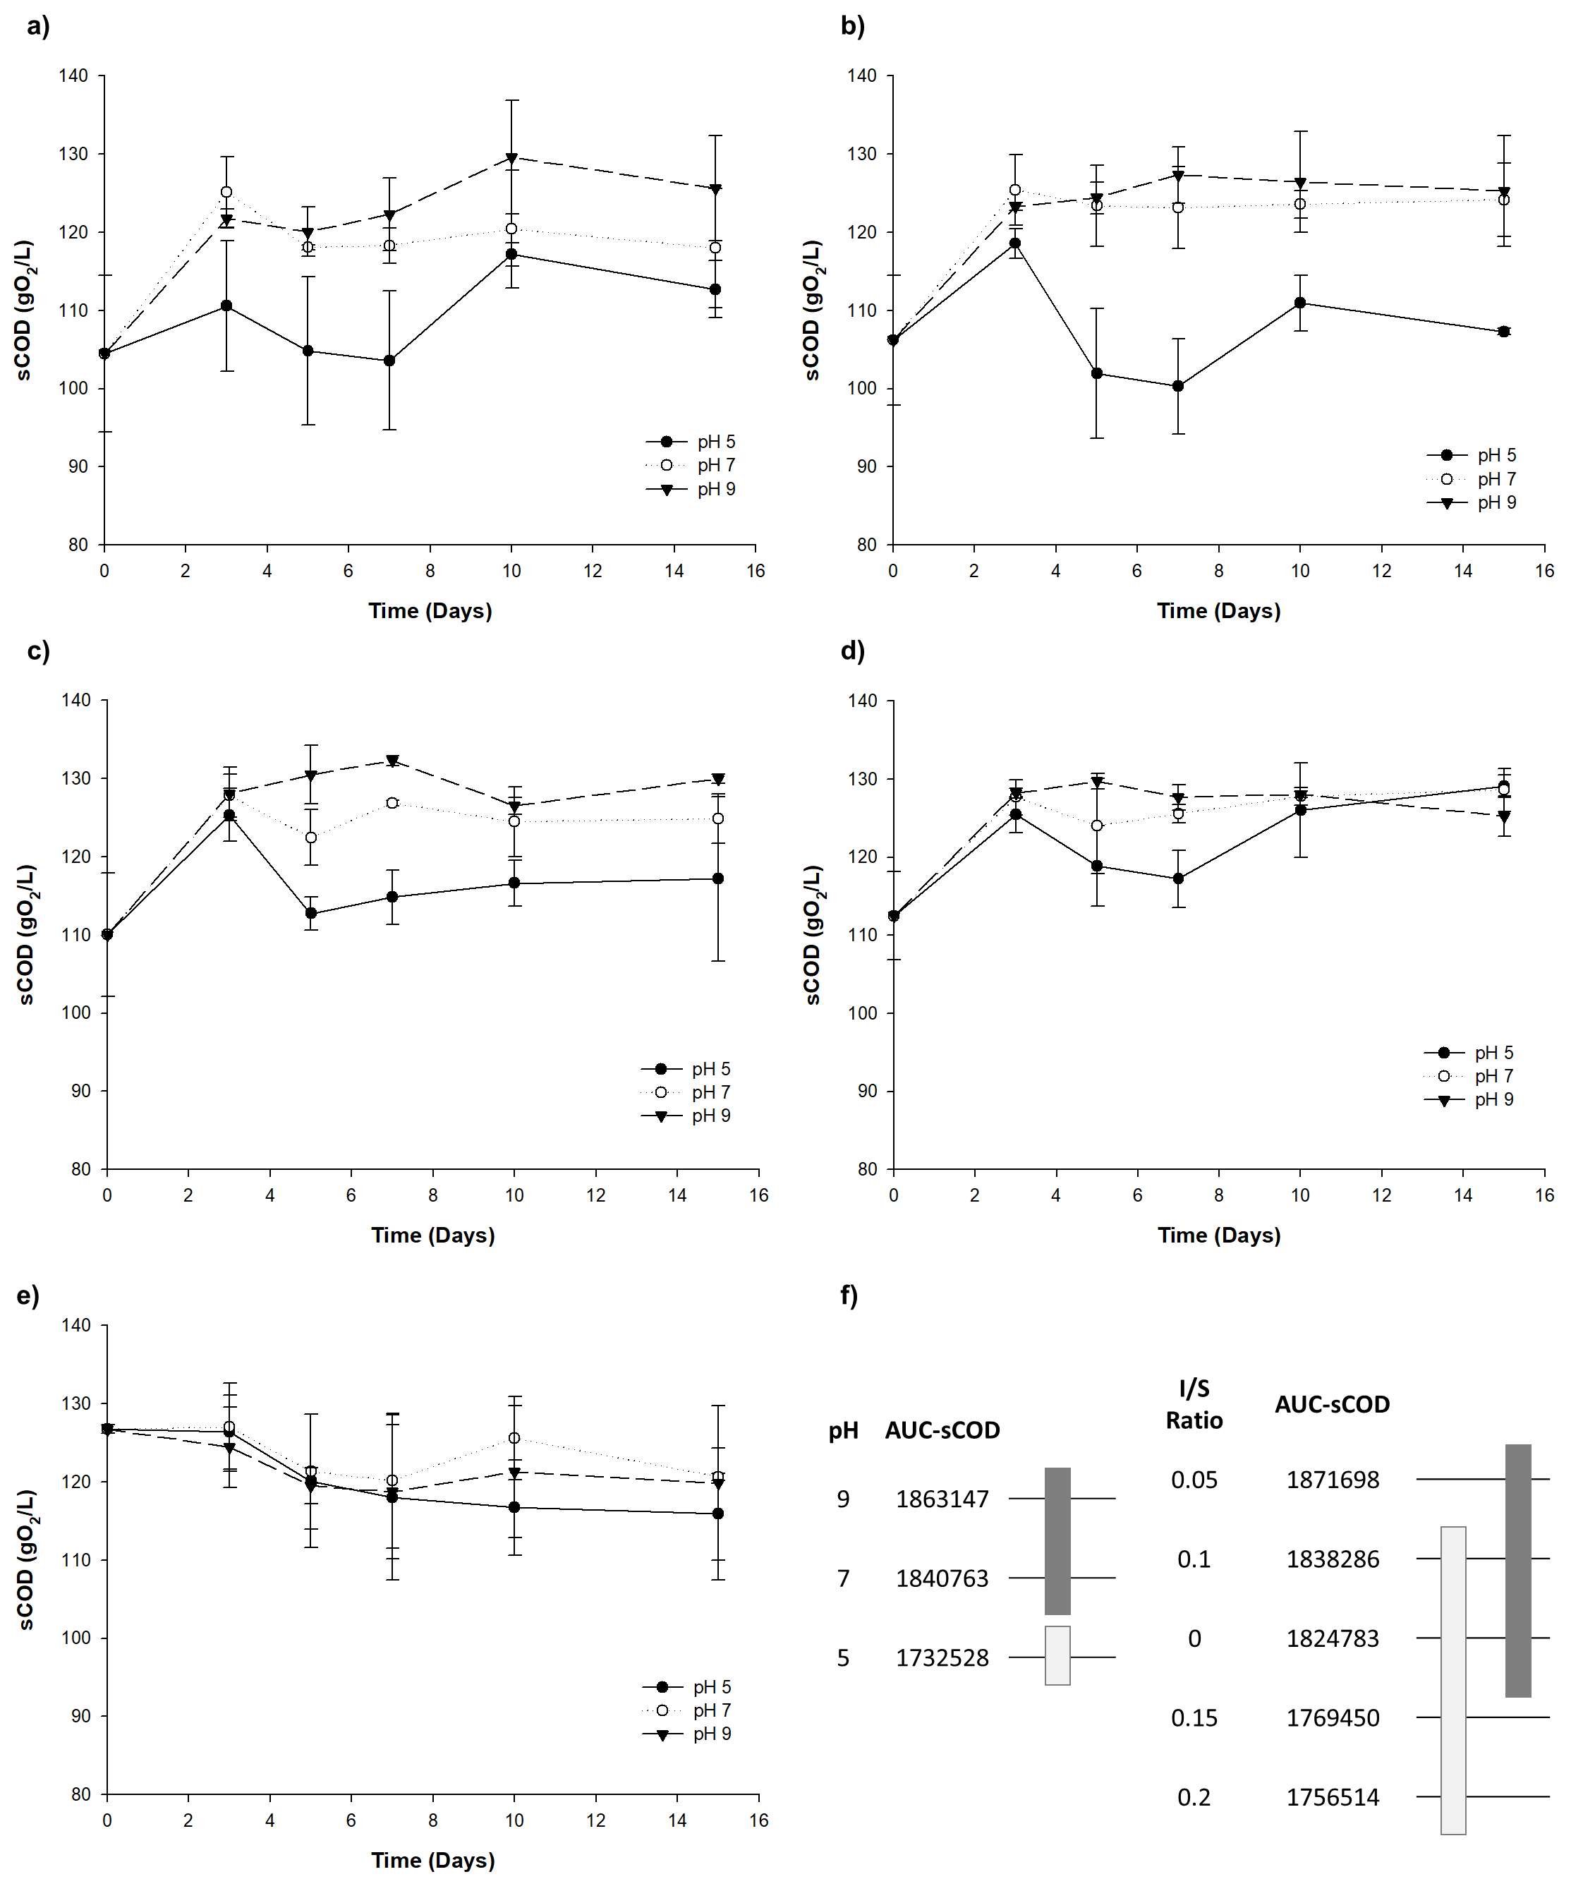
. Figure 2. . Soluble COD during FW transformation into VFA using different pH and I/S ratios: Each figure represents a different I/S value: a. 0.20, b. 0.15, c. 0.10, d. 0.05 and e. 0.00 f. Duncan groupings for means of pH and I/S ratio for the AUC-sCOD variable

* *Corresponding authors: E-mail address: lscadavidr@unal.edu.co | Jersson.placido@vedascii.org Phone: (57-2) 2868888 Ext: 35709 | (57-4) 3620154

