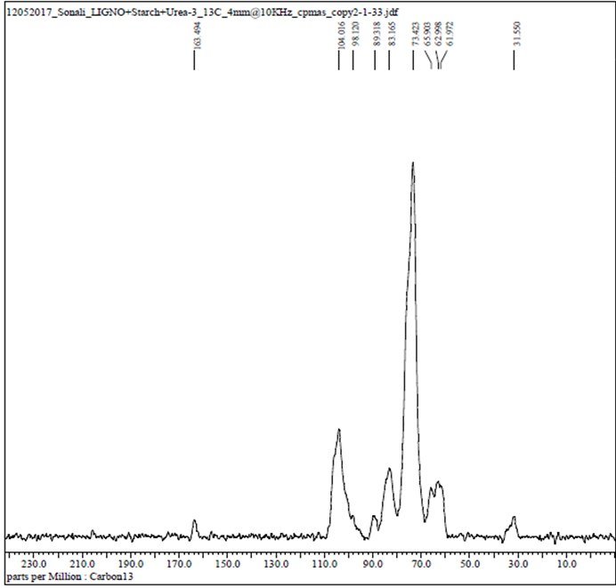
A
B

Fig S1. NMR of SSCF fermented DG (A) and HNG (B) using Palkonal MBW in bioreactor.

Table S1. Screening of different conditions in co-culture fermentation for ethanol production from glucose and xylose using S.cerevisae and P. membranifaciens
Substrate concentration (g) | Sugar conc. after fermentation(g) |  | Total sugar utilised in fermentation(g) | Ethanol (g/L)
 | Condition I
13 | 10.2 |  | 2.8 | 1.0
Condition II
13 | 8.5 | 4.5 |  | 2.1
Condition III
13 | 6.2 | 6.8 |  | 3.0

Table S2 (a). Batch fermentation for ethanol production from DG (A) and HNG (B)
Substrate concentration (g) | Glucose conc before fermentation(g) | Xylose conc before fermentation(g) | Residual glucose after fermentation(g) | Residual xylose after fermentation(g) | Total sugar utilised(g) | Ethanol(g/L)
A-20 | 10±0.35 | 3.0±0.1 | 6.2 | 1.2 | 5.6 | 1.9
B-20 | 6.5±0.18 | 2.0±0.31 | 3.4 | 1.0 | 4.1 | 1.5

Table S2(b). Fed-batch fermentation for ethanol production from DG and HNG
Substrate concentration  (Total concentration- 20 g) | Time difference (h) | Total time | Ethanol(g/L)  DG | Ethanol(g/L)  HNG
2.2+3.6+4.6+4.6+5 | 1+1+2+2 | 6 | 2.1 | 1.9
2.2+4.6+8.2+5 | 1+2+2+3 | 8 | 2.9 | 2.1
8.2+4.6+5+2 | 1+3+3+3 | 10 | 1.6 | 1.3

Table S3. SSCF of pretreated DG and HNG using commercial enzyme Palkonal MBW (A) and IC+Xyl (B).
SSCF of DG in reactor scale (A)
Substrate concentration (%) | Glucose concentration before fermentation, i.e. 24 h of enzymatic hydrolysis (g/l) | Glucose concentration after fermentation (g/l) | Xylose concentration before fermentation  (g/l) | Xylose concentration after fermentation  i.e. 24 h of enzymatic hydrolysis (g/l) | Ethanol  concentration  (g/270 g of biomass)
DG (A) | 72.1±0.21 | 1.8 ±0.15 | 19.3 ±0.18 | 0.2 ± 0.15 | 77.6
DG (B) | 36.3 ±0.33 | 1.5±0.23 | 20.7±0.11 | 0.4± 0.15 | 51.3
SSCF of HNG in reactor scale (B)
HNG(A) | 33.4±0.11 | 1.5±0.13 | 15.3±0.25 | 0.7±0.31 | 49.6
HNG(B) | 46.9±0.30 | 1.2±0.16 | 19.4±0.29 | 0.3±0.33 | 54.9

