Table. 3: Synthesis of pyranopyrazolone in the presence of CuFe₂O₄ NPs as catalyst in EtOH:H₂O (9:1) under reflux condition
Entry | Substrate | Products | Time (min) | Yield (%) | M.P(ºC) |  | Ref. | TON | TOF
 |  |  |  |  | Obs. | Rep. | Ref. | TON | TOF
5a | 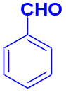 | 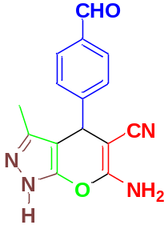 | 60 | 96 | 244-246 | 242-244 | 47 | 4.5 | 4.5
5b | 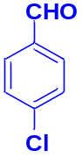 | 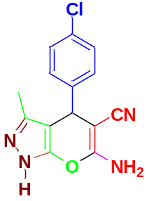 | 50 | 91 | 236-238 | 234-236 | 42 | 4.3 | 5.1
5c | 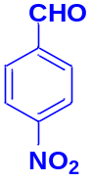 | 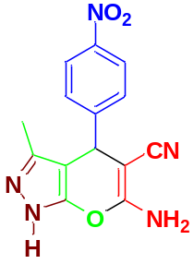 | 45 | 94 | 248-250 | 250-253 | 43 | 4.4 | 5.8
5d | 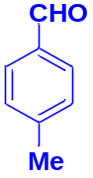 | 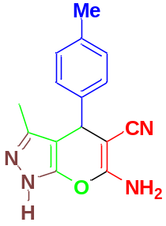 | 60 | 96 | 210-212 | 208-209 | 49 | 3.1 | 3
5e | 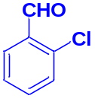 | 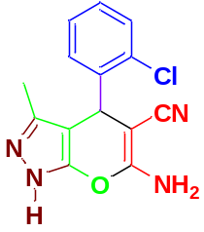 | 55 | 92 | 242-244 | 244-245 | 48 | 4.3 | 4.7
5f | 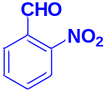 | 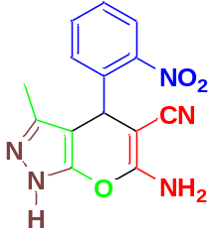 | 50 | 91 | 240-242 | 240-241 | 62 | 4.3 | 5.1
5g | 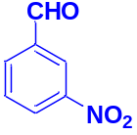 | 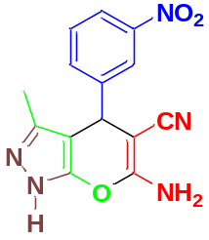 | 50 | 89 | 212-214 | 214-216 | 40 | 4.2 | 5.0
5h | 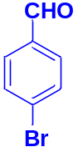 | 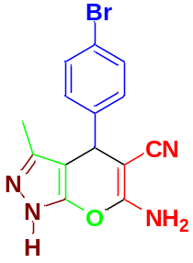 | 60 | 86 | 180-182 | 179-180 | 40 | 4.1 | 4.1
5i | 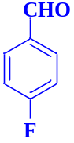 | 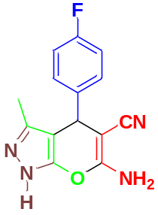 | 55 | 89 | 240-242 | 238-240 | 45 | 4.2 | 4.6
5j | 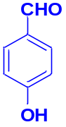 | 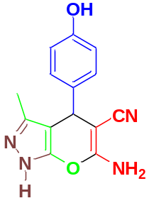 | 45 | 90 | 222 | 223-225 | 43 | 4.3 | 5.7
5k | 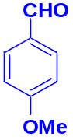 | 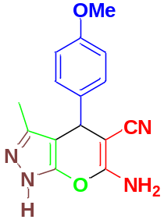 | 55 | 92 | 212-214 | 211-213 | 49 | 4.3 | 4.7
5l | 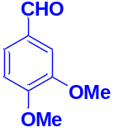 | 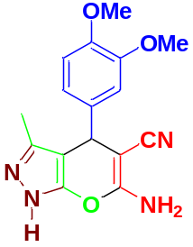 | 50 | 90 | 190-192 | 192-194 | 65 | 4.2 | 5.0
5m | 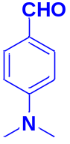 | 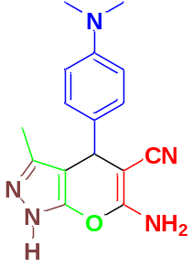 | 60 | 88 | 234-236 | 234-235 | 48 | 4.2 | 4.2

