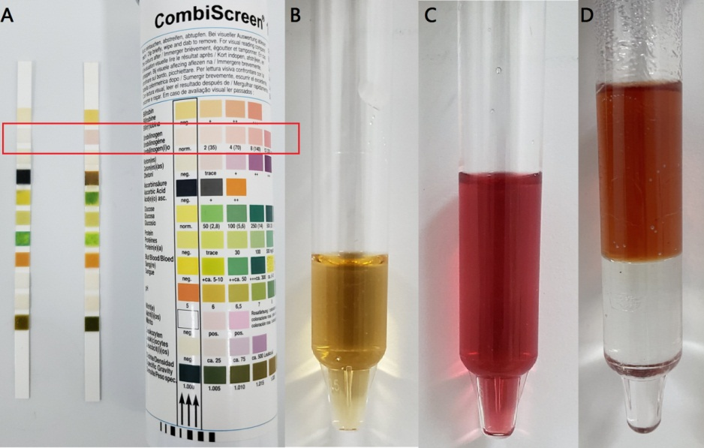
Figure 1. Elevated levels of urinary urobilinogen in acute hepatic porphyria patients were false-positive results caused by urinary PBG.
(A) A positive urinary urobilinogen result reported by the dipstick (the right dipstick in the red box). (B) Fresh urine sample of AHP patient. (C) Urine sample turned red after adding an equal volume of Ehrlich’s reagent. (D) Red color in the aqueous phase of the test tube after adding chloroform illustrated the existence of the PBG-Ehrlich compound, whereas no color in the chloroform phase excluded the existence of the urobilinogen-Ehrlich complex.

