Figure S1

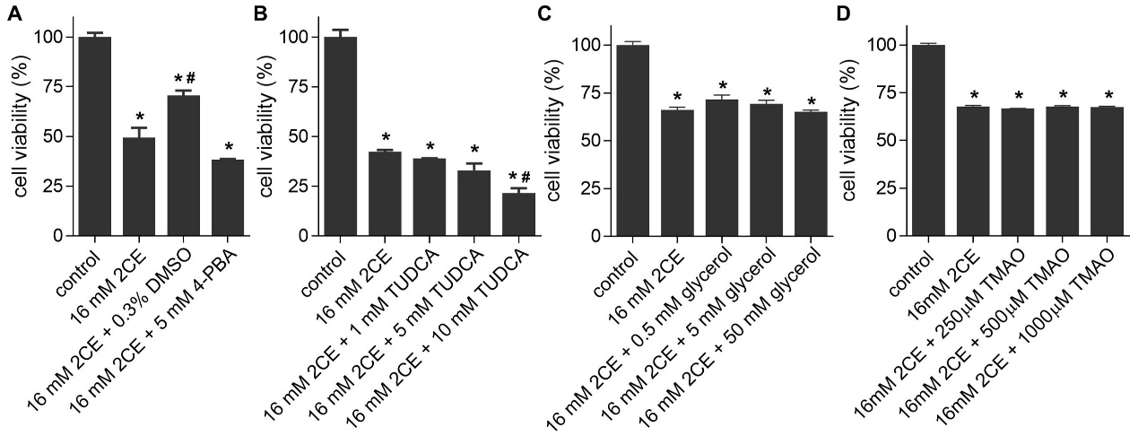

Effects of chemical chaperones on H4IIEC3 cell viability during 2CE intoxication. H4IIEC3 cells were co-treated with 16 mM 2CE and either 0.3% DMSO, 5 mM 4-PBA (A), 1–10 mM TUDCA (B), 0.5–50 mM glycerol (C), or 250–1000 μM TMAO (D). After a 24-hour incubation period, cell viability was assessed with untreated cells serving as the 100% baseline. *P < 0.05 compared to control, #P < 0.05 compared to 2CE; mean ± SEM, n = 3.

