Figure S2

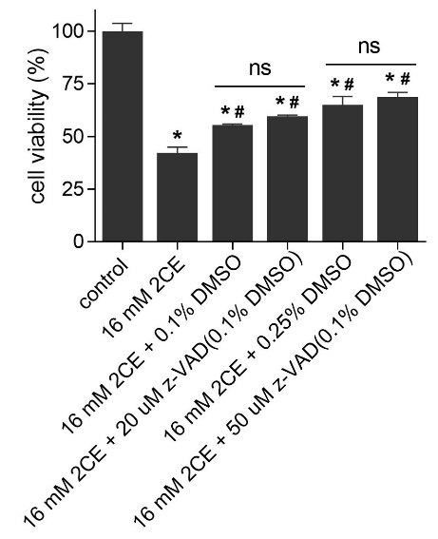

Inhibiting apoptosis does not ameliorate 2CE-induced cell death. Following pre-treatment with the pan-caspase inhibitor Z-VAD-FMK (20 or 50 μM) or vehicle control (0.1 or 0.25% DMSO) for 1 hour, cells treated with 16 mM 2CE were counted 24 hours later, with untreated cells serving as the 100% baseline. *P < 0.05 compared to the control group, #P < 0.05 compared to 2CE; mean ± SEM, n = 3.

