Section 1/9 – Identification
Participant's email:
Informed Consent Form (Not shown in this supplementary material version)
Tick here if you understand and accept the implications of participating in this research by responding to the online form:
  - I accept
Select the option that represents your age range:
  - 18 years or younger
  - Between 18 and 19 years
  - Between 20 and 29 years
  - Between 30 and 39 years
  - 40 years or older
Select the clinical option that applies to you:
  - Person with ASD (autism spectrum disorder, including Asperger's Syndrome), over 18 years old, and a student
  - Person with ADHD (attention deficit hyperactivity disorder), over 18 years old, and a student
  - Person with both ASD and ADHD
  - None of the above
Section 2/9 - Medication
If you are using any medication that helps you focus or complete daily tasks, we recommend that you continue using this medication while completing the form for greater comfort.
Did you START using any medication(s) to manage symptoms related to ADHD or Autism during the pandemic? If yes, which one(s)?

Did you STOP using any medication(s) to manage symptoms related to ASD or ADHD during the pandemic? If yes, which one(s)?

Section 3/9 - Hyperfocus in Specific Scenarios 1/2
The following scenarios discuss common experiences people may encounter when doing activities they enjoy or find rewarding.
Do not worry about the specific activities mentioned in each scenario. Instead, consider how you feel when doing an activity you enjoy – whether it’s studying for your favourite classes, working on something related to your favourite hobby, or engaging in your preferred screen time activities – and respond to the questions about your experiences, indicating how often you’ve gone through these experiences more intensely in the past year during the quarantine than you did before the COVID-19 pandemic:

When I’m working on a project I enjoy, like writing something creative or working on a complicated task for college or work, I can completely lose track of time; I start working after dinner, and the next time I check the clock, it’s already early morning.

Before the Pandemic:
  - Never
  - 1 to 2 times every six months
  - Once a week
  - 2 to 3 times a week
  - Daily
During the Pandemic:
  - Never
  - 1 to 2 times every six months
  - Once a week
  - 2 to 3 times a week
  - Daily
When I’m doing something I really enjoy, like reading a book I love, I can completely “zone out” from the real world. You could call my name or wave your hands in front of me, and I wouldn’t notice.

Before the Pandemic:
  - Never
  - 1 to 2 times every six months
  - Once a week
  - 2 to 3 times a week
  - Daily
During the Pandemic:
  - Never
  - 1 to 2 times every six months
  - Once a week
  - 2 to 3 times a week
  - Daily

When I’m browsing for clothes online or looking for ideas on Pinterest for new projects I want to start, I sometimes stand up and realise I’ve been stiff because I haven’t changed positions for hours.

Before the Pandemic:
  - Never
  - 1 to 2 times every six months
  - Once a week
  - 2 to 3 times a week
  - Daily
During the Pandemic:
  - Never
  - 1 to 2 times every six months
  - Once a week
  - 2 to 3 times a week
  - Daily

When I start researching for a project, I might have trouble stopping, even though I know I need to go to class or to work.

Before the Pandemic:
  - Never
  - 1 to 2 times every six months
  - Once a week
  - 2 to 3 times a week
  - Daily
During the Pandemic:
  - Never
  - 1 to 2 times every six months
  - Once a week
  - 2 to 3 times a week
  - Daily

When I’m shopping online, I can spend hours looking for the “perfect” choice. I browse through site after site, searching for the best deal, the perfect colour, the coolest brand, and so on. I read as many reviews as I can until I’m fully convinced I’ve found the best option.
Before the Pandemic:
  - Never
  - 1 to 2 times every six months
  - Once a week
  - 2 to 3 times a week
  - Daily
During the Pandemic:
  - Never
  - 1 to 2 times every six months
  - Once a week
  - 2 to 3 times a week
  - Daily

When I’m listening to music while doing other work, I can keep working indefinitely without realising the whole day has passed. I don’t even notice if people around me leave. When I look out of the window, I see that the day has already started to get dark, or it has already turned to night.

Before the Pandemic:
  - Never
  - 1 to 2 times every six months
  - Once a week
  - 2 to 3 times a week
  - Daily
During the Pandemic:
  - Never
  - 1 to 2 times every six months
  - Once a week
  - 2 to 3 times a week
  - Daily

I get easily addicted to Netflix and find it difficult to stop to do some work or anything else I need to do.

Before the Pandemic:
  - Never
  - 1 to 2 times every six months
  - Once a week
  - 2 to 3 times a week
  - Daily
During the Pandemic:
  - Never
  - 1 to 2 times every six months
  - Once a week
  - 2 to 3 times a week
  - Daily

Section 4/9 - Hyperfocus in Specific Scenarios 2/2
When I’m working on a new project, I can get so “immersed” that I feel there’s nothing else I could or should be doing. I feel as though I’m alone and don’t “hear” what others say, even though I act as if I’m listening to them.

Before the Pandemic:
  - Never
  - 1 to 2 times every six months
  - Once a week
  - 2 to 3 times a week
  - Daily
During the Pandemic:
  - Never
  - 1 to 2 times every six months
  - Once a week
  - 2 to 3 times a week
  - Daily

Sometimes, when working on a new project, I keep redoing the same detail repeatedly until it’s exactly how I want it, even though it looked fine from the start.

Before the Pandemic:
  - Never
  - 1 to 2 times every six months
  - Once a week
  - 2 to 3 times a week
  - Daily
During the Pandemic:
  - Never
  - 1 to 2 times every six months
  - Once a week
  - 2 to 3 times a week
  - Daily

I can play a game I enjoy for hours without moving. I get so focused on the screen that people I live with say the only way to get my attention is to jump in front of me or turn off the game.
Before the Pandemic:
  - Never
  - 1 to 2 times every six months
  - Once a week
  - 2 to 3 times a week
  - Daily
During the Pandemic:
  - Never
  - 1 to 2 times every six months
  - Once a week
  - 2 to 3 times a week
  - Daily

After starting a project, I stay up late thinking about it non-stop. I can’t clear my mind and leave it to think about the next day. I stay up all night anxious to get back to the project. Sometimes, I end up getting up and returning to my project in the middle of the night, and I can’t concentrate on tasks the following day.
Before the Pandemic:
  - Never
  - 1 to 2 times every six months
  - Once a week
  - 2 to 3 times a week
  - Daily
During the Pandemic:
  - Never
  - 1 to 2 times every six months
  - Once a week
  - 2 to 3 times a week
  - Daily

When I’m on the internet, it’s almost like being under a hypnotic spell. I check my email, reply to Facebook messages, look at friends’ photos, read some news, update my other social media pages… this goes on, and sometimes I can’t control it. I disconnect from the world and dive into the internet, even when I know I’m not doing anything particularly meaningful online.
Before the Pandemic:
  - Never
  - 1 to 2 times every six months
  - Once a week
  - 2 to 3 times a week
  - Daily
During the Pandemic:
  - Never
  - 1 to 2 times every six months
  - Once a week
  - 2 to 3 times a week
  - Daily

When I’m really focused on something, I feel like it’s the right thing to do. Sometimes I skip meals or accidentally stay up all night because I get so involved in what I’m doing.
Before the Pandemic:
  - Never
  - 1 to 2 times every six months
  - Once a week
  - 2 to 3 times a week
  - Daily
During the Pandemic:
  - Never
  - 1 to 2 times every six months
  - Once a week
  - 2 to 3 times a week
  - Daily

When I go online – mainly looking at things like Buzzfeed, Facebook, or Pinterest – I always think only a few minutes have passed, but then I look at the time and realise I’ve been online for an hour or two.
Before the Pandemic:
  - Never
  - 1 to 2 times every six months
  - Once a week
  - 2 to 3 times a week
  - Daily
During the Pandemic:
  - Never
  - 1 to 2 times every six months
  - Once a week
  - 2 to 3 times a week
  - Daily

Section 5/9 - Hyperfocus on Screen Time
What type of “screen time” do you engage in most frequently during your free time (i.e., when you are NOT doing something related to your work or school)? Please choose one of the following:
  - Watching TV channels, movies, or series
  - Video games (including computer games, online games, tablet, and mobile games)
  - Social media (e.g., Facebook, Twitter, Instagram, WhatsApp, TikTok, etc.)
  - Online shopping
  - Using online dating apps or websites (e.g., Tinder, Umatch, Badoo, or Happn)
  - “Surfing the web” (e.g., reading news, researching information, etc.)
  - Other

While engaging in the screen time activity you chose above, how often in the last year during the quarantine have you experienced any of the following more intensely than you did before the COVID-19 pandemic?
Completely losing track of time while doing the screen time activity (e.g., not knowing how long you've been watching TikTok videos since you started).
Before the Pandemic:
  - Never
  - 1 to 2 times every six months
  - Once a week
  - 2 to 3 times a week
  - Daily
During the Pandemic:
  - Never
  - 1 to 2 times every six months
  - Once a week
  - 2 to 3 times a week
  - Daily

Not noticing distractions while doing the screen time activity (e.g., not noticing if someone calls your name while you're responding to messages on WhatsApp).
Before the Pandemic:
  - Never
  - 1 to 2 times every six months
  - Once a week
  - 2 to 3 times a week
  - Daily
During the Pandemic:
  - Never
  - 1 to 2 times every six months
  - Once a week
  - 2 to 3 times a week
  - Daily

Accidentally missing meals, staying up all night, or continuing the screen time activity until it was urgently necessary to stop and go to the bathroom.
Before the Pandemic:
  - Never
  - 1 to 2 times every six months
  - Once a week
  - 2 to 3 times a week
  - Daily
During the Pandemic:
  - Never
  - 1 to 2 times every six months
  - Once a week
  - 2 to 3 times a week
  - Daily

Having difficulty stopping or pausing the screen time activity to continue later and start a new task, even if the new task is more important or urgent (e.g., stopping to study or do work instead of looking at Instagram photos).
Before the Pandemic:
  - Never
  - 1 to 2 times every six months
  - Once a week
  - 2 to 3 times a week
  - Daily
During the Pandemic:
  - Never
  - 1 to 2 times every six months
  - Once a week
  - 2 to 3 times a week
  - Daily

Feeling completely captivated or “hooked” by the screen time activity.
Before the Pandemic:
  - Never
  - 1 to 2 times every six months
  - Once a week
  - 2 to 3 times a week
  - Daily
During the Pandemic:
  - Never
  - 1 to 2 times every six months
  - Once a week
  - 2 to 3 times a week
  - Daily

Focusing heavily on one small detail of what you're doing, neglecting other important parts (e.g., spending too much time comparing prices and reviews online, and postponing making a decision about something to buy).
Before the Pandemic:
  - Never
  - 1 to 2 times every six months
  - Once a week
  - 2 to 3 times a week
  - Daily
During the Pandemic:
  - Never
  - 1 to 2 times every six months
  - Once a week
  - 2 to 3 times a week
  - Daily

Section 6/9 - Short Responses
Use the space provided to answer the following questions. Please provide as much detail as possible.
What types of activities tend to make you very focused (e.g., reading about a specific topic, doing a certain hobby, browsing the internet)? List as many activities as you can think of.

Please describe in as much detail as possible a time when you were very focused on something during the pandemic quarantine. How long did that episode of focus last? Do you believe this focus lasted more hours or days (or fewer hours, fewer days) than when you were focused on something before the pandemic?

How did you feel during that time? Did you feel like you lost track of time more easily or less easily?

Did you manage to accomplish something significant in the end (e.g., a piece of artwork, achieving a personal goal, etc.)?

Do you think your focus on something during quarantine negatively affected you more than it did before the pandemic? Did you postpone your personal needs more often (like eating or going to the bathroom, for example) or important activities you should have done (like college work, for instance)?

Section 7/9 - Diagnosis and Therapies
How was your diagnosis of ASD or ADHD made?
  - I read about the disorder online or talked to people who know about it and identified with it
  - I was diagnosed by a Neurologist/Neuropaediatrician
  - I was diagnosed by a Psychiatrist
  - Other
Do you undergo any kind of therapy?
  - Yes
  - No
Do you believe that this therapy influences your ability to intensely concentrate when doing an activity you are interested in? (For example, do you feel it is easier to stop doing your hobby to study or work on the days you attend therapy?)

Section 8/9 - Screen Time
The responses for this section are entirely optional!
We would like to know how much time you have spent on your mobile phone this week, and to do so, we have provided a tutorial below on how to find this information in your device’s settings, using a series of images that represent the step-by-step process to find this data!
In the images pointed out by the red arrow (1), we are representing the step-by-step process for an IOS phone, and in the images pointed out by the green arrow (2), we are representing an Android phone. If your phone doesn’t follow the exact pattern of these systems, it likely has some similarity to these settings.
(1) IOS: Start the process through the "Settings" widget; (2) Android: Start the process through the "Settings" widget.
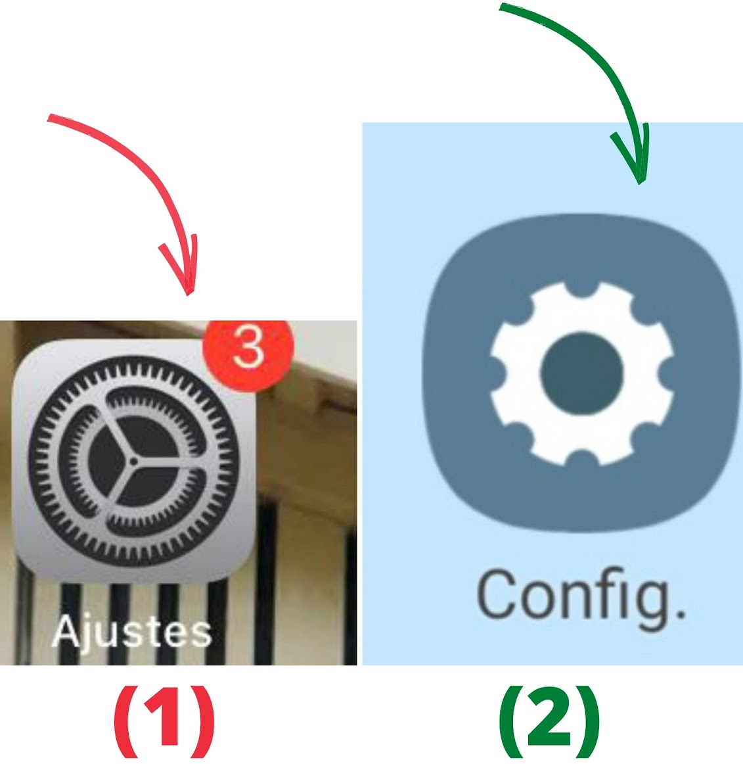
(1) IOS: Select "Screen Time"; (2) Android: Select "Digital Wellbeing & Parental Controls".
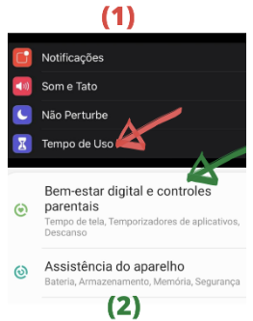
Identify the weekly average of hours you spent on your phone, as indicated by the system. In the examples, it would be 4h20min for IOS and 5h12min for Android.
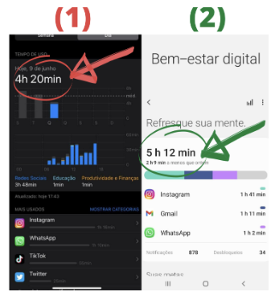
Now that you have identified your weekly average screen time, select the option that corresponds to this data:
  - Between 0 and 1 hour
  - Between 1 and 4 hours
  - Between 4 and 8 hours
  - Between 8 and 12 hours
  - More than 12 hours

