Respiratory Effort Monitoring: a Novel, Bedside, Non-invasive, Real-time Method
Authors：Yinxia Lv^{1‡}, Meiling Dong^{1‡}, Haisong Song^{2‡}, Jinglei Liu^{2‡}, Zhiwen Huang², Zhong Ni¹, Zhen Wang¹, Xiaorong Jing¹, Xiaoyong Zhou², Yongfang Zhou^{1*}, Bo Wang^{3*}, Yan Kang^{3*}

¹ Department of Respiratory Care, West China Hospital of Sichuan University, Chengdu 610041, China
² Shenzhen Mindray Bio-Medical Electronics Co. Ltd., Shenzhen, 518057,China
³ Department of Critical Care Medicine, West China Hospital of Sichuan University, Chengdu 610041, China

‡ These authors contributed equally to this work.
* Corresponding Author Email: kangyan@scu.edu.cn; drwangbowch@163.com; zyfmg@163.com; liujinglei@mindray.com

ONLINE DATA SUPPLEMENT

METHODS
Detailed Process of $P_{mus}$Formula Derivation
According to the respiratory mechanics equation, the respiratory system can be simplified as a first-order RC system, where R represents respiratory system resistance (viscous resistance) and C represents compliance (also noted as elastic resistance, E). During mechanical ventilation, respiratory drive originates primarily from two sources: the ventilator’s driving force (i.e., airway pressure, $P_{aw}$) and the patient’s respiratory muscle contractions ($P_{mus}$). Based on the first-order model [1, 2], the respiratory mechanics equation is given as follows:
$$P_{aw}\left(t\right)=\dot{V}\left(t\right)*R_{rs}+\frac{V\left(t\right)}{C_{rs}}+P_{mus}\left(t\right)+P_{0}$$ | (1)
Here, $P_{aw}$ represents the airway pressure, measured directly by an airway pressure sensor during mechanical ventilation; $\dot{V}$ represents the patient’s flow, measured by a flow sensor; V is the integral of the patient’s flow; $P_{0}$​ is the constant end-expiratory pressure term; $P_{mus}$ is the pressure generated by the patient’s respiratory muscles; $R_{rs}$​ represents the viscous resistance of the patient’s respiratory system; and $C_{rs}$ represents the compliance of the patient’s respiratory system.
As shown in Equation (1), $P_{mus}\left(t\right)$ is the unknown signal, and $R_{rs}$, $C_{rs}$, and $P_{0}$ are unknown parameters in the respiratory mechanics equation, while the remaining terms are known signals. Solving for $P_{mus}\left(t\right)$ during the patient's inspiratory phase, with $R_{rs}$, $C_{rs}$, and $P_{0}$ as unknowns, constitutes an underdetermined system of equations. This estimation problem can be reframed as an optimization problem for a specified objective function:
$$\min{J}=\sum_{k=0}^{k=m}{{\left(P_{aw}\left(t_{k}\right)-\dot{V}\left(t_{k}\right)*R_{rs}-\frac{V\left(t_{k}\right)}{C_{rs}}-P_{mus}\left(t_{k}\right)-P_{0}\right)}^{2}}$$ | (2)
Here, $t_{k}$ denotes the k-th time sample, as signal data are typically collected through sampling sensors, and k represents the total number of time samples during respiratory muscle activity. Here, $t_{0}$ represents the start time of inspiration, and $t_{m}$ marks the end of respiratory muscle activity. The parameters over which 𝐽 is minimized are $R_{rs}$, $C_{rs}$, $P_{0}$, $P_{mus}\left(t_{0}\right)$, $P_{mus}\left(t_{1}\right)$, …, $P_{mus}\left(t_{m}\right)$.
To solve this problem, we introduce a physiologically-based mathematical model along with prior constraints, as shown in Figure E1. Compared with previous studies [3-5], we incorporated clinical insights to make three key innovations: 1) we employed global constrained least-squares fitting over the $t_{0}$ and $t_{m}$ intervals, rather than using moving-window least-squares estimation; 2) to fit Pmus, we adopted a cubic function template that constrains the active expiratory pattern, instead of using monotonic constraints or other segmented functional constraints; and 3) we identified $t_{0}$ through waveform feature recognition instead of merely selecting the points where flow and volume are zero, and iteratively solved for $t_{m}$ based on both inspiratory and expiratory phase data, rather than selecting a fixed cycling-off time. To validate the superiority of the novel algorithm, we replicated algorithms from previous literature and patents and compared their performance using the same clinical patient dataset. The results, shown in Figure E3, highlight the advantages of the proposed method. The schematic in Figure E1(A) illustrates the algorithm’s solution approach.
First, $t_{0}$ is identified as the point where $P_{mus}$ begins to decrease. Clinical practice has shown that this point does not always coincide with the time when flow equals zero. The algorithm identifies this point by integrating the descending characteristics of the pressure waveform with the upturn in the flow waveform during exhalation, based on the IntelliCycle™ algorithm described in [6]. Priority is given to the flow signal feature over the pressure signal due to its faster response time.
Next, $t_{m}$ is iteratively determined as the duration of respiratory muscle activity, including both inspiratory effort and expiratory effort (if present). However, the position of $t_{m}$​ is highly uncertain, as it may occur during either the inspiratory or expiratory phase, making it challenging to pinpoint using only waveform characteristics. This part of the algorithm applies a constrained least-squares method to iteratively test different durations for $t_{m}$, selecting the optimal $t_{m}$ based on the shape and deviation of $P_{mus}$​, and the parameter ranges of $R_{rs}$, $C_{rs}$, and $P_{0}$.
Finally, optimal fitting of the $P_{mus}$​ profile is performed between $t_{0}$ and $t_{m}$. The distribution of the $P_{mus}$ signal does not vary arbitrarily within a single breath, it generally decreases monotonically at the onset of spontaneous breathing, then increases monotonically as the muscles relax. During passive exhalation, this pressure stabilizes at zero. During active exhalation, $P_{mus}$​ first increases and then decreases to near zero (as shown in Figure E1(B)). The polynomial order was empirically validated. A third-order polynomial optimally balanced physiological fidelity and computational robustness. Lower-order polynomials (e.g., second-order) failed to capture asymmetric profiles or active expiration, whereas higher-order models (e.g., fourth-order) led to overfitting of noise. The advantage of using third-order polynomials to fit Pmus morphology is demonstrated by the Normal scenario simulated by ASL5000, as shown in Figure E2.
Additionally, physiological knowledge can be incorporated into the estimation algorithm as regional constraints, where $P_{mus}$​ is represented by a constrained cubic function model (as shown in Figures E1(B), 1(C), and 1(D)).
$$P_{mus}\left(t_{k}\right)=a_{0}+a_{1} t_{k}+a_{2} {t_{k}}^{2}+a_{3}{t_{k}}^{3}$$ |  | (3)
Where the constraints are:
$$\left\{\begin{aligned}P_{mus}\left(t_{0}\right)=0 \\ P_{mus}\left(t_{m}\right)=0 \\ {P^{'}}_{mus}\left(t_{0}\right)<0 \\ {P^{''}}_{mus}\left(t_{0}\right)>0 \\ {P^{'''}}_{mus}\left(t_{0}\right)<0\end{aligned}\right.$$ | (4)
Here, $a_{0}$, $a_{1}$, $a_{2}$, and $a_{3}$ represent the intercept, linear, quadratic, and cubic term coefficients in the $P_{mus}$ model, respectively, while ${P^{'}}_{mus}$, ${P^{''}}_{mus}$, and ${P^{'''}}_{mus}$ are the first, second, and third derivatives of $P_{mus}$ with respect to time. These constraints account for active exhalation, making the model more accurately reflect the patient's actual $P_{mus}$ waveform.
To ensure solution accuracy, the ranges for $R_{rs}$, $C_{rs}$, and $P_{0}$, and $P_{mus}(t_{k})$are further constrained as follows:
$$\left\{\begin{aligned}{ R}_{min}≤R_{rs}≤R_{max} \\ { C}_{min}≤C_{rs}≤C_{max} \\ {P_{0}}_{min}≤P_{0}≤{P_{0}}_{max} \\ {{ P}_{mus}}_{min}≤P_{mus}(t_{k})≤{P_{mus}}_{max} \end{aligned}\right.$$ | (5)
Where $R_{min}$, $R_{max}$, $C_{min}$, $C_{max}$, ${P_{0}}_{min}$, ${P_{0}}_{max}$, ${P_{mus}}_{min}$, ${P_{mus}}_{max}$ are constants representing the clinically possible maximum range limits. In this study, these values are set to 1, 50, 5, 200, 0, 80, -50, and 50, respectively.
By combining Equations (2)-(5), the solution problem is transformed into an overdetermined system of equations, which is solved using the constrained least squares method as follows:
$$\min{J}=\sum_{k=0}^{k=m}{{\left(P_{aw}\left(t_{k}\right)-\dot{V}\left(t_{k}\right)*R_{rs}-\frac{V\left(t_{k}\right)}{C_{rs}}-P_{mus}\left(t_{k}\right)-P_{0}\right)}^{2}}={\left|\left|Y-A*X\right|\right|}^{2}$$ | (6)
Subject to Equations (4) and (5),
Where:
$$\left\{\begin{aligned}{Y=\left[Paw\left(t_{0}\right), …,Paw\left(t_{k}\right),…,Paw\left(t_{m}\right)\right]}^{T} \\ A={\left[R_{rs},1/C_{rs},P_{0},{a_{0},a}_{1},a_{2},a_{3}\right]}^{T} \\ X=[Flow\left(t_{k}\right),Volume\left(t_{k}\right),1,1,t_{k},t_{k}^{2},t_{k}^{3}] \\ for k=0,…m \end{aligned}\right.$$ | (7)
After iterative solving using the numerical optimization algorithm, the $P_{mus}$ waveform is obtained. A simple calculation yields the amplitude of the $P_{mus}$​ waveform over a single breathing cycle, which corresponds to the non-invasive real-time monitored N-$P_{mus}$. Further, integrating this result gives N-${PTP}_{mus}$ (the pressure–time product of $P_{mus}$​ per breath). The specific formula is as follows:
$${PTP}_{mus}=\int_{t_{0}}^{t_{m}}{P_{mus}\left(t\right) dt}=\sum_{k=0}^{k=m}{P_{mus}\left(t_{k}\right)} ∆t$$ | (8)
Here, $∆t$ represents the time interval between sampling points, determined by the sensor’s sampling frequency. The sampling rate for all data measurements is 1 kHz.
Detailed Process of Simulation Experiments
The simulation experiment was conducted using the Active Servo Lung 5000 (ASL 5000 sw3.6, IngMar Medical, Pittsburgh, Pennsylvania). Three main clinical scenarios were simulated: normal, restrictive and obstructive lungs, with Pmus intensities including 3 to 30cmH2O, and modes including commonly used V-AC, P-AC, PSV. The simulated parameters referenced the literature [6-8]. Spontaneous breathing was programmed in a sinusoidal mode in the active servo lung, with varying percentages of Pmus rise, hold, and release to simulate different morphologies (see Table E1). Experiments were performed using the SV800 ventilator (Mindray, Shenzhen, China). Each experimental scenario involved the analysis of 30 breaths (15 per minute, lasting 2 minutes), with recorded results of ASL5000-Pmus and ventilator-monitored N-Pmus. To minimize the impact of repeated measurements on analysis results, a mean value was calculated for each experimental scenario. A linear mixed-effects model was used to analyze and interpret correlations and to estimate differences and standard deviations in the agreement analysis. Detailed statistical results can be found in Table E1 and Figure E4.
Detailed Process of Clinical Trial Validation
The trial process was as follows:
1) Upon enrollment, patients were transitioned to the Mindray SV800 ventilator, and researchers completed a Case Report Form (CRF) to document essential information such as patient demographics, monitoring conditions, trial specifics, and ventilator settings.
2) During the trial, participants used the SV800 ventilator with its storage function activated to automatically record waveform data and monitoring parameters at a sampling rate of 50 Hz.
3) Esophageal balloon catheters (SDY-1, Mindray, Shenzhen, China) were used. Placement was performed via the nasal route to a depth of approximately 60 cm. Initial gastric placement was confirmed by auscultating air-entry sounds over the epigastrium during balloon inflation, along with a low-pressure baseline and small positive deflections on the pressure waveform. The catheter was then withdrawn until cardiac oscillations appeared, indicating placement in the lower esophagus. Fine adjustments were made to optimize placement using the Mindray SV800’s Assisted Placement Tool: the catheter was retracted in 2.5 cm increments until the occlusion ratio (ΔPes/ΔPaw) reached 0.8–1.2, followed by 1 cm micro adjustments to approach a ratio of 1.0 [7]. Continuous monitoring and collection of esophageal pressure waveforms followed.
4) Respiratory mechanics measurements were performed on participants. Sedatives and muscle relaxants were administered to inhibit spontaneous breathing. End-inspiratory esophageal pressure (PesI) and end-expiratory esophageal pressure (PesE) were recorded by manually holding inspiration and expiration for 5 seconds, respectively. These measurements were used to calculate chest wall compliance [8]：
$$C_{cw}=\frac{TV_{e}}{PesI-PesE}$$ | (9)
where Tve represents the expiratory tidal volume monitored by the ventilator, and PesI and PesE denote the steady esophageal pressures at end-inspiration and end-expiration, respectively.
5) After respiratory mechanics measurements, data collection began once the participant had resumed spontaneous breathing and maintained stable respiration for over 30 minutes. The researcher initiated the collection of N-Pmus data monitored by the Mindray ventilator and recorded the start time. An external USB flash drive was used for data storage throughout the trial.
6) After each participant discontinued using the SV800 ventilator, data were exported for analysis. As shown in Figure E4, we selected stable breathing periods with high-quality esophageal pressure and flow signals, excluding irregular events like spasms, swallowing, or coughing. From these periods, we selected data reflecting varying levels of respiratory effort, requiring a minimum ΔPes difference of 1 cmH2O between effort levels. Finally, each patient’s data included an average of 3 [IQR: 2–4] distinct effort levels based on individual conditions. Pes-Pmus is calculated as the difference between Pes and chest wall elastic recoil pressure (Pcw​), as shown below [9]:
$$P_{mus}\left(t_{k}\right)=P_{cw}\left(t_{k}\right)-P_{es}\left(t_{k}\right)=\frac{V\left(t_{k}\right)}{C_{cw}}-P_{es}\left(t_{k}\right)$$ | (10)
where $V\left(t_{k}\right)$ and $P_{es}\left(t_{k}\right)$ are real-time volume and esophageal pressure signals monitored by the ventilator, respectively. The chest wall compliance ($C_{cw}$​) is derived from prior measurements (Equation 9) and averaged across three trials to mitigate noise artifacts in $P_{es}$.
The pressure–time product of $P_{mus}$ per breath (${PTP}_{mus}$) is computed by numerically integrating $P_{mus}$​ over the inspiratory phase. The specific formula is as follows:
$${PTP}_{mus}=\sum_{k=0}^{k=m}{P_{mus}\left(t_{k}\right)}∆t= \sum_{k=0}^{k=m}{(\frac{V\left(t_{k}\right)}{C_{cw}}-P_{es}\left(t_{k}\right))}∆t$$ | (11)
where $∆t$ denotes the sampling interval (1ms, corresponding to a 1kHz sampling frequency).
7) A representative example illustrates specific patient data; as shown in Figure 2(A), a segment of data during stable patient breathing was selected for analysis. The figure displays the real-time Pmus waveform calculated using formula (10), where Pes-Pmus represents the oscillation amplitude of each cycle in the Pmus waveform, and Pes-PTPmus represents the area enclosed by the oscillation of each cycle. Figures 2(B) illustrate examples of fitting results using the non-invasive Pmus​ algorithm, where N-Pmus​ denotes the oscillation amplitude of each cycle in the fitted Pmus​ waveform, and N-PTPmus​ represents the area enclosed by the oscillation in each cycle of the fitted waveform.
8) Furthermore, to reduce measurement errors and minimize the influence of cardiac artifacts on the accuracy of Pes-Pmus at the single-breath level, we applied aggregated averaging for continuous single-cycle Pmus data with similar inspiratory effort levels. This approach achieved a mean-filter effect [10], helping to reduce the impact of repeated measurements on the analysis results [11].
9) Analyses of various subgroups based on aggregated Pmus data were conducted according to disease type, ventilation modes, and levels of inspiratory effort. To address the issue of limited sample sizes within these subgroups, we employed bootstrap resampling to simulate the data distribution, thereby enhancing the reliability of bias estimates and confidence intervals in the agreement analysis [12]. The results of the post-hoc subgroup analyses, including correlations and agreement outcomes, are presented in Table E2-E4 and Figure E6-E8.

RESULTS
Table E1. Experimental simulation scenarios and results in the bench study
Table E2. Correlation and agreement analysis of Pmus in subgroups by disease types
Table E3. Correlation and agreement analysis of Pmus in subgroups by ventilation modes
Table E4. Correlation and agreement analysis of Pmus in subgroups by levels of respiratory effort
Figure E1. Schematic of the physiologically-based model and solution algorithm
Figure E2. Typical waveforms and polynomial fitting results of different orders for ASL5000 normal scenario
Figure E3. Comparison of different algorithms for single-cycle Pmus fitting of a typical patient
Figure E4. Correlation and agreement analysis of Pmus classified by experimental simulation scenarios
Figure E5. Rules for processing clinical patient trial data during research
Figure E6. Subgroup analysis of the correlation and agreement of Pmus classified by disease types
Figure E7. Subgroup analysis of the correlation and agreement of Pmus classified by ventilation modes
Figure E8. Subgroup analysis of the correlation and agreement of Pmus classified by levels of respiratory effort

Table E1. Experimental simulation scenarios and results in the bench study
ASL5000 Settings |  |  |  |  |  |  | Ventilator Settings |  |  |  |  | Correlation and Agreement Analysis
 | FRC  (L) | Resistance  (cmH2O/L/s) | Compliance  (mL/cmH2O) | Frequency  (/min) | Pmusmax  (cmH2O) | Increase(%):  Release(%) | Mode | VT  (ml) | Pinsp, Psupp  (cmH2O) | PEEP  (cmH2O) | Intelli-Cycle | Marginal R² | Conditional R² | Spearman Correlation | P value | Bias  [95%CI] | Upper limit[95%CI] | Lower limit[95%CI]
Restrictive-mild | 0.5 | 13 | 40 | 20 | 5, 10, 15, 20, 25 | 20:20, 20:10, 20:30 | V-AC, P-AC, PSV | 400 | 5 | 5 | ON | 0.993 | 0.996 | 0.980 | <0.0001 | -0.32  [-0.58,  -0.07] | 0.77  [0.39,  1.17] | -1.42  [-1.84,  -1.05]
Restrictive-moderate | 0.5 | 13 | 30 | 20 | 5, 10, 15, 20, 25 | 20:20, 20:10, 20:30 | V-AC, P-AC, PSV | 400 | 5 | 5 | ON | 0.993 | 0.995 | 0.980 | <0.0001 | -0.22  [-0.47,  0.02] | 0.89  [0.5,  1.27] | -1.33  [-1.75,  -0.98]
Restrictive-severe | 0.5 | 13 | 20 | 20 | 5, 10, 15, 20, 25 | 20:20, 20:10, 20:30 | V-AC, P-AC, PSV | 400 | 5 | 5 | ON | 0.994 | 0.996 | 0.980 | <0.0001 | -0.15  [-0.4,  0.08] | 0.89  [0.52,  1.26] | -1.19  [-1.59,  -0.84]
Obstructive-mild | 0.8 | 15 | 60 | 15 | 10, 20, 30 | 20:20, 20:10, 10:20 | V-AC, P-AC, PSV | 500 | 10 | 5 | ON | 0.994 | 0.997 | 0.944 | <0.0001 | -0.01  [-0.34,  0.35] | 1.26  [0.71,  1.83] | -1.29  [-1.84,  -0.76]
Obstructive -moderate | 0.8 | 20 | 60 | 15 | 10, 20, 30 | 20:20, 20:10, 10:20 | V-AC, P-AC, PSV | 500 | 10 | 5 | ON | 0.993 | 0.995 | 0.944 | <0.0001 | -0.38  [-0.69,  -0.05] | 1.02  [0.48,  1.54] | -1.78  [-2.27,  -1.24]
Obstructive -severe | 0.8 | 25 | 60 | 10 | 10, 20, 30 | 20:20, 20:10, 10:20 | V-AC, P-AC, PSV | 500 | 10 | 5 | ON | 0.992 | 0.992 | 0.944 | <0.0001 | -0.57  [-0.85,  -0.3] | 0.89  [0.39,  1.35] | -2.02  [-2.48,  -1.48]
Normal | 0.5 | 10 | 50 | 15 | 3, 6, 9, 12, 15, 18 | 10:10, 20:10, 20:20 | V-AC, P-AC, PSV | 500 | 5 | 5 | ON | 0.988 | 0.995 | 0.986 | <0.0001 | -0.04  [-0.34,  0.23] | 0.99 [0.6,  1.37] | -1.07  [-1.5,  -0.61]
FRC functional residual capacity, ${Pmus}_{max}$ refers to the maximum respiratory muscle pressure, defined as ASL5000-Pmus.

Table E2. Correlation and agreement analysis of Pmus in subgroups by disease types
Subgroup |  | Median | Q1-Q3 | P value (Mann-Whitney U-test) | Marginal R² | Conditional R² | Spearman Correlation | P value | Bias[95%CI] | Upper limit[95%CI] | Lower limit[95%CI]
ARDS | N-Pmus | 13.2 | [9.03,16.4] | 0.74 | 0.955 | 0.959 | 0.970 | <0.0001 | -0.26  [-0.75, 0.35] | 2.35  [1.65, 3.1] | -2.87  [-3.64, -2.01]
ARDS | Pes-Pmus | 13.5 | [10.6,18.0]
COPD | N-Pmus | 3.15 | [1.74,4.70] | 0.41 | 0.822 | 0.865 | 0.925 | <0.0001 | -0.19  [-0.56, 0.17] | 1.47  [0.99, 1.99] | -1.85  [-2.35, -1.35]
COPD | Pes-Pmus | 3.44 | [2.21,4.84]
Other | N-Pmus | 2.75 | [1.77,4.73] | 0.61 | 0.876 | 0.876 | 0.905 | <0.0001 | -0.17  [-0.36, 0.1] | 1.22  [0.93, 1.62] | -1.56  [-1.79, -1.17]
Other | Pes-Pmus | 3.09 | [2.05,4.11]
Q1 1st quartile, Q3 3rd quartile, CI Confidence Interval

Table E3. Correlation and agreement analysis of Pmus in subgroups by ventilation modes
Subgroup |  | Median | Q1-Q3 | P value (Mann-Whitney U-test) | Marginal R² | Conditional R² | Spearman Correlation | P value | Bias[95%CI] | Upper limit[95%CI] | Lower limit[95%CI]
P-A/C | N-Pmus | 3.22 | [1.73,5.86] | 0.34 | 0.94 | 0.958 | 0.931 | <0.0001 | -0.43  [-0.73, -0.13] | 1.18  [0.74, 1.59] | -2.04  [-2.49, -1.58]
P-A/C | Pes-Pmus | 3.35 | [2.02,6.06]
PSV | N-Pmus | 6.06 | [3.71,12.2] | 0.99 | 0.956 | 0.957 | 0.971 | <0.0001 | -0.14  [-0.48, 0.24] | 2.17  [1.65, 2.77] | -2.46  [-2.95, -1.97]
PSV | Pes-Pmus | 6.20 | [3.38,12.9]
SIMV | N-Pmus | 2.78 | [1.7,5.07] | 0.92 | 0.912 | 0.912 | 0.970 | <0.0001 | -0.02  [-0.59, 0.5] | 1.45  [0.62, 2.3] | -1.48  [-2.37, -0.69]
SIMV | Pes-Pmus | 2.54 | [1.85,5.61]
V-A/C | N-Pmus | 12.5 | [2.5,17.7] | 0.75 | 0.978 | 0.982 | 0.977 | <0.0001 | -0.06  [-0.89, 0.75] | 2.76  [1.45, 4.08] | -2.88  [-4.22, -1.64]
V-A/C | Pes-Pmus | 13.1 | [2.75,18.9]
Q1 1st quartile, Q3 3rd quartile, CI Confidence Interval

Table E4. Correlation and agreement analysis of Pmus in subgroups by levels of respiratory effort
Subgroup |  | Median | Q1-Q3 | P value (Mann-Whitney U-test) | Marginal R² | Conditional R² | Spearman Correlation | P value | Bias[95%CI] | Upper limit[95%CI] | Lower limit[95%CI]
Low inspiratory effort | N-Pmus | 2.24 | [1.28,3.10] | 0.10 | 0.611 | 0.649 | 0.783 | <0.0001 | -0.24  [-0.41, -0.09] | 0.97  [0.72, 1.23] | -1.46  [-1.72, -1.22]
Low inspiratory effort | Pes-Pmus | 2.41 | [1.68,3.21]
Normal inspiratory effort | N-Pmus | 5.56 | [4.73,7.18] | 0.64 | 0.628 | 0.693 | 0.771 | <0.0001 | -0.36  [-0.77, -0.08] | 1.65  [1.03, 2.14] | -2.38  [-3.07, -1.79]
Normal inspiratory effort | Pes-Pmus | 5.91 | [4.84,6.73]
High inspiratory effort | N-Pmus | 14.8 | [12.7,19.0] | 0.72 | 0.895 | 0.916 | 0.924 | <0.0001 | -0.12  [-1.1, 0.59] | 2.79  [1.62, 3.99] | -3.04  [-4.52, -1.75]
High inspiratory effort | Pes-Pmus | 14.8 | [12.8,19.6]
Low inspiratory effort represents respiratory muscle pressure less than 4 cmH2O, High inspiratory effort represents respiratory muscle pressure greater than 10 cmH2O, Normal inspiratory effort is in between. Q1 1st quartile, Q3 3rd quartile, CI Confidence Interval

Figure E1. Schematic of the physiologically-based model and solution algorithm
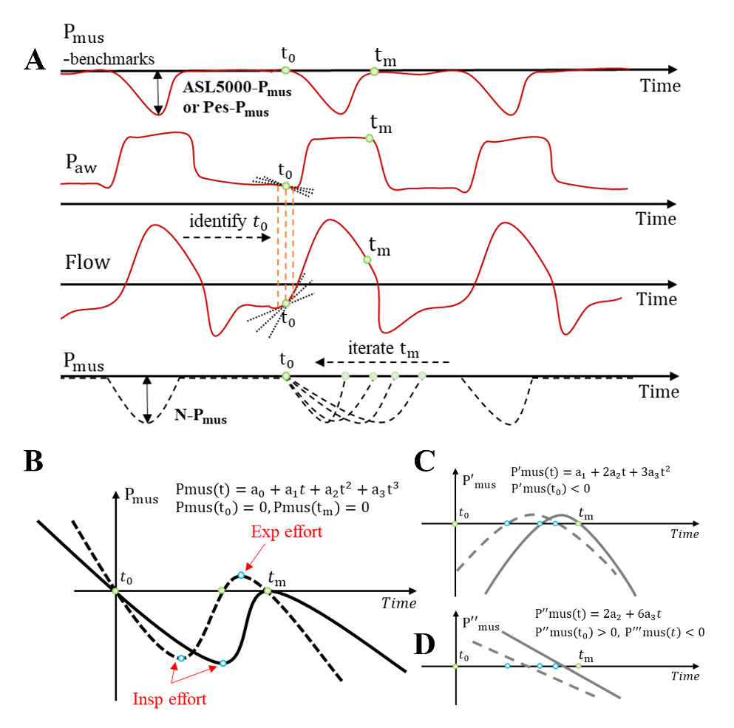
(A) The Pmus-benchmark waveform serves as the gold standard, obtained either from ASL5000 or esophageal pressure measurements. The Paw and Flow waveforms are measured by ventilator sensors, while the Pmus waveform is calculated in real-time and non-invasively based on Paw and Flow. Key steps include identifying t0 (the start of inhalation) and iterating to tm​ (the end of respiratory muscle activity). (B) shows how a cubic function is constrained to fit the Pmus waveform, ensuring accurate modeling of both inspiratory and expiratory efforts. (C, D) represent the first- and second-order derivative constraints of Pmus over time, respectively.
Figure E2. Typical waveforms and polynomial fitting results of different orders for ASL5000 normal scenario
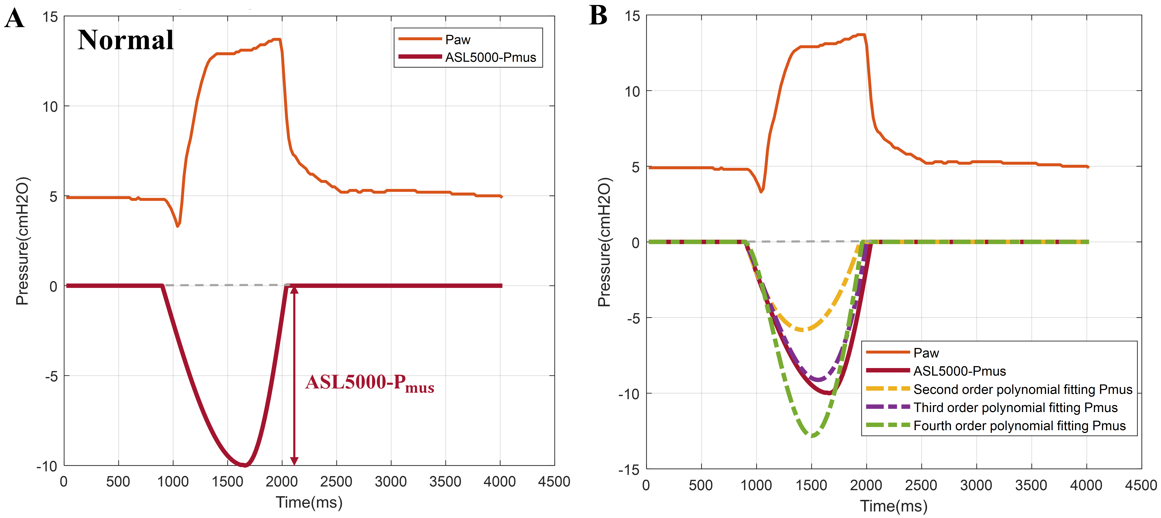
(A) Airway pressure (Paw) waveform and a sinusoidally simulated Pmus waveform under the ASL5000 normal scenario (resistance: 10 cmH₂O/L/s; compliance: 50 mL/cmH₂O). (B) Polynomial fitting results of various orders applied to the ASL5000 Pmus(t) waveform, with the third-order polynomial fitting providing the closest approximation to the original waveform.
Figure E3. Comparison of different algorithms for single-cycle Pmus fitting of a typical patient
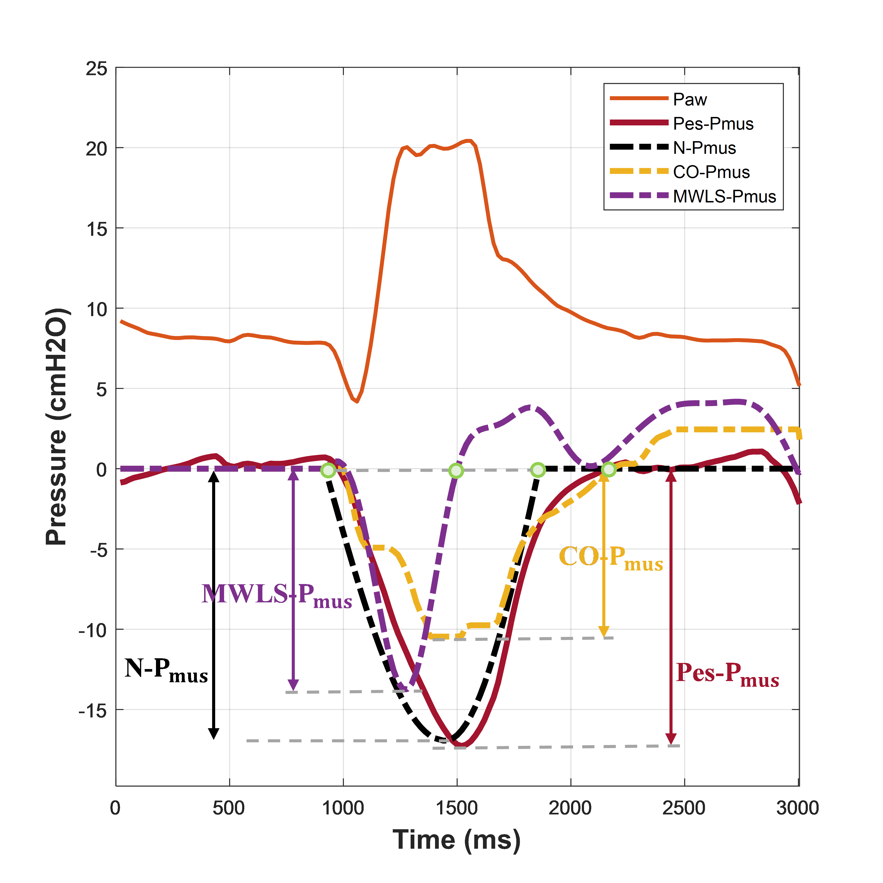
Paw represents airway pressure, while Pes-Pmus is the gold-standard waveform derived from esophageal pressure, with baseline Pmus defined as 0 cm H₂O. N-Pmus is the waveform generated by the innovative algorithm introduced in this study. MWLS-Pmus refers to the waveform fitted using the Moving Window Least Squares algorithm described in the patent[5], and CO-Pmus represents the waveform fitted using the quadratic programming constrained optimization algorithm mentioned in the literature[3-4]. Comparative analysis demonstrates that the N-Pmus algorithm surpasses previous methods in terms of descending speed, amplitude, and ascending speed of the Pmus waveforms.
Figure E4. Correlation and agreement analysis of Pmus classified by experimental simulation scenarios
(A) Violin plots comparing ventilator-measured N-Pmus values with the gold standard Pes-Pmus values derived from esophageal pressure, illustrating the distribution across experimental data for various simulation cases, including ARDS (light, mid, severe), COPD (light, mid, severe), and Normal adult. (B) Linear mixed-effects model fit plot between N-Pmus and Pes-Pmus. (C) Bland–Altman plots obtained using the linear mixed-effects model and bootstrap resampling methods (see annotated text and Table E1 for details).
Figure E5. Rules for processing clinical patient trial data during research

Figure E6. Subgroup analysis of the correlation and agreement of Pmus classified by disease types.
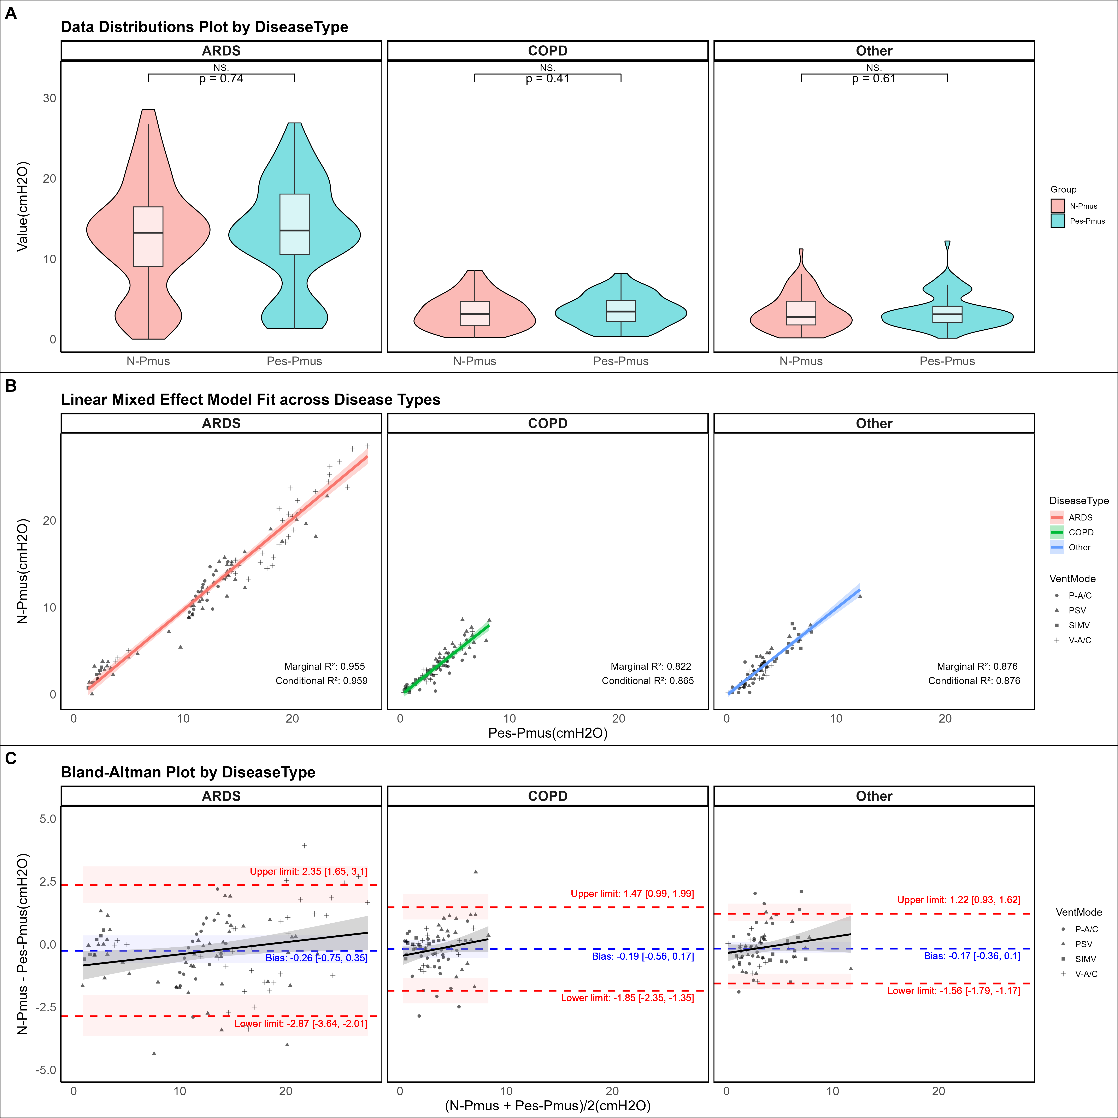
(A) Violin plots comparing ventilator-measured N-Pmus values with the gold standard Pes-Pmus values derived from esophageal pressure, showing the distribution across clinical trial patient data for various disease types, including ARDS, COPD, and Others. (B) Linear mixed-effects model fit plot between N-Pmus and Pes-Pmus. (C) Corresponding Bland–Altman plots obtained using the linear mixed-effects model and bootstrap resampling methods (see annotated text and Table E2 for details).
Figure E7. Subgroup analysis of the correlation and agreement of Pmus classified by ventilation modes.
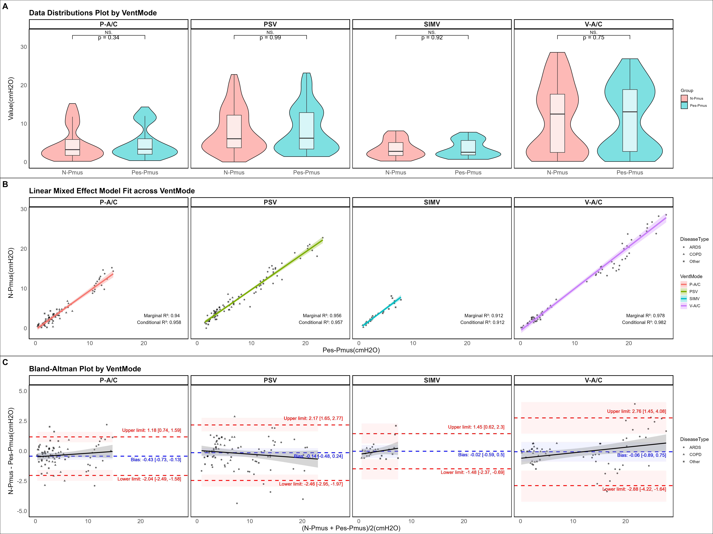
(A) Violin plots comparing ventilator-measured N-Pmus values with the gold standard Pes-Pmus values derived from esophageal pressure, showing the distribution across clinical trial patient data for different ventilation modes, including P-A/C, V-A/C, PSV, and SIMV. (B) Linear mixed-effects model fit plot between N-Pmus and Pes-Pmus. (C) Bland–Altman plots generated using the linear mixed-effects model and bootstrap resampling methods (see annotated text and Table E3 for details).
Figure E8. Subgroup analysis of the correlation and agreement of Pmus classified by levels of respiratory effort.
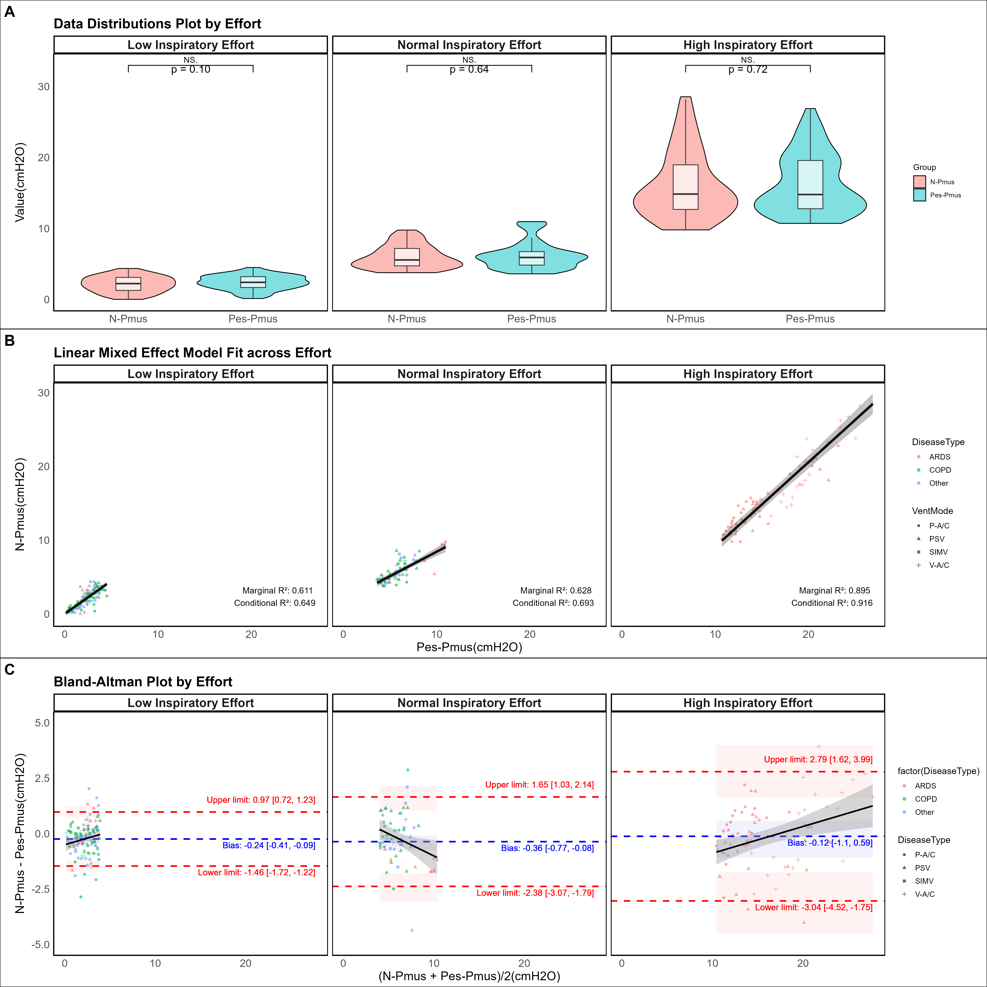
(A) Violin plots comparing ventilator-measured N-Pmus values with the gold standard Pes-Pmus values derived from esophageal pressure, displaying the distribution across clinical trial patient data categorized by inspiratory effort levels: Lower inspiratory effort (Pmus < 4 cmH₂O), Normal inspiratory effort (4 ≤ Pmus ≤ 10 cmH₂O), and High inspiratory effort (Pmus > 10 cmH₂O). (B) Linear mixed-effects model fit plot of N-Pmus versus Pes-Pmus. (C) Bland–Altman plots generated using the linear mixed-effects model and bootstrap resampling methods (see annotated text and Table E4 for details).

References:
1. Rohrer F: Der Zusammenhang der Atemkräfte und ihre Abhängigkeit vom Dehnungszustand der Atmungsorgane. Pflüger's Archiv für die Gesamte Physiologie des Menschen und der Tiere 1916, 165(8-10):419-444.
2. Otis AB, Fenn WO, Rahn H: Mechanics of breathing in man. J Appl Physiol 1950, 2(11):592-607.
3. Vicario F, Albanese A, Wang D, Karamolegkos N, Chbat NW, Ieee: Constrained Optimization for Noninvasive Estimation of Work of Breathing. In: 2015 37TH ANNUAL INTERNATIONAL CONFERENCE OF THE IEEE ENGINEERING IN MEDICINE AND BIOLOGY SOCIETY (EMBC). 2015: 5327-5330.
4. Vicario F, Albanese A, Karamolegkos N, Wang D, Seiver A, Chbat NW: Noninvasive Estimation of Respiratory Mechanics in Spontaneously Breathing Ventilated Patients: A Constrained Optimization Approach. IEEE Trans Biomed Eng 2016, 63(4):775-787.
5. Wang D, Vicario F, Albanese A, Karamolegkos N, Chbat NW: Non-invasive method for monitoring patient respiratory status via successive parameter estimation. United State patent US 15/579,228. 2018 Jun 28.
6. Liu L, Yu Y, Xu X, Sun Q, Qiu H, Chiumello D, Yang Y: Automatic Adjustment of the Inspiratory Trigger and Cycling-Off Criteria Improved Patient-Ventilator Asynchrony During Pressure Support Ventilation. Front Med (Lausanne) 2021, 8:752508.
7. Baydur A, Behrakis PK, Zin WA, Jaeger M, Milic-Emili J: A simple method for assessing the validity of the esophageal balloon technique. Am Rev Respir Dis 1982, 126(5):788-791.
8. D'Angelo E, Robatto FM, Calderini E, Tavola M, Bono D, Torri G, Milic-Emili J: Pulmonary and chest wall mechanics in anesthetized paralyzed humans. J Appl Physiol (1985) 1991, 70(6):2602-2610.
9. Akoumianaki E, Maggiore SM, Valenza F, Bellani G, Jubran A, Loring SH, Pelosi P, Talmor D, Grasso S, Chiumello D et al: The application of esophageal pressure measurement in patients with respiratory failure. Am J Respir Crit Care Med 2014, 189(5):520-531.
10. Qin Y, Huang Z, Zhou X, Gui S, Xiong L, Liu L, Liu J: A novel adaptive filter with a heart-rate-based reference signal for esophageal pressure signal denoising. J Clin Monit Comput 2024.
11. Bellani G, Bronco A, Arrigoni Marocco S, Pozzi M, Sala V, Eronia N, Villa G, Foti G, Tagliabue G, Eger M et al: Measurement of Diaphragmatic Electrical Activity by Surface Electromyography in Intubated Subjects and Its Relationship With Inspiratory Effort. Respir Care 2018, 63(11):1341-1349.
12. Parker RA, Weir CJ, Rubio N, Rabinovich R, Pinnock H, Hanley J, McCloughan L, Drost EM, Mantoani LC, MacNee W et al: Application of Mixed Effects Limits of Agreement in the Presence of Multiple Sources of Variability: Exemplar from the Comparison of Several Devices to Measure Respiratory Rate in COPD Patients. PLoS One 2016, 11(12):e0168321.

