Phototropic self-growing hydrogels based on a tricyanofuran derivatized photoswitch

Peixi Han, Xuehan Yang, Shuailong Zhou, Yifan Zheng, Zhaomiao Chu, Mengqi Du, Chuang Li*

State Key Laboratory of Precision and Intelligent Chemistry, Department of Polymer Science and Engineering, University of Science and Technology of China, Hefei, Anhui 230026, China.
*Correspondence: lichuang21@ustc.edu.cn

Materials
The monomer acrylamide (AAm) (99.0%, aladdin); Acrylonitrile (AN) (99.0%, aladdin); N, N'-Methylenebisacrylamide (MBAAm) (99.0% macklin); N, N, N', N'-Tetramethylethylenediamine (TEMED) (99%, aladdin) Ascorbic acid (Vc)(>99.0%, aladdin); N-methyl pyrrolidone (NMP) (>98.0%, aladdin); dimethylsulfoxide (DMSO) (99.8%, aladdin) were used as received.

General characterization
¹H NMR and ¹³C NMR spectra were recorded on a Bruker AVANCE III HD 400 spectrometer in DMSO-d₆, depending on the solubility of the material in these solvents. The chemical shifts are represented in δ (ppm) with SiMe₄ as an internal standard at room temperature. High-resolution accurate-mass electrospray ionization (MS-ESI) spectra were obtained in positive ion mode using a WATERS XEVO G2-XS-tof/4K mass spectrometer. UV‒vis absorption spectra were measured in absorption mode using a UV‒vis spectrometer (OCEAN-HDX, OceanInsight) with a four-way optical path and heatable sample cell. The path length was fixed at 1.0 cm. Aqueous Methanol and acetonitrile were used respectively was used as a background. The fluorescence emission spectra were obtained by using an F-4600 spectrophotometer (Hitachi). The emission spectra were recorded using an excitation wavelength of 450 nm and 5 nm (excitation)/5 nm (emission) slit widths. The hydrogel material was frozen with liquid nitrogen, and then the moisture was removed with a freeze dryer for 72 h. Dry samples were sputter coated with 99.99 % gold/palladium 60/40 (Cressington 208HR) for 60 seconds. SEM images were obtained on a scanning electron microscope (Quanta250FEG, FEI) at an accelerating voltage of 10 kV. The fluorescence emission spectra were obtained by using an F 4600 spectrophotometer (Hitachi).

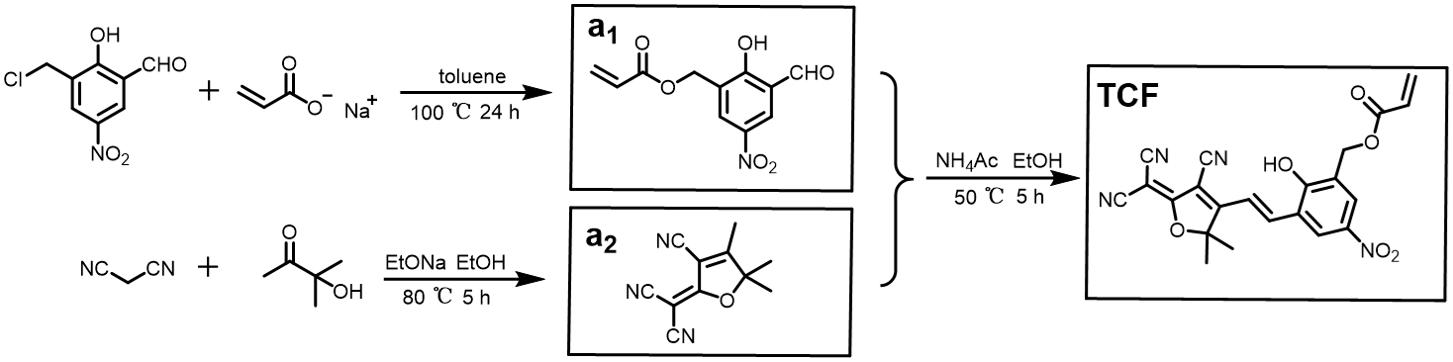
Scheme S1. Synthesis of TCF.

Synthesis of 3 -formyl-2-hydroxy-5-nitrobenzyl acrylate (a₁).
3-(chloromethyl)-2-hydroxy-5-nitrobenzaldehyde (1.075 g, 5 mmol) and sodium acrylate (0.95 g, 10 mmol) were added to toluene (30 mL). The mixture was refluxed at 100 °C for 24 hours. Heat filtration and the solvent was removed by rotary evaporation. The product was purified by silica column chromatography using DCM/MeOH=12: 1 as the eluent to obtain 3-formyl-2-hydroxy-5-nitrobenzyl acrylate as a yellow powder (2.35 mmol, 0.59 g, yield: 47 %).

¹H NMR (400 MHz, DMSO) δ (ppm): 10.22(s, 1H), 8.68-8.43(m, 2H), 6.40 (dd, J = 17.3, 1.6 Hz, 1H), 6.27 (dd, J = 17.3, 10.2 Hz, 1H), 6.01 (dd, J = 10.2, 1.6 Hz, 1H), 5.29 (s, 2H).

¹³C NMR (101 MHz, DMSO) δ (ppm): 190.61, 164.85, 159.01, 142.93, 134.15, 130.36, 128.00, 122.90, 120.92, 118.79.

MS-ESI (m/z)
[M] ⁺ calc. for C₁₀H₈O₄⁺ 250.0412; [M] ⁺ found 250.0425.

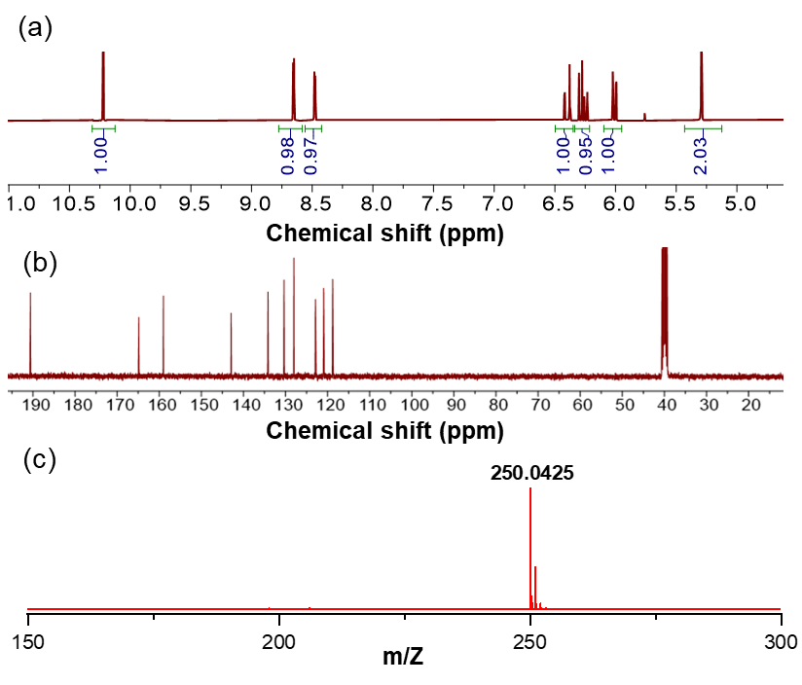
Figure S1. (a) ¹H NMR, (b) ¹³C NMR and (c) MS spectra of compound a₁.
Synthesis of 2- (3-cyano-4, 5, 5-trimethylfuran-2 (5H)-ylidene) malononitrile (a₂).
4-hydroxy-4-methylpentan-2-one (0.51 g, 5 mmol) and sodium ethoxide (0.34 g, 5 mmol) and malonitrile (0.33 g, 5 mmol) were added to ethanol (4 mL). The mixture was refluxed at 80 °C for 5 hours. After cooling at 0 ℃ for 30 minutes, the suspension is filtered and washed with ethanol, and dried at 50 ℃ to obtain a gray solid powder (2.57 mmol, 0.512 g, yield: 51 %).

¹H NMR (400 MHz, DMSO) δ (ppm): 1.63 (s, 6H), 2.36 (s, 3H).

¹³C NMR (101 MHz, DMSO) δ (ppm): 186.25, 177.83, 112.74, 112.01, 110.49, 104.11, 101.85, 55.18, 23.67, 14.69.

MS-ESI (m/z)
[M] ⁺ calc. for C₂₂H₁₆N₄O₆⁺ 199.0746; [M] ⁺ found 199.0755.
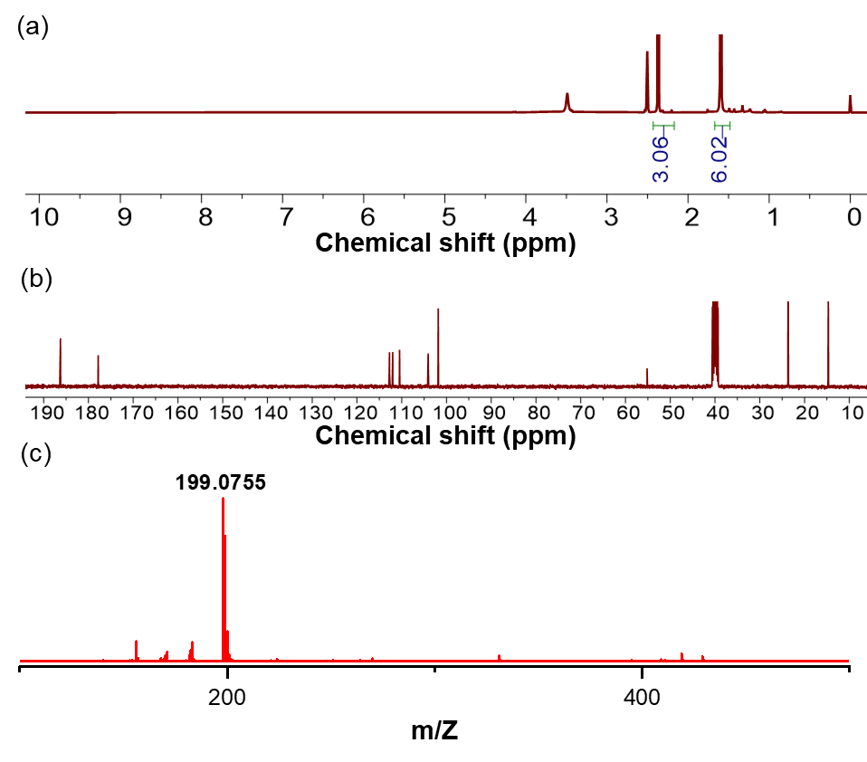
Figure S2. (a) ¹H NMR, (b) ¹³C NMR and (c) MS spectra of compound a₂.

Synthesis of (E)-3-(2-(4-cyano-5-(dicyanomethylene)-2, 2-dimethyl-2, 5-dihydrofuran-3-yl) vinyl)-2-hydroxy-5-nitrobenzyl acrylate (TCF).
3-formyl-2-hydroxy-5-nitrobenzyl acrylate (a₁, 1.26 g, 5 mmol) and 2-(3-cyano-4, 5, 5-trimethylfuran-2(5H)-ylidene) malononitrile (a_{2,} 0.99 g, 5 mmol) and Ammonium acetate (0.39 g, 5 mmol) were added to ethanol (10 mL). The mixture was refluxed at 50 °C for 5 hours and add 2 mL 5 wt% hydrochloric acid aqueous solution and stir at 50 ℃ for 5 h. After cooling at 0 ℃ for 30 minutes, the suspension is filtered and washed with ethanol, and dried at 50 ℃ to obtain a dark yellow solid powder (TCF) (3.12 mmol, 1.35 g, yield: 63 %).

¹H NMR (400 MHz, CH₃CN) δ (ppm): 8.81 (d, J = 2.9 Hz, 1H), 8.28 (d, J = 2.9 Hz, 1H), 8.19 (d, J = 16.5 Hz, 1H), 7.66 (d, J = 16.4 Hz, 1H), 6.38 (dd, J=17.3, 1.6Hz, 1H), 6.25 (dd, J = 17.3 Hz, 1H), 5.99 (dd, J = 10.2, 1.7 Hz, 1H),5.27 (s, 2H), 1.81 (s, 6H).

¹³C NMR (101 MHz, CH₃CN) δ (ppm): 177.33, 175.53, 168.20, 160.96, 141.72, 140.45, 133.32, 130.23, 127.90, 126.17, 124.85, 124.29, 118.97, 117.90, 112.71, 112.11, 111.36, 101.25,99.76, 62.58, 25.32.

MS-ESI (m/z)
[M] ⁺ calc. for C₂₂H₁₆N₄O₆⁺ 432.11; [M] ⁺ found 432.1443.

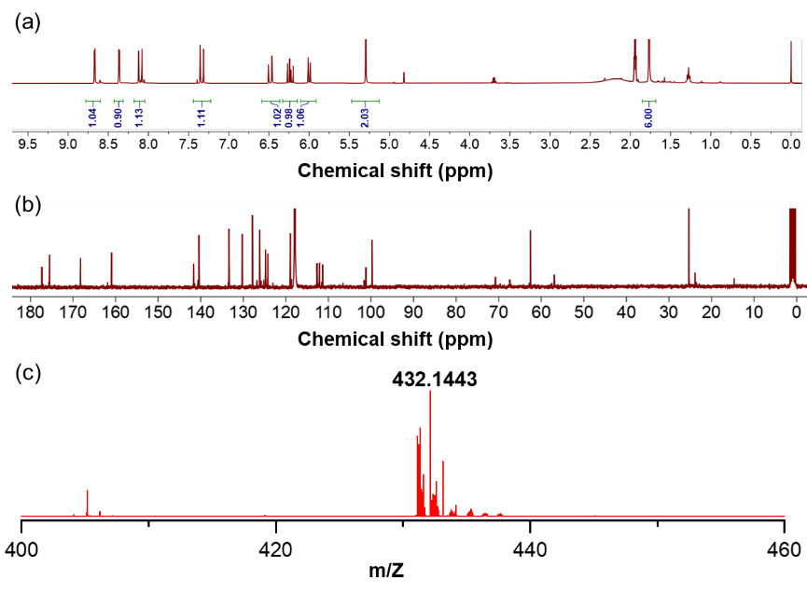
Figure S3. (a) ¹H NMR, (b) ¹³C NMR and (c) MS spectra of compound TCF.

Nuclear magnetism under different conditions
TCF was dissolved in 500 mL of deuterated acetonitrile (CD₃CN) and transferred to a nuclear magnetic resonance (NMR) tube, which was fully wrapped in aluminum foil to prevent light exposure and stored in the dark at 25 °C for 12 hours. Additionally, deuterated hydrochloric acid or deuterated sodium hydroxide were added to separate NMR tubes, and the pH of the solutions was adjusted to 1 mM acidic or basic conditions for subsequent light exposure experiments. Following this dark incubation, the sample was irradiated with blue light (450 nm) under cooling with ice to prevent overheating. After completing the light irradiation, the NMR tube was re-wrapped in aluminum foil and subjected to another 12 hours of dark treatment before further test.
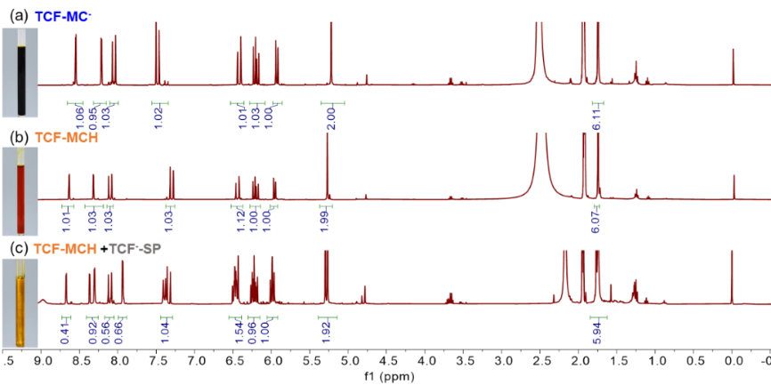
Figure S4. Nuclear magnetism under different conditions. (a) NMR of TCF-MC⁻ under alkaline conditions. (b) NMR of TCF-MCH under acidic conditions. (c) NMR of TCF-MCH+TCF⁻-SP after light (450 nm).
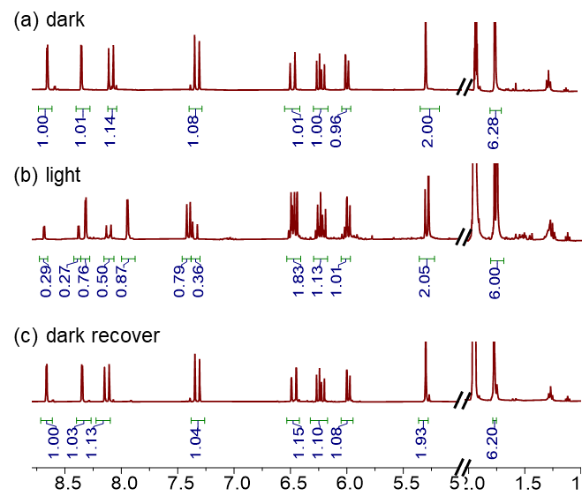
Figure S5. Nuclear magnetic resonance cycle test: (a) TCF was dissolved in deuterated acetonitrile and kept in the dark for 12 hours prior to NMR analysis. (b) The NMR spectrum of TCF was recorded following irradiation with 450 nm light. (c) After illumination, TCF was stored in the dark for an additional 12 hours before a subsequent NMR measurement.
UV‒vis absorbance spectra
TCF were separately dissolved in a solvent of acetonitrile to obtain a final concentration of 5 mM as a stock solution, followed by equilibration overnight in the dark at 25 °C. 20 μL of the stock solution was pipetted rapidly into 2000 μL of acetonitrile in a path length of a 10 mm removable quartz cuvette, followed by immediate irradiation with blue light (450 nm) and collection of absorbance spectroscopy using an Ocean Insight DH-2000-BD fiber spectrometer. A certain amount of hydrochloric acid or sodium hydroxide aqueous solution were added to acetonitrile solution and adjusted to 5 mM acidic or alkaline solution for ultraviolet light test. The photoisomerization rate under irradiation was obtained by plotting the characteristic absorbance of the TCF form vs irradiation time and fitting to the ExpDec1 function in Origin 2021 software.

Ultraviolet kinetic test of the interconversion of the three forms of TCF
An acetonitrile solution containing TCF were placed in a quartz cuvette, and the characteristic absorbance peaks at 540 nm and 380 nm were measured using an ultraviolet-visible spectrometer. After the solution was allowed to equilibrate in the dark for a period of time, it was irradiated with in situ blue light. The absorbance of the 540 nm was monitored until it equilibrated under blue light irradiation. Afterward, the blue light was turned off, allowing the solution to return to its initial state in the dark, and it was allowed to equilibrate for a period of time. Subsequently, 25 µL of 1 M hydrochloric acid was added in situ to the solution. Once the absorbance of the peaks at 380 nm and 540 nm stabilized, the solution was irradiated with blue light in situ again. Until the absorbance of the 380 nm peak remained unchanged, and the solution was allowed to equilibrate for a period of time. After turning off the blue light, the solution was allowed to return to its initial state in the dark. Finally, 25 µL of 1 M NaOH was added in situ to neutralize the hydrochloric acid, and the solution was allowed to equilibrate for a period of time until the absorbance peaks at 380 nm and 540 nm no longer changed.

Ultraviolet absorbance cycle test
An acetonitrile solution containing dissolved TCF and add 25 µL of 1 M hydrochloric acid solution. Measure the absorbance at 380 nm, then irradiate the solution in situ with blue light. Once the absorbance at 380 nm decreases and stabilizes, turn off the blue light and allow the solution to return to its initial state in the dark. This process is repeated ten times. Separately, an acetonitrile solution containing TCF, measure the absorbance at 540 nm, and irradiate the solution with blue light in situ. When the absorbance at 540 nm stabilizes, turn off the blue light and restore the solution to its initial state in the dark. This procedure is also repeated ten times.

Liquid fluorescence test experiment
TCF were separately dissolved in a solvent of N-Methylpyrrolidone to obtain a final concentration of 5 mM as a stock solution, followed by equilibration overnight in the dark at 25 °C. 20 μL of the stock solution was pipetted rapidly into 2000 μL of N-Methylpyrrolidone in a path length of a 10 mm removable quartz cuvette, hydrochloric acid or sodium hydroxide aqueous solution were added to NMP solution to obtain 5 mm acidic solution or alkaline solution for fluorescence test. The fluorescence emission spectra were obtained by using an F 4600 spectrophotometer (Hitachi).

Solid fluorescence test experiment
TCF were evenly applied to the quartz sheet, and then the quartz sheet with the sample is placed on the solid fluorescence test fixture for testing. The powder was illuminated in situ. TCF powder was evenly spread in a petri dish and sprayed with triethylamine to obtain the powder in the form of TCF-MC⁻ and repeated the procedure. The fluorescence emission spectra were obtained by using an F 4600 spectrophotometer (Hitachi).
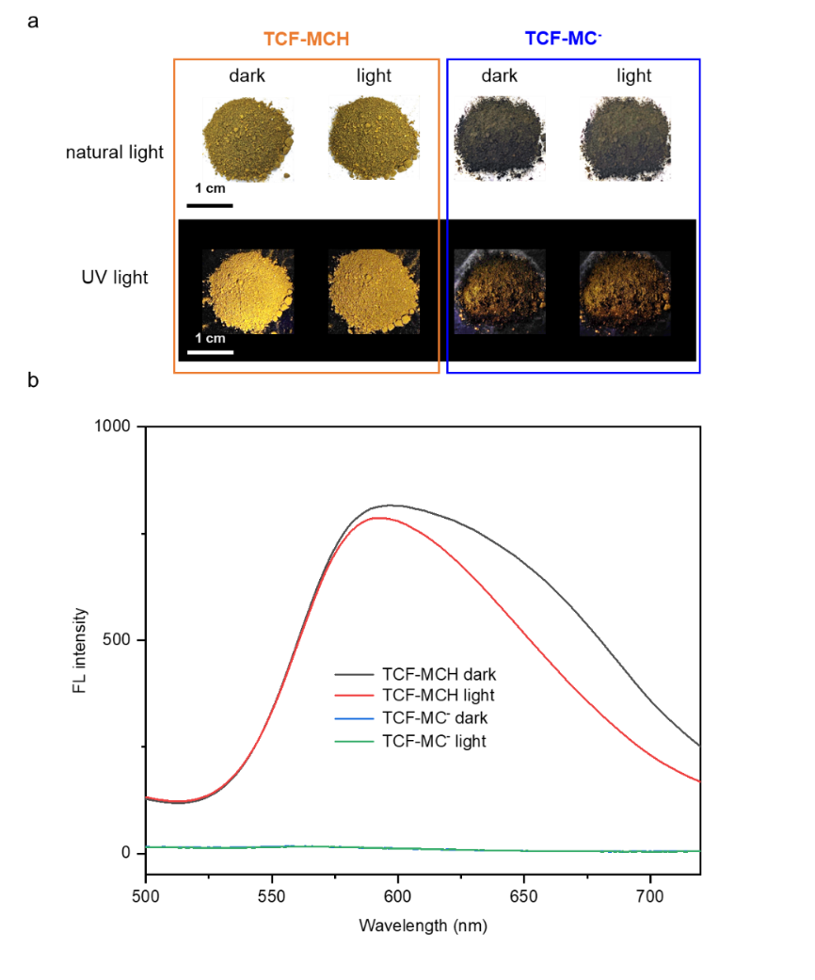
Figure S6. (a) Photographs of TCF-MCH and TCF-MC⁻ in powder form before and after exposure to natural and UV light. (b) Fluorescence spectra of TCF-MCH and TCF-MC⁻ in solid powder form before and after illumination.

UV‒vis absorbance spectra in N-Methylpyrrolidone (NMP)
TCF were separately dissolved in a solvent of N-Methylpyrrolidone to obtain a final concentration of 5 mM as a stock solution, followed by equilibration overnight in the dark at 25 °C. 20 μL of the stock solution was pipetted rapidly into 2000 μL of N-Methylpyrrolidone in a path length of a 10 mm removable quartz cuvette, hydrochloric acid or sodium hydroxide aqueous solution were added to NMP solution to obtain 5 mm acidic solution or alkaline solution for UV-Vis test.
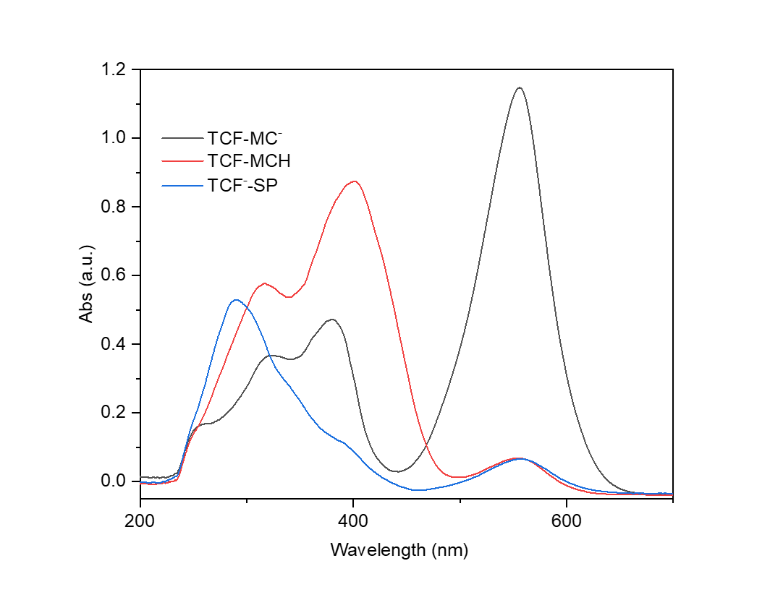
Figure S7. UV absorption spectra of TCF in NMP solution.

Fluorescence recovery kinetic test
After in-situ irradiation of the TCF NMP solution with blue light, the fluorescence intensity of the solution was measured every 15 seconds. The peak at 670 nm was then normalized and recorded.
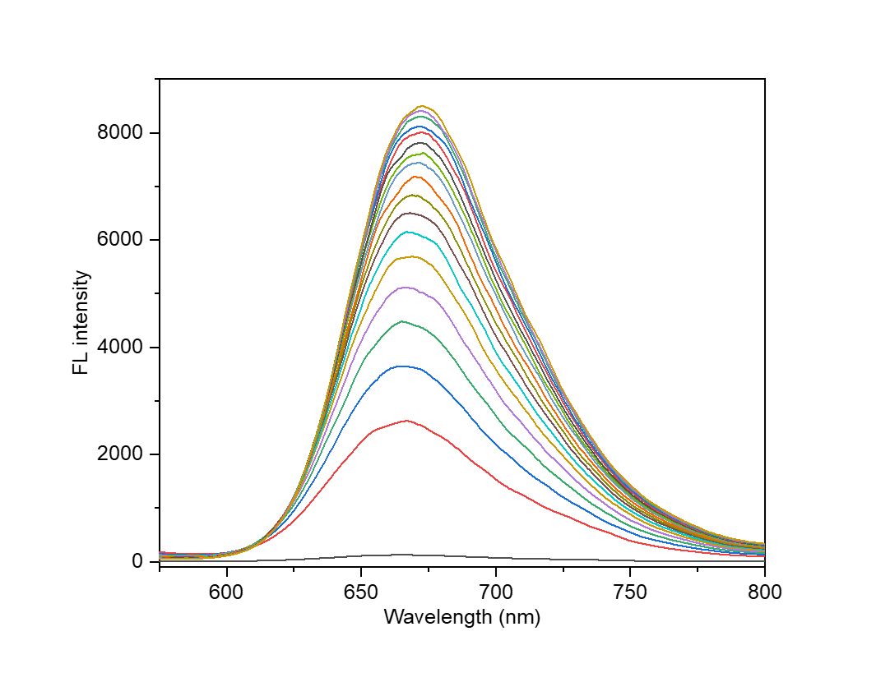
Figure S8. Kinetic test of dark recovery in TCF fluorescent solution.
Fluorescent solution cycle test
The NMP solution of TCF was placed in a quartz four-way colorimetric plate and irradiated with a blue light source, causing the solution to change from blue to colorless. The solution was then analyzed using a fluorescence spectrometer. After allowing the solution to recover in the dark for 10 minutes, its fluorescence was measured. This procedure was repeated ten times.

Organic gel preparation
Acrylamide (AAm), N, N-methylenebisacrylamide (MBAAm), acrylonitrile (AN), ascorbic acid (Vc), and mixed TCF were dissolved in 1 mL of NMP mixture solvent. The precursor solution was deoxygenated, and 200 μL of ammonium persulfate initiator (APS, 20 wt% aqueous solution) was added. Free-radical polymerization was carried out at 25 °C for 24 hours in a glass mold with a 0.5 mm gap. After polymerization, the organic gel was soaked in NMP to remove unpolymerized monomers and molecules, and then treated in the dark overnight after multiple transformations for further use.

Supplementary Table 1. Formulations with organic gel.
AAm | AN | MBAAm (0.1 g/ml) | TCF | NMP | 20 % APS | Vc
0.2 g | 30 μL | 110 μL | 2 mg | 1 mL | 50 μL | 5 mg

Organogels with vary fluorescent shapes.
The organogels were cut into different shapes and the fluorescence of the gels was observed under 365 nm light.

Rheological measurements.
To measure the mechanical changes in the gel as a function of irradiation time, the gel dishes were irradiated from both sides for different durations, after which the rheological properties were measured using a TA Discovery Hybrid Rheometer. Rheology experiments were performed in 8 mm parallel plates by using hydrogel films with a diameter of 8 mm and a thickness of 0.5 mm. A time scan was performed at a fixed frequency of 1 Hz and strain of 1.0 % at 25 °C. The gel is stabilized before light by using N-Methylpyrrolidone.

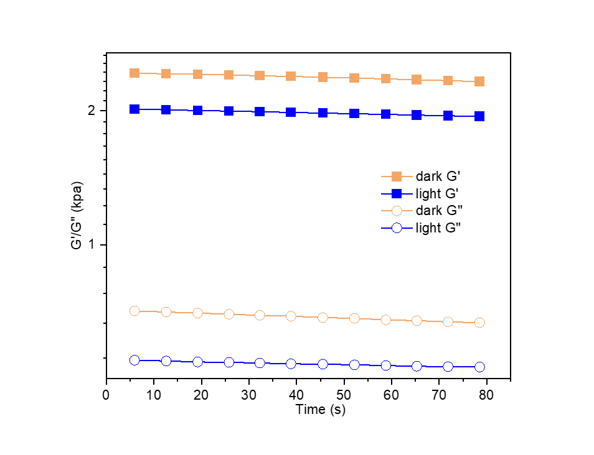
Figure S9. Rheological testing of the organogel before and after illumination. The organogels, both before and after exposure to light, were separately placed into the rheometer for analysis.

Fluorescence patterning of organogels.
The surface of the organogel was covered with different templates, and the uncovered areas were irradiated with a blue light source (450 nm). The fluorescence pattern of the gel was observed at 365 nm. After the patterned gel was placed in a dark environment, the fluorescence gradually faded until the pattern disappeared, at which point the gel's fluorescence pattern was re-established.
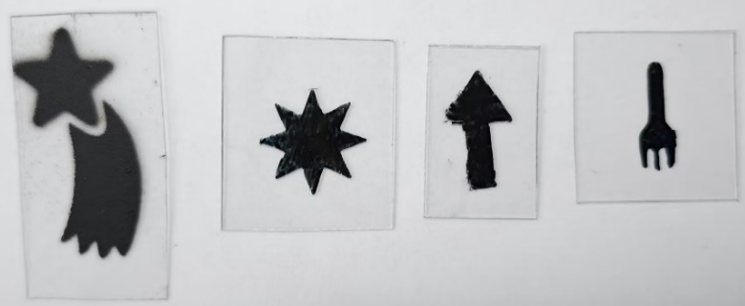

Hydrogel preparation.
Acrylamide (AAm), N, N-methylenebisacrylamide (MBAAm), acrylonitrile (AN), ascorbic acid (Vc) and mixed TCF were dissolved in a NMP mixture solvent (1 ml). The precursor solution was deoxygenated, followed by the addition of 200 μL of ammonium persulfate initiator (APS, 20 wt% aq). Free-radical polymerization was carried out at 25 °C for 24 h in a glass mold with a gap of 0.5 mm. After polymerization, the hydrogels were soaked in a large amount of DI water to replace the organic solvent, followed by incubation in DI water containing 5 mM HCl overnight before use.

Scanning electron microscopy (SEM) characterization.
Hydrogels were prepared following the same protocol described above and incubated in DI water containing 5 mM HCl before measurement. Hydrogels before or after irradiation (450 nm, 130 mW/cm²) for different durations were immediately frozen in liquid nitrogen and lyophilized, followed by coating with gold before observation using a scanning electron microscope (GeminiSEM500).

Rheological measurements.
To measure the mechanical changes in the hydrogel as a function of irradiation time, the hydrogel dishes were irradiated from both sides for different durations, after which the rheological properties were measured using a TA Discovery Hybrid Rheometer. Rheology experiments were performed in 8 mm parallel plates by using hydrogel films with a diameter of 8 mm and a thickness of 0.5 mm. A time scan was performed at a fixed frequency of 0.5 Hz and strain of 1.0 % at 25 °C. The gel is stabilized before light by using 5 mM HCl, while pure water is used to stabilize the gel after light-induced swelling.

Measurement of the change in hydrogel size under irradiation.
A hydrogel dish (diameter of 8 mm and thickness of 0.5 mm) was irradiated simultaneously from both sides instead of via single-sided irradiation to avoid any bending deformation, as bending might affect the accuracy of the diameter change. The hydrogel size was defined as the change in diameter of the dish-shaped hydrogel during the light irradiation process, during which images were taken and measured using ImageJ software.
$$swelling ratio \left(\%\right)=\frac{{length}_{ swelling} }{ {length}_{original}}×100$$
$$growth rate \left(\%\right)=\frac{{∆length}_{ (T_{4}-T_{3})} }{{∆length}_{ (T_{2}-T_{1})}}×100$$

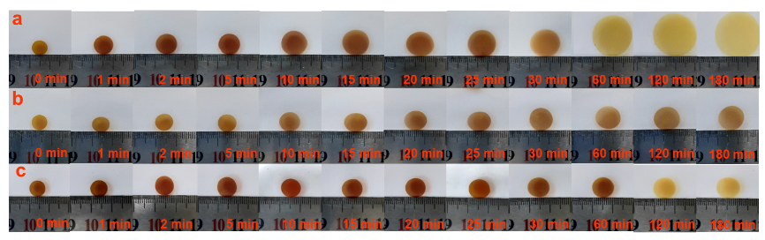
Figure S10. Swelling of hydrogel under different conditions. (a) The hydrogel (with a TCF grafting rate of 2.5 %) was stored in 5 mM HCl in a dark environment for 12 hours, then transferred to pure water (pH = 6.83), and irradiated with blue light (light intensity of 130 mW/cm²) for the swelling experiment. (b) The hydrogel (with a TCF grafting rate of 2.5 %) was stored in 5 mM HCl in a dark environment for 12 hours, and then transferred to pure water for the swelling experiment. (c) The hydrogel (with a TCF grafting rate of 2.5 %) was stored in 5 mM HCl in a dark environment for 12 hours, and the swelling experiment was conducted by irradiating the hydrogel with blue light (light intensity of 130 mW/cm²).

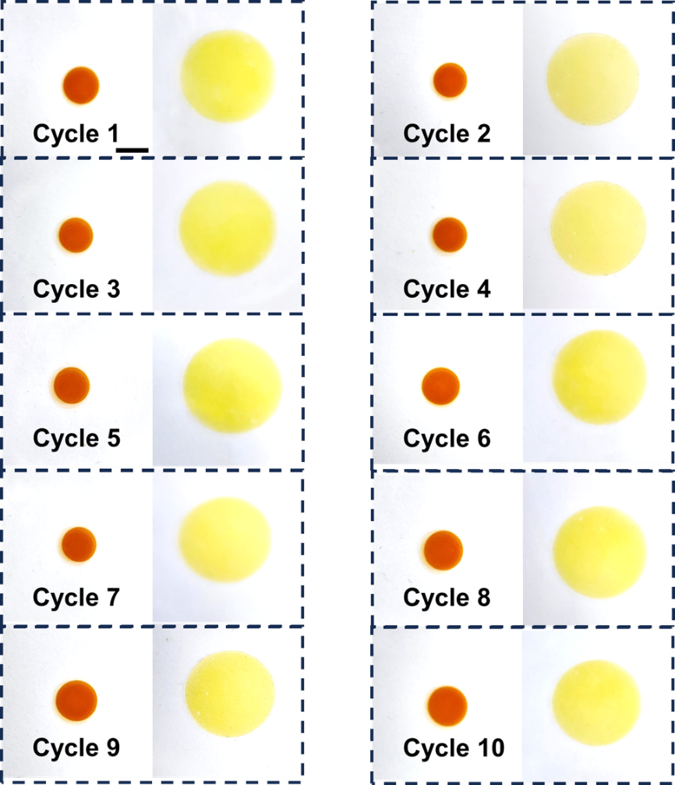
Figure S11. Hydrogel swelling cycle test. After incubating the hydrogel (with a TCF grafting rate of 2.5 %) in 5 mM HCl in a dark environment for 12 hours, it was transferred to pure water and irradiated with blue light (light intensity of 130 mW/cm²) to induce swelling. Once the hydrogel reached its maximum size, it was transferred back to 5 mM HCl and kept in a dark environment for 12 hours. After the hydrogel returned to its initial state, this experiment was repeated ten times.

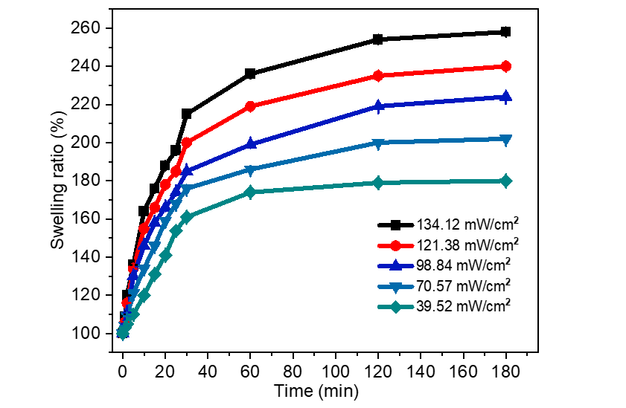
Figure S12. Comparison of hydrogel swelling rates under different light intensities. The hydrogel (with a TCF grafting rate of 2.5 %) was incubated in 5 mM HCl and stored in a dark environment for 12 hours. Subsequently, the hydrogel was transferred to pure water (pH = 6.83) and exposed to blue light at varying intensities (134.12 mW/cm², 121.38 mW/cm², 98.84 mW/cm², 70.57 mW/cm², 39.52 mW/cm²) for swelling tests.

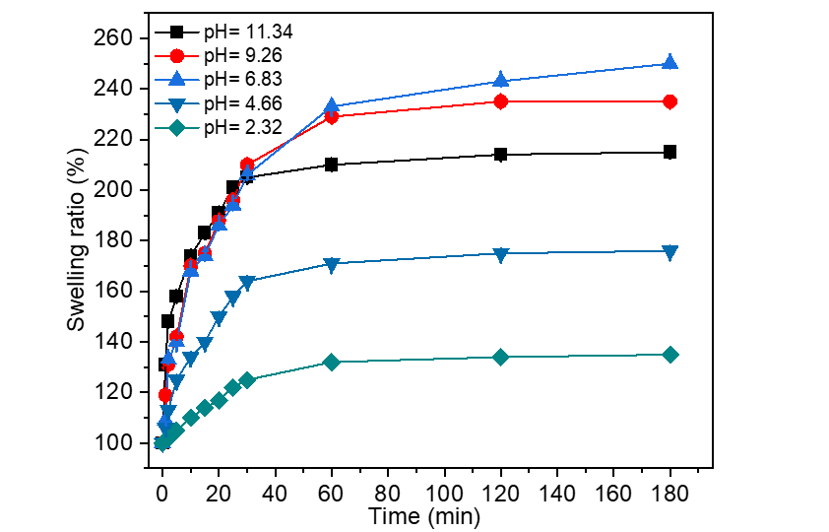
Figure S13. Comparison of hydrogel swelling rates at different pH levels. The hydrogel (with a TCF grafting rate of 2.5 %) was incubated in 5 mM HCl in a dark environment for 12 hours, and then transferred to aqueous solutions with different pH values (2.32, 4.66, 6.83, 9.26, 11.34) for swelling tests under blue light irradiation (light intensity of 130 mW/cm²).
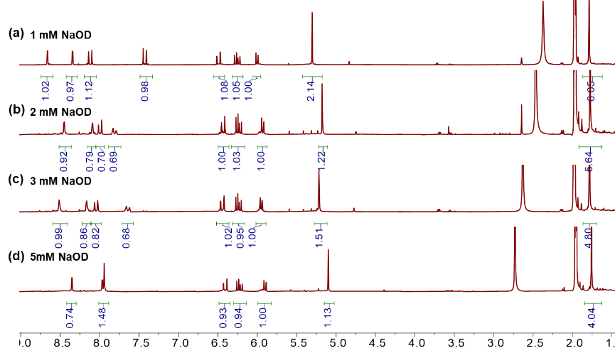
Figure S14. Nuclear magnetism under varying alkali concentration conditions. TCF was dissolved in deuterated acetonitrile (5 mg/ 500 μL), and four aliquots of the solution were each supplemented with 5 μL, 10 μL, 15 μL, or 25 μL of 1M NaOD solution. The mixtures were stored in a dark environment for 3 hours before being subjected to NMR analysis.

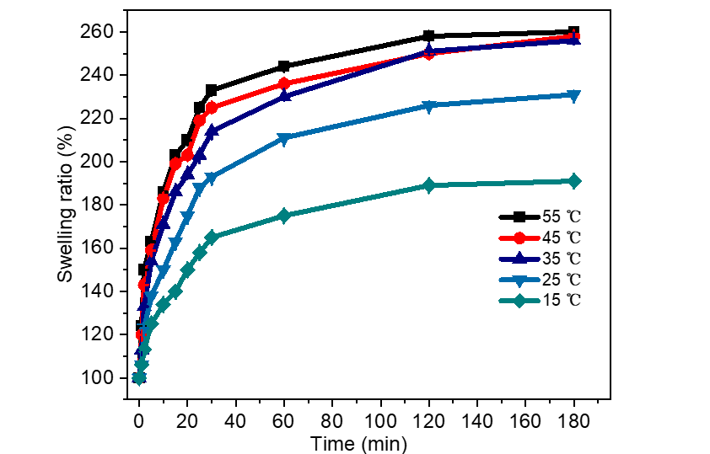
Figure S15. Comparison of hydrogel swelling rates at different temperatures. The hydrogel (with a TCF grafting rate of 2.5 %) was incubated in 5 mM HCl in a dark environment for 12 hours, and then transferred to pure water (pH 6.83). Simultaneously, the temperature of the pure water was controlled at different levels (15 °C, 25 °C, 35 °C, 45 °C, 55 °C) using a heated stirrer, and the swelling experiment was conducted under blue light irradiation (light intensity of 130 mW/cm²).

Supplementary Table 2. Formulations with different grafting ratio.
AAm | AN | MBAAm (0.1 g/ml) | TCF | NMP | 20 %APS | Vc
0.2 g | 30 μL | 110 μL | 20 mg | 1 mL | 200 μL | 20 mg
0.2 g | 30 μL | 110 μL | 16 mg | 1 mL | 200 μL | 20 mg
0.2 g | 30 μL | 110 μL | 12 mg | 1 mL | 200 μL | 20 mg
0.2 g | 30 μL | 110 μL | 8 mg | 1 mL | 200 μL | 20 mg
0.2 g | 30 μL | 110 μL | 4 mg | 1 mL | 200 μL | 20 mg

Supplementary Table 3. Formulations with different crosslinking ratio.
AAm | AN | MBAAm (0.1 g/ml) | TCF | NMP | 20 %APS | Vc
0.2 g | 30 μL | 110 μL | 20 mg | 1 mL | 200 μL | 20 mg
0.2 g | 30 μL | 138 μL | 20 mg | 1 mL | 200 μL | 20 mg
0.2 g | 30 μL | 165 μL | 20 mg | 1 mL | 200 μL | 20 mg
0.2 g | 30 μL | 193 μL | 20 mg | 1 mL | 200 μL | 20 mg
0.2 g | 30 μL | 221 μL | 20 mg | 1 mL | 200 μL | 20 mg

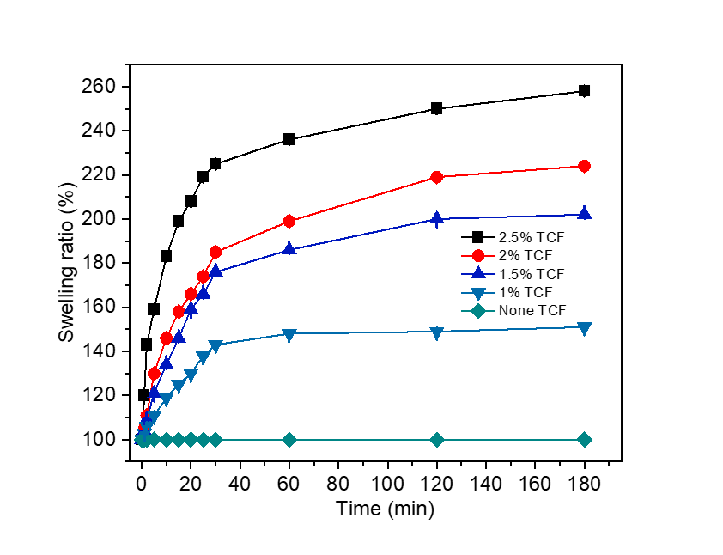
Figure S16. Comparison of hydrogel swelling rates with different grafting densities. Hydrogels with varying grafting rates (2.5 %, 2 %, 1.5 %, 1 %, none) were incubated in 5 mM HCl in a dark environment for 12 hours, and then transferred to pure water (pH 6.83) for swelling tests under blue light irradiation (light intensity of 130 mW/cm²).

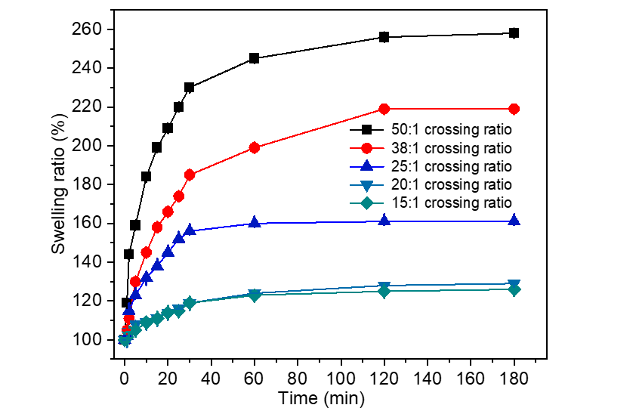
Figure S17. Comparison of hydrogel swelling rates at different crosslinking ratios. Hydrogels with various crosslinking ratios (50:1, 38:1, 25:1, 20:1, 15:1) were incubated in 5 mM HCl in a dark environment for 12 hours, and subsequently transferred to pure water (pH 6.83) for swelling tests under blue light irradiation (light intensity of 130 mW/cm²).

Characterization of the deformation of homogenous hydrogels.
As an example, TCF hydrogel ribbons (0.5 mm thick) were incubated overnight in DI water containing 5 mM HCl in the dark. The length and width of the hydrogel ribbons were fixed at 3.5 cm and 2 mm, respectively. The hydrogel ribbon was vertically suspended from the top using aluminum foil and immersed in a pure water tank. Immediately after immersion, blue light (450 nm) was applied from the left side, focused on the bottom portion of the ribbon. A digital camera was used to capture front-view images to monitor the bending process. Positive bending was defined as movement of the hydrogel ribbon toward the light source, while negative bending was defined as movement away from the light. ImageJ software was employed to measure the bending angle and length, and the changes in these parameters over time were recorded. Other hydrogel ribbons with varying compositions were characterized following the same protocol.
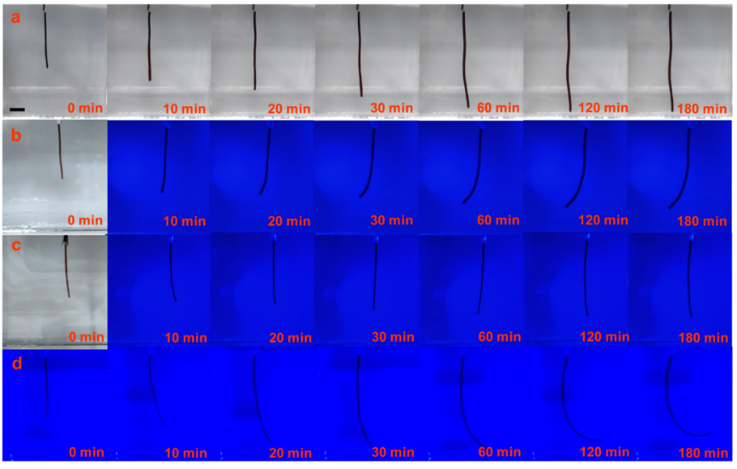
Figure S18. Bending behavior of the hydrogel under varying light intensities. (a) The hydrogel (with a TCF grafting rate of 2.5 %) was transferred from a 5 mM hydrochloric acid solution to pure water (pH 6.83) and allowed to swell. (b) The hydrogel was transferred from a 5 mM HCl solution to pure water (pH 6.83), and a blue light source (450 nm, 20 mW/cm²) was applied to the left side of the hydrogel. (c) The hydrogel was transferred from a 5 mM hydrochloric acid solution to pure water (pH 6.83), and a blue light source (450 nm, 50 mW/cm²) was applied to the left side. (d) The hydrogel was transferred from a 5 mM hydrochloric acid solution to pure water (pH 6.83), and a blue light source (450 nm, 100 mW/cm²) was applied to the left side.

$$growth rate \left(\%\right)=\frac{{∆length}_{ (T_{4}-T_{3})} }{{∆length}_{ (T_{2}-T_{1})}}×100$$

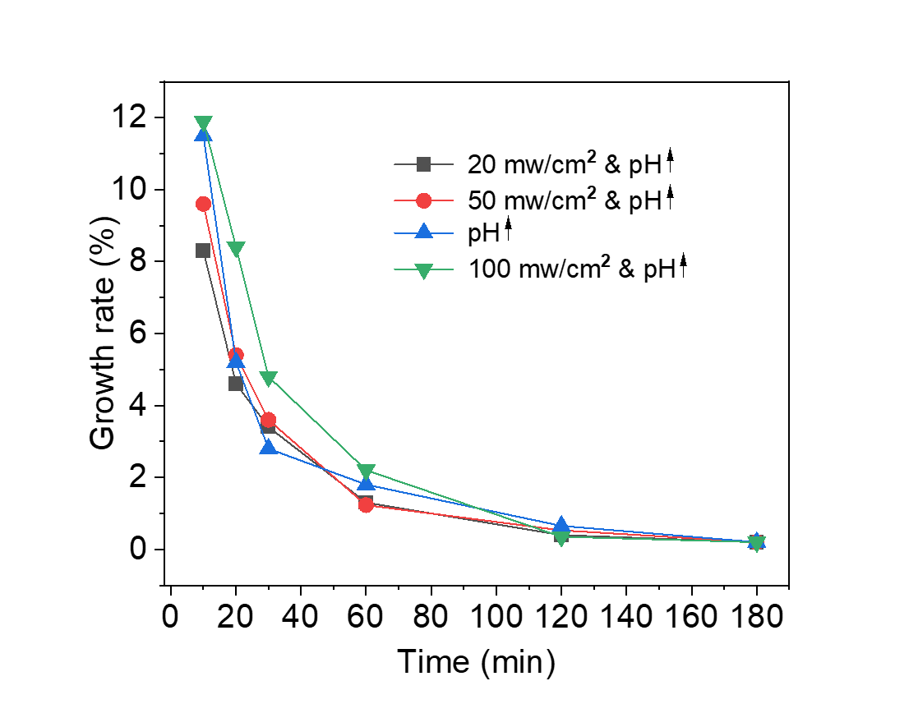
Figure S19. Swelling rate of hydrogel under different conditions.
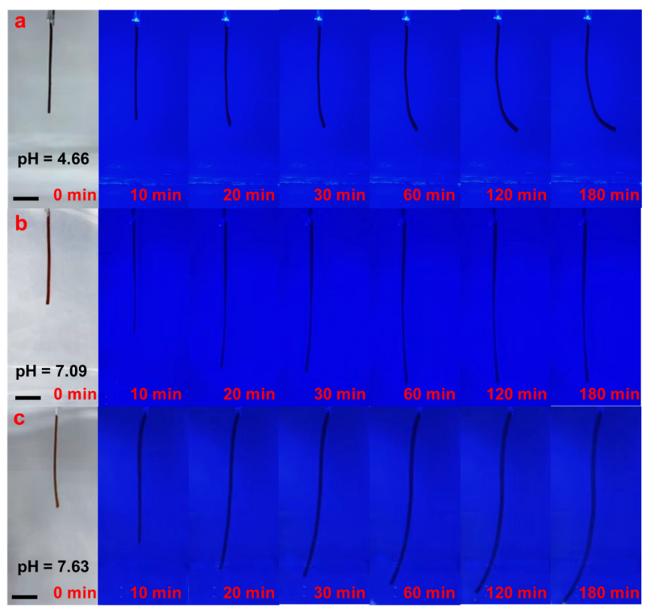
Figure S20. Bending behavior of the hydrogel under different pH conditions (with constant light intensity). (a) The hydrogel was transferred from a 5 mM HCl solution to an aqueous solution with pH 4.66, while a blue light source (450 nm, 70 mW/cm²) was applied to the left side of the hydrogel. (b) The hydrogel was transferred from a 5 mM HCl solution to an aqueous solution with pH 7.09, with the same blue light source (450 nm, 70 mW/cm²) applied to the left side. (c) The hydrogel was transferred from a 5 mM HCl solution to an aqueous solution with pH 7.63, while the blue light source (450 nm, 70 mW/cm²) continued to be applied to the left side.
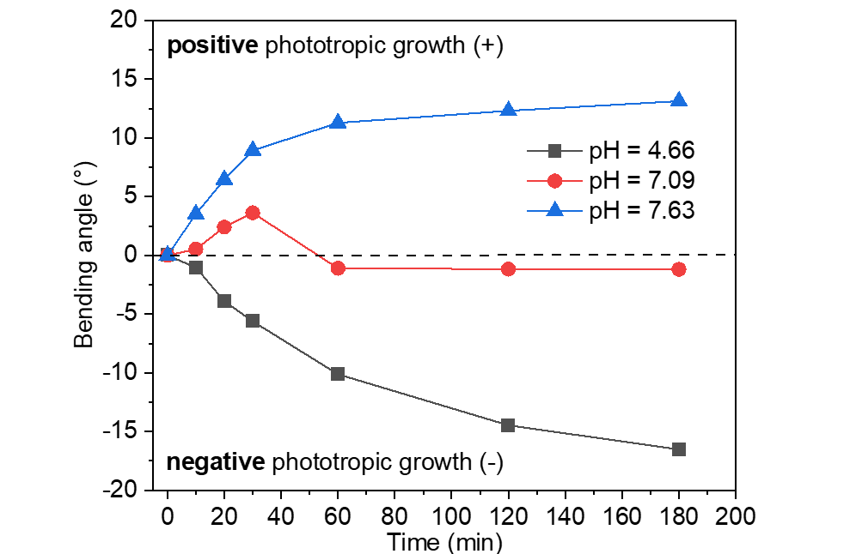
Figure S21. Plot of bending angles of the TCF hydrogel strip under various stimulus conditions.
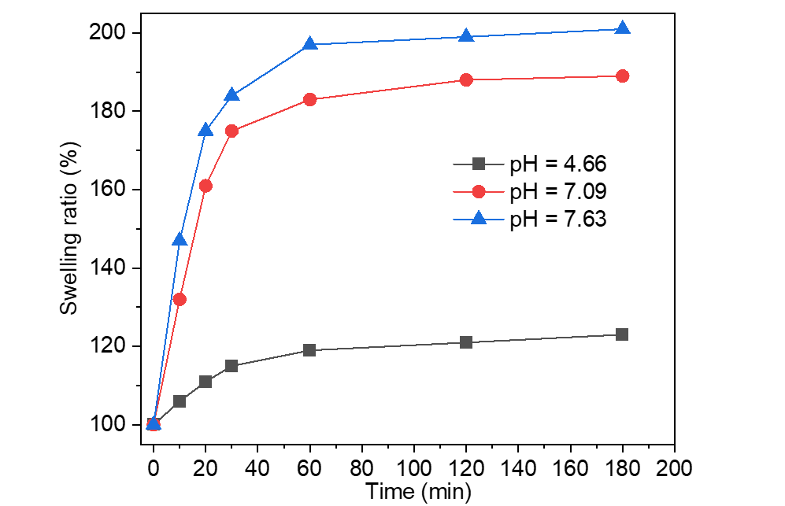
Figure S22. Plot of growing ratios of the TCF hydrogel strip under various stimulus
conditions.

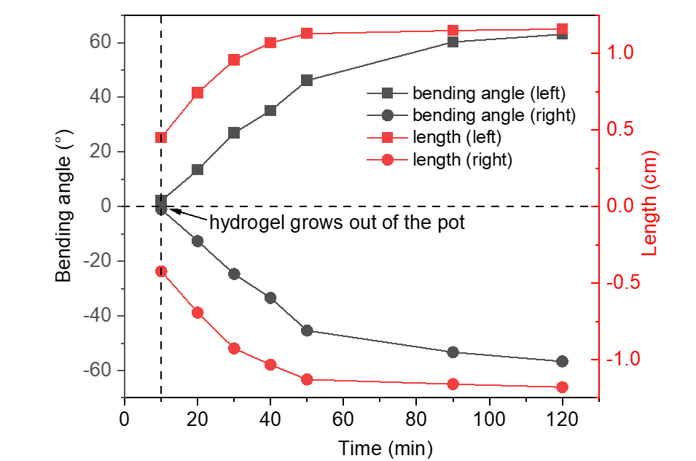
Figure S23. Plot of hydrogel swelling length and bending Angle under different illumination directions.

