SUPPLEMENTARY MATERIALS
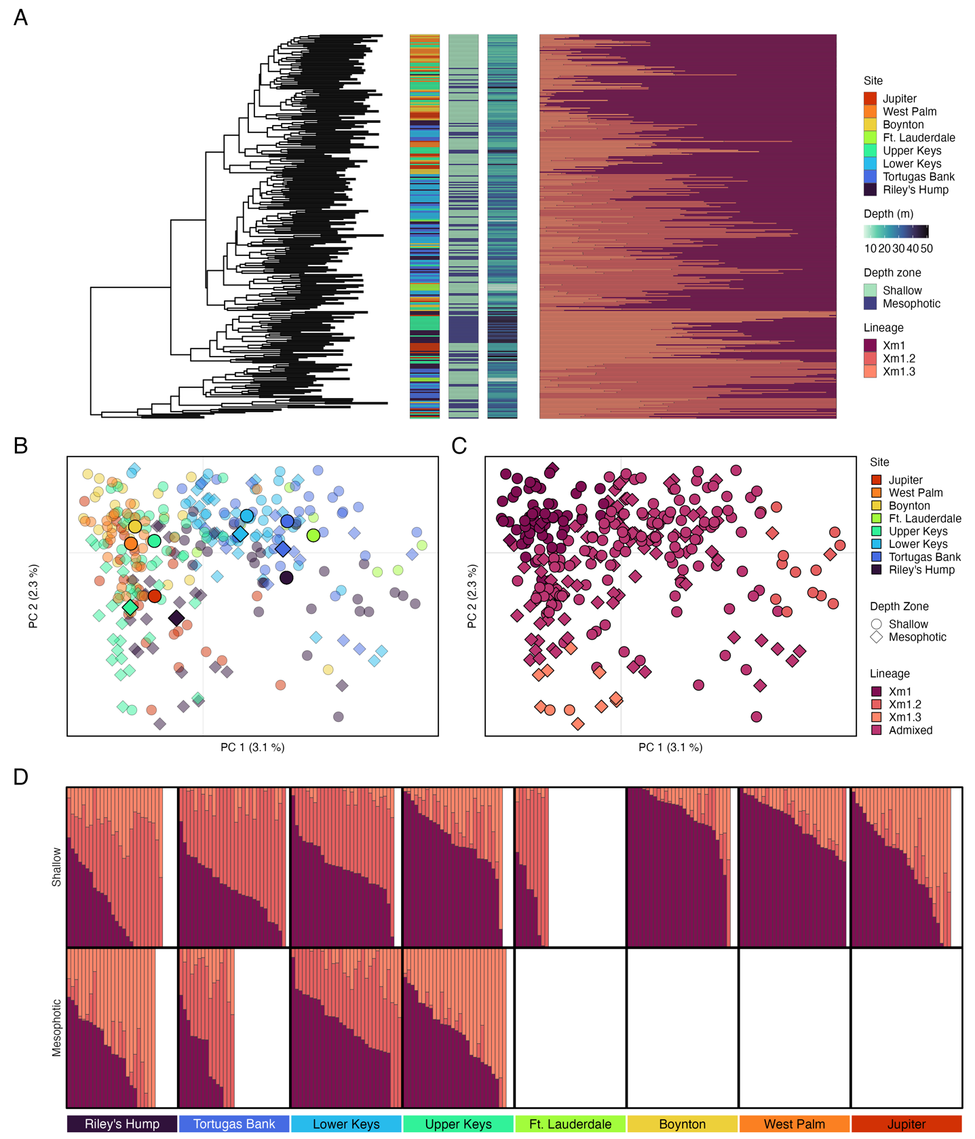
Supplementary Figure S1. Population substructure of dominant lineage, Xm1. A Dendrogram of samples based on IBS matrix from ANGSD with matching site, depth zone, and depth (m) data and structure plots for K = 3 within dominant Xm1 lineage. for each X. muta sample. B Principal component analysis from pcangsd, where color represents sampling site and shape represents sampling depth zone. Larger, opaque shapes are sample population centroids and smaller, transparent shapes individual samples. C Same plot as B with samples colored by lineage assignment from K = 3 data set. D Structure plot for K = 3 subset by sampling site and depth.

