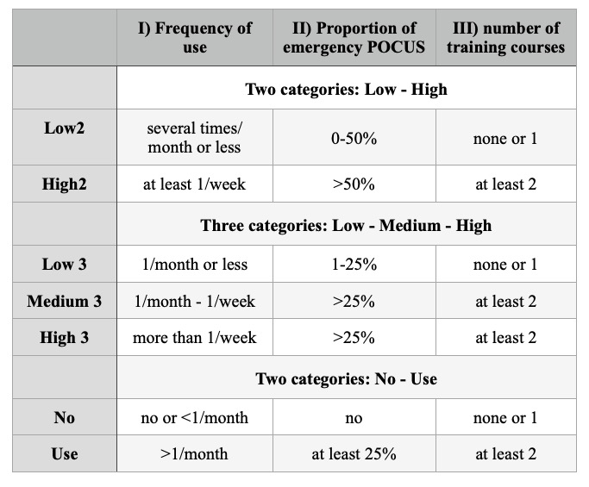

Table 1 The three different categorizations of competence in emergency POCUS examinations
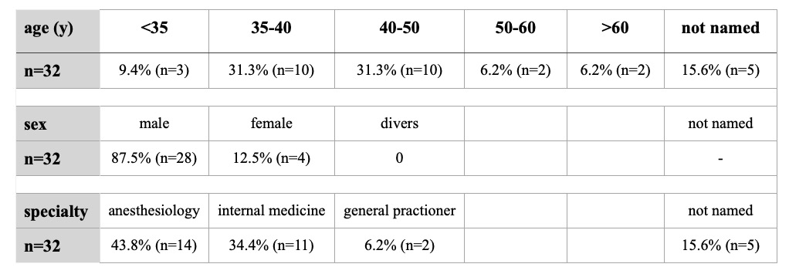
Table 2 Epidemiological data of EMS physicians that took followed up examinations

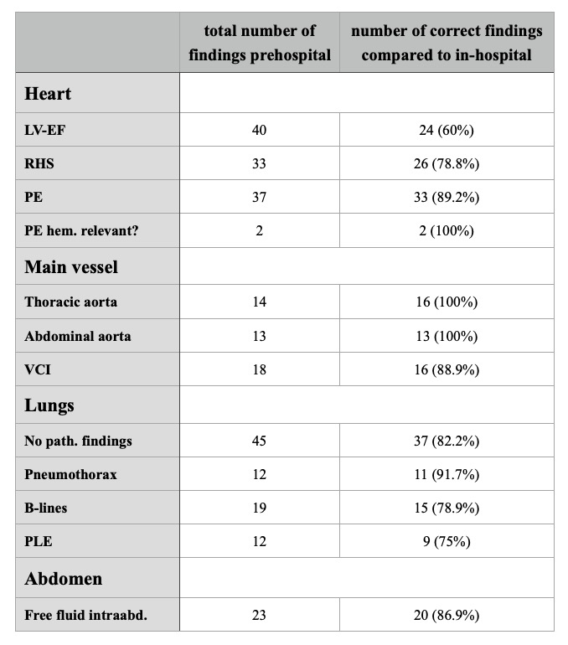
Table 3 Overview of followed-up POCUS findings and correct prehospital findings
LV-EF: Left-ventricular ejection fraction, RHS: right heart strain, PE: pericardial effusion, hem.: hemodynamically, VCI: vena cava inferior, path.: pathological, PLE: pleural effusion, intraabd.: intra-abdominal

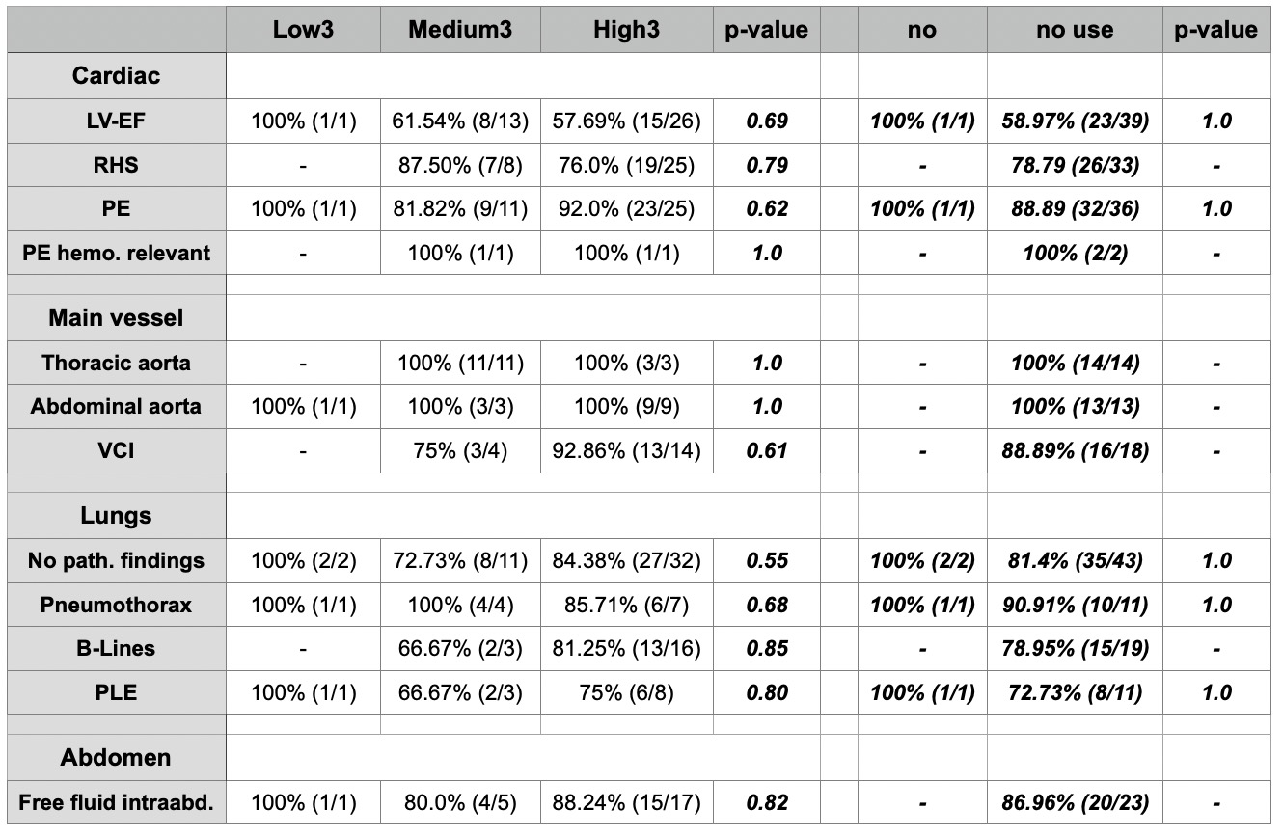
Table 4a Comparison of correct prehospital POCUS findings and level of competence of performing EMS
physicians and p-value. Three levels of competence Low3 - Medium3 - High3 (left side), and two levels of competence: no regular POCUS use (=no use) – regular POCUS use regularly (=use) (right side). - means no examinations in this subgroup, so comparison was not possible due to no comparable data.

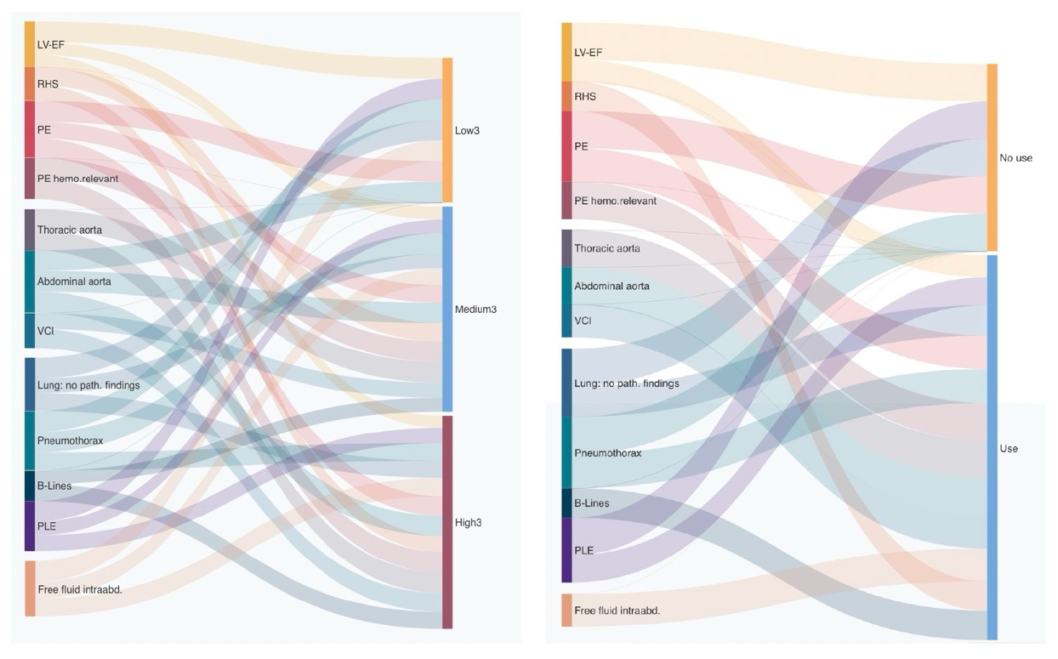
4b Comparison as above graphically shown as Alluvial diagrams. The connecting line widths are sized to be proportional to the number of correct prehospital sonographic findings.
Left side: EMS physicians divided into three levels of competence Low3 - Medium3 - High3 Right side: EMS physicians divided into two levels: no use and use POCUS during in-hospital work

