Nisaea sediminum sp. nov., a heavy metal resistant isolated from marine sediment in the East China Sea

Suting Zhu, Yuping Cheng, Chaobo Guo, Feilu Xie, Dawoon Jung, Weiyan Zhang* and Shan He*

Li Dak Sum Yip Yio Chin Kenneth Li Marine Biopharmaceutical Research Center, College of Food and Pharmaceutical Sciences, Ningbo University, Ningbo, 315800, P. R. China

*Correspondence: Weiyan Zhang, zhangweiyan13@126.com; Shan He, heshan@nbu.edu.cn

Table S1. The same characteristics of strain NBU1469^{T} and related type strains of the genus Nisaea.
Taxa: 1, strain NBU1469^{T}; 2, N. nitritireducens DSM 19540^{T}; 3, N. denitrificans DSM 18348^{T}. All data were taken from this study unless otherwise indicated. Data marked with ª was taken from Urios et al. [1]. -, negative; +, positive; R, resistant; S, susceptible.
Characteristic | 1 | 2 | 3
Cell morphology  Pigmentation | Rods  Cream | Rodsª  Creamª | Rodsª  Creamª
Oxidase and catalase activities | + | + | +
H₂S production  Voges-Proskauer, methyl red | +  - | +  - | +  -
Hydrolysis of:  Starch, casein, tween 40, 60, 80 | - | - | -
API 20NE test results:  Indole production, fermentation of _{D}-glucose,  arginine dihydrolase, gelatin hydrolysis,  aesculin hydrolysis, β-galactosidase | - | - | -
API ZYM test results:  Alkaline phosphatase, esterase (C4),  esterase lipase (C8), leucine arylamidase,  valin arylamidase, acid phosphohydrolase,  naphtol-AS-BI-phosphohydrolase  N-acetyl-β-glucosaminidas, lipase (C14),  cystin arylamidase, trypsin, α-fucosidase,  α-chymotrypsin, α-galactosidase,  β-glucuronidase, β-glucosidase,  α-mannosidase, β-galactosidase, α-glucosidase | +  - | +  - | +  -
API 50CH  _{L}-Arabinose, _{D}-xylose, _{L}-rhamnose,  _{D}-fucose, 2-ketogluconate  Erythritol, _{D}-adonitol, _{D}-mannose,  β-methyl-_{D}-xylopyranoside, dulcitol,  α-methyl-_{D}-mannopyranoside,  _{D}-sorbitol, α-methyl-_{D}-glucopyranoside,  arbutin, aesculin, melibiose, inulin, starch,  _{D}-xylitol, gentiobiose, _{D}-turanose,  _{D}-tagatose, _{L}-arabitol, _{D}-gluconic acid | +  - | +  - | +  -
Susceptibility to
Lincomycin, bacitracin, nystatin  Kanamycin, ofloxacin, amikacin,  rifampicin, novobiocin, minocycline | R  S | R  S | R  S

Fig. S1 Polar lipid profile of strains NBU1469^{T}, N. nitritireducens DSM 19540^{T} and N. denitrificans DSM 18348^{T}. All data were taken from this study. First dimension (left to right) was developed with chloroform-methanol-water (65:25:4) and second dimension (bottom to up) was developed with chloroform-acetic acid-methanol-water (80:15:12:4). PG, phosphatidylglycerol; PN, amino-phospholipids; PL, phospholipids; L, unidentified lipids. The following pictures used phosphomolybdic acid (5 g phosphomolybdic acid hydrated in 100 ml ethanol) to reveal the total polar lipid.
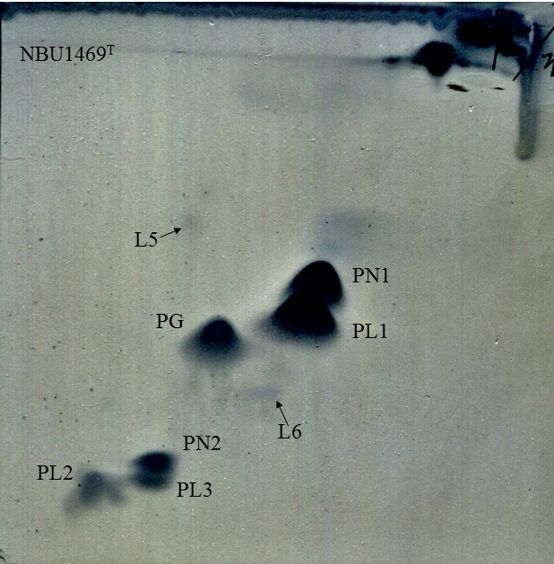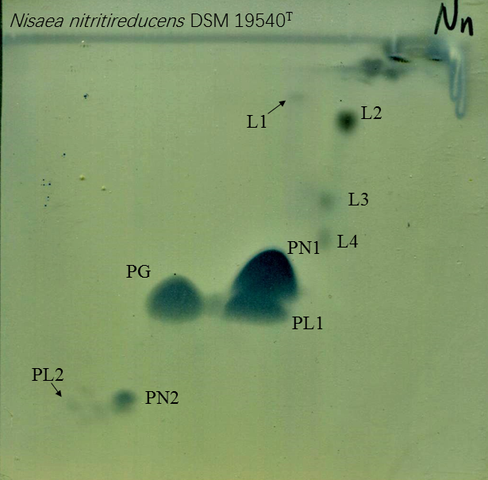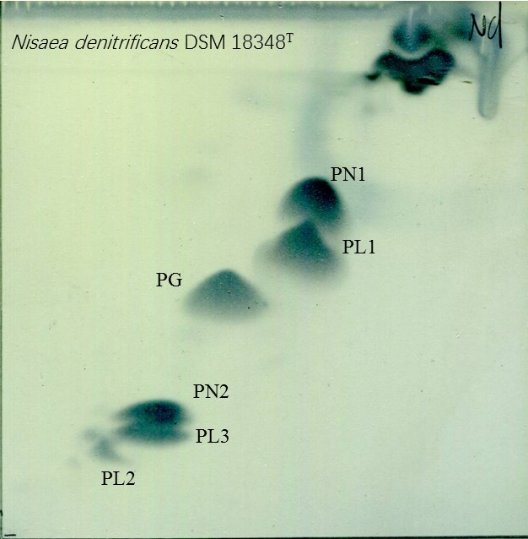

Fig. S2 Phylogenetic tree based on 16S rRNA gene sequences using maximum-likelihood method. Bootstrap values higher than 50% are indicated at branch-points. Bar, 0.02 substitutions per nucleotide position.
Nisaea nitritireducens DR41_18^{T} (DQ665839)
Nisaea denitrificans DR41_21^{T} (AUFM01000008)
Nisaea sediminum NBU1469^{T} (MT525301)

Thalassobaculum fulvum HSF7^{T} (KP976094)
Thalassobaculum litoreum DSM 18839^{T} (FNBW01000025)
Thalassobaculum salexigens DSM 19539^{T} (AUIR01000004)
Oceanibaculum pacificum MCCC 1A02656^{T} (LPXN01000088)
Oceanibaculum nanhaiense L54-1-50^{T} (MPOB01000022)
Oceanibaculum indicum P24^{T} (AMRL01000052)
Kaistia dalseonensis B6-8^{T} (AM409364)
Kaistia adipata Chj404^{T} (AY039817)
Tistlia consotensis DSM 21585^{T} (FZNU01000061)
Fodinicurvata halophila BA45AL^{T} (HG764424)
Fodinicurvata sediminis DSM 21159^{T} (ATVH01000016)
Fodinicurvata fenggangensis DSM 21160^{T} (JMLV01000013)
Hypericibacter terrae R5913^{T} (MG271952)
Hypericibacter adhaerens R5959^{T} (MH450230)
Aliidongia dinghuensis 7M-Z19^{T} (KX426600)
Lacibacterium aquatile LTC-2^{T} (HE795994)
Azospirillum thermophilum CFH 70021^{T} (CP029357)
Azospirillum humicireducens SgZ-5^{T} (CP015285)
Azospirillum oryzae COC8^{T} (AB185396)
100
88
100
100
91
100
100
79
100
90
99
95
95
86
64
65
74
0.02
Fig. S3 Phylogenetic tree based on 16S rRNA gene sequences using the maximum-parsimony method. Bootstrap values higher than 50% are indicated at branch-points. Numbers at branching points refer to bootstrap values based on 1000 resamplings.
Nisaea nitritireducens DR41_18^{T} (DQ665839)

Nisaea denitrificans DR41_21^{T} (AUFM01000008)

Nisaea sediminum NBU1469^{T} (MT525301)
Thalassobaculum fulvum HSF7^{T} (KP976094)
Thalassobaculum litoreum DSM 18839^{T} (FNBW01000025)
Thalassobaculum salexigens DSM 19539^{T} (AUIR01000004)
Oceanibaculum pacificum MCCC 1A02656^{T} (LPXN01000088)
Oceanibaculum nanhaiense L54-1-50^{T} (MPOB01000022)
Oceanibaculum indicum P24^{T} (AMRL01000052)
Lacibacterium aquatile LTC-2^{T} (HE795994)
Azospirillum thermophilum CFH 70021^{T} (CP029357)
Azospirillum humicireducens SgZ-5^{T} (CP015285)
Azospirillum oryzae COC8^{T} (AB185396)
Hypericibacter terrae R5913^{T} (MG271952)
Hypericibacter adhaerens R5959^{T} (MH450230)
Aliidongia dinghuensis 7M-Z19^{T} (KX426600)
Kaistia dalseonensis B6-8^{T} (AM409364)
Kaistia adipata Chj404^{T} (AY039817)
Tistlia consotensis DSM 21585^{T} (FZNU01000061)
Fodinicurvata halophila BA45AL^{T} (HG764424)
Fodinicurvata sediminis DSM 21159^{T} (ATVH01000016)
Fodinicurvata fenggangensis DSM 21160^{T} (JMLV01000013)
92
100
62
94
99
100
100
73
64
83
100
62
100
81
59
96
100

Fig. S4 Phylogenomic tree was generated by Type (strain) Genome Server (TYGS), showing the phylogenomic relationships of strain NBU1469^{T} and related taxa having genome sequences available.
0.02

100

100

100

100

100

100

100

100

100

Nisaea sediminum NBU1469^{T} (JACZCQ000000000)

Nisaea denitrificans DSM 18348^{T} (AUFM00000000)
Nisaea nitritireducens DSM 19540^{T} (JACZFS000000000)
Thalassobaculum fulvum HSF7^{T} (BMZS00000000)
Thalassobaculum salexigens DSM 19539^{T} (AUIR00000000)
Thalassobaculum litoreum DSM 18839^{T} (FNBW00000000)

Oceanibaculum pacificum MCCC 1A02656^{T} (LPXN00000000)
Oceanibaculum indicum P24^{T} (AMRL00000000)
Oceanibaculum nanhaiense L54-1-50^{T} (MPOB00000000)
Tistlia consotensis DSM 21585^{T} (FZNU00000000)
Aliidongia dinghuensis 7M-Z19^{T} (BMJQ00000000)
Hypericibacter adhaerens R5959^{T} (CP042582)
Hypericibacter terrae R5913^{T} (CP042906)

Fodinicurvata sediminis DSM 21159^{T} (ATVH00000000)
Fodinicurvata fenggangensis DSM 21160^{T} (JMLV00000000)

81

77

100

Azospirillum thermophilum CFH 70021^{T} (CP029352)
Azospirillum humicireducens SgZ-5^{T} (CP015285)
Azospirillum oryzae COC8^{T} (CP054619)

Fig. S5 The prediction of secondary metabolite gene clusters of strain NBU1469^{T}.