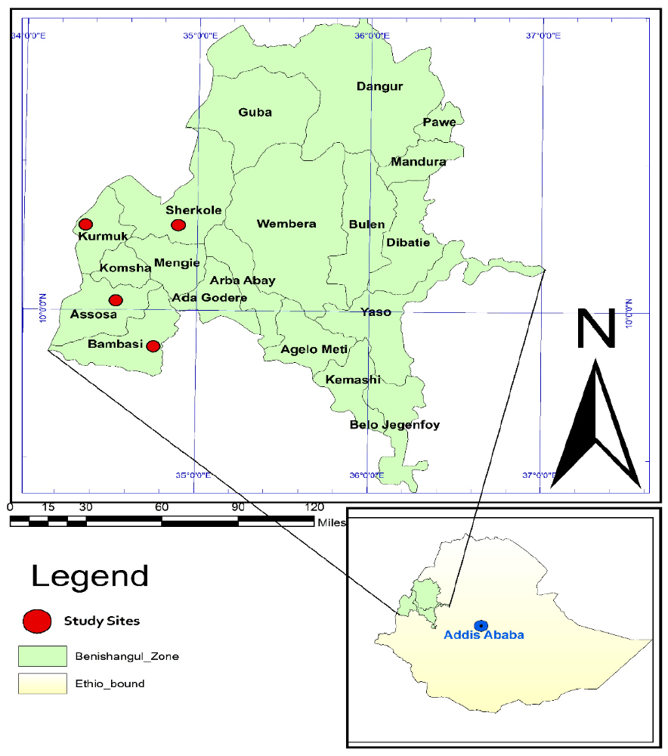

- Additional file 1. The map showing the study area in Assosa zone. The map generated using ArcGIS version 10.0 software.

