Supplementary
Table S1 Timing of non-breeding movements of brown skuas (Stercorarius antarcticus hamiltoni) from Amsterdam Island, tracked using GLS loggers in 2018-2019

 |  |  | Non-breeding
 |  |  | Date |  | Duration (days) | Distance to the colony (km)
Birds | Sex | Stage¹ | Start | End
DZ19105 | M | Chick-rearing | 22/02/2019 | 08/08/2019 | 167 | 1599.3 | migrant
DZ19216 | F | Chick-rearing | 15/04/2019 | 30/08/2019 | 137 | 1334.4 | migrant
DZ19248 | F | Chick-rearing | 02/03/2019 | 10/09/2019 | 192 | 4091.6 | migrant
DZ20234 ª | F | Incubation | NA² | NA | 181 | 878.6 | resident
DZ20235 ª | F | Chick-rearing | 03/03/2019 | 28/07/2019 | 147 | 2499.7 | migrant
DZ20236 | F | Chick-rearing | 21/03/2019 | 25/08/2019 | 153 | 3981.1 | migrant
DZ20238 | M | Chick-rearing | 01/05/2019 | 04/09/2019 | 126 | 4095.2 | migrant
DZ20239 | F | Chick-rearing | 02/03/2019 | 01/09/2019 | 183 | 4573.5 | migrant
DZ20241 ^{b} | F | Chick-rearing | 16/04/2019 | 01/08/2019 | 91 | 461.6 | migrant
DZ20242 ^{b} | M | Chick-rearing | 22/05/2019 | 25/09/2019 | 126 | 1794.8 | migrant
DZ20245 ^{c} | F | Chick-rearing | 21/04/2019 | 04/08/2019 | 105 | 2057.7 | migrant
DZ20246 ^{c} | M | Chick-rearing | 17/03/2019 | 19/09/2019 | 186 | 4530.3 | migrant
DZ28801 | M | Chick-rearing | 07/03/2019 | 22/09/2019 | 199 | 7528.9 | migrant
DZ28802 ^{d} | M | Chick-rearing | 27/02/2019 | 17/08/2019 | 171 | 4065.6 | migrant
DZ28803 ^{d} | F | Chick-rearing | 07/02/2019 | 16/08/2019 | 190 | 5977.0 | migrant
DZ28804 | F | Chick-rearing | 01/03/2019 | 05/09/2019 | 188 | 6288.9 | migrant
DZ28805 ^{e} | M | Chick-rearing | 01/03/2019 | Aug-Sept/2019 | 122 | 1512.9 | resident
DZ28806 ^{e} | F | Chick-rearing | 28/02/2019 | 04/08/2019 | 157 | 5358.6 | migrant
DZ28807 ^{f} | M | Chick-rearing | 22/04/2019 | 26/07/2019 | 61 | 729.6 | migrant³
DZ28808 ^{f} | F | Chick-rearing | 02/03/2019 | 09/08/2019 | 160 | 4211.2 | migrant
DZ28809 | F | Chick-rearing | 01/03/2019 | 02/09/2019 | 185 | 6317.4 | migrant
¹ all breeding couples failed at chick-rearing stage during the breeding season 2018/2019; ² inspection of movements and activity did not permit to identify non-breeding movements (see Materials and Methods Section); ³ this individual exhibited shortest migration period (~2 months); ^{a-f} individuals sharing the same letter are member of a breeding couple

Table S2a Results of principal components analyses (PCA) on six wet/dry metrics on brown skua (Stercorarius antarcticus hamiltoni) contribution of variables to each axis

 | Dim.1 | Dim.2 | Dim.3 | Dim.4 | Dim.5
Time spent on water | 39.76 | 2.03 | 0.85 | 4.64 | 52.73
Dry bouts number | 0.98 | 54.40 | 37.99 | 6.24 | 0.40
Dry bouts duration | 21.97 | 1.18 | 2.35 | 73.24 | 1.26
Wet bouts number | 37.21 | 0.06 | 2.51 | 15.27 | 44.95
Wet bouts duration | 0.085 | 42.33 | 56.30 | 0.62 | 0.66

Table S2b Results of principal components analyses (PCA) on six wet/dry metrics on brown skua (Stercorarius antarcticus hamiltoni) correlation of variables on each axis
 | Dim.1 | Dim.2 | Dim.3 | Dim.4 | Dim.5
Time spent on water | 0.91 | 0.14 | -0.09 | 0.18 | 0.33
Dry bouts number | 0.14 | -0.75 | 0.61 | 0.21 | 0.03
Dry bouts duration | -0.68 | 0.11 | -0.15 | 0.71 | 0.05
Wet bouts number | 0.88 | 0.02 | -0.16 | 0.32 | -0.31
Wet bouts duration | 0.04 | 0.66 | 0.75 | 0.07 | -0.04

Figure S1 Locations (black dots) of individual adult brown skuas (Stercorarius antarcticus hamiltoni) from Amsterdam Island during the inter-breeding period. A) Individuals with one year of tracking; B) Individuals with two years of tracking. The breeding colony is indicated (red dot).

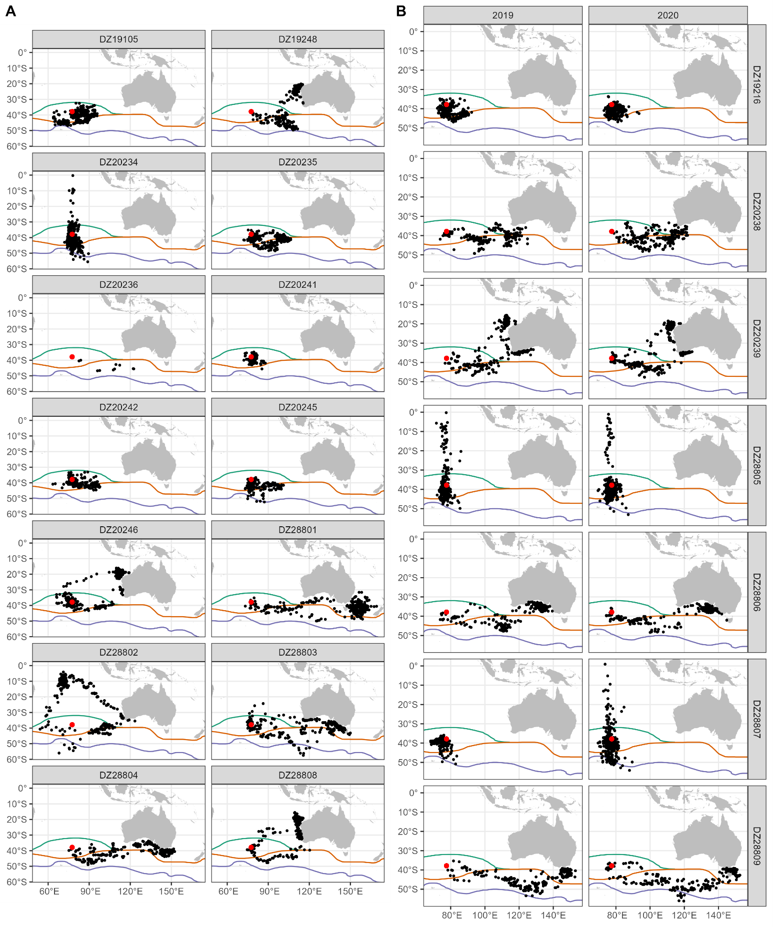

Figure S2 Individual i) distance to the breeding colony (in km; red line) and ii) percentage of time spent not immersed (i.e., in flight or on land; grey: daily values, black: weekly averages) of adult brown skuas (Stercorarius antarcticus hamiltoni) from Amsterdam Island during one year (January t to January t+1). A) Individuals with one year of tracking; B) Individuals with two years of tracking.

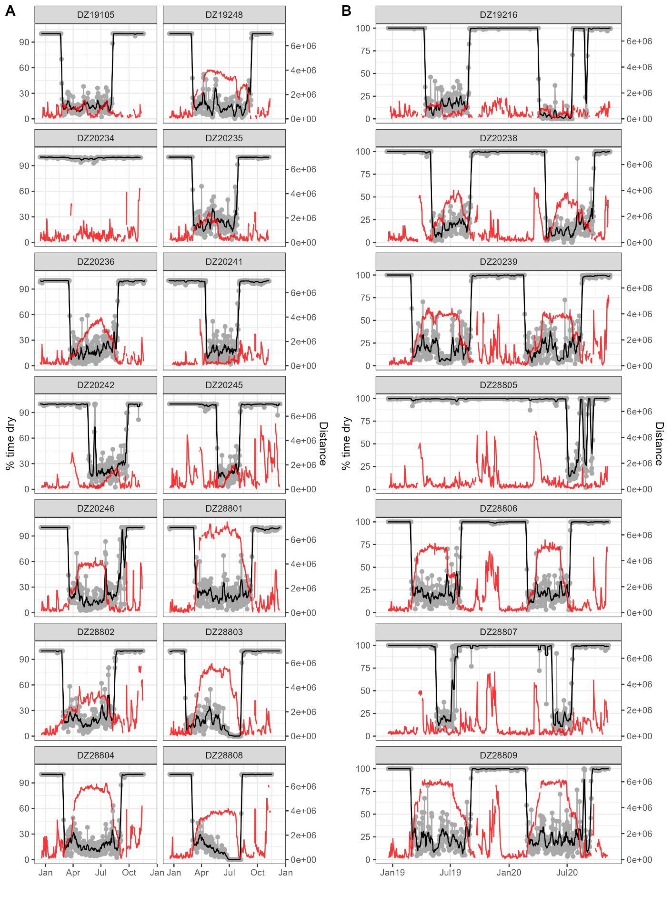
Figure S3 First axis of principal components analysis of activity parameters of individual (one color for each individual) according to month for a) female and b) male of adult brown skuas (Stercorarius antarcticus hamiltoni) from Amsterdam Island during the inter-breeding period. The two individuals DZ20234-B4100 (female) and DZ28805-B4123 (male) were resident all year long. Values are mean ± sd.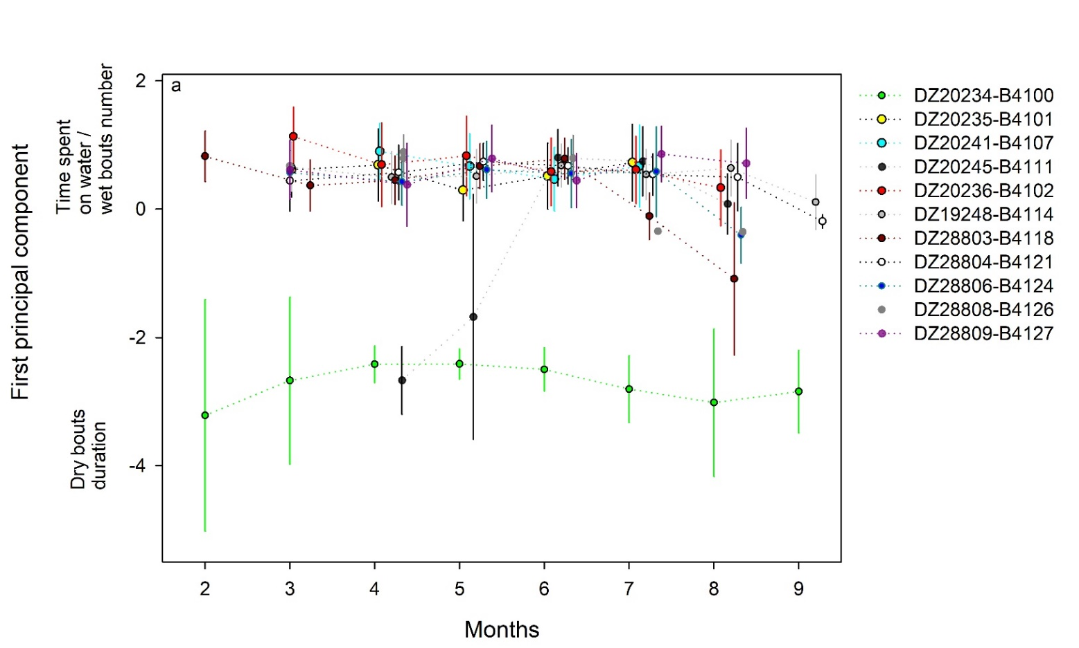
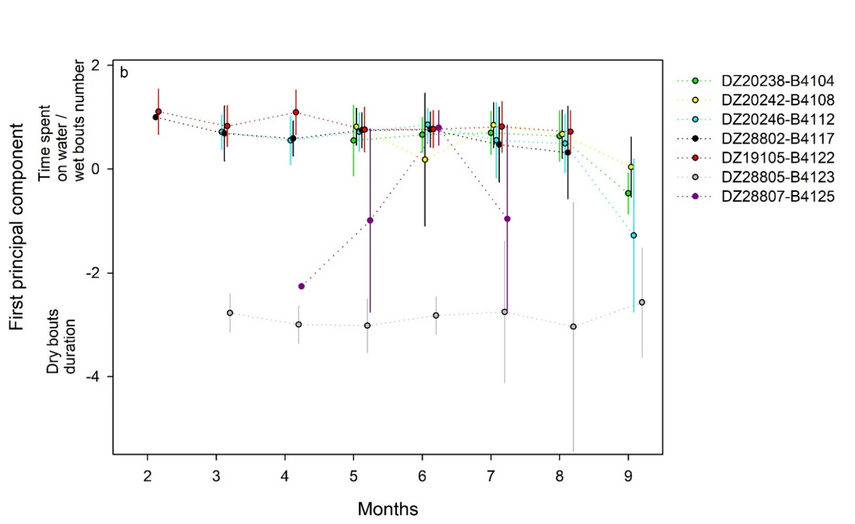

Figure S4 Sea surface temperature recorded by geolocators of individual (one color for each individual) according to month for a) female and b) male of adult brown skuas (Stercorarius antarcticus hamiltoni) from Amsterdam Island during the inter-breeding period. Values are mean ± sd.
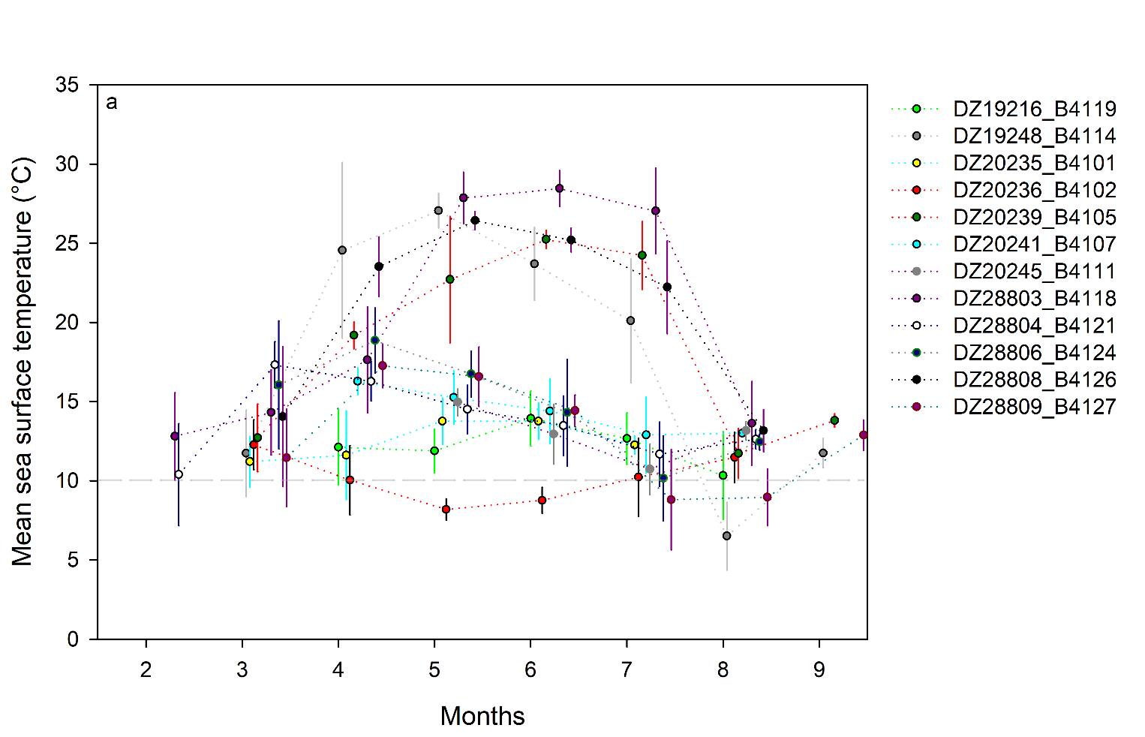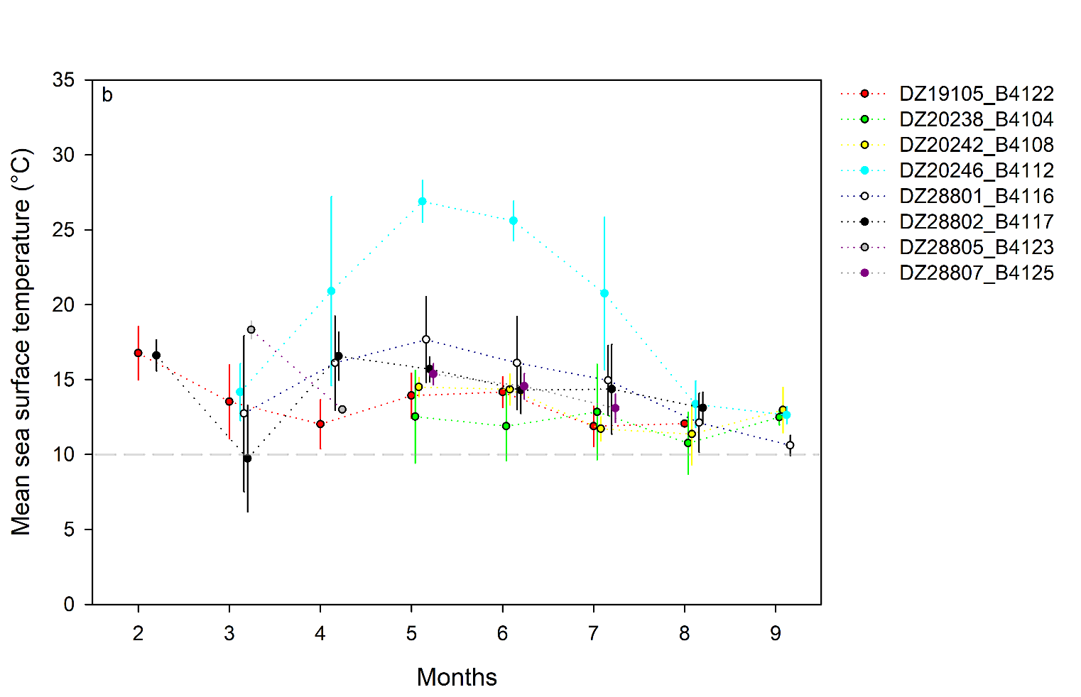
Figure S5 First and second axis of Principal Components Analysis of individual daily activity parameters, for each individual brown skua (Stercorarius antarcticus hamiltoni). Red: individual data, grey: population data.

