Hybridization of Lycium qingshuiheense and L. ningxiaense revealed using morphological, SSR markers, and chloroplast genomic data
Lei Zhang¹, Chaopan Zhang¹, Erdong Zhang¹, Yuqing Wei¹, Guoqi Zheng^{2*}

¹ Key Laboratory of Ecological Protection of Agro-Pastoral Ecotones in the Yellow River Basin, National Ethnic Affairs Commission of the People’s Republic of China, School of Biological Science & Engineering, North Minzu University, Yinchuan 750021, China
² Key Laboratory of the Ministry of Education for Protection and Utilization of Special Biological Resources in the Western, School of Life Science, Ningxia University, Yinchuan 750021, Ningxia, China

*Corresponding author
Guoqi Zheng, Key Laboratory of the Ministry of Education for Protection and Utilization of Special Biological Resources in the Western, School of Life Science, Ningxia University, Yinchuan 750021, Ningxia, China.
Email: zhengguoqi1977@163.com

Supplementary Infomation

Figure S1. Boxplots of nine quantitative traits for four Lycium species. (petiole length, leaf length, leaf width, leaf area, corolla radius, fruit color (R), fruit color (B), flower length and angle between corolla tube)

Figure S2 Phylogenetic tree obtained using the Bayesian inference (BI) methods for the four Lycium species based on 79 PCGs.

Figure S3 Phylogenetic tree obtained using the maximum likelihood (ML) methods for the four Lycium species based on complete cp genomes.

Figure S4 Phylogenetic tree obtained using the Bayesian inference (BI) methods for the four Lycium species based on complete cp genomes.

Figure S1

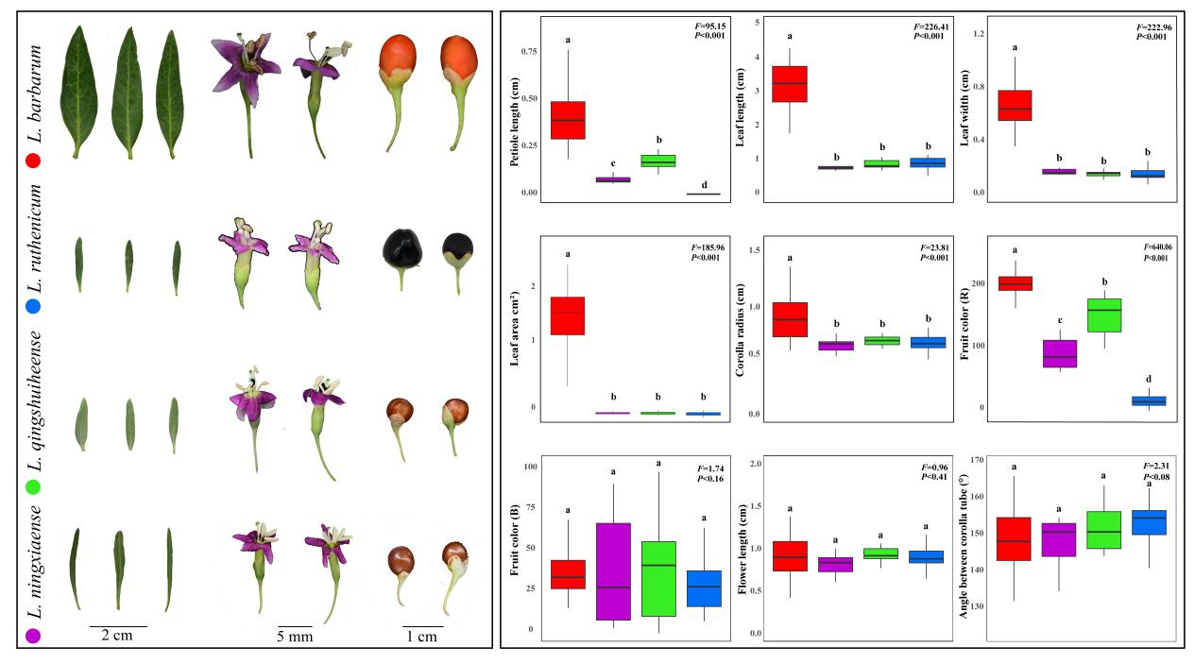

Figure S2

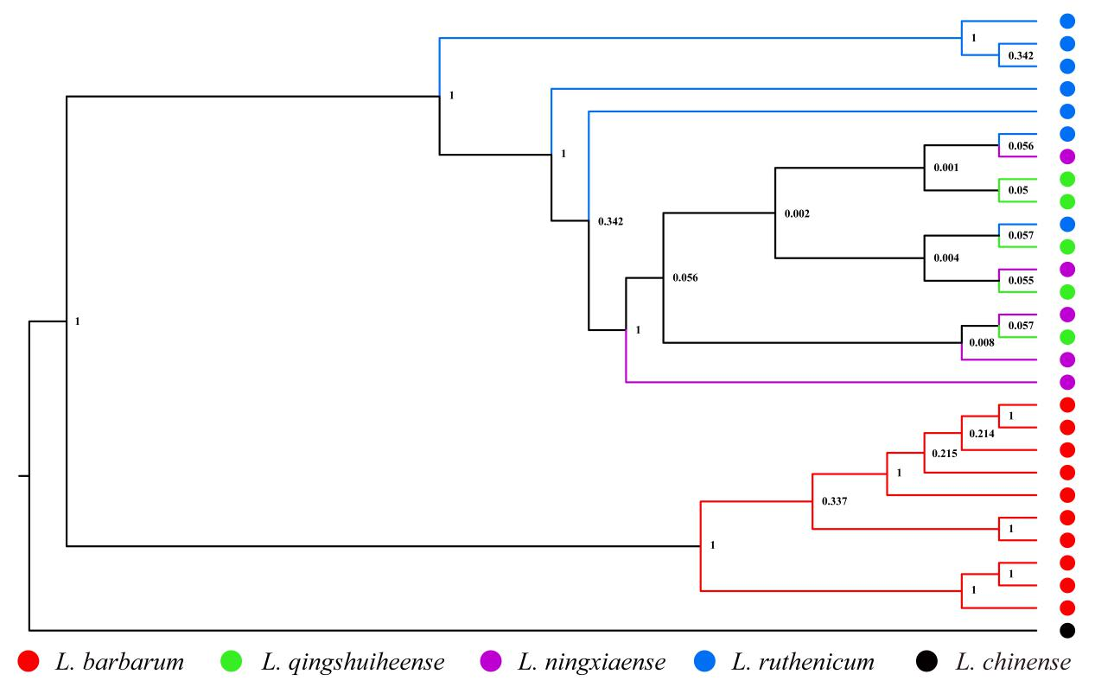

Figure S3

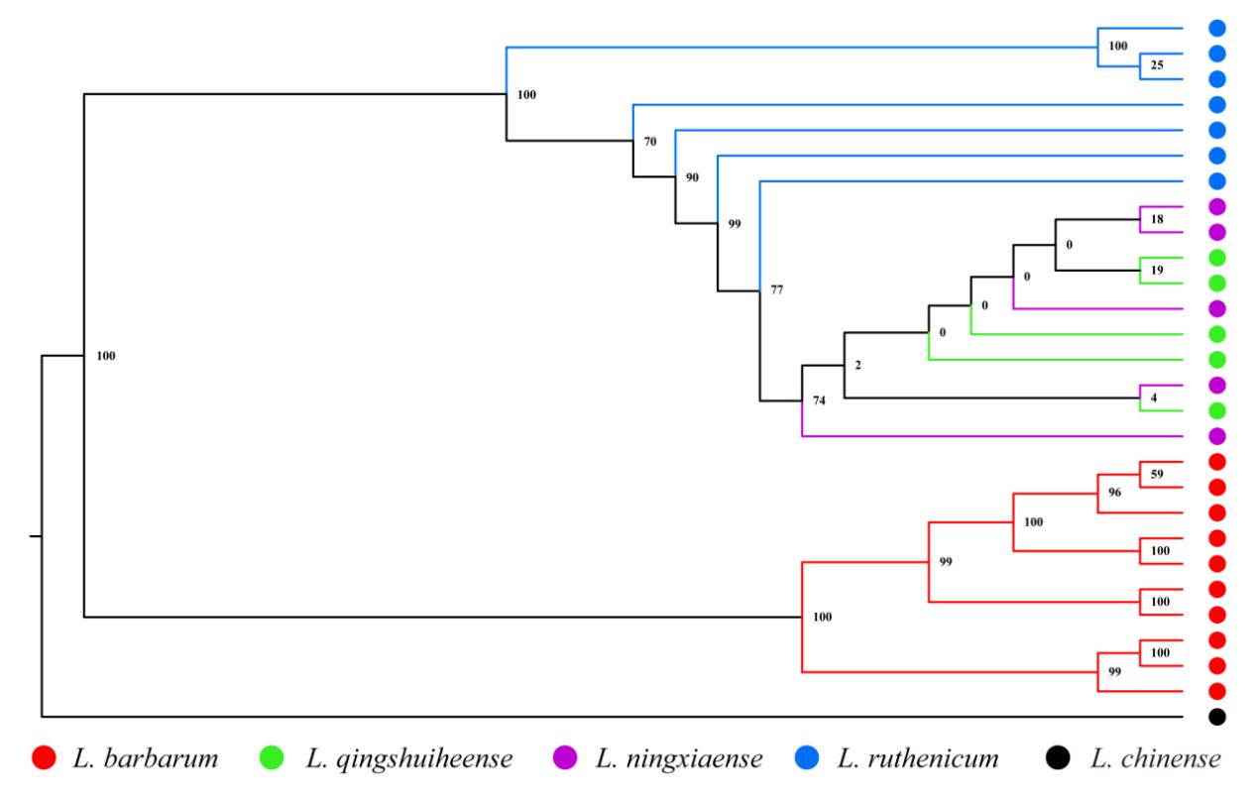

Figure S4

