Repression of Connexin26 Hemichannel activity protects the Barrier Function of Respiratory Airway Epithelial Cells against LPS-induced Alteration

Tina Lehrich ^{1#}, Anne Dierks ^{1#}, Masina plenge¹ Helena Obernolte ^{2, 3}, Klaudia Grieger ^{2, 3}, Katherina Sewald ^{2, 3,}, Frederic Rodriguez ^{4, 5}, Lucie Malet ^{4,5}, Peter Braubach ^{3, 6,} , Florence Bedos-Belval ^{4, 5}, Anaclet Ngezahayo ^{1, 7,} ✉

¹ Institute of Cell Biology and Biophysics, Department of Cell Physiology and Biophysics, Leibniz University Hannover, Hannover, Germany
² Fraunhofer Institute for Toxicology and Experimental Medicine (ITEM) Hannover Department of Area Airway Research, Hannover, Germany
³ Biomedical Research in Endstage and Obstructive Lung Disease Hannover (BREATH), German Centre for Lung Research, Hannover Medical School, Hannover, Germany
⁴ Université Paul Sabatier, Toulouse III, UMR 5068, Laboratoire de Synthèse et Physicochimie des Molécules d’Intérêt Biologique, Toulouse, France
⁵ CNRS, UMR 5068, Laboratoire de Synthèse et Physicochimie des Molécules d’Intérêt Biologique, Toulouse, France
⁶ Institute for Pathology, Hannover Medical School, Hannover, Germany
⁷ Center for Systems Neuroscience (ZNS), University of Veterinary Medicine Hannover Foundation, Hanover, Germany
# These authors contributed equally to this work
✉corresponding author: ngezahayo@cell.uni-hannover.de; Tel.: +49-511- 762 4568

Keywords:
Connexin channels; Lipopolysaccharide; Airway epithelium; Cytokine; Barrier function; Primary cells, PCLS, Calu-3 cells
Supplementary Materials
Uncropped Western Blot Images used for Fig S3:
Western Blot 1: 2 biological replicate, 1 technical replicate each
Upper membrane (immunoreaction: Cx26, Cx43, β-Tubulin) loading:
Lane 1 | 2 | 3 | 4 | 5 | 6 | 7 | 8 | 9 | 10
Marker | Negative siRNA | Cx26 siRNA3  + Cx43 siRNA2 | Cx26 siRNA3  + Cx43 siRNA2 | Data irrelevant for this paper | Data irrelevant for this paper | Data irrelevant for this paper | Data irrelevant for this paper | Data irrelevant for this paper | Data irrelevant for this paper
Lower membrane (immunoreaction: Cx26, Cx43, β-Tubulin) loading:
Lane 1 | 2 | 3 | 4 | 5 | 6 | 7 | 8 | 9 | 10
Negative siRNA | Marker | Cx26 siRNA3  + Cx43 siRNA2 | Cx26 siRNA3  + Cx43 siRNA2 | Data irrelevant for this paper | Data irrelevant for this paper | Data irrelevant for this paper | Data irrelevant for this paper | Data irrelevant for this paper | Data irrelevant for this paper
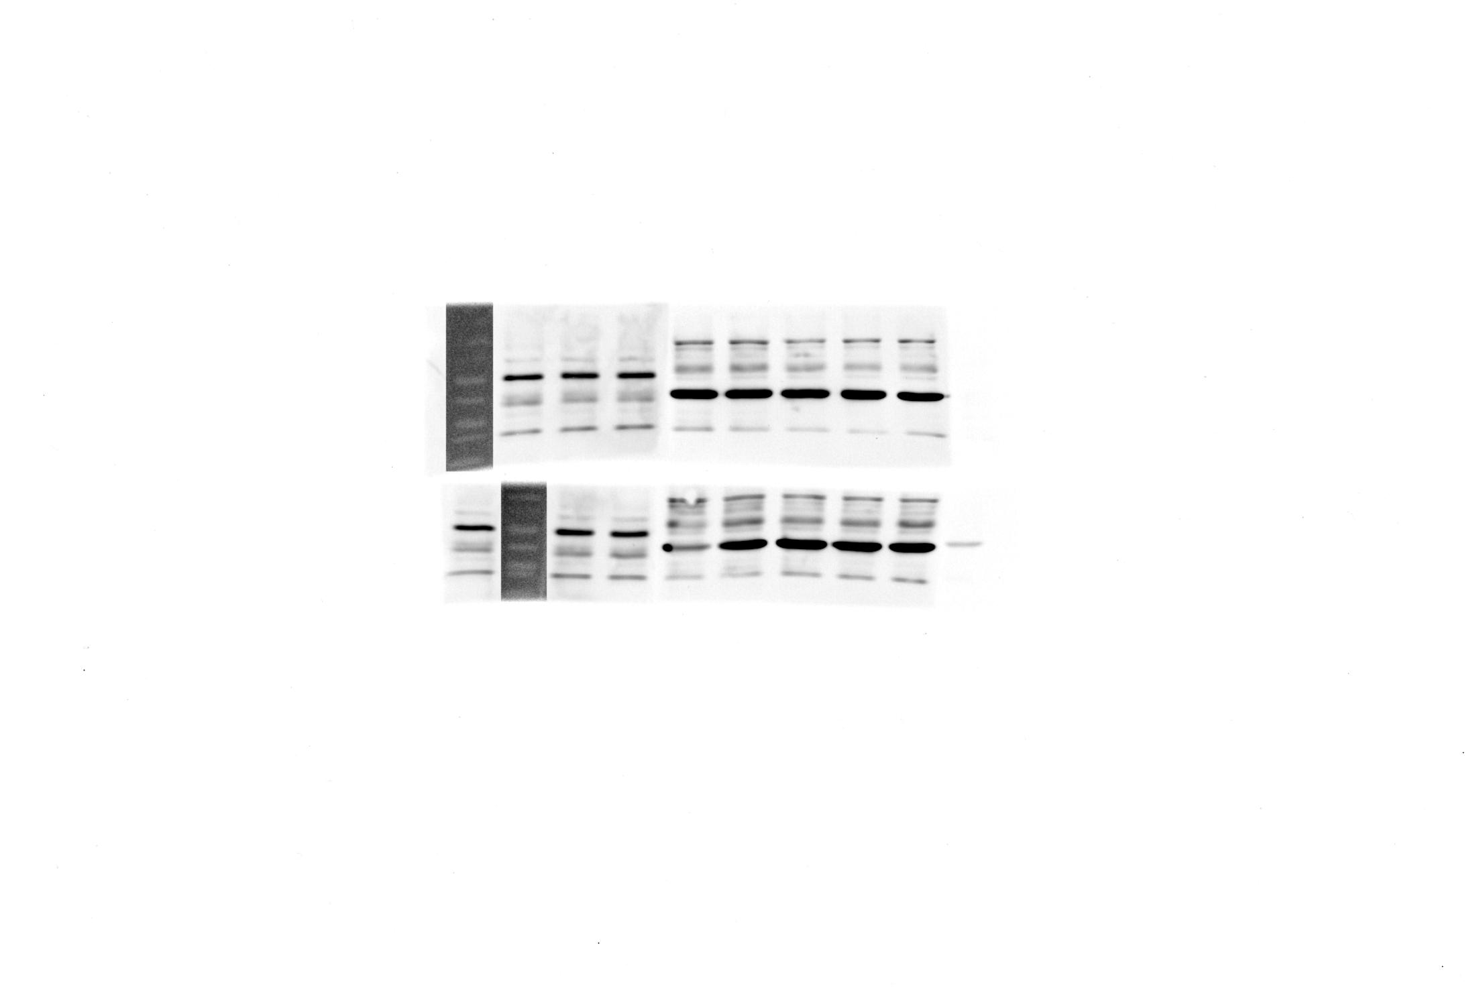

Western Blot 2: 1 biological replicate, 4 technical replicates
Only upper Membrane belongs to respective experiment. Lower membrane shows data irrelevant for this paper. Immunoreaction: Cx26, Cx43, β-Tubulin. Loading:
Lane 1 | 2 | 3 | 4 | 5 | 6 | 7 | 8 | 9 | 10
Marker | Cx26 siRNA3  + Cx43 siRNA2 | Negative siRNA | Cx26 siRNA3  + Cx43 siRNA2 | Negative siRNA | Cx26 siRNA3  + Cx43 siRNA2 | Negative siRNA | Cx26 siRNA3  + Cx43 siRNA2 | Negative siRNA | Marker
