Supplementary Information

A fluorescent probe for sensing of hydrogen sulfide in living cells by adopting the adjacent-group participation strategy

Yuting Du*, Hongliang Wang, Xingyu Xu, Jiayi Wang, Minmin Guo, Jinyu Sun

Department of Chemistry, Xinzhou Normal University, Xinzhou, Shanxi 034000, China
*Corresponding author. E-mail: yutingdu123@163.com

Synthesis of Compound DPM-H₂S
The synthesis process of the compound a and DPM were synthesized according to the procedures published previously^{[31-32, 40]}. Synthesis of DPM-H₂S: The compound DPM (450.0 mg, 1.7 mmol) and anhydrous potassium carbonate (468.0 mg, 3.4 mmol) were mixed in 20 mL of acetonitrile, then the mixture was stirred at room temperature for 1 hour under nitrogen atmosphere. During the stirring, a solution of 1-fluoro-2,4-dinitrobenzene (375 mg, 2.0 mmol) in acetonitrile was dropped into the mixture through a syringe. Then the mixture was heated to 50 ℃ for 16 hours. After the reaction was completed, the mixture was cooled to room temperature, and the solvent was removed by evaporation under reduced pressure. The crude product was extracted from the water with dichloromethane (3 × 20 mL), the organic phase was collected, and dried over anhydrous magnesium sulfate. Finally, the crude product was purified by silica gel column chromatography (eluent: EA/PE = 1/5, v/v) to obtain faint yellow solid DPM-H₂S (216.0 g, yield 48.0%). ¹H NMR (500 MHz, CDCl₃, ppm) δ 10.15 (s, 1H), 8.96 (s, 1H), 8.56 (s, 1H), 8.19 (d, J = 5 Hz, 1H), 8.02 (d, J = 10 Hz, 1H), 7.94 (d, J = 5 Hz, 1H), 7.86 (d, J = 10 Hz, 1H), 7.51 (t, J = 5, 10 Hz, 1H), 7.41 (t, J = 5, 10 Hz, 1H), 6.74 (d, J = 10 Hz, 1H); ¹³C NMR (125 MHz, CDCl₃) δ (ppm): 187.60, 159.55, 155.98, 152.46, 148.53, 141.84, 138.53, 137.11, 135.44, 134.41, 129.05, 128.82, 127.94, 126.81, 126.12, 122.44, 121.62, 116.00; HRMS (negative ion mode, m/z) for [DPM-H₂S-H]⁻: calcd.: 497.9390.

Table S1. A comparison of fluorescent probes for the detection of H₂S.
Probe | Solvent | Ex/Em  (nm) | Response time  (s) | Stokes shift | Ref.
 | DMF / PBS = 1: 1, v/v | Ex=540  Em=670 | 180 | 130 | 24
 | PBS buffer (10 mM, pH 7.4, 1 % DMSO, v/v) | Ex=565  Em=620 | 1800 | 55 | 25
 | PBS buffer (50 mM, pH 7.4, 10% DMSO, v/v) | Ex=590  Em=671 | 1800 | 81 | 26
 | DMSO/H₂O  (5/5, v/v) | Ex=572  Em=647 | 180 | 75 | 27
 | CH₃CN / PBS buffer (v/v = 1:1) | Ex=436  Em=542 | 5 | 106 | This work

Table S2. A comparison of the absolute fluorescent quantum yield (Φ_{fl}(%)) of DPM-H₂S in different solvents.

Solvents | Acetonitrile | Dimethyl sulfoxide | Methanol | Ethanol | THF
Φ_{fl}(%) | 30.48 | 29.12 | 23.21 | 13.56 | 8.9

Scheme S1. The process of Excited-State Intramolecular Proton Transfer of DPM.

Figure S1. ¹H NMR spectrum recorded DPM-H₂S after mixing with Na₂S of different proportions in DMSO-d₆.

Figure S2. The UV-Vis absorbance spectral titration of DPM-H₂S and the UV-vis spectra of DPM-H₂S at different pH condition.

Figure S3. Structural optimization and the molecular orbitals of probe DPM-H₂S and DPM.

Figure S4. Cell viability of HeLa cells treated with different concentrations of DPM-H₂S for 24 h.

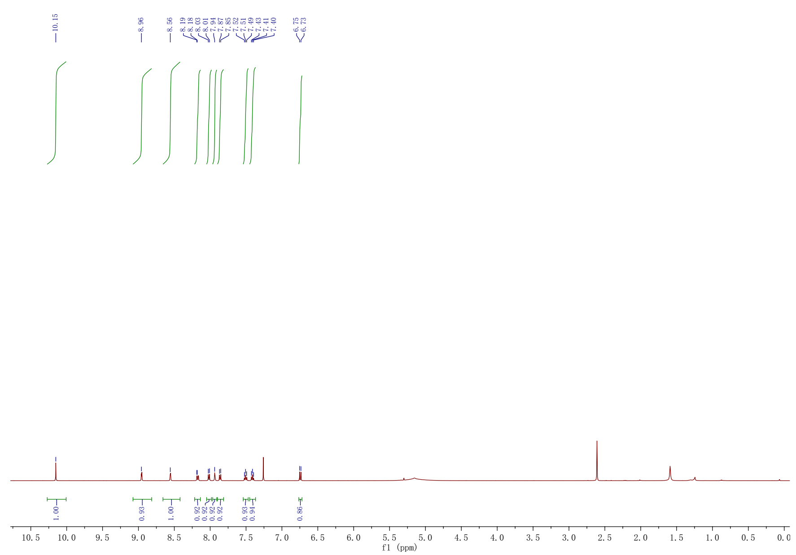

Figure S5. ¹H NMR spectra of DPM-H₂S in CDCl₃.

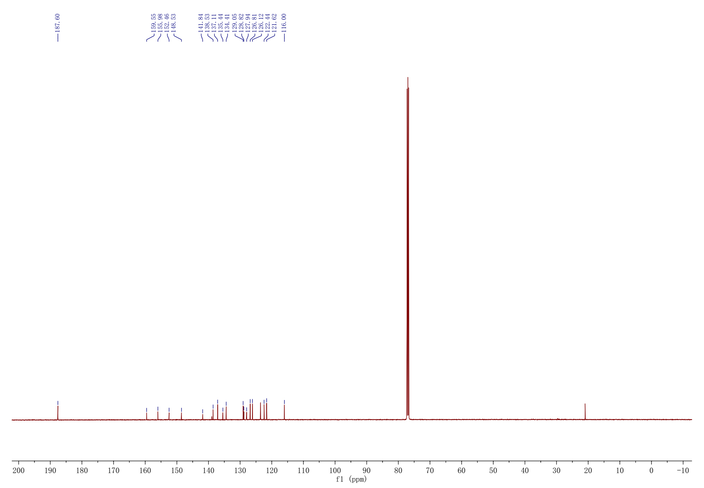
Figure S6. ¹³C NMR spectra of DPM-H₂S in CDCl₃.

Figure S7. HRMS spectra of DPM-H₂S.

