Supplementary information

Ultrahigh thermoelectricity obtained in classical BiSbTe alloy processed under super-gravity

Min Zhou^{1,9}*, Haojian Su^{1,2,9}, Jun Pei³, Li Wang⁴, Hualu Zhuang⁵, Jing-Feng Li⁵*, Kun Song⁶, Haoyang Hu⁶, Jun Jiang⁶*, Qinghua Zhang⁷, Jiangtao Li⁸ & Laifeng Li¹*

¹Key Laboratory of Cryogenic Science and Technology, Technical Institute of Physics and Chemistry, Chinese Academy of Sciences; Beijing, 100190, China.
²Centre of Materials Science and Optoelectronics Engineering, University of Chinese Academy of Sciences; Beijing, 100049, China.
³Beijing Municipal Key Laboratory of New Energy Materials and Technologies, School of Materials Science and Engineering, University of Science and Technology Beijing; Beijing, 100083, China.
⁴School of Mechanical Engineering, Tianjin Sino-German University of Applied Science; Tianjin, 300350, China.
⁵State Key Laboratory of New Ceramics and Fine Processing, School of Materials Science and Engineering, Tsinghua University; Beijing, 100084, China.
⁶Ningbo Institute of Materials Technology and Engineering, Chinese Academy of Sciences; Ningbo, 315201, China.
⁷Institute of Physics, Chinese Academy of Sciences; Beijing, 100190, China.
⁸Suzhou Institute for Advanced Research, University of Science and Technology of China; Suzhou, 215123, China.
⁹These authors contributed equally: Min Zhou, Haojian Su.

*Corresponding author. Email: mzhou@mail.ipc.ac.cn (M. Z.); jingfeng@mail.tsinghua.edu.cn (J.-F.L.); jjun@nimte.ac.cn (J.J.); lfli@mail.ipc.ac.cn (L.F.L.)

Table of contents
Effective mass modeling 5
Calculation of the thermal transport properties 6
Fig. S1 The flow chart of fabricating (Bi,Sb)₂Te₃ ingots by “chemical furnace”. 9
Fig. S2 The relationship between the radius (R_{B}) and the rising velocity (V_{B}) of bubble in melts under different gravity coefficient (G/g). 10
Fig. S3 The powder X-ray diffraction patterns of all the samples before and after SGF-RM. 11
Fig. S4 The thermal diffusivity coefficient (λ) of the (Bi,Sb)₂Te₃ samples before and after SGF-RM. 12
Fig. S5 The temperature dependence of heat capacity (C_{p}) for the (Bi,Sb)₂Te₃ alloy. 13
Fig. S6 Reproducibility of the thermoelectric properties for the Te-rich Bi_{0.48}Sb_{1.52}Te_{3.03} alloys after SGF-RM.. 14
Fig. S7 Temperature dependence of (A) electrical conductivity, (B) Seebeck coefficient, (C) thermal conductivity and (D) zT values for the (Bi,Sb)₂Te₃ samples before and after SGF-RM in the in-plane direction. 15
Fig. S8 The charge carrier transport properties.. 16
Fig. S9 The PALS spectra of BST and BST-1 samples. 17
Fig. S10 TEM images of the BST sample. 18
Fig. S11 TEM images of the BST-1 sample. 19
Fig. S12 The typical fractured surface SEM images of the BST and BST-1 samples. 20
Fig. S13 Schematic illustration of pore distribution supposing the pores are spherical and uniformly distributed. 21
Table S1. The density and viscosity of (Bi,Sb)₂Te₃ melts⁵⁷. 22
Table S2. The ICP-OES results, the corresponding carrier concentration and mobility of all the samples before and after SGF-RM. 23
Table S3. The density, relative density, and porosities of the (Bi,Sb)₂Te₃ samples before and after SGF-RM. 24
Table S4. Parameters for the calculation of the thermal transport properties. 25
Table S5. The thermoelectric properties of n-type counterparts. 26
References 27

Effective mass modeling
As a kind of degenerate semiconductor, the electrical transport properties can be analyzed by the Single Parabolic Band (SPB) Model with acoustic phonon scattering^{6,7,32}. The Seebeck coefficient can be expressed as:
$α=\frac{k_{B}}{e}(\frac{F_{1}^{2}\left(η\right)}{F_{0}\left(η\right)}-η)$ (S1)
The Lorenz number (L) is given by:
$L={(\frac{k_{B}}{e})}^{2}\frac{3F_{0}F_{2}-4F_{1}^{2}}{F_{0}^{2}}$ (S2)
The charge carrier concentration can be expressed as:
$n_{H}=4π\frac{{\left(2k_{B}Tm^{*}\right)}^{3/2}}{h^{3}}F_{\frac{1}{2}}(η)$ (S3)
The charge carrier mobility is directly correlated with the nondegenerate limits of drift mobility (μ₀), which can be expressed as:
$μ_{H}=μ_{0}\frac{F_{-\frac{1}{2}}(η)}{2F_{0}(η)}$ (S4)
The weighted mobility is always defined as:
$μ_{W}=μ_{0}{(\frac{m*}{m_{0}})}^{3/2}$ (S5)
The F_{j}(η) is Fermi integral, which can be expressed as:
$F_{j}\left(η\right)=\int_{0}^{∞}{\frac{x^{j}}{1+e^{(x-η)}}dx}$ (S6)
The electrical conductivity can be expressed as:
$σ=n_{H}μ_{H}e=2πμ_{0}e\frac{{\left(2k_{B}Tm^{*}\right)}^{3/2}}{h^{3}}\frac{{F_{\frac{1}{2}}(η)F}_{-\frac{1}{2}}(η)}{F_{0}(η)}=2πe\frac{{\left(2k_{B}T\right)}^{3/2}{ m_{0}}^{3/2}μ_{W}}{h^{3}}\frac{{F_{\frac{1}{2}}(η)F}_{-\frac{1}{2}}(η)}{F_{0}(η)}$ (S7)
Then the power factor can be expressed as:
$PF=α^{2}σ=2πμ_{0}k_{B}^{2}{\frac{{\left(2k_{B}Tm^{*}\right)}^{3/2}}{h^{3}e}(\frac{F_{1}^{2}\left(η\right)}{F_{0}\left(η\right)}-η)}^{2}\frac{{F_{\frac{1}{2}}(η)F}_{-\frac{1}{2}}(η)}{F_{0}(η)}$ (S8)

Calculation of the thermal transport properties
The expression of the Debye-Callaway’s model is shown as follows^{7,51}:
(S9)
where k_{B} is the Boltzmann constant, ‾ν is the average speed of sound, T is the absolute temperature, h is the reduced Planck constant, θ_{D} is the Debye temperature, x=hω/k_{B}T is the reduced phonon energy, ω is the phonon angular frequency. The total relaxation time τ(x) can be calculated according to the Matthiessen’s rule^{6,51,52}:
(S10)
In the Debye-Callaway’s model, the integrand item is the spectral lattice thermal conductivity:
(S11)
The frequency dependence of the spectral lattice thermal conductivity can be calculated using the following model:
(S12)
The lattice thermal conductivity can be obtained from the integral of κ_{s}(x) or κ_{s}(ω):
(S13)
or
(S14)
In the above equations, κ_{L} is the lattice thermal conductivity, k_{B} is the Boltzmann constant, ‾ν is the average speed of sound, T is the absolute temperature, h is the reduced Planck constant, ħ is the reduced Planck constant (ħ=h/2π), 𝜃_{D} is the Debye temperature, x is the reduced resonant frequency (x= ħω/κ_{B}T), ω is the phonon angular frequency, respectively.
The contribution of Umklapp process to the relaxation time can be expressed as^{51,53}:
(S15)
(S16)
where, ‾M is the average atomic mass of Bi_{0.5}Sb_{1.5}Te₃, γ is the Gruneisen parameter, θ_{D} is the Debye temperature, respectively.
The contribution of Normal process to the relaxation time can be expressed as^{51,53}:
(S17)
where, β is the ratio between the normal process and Umklapp phonon scattering.
The point defect scattering in Bi_{0.5}Sb_{1.5}Te₃ mainly comes from the anti-site defects (disordered arrangement of Bi and Sb atoms in the equivalent position), which can be expressed as^{51,54}:
(S18)
where, 𝛤 is the point defect scattering parameter.
The contribution of dislocation scattering is expressed as follows^{7,54}:
(S19)
where, the contribution of dislocation core is:
(S20)
The contribution of dislocation strain is:
(S21)
where, 𝐵_{D} is the effective Burger’s vector, 𝑁_{D} is the dislocation density, γ is the Grüneisen parameter, υ is the Poisson’s ratio, 𝑣_{L} is the longitudinal phonon velocity and 𝑣_{T} is the transverse phonon velocity, respectively. [Noting: In equation²⁷, “0.06” is a corrected value.]
The contribution of grain boundary scattering to the relaxation time can be expressed as¹⁹:
(S22)
where D is the average grain size, which is considered as 5 μm according to the SEM images (Fig. S12).
The contribution of micro-pores:
Supposing the micro-pores are spherical and uniformly distributed, and 1 cm⁻³ has N mirco-pores. Then each 1/N cm⁻³ would have one micro-pore at the middle, as illustrated by the single square shown in Fig. S13. Also, the volume of the square can be presented as (L+d)³. So, 1/N=(L+d)³. Supposing the porosity is ε in the matrix, N=6ε/πd³. The distance between two pores (L) is as follows:
(S23)
(S24)
where, d is the size of pores, ε is the porosity, ρ₀ is the theoretical density, ρ is the measured density.
According to the effective medium theory (EMT)^{6,55,56}, the relaxation time associated with the pore interface scattering is as follows:
(S25)
All parameters involved above are given in Table S4.

Fig. S1 The flow chart of fabricating (Bi,Sb)₂Te₃ ingots by “chemical furnace”. The right figures show the processed samples in different directions. Thermoelectric transport properties were also measured in different directions (cross-plane, in-plane directions).

Fig. S2 The relationship between the radius (R_{B}) and the rising velocity (V_{B}) of bubble in melts under different gravity coefficient (G/g).

Fig. S3 The powder X-ray diffraction patterns of all the samples before and after SGF-RM.

Fig. S4 The thermal diffusivity coefficient (λ) of the (Bi,Sb)₂Te₃ samples before and after SGF-RM.

Fig. S5 The temperature dependence of heat capacity (C_{p}) for the (Bi,Sb)₂Te₃ alloy.

Fig. S6 Reproducibility of the thermoelectric properties for the Te-rich Bi_{0.48}Sb_{1.52}Te_{3.03} alloys after SGF-RM. Temperature dependence of (A) electrical conductivity, (B) Seebeck coefficient, (C) thermal conductivity, (D) zT values. These repeated measurements were carried out in Beihang University.

Fig. S7 Temperature dependence of (A) electrical conductivity, (B) Seebeck coefficient, (C) thermal conductivity and (D) zT values for the (Bi,Sb)₂Te₃ samples before and after SGF-RM in the in-plane direction.

Fig. S8 The charge carrier transport properties. (A) Hall carrier concentration dependence of Seebeck coefficient (Pisarenko plot) at 300 K, (B) Hall carrier concentration dependence of Hall mobility at 300 K, (C) Electrical conductivity dependence of Seebeck coefficient at 300 K, (D) Power factor (PF) as a function of Hall carrier concentration predicted by m*=1.05 m₀ and μ₀=420 cm²/V s at 300 K. The blue filled circles represent the data of this work. The other filled symbols represent literature data^{6,7,19,28,33,34}.

Fig. S9 The PALS spectra of BST and BST-1 samples.

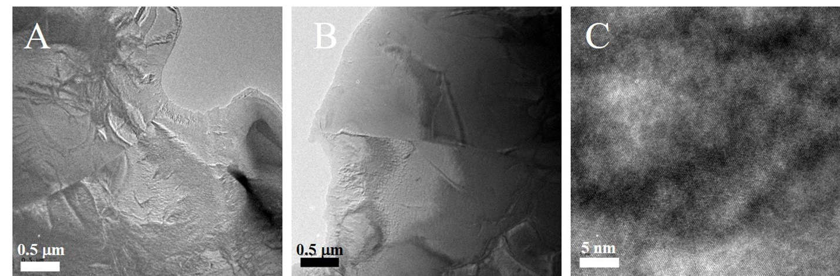

Fig. S10 TEM images of the BST sample. (A, B) Low-magnification in different regions, (C) high-magnification.

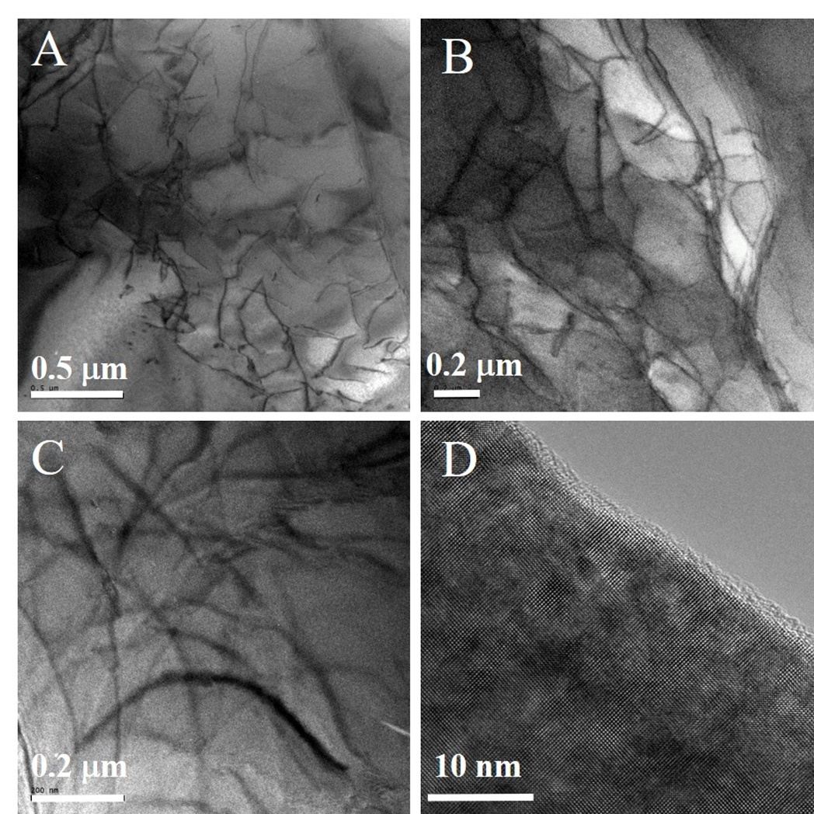

Fig. S11 TEM images of the BST-1 sample. (A, B, C) Low-magnification in different regions, (D) high-magnification.

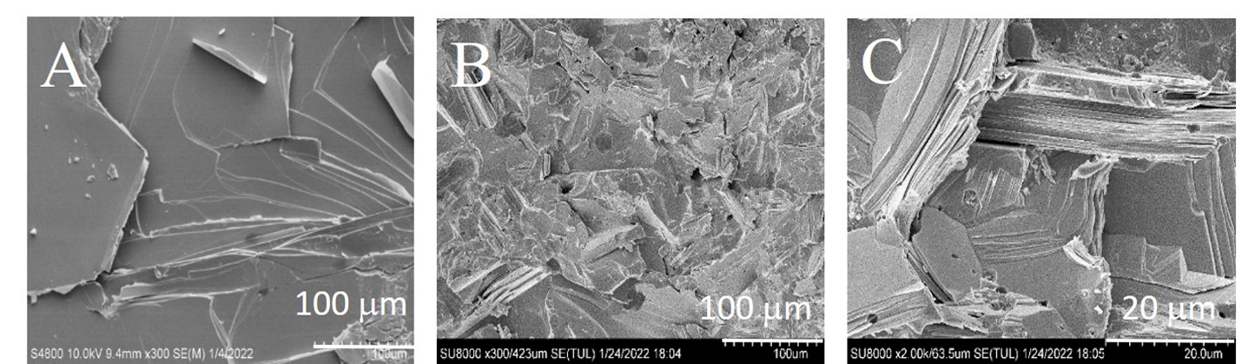

Fig. S12 The typical fractured surface SEM images of the BST and BST-1 samples. (A) BST (lower magnification), (B) BST-1 (lower magnification), (C) BST-1 (higher magnification).

Fig. S13 Schematic illustration of pore distribution supposing the pores are spherical and uniformly distributed. Here shows four squares, each one has a volume of 1/N cm⁻³.

Table S1. The density and viscosity of (Bi,Sb)₂Te₃ melts⁵⁷.
 | Density (g/cm³) | Viscosity (Pa S)
Bi | 10.03 | 0.0018
Sb | 6.49 | 0.0012
Te | 5.94 | 0.0020
Bi_{0.48}Sb_{1.52}Te_{3.03} | 6.54 | 0.0017(calculated)

Table S2. The ICP-OES results, the corresponding carrier concentration and mobility of all the samples before and after SGF-RM.
samples | ICP-OES results | Carrier concentration (10¹⁹ cm⁻³) | Mobility (cm²/V S)
BST | Bi_{8.51}Sb_{28.92}Te_{62.57} | 1.37 | 388.98
BST-S | Bi_{9.69}Sb_{30.31}Te_{56.99} | 2.08 | 279.01
BST-1 | Bi_{10.56}Sb_{29.44}Te _{62.17} | 2.42 | 358.62
BST-10 | Bi_{8.57}Sb_{29.12}Te _{62.30} | 2.69 | 315.06

Table S3. The density, relative density, and porosities of the (Bi,Sb)₂Te₃ samples before and after SGF-RM.
samples | Measured density  (g/cm³) | Relative density (%) | Porosities  Φ=100%*(ρ₀-ρ)/ρ₀ | (2-2Φ)/(2+Φ)
BST | 6.740 | 97.97 | 2.03 | 0.970
BST-1 | 6.016 | 87.44 | 12.56 | 0.823

Table S4. Parameters for the calculation of the thermal transport properties.
Parameters | Description | Values | Ref.
θ_{D} | Acoustic mode Debye temperature | 94 K | (58)
‾ν | Cross-plane average speed of sound | 2070 m/s (c-axis) | (59)
A | Comprehensive coefficient between Umklapp and Normal process | 2.6 | (7)
‾V | Average atomic volume of Bi_{0.5}Sb_{1.5}Te₃ | 3.13×10⁻²⁹ m³ | (19)
‾M | Average atomic mass of Bi_{0.5}Sb_{1.5}Te₃ | 2.22×10⁻²⁵ kg | Calculated
Γ | Point defect scattering parameter | 0.145 | (19)
B_{D} | Magnitude of Burgers vector | 12.7 Å(12.7*10⁻¹⁰m) | (19)
N_{D} | Dislocation density of BST-1 | 7E12 | Experimental
γ | Grüneisen parameter | 2.3 | (Sb₂Te₃)(60)
υ | Poisson’s ratio | 0.24 | (19)
ν_{L} | Longitudinal sound velocity along cross-plane | 2539 | (59)
ν_{T} | Transverse sound velocity along cross-plane | 1835 | (59)
ρ₀ | Theoretical density of the matrix | 6.88 g/cm³ | (17)
ρ | Measured density of BST-1 | 6.016 g/cm³
ε | The porosity of BST-1 | 12.56%
d | Pore average size of BST-1 | 1 μm

Table S5. The thermoelectric properties of n-type counterparts.
Temperature  (K) | Electrical conductivity  (S/cm) | Seebeck coefficient  (μV/K) | Thermal conductivity  (W/m K) | zT
300 | 1000 | -196 | 1.46 | 0.79
325 | 878 | -214 | 1.43 | 0.91
350 | 790 | -220 | 1.44 | 0.93
375 | 715 | -223 | 1.5 | 0.89
400 | 663 | -219 | 1.6 | 0.79
425 | 625 | -213 | 1.71 | 0.7
450 | 608 | -206 | 1.86 | 0.62
475 | 597 | -195 | 2.02 | 0.53
500 | 600 | -185 | 2.23 | 0.46

References
1. Bell, L. E. Cooling, heating, generating power, and recovering waste heat with thermoelectric systems. Science 321, 1457–1461 (2008).
2. He, J. & Tritt, T. M. Advances in thermoelectric materials research: Looking back and moving forward. Science 357, eaak9997 (2017).
3. Pei, Y. Z., Wang, H. & Snyder, G. J. Band Engineering of Thermoelectric Materials. Adv. Mater. 24, 6125–6135 (2012).
4. Tan, G. J. et al. High Thermoelectric Performance of p-Type SnTe via a Synergistic Band Engineering and Nanostructuring Approach. J. Am. Chem. Soc. 136,7006–7017 (2014).
5. Hu, L. P. et al. Tuning Multiscale Microstructures to Enhance Thermoelectric Performance of n-Type Bismuth-Telluride-Based Solid Solutions. Adv. Energy. Mater. 5, 1500411 (2015).
6. Pan, Y. et al. Melt-Centrifuged (Bi,Sb)₂Te₃: Engineering Microstructure toward High Thermoelectric Efficiency. Adv. Mater. 30, 1802016 (2018).
7. Zhuang, H. L. et al. Thermoelectric Performance Enhancement in BiSbTe Alloy by Microstructure Modulation via Cyclic Spark Plasma Sintering with Liquid Phase. Adv. Funct. Mater. 31, 2009681 (2021).
8. Xie, W. J. et al. Unique nanostructures and enhanced thermoelectric performance of melt-spun BiSbTe alloys. Appl. Phys. Lett. 94, 102111 (2009).
9. Lu, T. B. et al. Synergistically enhanced thermoelectric and mechanical performance of Bi₂Te₃ via industrial scalable hot extrusion method for cooling and power generation applications. Mater. Today Phys. 32, 101035 (2023).
10. Goldsmid, H. J. Bismuth Telluride and Its Alloys as Materials for Thermoelectric Generation. Materials 7, 2577–2592 (2014).
11. Poudel, B. et al. High-thermoelectric performance of nanostructured bismuth antimony telluride bulk alloys. Science 320, 634–638 (2008).
12. Scheele, M. N. et al. Synthesis and Thermoelectric Characterization of Bi₂Te₃ Nanoparticles. Adv. Funct. Mater. 19, 3476–3483 (2009).
13. Shin, H. S. et al. Thermoelectric properties of 25%Bi₂Te₃-75%Sb₂Te₃ solid solution prepared by hot-pressing method. J. Phys. Chem. Solids. 58, 671–678 (1997).
14. Lan, Y. C. et al. Structure Study of Bulk Nanograined Thermoelectric Bismuth Antimony Telluride. Nano Lett. 9, 1419–1422 (2009).
15. Ma, Y. et al. Enhanced thermoelectric figure-of-merit in p-type nanostructured bismuth antimony tellurium alloys made from elemental chunks. Nano Lett. 8, 2580–2584 (2008).
16. Tang, X. F. et al. Preparation and thermoelectric transport properties of high-performance p-type Bi₂Te₃ with layered nanostructure. Appl. Phys. Lett. 90, 012102 (2007).
17. Shen, J. J. et al. Recrystallization induced in situ nanostructures in bulk bismuth antimony tellurides: a simple top down route and improved thermoelectric properties. Energy Environ. Sci. 3, 1519–1523 (2010).
18. Cao, Y. Q. et al. Syntheses and thermoelectric properties of Bi₂Te₃/Sb₂Te₃ bulk nanocomposites with laminated nanostructure. Appl. Phys. Lett. 92, 143106 (2008).
19. Kim, S. I. et al. Dense dislocation arrays embedded in grain boundaries for high-performance bulk thermoelectrics. Science 348, 109–114 (2015).
20. Jo, S. et al. Simultaneous improvement in electrical and thermal properties of interface-engineered BiSbTe nanostructured thermoelectric materials. J. Alloys Compd. 689, 899–907 (2016).
21. Deng, R. G. et al. Thermal conductivity in Bi_{0.5}Sb_{1.5}Te_{3+x} and the role of dense dislocation arrays at grain boundaries, Sci. Adv. 4, eaar5606 (2018).
22. Li, H. P. & Sekhar, J. A. Dimensional Changes during Micropyretic Synthesis. Mat. Sci. Eng. A-Struct. 160, 221–227 (1993).
23. Paradis, P. F. & Ishikawa, T. Surface tension and viscosity measurements of liquid and undercooled alumina by containerless techniques. Jpn. J. Appl. Phys. Part 1-Regular Papers Brief Communications & Review Papers 44, 5082–5085 (2005).
24. Glorieux, B. Millot, F. Rifflet, J. C. & Coutures, J. P. Density of superheated and undercooled liquid alumina by a contactless method. Int. J. Thermophys. 20, 1085–1094 (1999).
25. Khan, A. U. et al. Nano-micro-porous skutterudites with 100% enhancement in ZT for high performance thermoelectricity. Nano Energy 31, 152–159 (2017).
26. Hyun, D. B. Hwang, J. S. You, B. C. Oh, T. S. & Hwang, C. W. Thermoelectric properties of the n-type 85%Bi₂Te₃-15%Bi₂Se₃ alloys doped with SbI₃ and CuBr. J. Mater. Sci. 33, 5595–5600 (1998).
27. Hwang, C. W. Hyun, D. B. Ha, H. P. & Oh, T. S. Effects of excess Te on the thermoelectric properties of p-type 25% Bi₂Te₃-75% Sb₂Te₃ single crystal and hot-pressed sinter. J. Mater. Sci. 36, 3291–3297 (2001).
28. Deng, R. G. et al. High thermoelectric performance in Bi_{0.46}Sb_{1.54}Te₃ nanostructured with ZnTe. Energ Environ. Sci. 11, 1520–1535 (2018).
29. Li, C. C. et al. Magnetism-induced huge enhancement of the room-temperature thermoelectric and cooling performance of p-type BiSbTe alloys. Energ Environ. Sci. 13, 535–544 (2020).
30. Zhang, C. C. et al. The Effect of Porosity and Milling Induced Defects on the Thermoelectric Properties of p-Type Bi₂Te₃-Based Bulks. Adv. Eng. Mater. 18, 1777–1784 (2016).
31. Jiang, J. Chen, L. D. Bai, S. Q. Yao, Q. & Wang, Q. Thermoelectric properties of textured p-type (Bi,Sb)₂Te₃ fabricated by spark plasma sintering. Scr. Mater. 52, 347–351 (2005).
32. Snyder, G. J. et al. Weighted Mobility. Adv. Mater. 32, 2001537 (2020).
33. Zheng, Y. et al. Unraveling the Critical Role of Melt-Spinning Atmosphere in Enhancing the Thermoelectric Performance of p-Type Bi_{0.52}Sb_{1.48}Te₃ Alloys. ACS Appl. Mater. Inter. 12, 36186–36195 (2020).
34. Huang, H. et al. Anisotropic thermoelectric transport properties of Bi_{0.5}Sb_{1.5}Te_{2.96+x} zone melted ingots. J. Solid State Chem. 288, 121433 (2020).
35. Dupasquier, A. & Mills Jr, A. Positron spectroscopy of solids (IOS press, 1995).
36. Jean, J. Y. Mallon, P. E. & Schrader, D. M. Principles and applications of positron and positronium chemistry (World Scientific, 2003).
37. Ning, X. et al. Modification of source contribution in PALS by simulation using Geant4 code. Nuclear Instruments & Methods in Physics Research Section B-Beam Interactions with Materials and Atoms 397, 75–81 (2017).
38. He, H. F. et al. Interplay between Point Defects and Thermal Conductivity of Chemically Synthesized Bi₂Te₃ Nanocrystals Studied by Positron Annihilation. J. Phys. Chem. C 118, 22389–22394 (2014).
39. Hanus, R. et al. Lattice Softening Significantly Reduces Thermal Conductivity and Leads to High Thermoelectric Efficiency. Adv. Mater. 31, 1900108 (2019).
40. Chen, Z. W. et al. Vacancy-induced dislocations within grains for high-performance PbSe thermoelectrics. Nat. Commun. 8, 13828 (2017).
41. Wang, Y. et al. High Porosity in Nanostructured n-Type Bi₂Te₃ Obtaining Ultralow Lattice Thermal Conductivity. ACS Appl. Mater. Inter. 11, 31237–31244 (2019).
42. Hu, H. H. et al. Thermoelectric Cu₁₂Sb₄S₁₃-Based Synthetic Minerals with a Sublimation-Derived Porous Network. Adv. Mater. 33, 2103633 (2021).
43. Zheng, G. et al. High thermoelectric performance of p-BiSbTe compounds prepared by ultra-fast thermally induced reaction. Energ Environ. Sci. 10, 2638–2652 (2017).
44. Guo, Z. et al. Broadening the optimum thermoelectric power generation range of p-type sintered Bi_{0.4}Sb_{1.6}Te₃ by suppressing bipolar effect. Chem. Eng. J. 426, 131853 (2021).
45. Hao, F. et al. High efficiency Bi₂Te₃-based materials and devices for thermoelectric power generation between 100 and 300 ℃. Energ Environ. Sci. 9, 3120–3127 (2016).
46. Wu, G. et al. Optimized Thermoelectric Properties of Bi_{0.48}Sb_{1.52}Te₃ through AgCuTe Doping for Low-Grade Heat Harvesting. ACS Appl. Mater. Inter. 13, 57514–57520 (2021).
47. Bernert, T. et al. In situ observation of self-propagating high temperature syntheses of Ta₅Si₃, Ti₅Si₃ and TiB₂ by proton and X-ray radiography. Solid State Sci. 22, 33-42 (2013).
48. Roy, S. K. & Biswas, A. COMBUSTION SYNTHESIS OF TIB AND TIB₂ UNDER VACUUM. J. Mater. Sci. Lett. 13, 371-373 (1994).
49. Rowe & Michael, D. Crc Handbook of Thermoelectrics (CRC press, 1995).
50. Li, Z. Y. & Li, J. F. Fine-Grained and Nanostructured AgPbmSbTem+2 Alloys with High Thermoelectric Figure of Merit at Medium Temperature. Adv. Energy Mater. 4, 1300937 (2014).
51. Hong, M. et al. Rashba Effect Maximizes Thermoelectric Performance of GeTe Derivatives. Joule 4, 2030-2043 (2020).
52. Li, J. et al. Low-Symmetry Rhombohedral GeTe Thermoelectrics. Joule 2, 976-987 (2018).
53. Toberer, E. S. Zevalkink, A. & Snyder, G. J. Phonon engineering through crystal chemistry. J. Mater. Chem. 21, 15843-15852 (2011).
54. Zou, J. Kotchetkov, D. Balandin, A. A. Florescu, D. I. & Pollak, F. H. Thermal conductivity of GaN films: Effects of impurities and dislocations. J.Appl. Phys. 92, 2534-2539 (2002).
55. Cohen, M. H. & Jortner, J. Effective Medium Theory for Hall-Effect in Disordered Materials. Phys. Rev. Lett. 30, 696-698 (1973).
56. Minnich, A. & Chen, G. Modified effective medium formulation for the thermal conductivity of nanocomposites. Appl. Phys. Lett. 91, 073105 (2007).
57. Sun, Y. X. et al. High Performance BiSbTe Alloy for Superior Thermoelectric Cooling. Adv. Funct. Mater. 33, 2301423 (2023).
58. Yang, G. S. et al. Significant Enhancement of Thermoelectric Figure of Merit in BiSbTe-Based Composites by Incorporating Carbon Microfiber. Adv. Funct. Mater. 31, 2008851 (2021).
57. Battezzati, L. & Greer, A. L. The Viscosity of Liquid-Metals and Alloys. Acta Metallurgica 37, 1791-1802 (1989).
58. Bessas, D. et al. Lattice dynamics in Bi₂Te₃ and Sb₂Te₃: Te and Sb density of phonon states. Phys. Rev. B 86, 224301 (2012).
59. Yang, F. Ikeda, T. Snyder, G. J. & Dames, C. Effective thermal conductivity of polycrystalline materials with randomly oriented superlattice grains. J. Appl. Phys. 108, 0234310 (2010).
60. Chen, X. et al. Thermal expansion coefficients of Bi₂Se₃ and Sb₂Te₃ crystals from 10 K to 270 K. Appl. Phys. Lett. 99, 261912 (2011).

