Table 1: Detailed size descriptions of the investigated PFMs. The degrees of polymerization (DP) are derived from NMR-conversion measurements, as described in the Supporting Information. Average molecular weight (Mn) and the ratio of LMA to NDAcrAm units are derived from the DP directly.

Name | PFM A | PFM B | PFM C | PFM D | PFM E
d.p. LMA m | 42 | 42 | 375 | 375 | 375
d.p. NDAcrAm n | 8 | 36 | 281 | 19 | 5
Mn [kDa] | 13 | 20 | 162 | 100 | 97
Functionalization [%] | 10 | 41 | 37 | 4 | 1
Schematic  Representation | 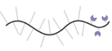 |  | 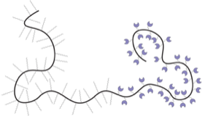 | 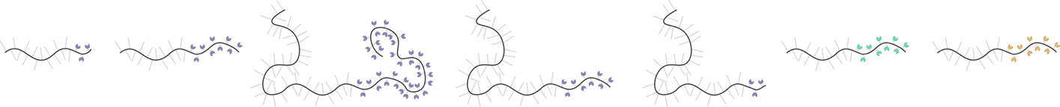 | 