Supporting Info:
Towards a Polymer-Brush-Based Friction Modifier for Oil
Authors: Tobias A. Gmür¹, Joydeb Mandal^{1,2}, Juliette Cayer-Barrioz³ and Nicholas D. Spencer¹*
¹ Laboratory for Surface Science and Technology, Department of Materials, ETH Zürich, Vladimir-Prelog-Weg 5, 8093 Zürich , Switzerland
²School of Chemistry, IISER Thiruvananthapuram, Maruthamala PO, Vithura, Thiruvananthapuram – 695551, Kerala, India
³ Laboratoire de Tribologie et Dynamique des Systèmes, CNRS UMR 5513, Ecole Centrale de Lyon, 36 avenue Guy de Collongue, 69134 Ecully Cedex, France
Table of Contents
1. Graft Copolymers 2
1.1 Synthesis 2
1.1.1 Poly(Pentafluorophenyl Acrylate) 3
1.1.2 Lubricious Chain 4
1.1.3 Polymer Modification 5
1.2 Evaluation 6
1.3 Conclusion 7
2. Block-Copolymer Synthesis 8
2.1 Materials and Methods 9
2.2 Small molecules 10
2.2.1 Pentafluorophenolacrylate 10
2.2.2 Nitrodopamine 11
2.3 Step 1: Macro-CTA 12
2.4 Step 2: Functional Block-Copolymer 14
2.5 Step 3: Post Polymerization Functionalization 16
3. QCM 18
4. Ellipsometry 21
5. IRIS results with contact visualization 23
6. Bibliography 26

Graft Copolymers

1.1 Synthesis
Figure S1: Schematic summary of the graft-copolymer synthesis. (1) Functional back- bone polymerization (2) Modification with lubricious units (3) Modification with anchoring units

1.1.1 Poly(Pentafluorophenyl Acrylate)
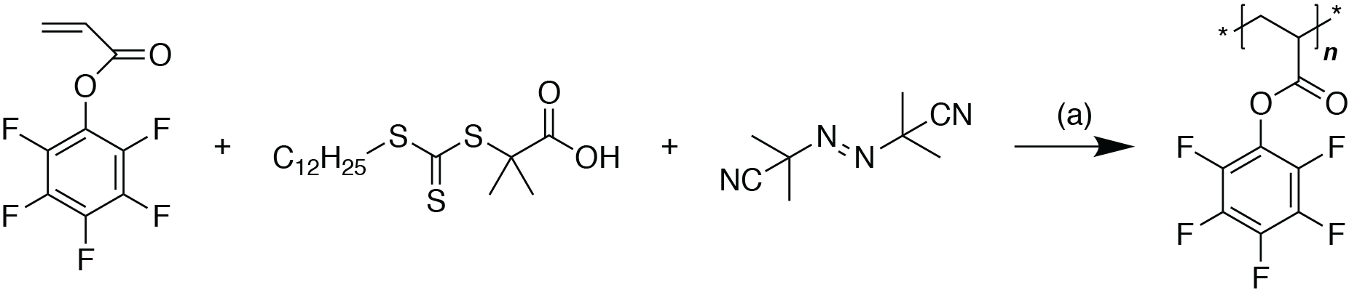
Figure S2: RAFT scheme for the poly(pentafluorophenyl acrylate) synthesis. (a) Toluene, 80 °C

The precursor polymer poly(pentafluorophenyl acrylate) (pPFPA) was synthesized according to a previously described RAFT polymerization recipe [1]. The monomer pentafluorophenyl acrylate was supplied by SuSoS AG (Dübendorf, Switzerland) and freshly distilled. 77 g of the monomer was added to a 250 ml two-neck round-bottom flask, together with 774mg chain transfer agent (2-(Dodecyl thiocarbonothioyl thio)propionic acid, Aldrich), and 129mg initiator AIBN (azobisisobutyronitrile, Aldrich, re- crystallized from EtOH) and 77 ml toluene. The solution was degassed by three freeze-pump-thaw cycles and the polymerization started at 80°C. The reaction was run overnight, after which the purification was acheived by precipitation in MeOH three times. After drying at high vacuum a slightly yellow powder was obtained. Yield: 64 g (82 %)

1.1.2 Lubricious Chain
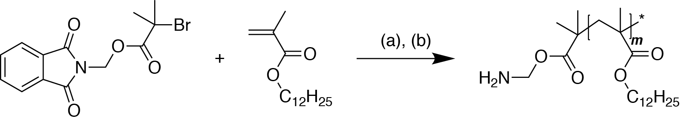
Figure S3: Dodecyl methacrylate ATR polymerization (a) dNbpy/Cu(I)Br, anisole, 110 °C (b) THF/N2H2, 80 °C, hydrolysis with HCl

To synthesize a polymeric chain with controlled size and end group amine function- ality, an ATRP approach with 1-(phthalimidomethyl) 2-bromoisobutyrate (Sigma- Aldrich) as a a protected amine initiator was chosen. 4,4‘-Dinonyl-2,2‘-dipyridyl (dNbpy, Sigma-Aldrich) served as ligand to the copper(I) bromide, which was purified beforehand by stirring with glacial acetic acid. The monomer dodecyl methacrylate (Acros) was freed from inhibitor by filtering through a short neutral alumina column.
4g of monomer were added to a 100ml Schlenk tube together with 131 mg ligand, 206 mg initiator, and 5 ml anisole. The solution was degassed by five repeat freeze-pump-thaw cycles and backfilled with argon. In another Schlenk tube 30 mg copper(I) bromide was added, the vessel evacuated and backfilled with argon five times as well. The solution was transferred via syringe and the polymerization started in an oil bath at 110°C. After an overnight reaction the polymer was cleaned twice by precipitation in MeOH. To deprotect the amine, the product from the previous step was dissolved in 100ml THF. Nitrogen was bubbled for 30min, 300μl hydrazine hydrate (Acros) added and the mixture stirred at 80°C overnight. The solvent was evaporated, 100 ml chloroform with 250 μl HCl (conc) added, and the whole mixture was stirred for 15 min. The solution was filtered, reduced and precipitated in MeOH twice. Yield: 2.55 g

1.1.3 Polymer Modification
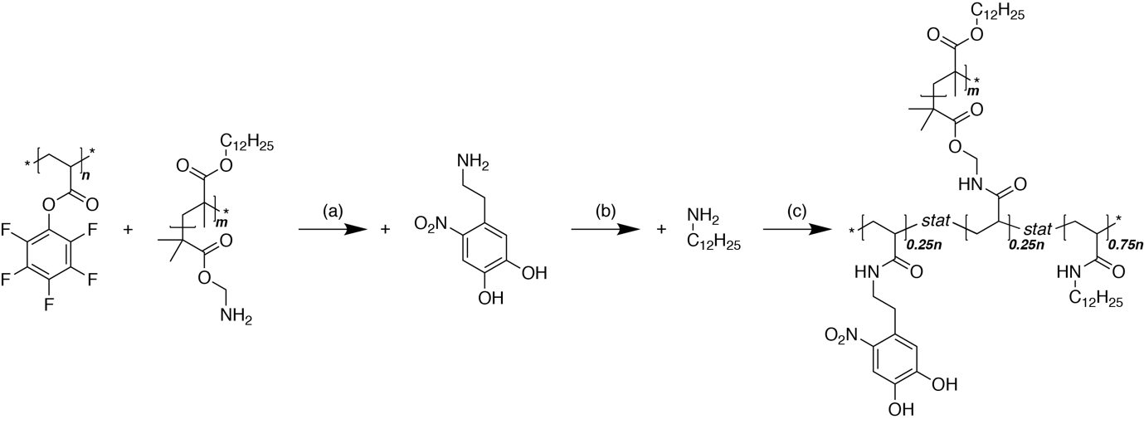
Figure S4: pPFPA modification with p12MA. (a) THF 50°C (b) THF/DMF,50°C (c) THF/DMF, 50 °C
250mg pPFPA was added in a two-neck round-bottom flask equipped with a reflux condenser together with 1.57g p12MA-NH2. Assuming a molecular weight of 6 kDa this corresponds to 0.25 equivalents of NH2 to PFPA moieties. The flask was evacuated and purged with nitrogen, and the two polymers dissolved in 15 ml THF at 50 °C. 0.45 ml TEA was added and the reaction left stirring over two nights. 77mg nitrodopamine was dried in a Schlenk flask at high vacuum for 30min and subsequently transferred under nitrogen with 10ml dry DMF via syringe. The reaction continued over another night, after which an excess of dodecylamine (Acros) was added with dry DMF under nitrogen. After another night the temperature was reduced, the solvents evaporated, the product precipitated in MeOH twice and dried in high vacuum.
¹H-NMR end-group analysis on the protected p12MA-N-Phth (CDCl3, 300 MHz) show a polymerization degree of 21 repeat units, judging by the relative ratios of the peak areas at δ = 7.86 ppm and δ = 7.86 ppm characteristic for the aromatic system of the phthalimido-group and the peak at δ = 3.85ppm corresponding to the C-CH₂-O function of the methacrylate. Deprotection was shown to be quantitative.(¹H-NMR, CDCl3, 300 MHz)
Aliquot ¹⁹F-NMR measurements (acetone D6, 300 MHz) during the polymer coupling step of modification showed a conversion of only 15 % after 18 hours, which is why the reaction was continued for another night. After the additional time, however, the conversion was with 63 % significantly above the expected 25 %. After the nitrodopamine modification the conversion was at 96 % (instead of 50 %), and complete after the addition of the backfiller.

1.2 Evaluation

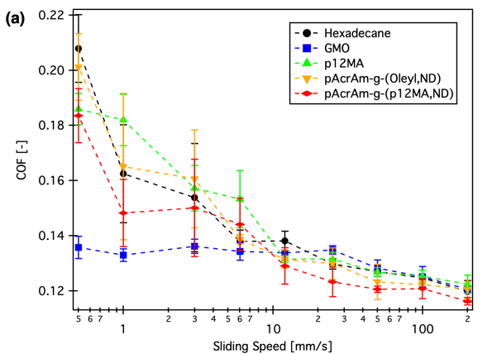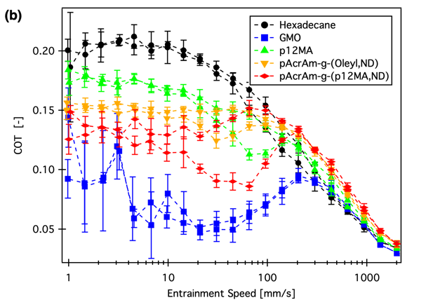
Figure S5: Tribological assessment of the lubricious group variation. (a) Pin-on-Disk (b) MTM
Pin-on-Disk measurements were performed on a Bruker UMT2 instrument at room temperature, with 0.5 wt % solutions of the PFMs in hexadecane. The disks (100Cr6) were freshly polished to a roughness of <20nm. The ball (6mm diameter, 100Cr6) and the disk were sonicated in toluene and isopropanol before use, the setup assembled and shimmed. A running-in procedure was performed at 5 N in hexadecane which resulted in a flat-on-flat contact. The normal load was reduced after the running-in step to 1 N resulting in an effective mean pressure of 20 MPa. On a new track on the disk three repeat Stribeck-type measure- ments were conducted with the lubricant solutions. Decreasing speed ramps from 500 mm/s to 0.5 mm/s were done, while for every step at least 3 full revolutions were performed and only the last half of measured friction coefficient were considered to avoid transient effects. The results of three repeat measurements are presented in Figure S5 (a).
The measurements presented in (b) have been performed on a MTM2 (PCS instruments) with standard specimens (100Cr6, 19.05 mm sphere), 2 N normal load, 50 % slide-to-roll ratio at 30 °C. Five repeat increasing/decreasing speed ramps from 1 mm/s to 2000 mm/s were performed and the averages and standard deviations are presented.

1.3 Conclusion
The conclusion for both measurements is similar: The PFMs seem to work to some extent, but even in the best-case scenario are about half as effective as the reference GMO.

Block-Copolymer Synthesis
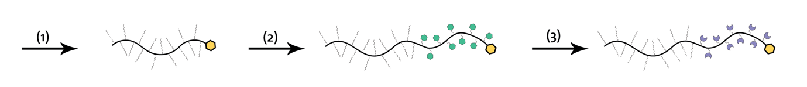
Figure S6: Schematic synthesis procedure for the investigated polymers. (1) oleophilic macro- CTA creation. (2) Addition of the functional block. (3) post-modification with anchoring units.

The synthetic pathway is summarized schematically in Figure S6. The first RAFT polymerization of an oleophilic monomer yields a polymer with an active chain end. This is used in a second polymerization as a macro CTA. A block of functional units is added to the polymer, which can be modified in a final step with a multitude of different anchoring moieties. The main advantage of this rather lengthy synthesis is that the influences of different architectural parameters – molecular weight, degree of functionalization, anchoring-block chemistry – on the polymeric friction modifiers’ performance can be assessed truly independently.
The motivation for the synthesized structures was to start off at what is reported to work: block-copolymers with an overall molecular weight of 25kDa [2] and a functionalization percentage of 10mol% [3]. This was achieved with structure A. The other structures were designed to investigate the effects of the different size parameters and anchoring chemistry independently. While B contained a larger anchoring block, D and E were supposed to take structure A to a higher molecular weight with constant relative and absolute anchoring block sizes. Polymer C is a larger version of B and was synthesized in light of the promising first results of the latter.

2.1 Materials and Methods
Common solvents and reagents were purchased from commercial suppliers (VWR, Acros, Sigma-Aldrich, Fluka, Fluorochem) at ≥95% quality and used as received. THF and DMF were dried in-house to (<5 ppm H2O). 2,6-Di-tertbutyl-4-methyl phenol (ABCR) was used as received as an inhibitor during monomer synthesis. Lauryl methacrylate (≥96%, Acros Organics) was filtered through a basic alumina column to remove inhibitor before use. Azobisisobutyronitrile (AIBN) (≥98 %, Aldrich) was recrystallized from EtOH before use. Triethylamine (TEA), (Sigma-Aldrich) was distilled from KOH before use
Nuclear magnetic resonance (NMR) measurements were performed either on a 300 MHz (7.0 T) or a 200 MHz (4.7 T) Bruker Avance IIIHD. The standard settings were used, expect for ¹⁹F measurements, where the number of scans was increased from 16 to 128.

2.2 Small molecules

2.2.1 Pentafluorophenolacrylate

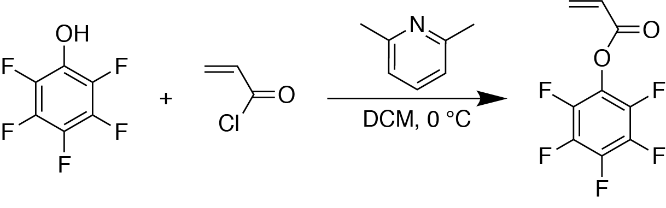
Figure S7: Scheme of the pentafluorophenyl acrylate synthesis

The monomer pentafluorophenyl acrylate was synthesized as described earlier [4] 15.51 g pentafluorophenol was added to a 250 ml round-bottom flask equipped with a dropping funnel. The assembly was purged with N₂ for 30 min, sealed with a rubber septum, and an Ar balloon was added. 60 ml dry DCM and 9.5ml 2,6-lutidine were added with a syringe, and the solution cooled to 0°C in an ice bath. 6.6 ml acryloyl chloride was added dropwise under stirring. The mixture was left to reach room temperature under stirring overnight. The product mixture was then filtered, washed with ultrapure water three times, dried with MgSO₄, one grain of the inhibitor added, and the DCM evaporated at 500 mbar and 40°C. The product was further purified by distillation at 9 mbar and 61 °C to give a colourless liquid (17.08 g, 88 %). Another grain of inhibitor was added and the product was stored until further use at 4 °C. Yield: 17.08 g
¹H-NMR (CDCl3,300 MHz): δ = 6.63 ppm (d, J = 18.2 Hz,1H), δ = 6.28 ppm (dd, J = 17.2, 10.5 Hz 1H),δ = 6.06 ppm (d, J = 10.5 Hz, 1H). ¹⁹F-NMR: δ = −152.8 ppm (2F), δ = −158.3 ppm (1F), δ = −162.6 ppm (2F).

2.2.2 Nitrodopamine

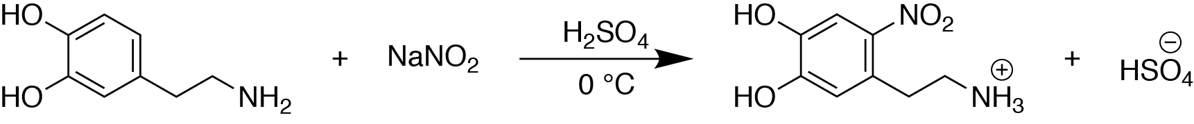
Figure S8: Scheme for the nitrodopamine synthesis
Nitrodopamine was synthesized as reported earlier [5]. Briefly 5 g of dopamine and 6.3 g of NaNO₂ were dissolved in 150 ml water and cooled to 0 °C under stirring in an ice bath. 25 ml sulfuric acid (20 vol %) was added dropwise and the reaction mixture was left stirring, warming up to room temperature overnight. The product mixture was cooled to 0°C again, filtered off, and washed with copious amounts of ultrapure water. The resulting nitrodopamine hydrogen sulfate was dried under high vacuum overnight to yield 4.46 g (57 %).
¹H-NMR (D2O, 300 MHz): δ = 7.61 ppm(s, 1H), δ = 6.81 ppm(s, 1H), δ = 3.23ppm(t, J = 7.2Hz, 2H), δ = 3.11ppm(t, J = 7.7Hz, 2H)

2.3 Step 1: Macro-CTA

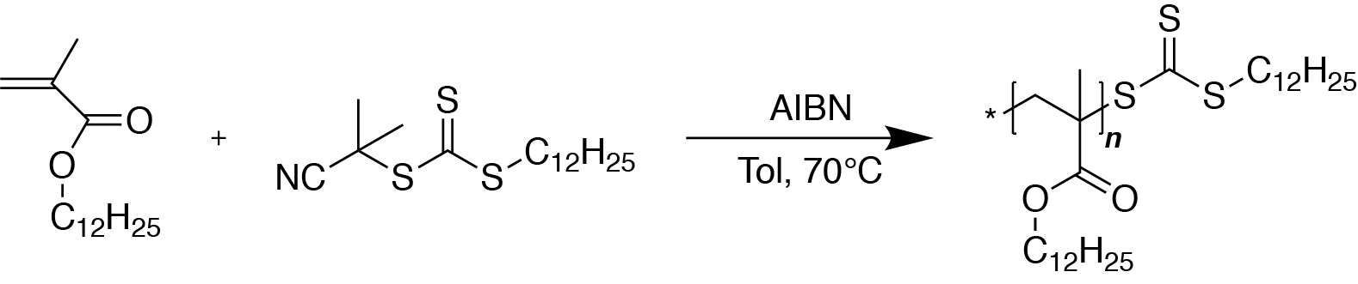
Figure S9: Scheme of the first polymerization step
Two versions of the oleophilic block were synthesized; the numbers in parentheses refer to the one with the smaller degree of polymerization (d.p.). The CTA/initiator ratio was kept constant at 20 / 1. To a 100 ml Schlenk flask containing a magnetic stirrer was added 31.6 g (30 g) dodecyl methacrylate, 866 mg (82.0mg) CTA 2-cyano-2-propyl dodecyl trithiocarbonate, 2 mg (20 mg) AIBN, and 31 ml (35 ml) toluene. The flask was closed with a rubber septum and subsequently degassed with five freeze-pump-thaw cycles (liquid nitrogen and pressure <1 × 10⁻² mbar), backfilled with nitrogen, and the polymerization started by immersing the flask into an oil bath at 70 °C.
The conversion of the polymerization reaction was measured by taking aliquots (0.1 ml of solution with 0.4 ml CDCl₃) for NMR analysis. After 21 (12) hours the conversion was at 74 % (80 %) and did not progress any further. Assuming linear and homogeneous growth from all initiating species, this corresponds to a degree of polymerization of 375 (42) repeat units. The product was purified by precipitation in MeOH, redissolution in hexane and reprecipitation in EtOH.
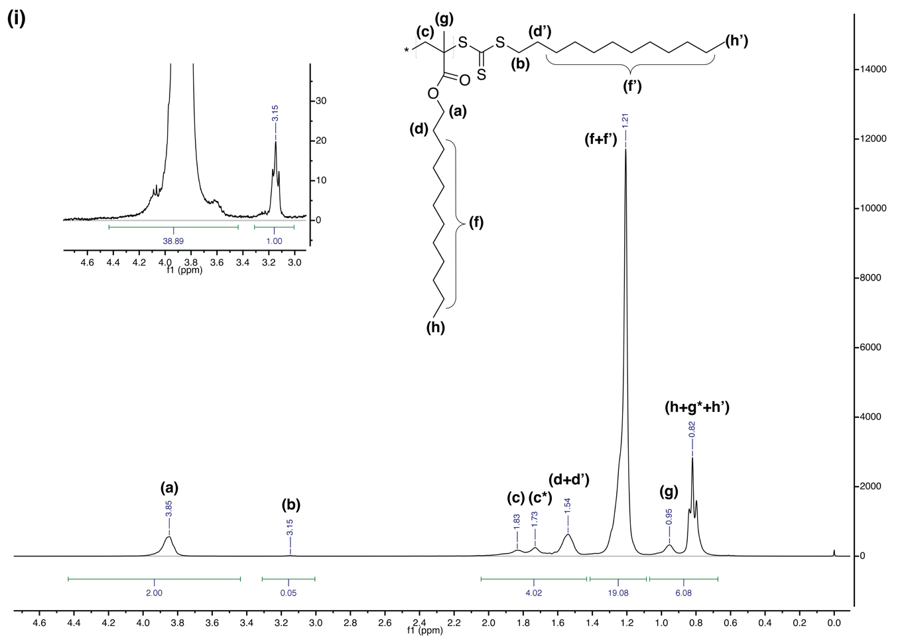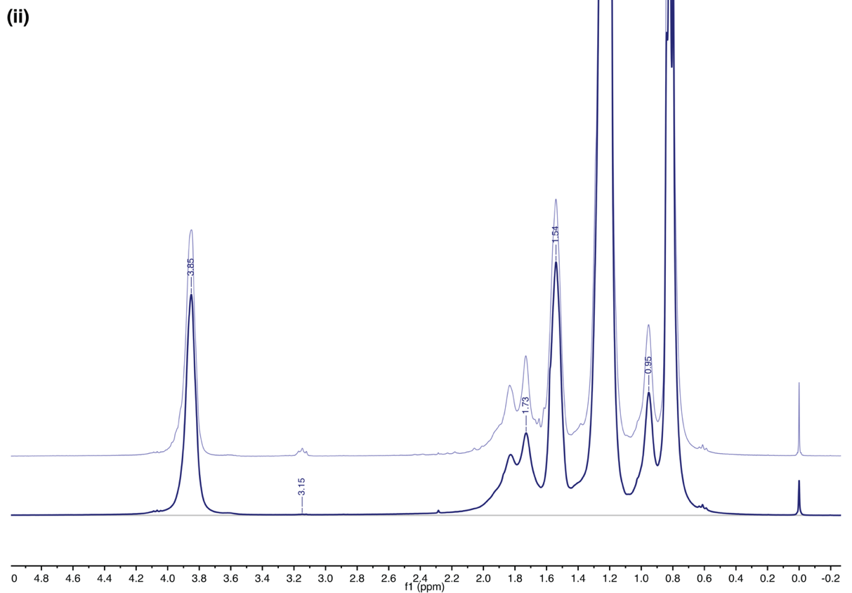
Figure S10: (i) 1H-NMR spectrum (CDCl3, 300 MHz) of p12MAshort with peak assign- ments. The assignments (c) and (c*) are motivated by the tacticity of the polymer[1] (ii) superpositon of the raw specta of the two p12MA homopolymers. Top: p12MA_{short} Bottom: p12MA_{long}

2.4 Step 2: Functional Block-Copolymer
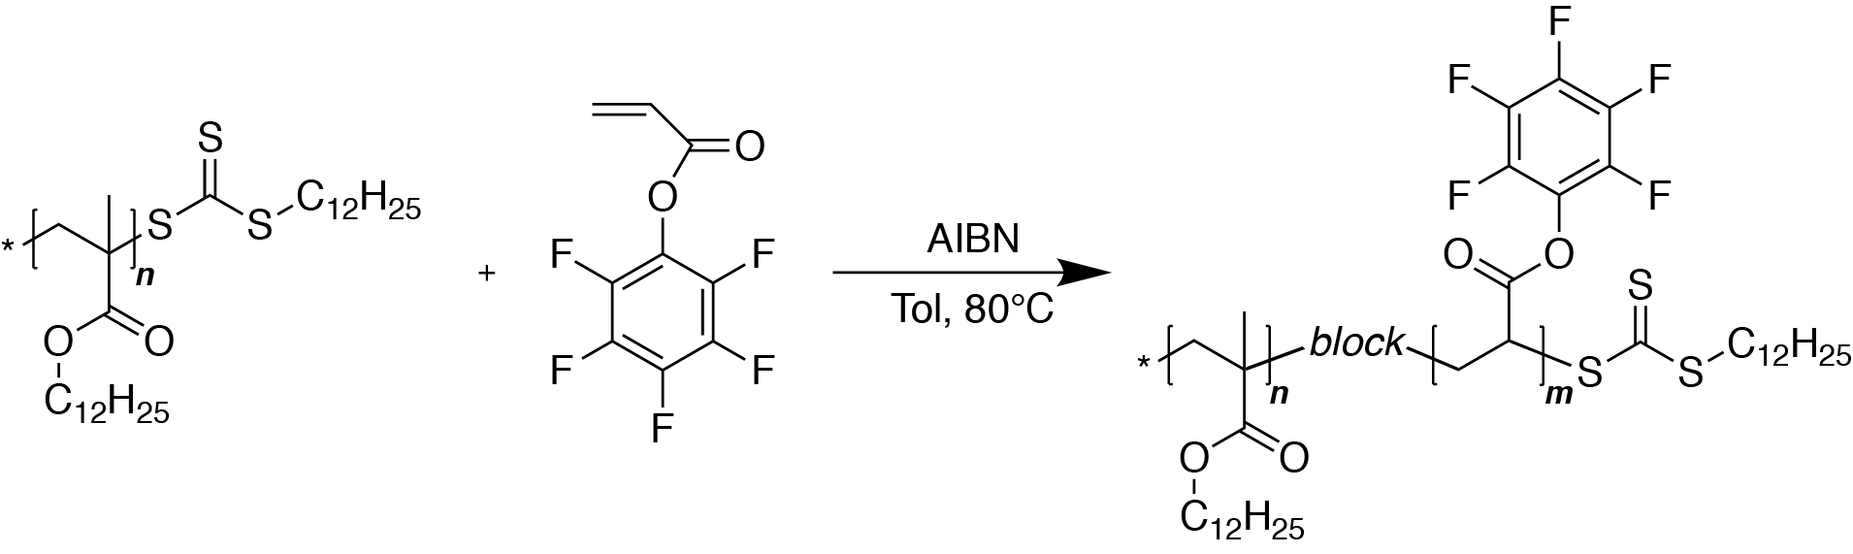
Figure S11: Scheme of the second polymerization step
For the second synthesis step, the macro-CTA (mCTA) of the first step was reacted with the functional monomer pentafluorophenyl acrylate (PFPA).
Five versions of the block copolymer were synthesized using the two versions of the macro-CTA from step 1, PFPA (filtered through neutral alumina) and AIBN as an initiator with toluene as a solvent. The respective weights and results are shown in Table S1. The ratio of mCTA to AIBN was kept constant at 4/1.
All components were loaded into a 100 ml Schlenk flask that was sealed with a rubber septum. The flask was degassed by five repeated freeze-pump-thaw cycles and backfilled with nitrogen, and the polymerization started by immersing the flask into an oil bath at 80 °C.
The crude product was worked up by precipitation in MeOH, dissolution in hexane, and reprecipitation in EtOH. The polymers were then dried overnight under high vacuum, and analyzed with ¹H- and ¹⁹F-NMR.
To assess the conversion, aliquots for NMR characterization were taken during the reaction. In the ¹H spectra, the vinylic range can be compared to the solvent intensity to assess conversion, while the ¹⁹F spectra exhibits a clearly distinguishable para-F signal. Both quantifications resulted in similar measured conversions.

Table S1:
Name | d.p. of oleophilic block (nmr) | Amount Macro-CTA [g] | Amount monomer [g] | Amount AIBN [mg] | Amount toluene [ml] | Conversion [%] | Yield [g] | d.p. of functional block (nmr)
A | 42 | 5.03 | 1.1 | 18.6 | 20 | 82 | 5.28 | 8
B | 42 | 5.02 | 4.32 | 18.6 | 20 | 90 | 7.22 | 36
C | 375 | 5.1 | 4.48 | 2.14 | 20 | 75 | 7.43 | 281
D | 375 | 5.06 | 0.509 | 2.14 | 20 | 45 | 4.72 | 19
E | 375 | 5.05 | 0.126 | 2.14 | 20 | 46 | 4.6 | 5

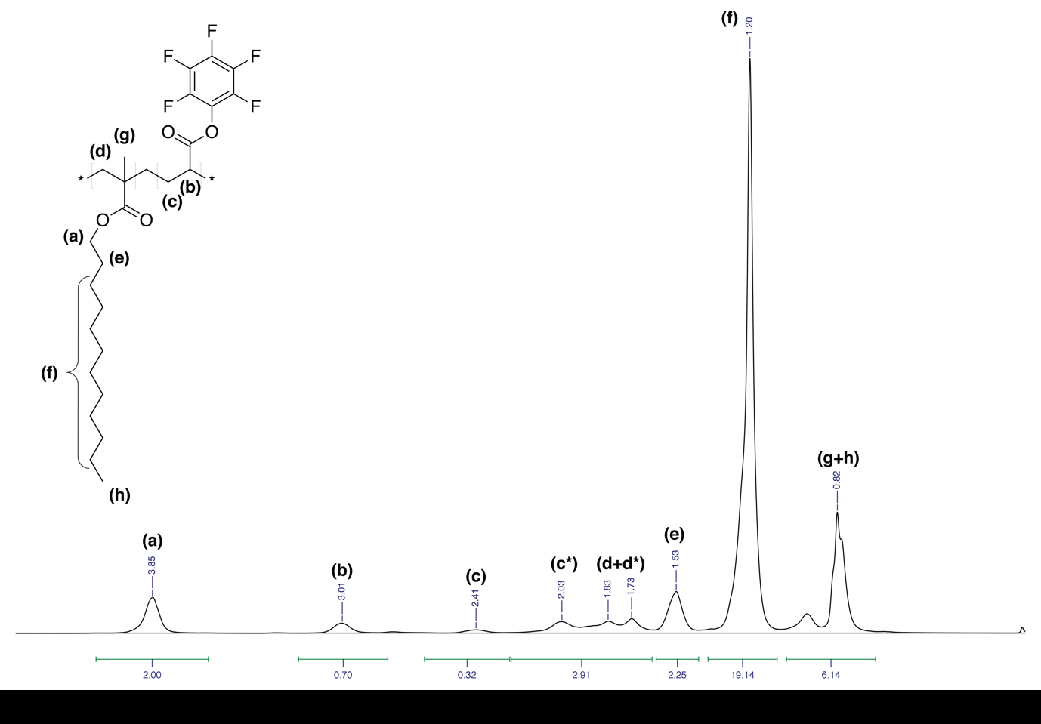
Figure S12: ¹H-NMR spectrum (CDCl3, 200 MHz) of polymer B with peak assign- ments. The large effect of tacticity visible in (c) and (c*) has been noted earlier [1]

2.5 Step 3: Post-Polymerization Functionalization
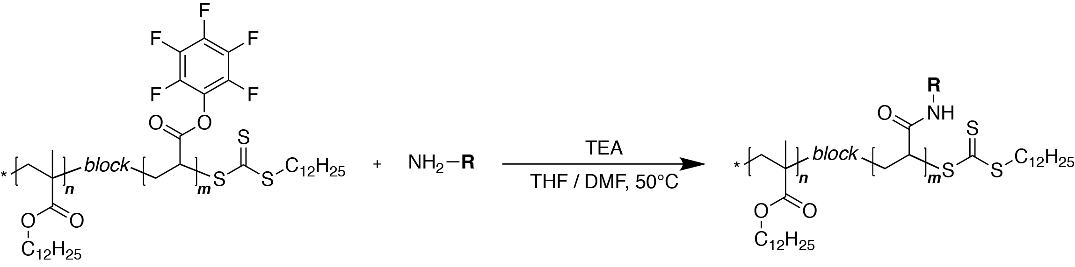
Figure S13: Scheme of the post-polymerization modification step.
The polymer post-modification was performed for each different polymer from step 2. To each 1 g, added to a two-neck round bottom flask equipped with a Vigreux column, the flask being sealed with a rubber septum and dried under high vacuum for 1 hour, was added 10 ml dry THF under nitrogen, followed by dissolution under stirring. A 1.1 equivalent amount of nitrodopamine (compared to the molarity of PFPA moieties) was added to a Schlenk flask, dried under high vacuum for 1 hour and 10 ml dry DMF were added. Once the nitrodopamine was dissolved, the solutions were transferred to the 2-neck flask, 3 equivalents of TEA were added, and the reaction temperature set to 50 °C overnight. The conversion was measured by taking aliquots and measuring the ¹⁹F-NMR in toluene-d8. In all instances the conversion was measured to be quantitative.
The resulting crude product was roughly dried, dissolved in DCM, precipitated in MeOH at 0°C, the mixture dissolved in 25 ml of DCM and 4 ml acetic acid, stirred for 3 hours, and precipitated in MeOH at 0°C, again. The polymer was dried under high vacuum overnight. Yields for polymers A/B/C/D/E: 88 % / 78 % / 76 % / 87 % / 78 %
The final polymers were analyzed by ¹H-NMR. As shown in Figure S15 for polymer B, the expected peaks stemming from the p(NDAcrAm) block could not be detected. This was reported earlier [1] and might be ascribed to the highly amphiphilic nature of the polymer, which leads to self-assembly, which in turn influences not only the Larmor frequency of the protons, but also their overall response. Post-synthesis ¹⁹F-NMR measurements showed no remaining trace amounts of pentafluorophenol.
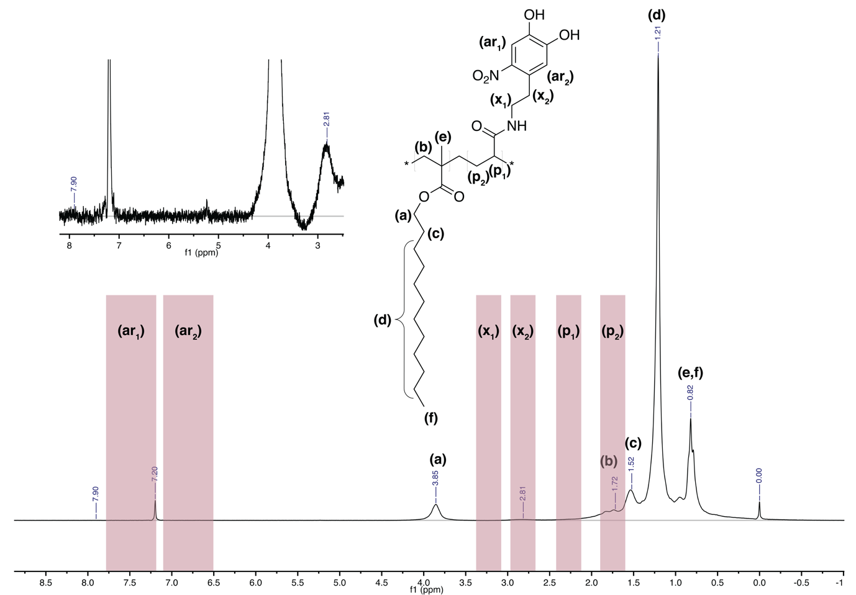
Figure S14: ¹H-NMR spectrum (CDCl3, 200 MHz) of polymer B with peak assignments for the LMA block and approximate predicted ranges for the p(NDAcrAm) block

QCM
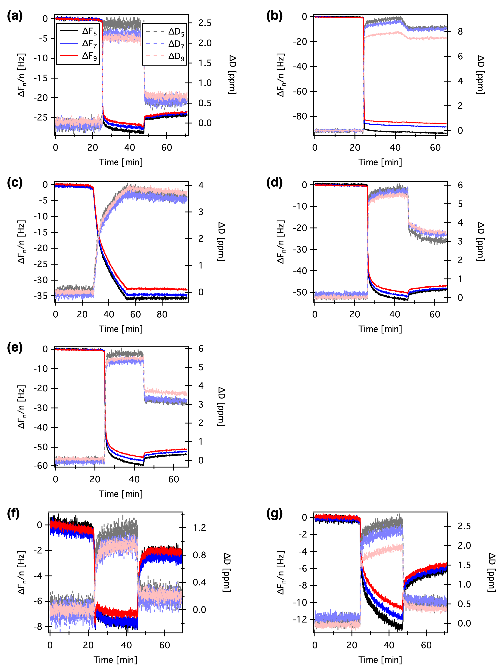
Figure S15: QCM-D raw results. (a) to (e) are polymers A, B, C, D, and E respectively. (f) and (g) GMO and p12MA_{short} are reference experiments.
Sample graphs for all QCM-D measurements on polymer solutions are depicted in Figure S15. The measurements are separated into three phases: The first approximately 25 min consist of a constant flow of hexadecane, to obtain a baseline, after which the lubricant solutions are added and reach the sensor cells. After an additional roughly 20min, the cells are purged with pure hexadecane for an additional 20min. Only the central three frequencies are shown and analyzed later on, since the higher and lower order overtones displayed a poor signal-to-noise ratio.
In Figure (f) – depicting the reference friction modifier GMO – a constant instrumental drift for the ∆Fn/n signal is clearly visible. This is observed in all measurements (with slightly different magnitudes and prefixes), but is best visible here because of the lower scale of the y-axis. Keeping this in mind one sees that the frequency shift signal, and the signal of the dissipation signal do return to pre-adsorption values after rinsing, which indicates a dynamic equilibrium and complete film detachment upon rinsing.
All polymer-containing lubricant formulations on the other hand show a residual change in ∆Fn/n, which means that the film is bound strongly enough to be irreversibly adsorbed. The dissipation data allowes a qualitative “rigidity” of the film to be deduced: upon rinsing, the dissipation shift decreases for some polymers, while it does so only minimally for others. The rationalization here is that rinsing removes some loosely bound or entangled polymers from the surface and the remaining polymers collapse to some extent, while for B and C this is not the case. The differences in measured bulk viscosity was accounted for with the Kanazawa-Gordon equation [6] and was found to be negligible.

Reviakine et al.[7] give a quantitative estimation for the applicability of Sauerbrey’s equation of ∆Dn/(∆Fn/n) < 4 × 10−7 Hz−1. This criterion was met for all measurements presented. Due to the variety of results for different lubricants, a robust automated fitting procedure was developed in matlab, as explained in Figure S16. In (a) the baseline determination is shown, where the first 15 min are fitted linearly, to accommodate the measurements’ inherent drift. The start of the adsorption part of the measurement is determined as the first point that deviates by five times the root mean square error of the linear baseline. From there on, the next 10 min are fitted with an exponential function of the form f(x) = Minf*(1-exp(t/tau)). The shown data is Minf
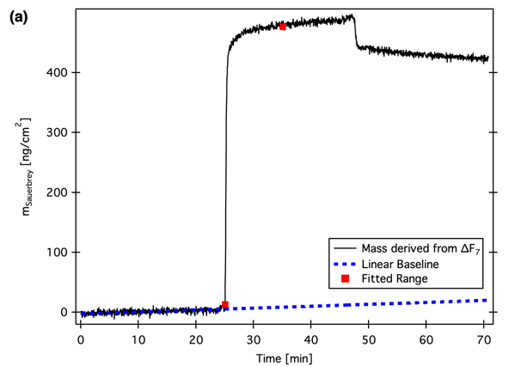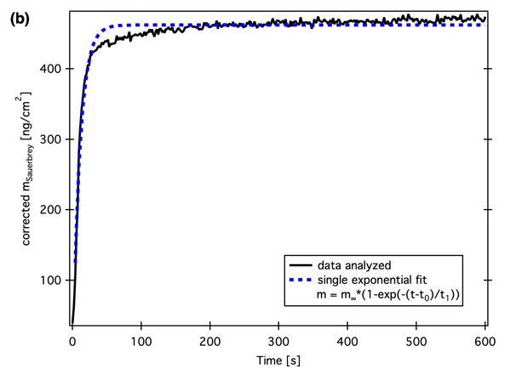
Figure S16: QCM fitting procedure. (a) Linear background subtraction and definition of the analysis range. (b) Exponential fit of the analysis data.

Ellipsometry
Ellipsometry was carried out using a M-2000 variable-angle spectroscopic ellipsometer (J. A. Woolam Co., USA) in a spectral range from 245nm to 1000 nm, and incident angles of 60°, 65° 70°, and 75°.
The measured samples were chromium-coated silicon wafers, chosen to mimic the composition of a Cr-containing steel surface. They were prepared by first cleaning by sonication in water, isopropanol, and toluene, blowing dry with N₂ and subsequentially treating with UV/Ozone (UV-cleaner, model 135500, Boekel Industries). In a second step, roughly 16 nm of chromium(>99.99 %, Unaxis, Liechtenstein) was evaporated onto the silicon wafer surface (MED 020 coating system, BALTEC, Liechtenstein.). The PFMs were adsorbed by covering the wafer surface with a 0.5 wt.% hexadecane solution of the additive for 10 minutes, the samples being subsequently rinsed with hexane and blown dry with N₂.
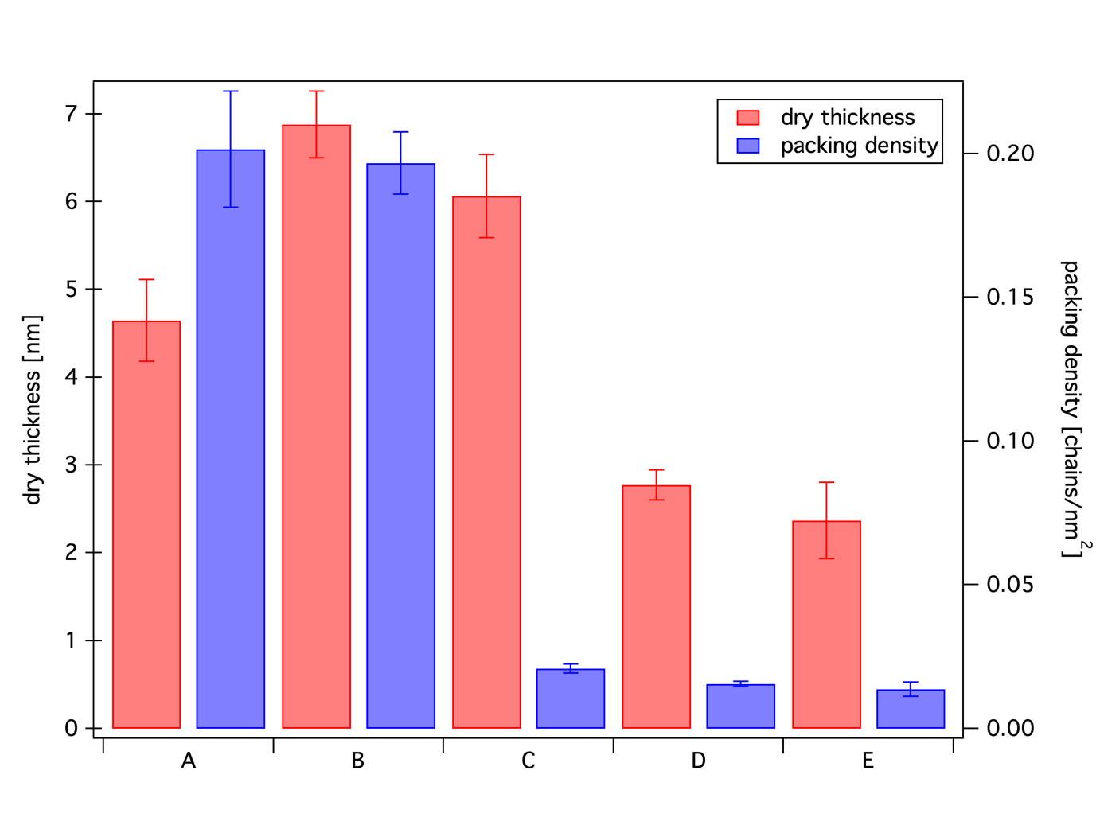
Figure S17: Ex-situ ellipsometry results for additives A-E, adsorbed from hexadecane solution on Cr-covered Si wafers. The packing density was derived from the dry thickness by assuming a density of 0.93 g/cm³ and the molecular weights given in Table 1.
If one assumes that the pLMA chains are sufficiently rigid that they occupy a cylinder with radius corresponding to one LMA chain (≈1.2 nm), and that the cylinders pack vertically on the surface in a hexagonal configuration, using the equation

$$L= √(\frac{2}{σ × \sqrt{3}})$$

Where L is the chain spacing and $σ$ is the packing density, we obtain a value for $σ$ of ≈0.2 chains.nm⁻², which corresponds to the value obtained from ellipsometry for PFM B. This would be consistent with the view that the pLMA chains are in a brush configuration. The difference between the thicknesses of PFM B measured dry (ellipsometry) and solvated (QCM) is roughly a factor of two, giving us an approximate swelling ratio of 2.

IRIS results with contact visualization
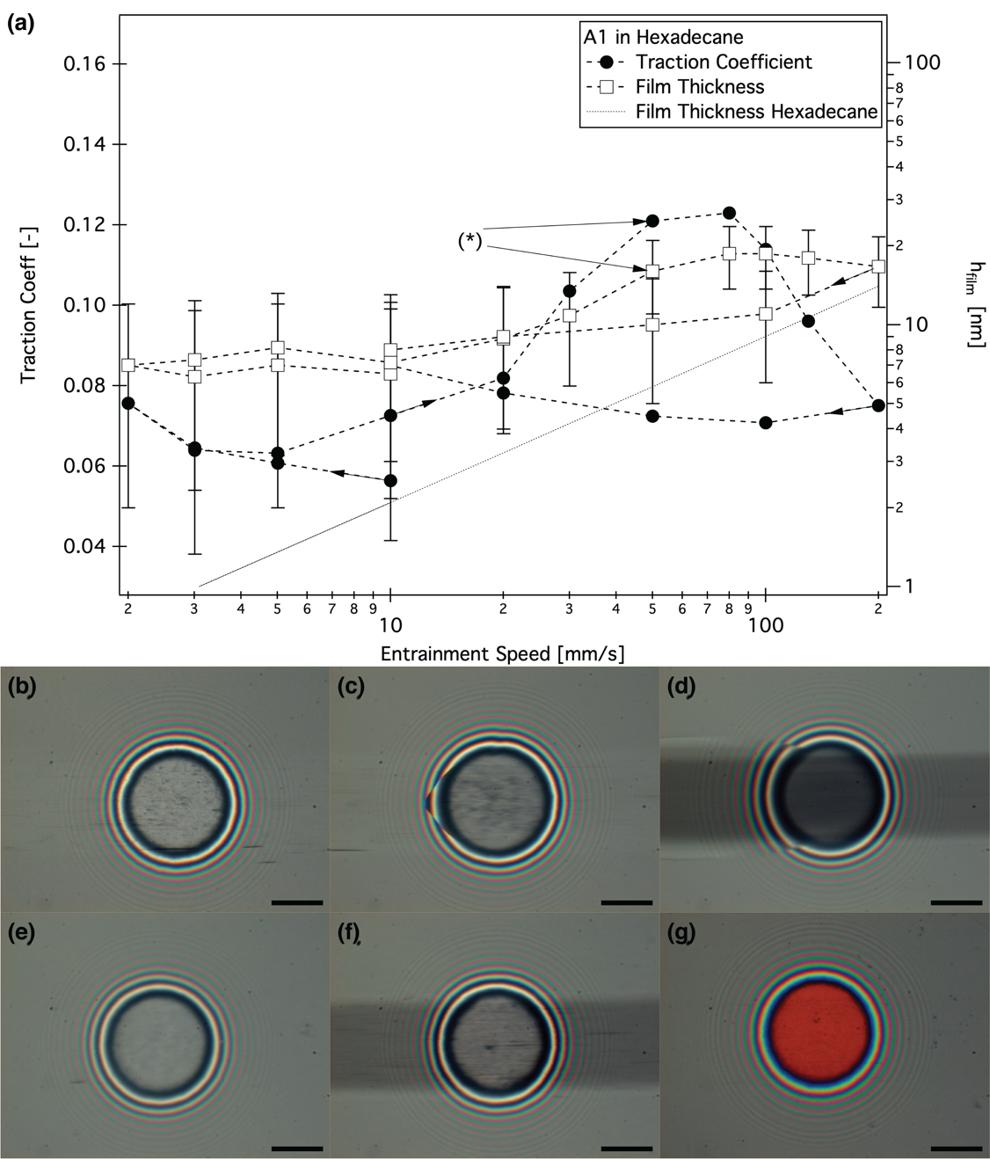
Figure S18: (a) Traction coefficient and film thickness for polymer A in hexadecane. (*) corresponds to the beginning of visible wear in contact visualization images. (b-g) Contact visualization during the measurement. The lubricant flow is from right to left, and the scale bars correspond to 100 μm. (b,c,d) sliding at 50 % SRR with entrainment speeds of 2 mm/s, 20 mm/s, and 200 mm/s respectively. (e,f) pure rolling step with 10 mm/s entrainment speed as the measurements’ initial and final steps. (g) static image of the ball loaded against a disk coated with a silica spacer layer for higher precision in the nm-thickness range. The derived adsorbed film thickness is between 5 nm and 8 nm.

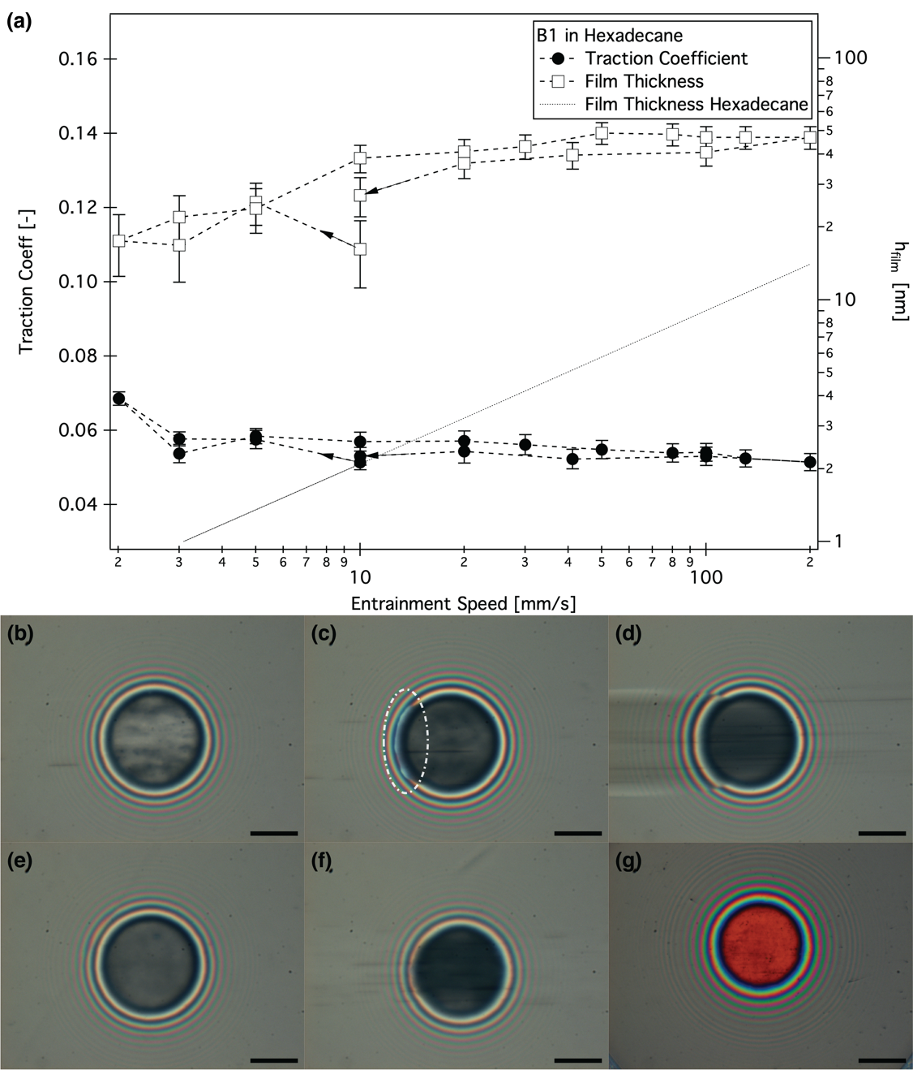
Figure S19: (a) Traction coefficient and film thickness for polymer B in hexadecane. (b-g) Contact visualization during the measurement. The lubricant flow is from right to left, and the scale bars correspond to 100μm. (b,c,d): sliding at 50% SRR with en- trainment speeds of 2mm/s, 20mm/s, and 200mm/s respectively. The area marked in (c) highlights the outlet zone. (e,f): pure rolling step with 10mm/s entrainment speed as the measurements’ initial and final steps. (g) static image of the ball loaded against a disk coated with a silica spacer layer for higher precision in the nm-thickness range. The derived adsorbed film thickness is between 14 nm and 20 nm.

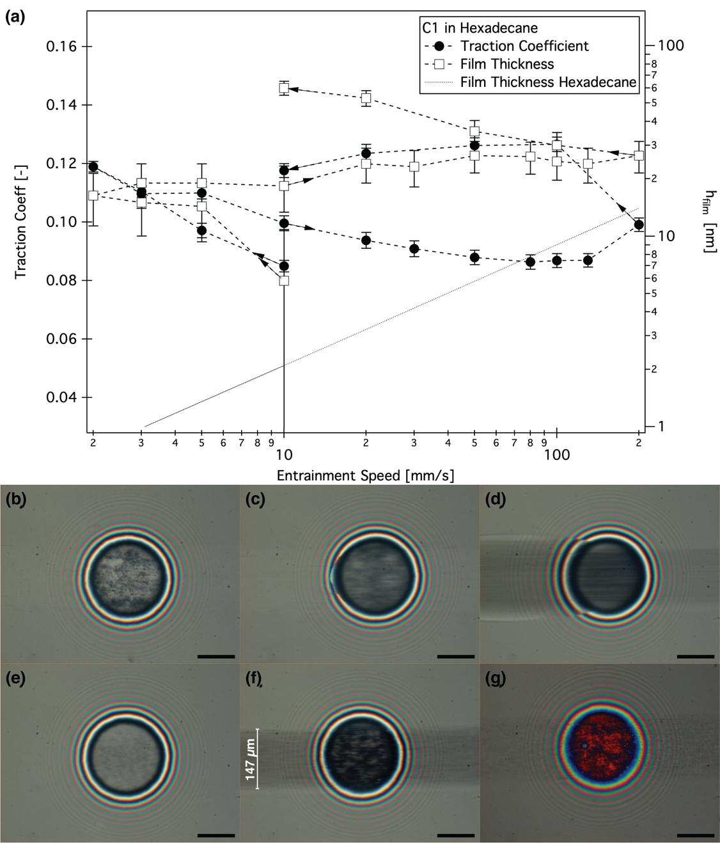
Figure S20: (a) Traction coefficient and film thickness for polymer C in hexadecane. (b-g) Contact visualization during the measurement. The lubricant flow is from right to left, and the scale bars correspond to 100μm. (b,c,d): sliding at 50% SRR with entrain- ment speeds of 2 mm/s, 20 mm/s, and 200 mm/s respectively. (e,f): pure rolling step with 10 mm/s entrainment speed as the measurements’ initial and final steps. (g): static image of the ball loaded against a disk coated with a silica spacer layer for higher precision in the nm-thickness range. The derived adsorbed film thickness is between 80 nm and 107 nm.

Bibliography
1. Serrano, Â.: Novel Polymer-Brush Based Coatings for Regulating Bioadhesion, (2014)
2. Dardin, A., Mueller, M., Eisenberg, B.: Lubricating oil composition with good frictional properties, US Patent No. 8,288,327 B2 (2012)
3. Fan, J., Müller, M., Stöhr, T., Spikes, H.A.: Reduction of friction by functionalised viscosity index improvers. Tribol. Lett. 28, 287–298 (2007). https://doi.org/10.1007/s11249-007-9272-3
4. Eberhardt, M., Mruk, R., Zentel, R., Théato, P.: Synthesis of pentafluorophenyl(meth)acrylate polymers: New precursor polymers for the synthesis of multifunctional materials. Eur. Polym. J. 41, 1569–1575 (2005). https://doi.org/10.1016/j.eurpolymj.2005.01.025
5. Napolitano, A., d’Ischia, M., Costantini, C., Prota, G.: A new oxidation pathway of the neurotoxin 6-aminodopamine. Isolation and characterisation of a dimer with a tetrahydro[3,4a]iminoethanophenoxazine ring system. Tetrahedron. 48, 8515–8522 (1992). https://doi.org/10.1016/S0040-4020(01)86599-6
6. Kanazawa, K.K., Gordon, J.G.: Frequency of a Quartz Microbalance in Contact with Liquid. Anal. Chem. 57, 1770–1771 (1985). https://doi.org/10.1021/ac00285a062
7. Reviakine, I., Johannsmann, D., Richter, R.P.: Hearing What You Cannot See and Visualizing What You Hear: Interpreting Quartz Crystal Microbalance Data from Solvated Interfaces. Anal. Chem. 83, 8838–8848 (2011). https://doi.org/10.1021/ac201778h

