Mn-Atomic-Layered Antiphase Boundary Induced Robust Ferroelectricity in Transparent KNN-Based Lead-Free Film
Liqiang Xu,ª Zhengyang Kong,ª Beibei Zhu,ª Xu Wang,ª Kun Han,ª Pingfan Chen,ª Chao Li,^{e} Wenbin Wu,^{b,d} Fangzhou Yao,^{f}* Ke Wang,^{c} Zhen Huang,^{a,}* and Feng Chen^{b,}*
ª Information Materials and Intelligent Sensing Laboratory of Anhui Province, Institutes of Physical Science and Information Technology, Anhui University, Hefei 230601, China
^{b} Anhui Province Key Laboratory of Condensed Matter Physics at Extreme Condition, High Magnetic Field Laboratory, Chinese Academy of Sciences, Hefei, Anhui 230031, China
^{c} State Key Laboratory of New Ceramics and Fine Processing, School of Materials Science and Engineering, Tsinghua University, Beijing 100084, China
^{d} Hefei National Laboratory for Physical Sciences at the Microscale, University of Science and Technology of China, Hefei 230026, China
^{e} School of Microelectronics and State Key Laboratory for Mechanical Behavior of Materials, Xi’an Jiaotong University, Xi’an, Shanxi, 710049, China
^{f} Research Center for Advanced Functional Ceramics, Wuzhen Laboratory, Jiaxing 314500, China
*Corresponding authors.
E-mail addresses: yaofangzhou@xjtu.edu.cn (F.-Z. Yao), huangz@ahu.edu.cn (Z. Huang), and fchen@hmfl.ac.cn (F. Chen)
These authors contributed equally to this work.

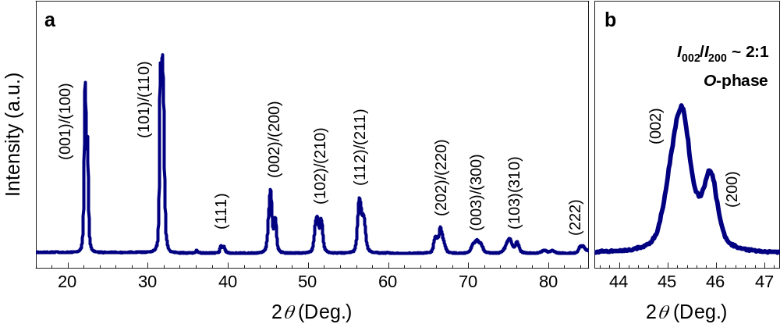
Figure S1. (a) The XRD pattern and (b) the enlarged part around (200)_{pc} peak of the KNNLT-M target.

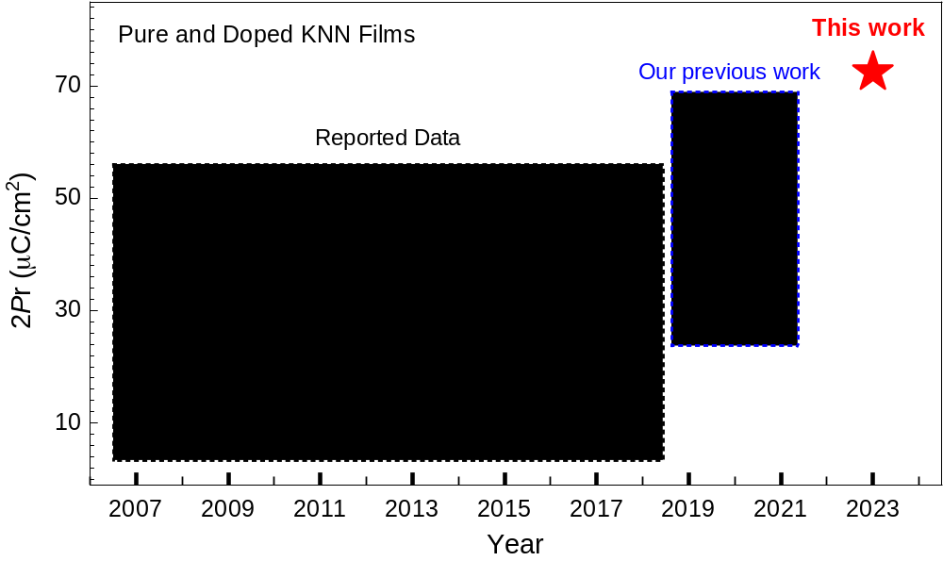
Figure S2. The comparison of polarization of the present KNNLT-M films with the previously experimentally measured twice remnant polarization (2P_{r}) values in pure and doped KNN films from the year of 2007 to 2024.

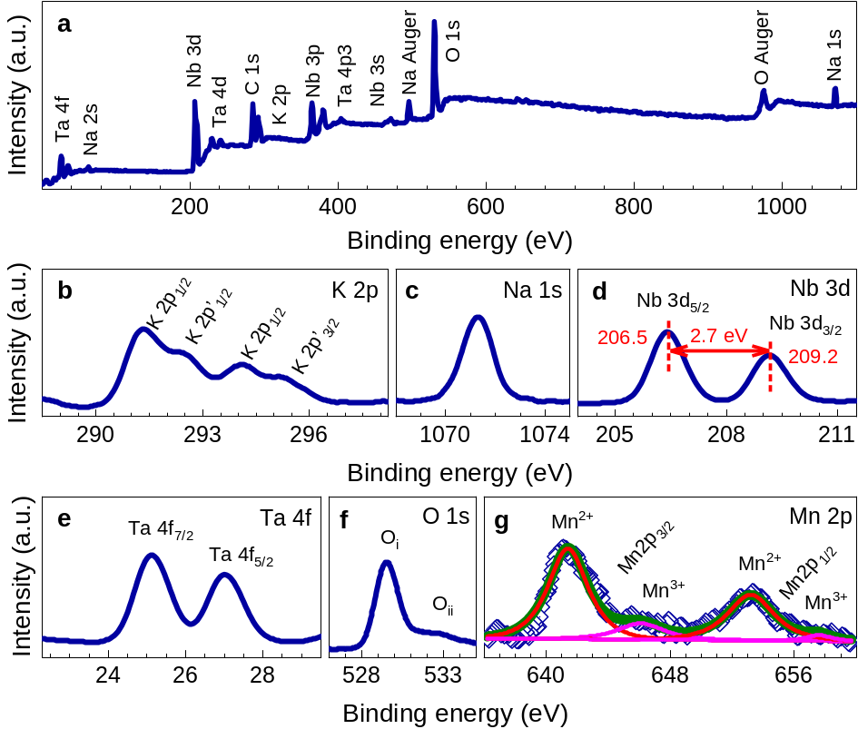
Figure S3. (a) XPS survey spectra and high-resolution spectra around (b) K 2p, (c) Na 1s, (d) Nb 3d, (e) Ta 4f, (f) O 1s and (g) Mn 2p of KNNLT-M films grown on the LSSO-coated STO (001) substrate.

Figure S4. (a) Typical X-ray linear scans, (b) zoom-in view and (c) rocking curves around KNNLT-M (020), RSMs on the (d) STO (002) and (e) STO ($\overline{1}$03) reflections for KNNLT-M films grown on LSSO-coated STO (001) substrate.

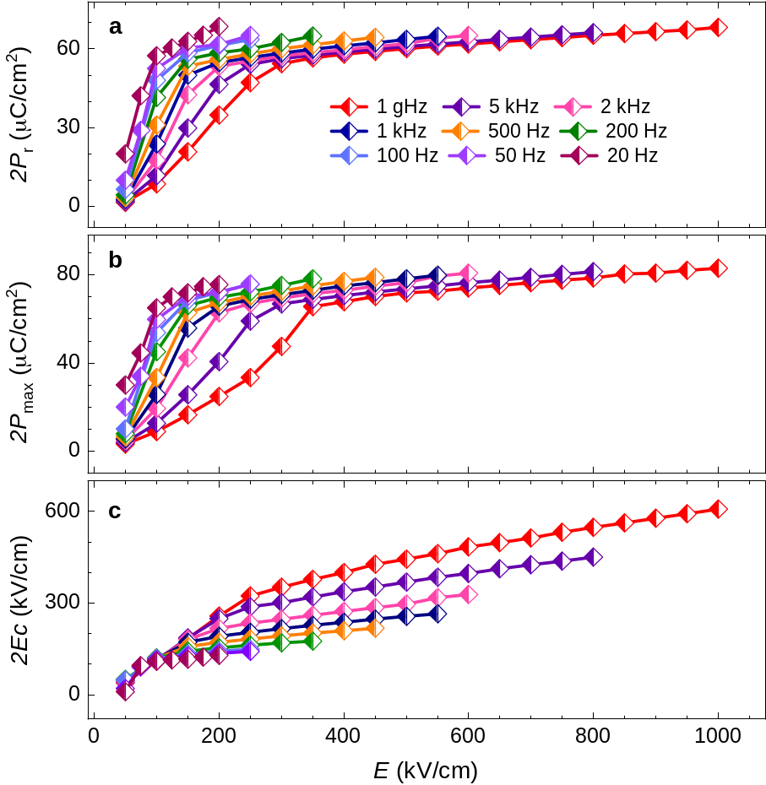
Figure S5. (a - c) The change of the twice remnant polarization (2P_{r}), twice maximum polarization (2P_{max}) and twice coercive electric field (2E_{C}) with different test frequencies from 20 Hz to 1 gHz for KNNLT-M films grown on LSSO-coated STO (001) substrate.

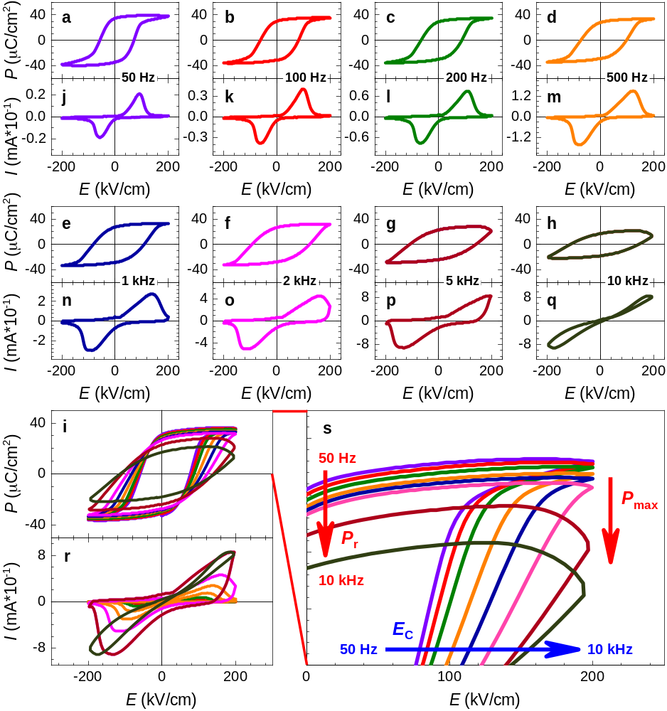
Figure S6. (a-i) The comparative P-E hysteresis loops and (j-r) corresponding switching current curves at the same electrical field of 200 kV/cm, and (s) the enlarge view of the comparative loops for KNNLT-M films grown on LSSO-coated STO (001) substrate from 50 Hz to 10 kHz.

Figure S7. (a-d) The surface STEM images along the in-plane directions from low-magnification to atomic resolution for KNNLT-M films grown on LSSO-coated STO (001) substrate.

Figure S8. High-resolution (a) out-of-plane and (h) in-plane cross-sectional testing areas for elemental analysis. The corresponding EDS maps of Nb, Ta and O in the (b-d) out-of-plane and (f-h) in-plane test areas, respectively.

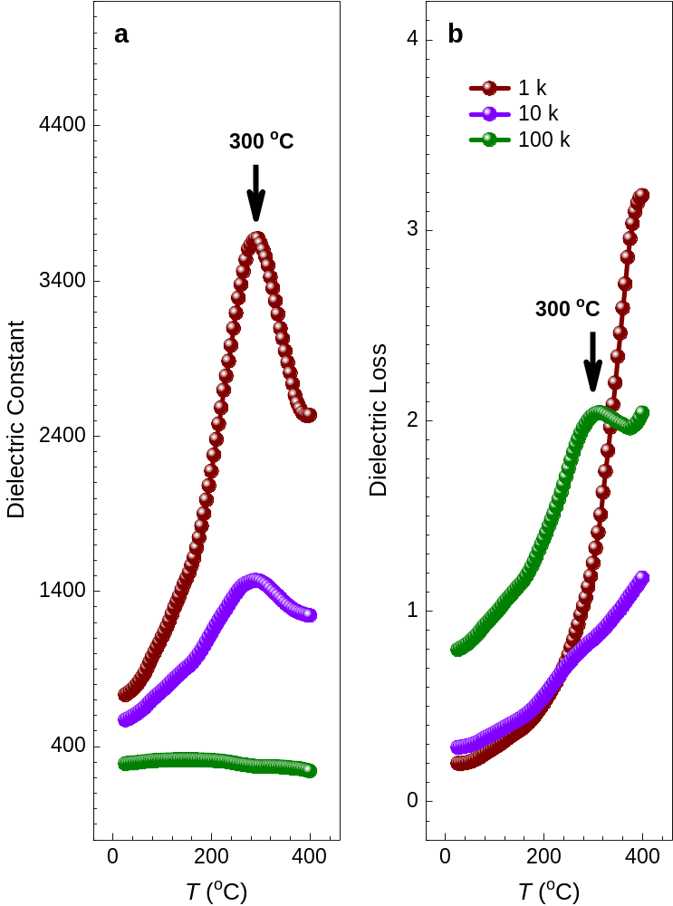
Figure S9. Temperature-dependent (a) dielectric constant and (b) dielectric loss measured at 1, 10 and 100 kHz for KNNLT-M films grown on LSSO-coated STO (001) substrate.

