Supplementary information
Supplemental Information includes 000 tables and 000 figures and can be found with this article online at https://doi.org/...

Supplementary Tables

Supplementary Table 1. Statistics of cryo-EM data collection, processing and refinement.
 | ompD-30S IC |  | ompD-TEC | ompD-TEC-30S IC
Data collection and processing
Microscope | FEI Titan Krios |  | FEI Titan Krios | FEI Titan Krios
Voltage (kV) | 300 |  | 300 | 300
Camera | Gatan K3 |  | Falcon 3 | Gatan K3
Magnification | 105,000 |  | 96,000 | 105,000
Pixel size at detector (Å) | 0.83 |  | 0.827 | 0.831
Total electron dose (e⁻/Å²) | 50 |  | 45.15 | 40.1
Exposure rate (e⁻/px/s) | 15.309 |  | 0.67 | 16.296
Frames per exposure | 42 |  | 40 | 40
Defocus range (μm) | -2.5 to -0.8 |  | -2.4 to -0.6 | -2.5 to -0.8
Micrographs collected | 9,104 |  | 1,619 | 12,011
Total extracted particles | 2,466,579 |  | 605,964 | 2,419,553
Reconstruction | State 1 | State 4 | ompD-TEC | TEC | 30S IC
Final particle (no.) | 19,140 | 62,096 | 41,790 | 8,354 | 8,354
Point-group symmetry | C1 | C1 | C1 | C1 | C1
Resolution (global, Å) | 3.0 | 3.0 | 3.3 | 5.8 | 3.9

Supplementary Figures

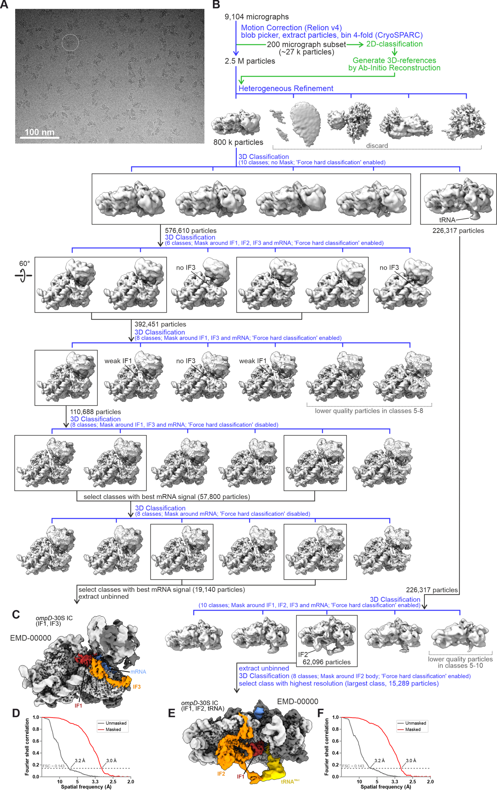
Supplementary Figure 1. Cryo-EM work flow for the 30S-ompD initiation complex.
(A) Representative electron micrograph. The white circle indicates a single 30S particle.
(B) Image processing workflow. Raw movies were motion-corrected in Relion v4 and micrographs were imported and further processed in CryoSPARC.
(C) Refined and locally filtered 3D map of the ompD-30S IC containing IF1 and IF3, colored by local resolution calculated in CryoSPARC.
Should be ompD-(dash!) 30S IC in figure
(D) Masked and unmasked Fourier Shell Correlation (FSC) plots for the final refinement of of the ompD-30S IC containing IF1 and IF3. Resolution is indicated at the FSC=0.143 cut-off.
(E) Refined and locally filtered 3D map of the ompD-30S IC containing IF1, IF2 and initiator tRNA, colored by local resolution calculated in CryoSPARC.
(F) Masked and unmasked Fourier Shell Correlation (FSC) plots for the final refinement of of the ompD-30S IC containing IF1, IF2 and initiator tRNA. Resolution is indicated at the FSC=0.143 cut-off.

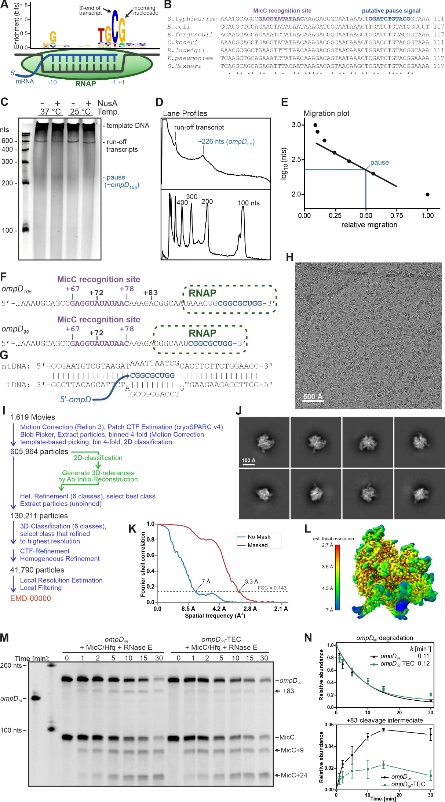

Supplementary Figure 2. A putative transcription pause site in the ompD ORF and assembly verification of the ompD-TEC by cryo-EM.
(A) HMMER logo for the transcription pause sequence adapted from (Imashimizu et al., 2015). Bases indicate sequences of the non-template DNA strand. The TEC is sketched with melted DNA in grey, nascent RNA in blue and RNAP in green.
(B) Multiple sequence alignment of the ompD gene. Positions that code for the MicC recognition site, or mark a putative transcription pause site are highlighted.
(C-E) In vitro transcription reactions in which ompD was transcribed by RNAP from the ompD-pMMB67HE plasmid at indicated temperatures in the absence or presence of NusA. Reactions were quenched by EDTA/SDS and analysed by SYBR gold-stained denaturing PAGE (C). PAGE lane profiles (D) are shown for averaged signal of in vitro transcription reactions (upper profile) and molecular marker bands (lower profile). The long product (‘run-off transcripts’) corresponds in length to transcription from the tac promoter until the T1 terminator in the pMMB67HE vector backbone, between which a 306 bp-segment of the ompD gene (positions -69 to +237) are inserted. The short transcript species was approximated to a length of 226±3 nts by interpolation between 200 nts and 400 nts standards after plotting logarithmic molecular marker sizes vs. migration distances (E). When accounting for vector-originated nucleotides and the length of the ompD 5’-UTR, the paused transcript species corresponds to transcription stalling at ompD position +109±3.
(F) 3’ sequences of ompD mRNA constructs. Terminal sequence segments for bubble formation are shown in bold blue letters. The recognition sequence for MicC is marked in purple. RNase E cleavage sites are annotated at +72 and +83. Green ovals delineate RNA nucleotides that are buried within the RNA polymerase (RNAP) in reconstituted ompD-TECs.
(G) Schematic of synthetic nucleic acid constructs fot TEC reconstitution. ntDNA, non-template DNA; tDNA, template DNA.
(H) Representative electron micrograph.
(I) Cryo-Em image processing workflow.
(J) Representative 2D class averages.
(K) Masked and unmasked Fourier Shell Correlation (FSC) plots for the three final Homogenous Refinement. Resolution is indicated at the FSC=0.143 cut-off.
(L) Refined and locally filtered 3D map of the ompD-TEC colored by local resolution calculated in CryoSPARC.
(M, N) Time-course experiment of MicC/Hfq-guided degradation of ompD₁₀₅ and ompD₁₀₅-TEC by RNase E. Graphs display relative abundances of indicated RNA species from the time-course experiment shown in b. Data are mean ± SD from three independent reactions. Colours: Data for free ompD₁₀₅ mRNA, black; Data for ompD₁₀₅-TEC, green.

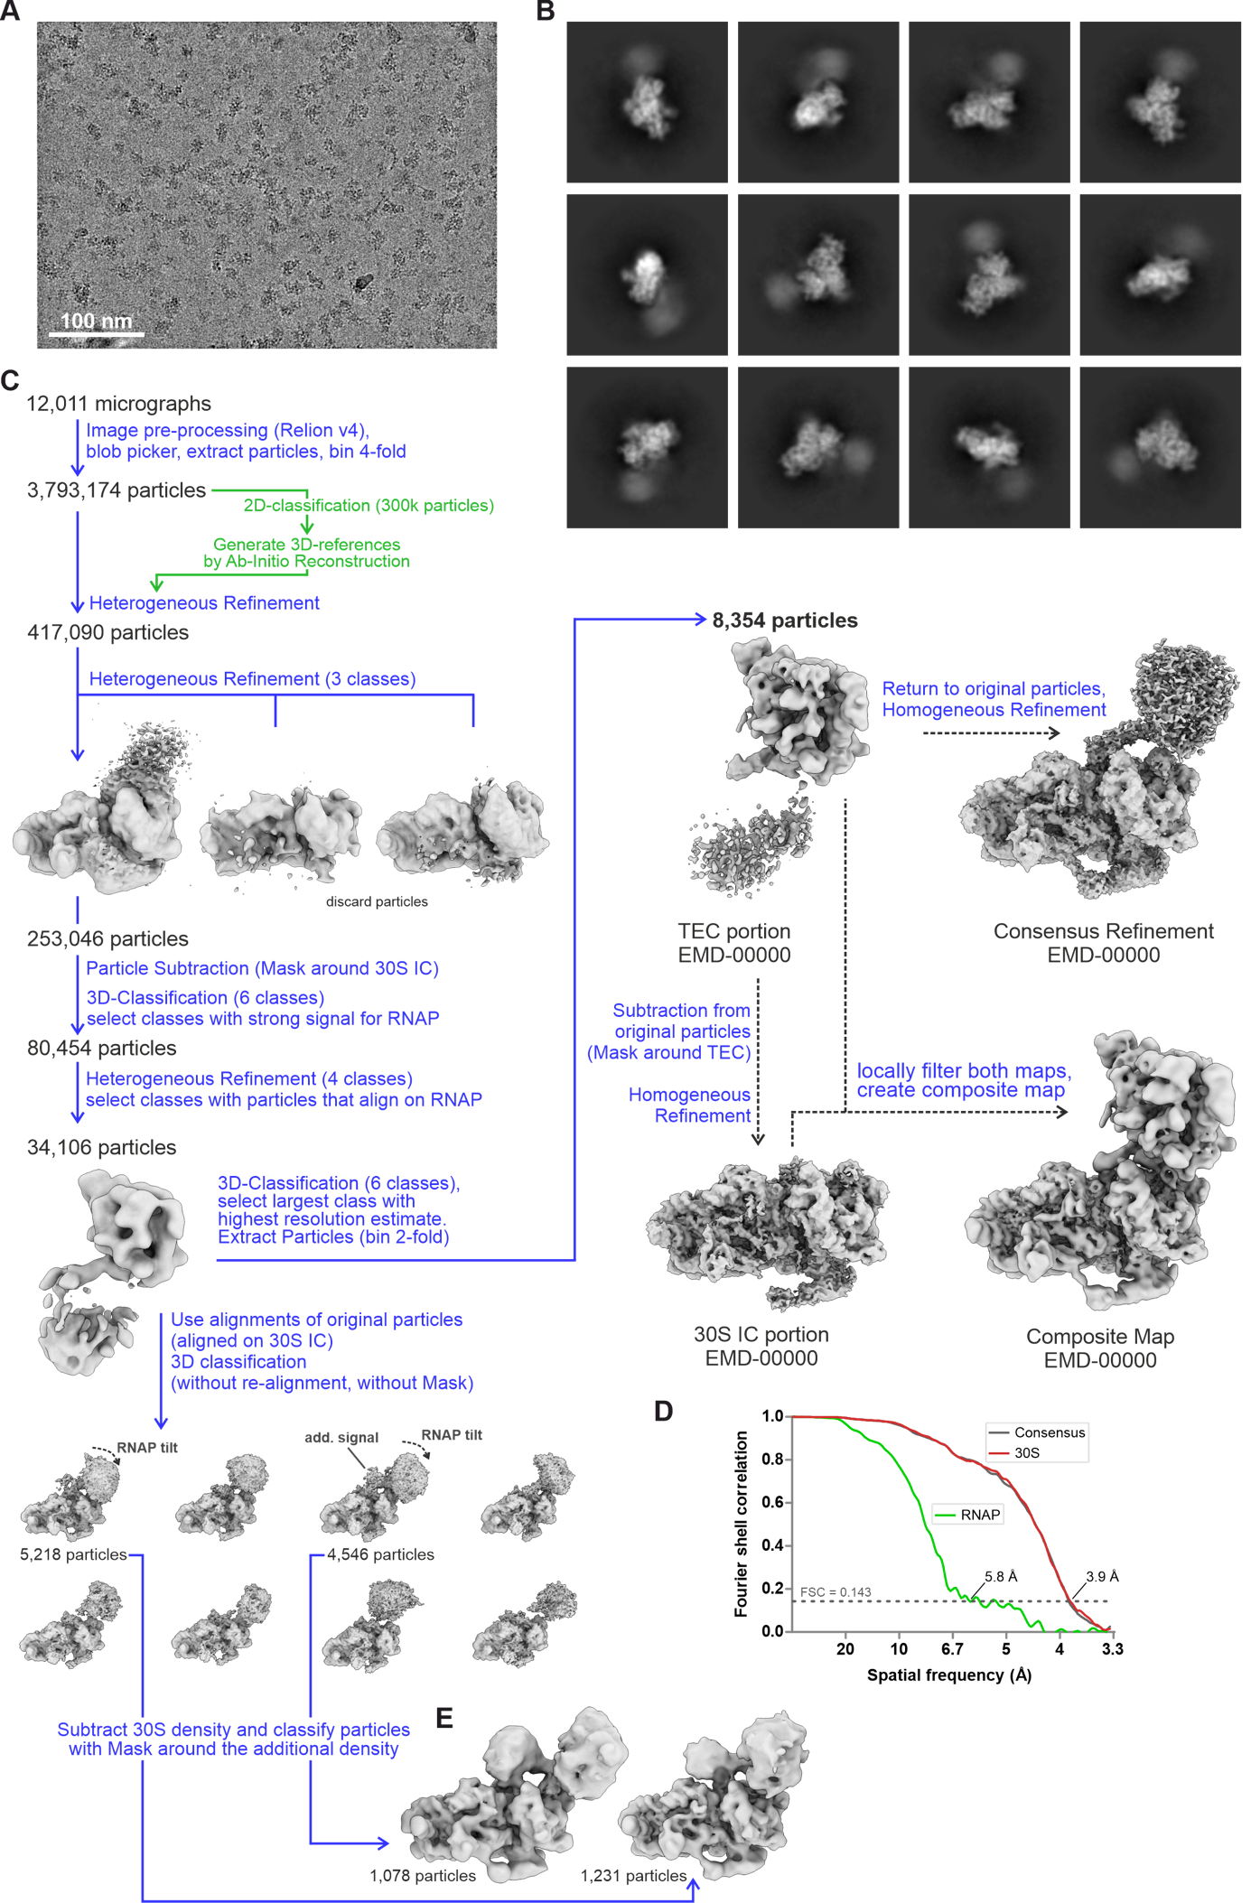
Supplementary Figure 3: Image processing overview for the coupled transcription elongation-translation initiation complex.
(A) Representative electron micrograph, est. defocus 2.0 µm, low pass filtered at 2 A.
(B) Representative 2D classes of the final particle set.
(C) Processing workflow.
(D) Fourier Shell Correlation (FSC) plots for the three final refinements. Resolution is indicated at the FSC=0.143 cut-off.
(E) Cryo-EM Reconstructions of TEC-30S IC complexes with additional unoccupied density in the mRNA path between RNAP and 30S.
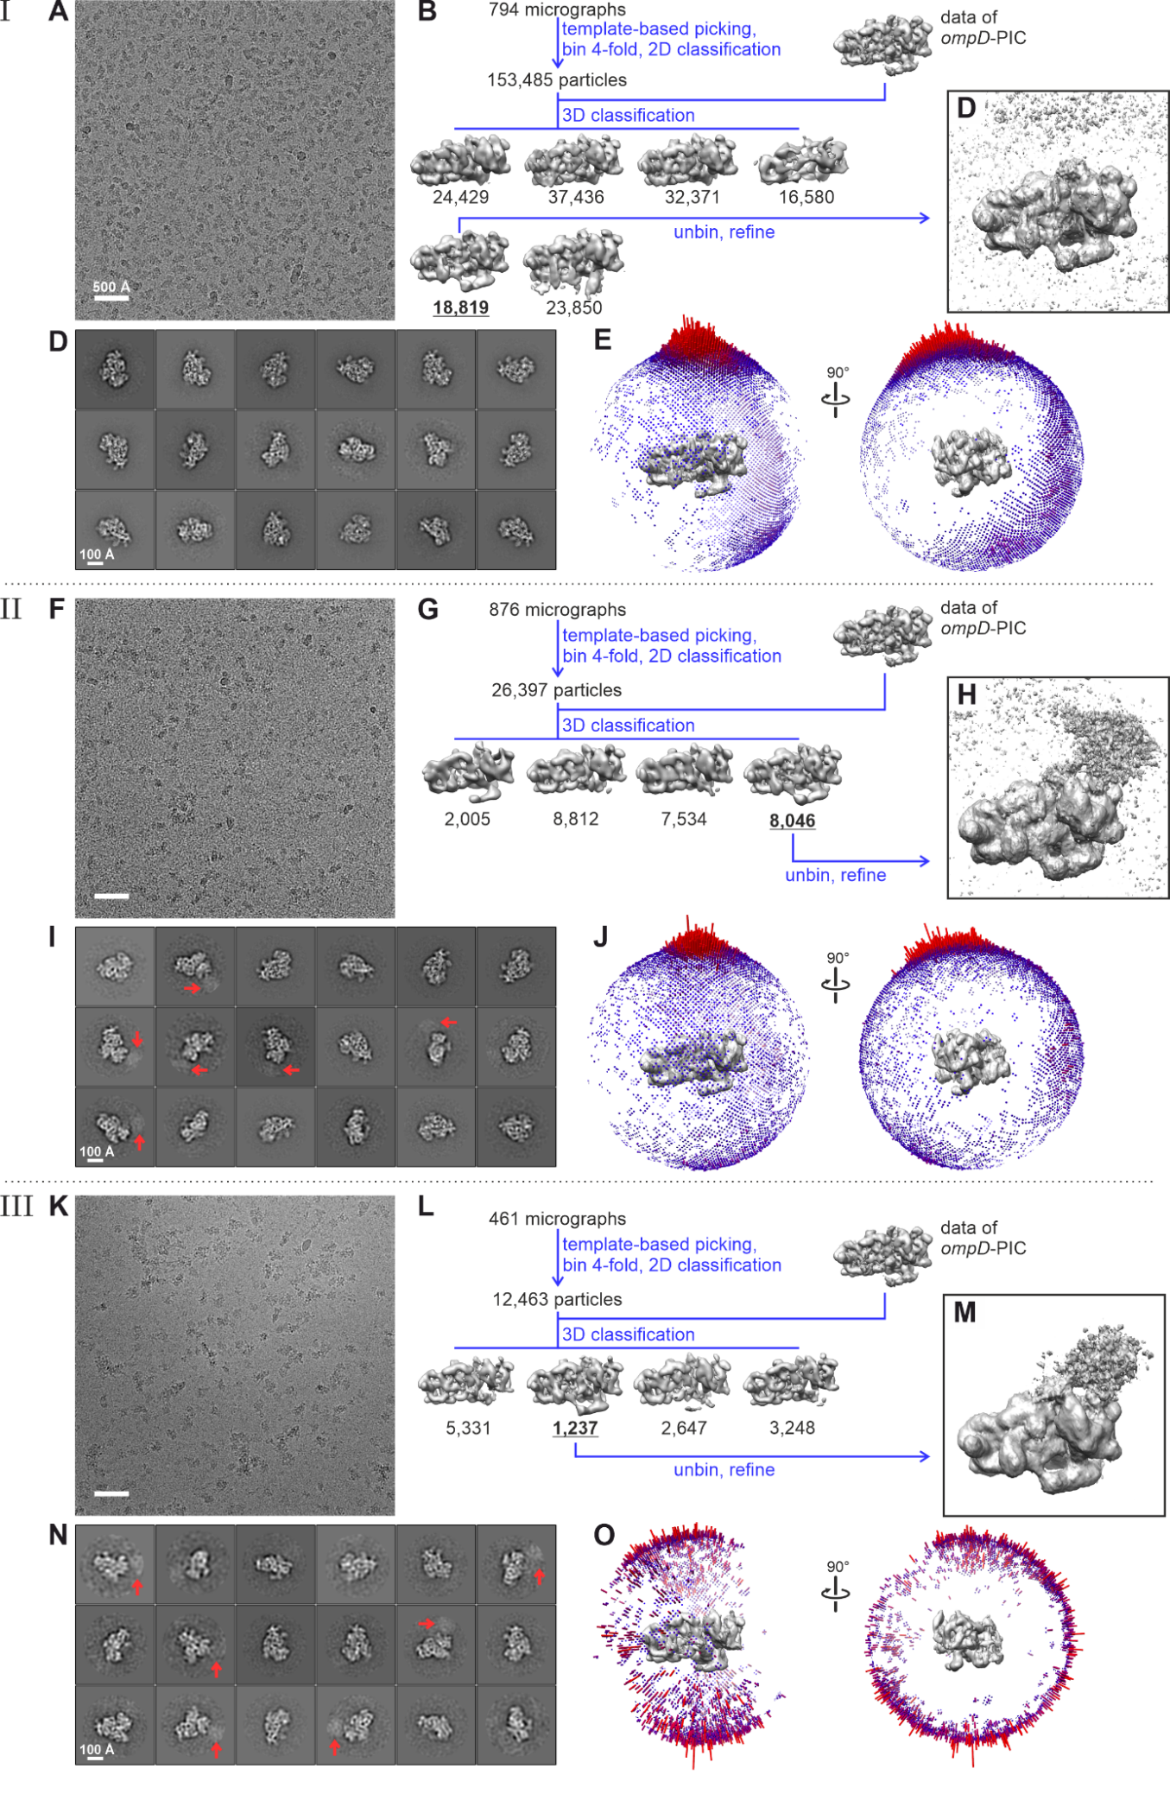
Supplementary Figure 4. Structural characterization of transcription-translation-coupled complexes. Three different samples were prepared for cryo-EM single particle analysis. (A-E) Sample I contains ompD-TEC and 30S IC in the absence of Nus-factors, vitrified on grids with 2 nm amorphous carbon support. (F-J) Sample II was prepared as Sample I but in the presence of Nus-factors NusA and NusG. (K-O) Sample III was also prepared in the presence of Nus-factors and was additionally treated with glutaraldehyde prior to vitrification on graphene oxide-coated grids. (A, F, K) Representative micrographs, recorded with a 200 kV Talos Arctica, scale bars indicate 50 nm. (B, G, L) Image processing flow charts. (C, H, M) Final reconstructions shown at low contouring level. (D, I, N) Representative 2D classes from classification of particles from final structures. Red arrows indicate signal for RNAP. Scale bars are 10 nm. (E, J, O) Spherical representation plot of angular distributions of particle projections. Red bars indicate higher, blue bars lower abundance.
Cryo-EM data was collected on a 200 kV FEI Talos Arctica equipped with a Falcon 3 detector in linear mode. Images were recorded at 92,000x fold magnification at a pixel size of 1.13 Å with dose rates between 0.58 and 0.63 e⁻/px/s and across a defocus range of -3.0 to -1.0 µm.

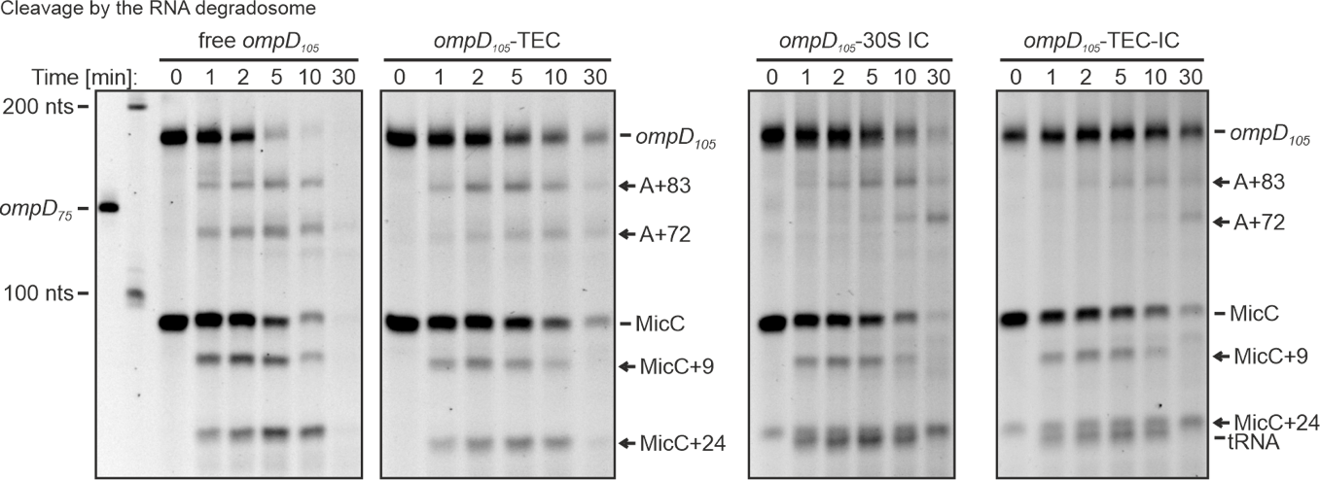
Supplementary Figure 5. Raw gels of degradation assays quantified in Figure 4.
Representative time course reactions of ompD₁₀₅-mRNA cleavage by the RNA degradosome in the presence of Hfq and MicC. Shown are reactions with free ompD₁₀₅ mRNA, ompD₁₀₅-TEC, ompD₁₀₅-30S IC and ompD₁₀₅-TEC-IC. Reactions were stopped at indicated time points and analysed by denaturing PAGE.

