Supplemental Information for

Human densities, not pollution, affect urban coyote boldness and exploration

Cesar O. Estien, Lauren A. Stanton, Christopher J. Schell

Contents:
Pages S1-10
Figures S14
Table S1-3

Methods

Data Cleaning
Once behavioral data was extracted, we manipulated our data to track instances where behaviors occurred but were not coded by the observer due to limitations in our coding software. For example, an individual may not be vigilant during the course of an observation and thus was vigilant for 0 seconds. However, this information is not captured by BORIS. Thus, we inserted these instances where behavior that was not observed into our data frame to capture the absence of the behaviors of interest. Our sample size is noted in Table S1.

Figures and Tables

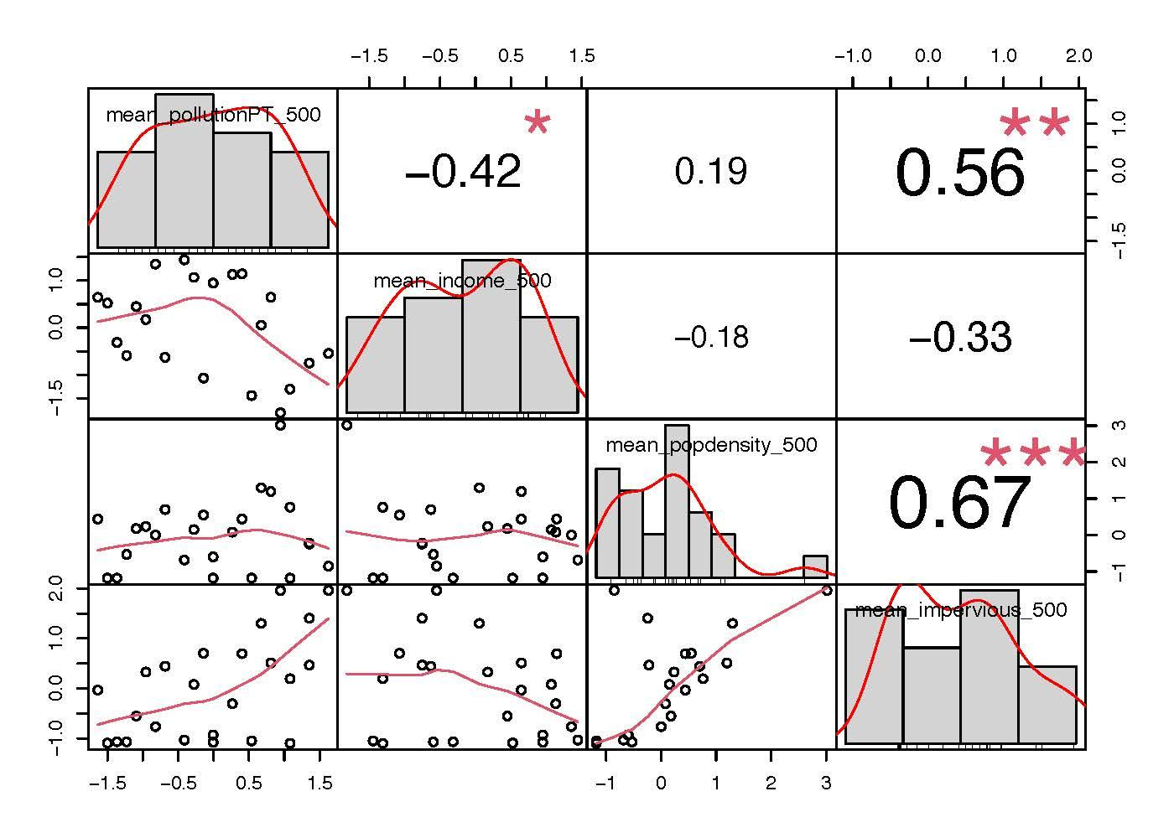

Figure S1. Correlation matrix between landscape variables initially considered. Median household income and impervious surfaces were excluded from our analysis.

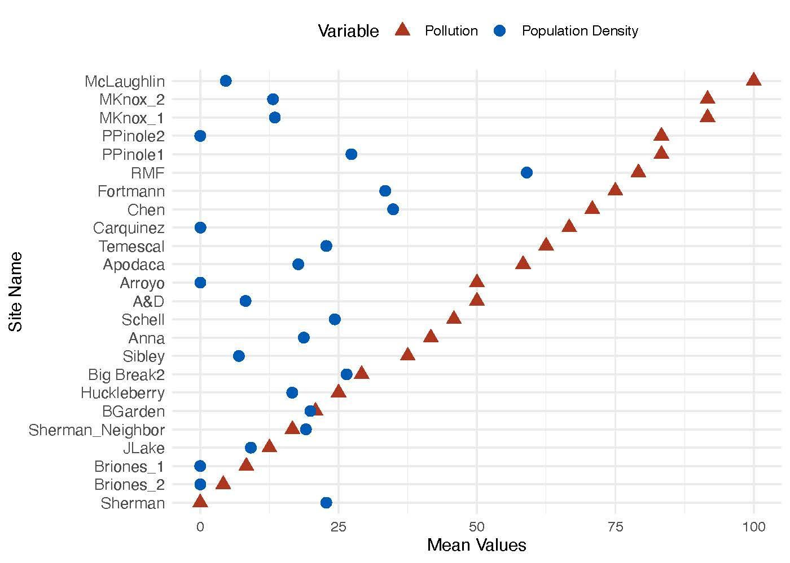
Figure S2. The distribution of pollution burden (triangle, red) and population density (circle, blue) metrics (x-axis) in our study area.

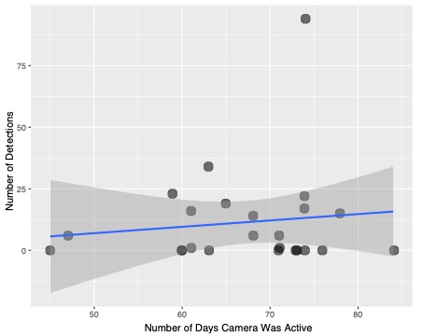
Figure S3. Correlation between the number a days a camera was active at a site and the number of coyote detections.

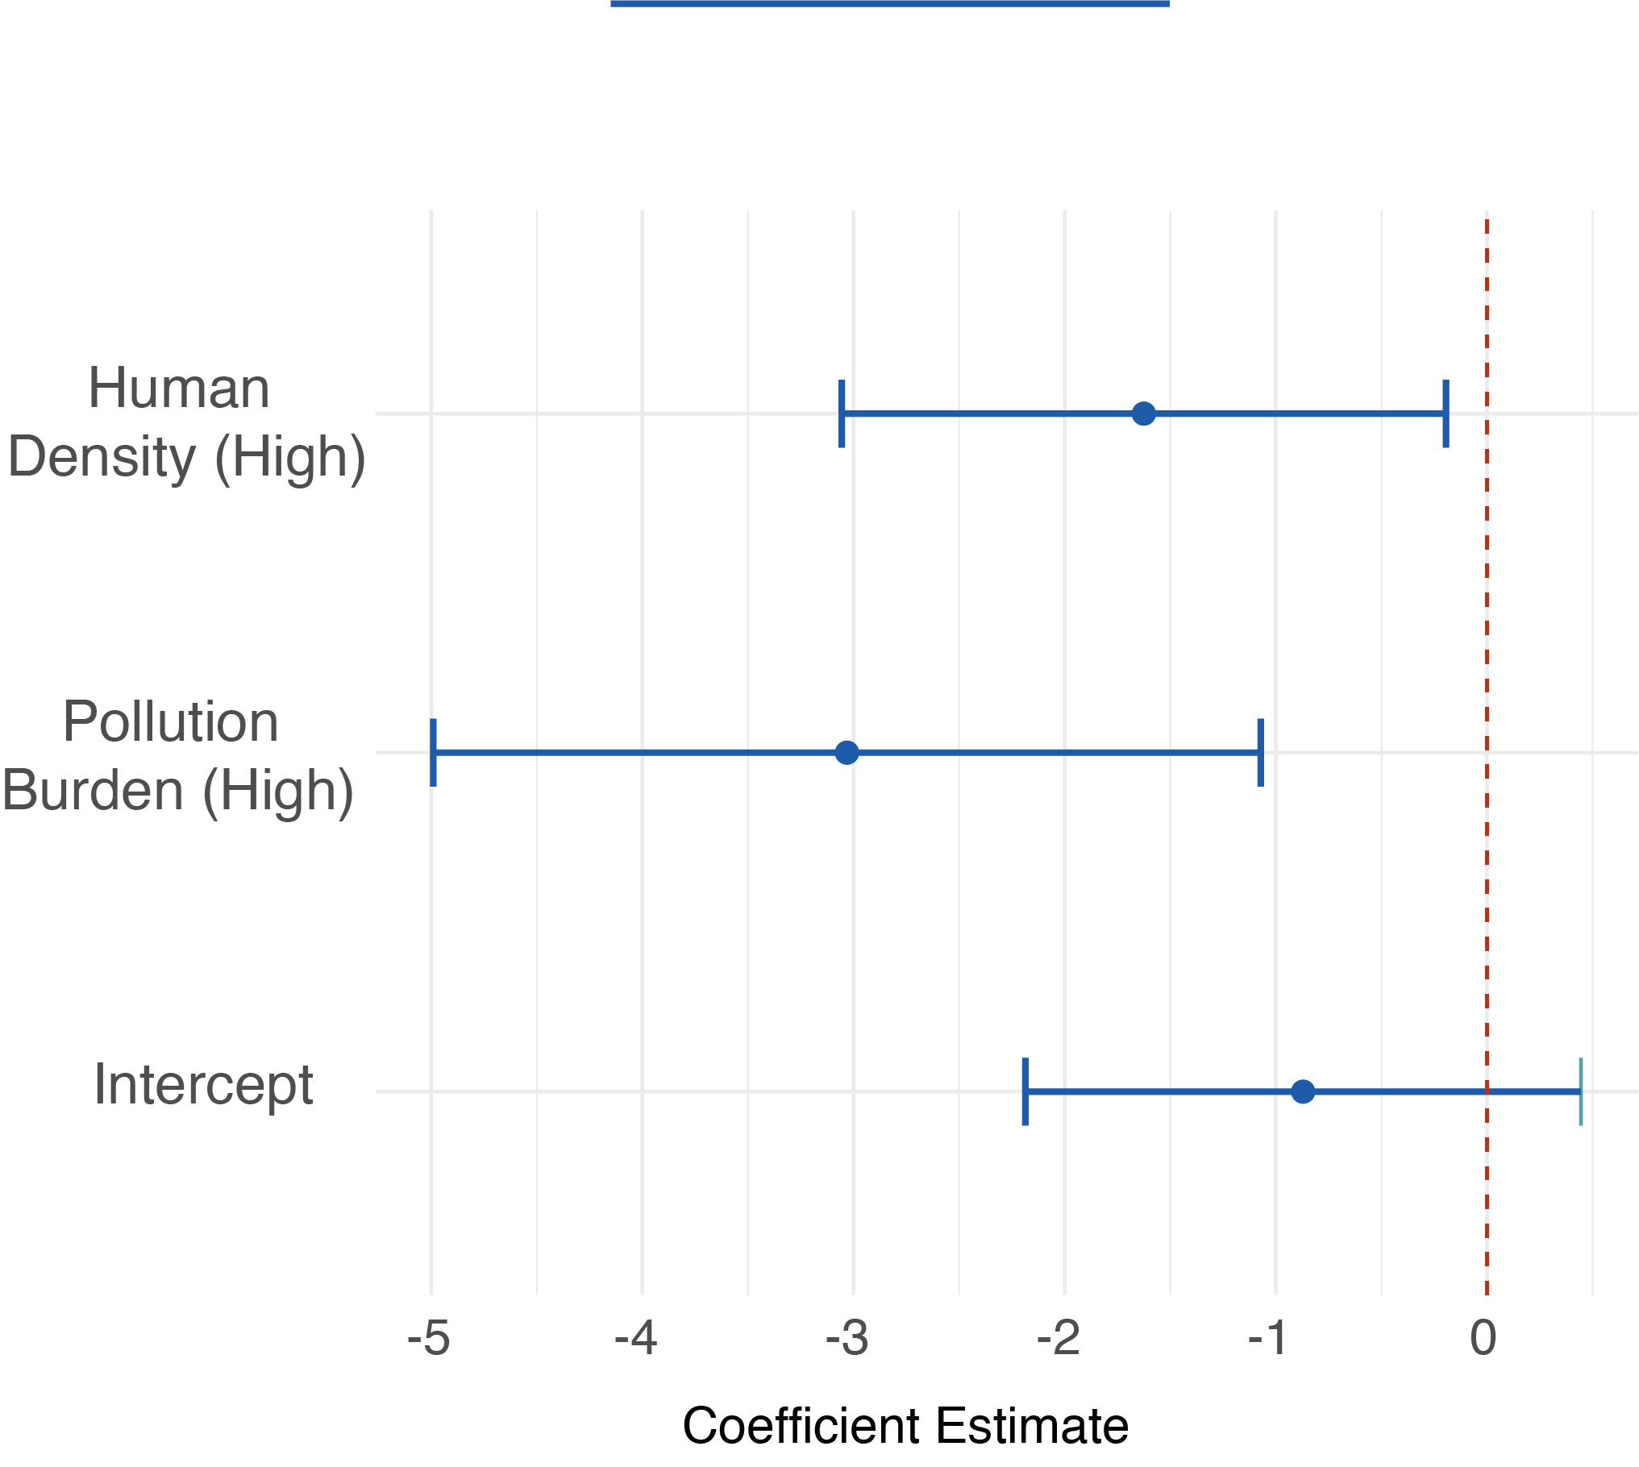

Figure S4. Coefficient estimates for fixed effects in our coyote detection models. Points represent the estimate and whiskers are 95% confidence intervals. Factors that cross the center dashed line are non-significant factors.

Table S1. Ethogram.

Behavior | Description
Alert | The focal species is alert by exhibiting one or multiple behaviors. For coyotes, individuals may flinch, have its tail tucked, have its ears perked, move hesitantly and/or be crouched while approaching the attractant/object.
Close | The focal species is within one body length of the novel object, including physical position directly on the attractant or within the object.
Far | The focal species is NOT within one body length of the novel object
Touch | The focal species physically touches the object.
Out of sight | The focal species is no longer within the video frame (i.e., not visible).
Dig | The focal species extends its front leg forward and then drags its paw across the ground toward its body. This occurs within one body length of the object. A separate dig event is considered each time an animal extends its appendage or switches appendages (left paw to right paw, both paws to one paw).
Other | The focal species exhibits a behavior not defined above
Sniff | The focal species is sniffing within one body length of the object, and its nose is pointed towards the object/ground.
Through | The focal species passes through the object

Table S2. Coyote detection model results.
Model | R²_{c} | Term | Estimate | SE | Pr (>|z|) | 95% CI
Coyote Detections | 0.391 | Intercept | -0.871 | 0.671 | 0.195 | -2.5186, 0.445
 |  | Human Density (High) | -1.625 | 0.7301 | < 0.05 | -3.056, -0.194
 |  | Pollution Burden (High) | -3.031 | 1.000 | < 0.01 | -4.991, -1.071

Table S3. Coyote and human disturbances selection results. K is the number of parameters for each model, ΔAICc is the difference in AICc score between the best model and the model being compared, Weight (0-1) is the AICc weight of evidence in favor of a given model, and LL is the log-likelihood of each model.

Behavior | Model | K | ΔAICc | Weight | LL
Time spent alert | Treatment | 6 | 8.32 | 0.01 | -666.94
 | Human Population Density | 6 | 7.54 | 0.02 | -666.56
 | Pollution Burden | 6 | 24.73 | 0.00 | -675.15
 | Human Population Density + Pollution Burden | 7 | 8.81 | 0.01 | -666.14
 | Human population density * Treatment | 8 | 0.00 | 0.79 | -660.69
 | Pollution Burden * Treatment | 8 | 11.66 | 0.00 | -666.52
 | Global | 10 | 3.13 | 0.17 | -660.12
 | Null | 5 | 24.09 | 0.00 | -675.87
Time spent close | Treatment | 6 | 11.55 | 0.00 | -887.59
 | Human Population Density | 6 | 53.24 | 0.00 | -908.44
 | Pollution Burden | 6 | 69.84 | 0.00 | -916.74
 | Human Population Density + Pollution Burden | 7 | 52.02 | 0.00 | -906.78
 | Human population density * Treatment | 8 | 0.30 | 0.46 | -879.87
 | Pollution Burden * Treatment | 8 | 10.92 | 0.00 | -885.18
 | Global | 10 | 0.00 | 0.54 | -877.59
 | Null | 5 | 68.82 | 0.00 | -917.27
Exploration Diversity | Treatment | 6 | 1.67 | 0.26 | -369.48
 | Human Population Density | 6 | 50.62 | 0.00 | -393.96
 | Pollution Burden | 6 | 57.25 | 0.00 | -392.27
 | Human Population Density + Pollution Burden | 7 | 52.71 | 0.00 | -393.36
 | Human population density * Treatment | 8 | 0.00 | 0.60 | -366.55
 | Pollution Burden * Treatment | 8 | 5.20 | 0.04 | -369.15
 | Global | 10 | 3.80 | 0.09 | -366.32
 | Null | 5 | 55.19 | 0.00 | -397.28

