GRAPHICAL ABSTRACT
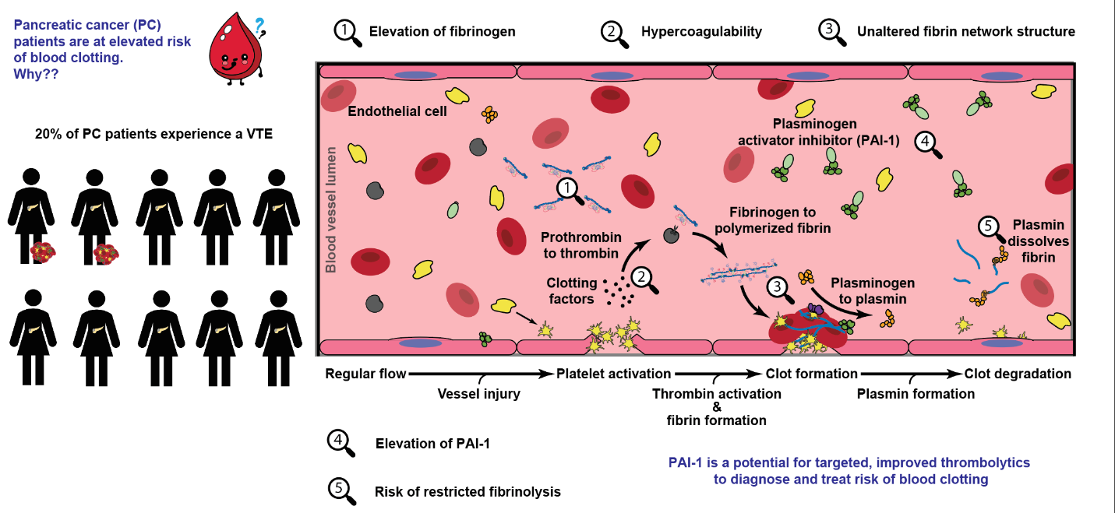
Graphical Abstract. Clot formation, structure, and fibrinolysis of pancreatic cancer patients. Schematic of blood clot formation and fibrinolysis with key features noted related to pancreatic cancer patients.

