Additional File 1
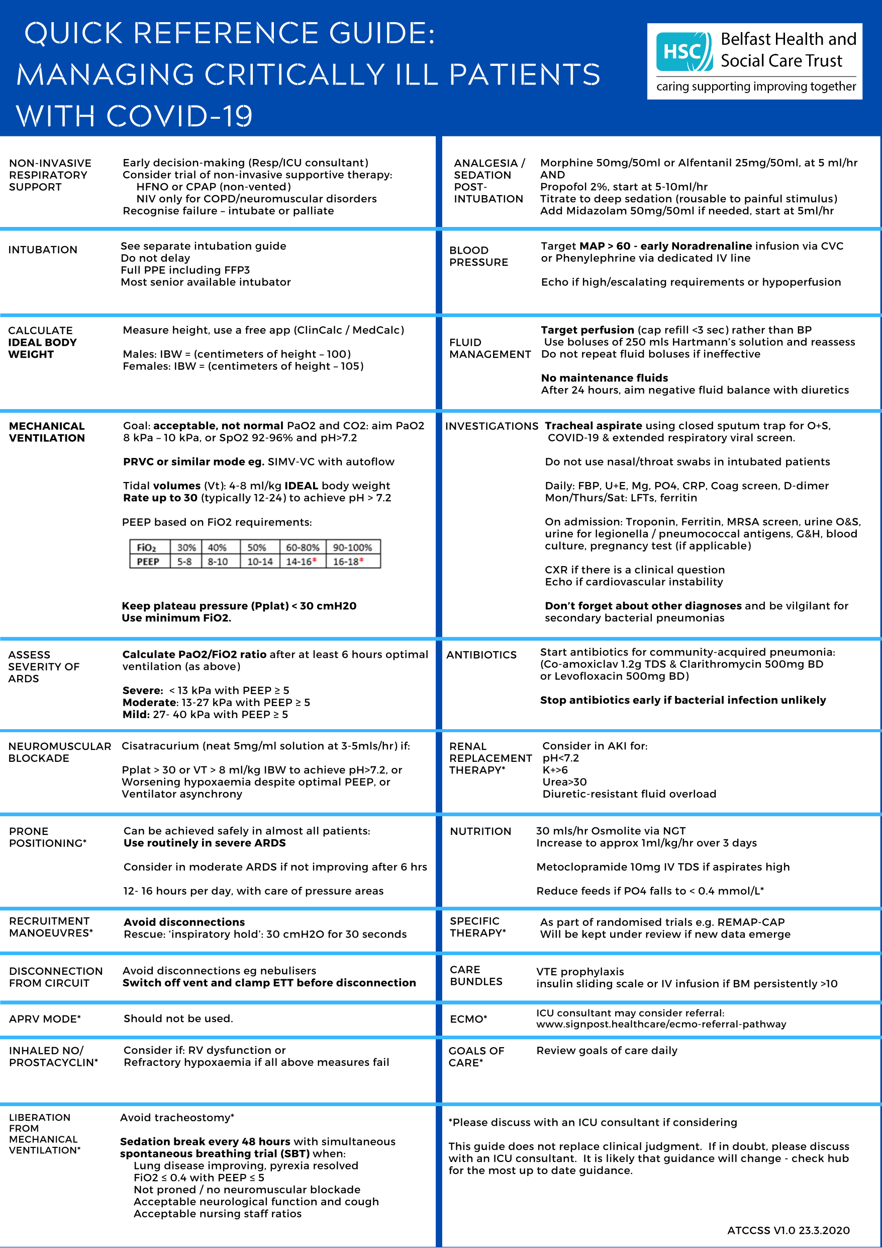
Institutional guideline for management of Covid-19 pneumonia in the ICU

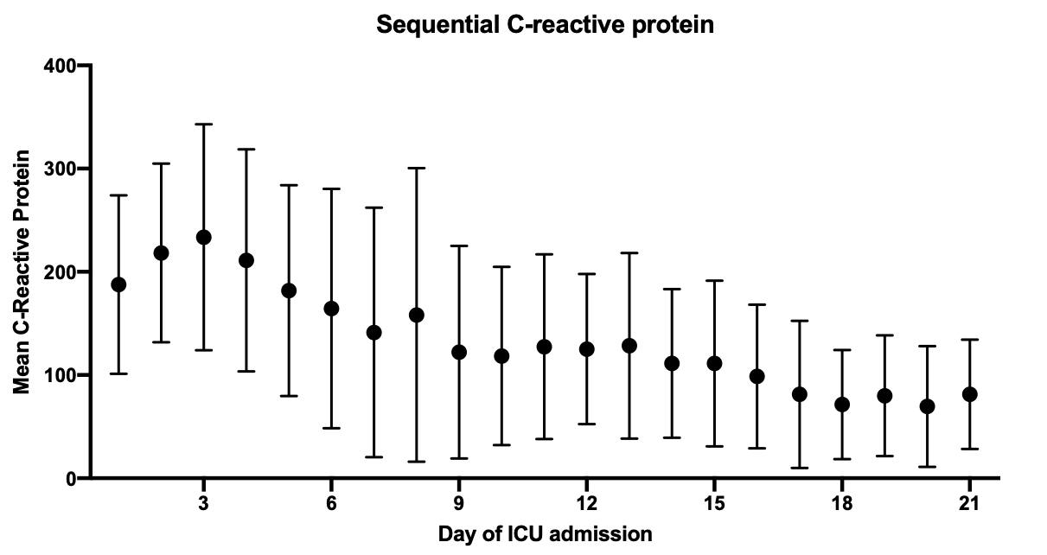
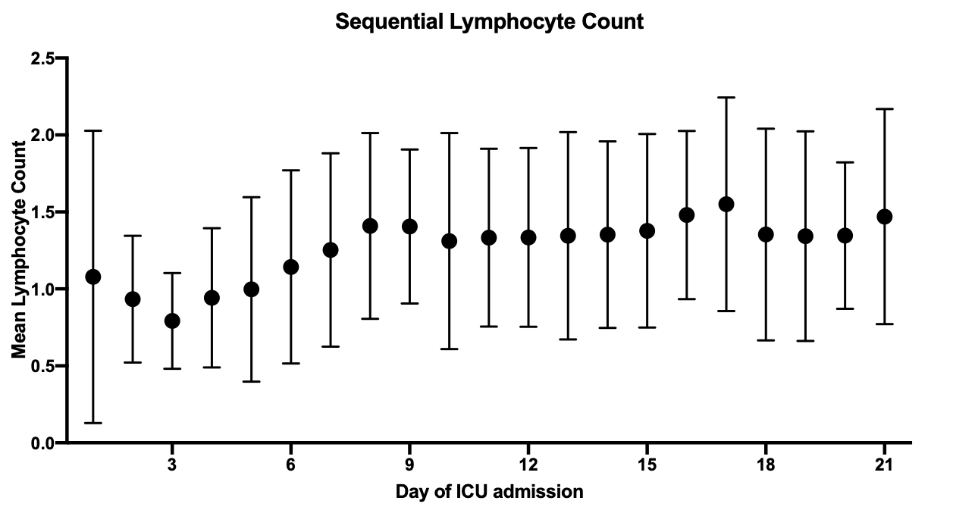

Trends in Lymphocyte count (x10⁹/L); and C-reactive protein (mg/L) values over time, mean +/- SD.

Dynamic pulmonary compliance
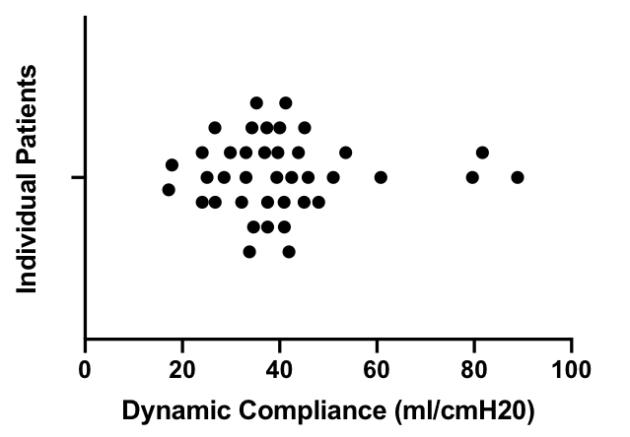

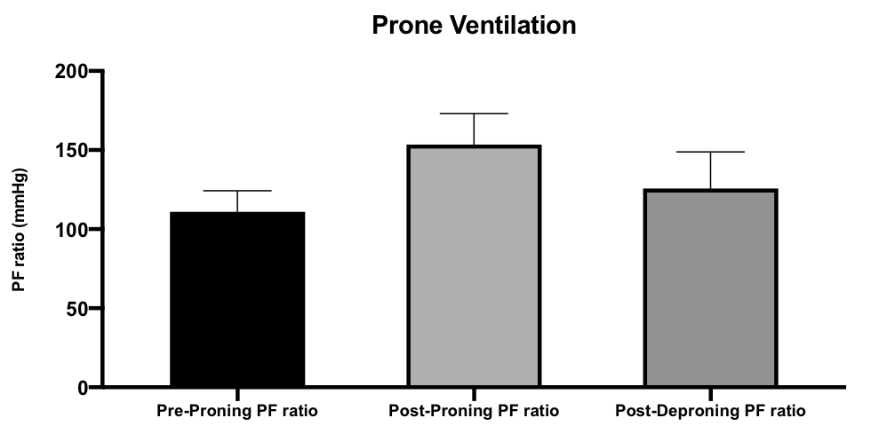
Effect of prone positioning, mean + SD

