Appendix A
Questions on Self-efficacy and Intrinsic Motivation to Learn from MSLQ

Question 17 | General Self-Efficacy Scale (GSE) - I can always manage to solve difficult problems if I try hard enough.
Question 18 | General Self-Efficacy Scale (GSE) - I am confident that I can deal efficiently with unexpected events.
Question 19 | General Self-Efficacy Scale (GSE) - I can solve most problems if I invest the necessary effort.
Question 20 | General Self-Efficacy Scale (GSE) - Thanks to my resourcefulness, I know how to handle unforeseen situations.
Question 21 | General Self-Efficacy Scale (GSE) - When I am confronted with a problem, I can usually find several solutions.
Question 22 | MSLQ survey questions for intrinsic motivation - I prefer class work that is challenging so I can learn new things.
Question 23 | MSLQ survey questions for intrinsic motivation - It is important for me to learn what is being taught in this class.
Question 24 | MSLQ survey questions for intrinsic motivation - I liked what I was learning in this class.
Question 25 | MSLQ survey questions for intrinsic motivation - I liked how I learned in this class.
Question 26 | MSLQ survey questions for intrinsic motivation - I was certain I could understand the ideas taught in this course.
Question 27 | MSLQ survey questions for intrinsic motivation - I will be able to use what I learn in this class in other classes.
Question 28 | MSLQ survey questions for intrinsic motivation - I expected to do very well in this class.
Question 29 | MSLQ survey questions for intrinsic motivation - I was confident that I could do an excellent job on the problems and tasks assigned for this class.
Question 30 | MSLQ survey questions for intrinsic motivation - I think I will receive a good grade in this class.
Question 31 | MSLQ survey questions for intrinsic motivation - I think that what I learned in this class is useful for me to know.
Question 32 | MSLQ survey questions for intrinsic motivation - Understanding how to write well is important to me.
Question 33 | MSLQ survey questions for intrinsic motivation - I use what I have learned from real-time or summative feedback from past assignments to do new assignments.

Appendix B
Questions From End-of-course Survey for the Feeling of Encouragement, Engagement, Supportedness

Question 1 | I felt encouraged throughout the course.
Question 3 | I felt engaged throughout the course.
Question 5 | I felt supported throughout the course.

Appendix C
Course Assistant Access Instructions Placed in Each Course Utilizing Assistants
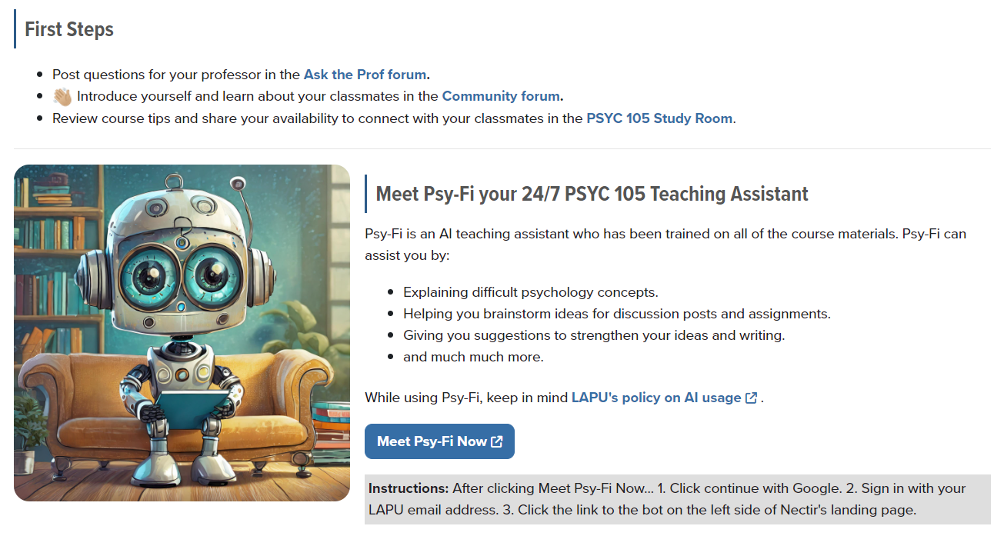
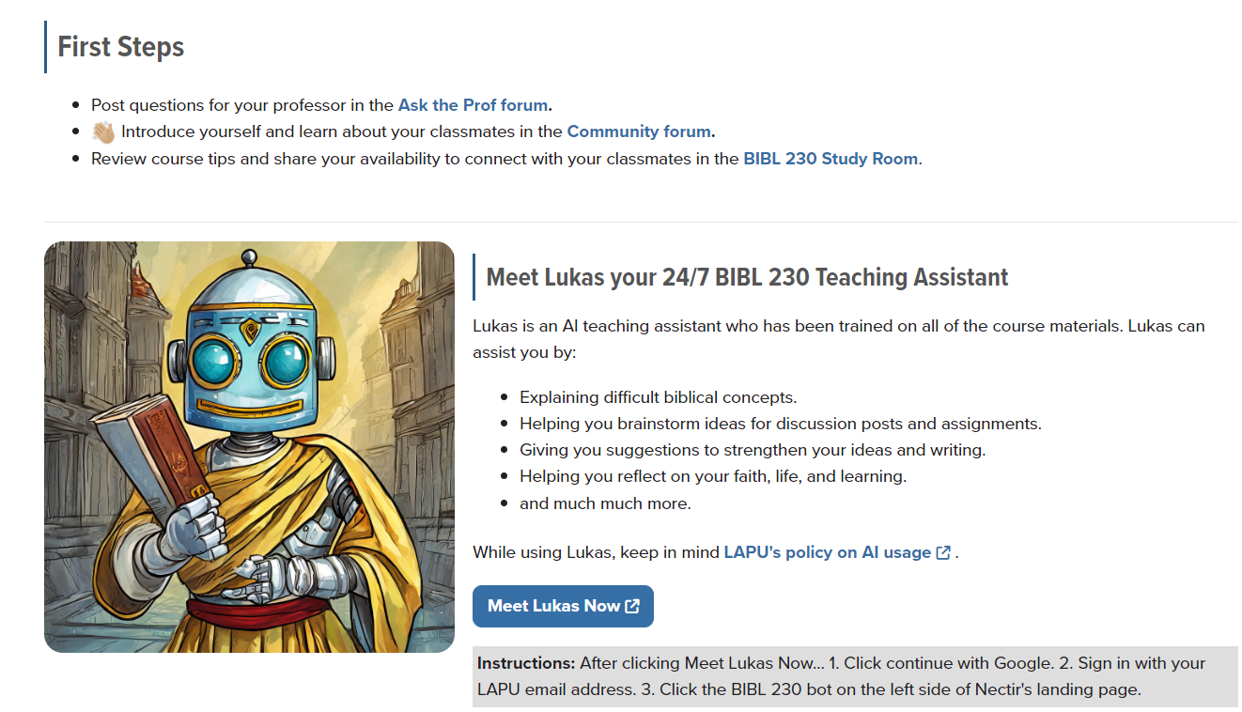

Appendix D
Student Infographic
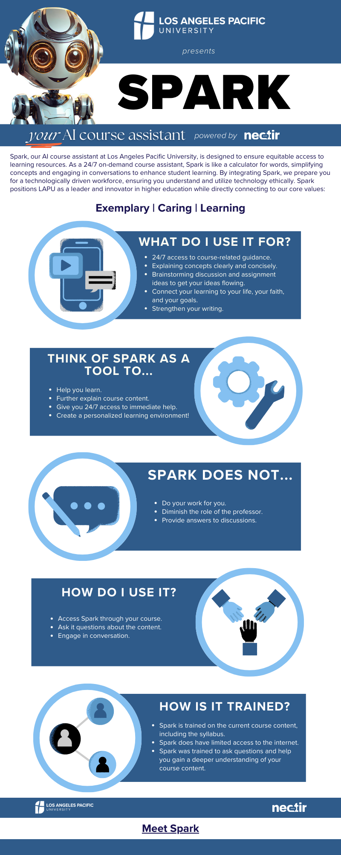
Appendix E
Example of Assistant Response to Being Asked to Write a Paper for a Student

Request:
Write this paper: In a 500 word reflection paper, or a 3 minute video or audio recording, conduct a faith check in with yourself. As we begin this course, consider your faith and your understanding of God as Father, Son, and Holy Spirit. If you do not have a relationship with God, think about your current views or experiences with faith.
Reflect on your feelings, attitudes, questions, and experiences about your faith journey so far, and what your goals are moving forward. The following questions may help guide your thinking:
Who is God to you? What has God meant to you throughout your life? How have you experienced God as Father, Son, and Holy Spirit?
If you don’t believe in God, who or what do you believe in?
Who is Jesus to you?
Incorporate 2-3 specific quotes or ideas from course resources in your reflection.
Submit your completed paper or recording before the deadline.

Response:
As an AI, I'm unable to write a personal reflection paper for you. However, I can guide you on how to structure your reflection paper.

1. Introduction: Start by introducing your current understanding of faith and your relationship with God. If you don't have a relationship with God, share your current views or experiences with faith.

2. Body: This is where you answer the guiding questions.
- Who is God to you? Describe your personal understanding of God.
- What has God meant to you throughout your life? Share experiences or moments where you felt a connection or disconnection with God.
- How have you experienced God as Father, Son, and Holy Spirit? Discuss your understanding of the Holy Trinity and how it has influenced your faith journey.
- If you don’t believe in God, who or what do you believe in? Share your beliefs and how they guide your life.
- Who is Jesus to you? Discuss your understanding of Jesus and his role in your faith journey.

3. Quotes or Ideas from Course Resources: Incorporate 2-3 specific quotes or ideas from the course resources that have influenced your understanding of faith. Explain why these quotes or ideas are significant to you.

4. Conclusion: Reflect on your feelings, attitudes, questions, and experiences about your faith journey so far. Discuss your goals moving forward.

Remember to write in the first person since this is a reflection paper. Be honest and open about your experiences and feelings. This is your faith journey, and there's no right or wrong answer.

Once you've written your paper, make sure to review it for clarity and coherence. Check for any grammatical or spelling errors. Finally, ensure you submit your completed paper before the deadline.

I hope this helps! If you have any other questions or need further clarification, feel free to ask.

